HMB Choto
45285209

CMPG 325

Milestone 2
Milestone Implementation Report

Contents
Project overview 3
Key design constraints 3
Physical topology 3
Devices 4
Logical Topology and VLAN Design 4
VLAN allocation 5
IP Addressing Plan 6
Key Static Assignments: 6
Router-on-a-Stick Configuration 7
NAT and Internet access 8
Server Configuration 9
Access Control List Policy 9
Policy Summary 9
ACL configuration set on R1 10
Testing and Verification 12
Before ACL 12
Post ACL verification 14
NAT Verification 17
Routing Verification 17
Conclusion 17

Project overview
North-West Asset Finance is a banking and finance client operating from a single Rustenburg site. The network prioritises departmental segmentation and controlled access to shared resources, while still allowing operational services such as printing to be shared efficiently across the business.

Key design constraints
- Printer sharing must cross departments.
- File sharing must not cross departments.
- Guest Wi-Fi must be isolated from all internal resources (Change Request CR3).
- Assigned addressing block: 192.168.14.0/24.

Physical topology
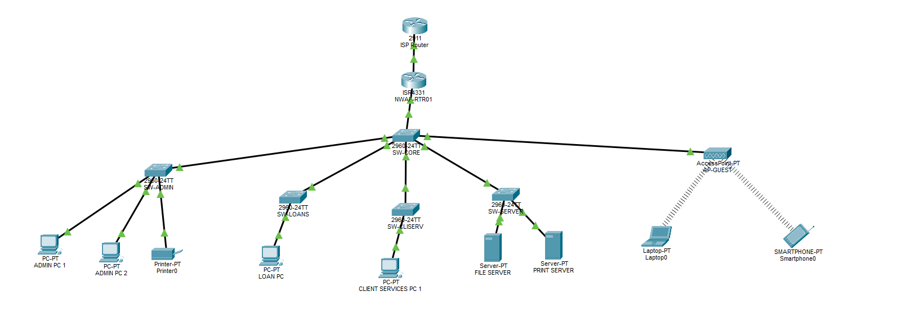
The physical design uses a collapsed-core architecture: a single Layer-3 edge router (R1 / NWAF-RTR01) performs inter-VLAN routing (router-on-a-stick) and hosts the ACL policy; a core/distribution switch (SW-CORE) trunks VLANs down to per-department access switches; a dedicated server switch (SW-SERVER) hosts the File Server and Print Server; and a wireless access point (AP-GUEST) serves the isolated guest network.

Devices
Device | Role | Model
ISP Router | Simulated Internet | 2911
R1 (NWAF-RTR01) | Edge router, ROAS, ACLs, NAT | ISR 4331
SW-CORE | Core/distribution switch | 2960-24TT
SW-ADMIN | Access switch — VLAN 10 | 2960-24TT
SW-LOANS | Access switch — VLAN 20 | 2960-24TT
SW-CLIENTS | Access switch — VLAN 30 | 2960-24TT
SW-SERVER | Access switch — VLAN 40 | 2960-24TT
AP-GUEST | Wireless access point | Access Point
File Server | Centralised file storage | Server-PT
Print Server | Centralised print services | Server-PT

Logical Topology and VLAN Design
Each department, the server farm, and guest Wi-Fi are placed on separate VLANs, each mapped to its own subnet carved from the assigned 192.168.14.0/24 block using VLSM.
VLAN configuration was verified directly on the switches. The interface status on SW-SERVER confirms the File Server and Print Server ports are connected and correctly placed in VLAN 40, with the uplink to SW-CORE operating as a trunk:
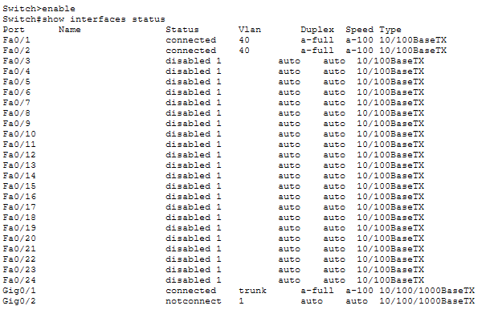
show interfaces status — SW-SERVER (Fa0/1, Fa0/2 in VLAN 40; Gi0/1 trunking to SW-CORE)

The VLAN database on SW-SERVER confirms all five VLANs (10, 20, 30, 40, 99) are active:
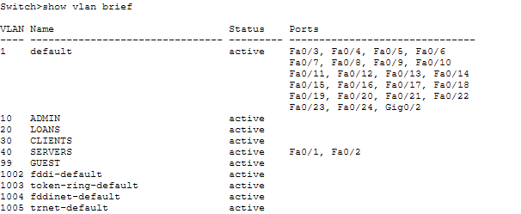
show vlan brief — SW-SERVER
Confirmation the trunk carries all VLANs at the distribution layer:
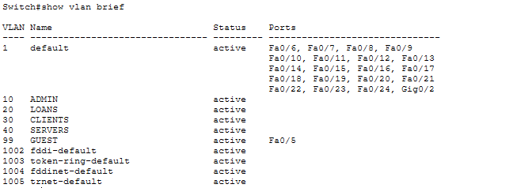
show vlan brief — SW-CORE

VLAN allocation
VLAN | Department / Purpose | Subnet | Gateway
10 | Administration | 192.168.14.0/27 | 192.168.14.1
20 | Loans | 192.168.14.32/27 | 192.168.14.33
30 | Client Services | 192.168.14.64/27 | 192.168.14.65
40 | Servers (File + Print) | 192.168.14.96/28 | 192.168.14.97
99 | Guest Wi-Fi | 192.168.14.112/28 | 192.168.14.113
— | Reserved (future) | 192.168.14.128/25 | —

IP Addressing Plan
Subnetting was performed with VLSM against the assigned block 192.168.14.0/24, sized to each VLAN's expected host count while leaving a reserved block for future growth.
VLAN | Network | Mask (CIDR) | Usable Range | Gateway | Hosts
10 | 192.168.14.0 | /27 | .1 – .30 | 192.168.14.1 | 30
20 | 192.168.14.32 | /27 | .33 – .62 | 192.168.14.33 | 30
30 | 192.168.14.64 | /27 | .65 – .94 | 192.168.14.65 | 30
40 | 192.168.14.96 | /28 | .97 – .110 | 192.168.14.97 | 14
99 | 192.168.14.112 | /28 | .113 – .126 | 192.168.14.113 | 14
— | 192.168.14.128 | /25 | .129 – .254 | — | 126 (reserved)

Key Static Assignments:
VLAN | Network | Mask (CIDR) | Usable Range | Gateway | Hosts
10 | 192.168.14.0 | /27 | .1 – .30 | 192.168.14.1 | 30
20 | 192.168.14.32 | /27 | .33 – .62 | 192.168.14.33 | 30
30 | 192.168.14.64 | /27 | .65 – .94 | 192.168.14.65 | 30
40 | 192.168.14.96 | /28 | .97 – .110 | 192.168.14.97 | 14
99 | 192.168.14.112 | /28 | .113 – .126 | 192.168.14.113 | 14
— | 192.168.14.128 | /25 | .129 – .254 | — | 126 (reserved)

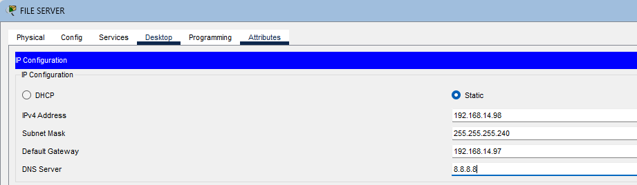
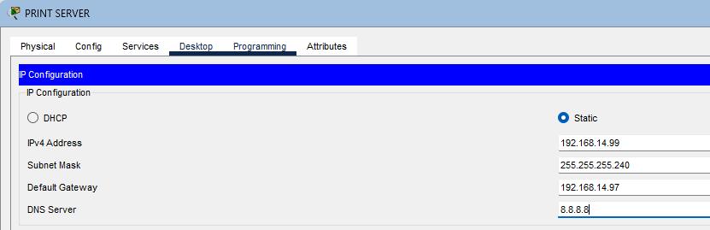

Router-on-a-Stick Configuration
R1 performs inter-VLAN routing using a single physical LAN interface (GigabitEthernet0/0/1) subdivided into 802.1Q sub-interfaces — one per VLAN.

R1 sub-interface configuration:
interface GigabitEthernet0/0/1
no shutdown
!
interface GigabitEthernet0/0/1.10
encapsulation dot1Q 10
ip address 192.168.14.1 255.255.255.224
!
interface GigabitEthernet0/0/1.20
encapsulation dot1Q 20
ip address 192.168.14.33 255.255.255.224
!
interface GigabitEthernet0/0/1.30
encapsulation dot1Q 30
ip address 192.168.14.65 255.255.255.224
!
interface GigabitEthernet0/0/1.40
encapsulation dot1Q 40
ip address 192.168.14.97 255.255.255.240
!
interface GigabitEthernet0/0/1.99
encapsulation dot1Q 99
ip address 192.168.14.113 255.255.255.240
Verification confirms all five sub-interfaces are up/up, alongside the WAN interface and the default route to the simulated ISP:
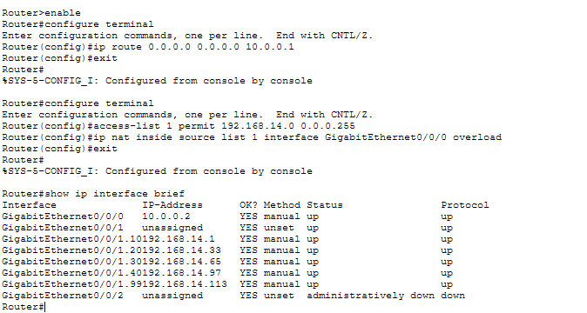
show ip interface brief — R1, captured alongside the NAT and default-route configuration session

NAT and Internet access
NAT overload (PAT) is configured on R1 so all internal VLANs can reach the Internet via the WAN interface. A default static route points to the simulated ISP.

interface GigabitEthernet0/0/0
ip address 10.0.0.2 255.255.255.252
ip nat outside
no shutdown
!
ip route 0.0.0.0 0.0.0.0 10.0.0.1
!
access-list 1 permit 192.168.14.0 0.0.0.255
ip nat inside source list 1 interface GigabitEthernet0/0/0 overload
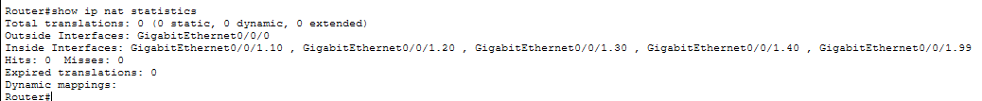
Immediately after configuration, NAT statistics confirm the inside/outside interfaces are correctly registered, zero hits at this point, since no traffic had yet been generated:
show ip nat statistics — R1, immediately after NAT configuration

The routing table confirms all five LAN subnets as directly connected, plus the WAN link and the default route via 10.0.0.1:
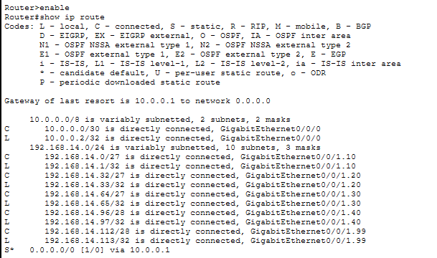
show ip route — R1, baseline routing table

Server Configuration
Both servers reside in VLAN 40 on the server switch (SW-SERVER), configured with static IPs in the 192.168.14.96/28 subnet.
Server | IP Address | Subnet Mask | Default Gateway
File Server | 192.168.14.98 | 255.255.255.240 | 192.168.14.97
Print Server | 192.168.14.99 | 255.255.255.240 | 192.168.14.97

Access Control List Policy
ACLs enforce the client's sharing policy at R1, applied inbound on each VLAN sub-interface so traffic is filtered as it enters the router from the LAN side.

Policy Summary
Rule | Action | Purpose
Admin VLAN → File Server | Permit | Own department's file share
Admin VLAN → Print Server | Permit | Cross-department printing
Loans VLAN → File Server | Deny | Cross-department file access blocked
Loans VLAN → Print Server | Permit | Cross-department printing allowed
Clients VLAN → File Server | Deny | Cross-department file access blocked
Clients VLAN → Print Server | Permit | Cross-department printing allowed
Any internal VLAN → Internet | Permit (NAT) | General business access
Guest VLAN → All internal VLANs | Deny | Guest isolation (CR3)
Guest VLAN → Internet | Permit (NAT) | Guest internet only
(Implicit deny all) | Deny | Standard IOS behaviour

ACL configuration set on R1
The access lists were defined and bound to each VLAN sub-interface directly on the router console:
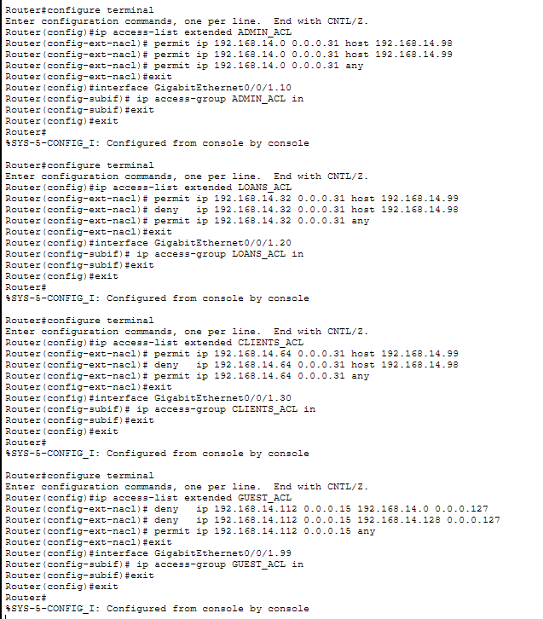
ACL definition and application — R1 console session

show ip access-lists confirms the four extended ACLs are active, with non-zero match counters from the verification pings performed in Testing and verification Section:
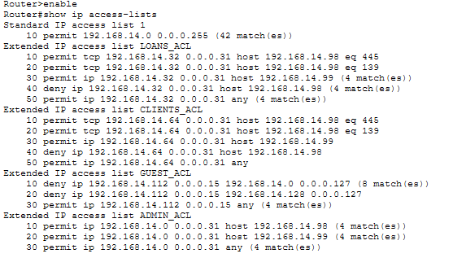
show ip access-lists — R1, post-testing match counters

Testing and Verification

Before ACL
Before ACLs were applied, Admin and Loans could both reach the File Server, Print Server, and the Internet. The first ping attempt to a newly-contacted host occasionally timed out once before succeeding — a normal ARP-resolution delay in Packet Tracer, not a connectivity fault.
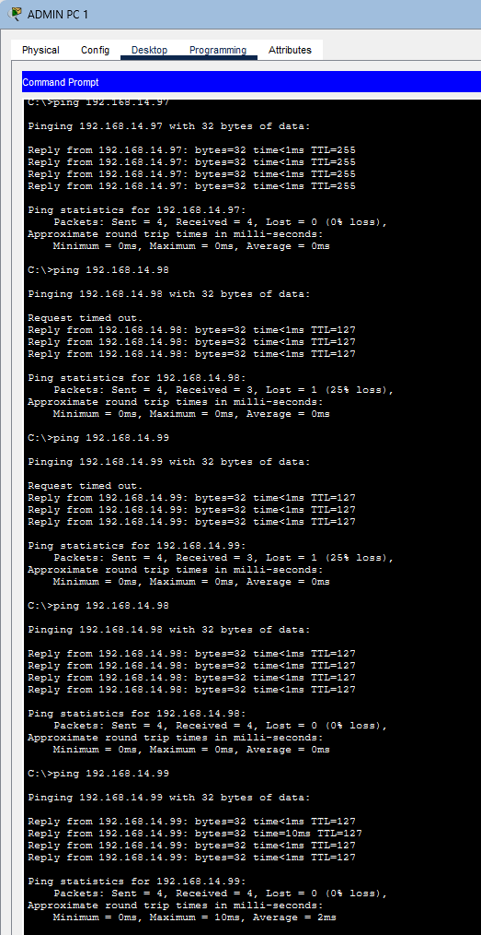
Admin PC — baseline pings to .97 (gateway), .98 (File Server), .99 (Print Server)

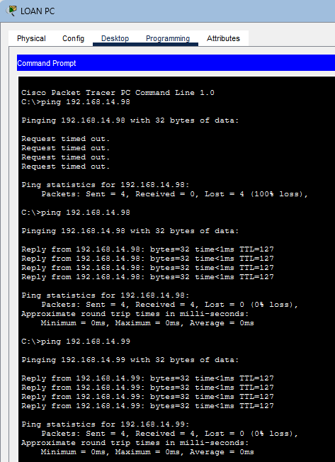
Loans PC — baseline pings to .98 (File Server) and .99 (Print Server), both succeeding pre-ACL

Post ACL verification
After the ACLs were applied, Admin PC retains full access to its own File Server, the Print Server, and the Internet, consistent with ADMIN_ACL:
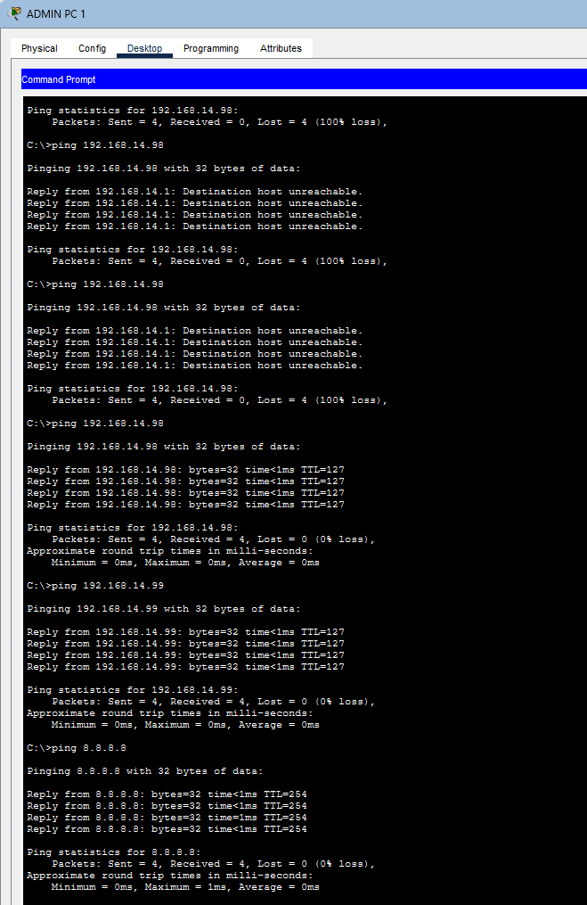
Admin PC post-ACL — .98 and .99 succeed, 8.8.8.8 succeeds
Loans PC is now blocked from pinging the File Server, while printing and Internet access remain permitted — the before/after contrast in a single capture is evidence the LOANS_ACL deny rule is active for ICMP. Note the caveat in Section 8: this confirms ICMP is blocked, not yet that real file-sharing (TCP/445, 139) is blocked — see the fix required there.
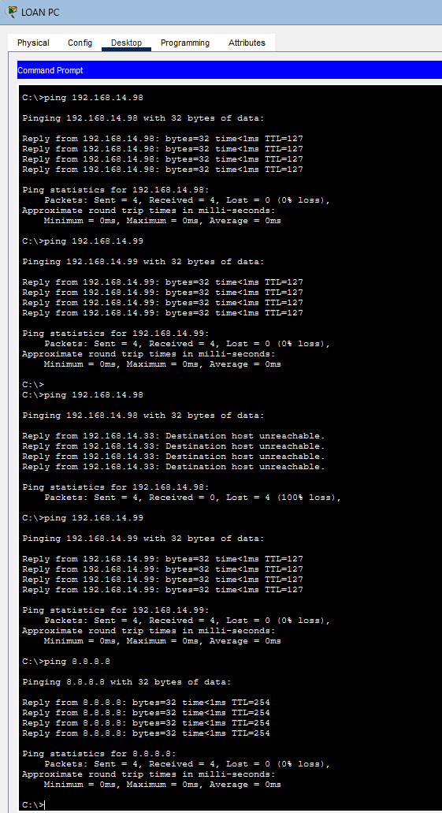
Loans PC — pre-ACL success to .98, then post-ACL: .98 blocked, .99 and Internet still succeed

The Guest laptop is blocked from every internal host it was tested against, while Internet access remains available, confirming guest isolation (CR3):

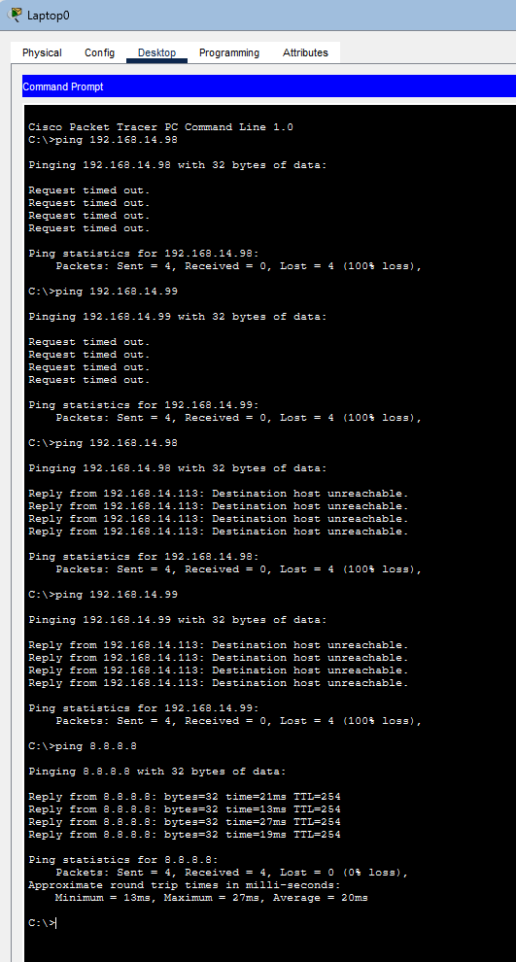
Guest laptop post-ACL — .98 and .99 blocked, 8.8.8.8 succeeds

NAT Verification
Translation entries confirm internal hosts are being translated to the WAN address when reaching the Internet:
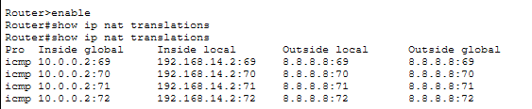
show ip nat translations — R1, active ICMP translations during testing
NAT statistics after the full test pass show a healthy hit count across the inside interfaces:
show ip nat statistics — R1, post-testing (26 hits)

Routing Verification
The routing table remains stable after ACL deployment — ACLs filter traffic, they do not alter routing — with all five LAN subnets, the WAN link, and the default route all present:
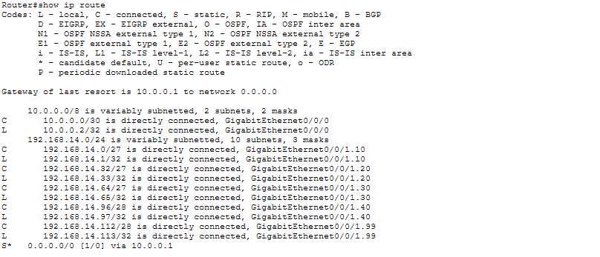
show ip route — R1, post-ACL

Conclusion
The design for North-West Asset Finance has been implemented and tested in Cisco Packet Tracer. Key deliverables achieved:
- Segmentation: five VLANs (Admin, Loans, Clients, Servers, Guest) with VLSM addressing from 192.168.14.0/24.
- Scalability: a reserved /25 block retained for future growth.
- Inter-VLAN routing: router-on-a-stick implemented at R1 with 802.1Q sub-interfaces, all confirmed up/up.
- Internet access: NAT overload configured and verified, with active translations and a default route to the ISP.
- ACL policy: cross-department printing and guest isolation are both confirmed working. Cross-department file-sharing restriction is confirmed for ICMP
- Guest isolation (CR3): Guest Wi-Fi is fully isolated from all internal VLANs, with Internet-only access confirmed.

