HMB Choto
45285209

CMPG 325

Milestone 1
Client Design Review

Contents
Project and Client Summary 3
Client Requirements 3
Functional Requirements 3
Non-Functional Requirements 3
Assumptions 4
Physical Topology 4
Logical Topology and VLAN Design 5
IP Addressing Plan 5
Key Static Assignments 6
ACL Policy 6
Initial GitHub Repository 6

Project and Client Summary
Student | Choto, HMB
Organisation | North-West Asset Finance
Industry | Banking and Finance
Addressing block | 192.168.14.0/24
Assigned Challenge | ACLs (traffic filtering policy) — Intermediate
Design Constraint | Printer sharing must cross departments; file sharing must not
Change Request (CR) | Guest Wi-Fi must be added for visitors, isolated from internal resources

Client Requirements
North-West Asset Finance is a banking and finance client operating from a single Rustenburg site. As a financial services organisation, the network must prioritise segmentation, confidentiality of departmental data, and controlled access between business units, while still allowing operational resources, such as printing, to be shared efficiently.

Functional Requirements
- Provide wired connectivity for three business departments: Administration, Loans, and Client Services.
- Provide centralised file storage and print services accessible according to the client's sharing policy.
- Provide a Guest Wi-Fi service for visitors, fully isolated from internal departmental resources (CR3).
- Permit printer sharing across all departments, while restricting file-share access to within a device's own department (design constraint, Section 8 of brief).
- Implement an Access Control List (ACL) policy that enforces the above sharing rules and demonstrates traffic filtering as the assigned technical challenge.
- Support future growth without re-addressing the whole network (spare capacity retained in the 192.168.14.0/24 block).

Non-Functional Requirements
- Security: department-level traffic isolation appropriate to a banking/finance environment; guest traffic must not reach any internal VLAN.
- Reliability: core/distribution design so a single access-layer fault does not take down the whole site.
- Scalability: VLSM addressing plan leaves a reserved /25 block for future departments or services.
- Manageability: consistent VLAN-to-subnet mapping and a documented IP addressing scheme for troubleshooting.

Assumptions
The project brief specifies the organisation, industry, addressing block, constraint and change request, but does not name specific departments or host counts. The following assumptions were made and are open for revision at the design review:
- Three operational departments were assumed: Administration, Loans, and Client Services, reflecting a typical small asset-finance branch.
- Up to ~20 hosts were assumed per department for current needs, sized to a /27 (30 usable addresses) for headroom.
- A single centralised File Server and Print Server were assumed, hosted in a dedicated Servers VLAN, rather than per-department servers.
- "File sharing must not cross departments": a department's file-share traffic is only permitted from that department's own VLAN; other departments are denied by ACL.
- "Printer sharing must cross departments": the Print Server/network printer is reachable from every departmental VLAN.

Physical Topology
The design uses a collapsed core: a single Layer-3 edge router performs inter-VLAN routing (router-on-a-stick) and hosts the ACL policy, a core switch trunks VLANs down to per-department access switches, a dedicated server switch, and a wireless access point for the isolated guest network.

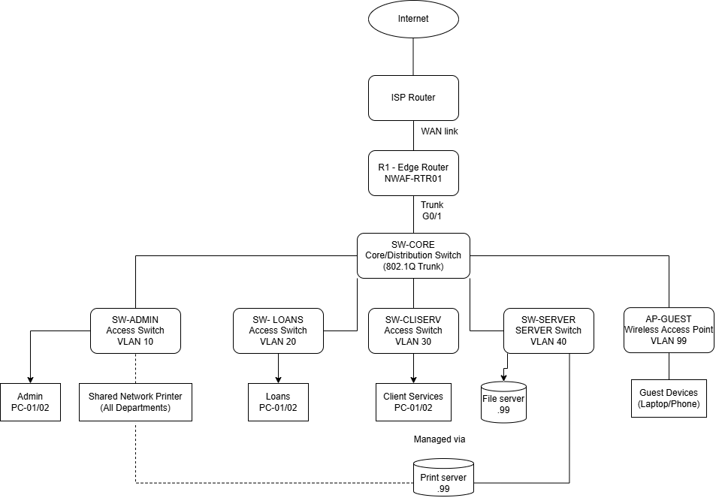

Logical Topology and VLAN Design
Each department, the server farm, and guest Wi-Fi are placed on separate VLANs, each mapped to its own subnet carved from the assigned 192.168.14.0/24 block using VLSM. Inter-VLAN routing and the ACL policy are applied at R1.
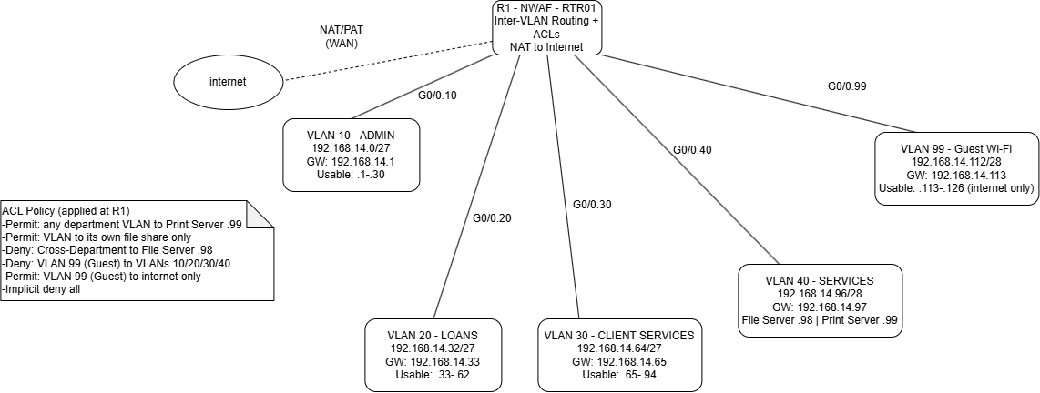

IP Addressing Plan
Subnetting was performed with VLSM against the assigned block 192.168.14.0/24, sized to each VLAN's expected host count while leaving a reserved block for future growth.
VLAN | Department / Purpose | Network | Mask (CIDR) | Usable Range | Broadcast | Gateway | Hosts (avail.)
10 | Admin / Management | 192.168.14.0 | /27 (255.255.255.224) | .1 – .30 | .31 | 192.168.14.1 | 30
20 | Loans Department | 192.168.14.32 | /27 (255.255.255.224) | .33 – .62 | .63 | 192.168.14.33 | 30
30 | Client Services | 192.168.14.64 | /27 (255.255.255.224) | .65 – .94 | .95 | 192.168.14.65 | 30
40 | Servers (File + Print) | 192.168.14.96 | /28 (255.255.255.240) | .97 – .110 | .111 | 192.168.14.97 | 14
99 | Guest Wi-Fi (CR3) | 192.168.14.112 | /28 (255.255.255.240) | .113 – .126 | .127 | 192.168.14.113 | 14
— | Reserved (future growth) | 192.168.14.128 | /25 | .129 – .254 | .255 | n/a | 126

Key Static Assignments
Device | VLAN | IP Address
R1 sub-interface G0/0.10 | 10 | 192.168.14.1
R1 sub-interface G0/0.20 | 20 | 192.168.14.33
R1 sub-interface G0/0.30 | 30 | 192.168.14.65
R1 sub-interface G0/0.40 | 40 | 192.168.14.97
R1 sub-interface G0/0.99 | 99 | 192.168.14.113
File Server | 40 | 192.168.14.98
Print Server | 40 | 192.168.14.99

ACL Policy
- Permit: any departmental VLAN (10/20/30) Print Server 192.168.14.99 (printing ports).
- Permit: a department's own VLAN to its file share on the File Server 192.168.14.98.
- Deny: cross-department access to the File Server (e.g. VLAN 20 192.168.14.98 file-share ports).
- Deny: VLAN 99 (Guest) to VLANs 10, 20, 30 and 40 (all internal resources).
- Permit: VLAN 99 (Guest) to Internet only, via NAT/PAT at R1.
- Implicit deny-all at the end of every ACL (standard Packet Tracer/Cisco IOS behaviour).

Initial GitHub Repository
An initial repository has been created with the structure below, ready for evidence to be committed as the project progresses (see README.md for full detail).
- /01-requirements — client requirements & assumptions (this document)
- /02-design — physical & logical topology diagrams, IP addressing plan
- /03-packet-tracer — working .pkt file(s)
- /04-configuration — device configs, ACL scripts
- /05-testing — connectivity & ACL verification evidence
- /06-video — link to the 15–20 minute demonstration video
- README.md — project overview, client summary, and portfolio index

