Open Ended Lab 11 - Worksheet

Name: Hatim Shabbir | Arsheel Abbas | ID: 11045 | 11163 | Section: T2

Note: Assumptions and logics should be explained separately in tasks after the task results.

Github: https://github.com/Hatim1947/Lab11-Git-ArsheelAbbasANDHatimShabbir

Task 1
Design Module Codes for Program Counter, PC Adder, Branch Adder, Mux2, immGen.
// ===== ProgramCounter.v =====
`timescale 1ns / 1ps
// Stores the PC. Updates on every positive clock edge. Synchronous reset to 0.
module ProgramCounter (
input clk,
input reset,
input [31:0] pc_next,
output reg [31:0] pc
);
initial pc = 32'd0;
always @(posedge clk) begin
if (reset) pc <= 32'd0;
else pc <= pc_next;
end
endmodule

// ===== pcAdder.v =====
`timescale 1ns / 1ps
// PC + 4
module pcAdder (
input [31:0] pc,
output [31:0] pc_plus4
);
assign pc_plus4 = pc + 32'd4;
endmodule

// ===== branchAdder.v =====
`timescale 1ns / 1ps
// PC + (sign-extended immediate << 1)
// immGen delivers B/J immediates WITHOUT the implicit zero bit, so the
// single "<< 1" lives here (the "Shift left 1" box in the lab diagram).
module branchAdder (
input [31:0] pc,
input [31:0] imm,
output [31:0] target
);
assign target = pc + (imm << 1);
endmodule

// ===== mux2.v =====
`timescale 1ns / 1ps
// 2-to-1 mux: sel = 0 -> d0, sel = 1 -> d1
module mux2 #(parameter WIDTH = 32)(
input [WIDTH-1:0] d0,
input [WIDTH-1:0] d1,
input sel,
output [WIDTH-1:0] y
);
assign y = sel ? d1 : d0;
endmodule

// ===== immGen.v =====
`timescale 1ns / 1ps
// Immediate generator (RV32I)
// I-type (addi, lw, jalr) : imm[11:0] sign-extended
// S-type (sw) : imm[11:0] sign-extended
// B-type (beq, bne) : imm[12:1] sign-extended (no trailing 0, branchAdder shifts)
// J-type (jal) : imm[20:1] sign-extended (no trailing 0, branchAdder shifts)
// U-type (lui) : imm[31:12] << 12
// I, S and B are what the lab asks for. J and U are needed because the
// Lab 10 program uses jal and lui.
module immGen (
input [31:0] instr,
output reg [31:0] imm
);
always @(*) begin
case (instr[6:0])
7'b0010011, // OP-IMM (addi)
7'b0000011, // LOAD (lw)
7'b1100111: // JALR
imm = {{20{instr[31]}}, instr[31:20]};
7'b0100011: // STORE (sw)
imm = {{20{instr[31]}}, instr[31:25], instr[11:7]};
7'b1100011: // BRANCH (beq, bne)
imm = {{20{instr[31]}}, instr[31], instr[7], instr[30:25], instr[11:8]};
7'b1101111: // JAL
imm = {{12{instr[31]}}, instr[31], instr[19:12], instr[20], instr[30:21]};
7'b0110111: // LUI
imm = {instr[31:12], 12'b0};
default: imm = 32'd0;
endcase
end
endmodule

Testbench:
// ===== tb_PCDatapath.v =====
`timescale 1ns/1ps
module tb_PCDatapath;
reg clk = 0, reset = 1, PCSrc = 0;
reg [31:0] instr = 0;
wire [31:0] pc, pc_plus4, imm, br_target, pc_next;
integer errors = 0;

ProgramCounter u_pc (.clk(clk), .reset(reset), .pc_next(pc_next), .pc(pc));
pcAdder u_p4 (.pc(pc), .pc_plus4(pc_plus4));
immGen u_im (.instr(instr), .imm(imm));
branchAdder u_br (.pc(pc), .imm(imm), .target(br_target));
mux2 #(32) u_mx (.d0(pc_plus4), .d1(br_target), .sel(PCSrc), .y(pc_next));

always #5 clk = ~clk;

task check(input [31:0] got, input [31:0] exp);
begin
if (got !== exp) begin
errors = errors + 1;
$display("FAIL t=%0t got=%h exp=%h", $time, got, exp);
end else
$display("PASS t=%0t val=%h", $time, got);
end
endtask

initial begin
$dumpfile("tb_PCDatapath.vcd");
$dumpvars(0, tb_PCDatapath);

// reset
@(negedge clk); @(negedge clk);
reset = 0; PCSrc = 0;
#1 check(pc, 32'd0);

// sequential, PCSrc = 0
@(posedge clk); #1 check(pc, 32'd4);
@(posedge clk); #1 check(pc, 32'd8);
@(posedge clk); #1 check(pc, 32'd12);

// forward branch: beq x1,x2,+8 at pc=12 -> 20
@(negedge clk);
instr = 32'h00208463; PCSrc = 1;
#1 check(imm, 32'd4);
#1 check(br_target, 32'd20);
@(posedge clk); #1 check(pc, 32'd20);

// backward branch: beq x1,x2,-8 at pc=20 -> 12
@(negedge clk);
instr = 32'hFE208CE3; PCSrc = 1;
#1 check(imm, 32'hFFFFFFFC);
#1 check(br_target, 32'd12);
@(posedge clk); #1 check(pc, 32'd12);

// back to sequential
@(negedge clk); PCSrc = 0;
@(posedge clk); #1 check(pc, 32'd16);

// immGen: I, S, S negative
PCSrc = 0;
instr = 32'hFFF00093; #1 check(imm, 32'hFFFFFFFF); // addi x1,x0,-1
instr = 32'h00500093; #1 check(imm, 32'd5); // addi x1,x0,5
instr = 32'h0020A423; #1 check(imm, 32'd8); // sw x2,8(x1)
instr = 32'hFE20AE23; #1 check(imm, 32'hFFFFFFFC); // sw x2,-4(x1)
// extras used by the Lab 10 program
instr = 32'h002622B7; #1 check(imm, 32'h00262000); // lui t0,0x262
instr = 32'h008000EF; #1 check(imm, 32'd4); // jal ra,+8 (halved)
instr = 32'hFE5FF06F; #1 check(imm, 32'hFFFFFFF2); // jal x0,-28 (halved)

if (errors == 0) $display("ALL TESTS PASSED");
else $display("%0d TEST(S) FAILED", errors);
$finish;
end
endmodule

Waveforms:
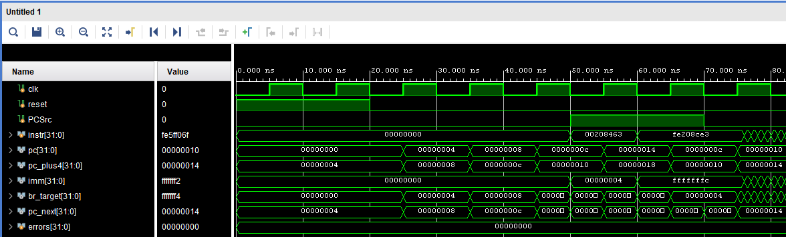
Assumptions and logic (Task 1)
ProgramCounter: 32-bit register with a synchronous reset to 0. It loads pc_next on every posedge of clk, so the PC changes once per cycle.
pcAdder: purely combinational, pc_plus4 = pc + 4. Instructions are 32 bits wide and byte addressed, so the next sequential instruction is 4 bytes ahead.
immGen: selects the format from opcode instr[6:0] and sign-extends from instr[31]. I-type (addi, lw, jalr) uses instr[31:20]. S-type (sw) joins instr[31:25] and instr[11:7]. B-type (beq, bne) joins instr[31], instr[7], instr[30:25], instr[11:8]. The B and J immediates are output without their implicit zero bit, so the left shift by 1 is done in one place only, inside branchAdder. J-type (jal) and U-type (lui) were added because the Lab 10 program uses jal and lui; unknown opcodes give 0.
branchAdder: target = pc + (imm << 1). This is the 'Shift left 1' box plus the adder of the lab diagram.
mux2: parameterised width, y = sel ? d1 : d0. With PCSrc = 0 it passes PC + 4, with PCSrc = 1 it passes the branch target. The same module is reused for the ALU input muxes, write-back muxes and JALR mux in Task 2.
Testbench logic: a 10 ns clock is used. After reset the PC is checked to count 0, 4, 8, 12 with PCSrc = 0. Then a forward beq (offset +8, PC 12 to 20) and a backward beq (offset -8, PC 20 to 12) are applied with PCSrc = 1. Finally PCSrc returns to 0 and the PC continues by 4. The immGen checks cover positive and negative I and S immediates, plus the lui and jal cases. The testbench prints PASS or FAIL per check and ALL TESTS PASSED at the end.

Task 2
Design module code of TopLevelProcessor module:

// ===== TopLevelProcessor.v =====
`timescale 1ns / 1ps
//==================================================================
// TopLevelProcessor : modular single-cycle RV32I processor + Basys 3 I/O
//
// clk (100 MHz) -> clockDivider -> cpu_clk (10 MHz)
// PC -> instructionMemory -> main_control / immGen / RegisterFile
// RegisterFile / immGen -> ALU -> dataMemory or memory-mapped I/O
//
// btnC : memory-mapped RESET button read by the program
// btnU : processor hardware reset (PC = 0)
// SIM_FAST = 1 : shortens the 1 s delay (simulation only, keep 0 for FPGA)
//
// Port names are the same as lab10_top, so lab10's XDC pin mapping is reused.
//==================================================================
module TopLevelProcessor #(
parameter SIM_FAST = 0
)(
input clk,
input btnC,
input btnU,
input [15:0] sw,
output [15:0] led
);
//---------------- 10 MHz processor clock ----------------
wire cpu_clk;
clockDivider #(.DIV(10), .USE_BUFG(SIM_FAST ? 0 : 1)) u_clkdiv (
.clk_in (clk),
.clk_out(cpu_clk)
);

//---------------- hardware reset synchroniser ----------------
reg rst_m = 1'b0, rst_s = 1'b0;
always @(posedge cpu_clk) begin
rst_m <= btnU;
rst_s <= rst_m;
end

//---------------- datapath wires ----------------
wire [31:0] pc, pc_plus4, br_target, jalr_target;
wire [31:0] pc_br_sel, pc_next, instr, imm;
wire [31:0] rd1, rd2, alu_a, alu_b, alu_result;
wire [31:0] mem_rdata, wb_alu_mem, wb_data;
wire zero, take_branch, PCSrc;

//---------------- control wires ----------------
wire RegWrite, ALUSrc, MemRead, MemWrite, MemtoReg, Branch, Jal, Jalr, Lui;
wire [1:0] ALUOp;
wire [3:0] ALUCtrl;

//---------------- fetch ----------------
ProgramCounter u_pc (.clk(cpu_clk), .reset(rst_s), .pc_next(pc_next), .pc(pc));
pcAdder u_pcp4 (.pc(pc), .pc_plus4(pc_plus4));

instructionMemory #(.OPERAND_LENGTH(31), .SIM_FAST(SIM_FAST)) u_imem (
.instAddress(pc),
.instruction(instr)
);

//---------------- decode ----------------
main_control u_ctrl (
.opcode (instr[6:0]),
.RegWrite(RegWrite), .ALUSrc(ALUSrc), .MemRead(MemRead), .MemWrite(MemWrite),
.MemtoReg(MemtoReg), .Branch(Branch), .Jal(Jal), .Jalr(Jalr), .Lui(Lui),
.ALUOp (ALUOp)
);

immGen u_imm (.instr(instr), .imm(imm));

RegisterFile u_rf (
.clk(cpu_clk), .rst(rst_s), .WriteEnable(RegWrite),
.rs1(instr[19:15]), .rs2(instr[24:20]), .rd(instr[11:7]),
.WriteData(wb_data), .ReadData1(rd1), .ReadData2(rd2)
);

//---------------- execute ----------------
mux2 #(32) u_alua (.d0(rd1), .d1(32'd0), .sel(Lui), .y(alu_a)); // lui: 0 + imm
mux2 #(32) u_alub (.d0(rd2), .d1(imm), .sel(ALUSrc), .y(alu_b));

alu_control u_aluc (.ALUOp(ALUOp), .funct3(instr[14:12]), .funct7(instr[31:25]),
.ALUControl(ALUCtrl));

ALU u_alu (.A(alu_a), .B(alu_b), .ALUControl(ALUCtrl), .ALUResult(alu_result), .Zero(zero));

//---------------- next PC ----------------
branchAdder u_br (.pc(pc), .imm(imm), .target(br_target));

// beq: take when Zero. bne: take when !Zero. (other branch types not supported)
assign take_branch = Branch & (((instr[14:12] == 3'b000) & zero) |
((instr[14:12] == 3'b001) & ~zero));
assign PCSrc = take_branch | Jal;

mux2 #(32) u_pcsrc (.d0(pc_plus4), .d1(br_target), .sel(PCSrc), .y(pc_br_sel));
assign jalr_target = {alu_result[31:1], 1'b0};
mux2 #(32) u_jalr (.d0(pc_br_sel), .d1(jalr_target), .sel(Jalr), .y(pc_next));

//---------------- memory / I/O ----------------
wire sel_ram, sel_led, sel_sw, sel_rst;
addressDecoder u_dec (
.addr(alu_result),
.sel_ram(sel_ram), .sel_led(sel_led), .sel_sw(sel_sw), .sel_rst(sel_rst)
);

wire [31:0] ramData;
dataMemory u_dmem (
.clk(cpu_clk), .memWrite(MemWrite & sel_ram),
.address(alu_result), .writeData(rd2), .readData(ramData)
);

wire [15:0] sw_sync, led_out;
wire btn_sync;
ioInterface u_io (
.clk(cpu_clk), .sw_in(sw), .btn_in(btnC),
.ledWrite(MemWrite & sel_led), .ledData(rd2[15:0]),
.sw_sync(sw_sync), .btn_sync(btn_sync), .led_out(led_out)
);
assign led = led_out;

assign mem_rdata = sel_ram ? ramData :
sel_sw ? {16'd0, sw_sync} :
sel_rst ? {31'd0, btn_sync} :
sel_led ? {16'd0, led_out} : 32'd0;

//---------------- write back ----------------
mux2 #(32) u_memtoreg (.d0(alu_result), .d1(mem_rdata), .sel(MemtoReg), .y(wb_alu_mem));
mux2 #(32) u_link (.d0(wb_alu_mem), .d1(pc_plus4), .sel(Jal | Jalr), .y(wb_data));
endmodule

Datapath Diagram:
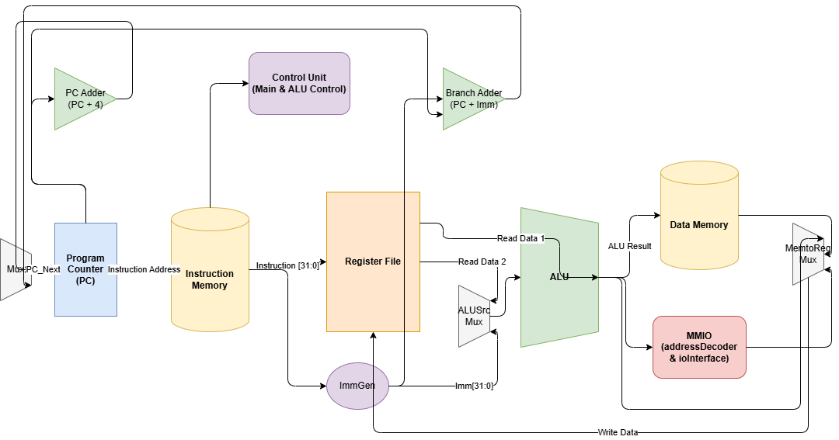

RTL Schematic:
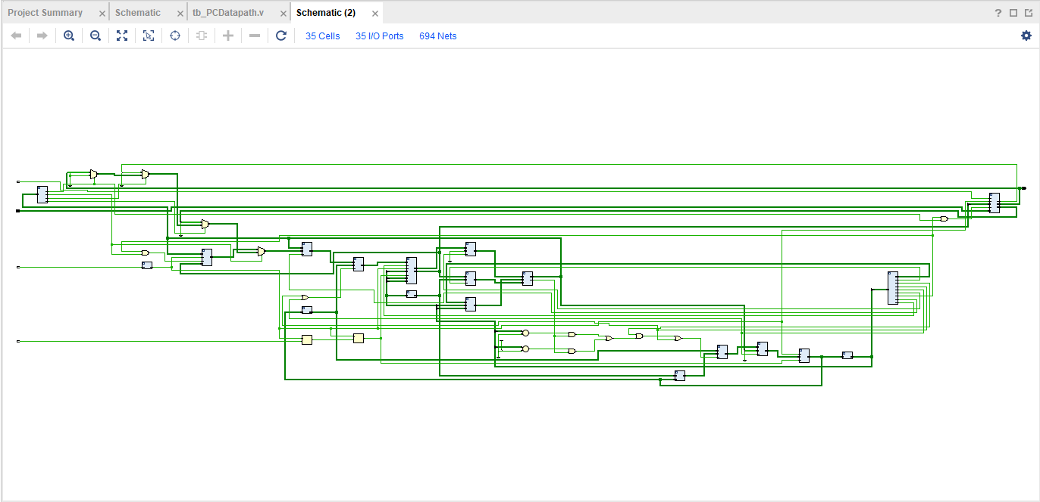

Utilization Report:
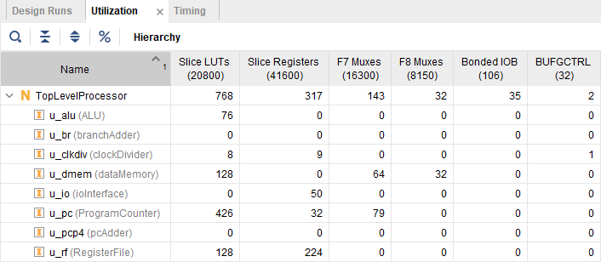

Timing Analysis Report:
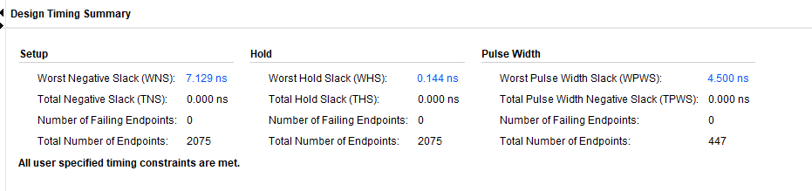

Assumptions and logic (Task 2)
The processor is a single-cycle RV32I design. TopLevelProcessor instantiates ProgramCounter, pcAdder, instructionMemory, main_control, immGen, RegisterFile, alu_control, ALU, branchAdder, addressDecoder, dataMemory, ioInterface and the reused mux2 modules. instructionMemory output goes to main_control (opcode), immGen, and the RegisterFile (rs1, rs2, rd). main_control and alu_control drive the ALU, register file and data memory signals.
Clock: the 100 MHz board clock is divided by 10 to a 10 MHz cpu_clk. btnU is the hardware reset; it is passed through two flip-flops (rst_m, rst_s) to synchronise it to cpu_clk before it resets the PC and register file. btnC is a memory-mapped RESET button that the program reads.
Next PC: PCSrc = (Branch and condition) or Jal, selecting between pc_plus4 and the branch target. The branch condition is Zero for beq (funct3 = 000) and not Zero for bne (funct3 = 001); other branch types are not supported. A second mux for jalr selects {ALUResult[31:1], 0} as the next PC.
Execute: ALU input A is forced to 0 for lui so the ALU computes 0 + imm. ALU input B is rd2 or imm depending on ALUSrc.
Memory and I/O: addressDecoder looks at the ALU result and selects RAM, LED, switch or reset-button registers. Stores are enabled only for the selected device (MemWrite & sel). Reads are multiplexed by the same select signals. LEDs show the ioInterface output, switches and btnC are synchronised before being read.
Write-back: MemtoReg chooses between ALU result and memory read data. For jal and jalr the link value PC + 4 is written to rd.
SIM_FAST is a parameter: 0 for the FPGA (full 1 s delay and BUFG on the divided clock), 1 for simulation only. Port names match the Lab 10 top module, so the Lab 10 XDC pin mapping is reused (lab11_basys3.xdc).
Datapath diagram, RTL schematic, utilization report and timing report are pasted from Vivado in their boxes above.

Lab 11: Design and FPGA Implementation of a Single-Cycle RISC-V Processor
Points Distribution
Task No. | OE2 (Design) | OE5 (Report) | OE6 (Reflection) | AR7
Task 1 | /40 | - | - | /20
Task 2 | /20 | /30 |  | /20
Viva |  |  | /10 | /20
Total Points | /80 |  |  | /20
CLO Mapped | CLO 3
For description of different levels of the mapped rubrics, please refer the provided Lab Evaluation Assessment Rubrics and Affective Domain Assessment Rubrics.
# | Assessment Elements | Level 1: Unsatisfactory  Points 0-1 | Level 2: Developing  Points 2 | Level 3:Good  Points 3 | Level 4:Exemplary  Points 4
LR2 | Program/Code/ Simulation Model/ Network Model | Program/code/simulation model/network model does not implement the required functionality and has several errors. The student is not able to utilize even the basic tools of the software. | Program/code/simulation model/network model has some errors and does not produce completely accurate results. Student has limited command on the basic tools of the software. | Program/code/simulation model/network model gives correct output but not efficiently implemented or implemented by computationally complex routine. | Program/code/simulation /network model is efficiently implemented and gives correct output. Student has full command on the basic tools of the software.
LR5 | Results & Plots | Figures/ graphs / tables are not developed or are poorly constructed with erroneous results. Titles, captions, units are not mentioned. Data is presented in an obscure manner. | Figures, graphs and tables are drawn but contain errors. Titles, captions, units are not accurate. Data presentation is not too clear. | All figures, graphs, tables are correctly drawn but contain minor errors or some of the details are missing. | Figures / graphs / tables are correctly drawn and appropriate titles/captions and proper units are mentioned. Data presentation is systematic.
AR9 | Report | All the in-lab tasks are not included in report and / or the report is submitted too late. | Most of the tasks are included in report but are not well explained. All the necessary figures / plots are not included. Report is submitted after due date. | Good summary of most the in-lab tasks is included in report. The work is supported by figures and plots with explanations. The report is submitted timely. | Detailed summary of the in-lab tasks is provided. All tasks are included and explained well. Data is presented clearly including all the necessary figures, plots and tables.

