**Homework 4  
Algorithms Design (14016201-3)  
Spring 2021**

- Exercise 22.1-3

- Exercise 22.2-1

- Exercise 24.3-1

- Use Dijkstra's Algorithm to find the shortest path between the source node (node 3) and

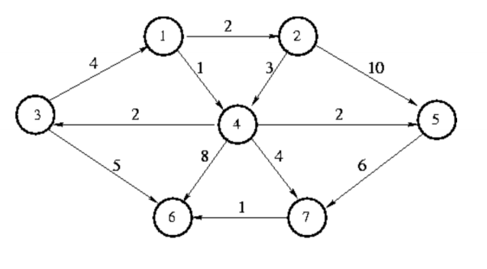destination node (node 5) in the following directed weighted graph.