**HW1**

**Computer Programming  
Fall 2021**

**Dr. Hatim Alsuwat**

Q1: Draw the flowchart that expresses the algorithm for solving the following problems:

**a- Problem Description:**

Reads in a sequence of integer values and stops when a negative number is entered. Right before the algorithm stops, it should print out the largest and smallest numbers ever seen in the sequence. It should also print out the sum and the average of the entered numbers. 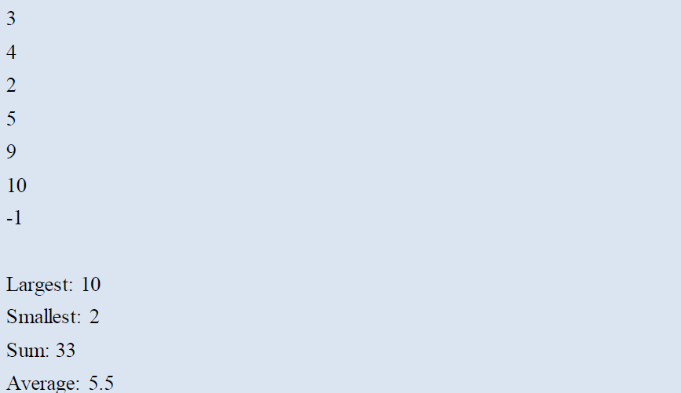

**b- Problem Description:**

Reads in two integer values from the user. Right before the algorithm stops, it should print out the sum (addition), multiply, subtract, divide and remainder of the two numbers.

**c- Problem Description:**

Reads in the height and the width values from the user. Right before the algorithm stops, it should print out the area and perimeter of a rectangle

**Q2:**  Write a Java program to print the sum (addition), multiply, subtract, divide and remainder of two numbers.

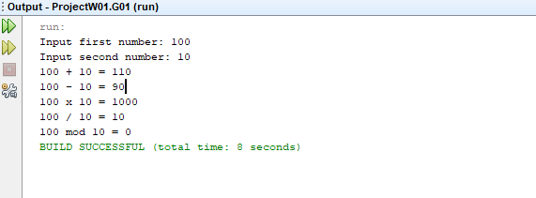

Q3: Write a Java program that takes a number as input and prints its multiplication table up to 15

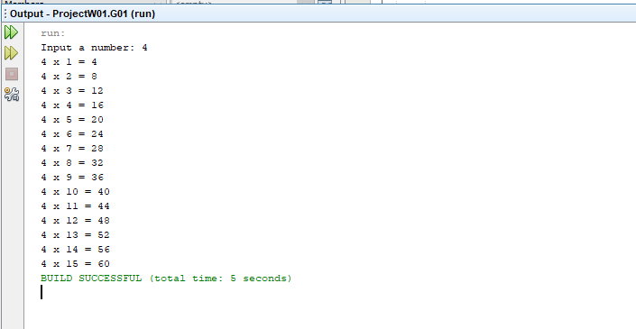

Q4: Write a Java program that takes four numbers as input to calculate and print the average of the numbers.

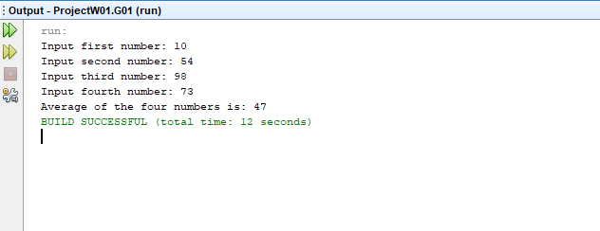

Q5: Write a Java program to print the area and perimeter of a rectangle

