**HW3**

**Computer Programming  
Fall 2021**

**Dr. Hatim Alsuwat**

**Q1:**  Write a Java program that reads an integer between 0 and 1000 and adds all the digits in the integer.

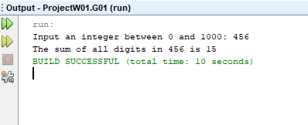

Q2: Write a Java program to accept a number and check the number is even or not. Prints 1 if the number is even or 0 if the number is odd.

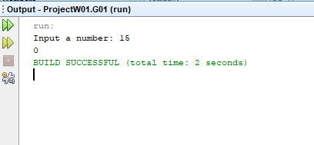

Q3: Write a Java program to get a number from the user and print whether it is positive or negative

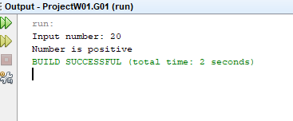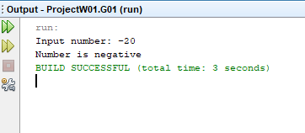

Q4: Take three numbers from the user and print the greatest number

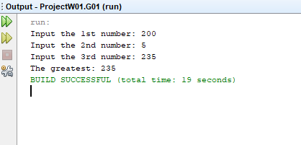

Q5: Write a Java program that keeps a number from the user and generates an integer between 1 and 7 and displays the name of the weekday.

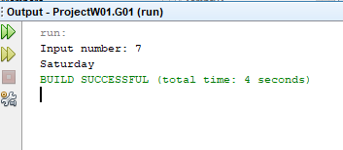

Q6: Write a program in Java to display the pattern like right angle triangle with a number.

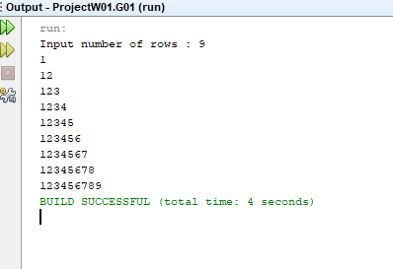

**Q7:**  Write a Java program to convert a binary number to decimal number.

Q8: Write a Java program to reverse a string.

Q9: Write a Java program to calculate power of a number using for loop

Q10: Write a Java program to display first **n** prime numbers

