**Assignment 3 – Hash Functions Analysis**

# Hash function 1 – summation

**Algorithm** – summation hash function

**Input** – string word

**Output** – hash code

hashcode = 0

**for** each character c **in** word **do**

hashcode = hashcode + **(askii of c)**

**return** hashcode

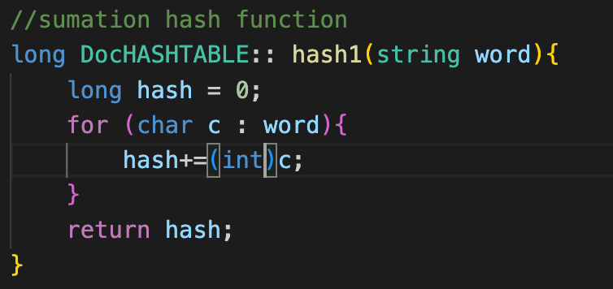

# Hash function 2 – polynomial

Algorithm – polynomial hash function

Input – word

Output – hashcode

hashcode = 0

length = length of word

constant = 3

**For** each character c **in** word **do**

hashcode = **(askii of c)** * (constant^length)

Length = length -1

**Return** hashcode

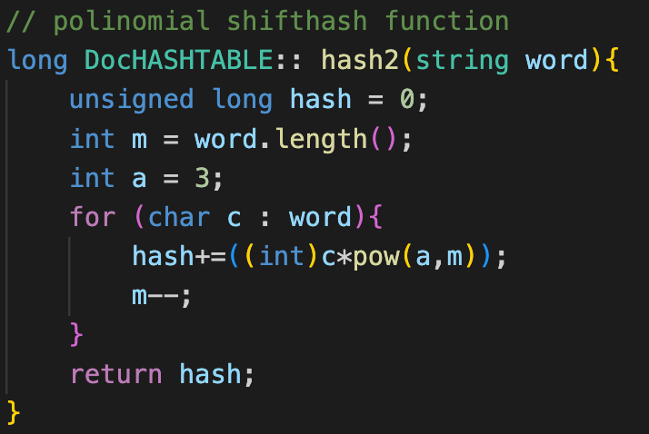

# Hash function 3 – standard cycle shift

**Algorithm** – cycle shift hash function

**Input** – word

**Output** – hashcode

hashcode = 0

**For** each character c **in** word **do**

c = **Bitwise shift** to the **left** by 5

c = **bitwise shift** to the **right** by 11

hashcode = hashcode + (updated bit value of c)

**return** hashcode

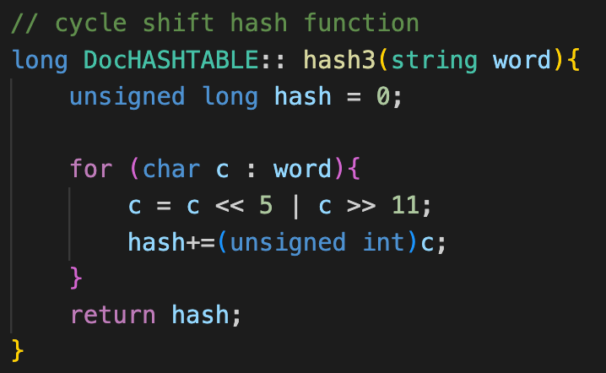

# Hash function 4 – djb2 Hash Function

**Algorithm** – djb2 hash function

**Input** – word

**Output** – hashcode

hashcode = **5381**

**For** each character c **in** word **do**

Hashcode = hashcode + (**bitwise left-shift by 5 on hashcode**) + character c

**return** hashcode

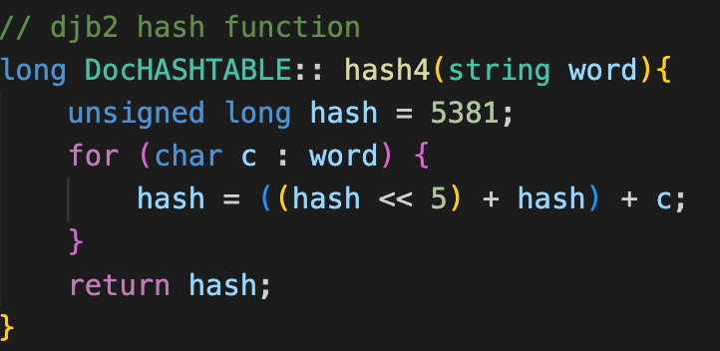

# Hash function 5 – FNV hash function

**Algorithm** – FNV hash

**Input** – word

**Output** – hashcode

**Constant** int fnv_prime = 0x811C9DC5

Hashcode = 0

**For** each character c **in** word **do**

Hashcode = Hashcode * fnv_prime

Hashcode = Hashcode ^ c

**Return** Hashcode

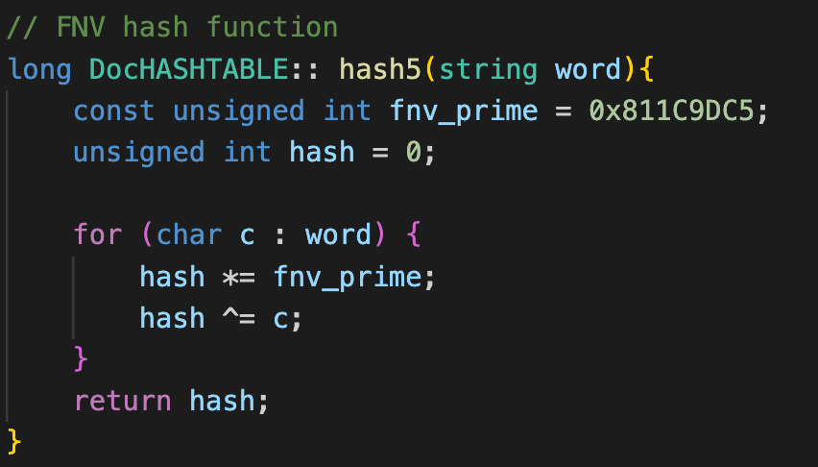

# Hash function 6 – Jenkins one-at-a-time Hash Function

**Algorithm** – Jenkins hash

**Input** – word

**Output** – hashcode

Hashcode = 0

**For** each character c **in** word **do**

Hashcode = **(bitwise left shift of 4 on Hashcode)** + c

Second_shift = **bitwise ‘and’ operation on Hashcode and ‘0xF0000000L’**

**If** Second_shift != 0 **then**:

Hashcode = Hashcode ^ **(bitwise right shift of 24 on Hashcode)**

Hashcode = **bitwise ‘and’ operation on Hashcode and ~Second_shift**

**Return** Hashcode

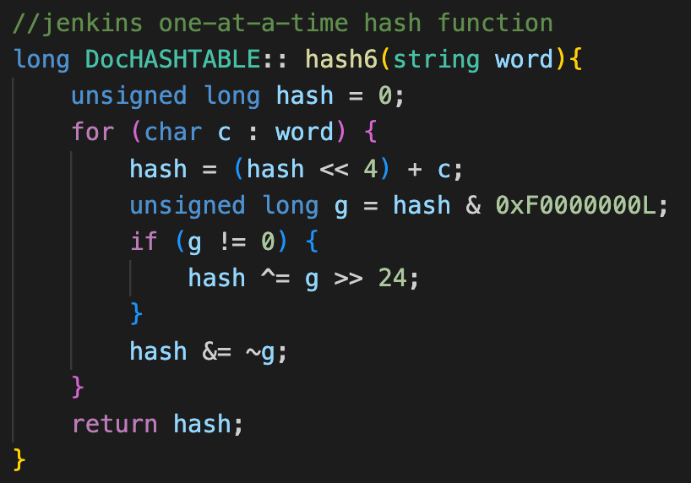

# Compression Function

**Algorithm** – compression

**Input** – Hashcode

**Output** – index in hashtable

constant = 3

offset = 5

**Return** (constant*Hashcode + offset) % (capacity of Hashtable)

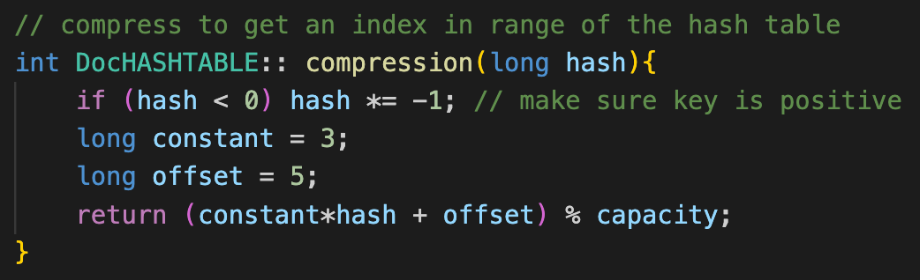

# Capacity

**Algorithm** – getCapacity

**Input** – file path

**Output** – optimal capacity for table

**DocHASHTABLE** hashTable

hashTable.**import(path)**

capacity = **(number of unique words in hashtable) *125%**

**while** (is_not_prime(capacity)) **do**

capacity = capacity +1

**return** capacity

# Default Hash Function

|  |  |  |
| --- | --- | --- |
| **Hash Function** | **Average Collisions** | **No. of files (with min collisions)** |
| **Summation - 1** | 5942 | 0 |
| **Polinomial Shift - 2** | 2474 | 3 |
| **Cyclic shift -3** | 6745 | 0 |
| **djb2 - 4** | 2196 | 30 |
| **FNV - 5** | 2189 | 40 |
| **Jenkins - 6** | 2198 | 28 |

* As seen in the above table, the FNV hash function has the lowest average collisions of all the hash functions. However, it must be noted that the djb2 and Jenkins hash functions are very close.
* Additionally, it also results in the lowest collisions for 40 out of 101 files. This is 10 more than the djb2 hash function which is 2nd.
* Nevertheless, due to the above results, **the FNV hash function (Hash 5) will be the default hash function** in the system.

# Data for each file

|  |  |  |  |  |  |  |  |  |
| --- | --- | --- | --- | --- | --- | --- | --- | --- |
| **Filename** | **Unique Words** | **Table Capacity** | **Collisions for hash functions for a given file** | | | | | |
| **Hash 1** | **Hash 2** | **Hash 3** | **Hash 4** | **Hash 5** | **Hash 6** |
| 23210-0.txt | 2549 | 3187 | 1614 | 843 | 2208 | 818 | 804 | 776 |
| 3254.txt | 69243 | 86561 | 67148 | 26866 | 68695 | 21559 | 21589 | 21468 |
| 30044.txt | 1396 | 1747 | 731 | 441 | 1216 | 417 | 434 | 415 |
| 39706.txt | 3235 | 4049 | 2348 | 1167 | 3036 | 986 | 977 | 1017 |
| 51493.txt | 1850 | 2333 | 1098 | 571 | 1647 | 594 | 591 | 593 |
| 32040.txt | 2440 | 3061 | 1547 | 806 | 2234 | 743 | 755 | 771 |
| 51268.txt | 2630 | 3299 | 1789 | 849 | 2423 | 827 | 827 | 792 |
| 51687.txt | 2315 | 2897 | 1448 | 777 | 2114 | 739 | 729 | 707 |
| 29503.txt | 1756 | 2203 | 1012 | 563 | 1556 | 537 | 536 | 552 |
| 51296.txt | 1978 | 2473 | 1210 | 637 | 1788 | 605 | 615 | 586 |
| 5592.txt | 10715 | 13397 | 9389 | 3772 | 10425 | 3287 | 3333 | 3353 |
| 32735.txt | 2500 | 3137 | 1631 | 822 | 2290 | 764 | 757 | 759 |
| 32133.txt | 1933 | 2417 | 1187 | 607 | 1739 | 591 | 596 | 605 |
| 9790-8.txt | 15762 | 19709 | 14159 | 5695 | 15373 | 4912 | 4880 | 4878 |
| 57040-0.txt | 12224 | 15287 | 10765 | 3961 | 11783 | 3790 | 3751 | 3849 |
| 59368.txt | 1732 | 2179 | 968 | 550 | 1536 | 540 | 556 | 561 |
| 2781-0.txt | 4487 | 5623 | 3259 | 1531 | 4017 | 1359 | 1391 | 1400 |
| 32078.txt | 2370 | 2963 | 1535 | 780 | 2167 | 739 | 746 | 743 |
| 40745-8.txt | 9208 | 11519 | 7877 | 3175 | 8894 | 2839 | 2901 | 2885 |
| 34766-0.txt | 14819 | 18523 | 13278 | 5360 | 14143 | 4618 | 4692 | 4578 |
| 32046-8.txt | 17405 | 21757 | 15887 | 6079 | 17010 | 5350 | 5429 | 5447 |
| 9629-8.txt | 7038 | 8803 | 5771 | 2439 | 6761 | 2193 | 2159 | 2209 |
| 1982-0.txt | 965 | 1213 | 383 | 377 | 795 | 278 | 283 | 301 |
| 6120-0.txt | 13011 | 16267 | 11443 | 4597 | 12537 | 3984 | 4034 | 4090 |
| 10947-8.txt | 15346 | 19183 | 13787 | 5396 | 14943 | 4784 | 4756 | 4774 |
| 42664.txt | 1766 | 2207 | 1067 | 558 | 1590 | 562 | 543 | 548 |
| 31217-8.txt | 15943 | 19937 | 14389 | 5684 | 15559 | 5099 | 4924 | 4981 |
| 17669-8.txt | 15356 | 19207 | 13883 | 5399 | 14976 | 4779 | 4780 | 4807 |
| 23099.txt | 1321 | 1657 | 656 | 421 | 1143 | 413 | 418 | 398 |
| 58991.txt | 2369 | 2963 | 1526 | 803 | 2173 | 727 | 708 | 735 |
| 2327-8.txt | 6701 | 8377 | 5405 | 2271 | 6407 | 2110 | 2034 | 2074 |
| 2334-0.txt | 27913 | 34897 | 26038 | 10343 | 27120 | 8786 | 8647 | 8754 |
| 32845-8.txt | 15796 | 19751 | 14290 | 5703 | 15435 | 5017 | 4916 | 4928 |
| 14744-8.txt | 8525 | 10657 | 7243 | 2912 | 8229 | 2647 | 2669 | 2680 |
| 23942-8.txt | 2008 | 2521 | 1219 | 646 | 1829 | 651 | 631 | 617 |
| 51008.txt | 1544 | 1931 | 845 | 472 | 1367 | 481 | 477 | 502 |
| 51752.txt | 2318 | 2897 | 1484 | 790 | 2115 | 742 | 743 | 732 |
| 30029-8.txt | 1875 | 2347 | 1071 | 565 | 1670 | 553 | 585 | 574 |
| 1944-0.txt | 8806 | 11027 | 7414 | 3184 | 8296 | 2697 | 2704 | 2746 |
| 38531-8.txt | 15496 | 19373 | 13911 | 5406 | 15088 | 4808 | 4799 | 4779 |
| 31840.txt | 1898 | 2377 | 1115 | 578 | 1709 | 580 | 572 | 641 |
| 57006-0.txt | 7490 | 9371 | 6145 | 2677 | 7058 | 2308 | 2263 | 2356 |
| 51193.txt | 2482 | 3109 | 1630 | 839 | 2278 | 763 | 743 | 757 |
| 56870-8.txt | 9246 | 11579 | 7896 | 3324 | 8944 | 2875 | 2905 | 2877 |
| 32347.txt | 1291 | 1613 | 640 | 399 | 1230 | 381 | 392 | 398 |
| 13799.txt | 11837 | 14797 | 10411 | 4200 | 11527 | 3699 | 3698 | 3765 |
| 24878-8.txt | 11550 | 14437 | 10177 | 4113 | 11234 | 3609 | 3596 | 3598 |
| 8933-0.txt | 12154 | 15193 | 10730 | 4283 | 11553 | 3789 | 3785 | 3744 |
| 59255.txt | 2548 | 3187 | 1684 | 822 | 2346 | 797 | 779 | 745 |
| 28650.txt | 1556 | 1949 | 867 | 505 | 1370 | 480 | 449 | 484 |
| 2518.txt | 7226 | 9041 | 6049 | 2709 | 6973 | 2183 | 2208 | 2285 |
| 41562.txt | 2199 | 2749 | 1406 | 758 | 2086 | 681 | 640 | 666 |
| 50877.txt | 2028 | 2539 | 1232 | 630 | 1832 | 653 | 645 | 631 |
| 38172-8.txt | 13620 | 17027 | 12130 | 4812 | 13252 | 4271 | 4232 | 4299 |
| 34313-8.txt | 7743 | 9679 | 6371 | 2559 | 7480 | 2382 | 2437 | 2389 |
| 18776-8.txt | 10308 | 12889 | 8921 | 3776 | 9992 | 3215 | 3208 | 3157 |
| 22897-8.txt | 2793 | 3491 | 1861 | 885 | 2567 | 883 | 851 | 865 |
| 2550-0.txt | 10139 | 12689 | 8623 | 3499 | 9669 | 3178 | 3187 | 3168 |
| 1626-0.txt | 12695 | 15877 | 11049 | 4308 | 12083 | 3891 | 3961 | 4008 |
| 3181-0.txt | 2582 | 3229 | 1670 | 857 | 2327 | 825 | 804 | 826 |
| 58743.txt | 1927 | 2411 | 1208 | 601 | 1739 | 582 | 591 | 618 |
| 25035.txt | 2466 | 3083 | 1608 | 847 | 2263 | 755 | 781 | 774 |
| 28698.txt | 2468 | 3089 | 1640 | 854 | 2277 | 775 | 776 | 789 |
| 51603.txt | 1666 | 2083 | 919 | 562 | 1485 | 545 | 511 | 509 |
| 28726-8.txt | 14293 | 17881 | 12832 | 5236 | 13961 | 4455 | 4439 | 4450 |
| 55514-0.txt | 14405 | 18013 | 12877 | 4890 | 13739 | 4481 | 4455 | 4461 |
| 2305-0.txt | 11360 | 14207 | 9703 | 3998 | 10945 | 3524 | 3571 | 3592 |
| 373-0.txt | 12554 | 15727 | 11073 | 4318 | 11965 | 3923 | 3933 | 3930 |
| 29618.txt | 1630 | 2039 | 892 | 549 | 1445 | 506 | 531 | 500 |
| 5737-0.txt | 11307 | 14143 | 9794 | 4043 | 10911 | 3495 | 3521 | 3553 |
| 28062.txt | 1902 | 2377 | 1160 | 584 | 1710 | 571 | 560 | 587 |
| 29750.txt | 1704 | 2131 | 953 | 546 | 1502 | 528 | 505 | 532 |
| 6168.txt | 4510 | 5639 | 3546 | 1550 | 4296 | 1415 | 1405 | 1414 |
| 49598-8.txt | 7594 | 9497 | 6321 | 2709 | 7316 | 2430 | 2367 | 2408 |
| 58995-8.txt | 1660 | 2081 | 968 | 529 | 1485 | 532 | 503 | 507 |
| 51699.txt | 2133 | 2671 | 1345 | 703 | 1934 | 672 | 660 | 679 |
| 51129.txt | 2164 | 2707 | 1361 | 712 | 1964 | 692 | 677 | 671 |
| 6073-0.txt | 9370 | 11717 | 7947 | 3309 | 8868 | 2970 | 2904 | 2884 |
| 26772.txt | 2898 | 3623 | 1983 | 950 | 2677 | 888 | 910 | 878 |
| 58735.txt | 1847 | 2309 | 1056 | 563 | 1647 | 557 | 579 | 582 |
| 32077.txt | 2062 | 2579 | 1253 | 661 | 1870 | 634 | 636 | 619 |
| 51498.txt | 1641 | 2053 | 905 | 520 | 1452 | 541 | 520 | 486 |
| 24313-8.txt | 10608 | 13267 | 9210 | 3702 | 10276 | 3332 | 3344 | 3305 |
| 22662-8.txt | 2229 | 2789 | 1422 | 736 | 2024 | 711 | 718 | 734 |
| 8129-8.txt | 5214 | 6521 | 4204 | 1782 | 4982 | 1622 | 1607 | 1639 |
| 55865-0.txt | 5248 | 6563 | 4043 | 1819 | 5037 | 1620 | 1634 | 1671 |
| 22522-8.txt | 5521 | 6907 | 4411 | 1847 | 5248 | 1760 | 1716 | 1739 |
| 54183-0.txt | 9005 | 11257 | 7602 | 2932 | 8398 | 2840 | 2787 | 2863 |
| 877-0.txt | 2320 | 2903 | 1511 | 760 | 2053 | 726 | 716 | 713 |
| 22426-8.txt | 4376 | 5471 | 3356 | 1413 | 4153 | 1367 | 1366 | 1369 |
| 58341-0.txt | 11711 | 14639 | 10242 | 3819 | 11144 | 3660 | 3648 | 3615 |
| 15717-8.txt | 9894 | 12373 | 8442 | 3682 | 9515 | 3113 | 3110 | 3073 |
| 32067.txt | 2501 | 3137 | 1612 | 811 | 2296 | 780 | 769 | 779 |
| 21782.txt | 2352 | 2953 | 1490 | 767 | 2142 | 765 | 739 | 747 |
| 6040.txt | 7755 | 9697 | 6514 | 2717 | 7492 | 2420 | 2377 | 2407 |
| 6696-8.txt | 15363 | 19207 | 13725 | 5130 | 14696 | 4843 | 4805 | 4792 |
| 9205.txt | 1725 | 2161 | 1030 | 548 | 1537 | 518 | 550 | 546 |
| 24558.txt | 2816 | 3527 | 1881 | 899 | 2596 | 896 | 887 | 901 |
| pg4081.txt | 10649 | 13313 | 9315 | 3949 | 10376 | 3309 | 3290 | 3360 |
| 32104.txt | 2195 | 2749 | 1366 | 743 | 2075 | 696 | 655 | 674 |
| 2429-0.txt | 6335 | 7919 | 5092 | 2259 | 5877 | 1949 | 2012 | 2039 |
| **Average values** | **7044** | **8810** | **5942** | **2474** | **6745** | **2196** | **2189** | **2198** |