CPJ | Coffee Part Job - **System Diagrams**

This document includes the main system diagrams created for the CPJ graduation project. It outlines the structure, processes, and data flow of the system through various visual models.

***Created by Hatoon Alsaihati 2022***

Contents

Use Case Diagram 3

Context Diagram 4

FDD 5

DFD 6

ERD 7

ERM 8

Site map 9

# Use Case Diagram

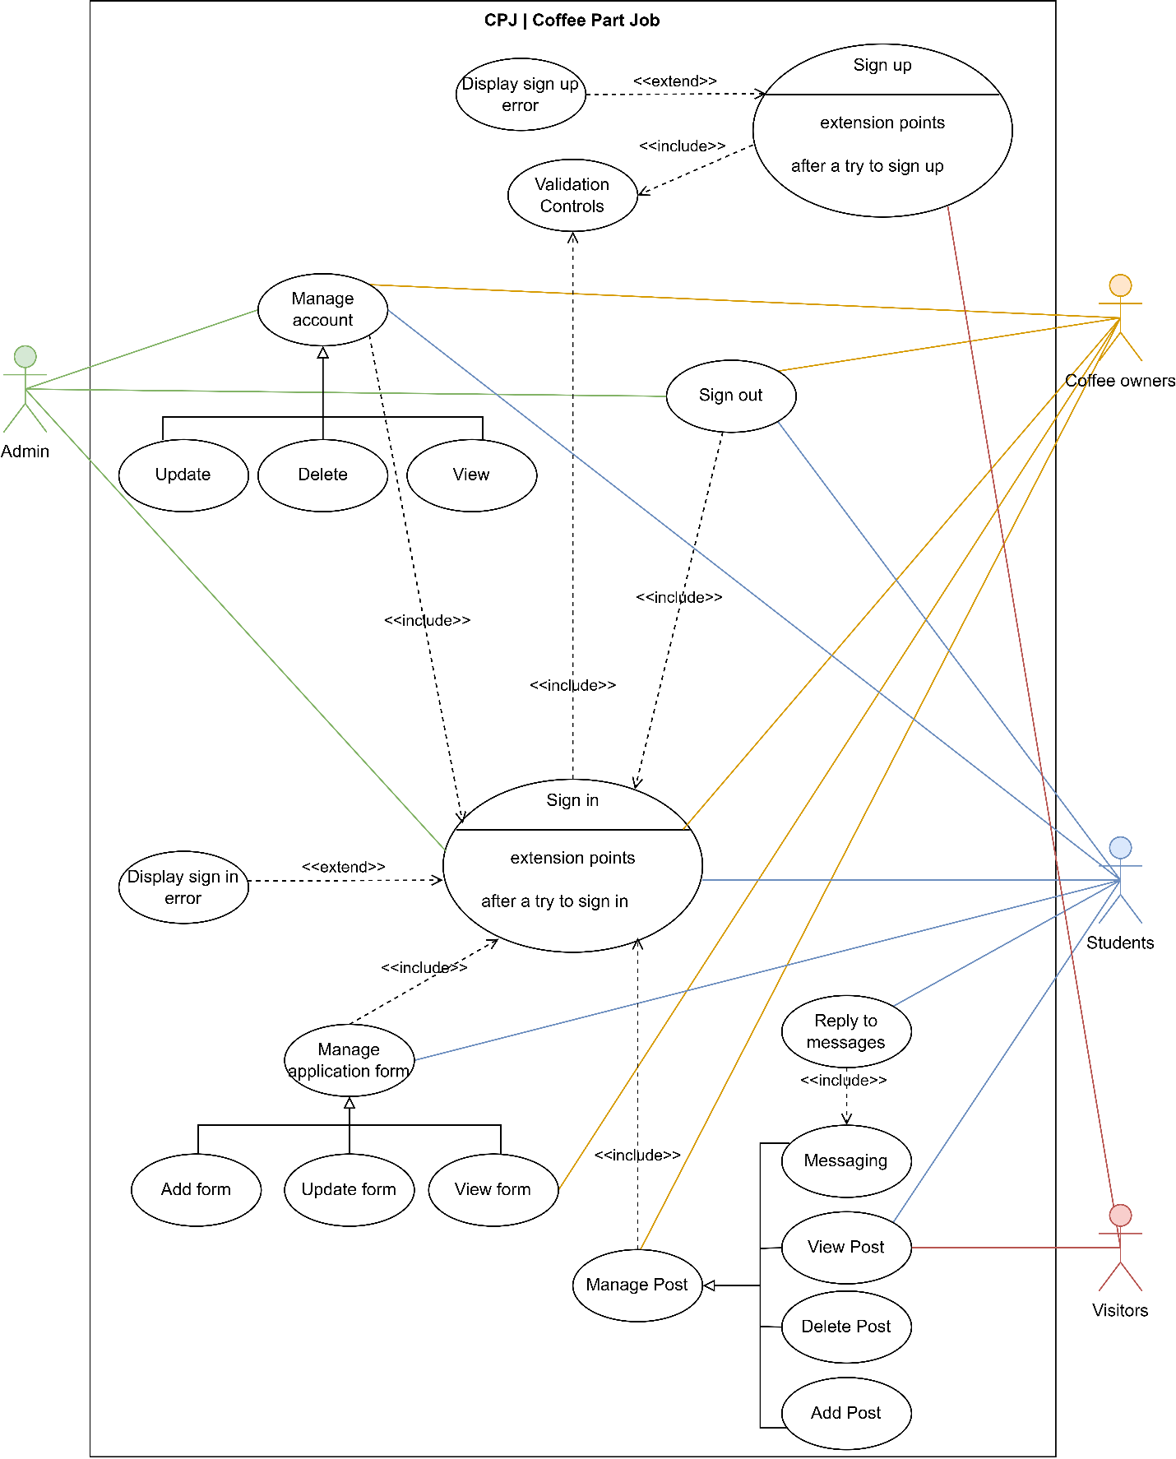

# Context Diagram

# FDD

# DFD

# ERD

# ERM

# Site map

