**Android之Color颜色值和RGB颜色对照表**

<https://blog.csdn.net/u011068702/article/details/48553787>

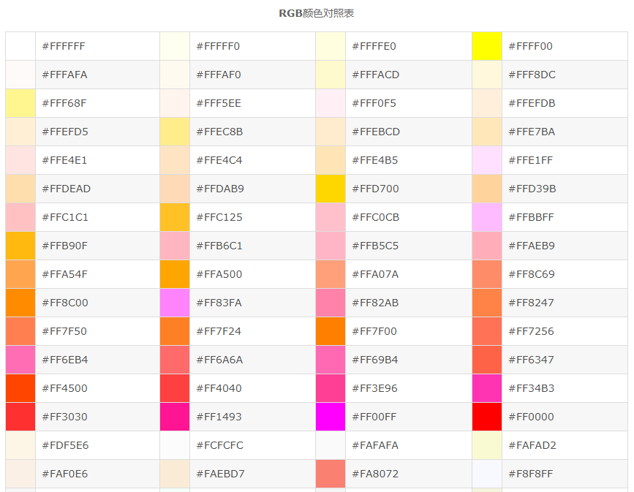

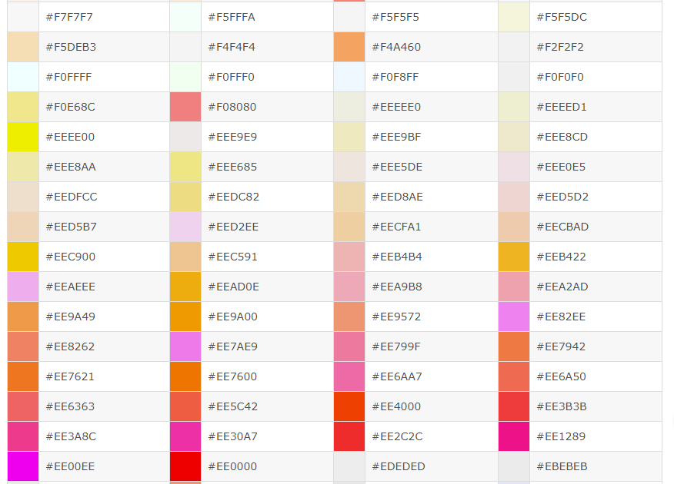

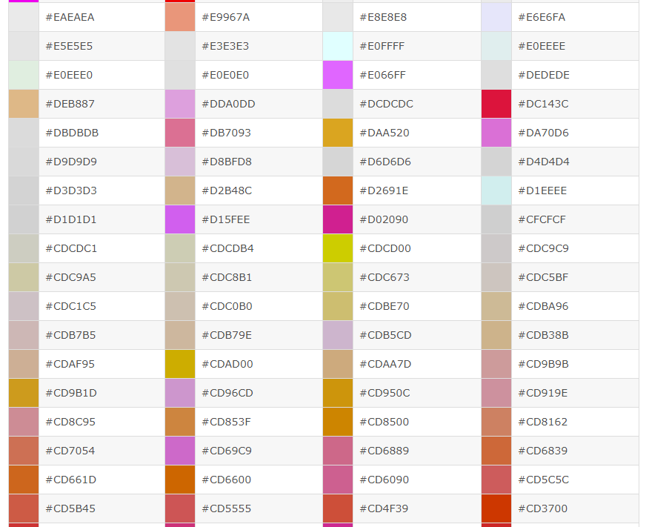

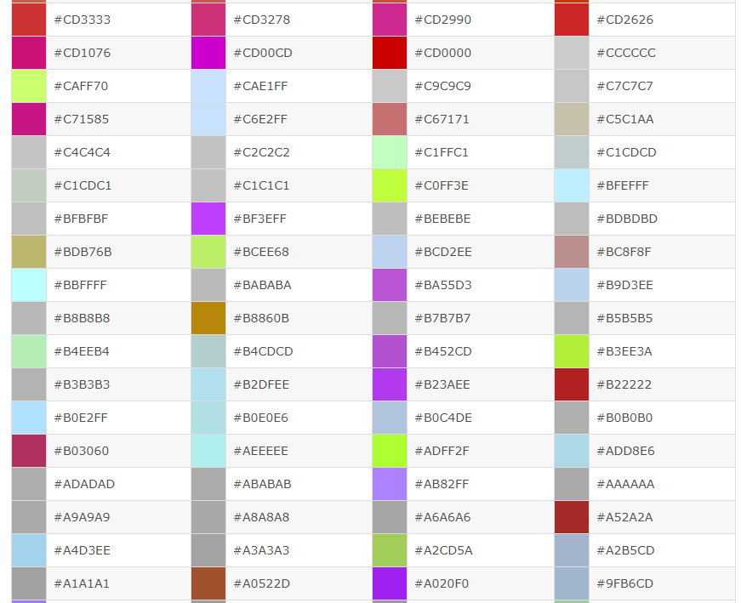

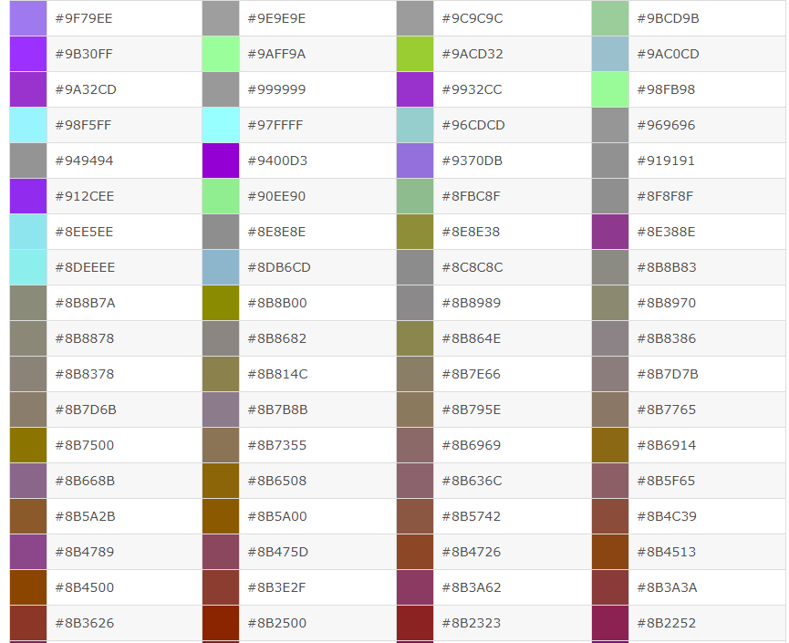

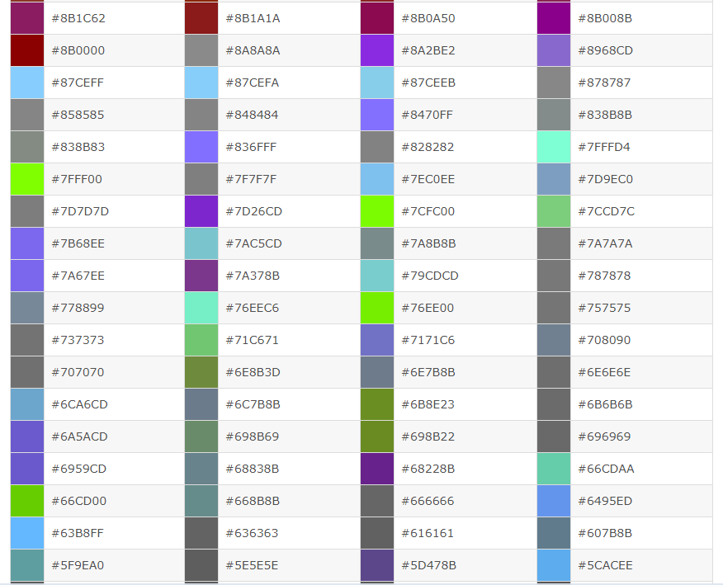

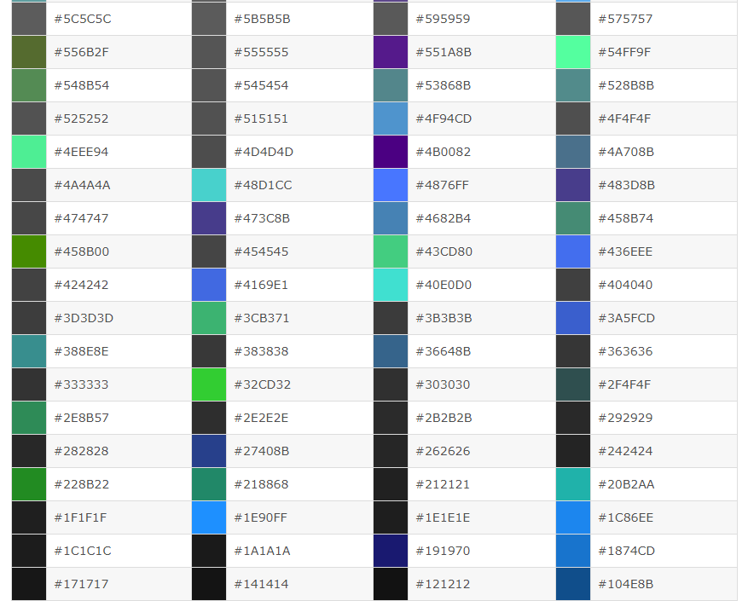

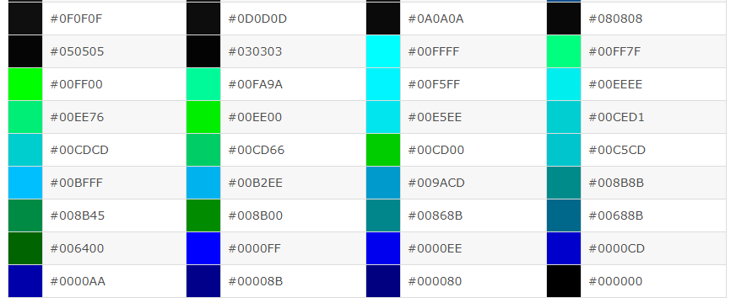

<color name="white">#FFFFFF</color><!--白色 -->

<color name="ivory">#FFFFF0</color><!--象牙色 -->      
<color name="lightyellow">#FFFFE0</color><!--亮黄色-->      
<color name="yellow">#FFFF00</color><!--黄色 -->      
<color name="snow">#FFFAFA</color><!--雪白色 -->      
<color name="floralwhite">#FFFAF0</color><!--花白色 -->      
<color name="lemonchiffon">#FFFACD</color><!--柠檬绸色 -->      
<color name="cornsilk">#FFF8DC</color><!--米绸色 -->      
<color name="seashell">#FFF5EE</color><!--海贝色 -->      
<color name="lavenderblush">#FFF0F5</color><!--淡紫红 -->      
<color name="papayawhip">#FFEFD5</color><!--番木色 -->      
<color name="blanchedalmond">#FFEBCD</color><!--白杏色 -->      
<color name="mistyrose">#FFE4E1</color><!--浅玫瑰色 -->      
<color name="bisque">#FFE4C4</color><!--桔黄色 -->      
<color name="moccasin">#FFE4B5</color><!--鹿皮色 -->      
<color name="navajowhite">#FFDEAD</color><!--纳瓦白 -->      
<color name="peachpuff">#FFDAB9</color><!--桃色 -->      
<color name="gold">#FFD700</color><!--金色 -->      
<color name="pink">#FFC0CB</color><!--粉红色 -->      
<color name="lightpink">#FFB6C1</color><!--亮粉红色-->      
<color name="orange">#FFA500</color><!--橙色 -->      
<color name="lightsalmon">#FFA07A</color><!--亮肉色 -->      
<color name="darkorange">#FF8C00</color><!--暗桔黄色 -->      
<color name="coral">#FF7F50</color><!--珊瑚色 -->      
<color name="hotpink">#FF69B4</color><!--热粉红色 -->      
<color name="tomato">#FF6347</color><!--西红柿色 -->

<color name="orangered">#FF4500</color><!--红橙色 -->      
<color name="deeppink">#FF1493</color><!--深粉红色 -->      
<color name="fuchsia">#FF00FF</color><!--紫红色 -->      
<color name="magenta">#FF00FF</color><!--红紫色 -->      
<color name="red">#FF0000</color><!--红色 -->      
<color name="oldlace">#FDF5E6</color><!--老花色 -->      
<color name="lightgoldenrodyellow">#FAFAD2</color><!--亮金黄色 -->      
<color name="linen">#FAF0E6</color><!--亚麻色 -->      
<color name="antiquewhite">#FAEBD7</color><!--古董白 -->      
<color name="salmon">#FA8072</color><!--鲜肉色 -->      
<color name="ghostwhite">#F8F8FF</color><!--幽灵白 -->      
<color name="mintcream">#F5FFFA</color><!--薄荷色 -->      
<color name="whitesmoke">#F5F5F5</color><!--烟白色 -->      
<color name="beige">#F5F5DC</color><!--米色 -->      
<color name="wheat">#F5DEB3</color><!--浅黄色 -->      
<color name="sandybrown">#F4A460</color><!--沙褐色-->      
<color name="azure">#F0FFFF</color><!--天蓝色 -->      
<color name="honeydew">#F0FFF0</color><!--蜜色 -->      
<color name="aliceblue">#F0F8FF</color><!--艾利斯兰 -->      
<color name="khaki">#F0E68C</color><!--黄褐色 -->      
<color name="lightcoral">#F08080</color><!--亮珊瑚色 -->      
<color name="palegoldenrod">#EEE8AA</color><!--苍麒麟色 -->      
<color name="violet">#EE82EE</color><!--紫罗兰色 -->      
<color name="darksalmon">#E9967A</color><!--暗肉色 -->      
<color name="lavender">#E6E6FA</color><!--淡紫色 -->      
<color name="lightcyan">#E0FFFF</color><!--亮青色 -->      
<color name="burlywood">#DEB887</color><!--实木色 -->

<color name="plum">#DDA0DD</color><!--洋李色 -->      
<color name="gainsboro">#DCDCDC</color><!--淡灰色 -->      
<color name="crimson">#DC143C</color><!--暗深红色 -->      
<color name="palevioletred">#DB7093</color><!--苍紫罗兰色 -->      
<color name="goldenrod">#DAA520</color><!--金麒麟色 -->      
<color name="orchid">#DA70D6</color><!--淡紫色 -->      
<color name="thistle">#D8BFD8</color><!--蓟色 -->      
<color name="lightgray">#D3D3D3</color><!--亮灰色 -->      
<color name="lightgrey">#D3D3D3</color><!--亮灰色 -->      
<color name="tan">#D2B48C</color><!--茶色 -->      
<color name="chocolate">#D2691E</color><!--巧可力色 -->      
<color name="peru">#CD853F</color><!--秘鲁色 -->      
<color name="indianred">#CD5C5C</color><!--印第安红 -->      
<color name="mediumvioletred">#C71585</color><!--中紫罗兰色 -->      
<color name="silver">#C0C0C0</color><!--银色 -->      
<color name="darkkhaki">#BDB76B</color><!--暗黄褐色 -->      
<color name="rosybrown">#BC8F8F</color> <!--褐玫瑰红 -->      
<color name="mediumorchid">#BA55D3</color><!--中粉紫色 -->      
<color name="darkgoldenrod">#B8860B</color><!--暗金黄色 -->      
<color name="firebrick">#B22222</color><!--火砖色 -->      
<color name="powderblue">#B0E0E6</color><!--粉蓝色 -->      
<color name="lightsteelblue">#B0C4DE</color><!--亮钢兰色 -->      
<color name="paleturquoise">#AFEEEE</color><!--苍宝石绿 -->      
<color name="greenyellow">#ADFF2F</color><!--黄绿色 -->      
<color name="lightblue">#ADD8E6</color><!--亮蓝色 -->      
<color name="darkgray">#A9A9A9</color><!--暗灰色 -->      
<color name="darkgrey">#A9A9A9</color><!--暗灰色 -->      
<color name="brown">#A52A2A</color><!--褐色 -->

<color name="sienna">#A0522D</color><!--赭色 -->      
<color name="darkorchid">#9932CC</color><!--暗紫色-->      
<color name="palegreen">#98FB98</color><!--苍绿色 -->      
<color name="darkviolet">#9400D3</color><!--暗紫罗兰色 -->      
<color name="mediumpurple">#9370DB</color><!--中紫色 -->      
<color name="lightgreen">#90EE90</color><!--亮绿色 -->      
<color name="darkseagreen">#8FBC8F</color><!--暗海兰色 -->      
<color name="saddlebrown">#8B4513</color><!--重褐色 -->      
<color name="darkmagenta">#8B008B</color><!--暗洋红 -->      
<color name="darkred">#8B0000</color><!--暗红色 -->      
<color name="blueviolet">#8A2BE2</color><!--紫罗兰蓝色 -->      
<color name="lightskyblue">#87CEFA</color><!--亮天蓝色 -->      
<color name="skyblue">#87CEEB</color><!--天蓝色 -->      
<color name="gray">#808080</color><!--灰色 -->      
<color name="grey">#808080</color><!--灰色 -->      
<color name="olive">#808000</color><!--橄榄色 -->      
<color name="purple">#800080</color><!--紫色 -->      
<color name="maroon">#800000</color><!--粟色 -->      
<color name="aquamarine">#7FFFD4</color><!--碧绿色-->      
<color name="chartreuse">#7FFF00</color><!--黄绿色 -->      
<color name="lawngreen">#7CFC00</color><!--草绿色 -->      
<color name="mediumslateblue">#7B68EE</color><!--中暗蓝色 -->      
<color name="lightslategray">#778899</color><!--亮蓝灰 -->      
<color name="lightslategrey">#778899</color><!--亮蓝灰 -->      
<color name="slategray">#708090</color><!--灰石色 -->      
<color name="slategrey">#708090</color><!--灰石色 -->      
<color name="olivedrab">#6B8E23</color><!--深绿褐色 -->

<color name="slateblue">#6A5ACD</color><!--石蓝色 -->      
<color name="dimgray">#696969</color><!--暗灰色 -->      
<color name="dimgrey">#696969</color><!--暗灰色 -->      
<color name="mediumaquamarine">#66CDAA</color><!--中绿色 -->      
<color name="cornflowerblue">#6495ED</color><!--菊兰色 -->      
<color name="cadetblue">#5F9EA0</color><!--军兰色 -->      
<color name="darkolivegreen">#556B2F</color><!--暗橄榄绿  -->      
<color name="indigo">#4B0082</color><!--靛青色 -->      
<color name="mediumturquoise">#48D1CC</color><!--中绿宝石 -->      
<color name="darkslateblue">#483D8B</color><!--暗灰蓝色 -->      
<color name="steelblue">#4682B4</color><!--钢兰色 -->      
<color name="royalblue">#4169E1</color><!--皇家蓝 -->      
<color name="turquoise">#40E0D0</color><!--青绿色 -->      
<color name="mediumseagreen">#3CB371</color><!--中海蓝 -->      
<color name="limegreen">#32CD32</color><!--橙绿色 -->      
<color name="darkslategray">#2F4F4F</color><!--暗瓦灰色 -->      
<color name="darkslategrey">#2F4F4F</color><!--暗瓦灰色 -->      
<color name="seagreen">#2E8B57</color><!--海绿色 -->      
<color name="forestgreen">#228B22</color><!--森林绿 -->      
<color name="lightseagreen">#20B2AA</color><!--亮海蓝色 -->      
<color name="dodgerblue">#1E90FF</color><!--闪兰色 -->      
<color name="midnightblue">#191970</color><!--中灰兰色 -->      
<color name="aqua">#00FFFF</color><!--浅绿色 -->      
<color name="cyan">#00FFFF</color><!--青色 -->      
<color name="springgreen">#00FF7F</color><!--春绿色-->      
<color name="lime">#00FF00</color><!--酸橙色 -->      
<color name="mediumspringgreen">#00FA9A</color><!--中春绿色 -->

<color name="darkturquoise">#00CED1</color><!--暗宝石绿 -->      
<color name="deepskyblue">#00BFFF</color><!--深天蓝色 -->      
<color name="darkcyan">#008B8B</color><!--暗青色 -->      
<color name="teal">#008080</color><!--水鸭色 -->      
<color name="green">#008000</color><!--绿色 -->      
<color name="darkgreen">#006400</color><!--暗绿色 -->      
<color name="blue">#0000FF</color><!--蓝色 -->      
<color name="mediumblue">#0000CD</color><!--中兰色 -->      
<color name="darkblue">#00008B</color><!--暗蓝色 -->      
<color name="navy">#000080</color><!--海军色 -->      
<color name="black">#000000</color><!--黑色 -->