静态分析报告

#### 1. 环境

SonarLint + IDEA

#### 2. 静态分析结果

**2.1 AdminMapper.java**

* Credentials should not be hard-coded



**2.2 AdminService.java**

* Local variable and method parameter names should comply with a naming convention



**2.3 CommentController.java**

* Cognitive Complexity of methods should not be too high



**2.4 CommentMapper.java**

* Unnecessary imports should be removed



**2.5 CommentService.java**

* Unnecessary imports should be removed

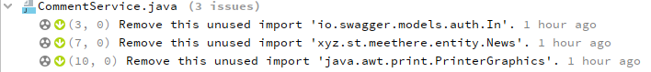

**2.6 FileController.java**

* Throwable.printStackTrace(...) should not be called
* Local variable and method parameter names should comply with a naming convention



**2.7 FileService.java**

* Printf-style format strings should be used correctly
* "Preconditions" and logging arguments should not require evaluation
* Unnecessary imports should be removed
* "Random" objects should be reused
* Local variable and method parameter names should comply with a naming convention

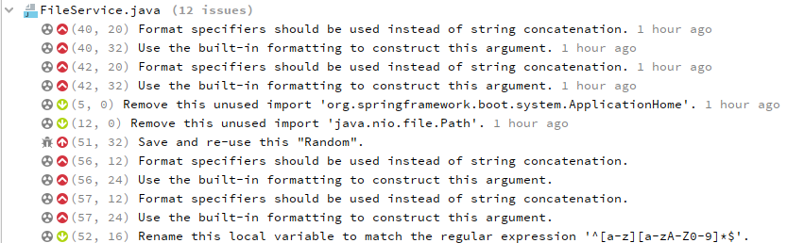

**2.8 Ground.java**

* Unnecessary imports should be removed



**2.9 GroundController.java**

* Unnecessary imports should be removed
* Throwable.printStackTrace(...) should not be called



**2.10 GroundService.java**

* "java.nio.Files#delete" should be preferred
* Printf-style format strings should be used correctly
* "Preconditions" and logging arguments should not require evaluation
* Unnecessary imports should be removed

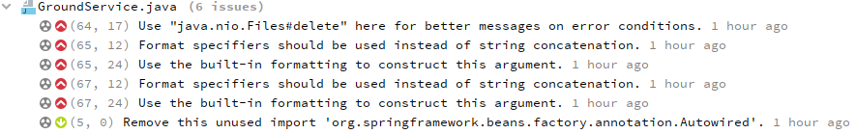

**2.11 MailService.java**

* Local variable and method parameter names should comply with a naming convention



**2.12 MyServerConfig.java**

* Instance methods should not write to "static" fields
* Unused method parameters should be removed
* Static fields should not be updated in constructors
* Printf-style format strings should be used correctly
* "Preconditions" and logging arguments should not require evaluation
* "public static" fields should be constant
* Class variable fields should not have public accessibility

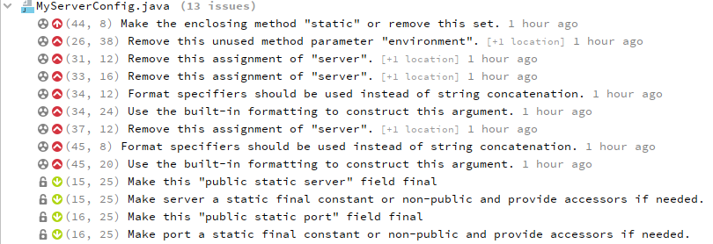

**2.13 MyWebMvcConfig.java**

* "public static" fields should be constant
* Class variable fields should not have public accessibility



**2.14 OrderMapper.java**

* Unnecessary imports should be removed



**2.15 OrderService.java**

* Standard outputs should not be used directly to log anything
* Null pointers should not be dereferenced
* Anonymous inner classes containing only one method should become lambdas
* Unnecessary imports should be removed
* Local variables should not be declared and then immediately returned or thrown

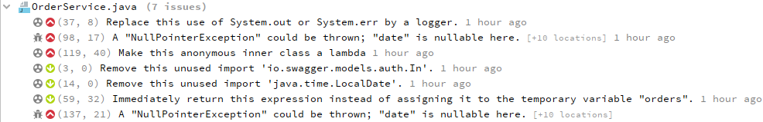

**2.16 ResponseMsg.java**

* Declarations should use Java collection interfaces such as "List" rather than specific implementation classes such as "LinkedList"



**2.17 User.java**

* Methods should not have too many parameters



**2.18 UserController.java**

* Unnecessary imports should be removed
* Throwable.printStackTrace(...) should not be called



**2.19 UserMapper.java**

* Credentials should not be hard-coded



**2.20 UserService.java**

* "java.nio.Files#delete" should be preferred
* Printf-style format strings should be used correctly
* "Preconditions" and logging arguments should not require evaluation
* Unnecessary imports should be removed
* Local variables should not be declared and then immediately returned or thrown
* Return of boolean expressions should not be wrapped into an "if-then-else" statement
* Local variable and method parameter names should comply with a naming convention

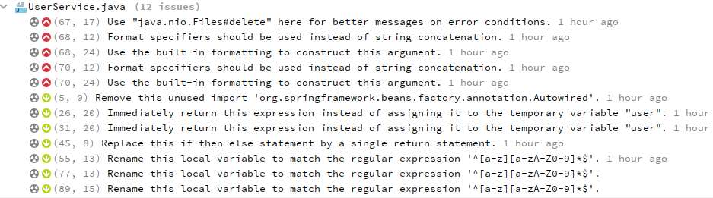

#### **3. 改进后再次进行静态分析结果**

**3.1 修复的问题**

* Credentials should not be hard-coded
* Local variable and method parameter names should comply with a naming convention
* Cognitive Complexity of methods should not be too high
* Unnecessary imports should be removed
* Throwable.printStackTrace(...) should not be called
* Printf-style format strings should be used correctly
* "Preconditions" and logging arguments should not require evaluation
* Instance methods should not write to "static" fields
* Unused method parameters should be removed
* Class variable fields should not have public accessibility
* Standard outputs should not be used directly to log anything
* Null pointers should not be dereferenced
* Anonymous inner classes containing only one method should become lambdas
* Local variables should not be declared and then immediately returned or thrown
* Declarations should use Java collection interfaces such as "List" rather than specific implementation classes such as "LinkedList"
* Methods should not have too many parameters
* Credentials should not be hard-coded
* Return of boolean expressions should not be wrapped into an "if-then-else" statement

**3.3 修复后静态分析结果**

**3.3.1 FileService.java**

* "Random" objects should be reused

未解决理由：Random类没有重用的需要，仅在FileService的功能中使用过一次。

