R1Q10, should we include the CLAS note 2013-008 into the analysis note? Maybe as an annex? If not, at least make sure it is properly cited in the note that we follow the procedure from this note.
Nathan to send me the latex source file and will add it in the appendix.
R1Q13, the figure 2.19 could be simply dropped from the note, it does not add much.
Okay, we will drop it from the note.
R1Q14: Need to write things in latex and explain them
Done
Caption Fig. 8 need to be clarified. I can't figure out what is in there.
It is clarified.
R1 Q31 Table 1: Range to compare are -50 to -30 and 30 to 50, so that you have the same size as in the middle. I think it indicates a ~5 to 10% contamination. This should be discussed to see if we need to add this as a contamination.
The table is updated. The answer is updated.
R1Q41: I am still puzzled by the question, could you check that question in the original document. It seems we changed it.
The original question is retrieved. We all agree on the answer.
R1Q44: If we do apply a correction for accidentals (R1Q31), this needs to be modified.
The correction will be implemented for the final asymmetries as
1/(1- contamination factor). The answer is updated.
R1Q46 part 2 and Fig. 30: I am a little surprised by the result is very clean, I would say too clean. Are you applying a Delta z cut on the Helium? If so, that is like making a cut on the z of the electron. Else there must be some background.
This is true, Delta z was applied. The figure and the answer are updated.
R2Q8 There is an inconsistency in the number of parameter of the fit that is not addressed.
The accurate number of degrees of freedom is 4. Corrected in R1Q5 and R2Q8.
R2Q12 Nathan is the issue with phi distribution solved? Is this normal distributions?
From looking to the sector-dependent coplanarity of the identified coherent DVCS events, we conclude that the resolution is too poor to bother with it for DVCS. This is due to the different beam energies and how the coplanarity is calculated using the planes between gamma, gamma* and He4.
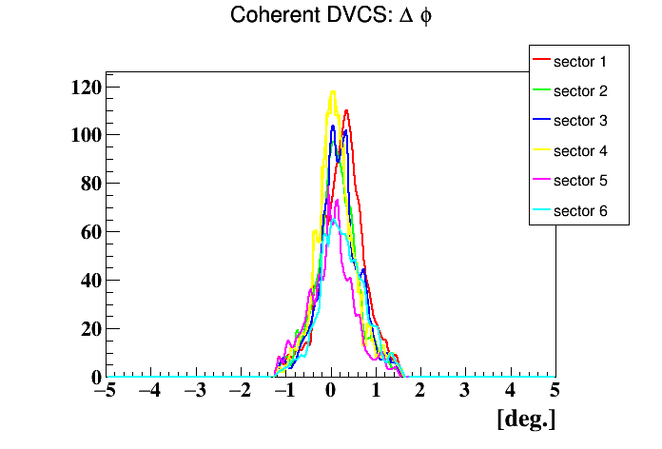
R2Q28 More tmin need to be drawn on Fig. 42.
Done

R2Q49
We will not reproduce the results of the others. We will use F.X's results from his tables which are close to our kinematics and compare them to our asymmetries. Kawtar agrees on this.
R3Q11 Results for different period need to be added
Done.
R3Q20 answer to c) is missing
Done.

Raphael: Remaining issues:
- Substract accidentals (R1Q31&44), I will correct the final asymmetries by applying 1/(1- contamination factor)
- tmin drawing on Fig. 40: Done
- Compare to FX results (R2Q49): We agree that we will use their published results.
- Clarify how you add the systematic for R3Q20c, Done

