**Snake User Manual**

***Rules***

- Collect items by colliding into them with the head of the snake

- Avoid colliding into the sides and the following snake

- Collected Blue items will increase the users score by 10 points

- Collected White items will increase the users score by 30 points

- Obtain the highest score possible, the score is recorded in the game's side panel. The current score and high score is shown.

***Buttons***

Play: Creates a new game the snake only has one square. If play is clicked while the game is going it will reset the game (see reset button below).

Reset: Resets the games current score, the high score will not be reset. Resets the snake.

Pause: Pauses the game and un-pauses the game. The word pause will appear on the screen when the game is paused. *Note the Play and Reset buttons cannot be accessed while the game is paused. This is done in case the player accidently clicks on those buttons instead of clicking on pause again to un-pause the game.

Sort: Sorts the snake based on color.

Rules: Displays the rules of the game.

Slow: Sets the snake's speed to a slow speed.

Normal: Sets the snake's speed to a traditional average speed.

Fast: Sets the snake's speed to a fast speed.

***Key Pressed***

Directional Keys/ WASD Keys: Movement directions

P Key: Shortcut for the Play Button

Space: Shortcut for the Pause Button

***Setting Up the Game***  
Click the Play button to create a new game environment. Use either the movement keys or WASD to move the snake in the desired direction.

***Playing the Game***

The objective of the game is to obtain the highest score possible. The players score is increased by obtaining either blue or white items. One item is available on the screen at a time. Once the item is collected another will appear in a different location. Blue items are worth 10 points and white items are worth 30 points. White items appear far less than blue items. The score is recorded in the game's side panel. The side panel shows both the current score and high score. The current score is the present score of the game. The high score is the highest score throughout all the games played. Each time an item is collected the snake will gain a following square. The game will end if the head (square of the snake that you control) collides with a following square or if the head collides with a boundary. The boundaries in the game are shown by a white rectangle.

***Winning the Game***  
It is very difficult to win a game of snake. In order to officially win the game the player has to collect as many followers as it takes to fill the screen. Otherwise, play the game to obtain the highest score.

***Example - Playing a Simple Game of Snake***

First run the program - This should be shown

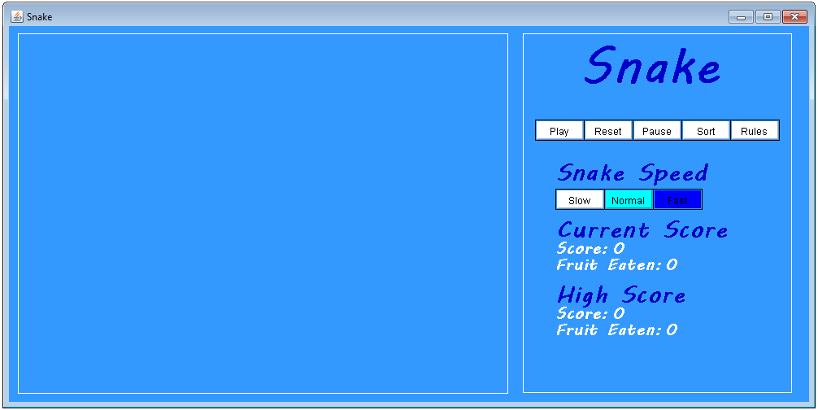

Click the play button - circle shown on button

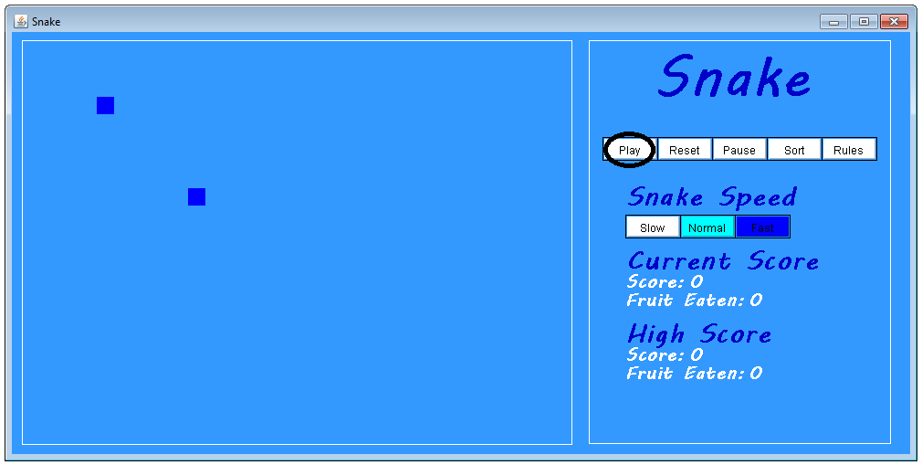

Press any directional key or WASD - collect square.

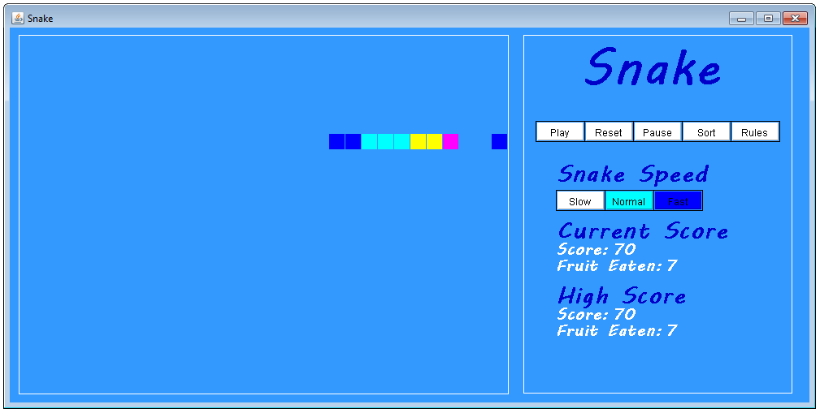

This should result in gaining following squares. Those are the basics - Have fun!

***Losing the Game***

Collision with a side

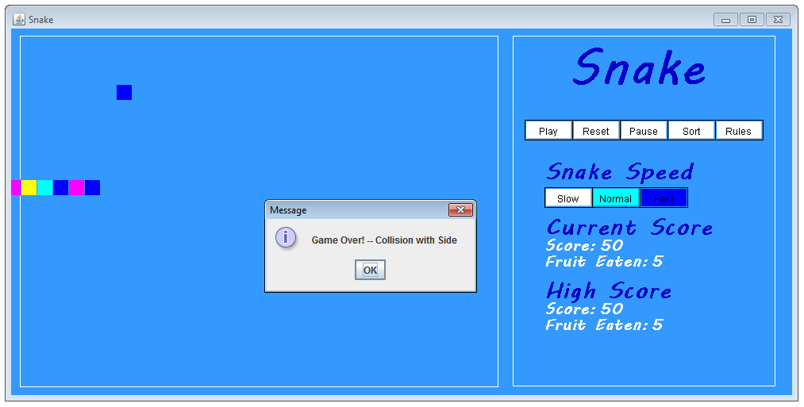

Collision with the snake

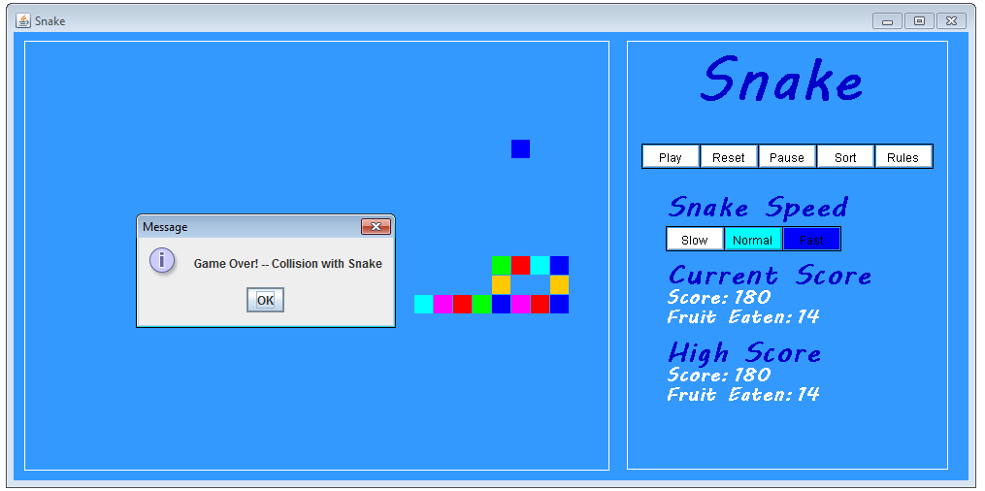

***Button Effects***

Reset Button - This should not delete the item from the screen, just the snake.

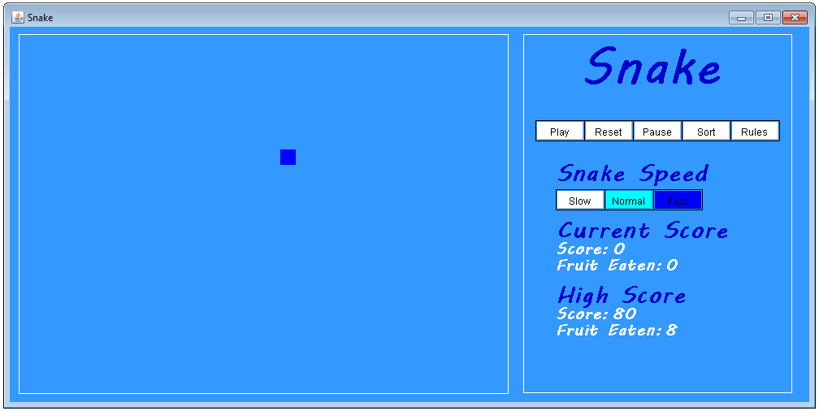

Pause Button - Pauses the game, you should see Pause in the middle of the screen

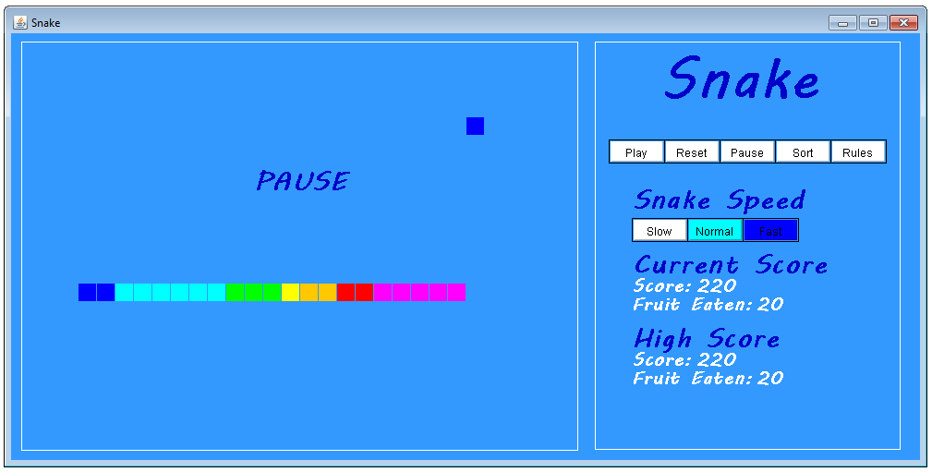

Sort Button - A previously unsorted snake will be sorted according to color

Before:

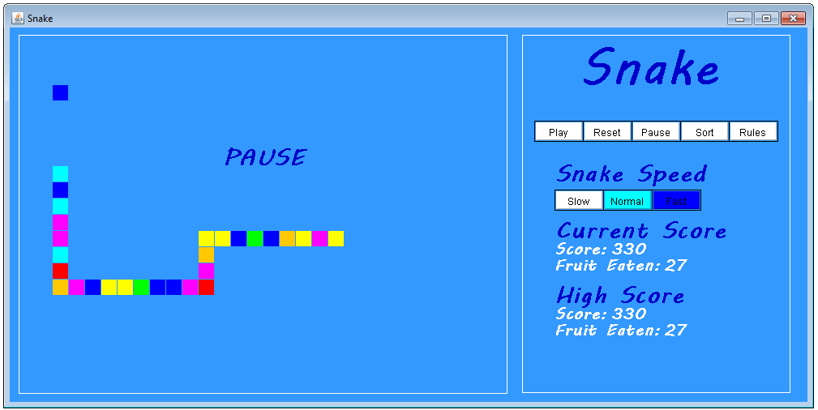

After:

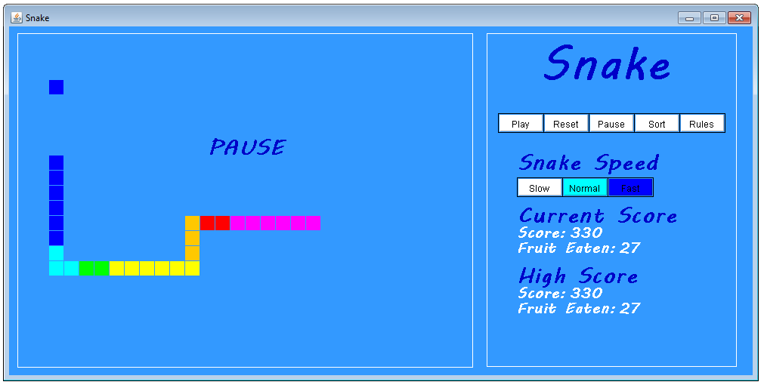

Rules Button - Displays the instructions

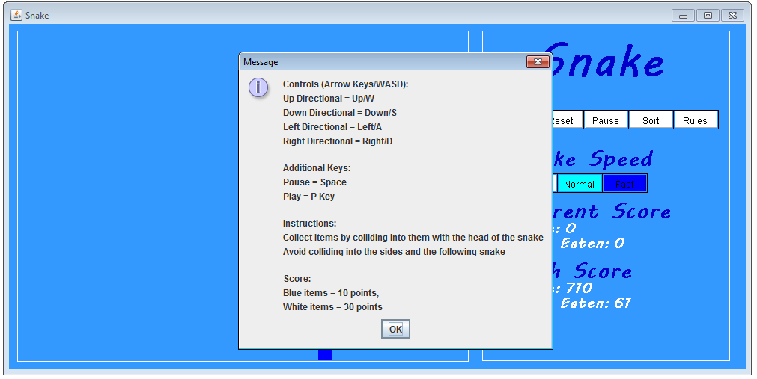

The Slow/Normal/Fast Buttons increase/decrease the speed of the snake, however, it is difficult to show this in a picture.