Research Proposal

Subject: Detecting Fake News in Social Media Networks

**Team members:** Or Ben-Ami, 318417763

Chen Ben-Ami, 315800961

Amit Kabalo, 314993247

**Paper**: Monther Aldwairi, Ali Alwahedi

"Detecting Fake News in Social Media Networks"

**Abstract**:

1. This paper discusses the problem of fake news and clickbaits in social media networks and proposes a solution to detect and filter out potential sources of fake news. The proposed solution involves the use of a tool that can identify and remove fake sites from the results provided to a user by a search engine or a social media news feed. The authors also discuss the attributes selection process and the classifiers used to evaluate the effectiveness of the proposed solution.
2. In evaluating the classifiers, the paper considered various metrics such as Precision, Recall, F-Measure, and ROC. According to the table , the Logistic classifier demonstrates the highest precision at 99.4%, indicating superior classification quality. Both Logistic and RandomTree classifiers exhibit the best recall, reflecting a high sensitivity of 99.3%. The F-Measure, which combines precision and recall, shows that Logistic and RandomTree classifiers outperform others, achieving a score of 99.3%. Additionally, BayesNet and Naivebayes excel in terms of the area under the ROC curve.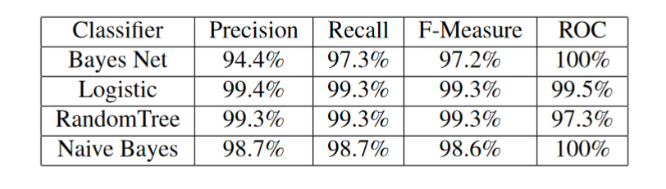
3. we are planning to use deep learning models like Roberta, Bert and such to approach this problem and we are expecting good results.

**Related work**

<https://arxiv.org/pdf/1705.00648.pdf>

The paper evaluated several popular learning-based methods on the LIAR dataset, including logistic regression, support vector machines, long short-term memory networks, and a convolutional neural network model.

**Dataset**: GonzaloA/fake_news

<https://huggingface.co/datasets/GonzaloA/fake_news>

English-language dataset containing just over 45k unique news articles.

The articles are classified as true (1) or false (0).