Crypto.lib库的安装与使用

安装环境：Windows 7 + Visual Studio 2010

一 配置(以test为例)

1. 双击VC++控制台应用程序test

2．在项目名称中点击“右键”，选择“属性”，从里面找到“VC++目录”，设置库目录：库目录指向Crypto.lib所在的目录;包含目录指向openssl目录所在的目录。

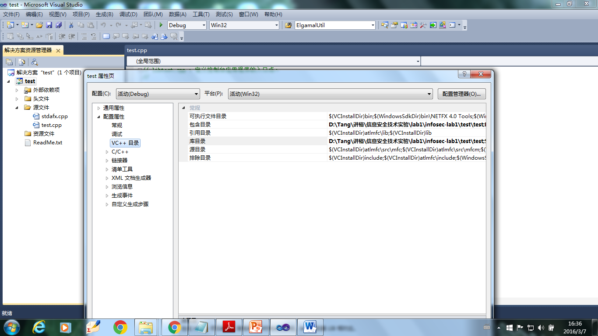

3. 切换到“链接器”-> “输入”：

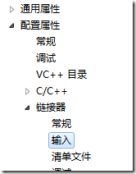

在“附加依赖项”中，加入Crypto.lib文件：

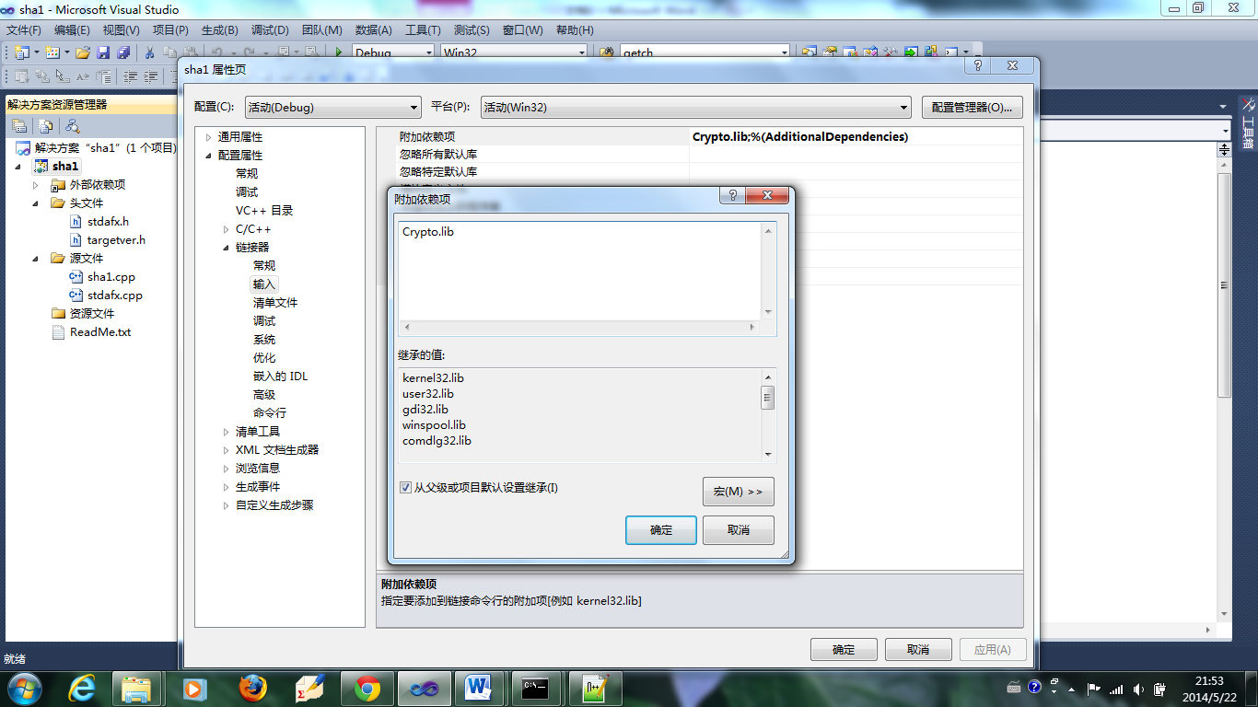

4. 引用

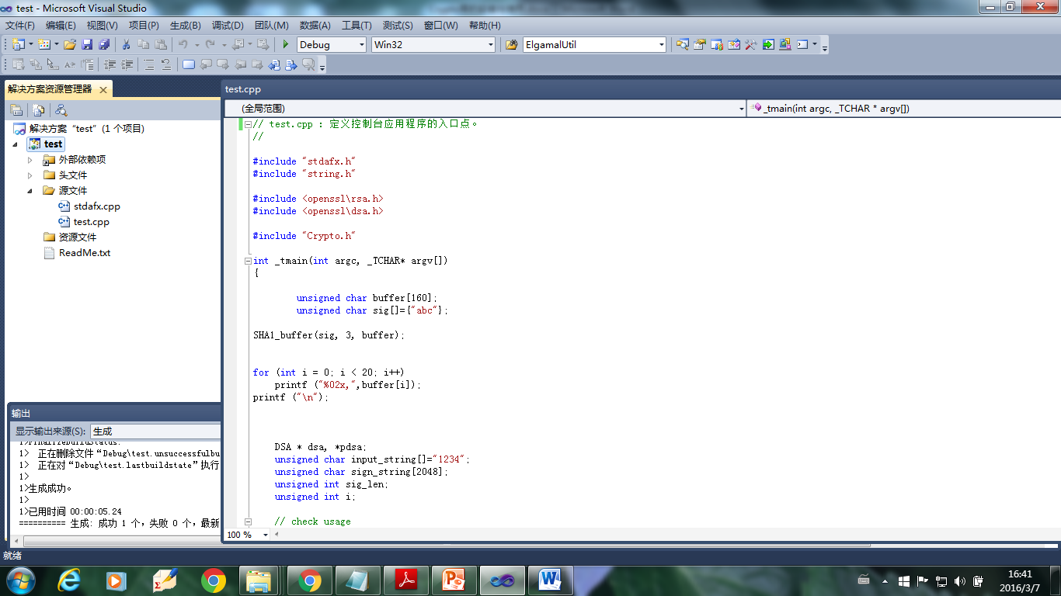

5.运行

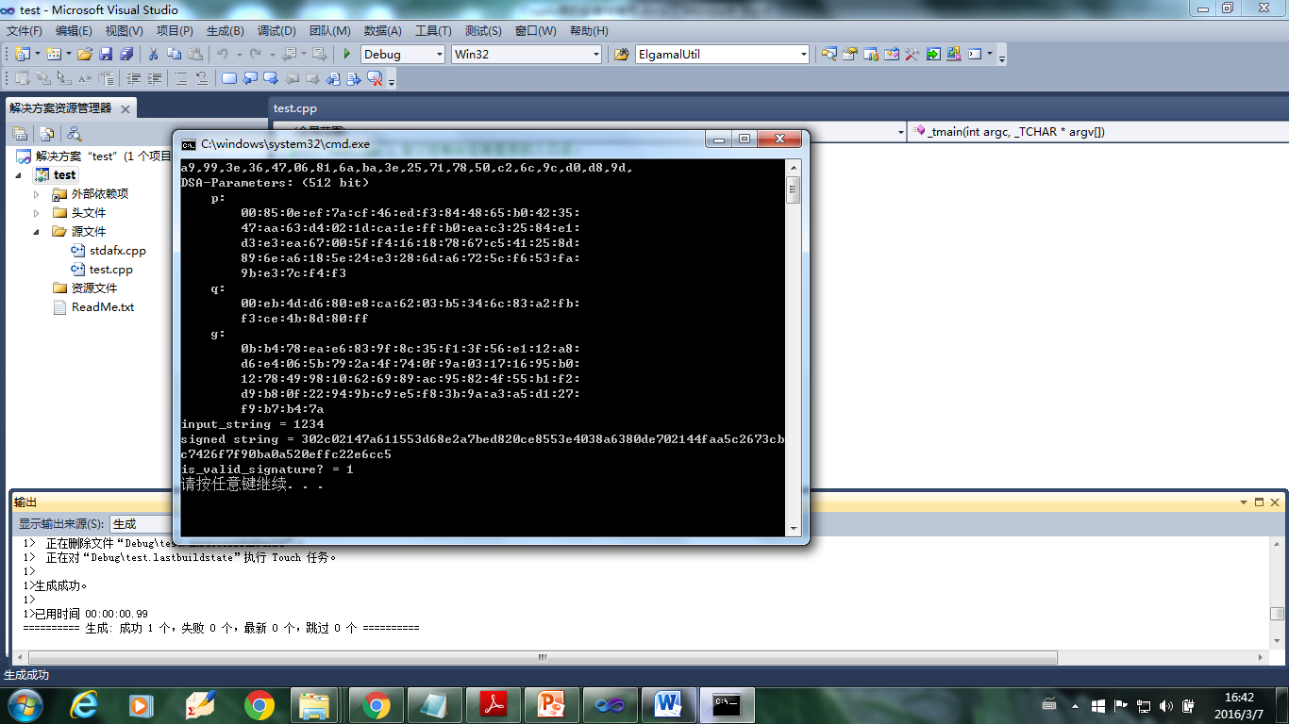

二 函数接口

本接口函数在openssl基础上开发，需要使用openssl中的头文件。

1.Crypto.lib 有关SHA1的函数接口

#define SHA_DIGEST_LENGTH 20

void SHA1_buffer(unsigned char * buffer, int bufferlength, unsigned char *outputSHA1Value);

void SHA1_file(char * filename, unsigned char *outputSHA1Value);

2．Crypto.lib 有关AES的函数接口和宏

#define AES_BLOCK_SIZE 16

#define AES_ENCRYPT 1

#define AES_DECRYPT 0

void AES_CBC128_encrypt_buffer (unsigned char *in, unsigned char *out, unsigned int length, unsigned char *key, unsigned char *iv);

void AES_CBC128_decrypt_buffer (unsigned char *in, unsigned char *out, unsigned int length, unsigned char *key, unsigned char *iv);

void AES_CTR128_encrypt_buffer (unsigned char *in, unsigned char *out, unsigned int length, unsigned char *key, unsigned char *counter);

void AES_CTR128_decrypt_buffer (unsigned char *in, unsigned char *out, unsigned int length, unsigned char *key, unsigned char *counter);

void AES_ECB128_encrypt_buffer(unsigned char *in, unsigned char *out, unsigned int length, unsigned char *key);

void AES_ECB128_decrypt_buffer(unsigned char *in, unsigned char *out, unsigned int length, unsigned char *key);

void AES_CFB128_encrypt_buffer (unsigned char *in, unsigned char *out, unsigned int length, unsigned char *key, unsigned char *iv);

void AES_CFB128_decrypt_buffer (unsigned char *in, unsigned char *out, unsigned int length, unsigned char *key, unsigned char *iv);

void AES_OFB128_encrypt_buffer (unsigned char *in, unsigned char *out, unsigned int length, unsigned char *key, unsigned char *iv);

void AES_OFB128_decrypt_buffer (unsigned char *in, unsigned char *out, unsigned int length, unsigned char *key, unsigned char *iv);

说明：

1. 上述函数针对12位密钥的AES的五种工作模式，即ECB、CBC、CTR、CFB和OFB下的对给定缓冲区数据的AES加密；
2. 各个参数说明

in： 待加/解密数据缓冲区；

out： 已加/解密数据缓冲区；

length：待加/解密数据长度；

key： 128位AES密钥；

iv： 128位初始向量

1. Crypto.lib 有关RSA的函数接口

需要使用 <openssl\rsa.h>中的函数定义

void RSA_init_keypair (int bits, RSA ** publickey, RSA ** privatekey);

void RSA_free_keypair (RSA * publickey, RSA * privatekey);

void RSA_public_encrypt_buffer (unsigned char *in, int insize, unsigned char *out, int *outsize, RSA *key);

void RSA_private_decrypt_buffer (unsigned char *in, int insize, unsigned char *out, int *outsize, RSA *key);

void RSA_private_encrypt_buffer (unsigned char *in, int insize, unsigned char *out, int *outsize, RSA *key);

void RSA_public_decrypt_buffer (unsigned char *in, int insize, unsigned char *out, int *outsize, RSA *key);