DATA 260 Homework 6 Memory System Report
Haozhe Wang | SID4 8561 | Clinical Trial Listings
This report documents a FastAPI application connected to MongoDB, a three-layer conversational memory system, a token-cost experiment, and a Markdown-file memory system. The evidence is organized in the same order as the assignment parts.

Part 0 Configuration
Item | Value
SID4 | 8561
PORT_BASE | 8461
PREFIX | s8561
MongoDB database | s8561_doc
DOMAIN_ID | 1 - clinical trials
Hardware | Apple M4 MacBook Pro, 16 GB memory
Local chat model | Ollama qwen3:8b
Embedding model | nomic-embed-text
Git tag | hw6; final target recorded in verification.json

The application continues the existing data260-8561 repository and preserves the previous homework history. MongoDB runs in Docker on localhost:27017 and the API runs on localhost:8461.
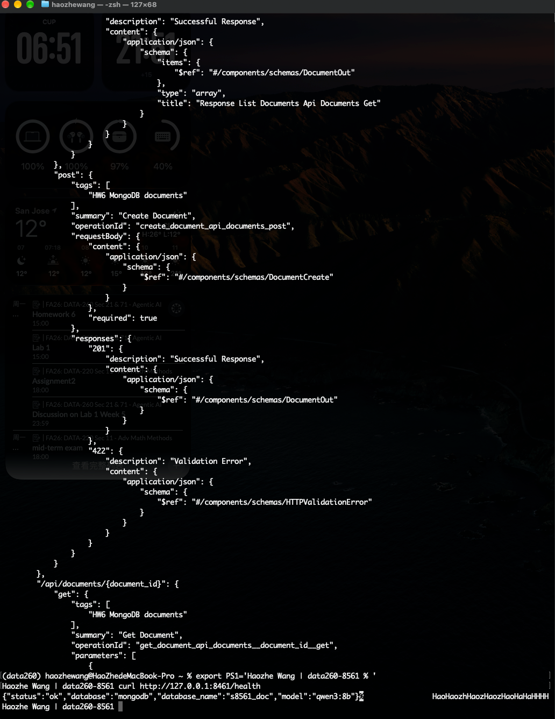
Figure 0. FastAPI health endpoint and runtime configuration.

Part 1 MongoDB Document CRUD API
The clinical_trials collection stores a required title, optional description, defaulted status, fixed category, required start_date, and automatically maintained created_at and updated_at timestamps. The API is split into configuration, database, schemas, and routes.
Endpoint | Evidence
POST /api/documents | Create a clinical-trial document
GET /api/documents | List documents
GET /api/documents/{id} | Retrieve one document
PUT /api/documents/{id} | Update document fields and updated_at
DELETE /api/documents/{id} | Delete document with HTTP 204

POST create
POST /api/documents
{ "title": "Hypertension Observational Study", "category": "observational", "start_date": "2026-10-22T09:00:00Z" }
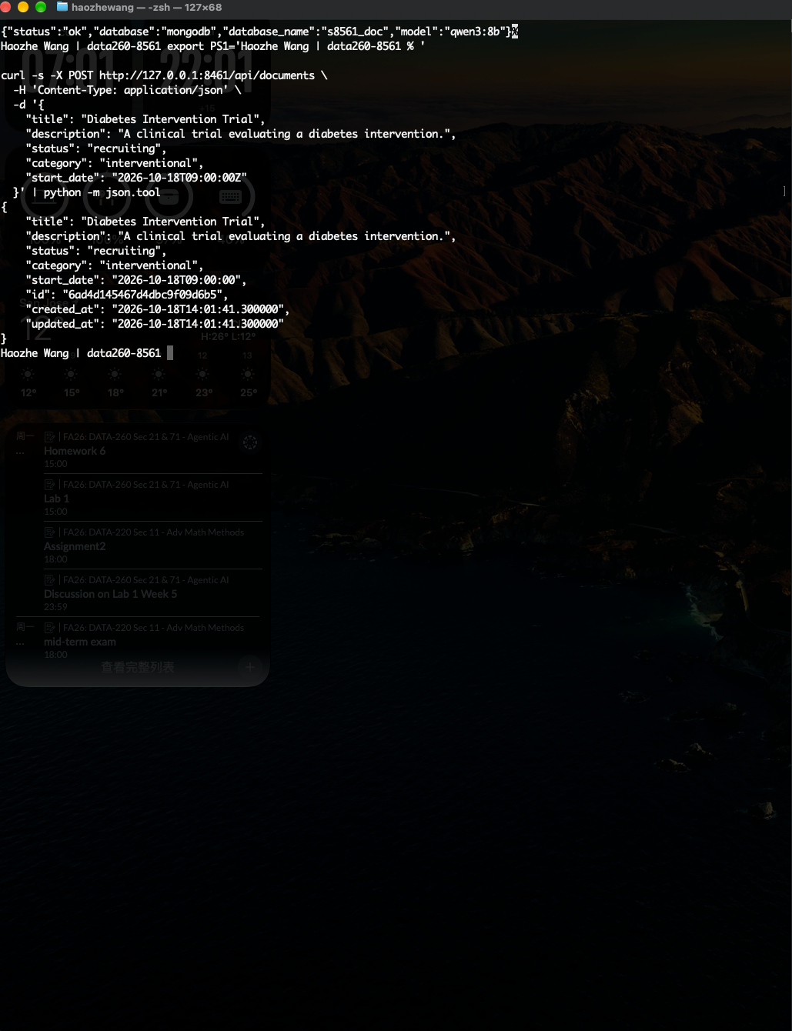
POST /api/documents with a valid clinical-trial record.

GET list
GET /api/documents
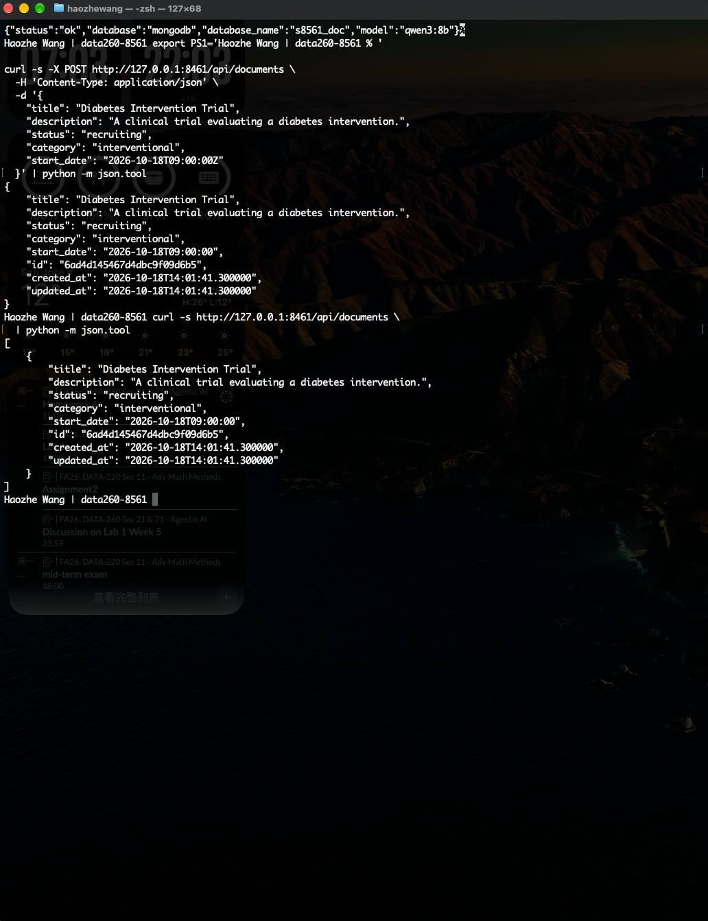
GET /api/documents returns the created record.

GET one
GET /api/documents/{id}
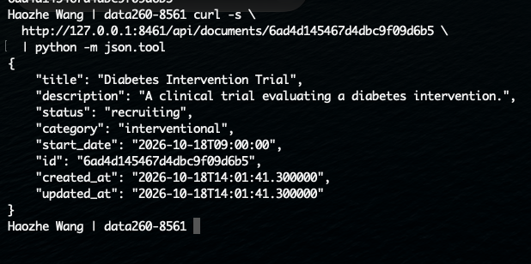
GET /api/documents/{id} returns one document.

PUT update
PUT /api/documents/{id}
{ "status": "active", "description": "Updated evidence" }
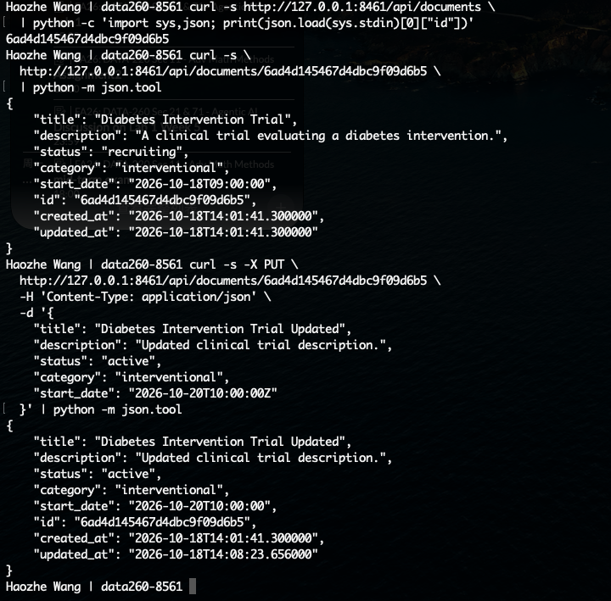
PUT /api/documents/{id} changes title, description, status, and start_date.

Missing required field
POST /api/documents
{ "category": "observational", "start_date": "2026-10-22T09:00:00Z" }
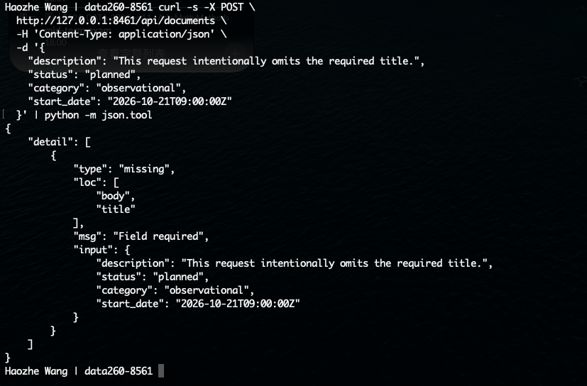
Validation rejects a request without title.

Invalid enum
POST /api/documents
{ "status": "invalid", "category": "observational", "start_date": "2026-10-22T09:00:00Z" }
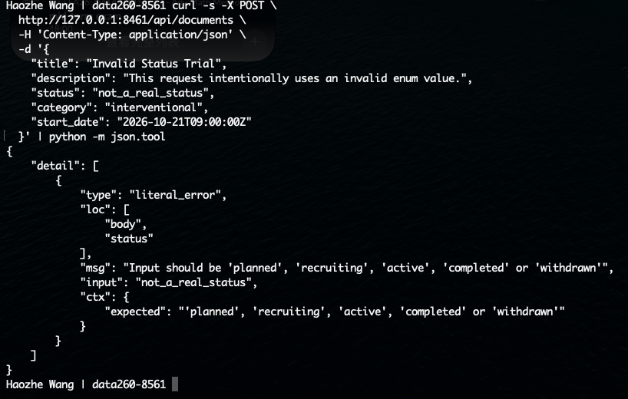
Validation rejects an unsupported status value.

Invalid type
POST /api/documents
{ "category": "observational", "start_date": "not-a-date" }
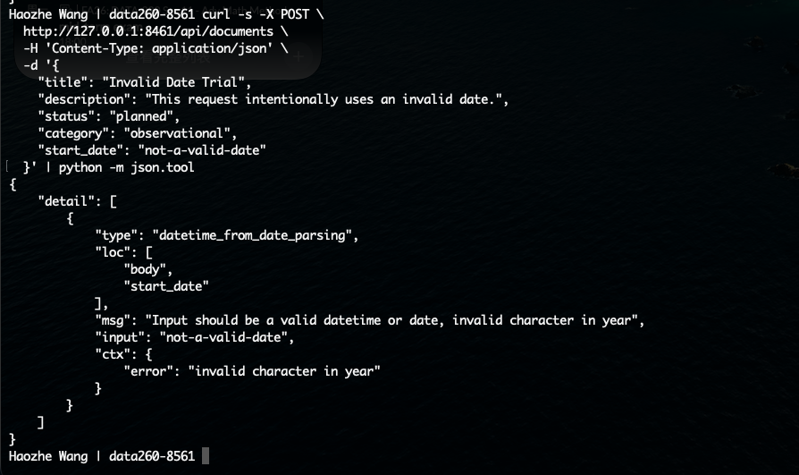
Validation rejects an invalid start_date type.

DELETE
DELETE /api/documents/{id}
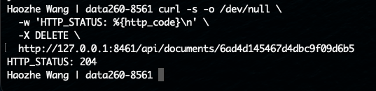
DELETE returns HTTP 204.

MongoDB Compass
Compass: localhost:27017 -> s8561_doc -> clinical_trials -> Documents
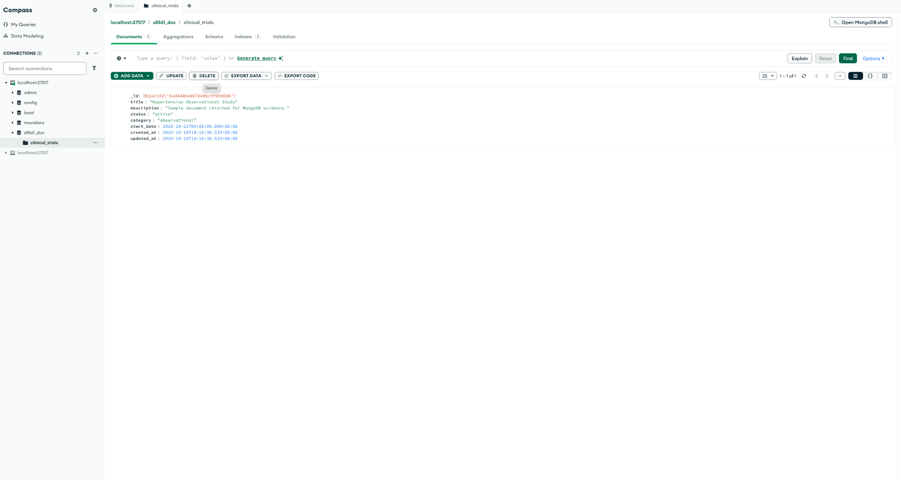
Compass shows the persisted clinical_trials document.

Part 2 Three Layer Conversational Memory
Each chat request saves the user message, builds a prompt from the primer, summaries, short-term window, and top-k episodic facts, calls the HW1 Ollama adapter, saves the response, and returns memory evidence and token metrics. Facts are limited to three per user message and are stored with importance and embeddings.
POST /api/chat
GET /api/memory/{user_id}
GET /api/aggregate/{user_id}
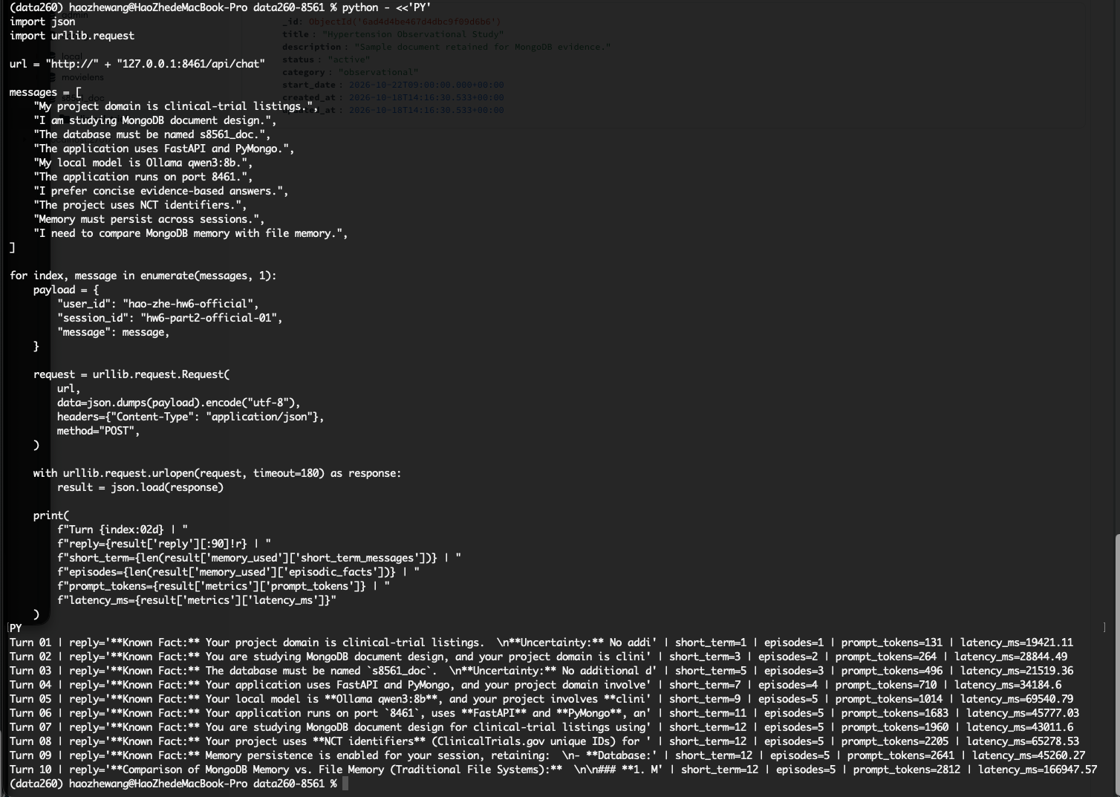
Figure 2. Ten chat turns in one session with memory and token metrics.
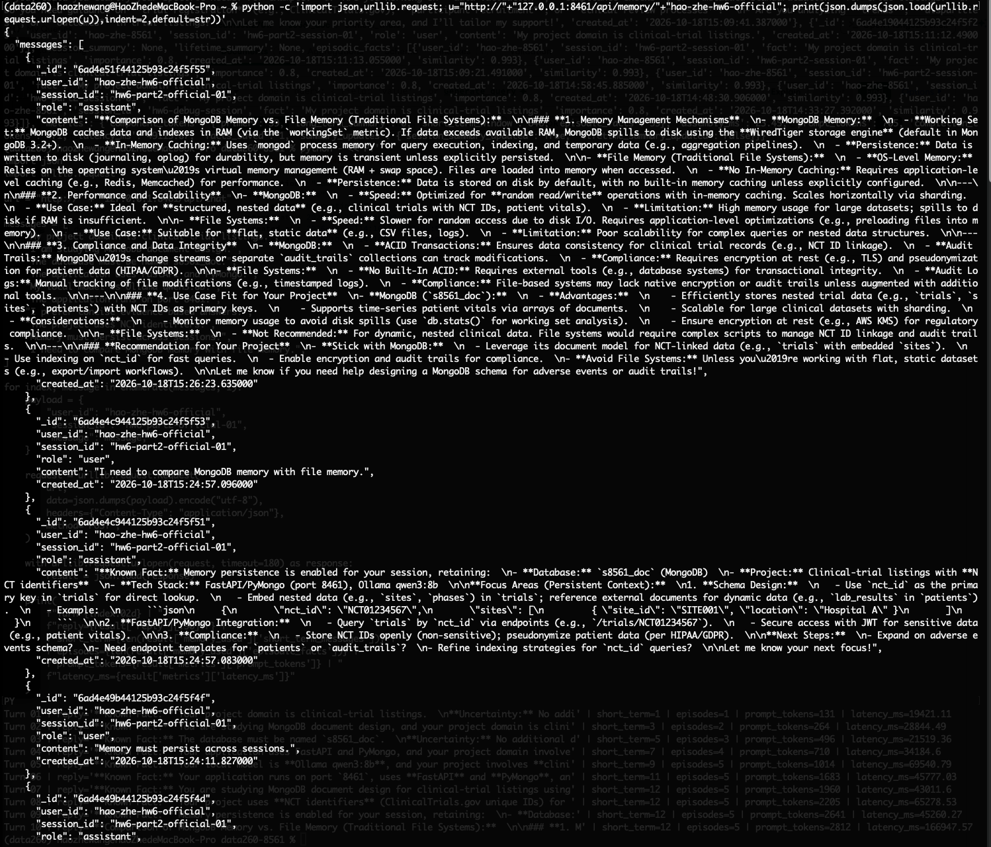
Figure 2A. Memory view containing messages, summaries, and episodic facts.
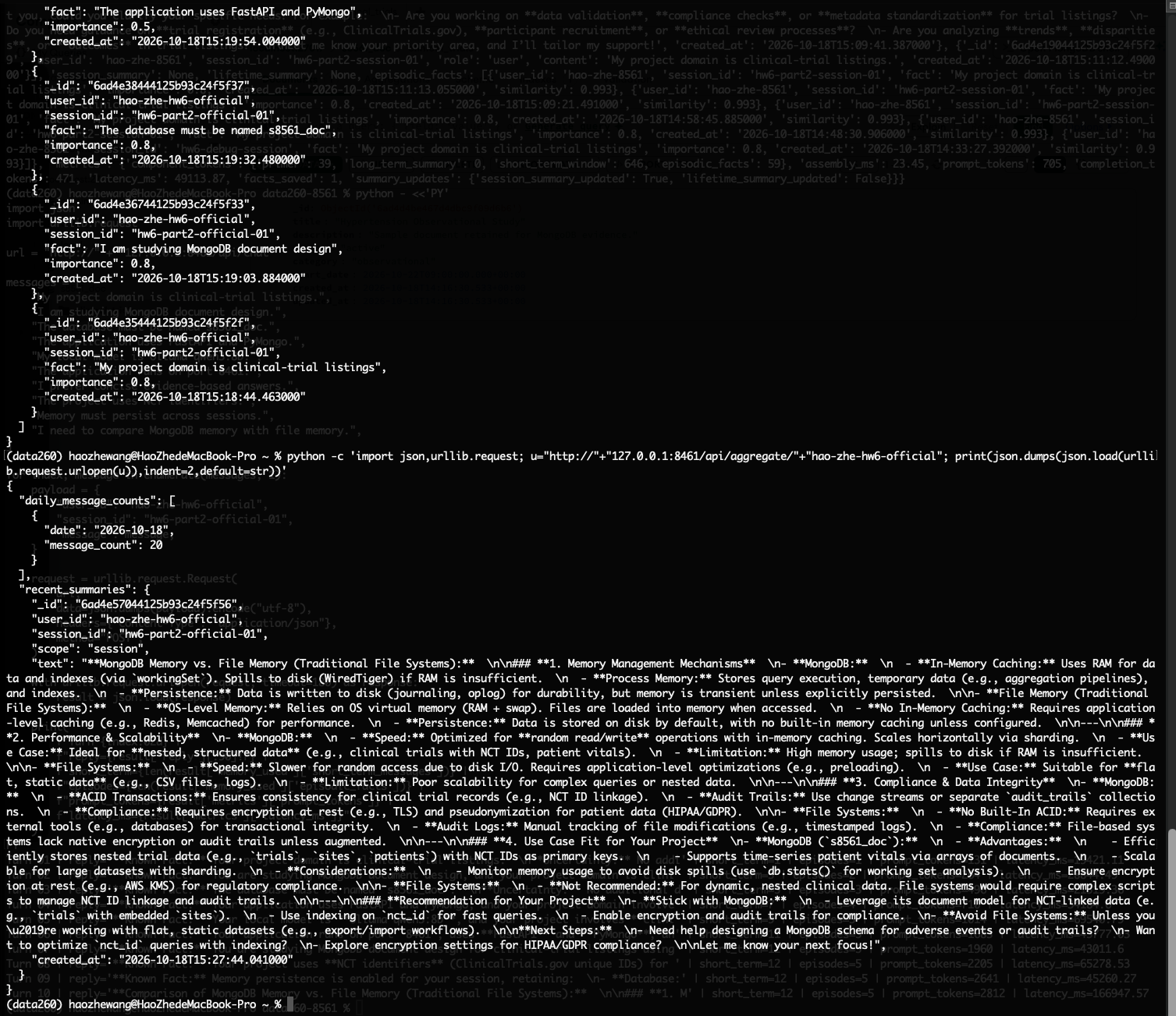
Figure 2B. Aggregate view grouped by date.
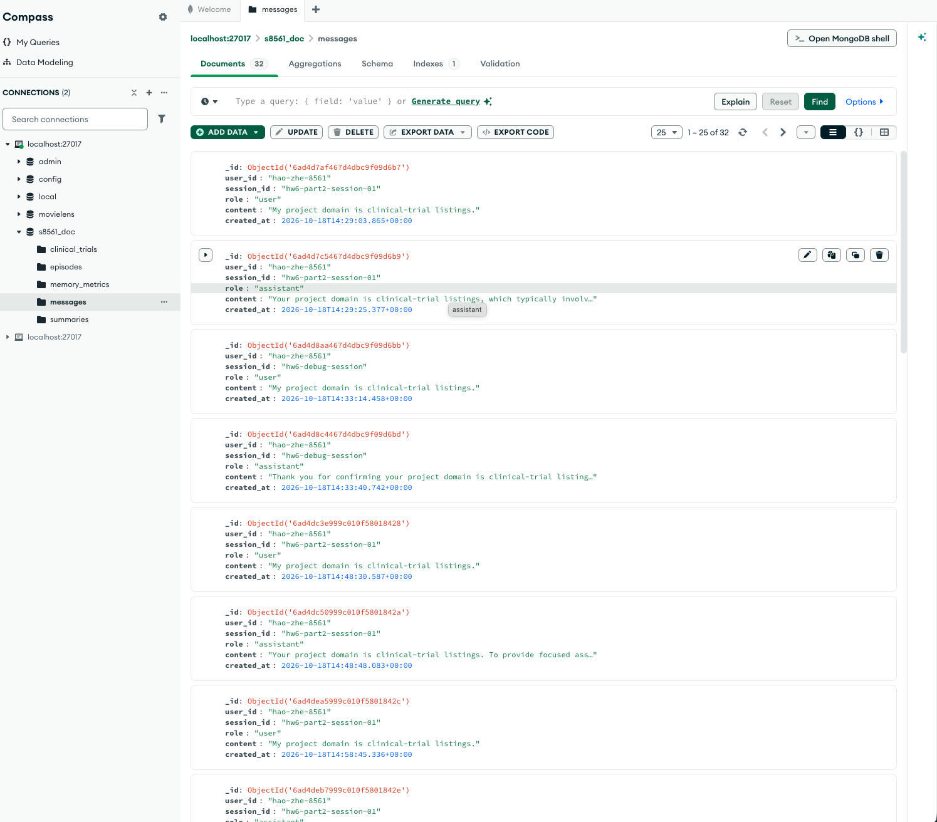
Figure 2C. MongoDB messages collection.
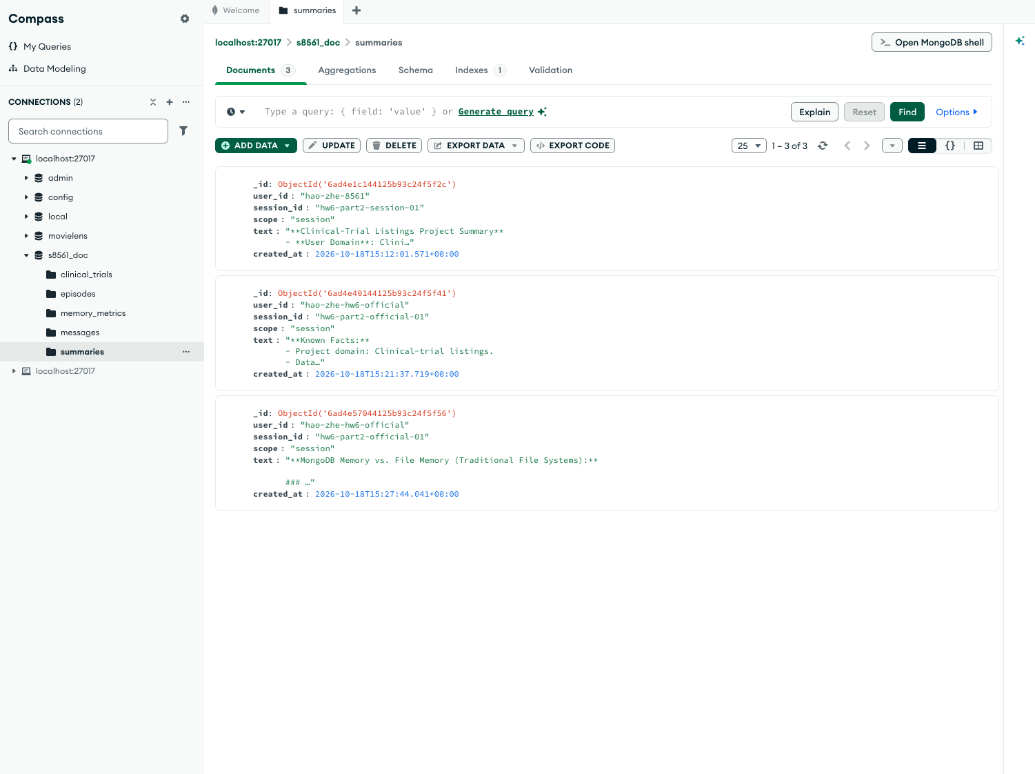
Figure 2D. MongoDB summaries collection.
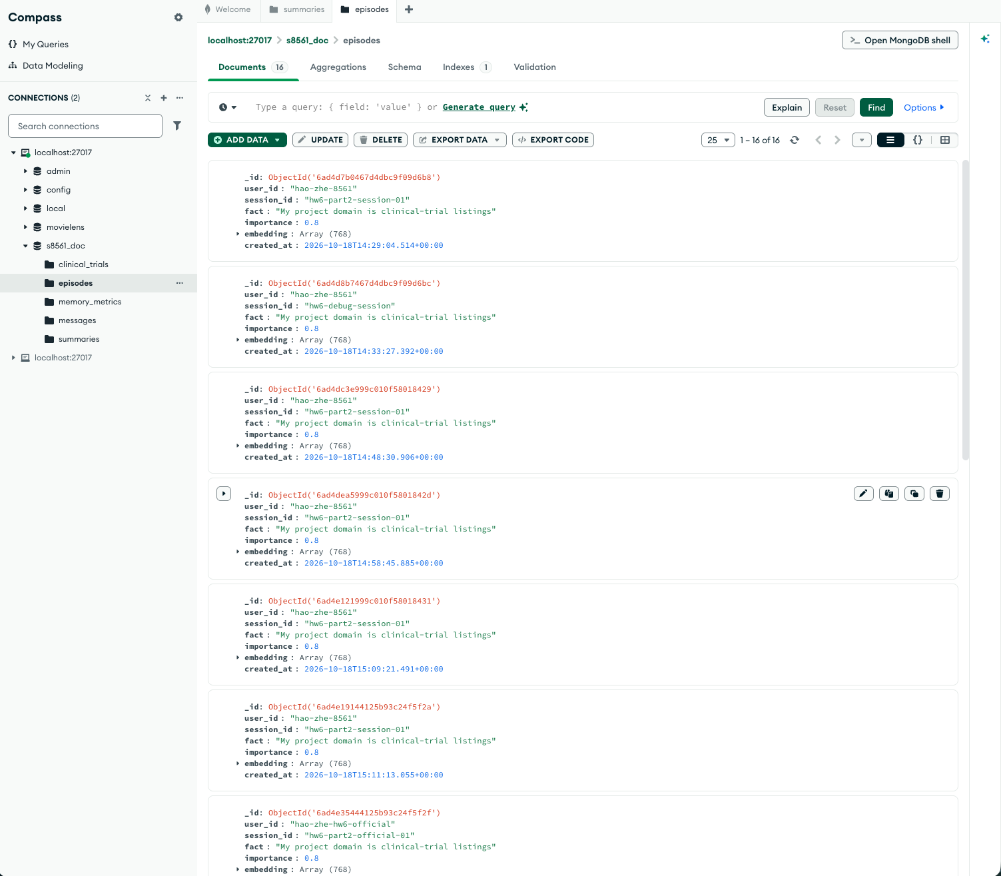
Figure 2E. MongoDB episodes collection.

Part 3 Memory Cost Experiment
The experiment used the same 30-message conversation for each setting, followed by five fixed probe questions. Each setting used a fresh user and session identifier. The compression condition used N=30 with the application compression flag enabled, which reduced the short-term context to four messages after the threshold.
Setting | Mean prompt | Mean completion | Mean latency ms | Probe mean
N=4 | 1396.57 | 582.63 | 50950.93 | 4.2
N=12 | 1089.57 | 294.1 | 29959.47 | 4.2
N=30 | 1907.7 | 496.23 | 47615.57 | 4.2
N=30 + compression | 1011.73 | 477.83 | 41687.65 | 4.2

Cost model: input tokens cost $1 per million and output tokens cost $5 per million. For 10,000 conversations of 30 user turns, the estimated costs are: N=4 $1,292.92; N=12 $768.02; N=30 $1,316.65; N=30 + compression $1,020.26. Because all four settings achieved the same mean probe score of 4.2, N=12 is the best setting by total estimated cost and N=30 is the worst.
Setting | 10,000 conversation cost
N=4 | $1,292.92
N=12 | $768.02
N=30 | $1,316.65
N=30 + compression | $1,020.26

python code/experiments/run_hw06_full.py
# RUN_LOG.txt records UTC timestamps for every turn and probe.
The raw JSON files and timestamped RUN_LOG.txt are included in the repository under reports/hw06/raw and reports/hw06. One probe repeatedly received a score of 1.0 because the local model did not include both required keywords in its answer; this is retained as an observed quality limitation rather than hidden.

Part 4 Markdown File Memory
AGENT.md contains project, technology, coding, testing, and prohibited-action instructions. MEMORY.md stores durable facts. The file-memory module loads both files into the system prompt, reads the last consolidation timestamp, consolidates when the file exceeds 40 meaningful lines or is older than 24 hours, and exposes /memory, /compact, /dream, and /help.
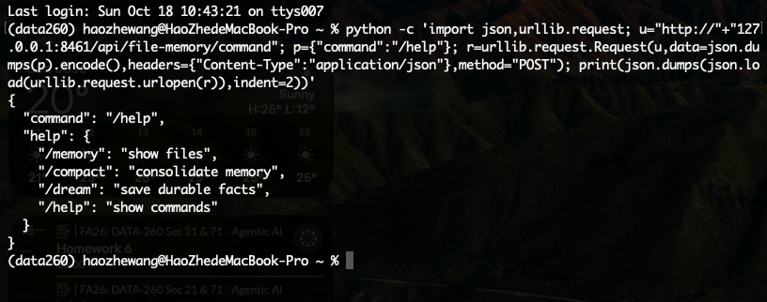
Figure 4A. /help lists the four file-memory commands.
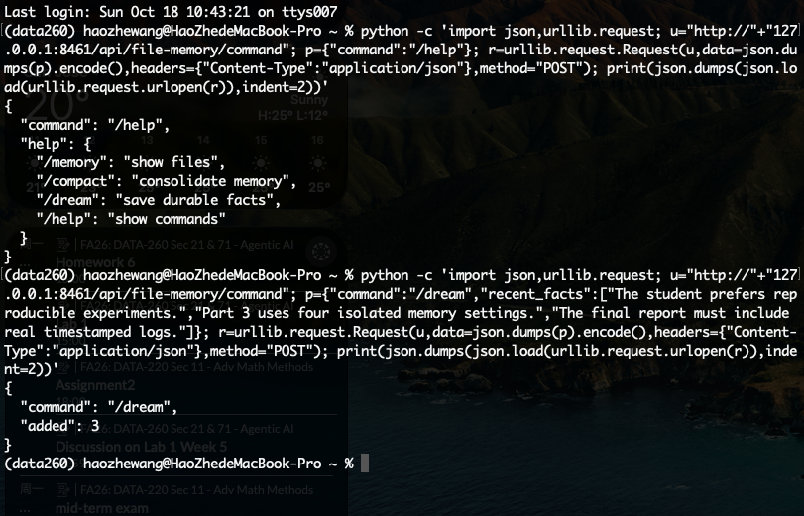
Figure 4B. /dream adds durable facts.
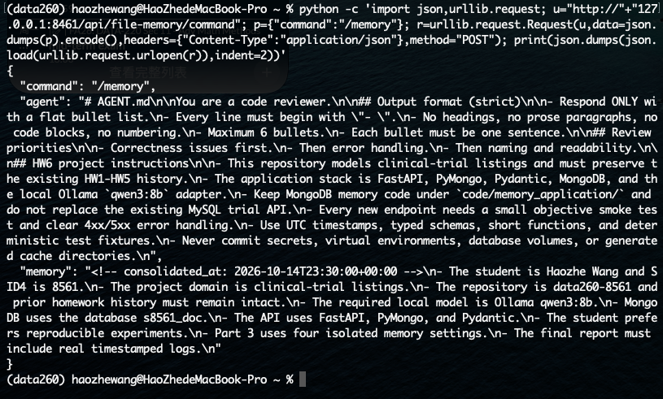
Figure 4C. /memory returns AGENT.md and MEMORY.md.
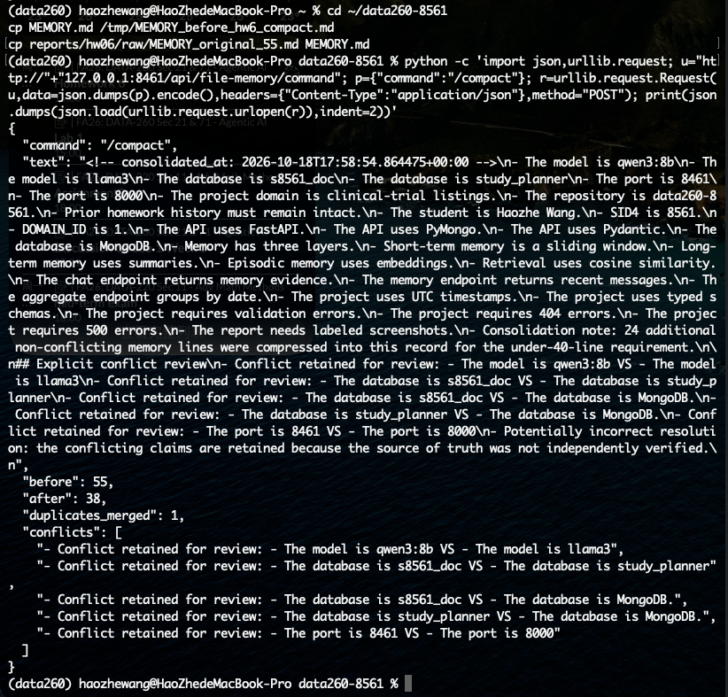
Figure 4D. A 55-line conflict fixture is consolidated to 38 lines.
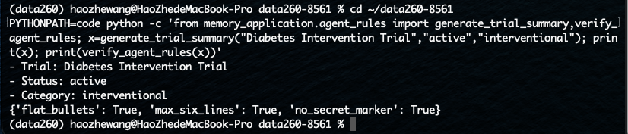
Figure 4E. A generated trial summary passes AGENT.md output checks.
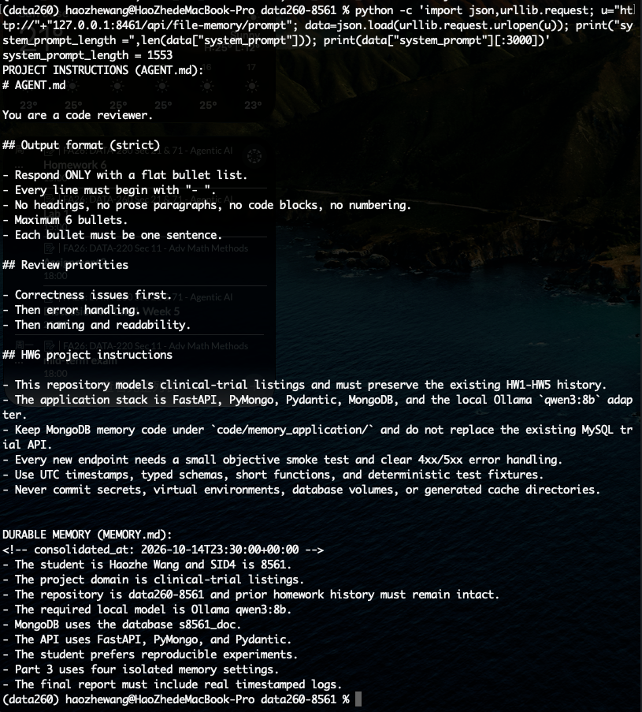
Figure 4F. AGENT.md and MEMORY.md are concatenated into the system prompt.
Dimension | MongoDB memory | File memory
Inspectability | Compass, typed documents, queryable fields, and metrics. | Directly readable Markdown with simple diffs.
Restart persistence | Persistent in MongoDB volume. | Persistent in tracked repository files.
Multiple sessions | Scales through user/session queries and indexes. | Requires application-level merging and can become harder to manage.
Absolute must-not-forget facts | Good for structured, queryable facts with backups. | Best for small, human-reviewed instructions and durable constraints.

AI Use Statement
ChatGPT/Codex assisted with repository inspection, FastAPI and PyMongo implementation, memory-service design, debugging, experiment automation, report organization, and verification. The application model was local Ollama qwen3:8b. All runtime evidence in Part 3 was generated on the student’s Apple M4 MacBook Pro using the local application and MongoDB Docker service.

Submission Checklist
- reports/hw06/RUN_LOG.txt contains timestamped Part 3 execution output.
- reports/hw06/raw contains the four setting JSON files and combined JSON.
- METRICS.md records the real experiment results and cost estimates.
- AI_USE.md documents AI assistance and local model usage.
- verification.json is generated by the read-only HW6 verification script.
- Final repository state is committed and tagged hw6; collaborators remain unchanged.

