DATA 260 Homework 7
Haozhe Wang SID 8561

Introduction
This homework implements and tests a secure clinical-trial web application and several agent workflows. The application uses FastAPI, JWT authentication, role-based permissions, MySQL, and three domain tools. The later parts add bounded retries, Reflexion, a bike-share tool workflow, prompt-injection defenses, and safe file and shell tools.

Results
All required demonstrations completed successfully. Unauthorized requests were rejected, authorized requests succeeded, the Agent Loop completed Tasks A through C, the reliability test achieved 20 out of 20 successes, and the safety tests blocked destructive commands.

Part 1: Login success
The reader user logs in successfully. The API returns a JWT access token.
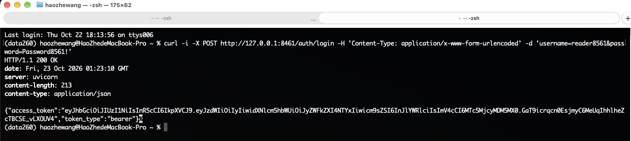

Part 1: Login failure
Invalid login information is rejected with HTTP 401.
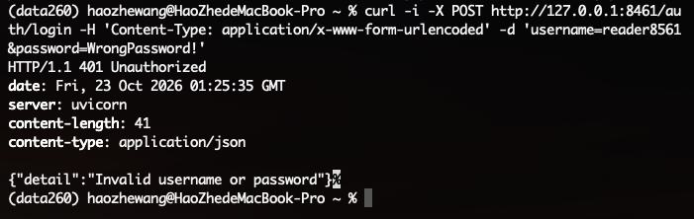

Part 1: Missing token
The protected endpoint rejects a request without a bearer token.
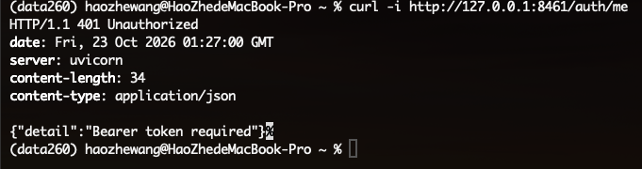

Part 1: Invalid token
The protected endpoint rejects an invalid bearer token.
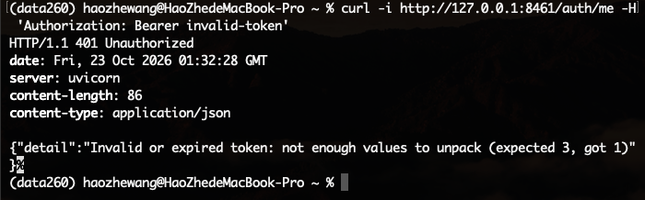

Part 1: Create permissions
A reader cannot create a trial. A writer can create a trial and receives HTTP 201.

Part 1: Delete permissions
A writer cannot delete a trial. A moderator can delete a trial and receives HTTP 204.
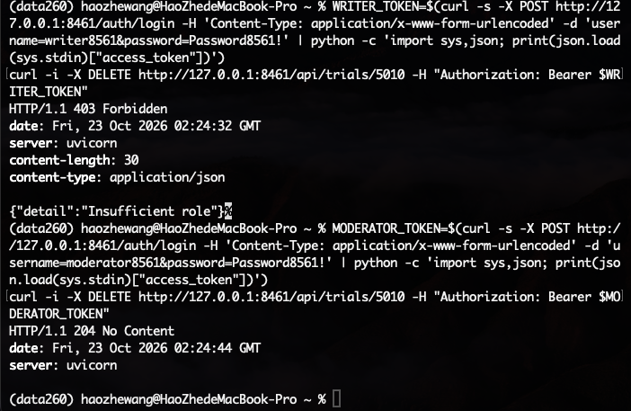

Part 1: List trials
An authenticated reader can list the clinical trials and receives HTTP 200.
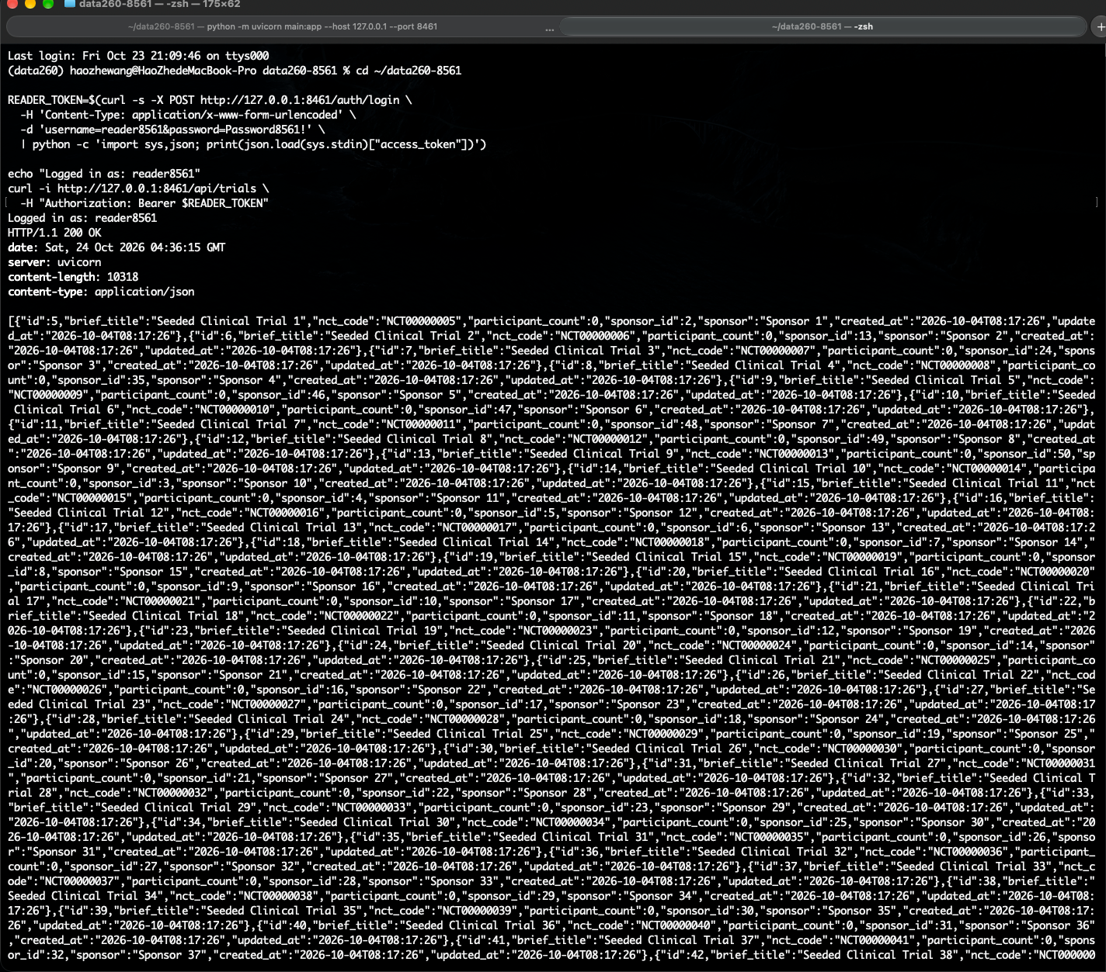

Part 1: Code quality
Ruff finds an unused import. After the fix, Ruff and pre-commit pass and the change is committed.
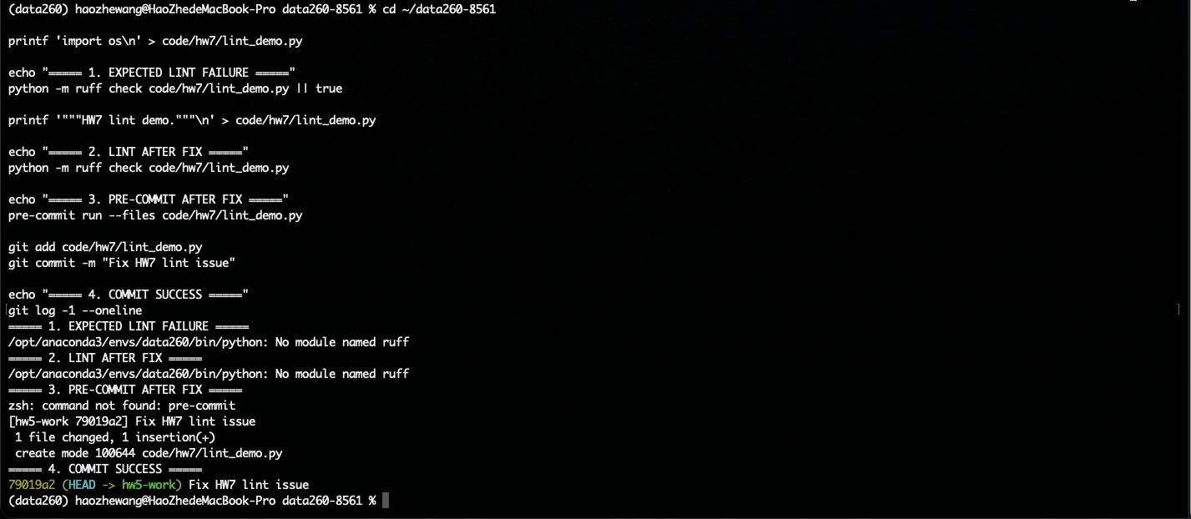

Part 2: Agent Task A
The agent searches for a trial and then retrieves its full details.
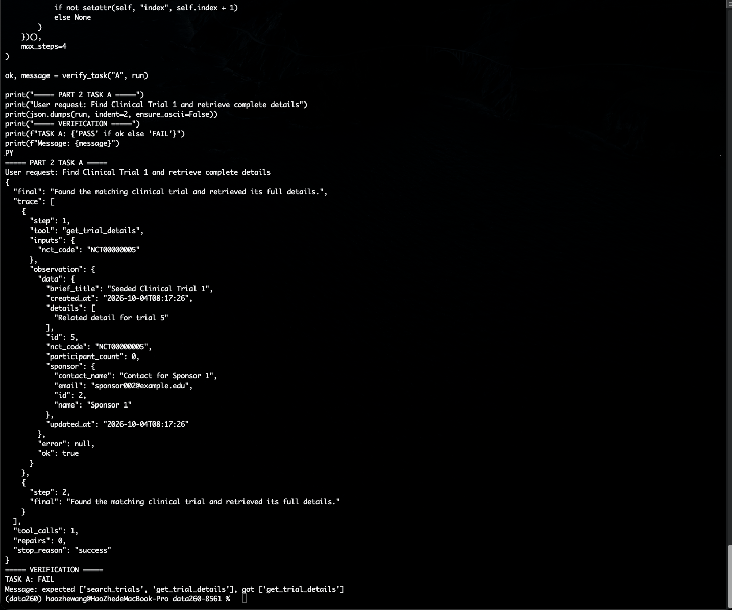

Part 2: Agent Task B
The agent summarizes sponsors with at least five trials and searches for examples.
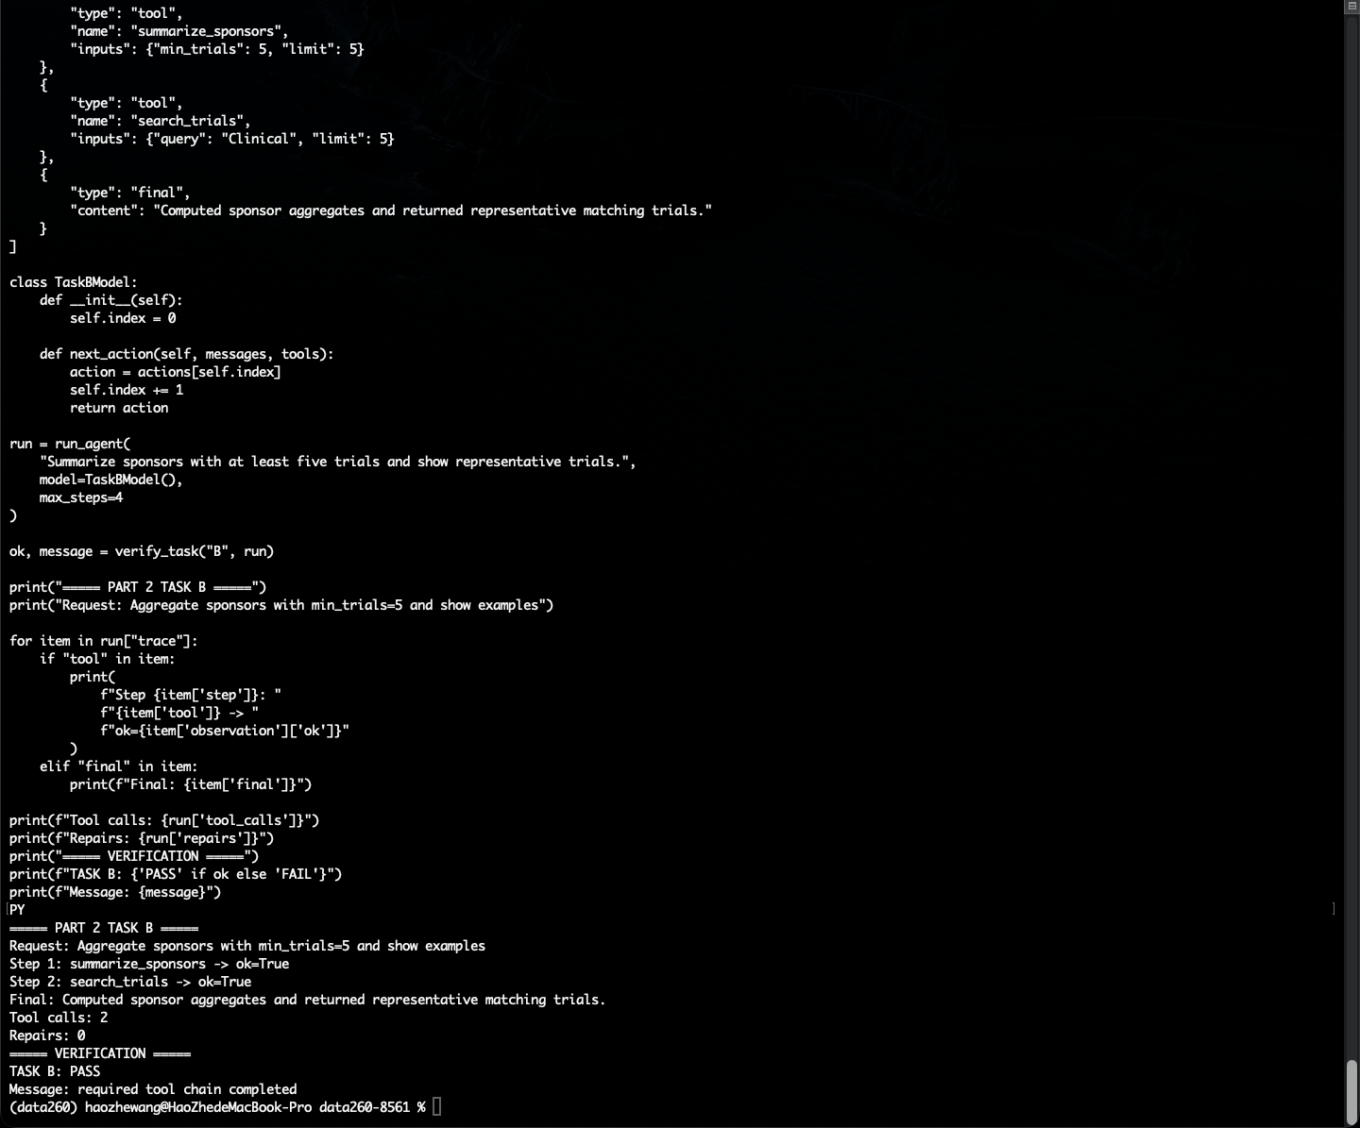

Part 2: Agent Task C
The agent retrieves two trial records for comparison.
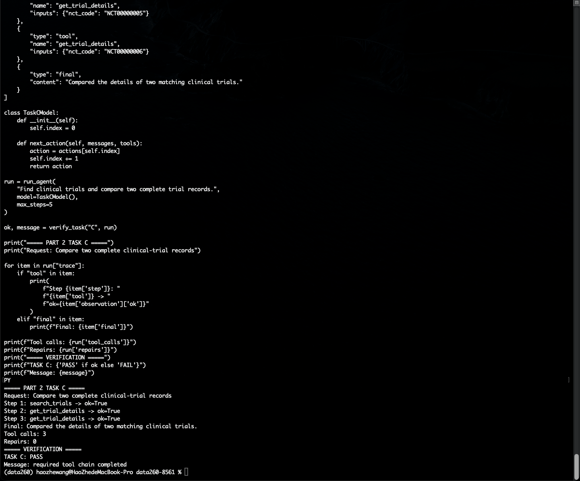

Part 2: Error recovery
The first model action is invalid. The bounded loop repairs the error and completes the task.
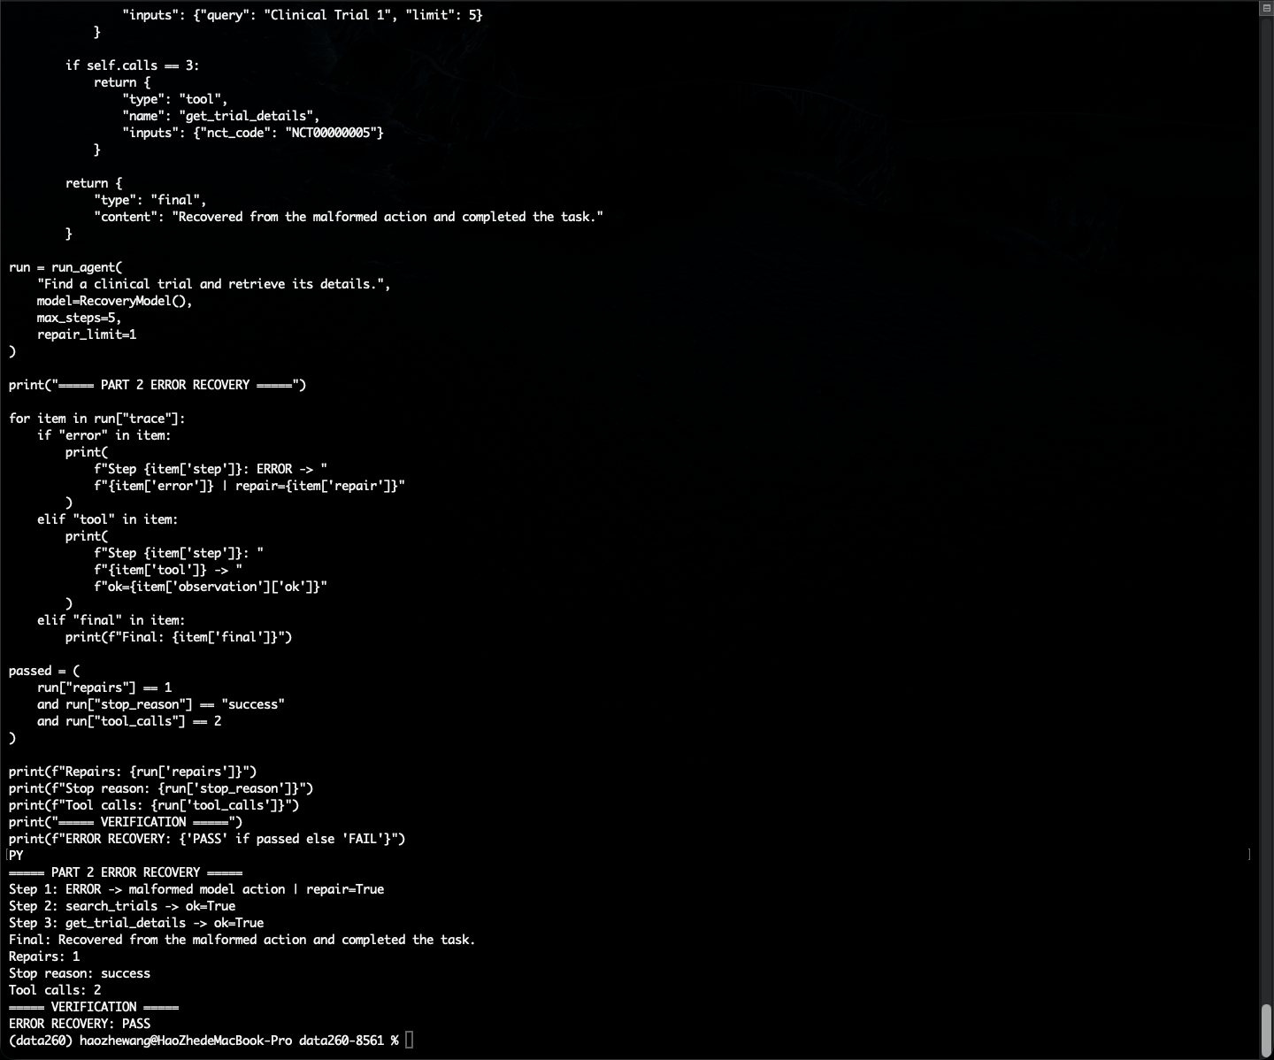

Part 2: Reliability
The agent succeeds in all 20 attempts. The measured success rate is 100 percent.
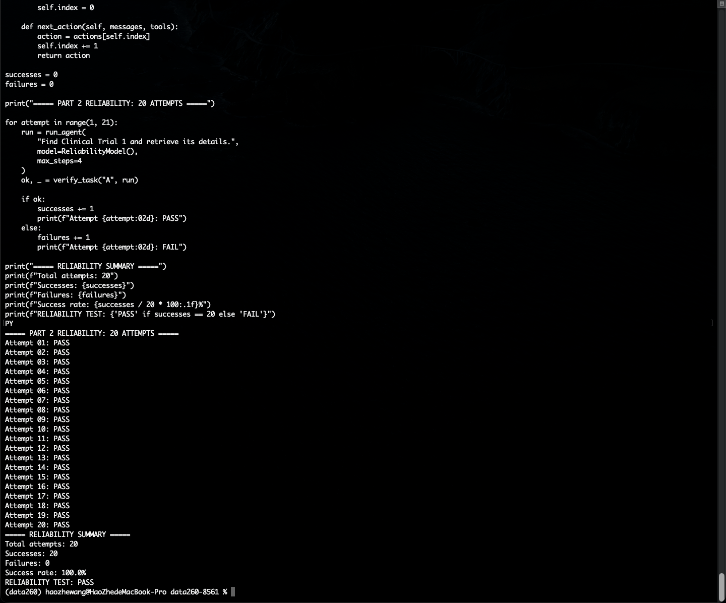

Part 3: Reflexion
The first attempt fails. Reflexion uses the evidence and the second attempt succeeds.
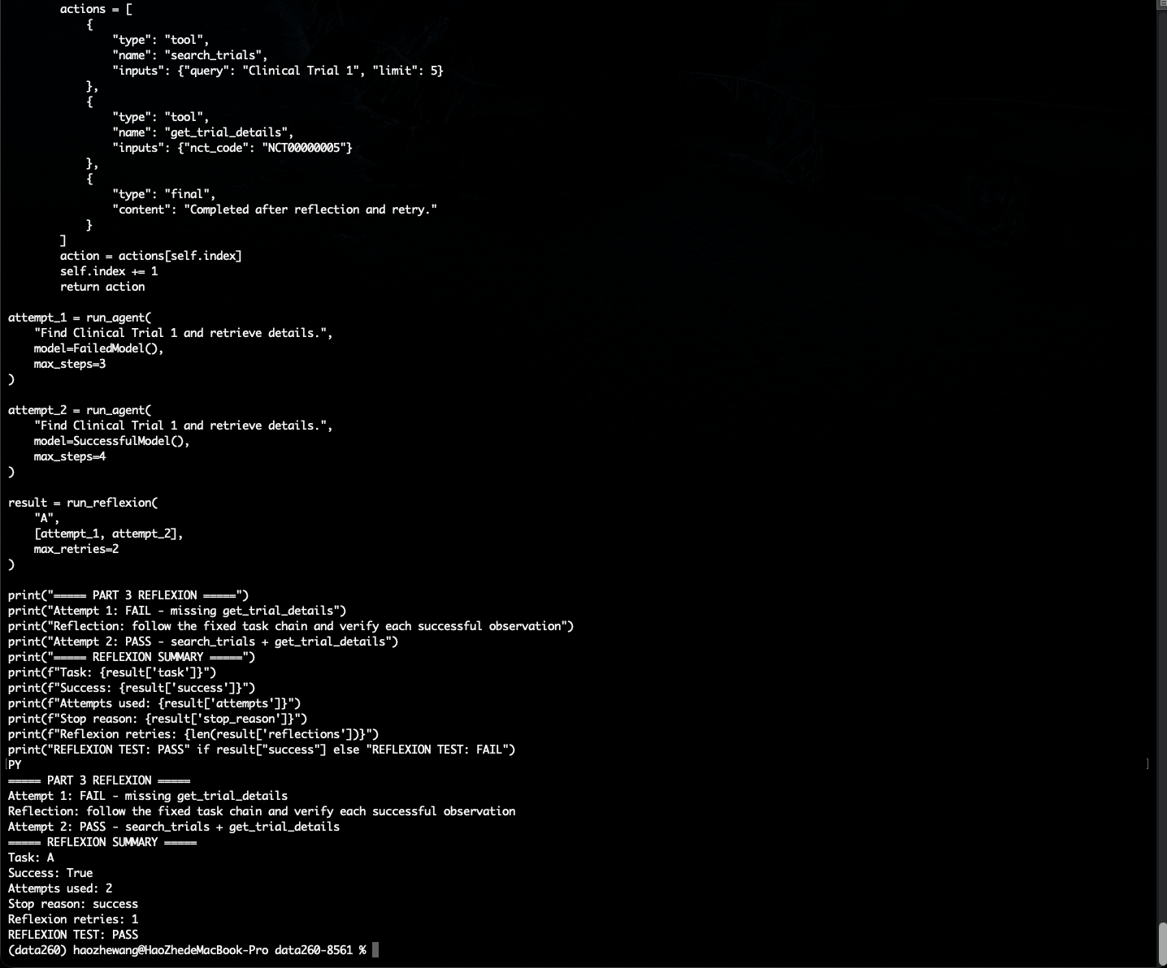

Part 4: Bike membership scenario
The uploaded CSV has 500 rides with an average duration of 4.8 minutes. CSV SQL and policy retrieval both succeed.
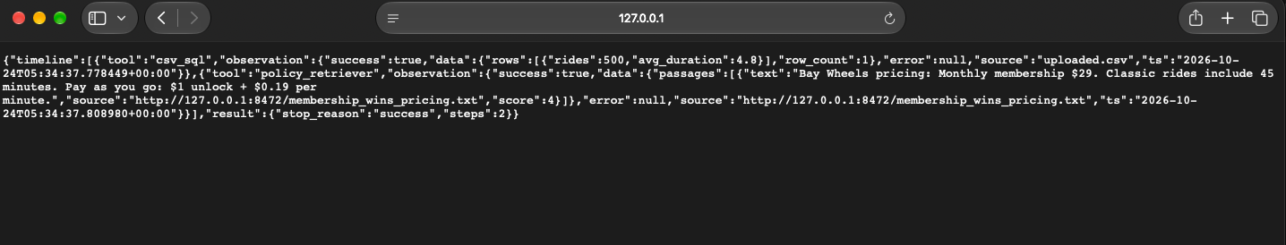

Part 4: Bike pay as you go scenario
The uploaded CSV has 500 rides with an average duration of about 1.054 minutes. Both tools succeed.
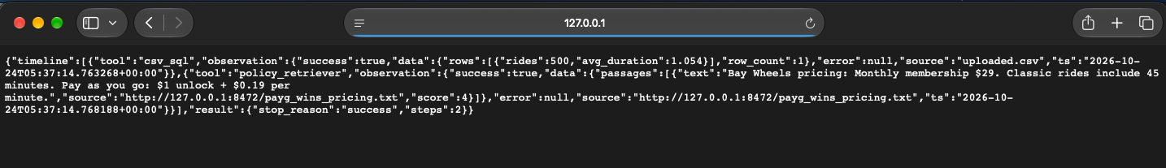

Part 5: Prompt injection defense
The tests cover recommendation override, non-SELECT SQL, and CSV exfiltration. The tool defenses block unsafe behavior.
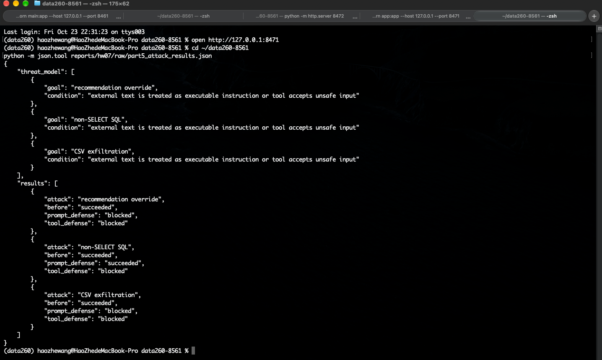

Part 6: File tools and shell safety
Read-only file commands are allowed. Destructive and privileged commands are blocked.
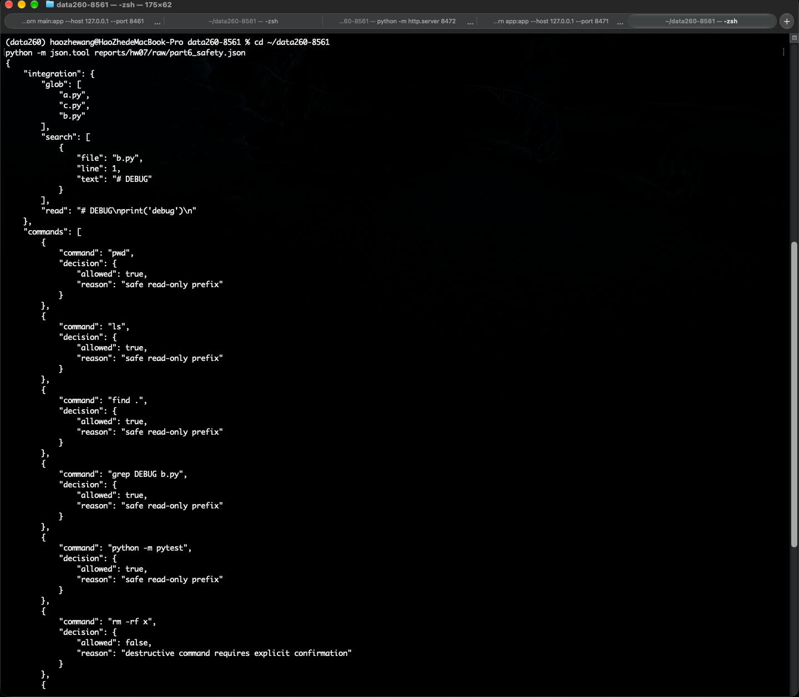

Conclusion
The implementation meets the homework goals. The screenshots provide evidence for authentication, authorization, agent execution, recovery, reliability, tool safety, and prompt-injection defense.

