

**THE STATE UNIVERSITY OF ZANZIBAR**

**SCHOOL OF BUSINESS (SOB) CHWAKA**

**REACT PROJECT**

**PROJECT TITLE:** BOOK STORE

**COURSE:** DEGREEOFICTWITHACCOUNT

**STUDENT NAME**: SABIHA KHAMIS MSHAMBA

**REGISTRATION** **NO**. BITA/4/20**/**007**/**TZ

**ACADEMIC YEAR:** 2021**/**2022

**FACILITATO:** MR**.** MASSOUD

# **CHAPTER ONE**

# **INTRODUCTION**

This chapter consist part of background information about project, problem statement and solution of problem, purpose of project, objective of project, Significant of system, Limitation of the project.

## **BACKGROUND INFORMATION ABOUT THE PROJECT**

The project's main goal is to build an online book store where users can search for and buy books based on title, author, and subject. The chosen books are shown in a tabular style and the customer may buy them. Using this Website, the user may buy a book online rather than going to a bookshop and spending time. An online book store is a web application that allows customers to purchase books. Through a web browser the customers can search for a book by its title. The client may sign in using his login credentials, or new clients can simply open an account. Customers must submit their full name, contact details, and shipping address. The user may also provide a review of a book by rating it.

## **Problem Statement**

The software to be designed is for a bookstore that wishes to go online. It is to be developed to improve the efficiency for the customer.

The important features to be developed include:

1. The Login/Registration module requires the customer to login into the system or he can create an account if he does not yet have one.
2. Order module requires a customer to enter the book details that he/she wants to buy.
3. Book detail(s) module allows the system to keep book information in detail by name, genre etc.
4. Payment module allows the customer to make online payments like Paytm and credit/debit cards or cash on delivery.
5. Delivery and tracking module gives information about tracking and by whom it is delivered.
6. User feedback module.

## **Purpose and Motivation**

### Main Purpose

The main objective of the project is to create an online book store that allows users to search and purchase a book based on the title, author and subject. The selected books are displayed in a tabular format and the user can order their books online and make payment. The Administrator will have additional functionalities when compared to the common user.

### General Purpose

* To save cost (there are no need of having a store)
* To save Time
* To make Easy operation
* To reduce destruction of book.

The motivation to create this project has many sources:

* Interest to develop a good user-friendly website with many online transactions using a database.
* To increase my knowledge horizon in technologies like. HTML, CSS, JS and REACT.
* To gain good experience in .NET before joining a full-time job.
* To gain expertise using Data Grid, Data Set, Data Table, Data Adapter and Data Readers.

## **ADVANTAGES OF SYSTEM**

### **You Don’t Need a Physical Store:** When you opt an online business instead of a physical store, you can save yourself from the hard work of searching for an ideal store at an ideal location and evaluating the space for your collection. , Start uploading your product or service catalogue and you are done

### **Save Cost**

### **Save Time:** By opting an online bookstore website, you can save your time as well. You don’t have to be present around all the time. You can run your business from your home, your full-time job or even from a vacation resort.

### **Be Your Own Boss**: Another benefit that you will get by setting up an online bookstore is that you get to be your own boss. There will be no boss buzzing around your head to do a particular job, instead, you can do all you want at your own pace and earn at the same time.

### **You can display your own work as an Author**

# 

# **CHAPTER** **TWO**

## **METHODOLOGY**

It is important to fulfill the planning for the implantation phase. This can only be done if proper methodology is selected. Methodology is important to make sure all project life cycle activities are being carried out without any shortcuts. Methodology helps the system developers to take one step at a time towards accomplishing the full system.

## 

## **APPROACH** **USED** **IN** **SYSTEM** **DEVELOPMENT**

In this project the waterfall model will be used. By using this waterfall allows users to review all phases until the users are satisfied with the library registration system web portal. Waterfall model approach is used as a model of angular Management System.

We choose the WATERFALL MODEL due to the following reasons:

* This model is chosen because our requirements are very well known, clear and fixed.
* Product definition is stable.
* There are no ambiguous requirements in our project.
* The project is short.
* This model is simple and easy to understand and use.
* It is easy to manage due to the rigidity of the model – each phase has specific deliverables and a review process.
* In this model, phases are processed and completed one at a time. Phases do not overlap.
* Waterfall model works well for smaller projects where requirements are very well understood.

## **ADVANTAGES OF WATERFALL MODEL**

The approach is suitable for this project because it provides the following advantages:-

* Easy to explain to the users.
* Stages and activities are well defined.
* Helps to plan and schedule the project.
* Verification at each stage ensures early detection of errors/misunderstanding.
* Each phase has specific deliverables.

Requirement Analysis

System Design

Implementation

Testing

Deployment

Maintenance

Waterfall model

First of all the feasibility study is done. Once that part is over the requirement analysis and project planning begins. After the requirements study is done, the design process begins, followed by the coding process. Once the programming is completed the testing is done.

In this model, the sequence of activities performed in a software development project are: -

1. Requirement Analysis
2. Project Planning
3. System design
4. Detail design
5. Coding
6. Unit testing
7. System integration & testing

Here the linear ordering of these activities is critical. End of the phase and the output of one phase is the input of another phase. The output of each phase is to be consistent with the overall requirement of the system. Some of the qualities of the spiral model are also incorporated after the people concerned with the project review completion of each of the phases of the work done. WATERFALL MODEL was chosen because all requirements were known beforehand and the objective of our software development is the computerization/automation of an already existing manual working system.

## **SYSTEM ARCHITECTURE**

The architecture we will use will be only one layer architecture. Include:

An Application Layer that uses an application server and processes the business logic for the application. This might be written in angular.

## **SYSTEM DEVELOPMENT TOOLS**

In order for our system to function effectively we need to consider the following:

## HARDWARE REQUIREMENTS:

* Laptop PC (RAM 4, HDD 500, 64BIT )
* Keyboard
* Mouse

## **SOFTWARE** **REQUIREMENTS**:

* Operating system: Windows XP, Windows 7, Windows 8, Windows 10 and other OS.
* Technology: React, HTML, CSS, and JS
* Tools: Sublime, visual studio code and Microsoft FrontPage.
* Antivirus software.
* Browser: Google Chrome, Firefox and other browser.
* Database: MySQL.
* Back-end: Spring boot.

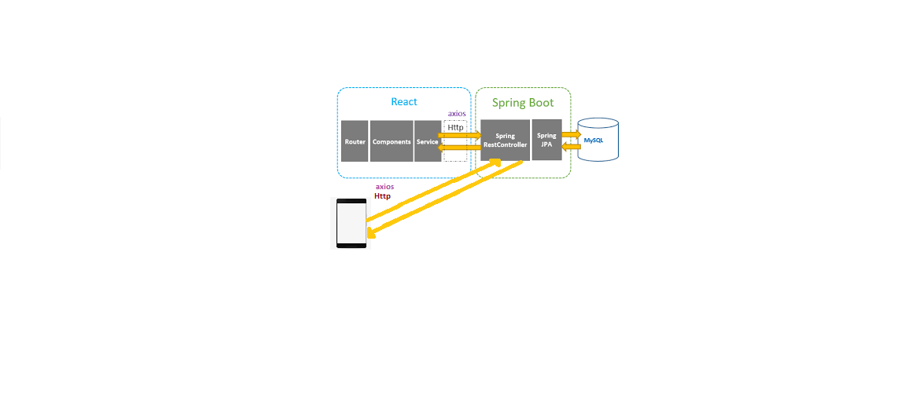

# **CHAPTER** **THREE**

## **REQUIREMENTS** **ANALYSIS** **AND** **MODELING**

System analysis is the process of gathering and interpreting facts, diagnosing problems and using the information to recommend improvements on the system. System analysis is a problem solving activity that requires intensive communication between the system users and system developers.

System analysis or study is an important phase of any system development process. The system is viewed as a whole, the inputs are identified and the system is subjected to close study to identify the problem areas.

## **SYSTEM** **REQUIREMENT** **DETERMINATION**

The system consists of one part which are consist Customer, Supplier and normal reader as the user of the system.

* Supplier:

The staff is the super user of this system can access the system staff may be many of the library. The staff has all the information about all the student and normal reader.

* Customer:

The new Customer and existing Customer will have will purchase the books in the system, through a web browser the customers can search for a book by its title. .

## **INFORMATION** **GATHERING** **TECHNIQUES**

Data collection is an important aspect of any type of research study. In this system, the data was collected from the staff on book store since that is the place where the system is going to be used.

The following are the methods which were used to collect data for the system.

Reading available Literature: In order to gain an understanding of the general idea and the context of this project. The literature review was based on the existing of Book store systems around the world, based on the different concept and views of others on how to design and implement the integrated system.

Interview: We used interview method in order to get and gathering accurate information related to system that needed in accomplishment of system design.

## **FUNCTIONAL** **REQUIREMENTS**

|  |  |
| --- | --- |
| REQ NO. | REQUIREMENT DESCRIPTION |
| ReqNo. 01 | * System must ensure that, only a registered customer can purchase items. |
| ReqNo. 02 | * The system must be able to search databases or records to provide quick result based on user’s query. * System allow users to register |
| ReqNo. 03 | * The system should ask user to fill the specified form |
| ReqNo. 04 | * The system must identify the Supplier and Customer. |
| ReqNo. 05 | * System shouldn’t allow users to access book before purchasing |
| ReqNo. 06 | * The system should generate primary keys in most cases unless specified by user, and the unique keys should be visible. |
| ReqNo. 07 | * System must allow users to search type of book that they wants |
| ReqNo. 08 | * The system must allow user to perform specific planned payment. |
| ReqNo. 09 | * The software system should be integrated with database in order to store data. |
| ReqNo. 10 | * The system must carry out only actions specified by the user (browse, modify, delete, add). |
| ReqNo. 11 | * The software system should pass accessibility requirement. |
| ReqNo. 12 | * The system must provide the information to the user if the books are not founded |
| ReqNo. 13 | * The system should enable the user to read the book without any problem |
| ReqNo. 14 | * The system must encrypt the id of the customer for security. |

## **NON** **FUNCTIONAL** **REQUIREMENTS**

## **EFFICIENCY** **REQUIREMENT**

When Book store system can enable the customer to purchase, view detail and search books.

## **RELIABILITY** **REQUIREMENT**

The system should provide a reliable environment to both stakeholder.

## **USABILITY** **REQUIREMENT**

The Book store system is easy to use and designed for user friendly environment.

* **REQUIREMENT** **STRUCTURING**

Requirements structuring is the process to use some kind of systematical and standard, well-structured methods to model the real world. Traditionally, we use data flow diagram for process modeling, decision table or decision tree for logic modeling, and entity-relationship diagram for data modeling.

## **PROCESS MODELING**

Process modeling is a technique for organizing and documenting the structure and flow of data of system and procedures to be implemented by a system's processes

## **Data flow diagram**

The data flow diagram is a graphical representation of the flow of data in an information system. It is capable of depicting incoming data flow, outgoing data flow and stored data. The DFD does not mention anything about how data flows through the system. There is a prominent difference between DFD and Flowchart. The flowchart depicts a flow of control in program modules. DFDs depict the flow of data in the system at various levels. DFD does not contain any control or branch elements.

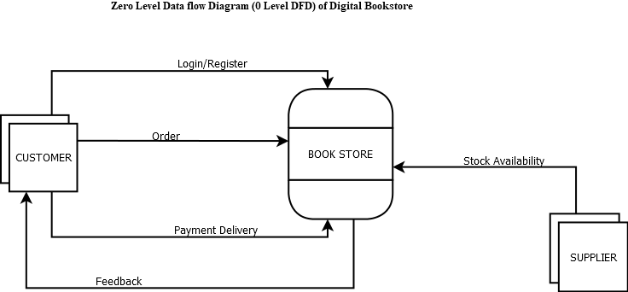

Data Flow Diagram (DFD) that illustrate how proposed system is implemented

# 

# **CHAPTER** **FOUR**

## **SYSTEM** **DESIGN**

System design is the solution for the creation of a new system. This phase focuses on the detailed implementation of the feasible system. It emphasis on translating design. Specifications to performance specification. System design has two phases of development

* Logical design
* Physical design

During logical design phase the analyst describes inputs (sources), outputs (destinations), databases (data sores) and procedures (data flows) all in a format that meets the user requirements. The analyst also specifies the needs of the user at a level that virtually determines the information flow in and out of the system and the data resources.

Here the logical design is done through data flow diagrams and database design.

The physical design is followed by physical design or coding. Physical design produces the working system by defining the design specifications, which specify exactly what the candidate system must do.

The programmers write the necessary programs that accept input from the user, perform

Necessary processing on accepted data and produce the required report on a hard copy or display it on the screen.

## **ARCHITECTURAL** **DESIGN**

The Architectural design have described the Structure of Book Store System shows a view of the entire system. This System is divided into two major sections, Supplier and Customer section, and normal reader section.

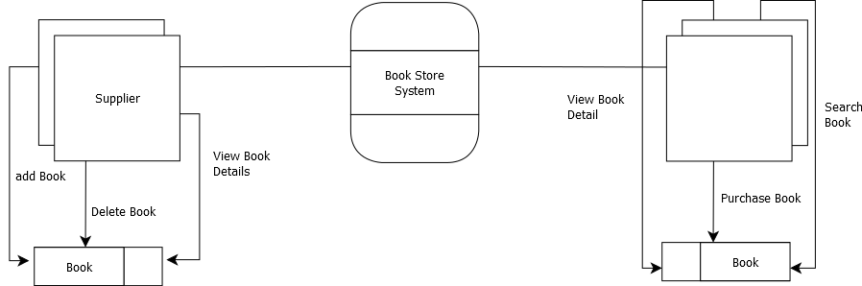

Customer

# 

## **THE USE CASE DIAGRAM**

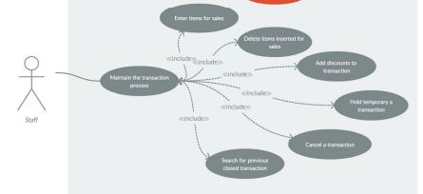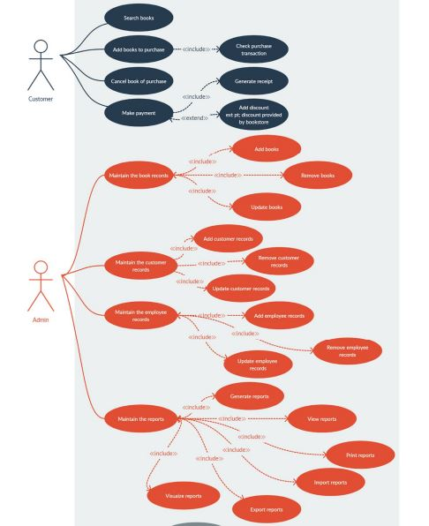

## **CLASS DIAGRAM**

The class diagram is a static diagram. It represents the static view of an application. The class diagram is not only used for visualizing, describing, and documenting different aspects of a system but also for constructing executable code of the software application. The class diagram describes the attributes and operations of a class and also the constraints imposed on the system. Since they're the only UML diagrams that can be translated directly to object-oriented languages, class diagrams are frequently utilised in the designing of object-oriented systems. The class diagram shows a collection of classes, interfaces, associations, collaborations, and constraints.

### Purpose of Class Diagram

The class diagram is used to represent the basic perspective of a system. Class diagrams are the only designs that can be highly associated with object-oriented languages and are thus generally applied throughout development. UML diagrams like activity diagrams, sequence diagrams can only give the sequence flow of the application, however, the class diagram is a bit different. That's the most widely used UML diagram in the computing world.

The class diagram's aim may be described as:

* Design and development of a software's static view.
* Describe the responsibilities of a system.
* The base for component and deployment diagrams.
* Forward and reverse engineering

### CLASS DIAGRAM OF BOOK STORE

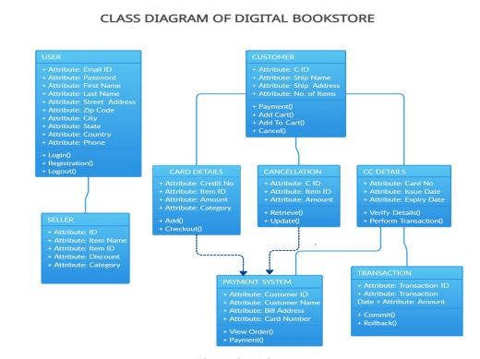

## **Entity Relationship Diagram for Book Store**

Entity Relationship Diagram of Book Store. The diagram is widely used in database design and systems analysis to represent systems or problem domains. This diagram contains entities like book, user, category, Author etc.

Consider the following E_R diagram, which models an online BookStore.

List the entity sets and their primary keys.

