CS 330 Homework 3 – CFG

Key

This assignment is due at the beginning of class on Wednesday (10/12). Submit a hardcopy. The assignment is worth 100 points and will be graded based on effort as well as correctness.

- Consider the following CFG for Expression:

E→ E * E |
E + E |
E - E |
T

T →a..z

Where E, T, D are non-terminals with E being the start symbol, and a through z are terminals.
This is grammar is ambiguous in two aspects:
- Undefined operator precedence (* vs + vs -)
- Undefined associativity (left vs right)

- Prove that this language is ambiguous by drawing two different parse trees for the E string a+b*c. Name them tree 1 and tree 2 respectively. (20)

Tree 1 - interpreting it as (a+b)*c

E

E * E

E + E T

T T c

a b

Tree 2 - interpreting it as a+(b*c)
E

E + E

T E * E

a T T

b c

- Each of the two parse trees gives its own interpretation of the string a*b+c a+b*c Calculate the value for the string a+b*c based on each interpretation, using a=5, b=2, c=1. C=4 (5 points each )

a+b*c evaluate to ____28________, based on interpretation given by tree 1

a+b*c evaluate to _____13_______, based on interpretation given by tree 2

- Rewrite the Expression grammar so that it is unambiguous with precedence * over -, and left associative. (20 points)
E→ E + F
| E - F
| F

F →F * T | T

T →a..z

F is a new non-terminal

- Give CFGs for one of the following two languages. Assume the alphabet Σ = {0,1} (20 points each):

- Palindrome {w | w = w^{R} }

S → 0S0
| 1S1
| 0 // odd length with 0 in the middle
| 1 // odd length with 1 in the middle
| ε // even length

- Any word that is odd length and its middle symbol is 0

S → DSD // expand string by 2
| 0

D → 1 | 0
- Draw the PDA that recognize L = {a^{n}b^{n}} (10 points)
From CT2.ppt – just draw it yourself and change 0 to a, 1 to b, …
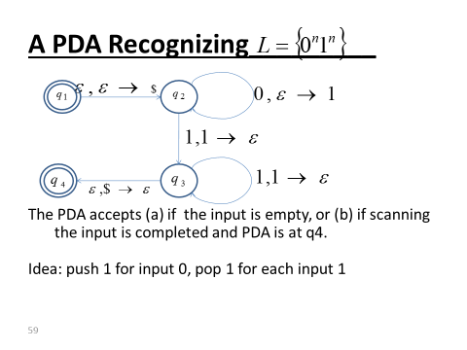
What is the CFG for this?
S → aSb | ε
Can we use it to draw PDA?

