CS330 - Programming Languages

Focus of the course:

- Provide the tools for critical evaluation of programming languages constructs and implementations.

Two general approaches:
  - Horizontal:
    - Focuses on several languages.
    - Discuss each in depth.

  - Vertical:
- Present general language concepts and constructs in some particular sequence.
- Individual languages are used ONLY for illustration.

Our approach is hybrid:
- Vertical and
- Somewhat detailed discussions of languages from very different (not necessarily most popular) paradigms: Scheme, Prolog,

- Give flavor of different types of languages
- Somewhat extensive discussion

Scheme: example of Functional languages.

Prolog: example of Logic languages
Others: Student presentations

3. Prepare for the study of advanced topics such as compiler design.

Name some languages you know:
Java, C, C++, Bash, python, assembly, Ruby, Haskell, go, cobol, basic

Chapter 1 - Introduction

Why are there so many programming languages?

- Orientation toward special hardware, ex., FORTRN 1
  - Both If and Do statements (post-test loop) are implemented with 1 machine instruction on IBM 704.
  - Efficient object code
- Evolution: we've learned better ways of doing things over time
Ex., goto-control → structured programming → OOPS
OOPS is not perfect

- Orientation toward special purposes
  - Lisp/scheme for symbolic manipulation
  - Awk for string processing - example here
  - C for system programming
  - Prolog for logical reasoning: focus on relationship

- Personal Preference - there are diverse ideas about what is pleasant to use

What makes a language successful, or popular?
- Easy to learn (BASIC, Pascal, Scheme, Java)
- Expressive power - what features and abstraction facilities are provided, although
  - All languages are Turing Complete.
    - Turing machine is simple, but can simulate any algorithm (+, *, …).
  - Features not available in a language can often be simulated, but at a cost
  - The choice of programming language construct limits the control, data structure and abstractions used to some extent, example later.
- Easy to implement (limited hardware resources required): Basic,
- Excellent compiler: Fortran I, II, III
- Backing of a powerful sponsor: Ada, COBOL
- Wide dissemination at minimal cost: PASCAL, java
- Open source, ex., C (unix, linux, etc)
1.3 Why study programming languages

- Make it easier to learn new languages – learn how to learn:
  - Easier if you already know a similar language,
  - Easier if you are exposed to spectrum of languages
  - Easier if you know how to quickly learn a new language: read a definition (CFG, diagram, etc)

Improved background for choosing appropriate languages, or be advocate for a language - language features determine/limit form of algorithms.
  - C vs. Modula-2 for systems programming
  - Fortran vs. APL vs. Ada for numerical computations
  - Ada vs. Modula-2 for embedded systems
  - Common Lisp vs. scheme vs. ML vs Haskell for symbolic data manipulation

- understand relatively obscure features:
  - In C, help you understand unions, arrays & pointers, separate compilation, var args, catch and throw
  - In Common Lisp, help you understand first-class functions/closures, streams, catch and throw, symbol internals

- Simulate useful features in languages that don’t support them
  - Ex., what data structure would you use to represent the following expression: A*(B–C)

*

A -

B C

Implementations in C, C++, java,

struct node
{
string symbol;
node *left, *right;
};

double eval (node* r)
{
switch (r->symbol)
{
case ‘+: return eval(r->left)+eval(r->right);
break;
case ‘-: return eval(r->left)-eval(r->right);
break;
case ‘*’: return eval(r->left)*eval(r->right);
break;
case ‘/’: return eval(r->left)/eval(r->right);
break;
default:
return lookup(r->symbol);

}
}

If we have to use a language that supports array but not pointers, how should we represent the tree?

3 parallel arrays

Symbol (string)
* | A | - |  |  | B | C
0 1 2 3 4 5 6 7

Left (int)
1 | -1 | 5 |  |  | -1 | -1

Right (int)
2 | -1 | 6 |  |  | -1 | -1

Example of Turing Machine: ++

State | Symbol read | Write | Head Move | next state
-1 | Blank | Blank | Right | -1
-1 | 0 | 0 |  | 0
-1 | 1 | 1 |  | 0
0 | 0 | 0 | Right | 0
0 | 1 | 1 | Right | 0
0 | Blank | Blank | Left | 1
1 | 0 | 1 | Left | 2
1 | 1 | 0 | Left | 1
1 | Blank | 1 |  | 2
2 | Blank | Blank |  | Stop
2 | 0 | 0 | Left | 2
2 | 1 | 1 | Left | 2
1.2 Spectrum of Programming Languages

Languages can be categorized as
- Imperative (programmer specify how to do it)
- von Neumann (Fortran, Pascal, Basic, C)
- OOPS (Smalltalk, Eiffel, java, C++)
- scripting languages (Perl, Python, JavaScript, PHP)
- declarative (programmers specify what need to be done)
- functional (Scheme, ML, pure Lisp, FP)
- logic, constraint-based (Prolog, VisiCalc, RPG)
- dataflow

Example – Calculating Greatest Common Divisor (GCD) (figure 1.2)

Algorithm for gcd (a, b)
While (a!=b)
{
If (a > b)
a =a-b;
else
b= b-a;
}
Return a;

C++:

int gcd(int a, int b)
{
while (a!=b)
{
if (a > b)
a =a-b;
else
b= b-a;
}
return a;

}

Scheme:

(define gcd
(lambda (a b)
(cond ((= a b) a)
((> a b) (gcd (- a b) b))
(else (gcd (- b a) a))))
)

Prolog:

gcd(A, B, G) :- A = B, G =A.
gcd(A,B, G) :- A > B, C is A-B, gcd(C,B,G).
gcd(A, B, G) :- B > A, C is B-A, gcd (C,A,G).

Evolution of programming

  - Compilation vs. Interpretation

Pure Compilation
- The compiler translates the high-level source program into an equivalent target program (typically in machine language), and then goes away:
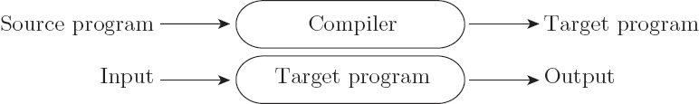

- Better performance

Pure Interpretation
- Interpreter stays around for the execution of the program
- Interpreter is the locus of control during execution
- Greater flexibility
- Better diagnostics (higher, language level error messages)

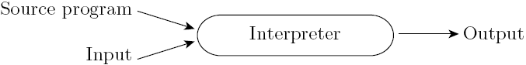

Common case is compilation or simple pre-processing, followed by interpretation
- Most language implementations include a mixture of both compilation and interpretation
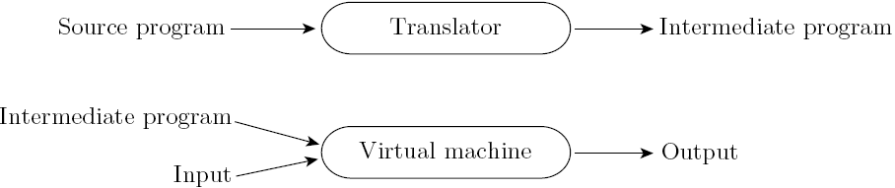

- Note that compilation does NOT have to produce machine language for some sort of hardware

Compilation vs. Interpretation vs. pre-processing:
- Compilation is translation from one language into another, with full analysis of the meaning of the input
- Compilation entails semantic understanding of what is being processed; pre-processing does not
- A pre-processor will often let errors through.
- Many compiled languages have interpreted pieces, e.g., formats in Fortran or C
- Most compiler use “virtual instructions” in addition to machine code
- set operations in Pascal
- string manipulation in Basic

- Some compilers produce nothing but virtual instructions, e.g., Pascal P-code, Java byte code, assembly

Implementation strategies:

- Preprocessor
  - Removes comments and white space
  - Groups characters into tokens (keywords, identifiers, numbers, symbols)
  - Expands abbreviations in the style of a macro assembler
  - Identifies higher-level syntactic structures (loops, subroutines)
  - Some allows conditional compilation – part of code maybe deleted, ex.,
/* C preprocessor allows us to turn on and off of prinf */

#ifdef DEBUG
printf("debug:x = %d, y = %f\n", x, y);
...
#endif

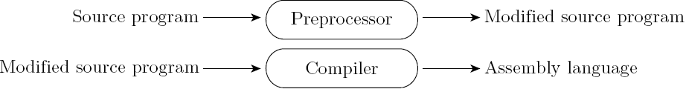

- Library of Routines and Linking
  - Compiler uses a linker program to merge the appropriate library of subroutines (e.g., math functions such as sin, cos, log, etc.) into the final program:

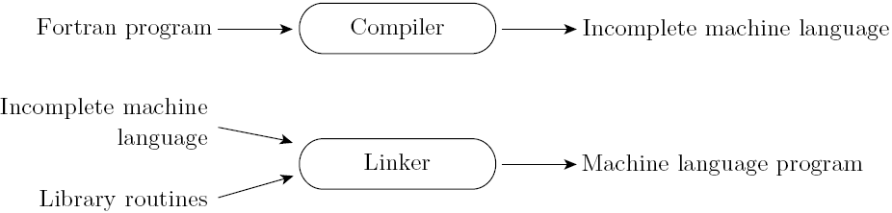

Post-compilation Assembly

- Source program is compiled into assembly
- Facilitates debugging (assembly language easier for people to read)
- Isolates the compiler from changes in the format of machine language files (only assembler must be changed, is shared by many compilers)

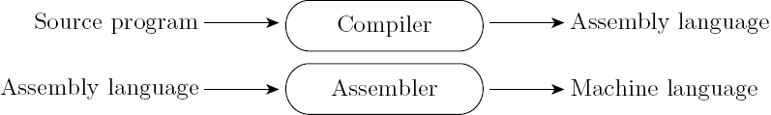

- Source-to-Source Translation (C++)
  - C++ implementations based on the early AT&T compiler generated an intermediate program in C, instead of an assembly language:

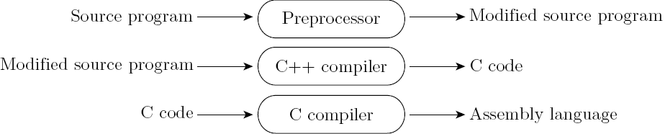

If I design a new language called Z, what languages could we use to write the compiler for my new language?

- Bootstrapping – compiler of a language written in that language
How do we compile/interpret/execute the compiler?
- Write another translator
- Use another compiler
- Grow your compiler in size &
Start by hand translating your first (very small) compiler

Example: PASCAL bootstrapping
Early Pascal compiler were built with the following tool set
- A Pascal to p-code compiler (written) in Pascal,
- A Pascal to p-code compiler in p-code
- A p-code interpreter written in Pascal

Step 1 - hand translate the p-code interpreter from Pascal to local ML

- A p-code interpreter written in ML

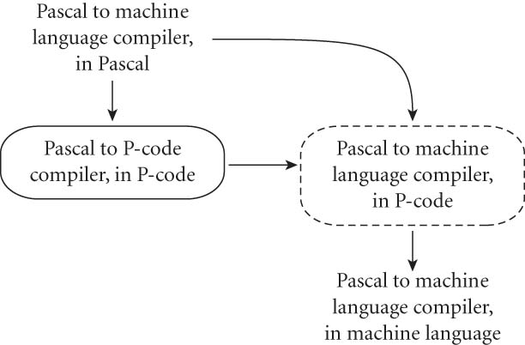

Timing of compilation
- Early (too early?) - Compilation of Interpreted Languages
  - The compiler generates code that makes assumptions about decisions that won’t be finalized until runtime. If these assumptions are valid, the code runs very fast. If not, a dynamic check will revert to the interpreter.

- Late (or delayed) - Just-in-Time (JIT) Compilation
  - In some cases a programming system may deliberately delay compilation until the last possible moment.
- Lisp and Prolog implementation systems often invoke the compiler on the fly, to translate newly created source into machine language, or to optimize the code for a particular input set.
- The Java language definition defines a machine-independent intermediate form known as byte code, which is how java programs are distributed. They are often compiled to machine code at run time, just before execution.

Compiler vs. interpreter (continued)
- Compilers exist for some interpreted languages, but they aren't pure:
  - Selective compilation of compliable pieces and extra-sophisticated pre-processing of remaining source.
  - Interpretation of parts of code, at least, is still necessary for reasons above.

- Unconventional compilers
  - text formatters,
  - silicon compilers
  - query language processors., ex SQL processor in DBMS

  - An Overview of Compilation Process

Phases of compilation:
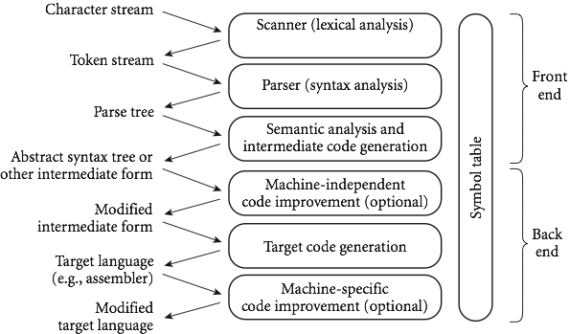

“Many Compiler phases can be created automatically from a formal description of the source and/or target language.” (p. 26)

The phases (or passes):

- Scanning:
- divides the program into "tokens", which are the smallest meaningful units; this saves time, since character-by-character processing is slow
- we can tune the scanner better if its job is simple; it also reduce complexity (lots of it) for later stages
- you can design a parser to take characters instead of tokens as input, but it isn't pretty
- Example:
/* GCD Program (in C++) */
int main() {
int i = getint(), j = getint(); /* some hypothetic I/O procedure */
while (i != j) {
if (i > j) i = i - j;
else j = j - i;
}
putit(i);
}

Tokens – figure 1.21

int | main | ( | ) | int

- Parsing – understand the syntax

- Parsing discovers the "context free" structure of the program
- Parsing organizes tokens into a parse tree that represents higher-level constructs in terms of their constituents
- Informally, it finds the structure you can describe with syntax diagrams (the "circles and arrows" in a Pascal manual - example)
- Potentially recursive rules known as context-free grammar (CFG) define the ways in which these constituents combine. Example, while loop in C can be defined as:

iteration-statement → while ( expression ) statement

The statement is often a list enclosed in braces:

statement → compound-statement
compound-statement → { block-item-list_opt }

//where
block-item-list_opt → block-item-list
//or
block-item-list_opt → ϵ
//and
block-item-list → block-item
block-item-list → block-item-list block-item
block-item → declaration
block-item → statement

GCD Program Parse Tree

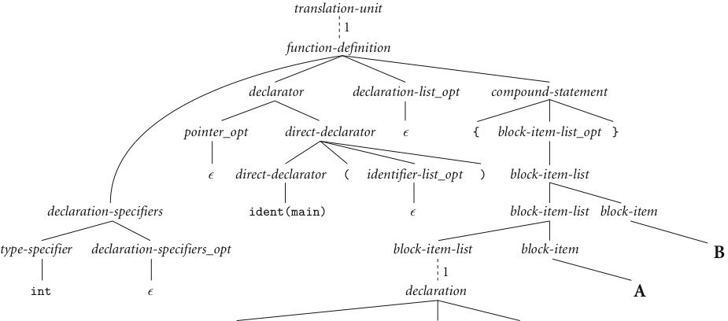

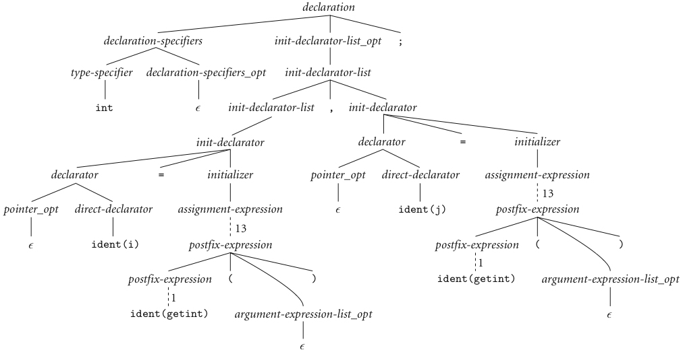

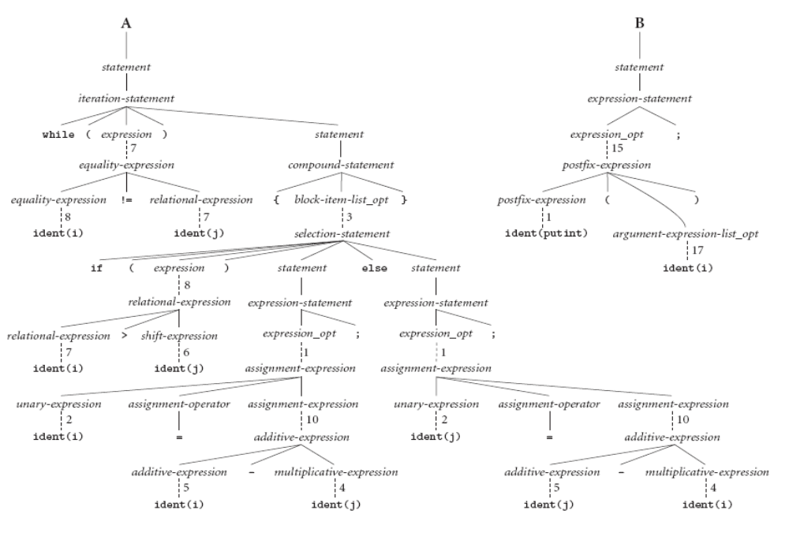

- Semantic analysis - the discovery of meaning in the program
- The compiler actually does what is called STATIC semantic analysis to determine meaning that can be figured out at compile time.
  - Recognize multiple occurrences of the same identifier, such as I in our example, often by creating a symbol table
  - Track data type of identifiers and expressions
  - Parameter matching

- This often results in the generation of a syntax tree. Ex.,

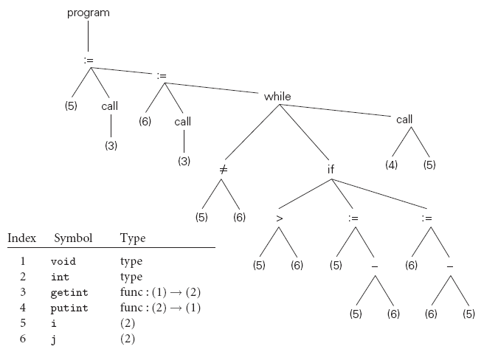
- Some things (e.g., array subscript out of bounds) can't be figured out until run time. They are part of the program's DYNAMIC semantics. Example:
  - Variables must have values before they appear on the RHS of an expression
  - Pointers must refer to valid object when dereferenced (i.e., going to the pointee)
  - Subscript must be in bound

- Intermediate Form (IF) - done after semantic analysis (if the program passes all checks)
- IFs are often chosen for machine independence, ease of optimization, or compactness (these are somewhat contradictory)
- They often resemble machine code for some imaginary idealized machine; e.g. a stack machine, or a machine with arbitrarily many registers
- Many compilers actually move the code through more than one IF

- Optimization - takes an intermediate-code program and produces another one that does the same thing faster, or in less space
- The term is a misnomer; we just improve code
- The optimization phase is optional

- Code generation phase - produces assembly language or re-locatable machine language
- Certain machine-specific optimizations (use of special instructions or addressing modes, etc.) may be performed during or after target code generation
- Symbol table
- all phases rely on a symbol table that keeps track of all the identifiers in the program and what the compiler knows about them
- This symbol table may be retained (in some form) for use by a debugger, even after compilation has completed

