Chapter 2 Programming Language Syntax

- Natural languages are ambiguous
Ex., He hit the wall with his head and it broke.
- Programming languages must be precise,
  - So that the computer can understand
  - Precise both in terms of syntax and semantics

Q. What are different ways we could describe a language’s syntax and/or semantics?
  - Books and menus – detailed but imprecise
  - Schema diagram (ex., Pascal syntax diagram) – precise, but not in a computer ready form.
  - Formal grammar
  - Computation model

    - Token and Regular Expressions

Token
- The basic building block of programs
- The shortest string of characters with individual meaning
- Examples: +, identifier, etc
- Identifier can take many forms ex., foo, linkedList, count1

Since tokens can take many shapes and forms, how do we characterize them in general?

To specify tokens (and other similar concepts) concisely and formally, we could (and often do)
- use the notation language called regular expression, defined as “a pattern describing a certain amount of text”,
- Alternatively, use a Finite Automata, a type of computational model, see CT1.ppt
- Both define regular language

Syntactically, a regular expression (or simply written as regex) is defined, recursively, as one of the following:
- The empty string, denoted by ε
- A single character in the alphabet
- Two regular expressions concatenated with º (sometimes omitted, other possible symbols: +, &)
- Two regular expressions separated by | (union, other possible symbols: U)
- A regular expression followed by the Kleene star (repeated zero or more times)

Two formats:

- Use a rule

name (of regex) → regex

Example – the syntax of numeric constants accepted by a hand-held calculator, define with a rule set (Example 2.3)
number → integer | decimal
integer → digit digit* // or digit⁺
decimal → digit*(digit. | .digit) digit*
digit → 0 | 1 | 2 | 3 | 4 | 5 | 6 | 7 | 8 | 9 | // often written as 0-9

Defined on the alphabet ∑={0-9}

We can use this rule set to derive any real number, ex., 3.14

number -> decimal -> digit*(digit. | .digit) digit*-> digit.digit digit
-> 3. 1 digit* -> 3.1 digit -> 3.14

A rule is of the form: LHS → RHS

LHS contains
- Name of the concept we are defining (ex., number), or
- Intermediate terms used to define additional rules

RHS – a regular expression

Note that multiple rules can often be combined into a single rule, ex.,

Integer → (0-9)⁺

Regular expressions capture the pattern of data string by using 3 basic operators:
concatenation,
union (U or |),
star (*).

What’s special about these 3 operators? They are closed in RL

How is regex related to FA? They define/represent/describe the same Regular Language
….

Continue on page 53 of CT1.ppt

…
Return from end of CT1.ppt

Examples - give regular expressions for the following languages on the alphabet ∑={0,1,2,3,4,5,6,7,8,9}

- Words that contains the substring 110

∑*110∑*

- Words of length 3

∑∑∑ or ∑³

- Words that contains exactly 3 1s

(0U(2-9))*1 (0U(2-9))*1 (0U(2-9))*1 (0U(2-9))*
Identifiers - words that starts with a letter, followed by any number of letters and digits
∑={0-9, A-Z, a-z}

((A-Z) | (a-z)) ∑*

- Passwords - 8 or more characters with at least a number and a letter

No elegant way to express in standard regular expression

Easier to write in extended regex used in most modern programming languages either built-in (ex., perl, ruby, awk), or with library (java, c++, etc)
Example, perl regex (http://www.somacon.com/p127.php )

Possible solution in perl regex
^(?=.*[a-zA-Z])(?=.*\d) (?=.{8,})$

^ → start
?= → match
. → ∑
$ → end

Q. Why don’t we just use that?

A. extended regex no longer define regular language
More about this later

2.2 Scanning

A scanner is responsible for
- tokenizing source
- removing comments
- saving text of identifiers, numbers, strings
- saving source locations (file, line, column) for error messages

Example 2.9 – a simple calculate language

Regex (rules) for tokens:

Assign → :=
Plus → +
Minus → -
Times → *
Div → /
Lparen → (
Rparen → )
Id → letter (letter | digit)*
except for read and write

number → digit digit* | digit* ( . digit | digit . ) digit*
comment → /* (non-* | * non-/)* */
| // (non-newline)* newline

Note that non-* represents any char except *, the same goes for non-/, non-newline, etc

How would you write this token scanner?

Figure 2.5 – Outline of an ad hoc scanner in (C-type of syntax)

Skip white spaces;
If (strchr(curChar, “()+-*”)
return lookUpToken(curChar) ;
//lookUpToken look up existing or create new entry in token table if not found

else if (curChar==’:’)
{
getc(fin, nextChar);
if (nextChar==’=’)
return assign
else
ferror << “error\n”;
}
Else if (curChar==’/’)
{
getc(fin, nextChar);

if (nextChar==’/’)
while(nextChar!=’\n’)
getc(fin, nextChar); // skip until end of line
else if (nextChar == ‘*’)
{
while(!(curChar==’*’ && nextChar==’/’)
{ curChar=nextChar; getc(fin, nextChar);
}

Else
Return div; // lookUpToken call may be necessary
}
Else if (curChar==’.’)
{
getc(fin, nextChar);
If (isdigit(nextChar)
{
While (isdigit(nextChar))
getc(fin, nextChar);
… // package the number
Return number;
}

Else
ferror << “error\n”;
}
Else if (isdigit(curChar))
{
While (isdigit(nextChar))
getc(fin, nextChar);
If (nextChar==’.’)
While (isdigit(nextChar)) getc(fin, nextChar);
… // package the number
Return number;
}
Else if (isletter(curChar))
{
string id;
While(getc(fin, curChar) && isalpha(curChar)) // curChar is letter or digit
{
id = id+curChar; // make string
}
if (id== “read ” || …) // check for special symbols
return getToken(id);

Return id
}

Else
Ferror << “error\n”;

Pictorial representation of a scanner for calculator tokens, in the form of a finite automaton:
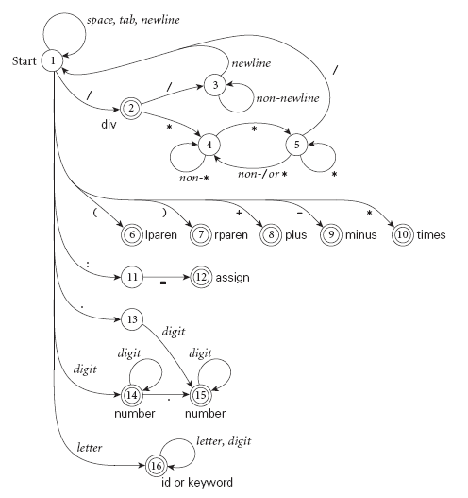

Notes and Observations

- This is a DFA that recognized one token.
- Programs such as fLex, yyac, and ANTLR (called scanner and/or parser generators) build these things automatically from a set of rules in the form of regular expressions. How?

They implicitly construct a FA that accepts the language from Regex, and then use the FA as a base to generate the scanner program

2.2.1 Generating a finite automaton

For basics of finite automata, see CT chapter 1 (CT1.ppt )

Regular expression → minimized DFA
- Systematic approach that can be implemented by a program
- 3 easy steps:
  - regular expression to NFA (part of proof for Regex==FA, see also CT1)
  - NFA to DFA (part of NFA, DFA equivalence proof, see also CT1)
  - Minimizing DFA

Step 1 regular expression to NFA (in somewhat general form, figure 2.7)

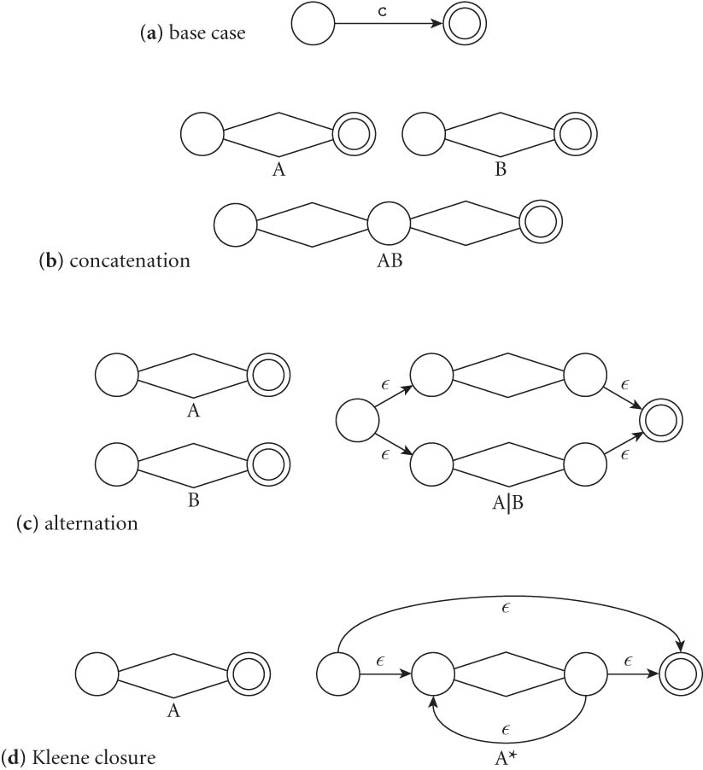

If you prefer rules from basic building blocks, here is another illustration
We will use the rules which defined a regular expression as a basis for the construction:
- The NFA representing the empty string is:
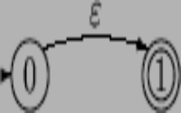
- If the regular expression is just a character, e.g. a,
then the corresponding NFA is :
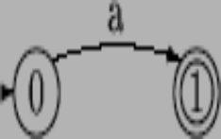
- The union operator is represented by a choice of transitions from a node; thus a|b can be represented as:
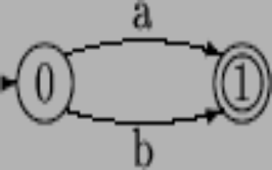
- Concatenation simply involves connecting one NFA to the other; e.g. ab is:
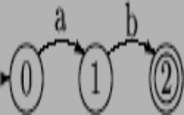
- The Kleene closure (or star) must allow for taking zero or more instances of the letter from the input; thus a* looks like:
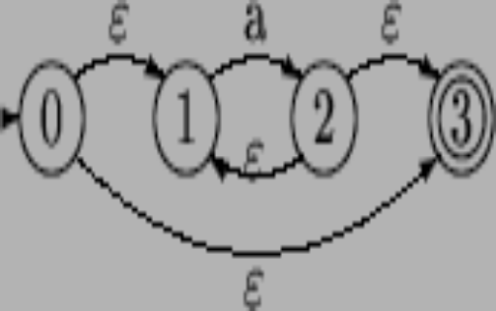

Example (Figure 2.8) – Use these rules to build a NFA for d* (.d | d. ) d* bottom up

Try it yourself

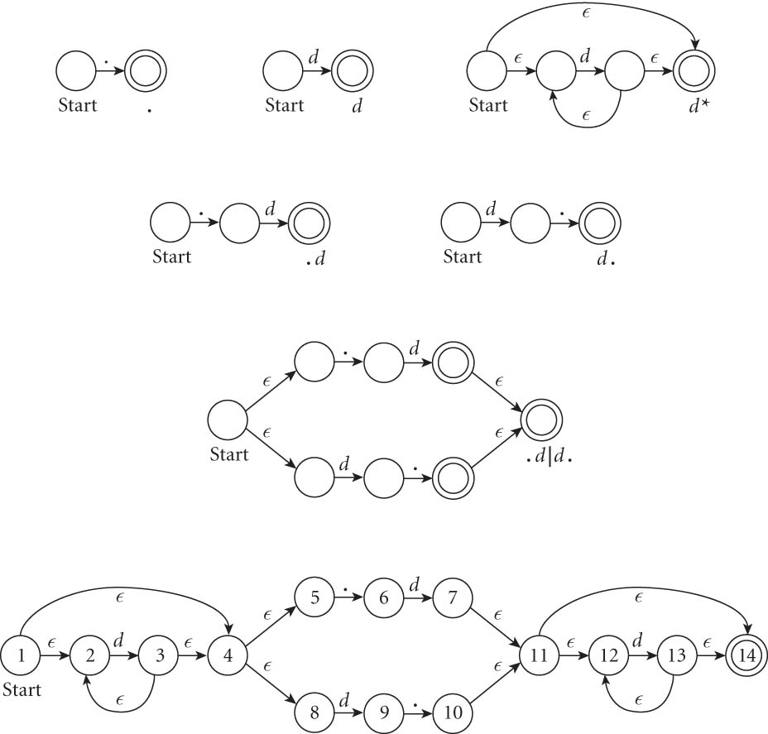

Step 2 – convert NFA to DFA (figure 2.9)
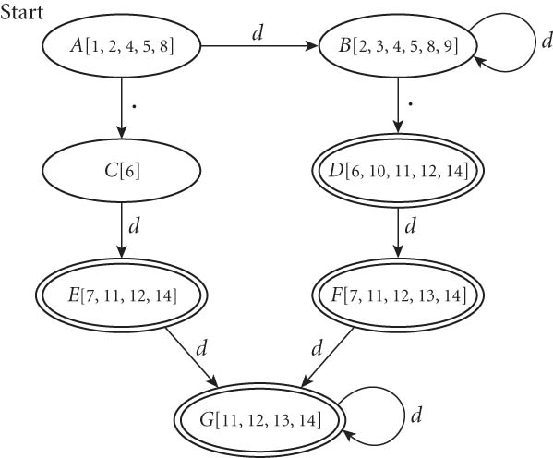

Step 2: NFA → DFA
- Each state in the newly created DFA represents a subset of states in the original NFA

Key operations - two basic functions:

- The function closure takes a state and returns the set of states reachable from it based on ε-transitions.
Ex., closure(1) = {1,2,4,5,8}
Note that
  - This set will always include the state itself.
  - We should be able to get from a state to any state in its -closure without consuming any input.
- The function move takes a (newly created) DFA state and a character, and returns the set of states (from original NFA) reachable by one transition on this character. This set is then matched to existing DFA or created new if necessary.

We can generalize both these functions to apply to sets of states by taking the union of the application to individual states.
Eg. If A, B and C are states, move({A,B,C},`a')
= closure(move(A,’a’)) U closure(move(B,’a’)) U closure(move(C,’a’))

The Subset Construction Algorithm (From NFA to DFA)
- Create the start state of the DFA by taking the -closure of the start state of the NFA.
- Perform the following for the new DFA state(s):
For each possible input symbol:
  - For each state represented by the newly-created state, apply move on it and the input symbol; this will return a set of states, one from each move
  - Apply the -closure to this set of states, possibly resulting in a new set.
  - This set of NFA states will be a single state in the DFA (create if necessary), to which the transition will now lead.

- Each time we generate a new DFA state, we must apply step 2 to it. The process is complete when applying step 2 does not yield any new states.
- The accept states of the DFA are those which contain any accept state(s) of the original NFA.

Step 3 – minimizing DFA

- Place states into two equivalence classes: accept states and non-accept states
- Repeatedly break the classes by looking for ANY input symbol c which cause the transition from one equivalence class to multiple equivalence classes.
Ex.,

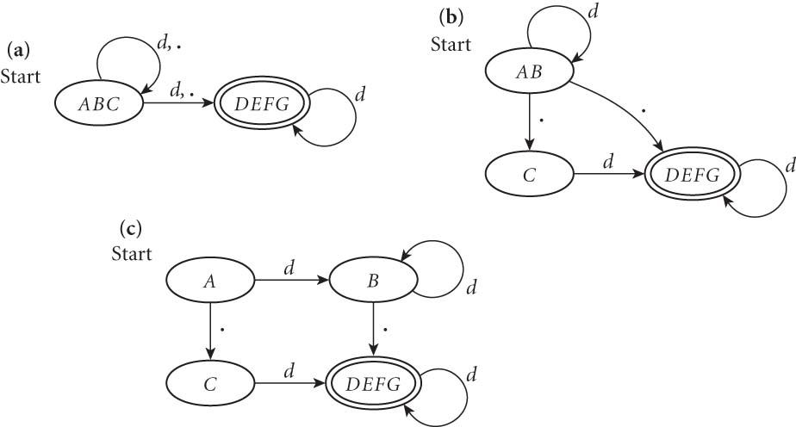

2.2.2 Generating Scanner Code
Scanners can be built three ways

Option 1. ad-hoc (manually)- generally yields the fastest, most compact code by doing lots of special-purpose things. However, good automatically-generated scanners could come very close in terms of performance.

Option 2. semi-mechanical (manually or by program such as ANTLR), based on FA, usually realized as nested case statements, ex.,

Int curState = 1; // start state
// …
// 15 = real rec
// 16 = identifier rec
// …
while (fin.read(curChar)) // while not EOF
{
switch (curState)
{
case 1:
switch (curChar)
case ‘\t’: case ‘ ‘: curState = 1; // skip & continue
…
case ‘0’..’9’: // start of new token, move
rememberState = 1; // for recovering
curState = 14; // start of a number
case ‘a’...’z’:
rememberState = 1; curState = 16;
id = curChar;
// start of a identifier
break;
…
case 16:
switch (curChar)
case ‘a’..’z’:
\ case ‘A’..’Z’:
Case ‘0’..’9’: // continue
id = id+curchar; // append curChar to end of id
curState = 16;
case ‘\t’: case ‘ ‘:
case ‘+’: case ‘-‘:
…. :// id is read, recognize
putc(curChar); // put curChar back
// since it’s not part of cur token
Return tokenTable[id]; // return id tag
Default: // error
Print(“error code\n”)
curState = rememberState; // skip current token
…
break;
…
}
}

Some issues to consider:

What to do when there are multiple ways of getting a token and how do we recognize the end of the current token?

If the input stream contains: SIUe …
SIUe could be accepted as:
- S (a single letter identifier)
- SI
- SIU
- SIUe

Solution: always return the longest-possible tokens

- Recognize only when the next character can't be used to continue the current token (look ahead of one symbol)
  - the next character will generally need to be saved in case it’s part of the next token,
e.x., SIUE:= …
we recognize SIUE as a identifier when we see the :,
we need to save ‘:’ (i.e., put it back to input stream) since it could be part of the next token.

- In some cases, you may need to perform >1 character of look-ahead in order to know whether to proceed. Ex., when you have a 3 and you see a dot
  - do you proceed (in hopes of getting 3.14)?
or
  - do you stop (in fear of getting 3..5)?

    - What about keywords and reserved words?
Treat them as exception, to be handled after a token is recognized, via a look-up table

    - In the switch code, two pieces of info are used to determine the proper action and next state. What are the two pieces?

curState and curChar
Option 3. Table-driven DFA program – This is almost always done by a program (ex., lex)
  - Represents the automaton as a 2d table (ex., scanTab) of curState (row) and curChar (column), where each entry describes possible actions:
    - Continue reading the current token
    - Recognize – end of a token is recognized with help of another table such as tokenTab. It looks up keyword and update token table before starting another token
    - Move to a new state at the end of current token
    - Error – print and ignore

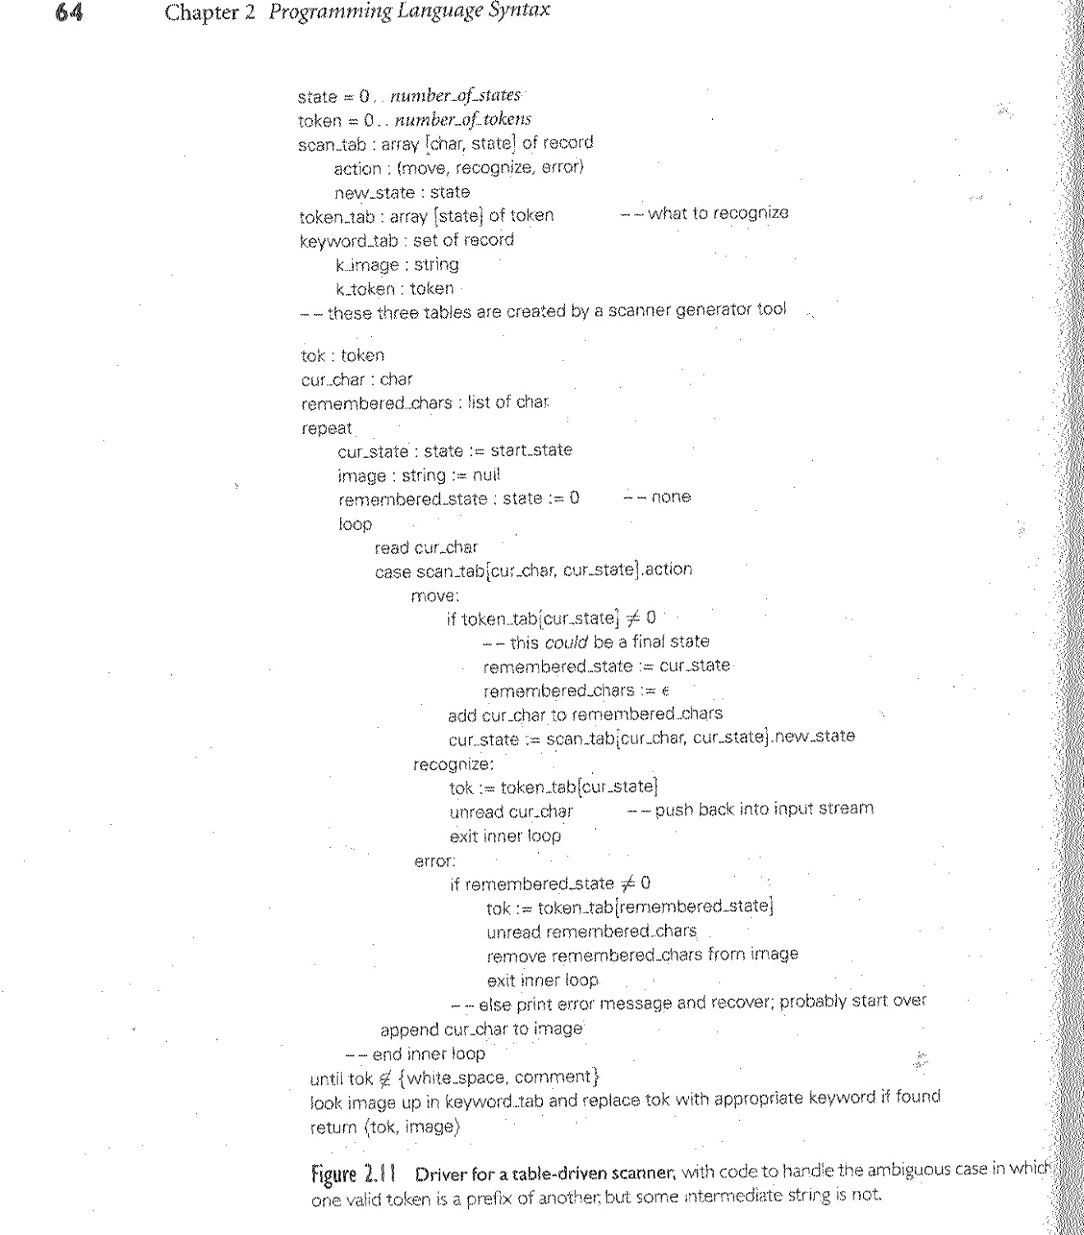
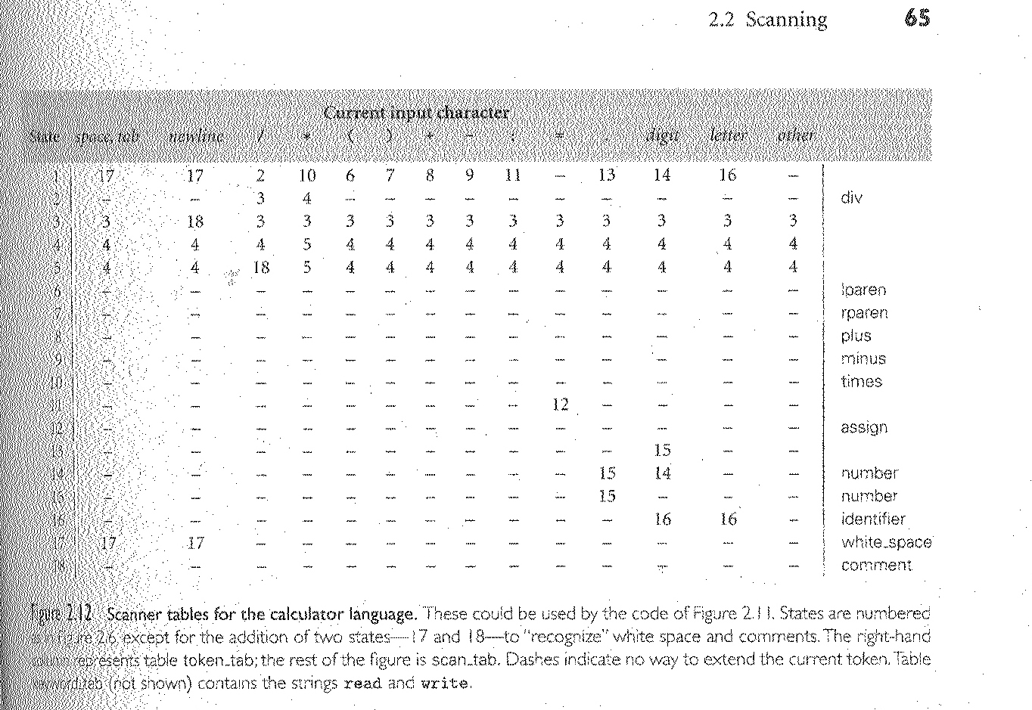

Limit of Regular Expression

- does not allow recursive definition (either directly or indirectly)
- cannot be used to define nested structures, such as
  - exp → … | ( exp )
  - palindrome, ex., racecar

How do we know that is true?

See proof on page 109 of CT1.ppt

    - & 2.1.3 Context-Free Grammars (CFG) and parse tree

CFG
- Defined by Noam Chomsky.
- Also referred to as Backus-Naur Form (BNF) as the two are almost identical.
- BNF was invented by John Backus, modified by Peter Naur
- A popular method for describing grammar for programming language
- Use productions rules to describe concepts/abstractions.

General form of the rules:

LHS →RHS

LHS: variables representing the concept being defined,
RHS:
- May contain variables and terminals,
- Explanation and expansion of the concept in terms of
tokens, lexemes, and other concepts.
Ex.,
<assignment stmt> → <var> = <expression>;

In general, a CFG is a 4-tuple (T, N, S, R), consisting of
  - A set of terminals T (also represented as ∑)
  - A set of non-terminals N (or V for variables)
  - A start symbol S (a non-terminal, thus is part of N)
  - A set of productions rules R

Ex., Pascal’s if statement

<if-stmt> → if <logic-expr> then <stmt>
| if <logic-expr> then <stmt> else <stmt>

- CFG use recursive rules (directly or indirectly) to describe variable-length list

Do you see any recursion in the above rule for <if-stmt> statement?

There is recursive definition, indirectly, implicitly, ex.,

<stmt> → <for-stmt> ….
| <while-stmt> …
| …
| <if-stmt>

A variable-length list may repeat any number of times

E.G., variable declaration in Pascal

Informally, we could use (and often does) …

<type> <identifier>, <identifier>, …

To define it formally in CFG, we must use recursive rules to define

variable-length list such as that.

Ex.,
<var-declaration> → <Type> <identifier-list>
<identifier-list> →<identifier> | <identifier>, <identifier-list>

<identifier> → A..Z | a..z

A CFG rule is

- Left recursive – LHS also appears at the beginning of RHS.
<CON> → <CON> terminals

- Right recursive – LHS is repeated at the end of RHS.
<CON> →terminals <CON>

A CFG sentence (or word) is a string of terminals - this is something a parser takes as input

Derivations – the generation of a sentence, through a sequence of rule applications until the string is entirely made of terminals, beginning with the start symbol. Ex.,

IDL => ID, IDL => a, IDL => a, ID => a,b

Some applications of CFG:

(a) Generate random sentence(s) by repeatedly applying rules

(b) Derive a given sentence to show that it is part of a language as described by the CFG

(c) Derive/generate a parse trees for a given sentence to
(i) shows it belongs to the language
(ii) illustrates syntactic structure of the sentence (part of meaning)

Example 2B - A grammar for simple assignment statement with arithmetic’s

<assign> → <id> := <expr>
<id> → A | B | C
<expr> → <expr> + <expr> |
<expr> - <expr> |
<expr> * <expr> |
<id>

< > indicates non-terminals
<assign> is the start symbol for this set (i.e., it’s the top-level concept)
A B C + - * := are terminals

An example derivation for A:=B+C

<assign>

=> <id> := <expr>

=> A := <expr>

=> A := <expr> + <expr>

=> A:= <id> + <expr>

=> A:= B+<expr>

=> A:=B+<id>

=> A:=B+C

Leftmost derivation – always replace the leftmost non-terminal first.

Class exercise:

Generate the sentence A := A – B * C using leftmost derivation

<assign>
→ <id> := <expr>
→ A := <expr>
→ A := <expr> * <expr>
→ A := <expr> - <expr> * <expr>
→ A := <id> - <expr> * <expr>
→ A := A - <expr> * <expr>
→ A := A - <id> * <expr>
→ A := A - B * <expr>
→ A := A - B * <id>
→ A := A - B * C

We could also use <expr> → <expr> - <expr> before * resulting in a different sequence (i.e., derivation) :

<assign>
→ <id> := <expr>
→ A := <expr>
→ A := <expr> - <expr>
→ A := <id> - <expr>
→ A := A - <expr>
→ A := A - <expr> * <expr>
→ A := A - <id> * <expr>
→ A := A - B * <expr>
→ A := A - B * <id>
→ A := A - B * C

Create a parse tree for A := A – B * C

<assign>

<id> := <expr>

A <expr> * <expr>

<expr> - <expr> <id>

<id> <id> C

A B

Q. What does this parse tree tell us?

Interpretation the sentence syntax
For example, according to the tree, the operations are carried out in the order of
-, *, :=

Q. Can we create another parse tree for the A:=A-B*C statement?

Yes

<assign>

<id> := <expr>

A <expr> - <expr>

<id> <expr> * <expr>

A <id> <id>

B C

So, what does this mean?
Ambiguous grammar – a grammar is ambiguous if, for the same sentence
- There are 2 or more distinct parse trees for the same sentence, resulting in 2 or more interpretations.
- There are 2 or more leftmost derivations.
Ex., A := A – B * C

Here are the two possible interpretation/evaluations from this grammar 2B:

A := [A-B]*C

A := A-[B*C]

How do we know which one is appropriate? We don’t

Languages often have additional rules for resolving ambiguity, somewhere else, ex.,
Operator Precedence (* over +) and associativity (left to right)

However, those rules are NOT explicitly represented in the given grammar
- Two distinct parse trees → operator precedence/associativity is not explicitly defined
- Operator precedence/associativity may be hidden somewhere else
- To create the parser automatically, precedence/associativity info often needs to be incorporated into grammar explicitly
  - Grammar with operator precedence → unique parse tree for each sentence
  - Operators at a lower level of the parse tree have higher precedence over operators at higher level.

How do we rewrite 2B to incorporate this info?
<assign> → <id> := <expr>
<id> → A | B | C
<expr> → <expr> + <expr> |
<expr> - <expr> |
<expr> * <expr> |
<id>

Let’s fix precedence first!!!!

-------------------------------------- * over + - ---------------------------------------

<assign> → <id> := <expr>
<expr> → <expr> + <expr> |
<expr> - <expr> |
<term> // Exp Rule

<term> → <term> * <term> |
<id> // Term Rule

Try A := A – B * C

See board

What about associativity?

This grammar is __both___ left and right recursive // try draw A:=A-B+C

Associativity is undefined

Fix it!!!!!!!!!!!!!!!!!!!!!!!!!!!!

How? Make it left recursive

<expr> → <expr> + <term> |
<expr> - <term> |
<term>

<term →<term*<id> | <id>

Goal: Each sentence in an unambiguous grammar has a unique parse tree.

In General – for simple rules such as <E> → <E>+<T>

- Left recursive → left associative
- Right recursive → right associative

Associativities of common operators?

+ left
- left

* left

/ left

^ (exponentiation) right

How do we design rules to define right associative operators?

Make it right recursive

<factor> → <id>^<factor> | <id>

Also change * rule from:

<term> →<term*<id> | <id>

To
<term> →<term*<factor > | <factor

eBNF

- Increased readability and writability
- Same descriptive power

The additions:

- Use [ ] to describe optional components.
([] is often see in language manuals, ex., mysql select statement
Ex.,
<if-stmt> → if <logic-expr> then <stmt> [else <stmt>]

Compare and contrast with

<if-stmt> → if <logic-expr> then <stmt>
| if <logic-expr> then <stmt> else <stmt>

- Use ( )* for repeating 0 or more times.

Ex.,

<identifier-list> → <identifier> (, <identifier>)*

same as
<identifier-list> →<identifier> | <identifier>, <identifier-list>

What about
<identifier-list> → (<identifier>, <identifier>)*

Is this correct? NO

- Use ( | ) to describe multiple choice options.

Ex.,
<expr> → <expr>*(A|B|C)

same as

<expr> → <expr>*A | <expr>*B | <expr>*C

same as
<expr> → <expr>*<id>
<id> → A|B|C

Go to CT2.ppt for Recap/review of CFG and introduction of PDA

2.3 Parsing
- A parser is a language recognizer
  - Created from a given CFG (by whom? Another program)
  - It determines the syntax structure of a sentence and whether it belongs to the language as define by the CFG.

- There is an infinite number of grammars for every context-free language,
  - NOT all grammars are created equal, some are more elegant, efficient than other.
  - for any CFG, we can create a parser that runs in O(n³) time. Ex.,
- Earley's algorithm – dynamic programming
- Cooke-Younger-Kasami (CYK) algorithm (LR)

- Is O(n³) time good for a parser in a compiler?
  - What is n here? N is the number of tokens of a complete sentence in the particular grammar. It could be a complete program

- Luckily, there are large classes of grammars for which we can build parsers that run in linear time. The two most important classes of parsers are called LL and LR

- LL stands for 'Left-to-right, Leftmost derivation'.
  - LL parsers are also called 'top-down', or 'predictive' parsers
  - From start symbol to token symbols…
Top-down to create a parse tree

- LR stands for “Left-to-right, Rightmost derivation’.
  - LR parsers are also called 'bottom-up', or 'shift-reduce' parser.
  - From token stream to start symbol, backwards
  - When the derivation is done, it looks like a rightmost derivation in reverse order

- LL or LR are usually written with a number in parentheses after it, indicating how many tokens of look-ahead (including current) are required in order to parse
  - Almost all real compilers use (at least) one token look-ahead
- Additional properties:
  - Every LL(1) grammar is also LR(1), though right recursion in production tends to require very deep stacks and complicates semantic analysis
  - Every CFL that can be parsed deterministically has an Simple LR(1) grammar
  - Every deterministic CFL with the prefix property (no valid string is a prefix of another valid string) has an LR(0) grammar.
    - Does identifier grammar have prefix property?

Comparing and Contrasting LL and LR with an example – a grammar for identifier list (figure 2.20)

id_list → id id_list_tail
id_list_tail → , id id_list_tail | ;

id → ‘A’..’Z’ | ‘a’..’z’

Note that this grammar is right recursive!

This is an LL(1) grammar - LL parsers hate left-recursive grammar!!!!!

Consider possible parsing of the identifier list: A, B, C;

Class Exercise – answer the following questions as relates to the given identifier grammar:
      - What is the set of terminals ∑ ?

∑ = {A, B, …, Z, ‘;’ , ‘,’ }

      - What is the set of non-terminals (i.e., variables) V ?

V = { id_list, id, id_list_tail }

      - What is the start symbol?

id_list

      - Derive the sentence A, B, C; using left most derivation (i.e., always replace left most symbol). Draw parse tree for the sentence (or word) and explain how you did it!

LL derivation:

id_list
- id id_list_tail
- A id_list_tail
- A, id id_list_tail
- A, B id_list_tail
- A, B, id id_list_tail
- A, B, C id_list_tail
- A, B, C;

At each step of the derivation process, LL(1) pick a rule based on
(a) current input symbol
(b) current left-most non-terminal which we are replacing

LL Parsing LR parsing?

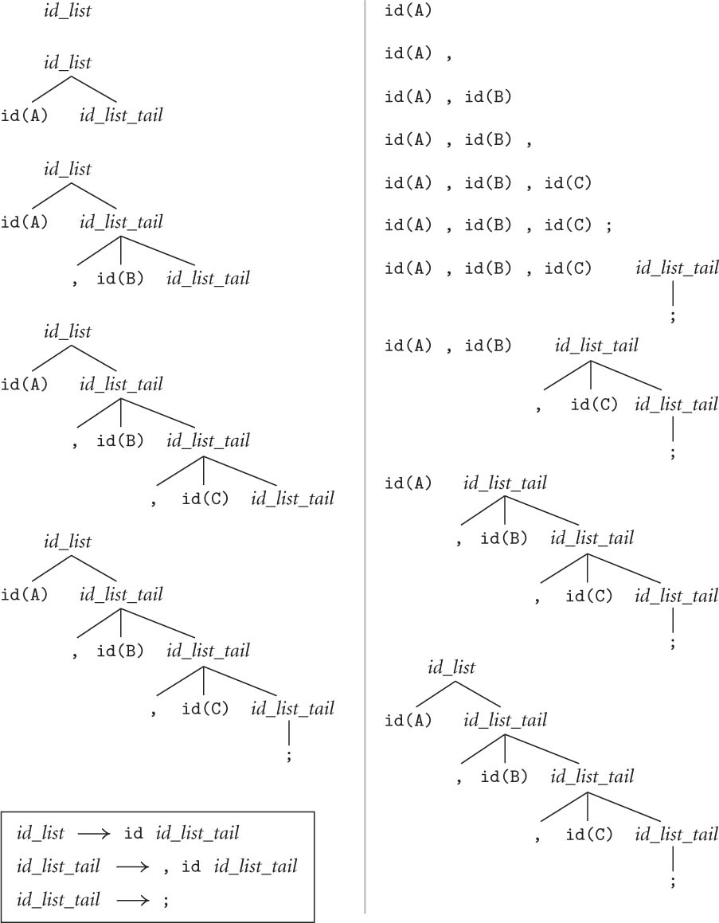

LR build the tree bottom up, it uses the grammar rule in reverse order

So what did we learn from this example?

Is LL parsing better than LR parsing?

- LL and LR generate the same tree
  - leftmost or rightmost does not affect the tree, just different process
- This grammar is right recursive (also called tail recursive)
- Good for LL parser, less so for LR (though still doable)

To make it easier for LR parser, we could change the grammar to make it left recursive. How?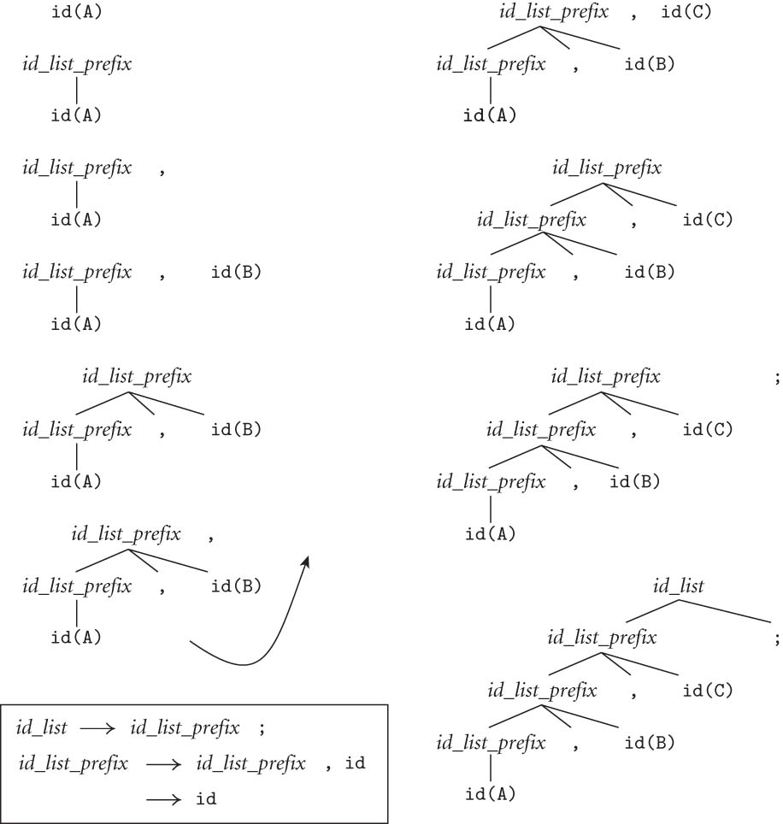

LL(1) does not work with this new grammar, why?

Try a leftmost derivation of A, B, C; with this grammar
LL(1) does not work in this case because the grammar is left-ambiguous
In order to parse with this grammar using LL, we need to have >1 look-ahead i.e., LL(*)

2.3.1 Recursive Descent parsing and LL(1)
Recursive descent parsing:
    - Also called top-down, predictive parsing
    - An intuitive method
    - Only works with LL(1) grammar (i.e., not left-ambiguous)

2B (our unambiguous grammar with correct precedence and associativity) Extended

Expr → term
| Expr add_op term
Term → factor
| term mul_op factor
Factor → id
| number
| - factor
| (expr)
add_op → + | -
mult_op → * | /

Would an LL(1) parser work with this grammar? No

Consider the sentence A+B*C

Since the first symbol is A, with 1 token Look-ahead, we look for a rule (or derivation) sequence ->* that will take us from Expr to id. We found 2:

Expr →* id (via Expr->term->factor -> id)

Expr →* id (via expr add_op term->term add_op term -> factor add_op term -> id add_op term)

Can we pick the right rule simply based on the current token alone?

No, we’d need to look ahead a little more

Because we can’t decide which option (or branch) of a rule to use based on the current symbol, with only 1 symbol Look-ahead. i.e., it’s not LL(1)

Our grammar - extended 2B
The good news:
- It is unambiguous.
- It has correct associativity: left by using left recursive rules
- It supports the correct operator precedence: mul_op over add_op by having add_op rule appear BEFORE mul_op rule

The bad news:
- It’s left ambiguous due to left recursive rule
- It is NOT LL(1)

Now what?

Rewrite/extend the grammar further to make it LL(1) (Fig 2.15):
(Note: the expression part of this grammar describe the SAME language, but in a way that removes left-ambiguity, i.e., if we see an ID A, we know exactly which rule to use.)

Production Rule Rule #
--------------------------------------- ----------------------
program → stmt_list $$ 1
stmt_list → stmt stmt_list 2
|
ε 3
stmt → id := expr 4
|
read id 5
|
write expr 6

expr → term term_tail 7
term_tail → add_op term term_tail 8
|
ε 9
term → factor fact_tail 10
fact_tail → mult_op fact fact_tail 11
|
ε 12
factor → ( expr ) 13
|
id 14
|
number 15
add_op → + 16
|
- 17
mult_op → * 18
|
/ 19

This new grammar
- Has additional rules for prog, stmt_list, and stmt.
- Changed Expr rules to remove left-recursion.
- Still maintain same (and correct) operator associativity and precedence of the previous version, though NOT as intuitive,
- is now an LL(1) grammar

How do we parse a string with this grammar?

Exercise – draw parse tree for the following program (in italic) using 1 token look-ahead. i.e., start at the top and select/predict needed productions on the basis of the current left-most non-terminal in the tree and the current input token

Start symbol: program

read A
read B
sum := A + B
write sum
write sum / 2
$$

How do we program this?

Option 1 – we could create a bunch of subroutines, one for each non-terminal.
  - In other words, for every rule of the form LHS → RHS, the parser contains a function to parse LHS, whose body parses RHS by match (terminal) and call (non-terminal)
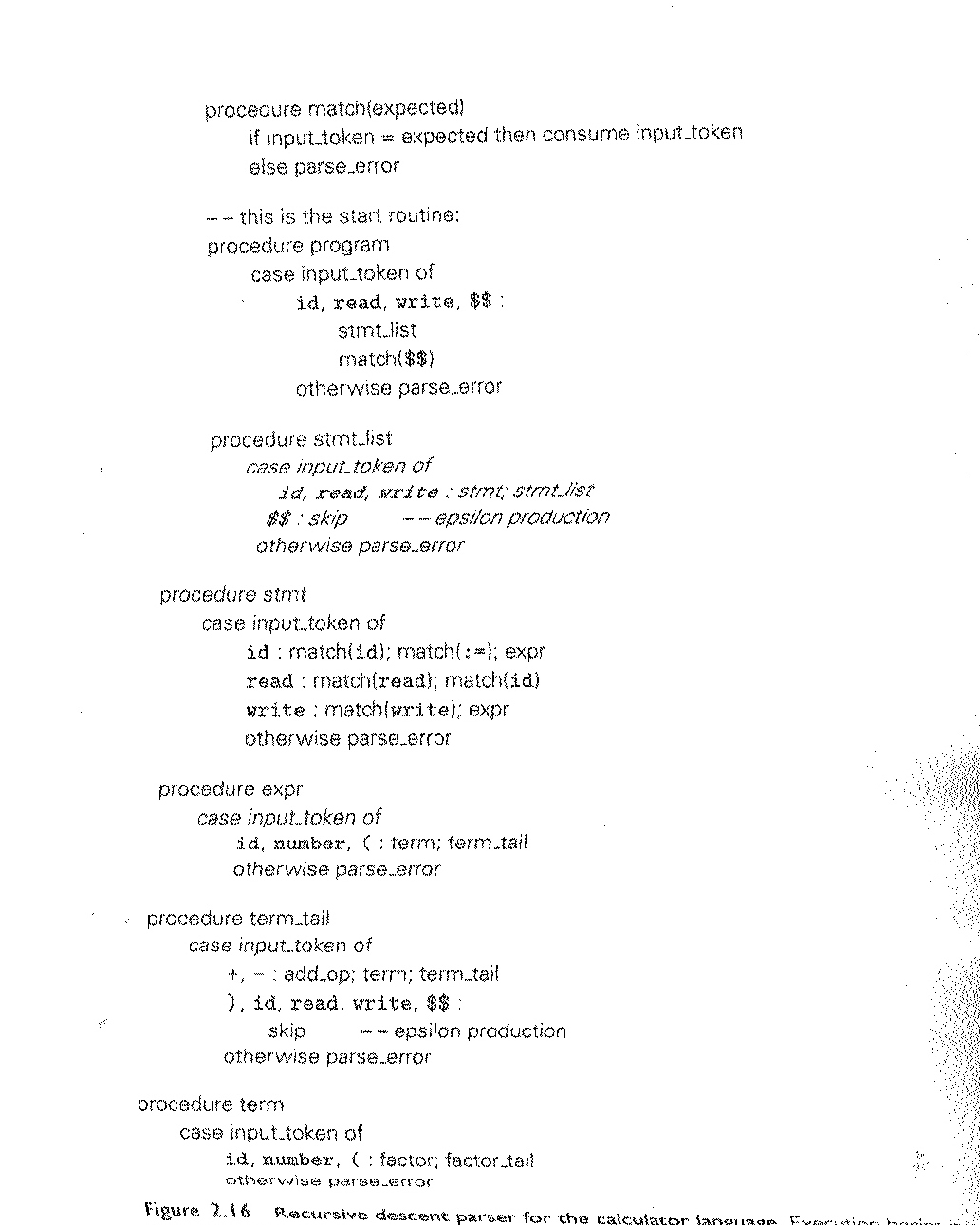

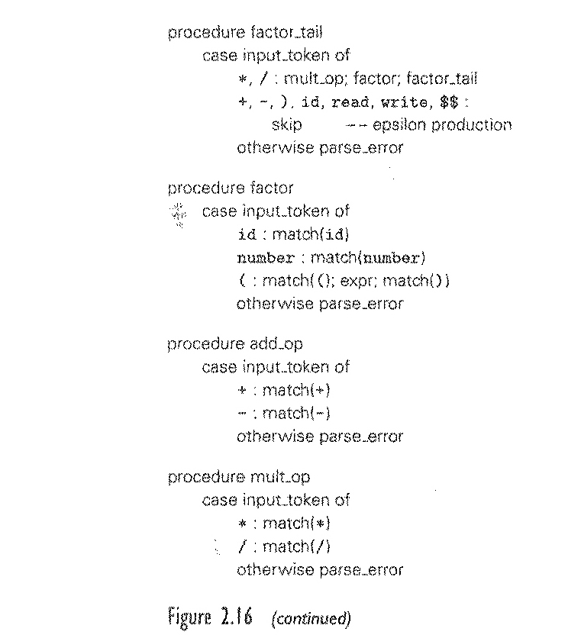

Let’s try a few steps!
See board

Resulting parse tree: (Figure 2.17)

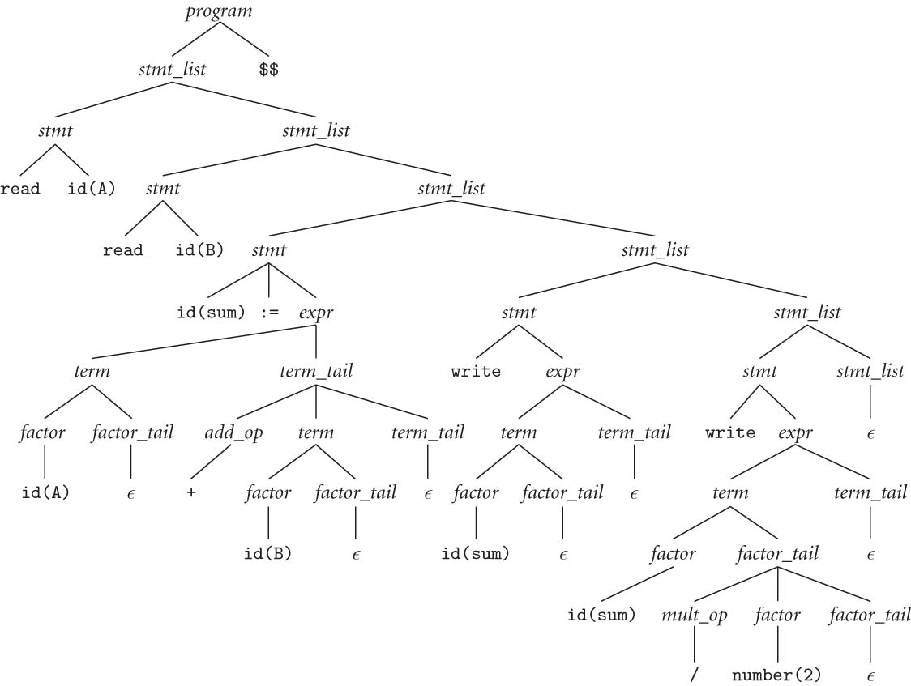

- This algorithm is most popular with us programmers. We can write this easily!
- It uses (implicitly through subroutine calls) a (runtime) stack to keep track of all the tokens to be matched and non-terminal symbols yet to be expanded.

What are the things that determine the parser’s next action during the parsing process?

The current non-terminal that we are trying to expand (when we do it by hand) or complete (when the program is in that subroutine) AND the current token (i.e. the input_token)

How does the program keep tracks of the remainder of the rules yet to be completed?

On run time stack

Any alternative implementation?

    - Table-driven Top-down (LL) parsing

Option 2 - use a big loop in which we repeatedly look up an action in a two-dimensional table based on (i.e., indexed on) current leftmost non-terminal (on top of stack) and current input token. The actions are
(1) match a terminal. (Remember, part or all of RHS could be terminal)
(2) predict a production (all numbered)
(3) announce a syntax error

Figure 2.19 - LL(1) A parse table for calculator language
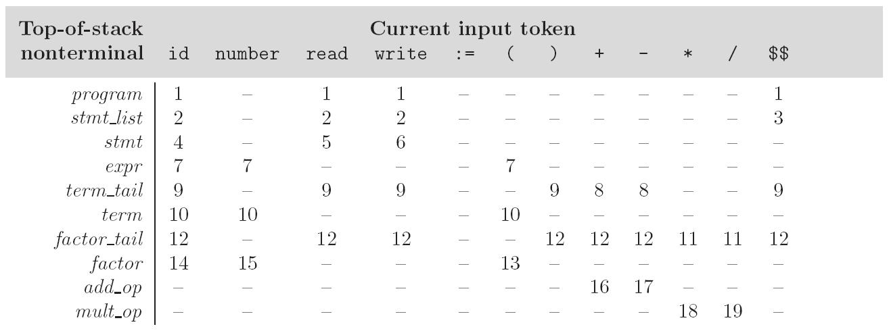

- To keep track of (i.e., following through) the (current) left-most non-terminal, we push the as-yet-unseen (or unmatched) portions of productions onto a stack. Ex.,

Figure 2.20 – Trace of table driven LL parsing of sample program

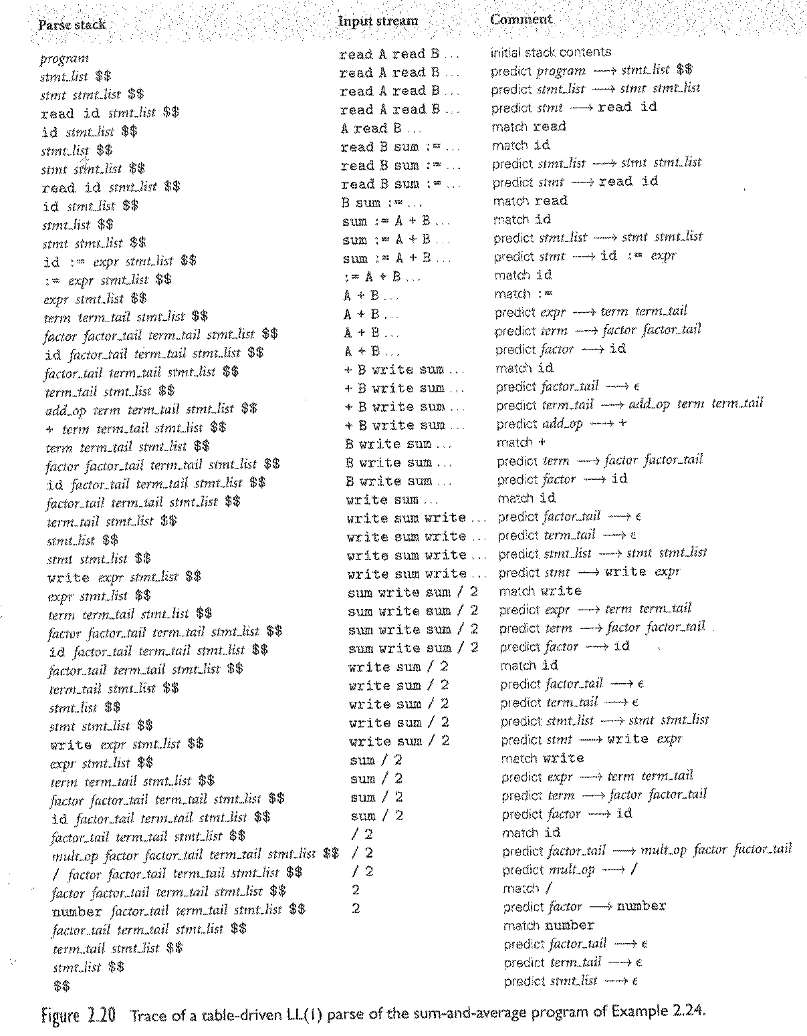

- The key: the stack contains all the stuff you expect to see between now and the end of the program execution.
- It’s an error if not everything is matched.
- How do we predict?

Predict Sets

- A set of terminal symbols associated with each unique production
- The combination of LHS non-terminal of the rule and a symbol in the predict set indicate/determine/predict the application of the production rule
- By applying the rule, we remove the LHS symbol from stack and replace it with the sequence of symbols (a mix of terminal and non-terminal) on the RHS

The algorithm to build predict sets is tedious (for a "real" sized grammar), but conceptually simple, with three stages:
- compute FIRST sets for symbols
- compute FOLLOW sets for non-terminals (this requires computing FIRST sets for some strings)
- compute predict sets or table for all productions

Formally, First/Follow/Predict (→* represents sequence of derivation):
- PredictSet (A → X₁ ... X_{m}) == (FIRST (X₁ ... X_{m}) )
∪ (if X₁, ..., X_{m} →* ε then FOLLOW (A) ELSE NULL)
- First(X₁ ... X_{m}) == First(X₁) ∪ (if X₁-->* ε Then Follow(X₁) …
- FIRST(α) == {a : α →* a β}
∪ (if α =>* ε THEN {ε} ELSE NULL)
- FOLLOW(A) == {a : S →⁺ α A a β}
∪ (if S →* α A THEN {ε} ELSE NULL)

For example:

Predict set(program →stmt_list $$)

First(stmt_list) = { ε, id, read, write}

Follow(stmt_list) = {$$}

Predict set(program →stmt_list $$) = {id, read, write, $$}

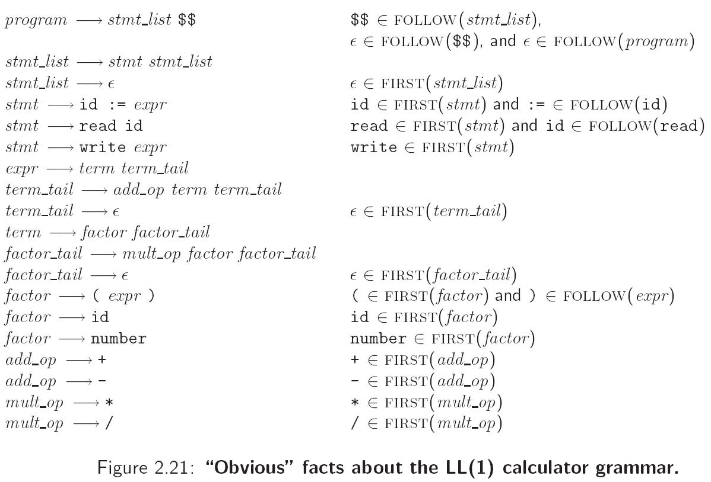

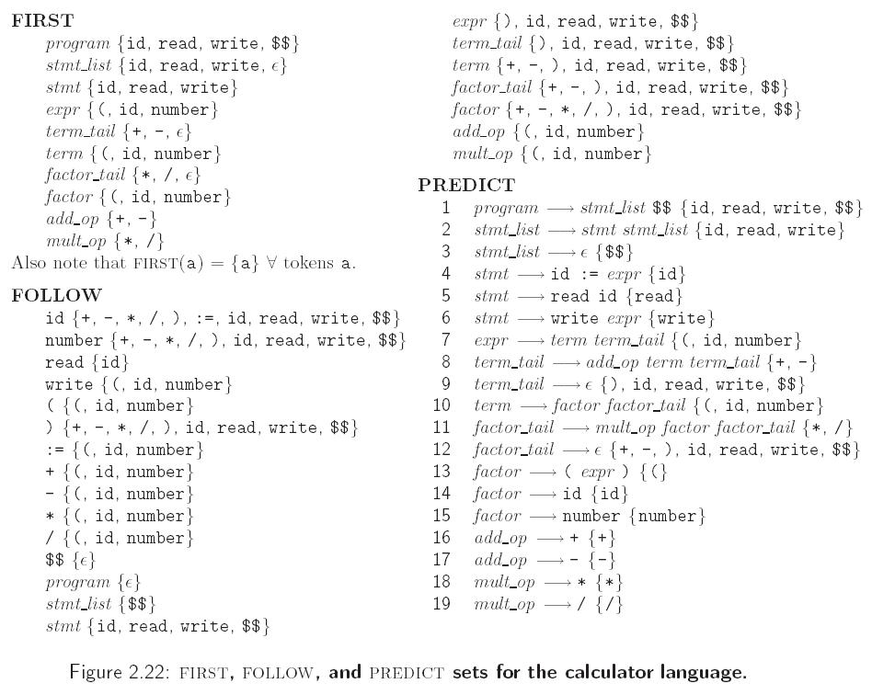

Q:
- Can the same token belong to the predict (set) of >1 production rule? Yes

Ex.,

A → a B // a is in predict set (A → a B)
C → a D // a is in predict set (C → a D)

- Can the same token belong to the predict (set) of >1 production rule with the same LHS? NO

Ex.,

A → a B // a is in predict set (A → a B)
A → a D // a is in predict set (A → a D)

Another Example
S -> Ab
| Bc
A -> D
| CA
B -> gA
| ε
C -> dC
| c
D -> h
| i

1. S -> Ab First(Ab) = First(A) = First(D) U First(CA)
First(D) = {h, i} // note we only looked at A since it’s not nullable
// so we will never get to b in First(Ab)
First(CA) = { d, c} // same as above
so First(A) = {c, d, h, i}
predict(1) = {c, d, h, i}

2. S -> Bc First(Bc) = First(B) = {g, ε }
since B is nullable (i.e, B→* ε), we add Follow(B) = {c} to predict(2)
predict(2) = { g, ε, c }

3. A -> D First(D) = {h, i}
Predict(3) = {h ,i}

4. A -> CA First(CA) = First(C) = {d, c}
Predict(4) = {d, c}

5. B -> gA First(gA) = { g }
Predict(5) = { g }

6. B -> ε First(ε) = ε, so we find Follow(B) = { c }
// note only B on RHS is in production #2
Predict(6)= {c}

7. C -> dC First(dC) = { d }

8. C -> c First(c) = { c }

9. D -> h First(h) = { h }

10. D -> i First(i) = { i }

Is this grammar LL(1)?

Writing an LL(1) Grammar
Two potential problems (i.e., enemies of LL(1) parsing):

      - left recursive rules
example:
id_list → id
| id_list , id // this could span many rules

Solution – replace them with equivalent, non left-recursive rules, ex.,

id_list → id id_list_tail
id_list_tail → , id id_list_tail | epsilon

We can get rid of all left recursion mechanically in any grammar

  - common prefixes (left-ambiguous): another thing that LL(1) parsers can't handle

example:
stmt → id := expr
| id ( arg_list )
…

solution: left-factoring

stmt → id id_stmt_tail
id_stmt_tail → := expr
| ( arg_list)

We can eliminate left-recursive and common prefixes by left-factoring mechanically.
This works for most languages but not all

- Some languages are inherently non-LL(k). Ex., the"dangling else" problem in PASCAL:
<stmt> → if <cond> <thenClause> <elseClause>
| <other>

<thenClause> → then <stmt>
<elseclause> → else <stmt> | ε

How do we parse the following?

If A=True then if B=False then C:=80 else C:= 100;

Does the else go with the 1st then or 2nd then ??

- The usual approach, whether top-down OR bottom-up, is to use the ambiguous grammar together with a disambiguating rule that says
  - else goes with the closest then or, to incorporate into grammar rule more generally,
  - or, we can say, when there are >1 possible productions, the first one listed is the one to predict (or reduce/use)

- A better solution - languages (since Pascal) generally employ explicit end-markers, which eliminate this problem. Ex.,
  - in Modula-2, for example, one says:
if A = B then
if C = D then E := F end
else

G := H
end
- Ada says 'end if'; other languages say 'fi'

- One problem with end markers is that they tend to bunch up, when ‘extended if then .. else … is’ used. Ex., in Pascal, normally,

if A = B then …
else if A = C then …
else if A = D then …
else if A = E then …
else ...;

With end markers this becomes
if A = B then …
else if A = C then …
else if A = D then …
else if A = E then …
else ...;
end; end; end; end;

The automata that can process CFG – Goto CT2.ppt page 51

A quick recap
A scanner (i.e., Lexer) uses a DFA
- it can be specified with a state diagram

An LL parser can be implemented with a PDA (plus some other stuff to make the parse tree)
- A PDA can be specified with a state diagram and a stack
- An LL(1) grammar can be represented by a PDA with one state!
  - all the arcs are self loops; each corresponds to one particular production. the only difference between them is the choice of whether to push or pop
  - the final state is reached by a transition that sees EOF on the input and the stack
  - well, it needs a second accept state, but that's all (it's pretty simple)
  - OK, we may throw in an extra start state.

    - LR Parsing

Basics: see lrparser.ppt

Implementation - please read

LR parsers are almost always table-driven:
- like a table-driven LL parser, an LR parser uses a big loop in which it repeatedly inspects a two-dimensional table to find out what action to take
- unlike the LL parser, however, the LR driver has non-trivial state (like a real PDA), and the table is indexed by current input token and current state
- the stack contains a record of what has been seen SO FAR (NOT what is expected)

An LR parser is also a PDA though different from the PDA in LL
- It has multiple states
- It is a "recognizer," not a "predictor"
- it builds a parse tree from the bottom up
- the states keep track of which productions we might be in the middle

To illustrate LR parsing, consider this grammar, (Figure 2.24):
- program → stmt list $$
- stmt_list → stmt_list stmt
- | stmt
- stmt → id := expr
- | read id
- | write expr
- expr → term
- | expr add op term
- term → factor
- | term mult_op factor
- factor → ( expr )
- | id
- | number
- add_op → +
- | -
- mult_op → *
- | /

This grammar is SLR(1), a particularly nice class of bottom-up grammar
- It’s left-recursive, which is LR friendlier
- epsilon production was removed for simplicity

Important terms and concepts in LR parsing:

Handle
- A sequence of symbols (terminal and non-terminal) that matches the RHS of some production in an LR grammar
- can be reduced to its corresponding LHS, leading us a step closer to the goal (if that’s the case).
- Our goal in LR parsing is reducing the entire input stream of tokens into the start symbol

Examples of handle for grammar 2.24:

read id stmt atmt_list stmt

Item: A production with “• " somewhere on the RHS. Intuitively,
- grammar symbols before the “•” are on stack;
- grammar symbols after the “•” represent yet-to-be-seen symbols in the input stream.

Item set: A set of items, representing the state of the parser.
Example from grammar 2.24:

Self Interest

At the beginning, we are in state 0, which can be represented by the following item set:

Program → . stmt_list $$
Stmt_list → . stmt_list stmt
Stmt_list → . stmt
Stmt → . id = expr
Stmt → . read id
Stmt → . write id

Note that in the above item set, program → . stmt_list $$ is the base, while the rest is the closure. In general, given an item:

A → α• B β

closure(A → α . B β ) is the smallest set that contains
- the item A → α • B β and
- every item in closure(B → • γ ) for every production B → γ in the grammar

LR parser uses

A set of states to keep track of where we are

A symbol stack to keep track of the symbols either directly seen (i.e., terminals) or derived through reduction (non-terminals)

It determines the current action by looking up the current state and current symbol either in the input stream or non-terminal symbol just reduced.

The LR parsing can be represented as a Characteristic Finite State Machine

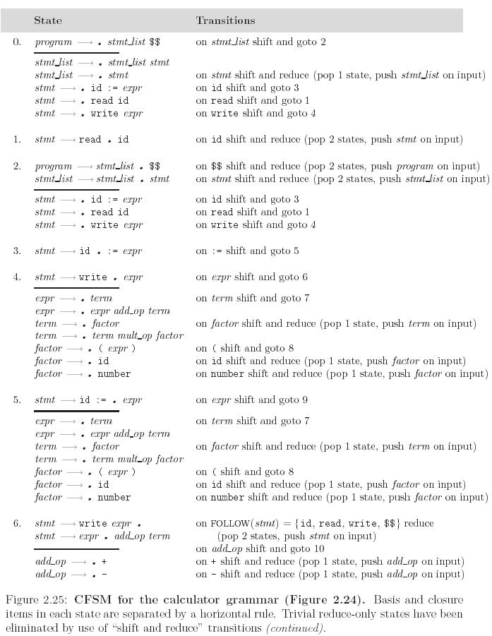

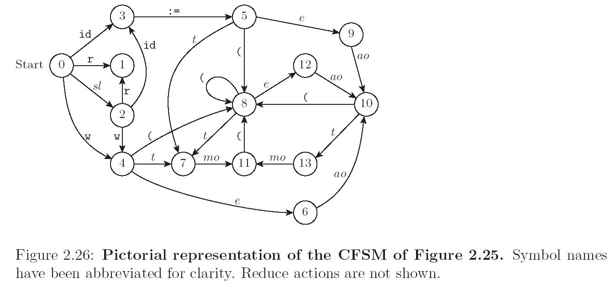

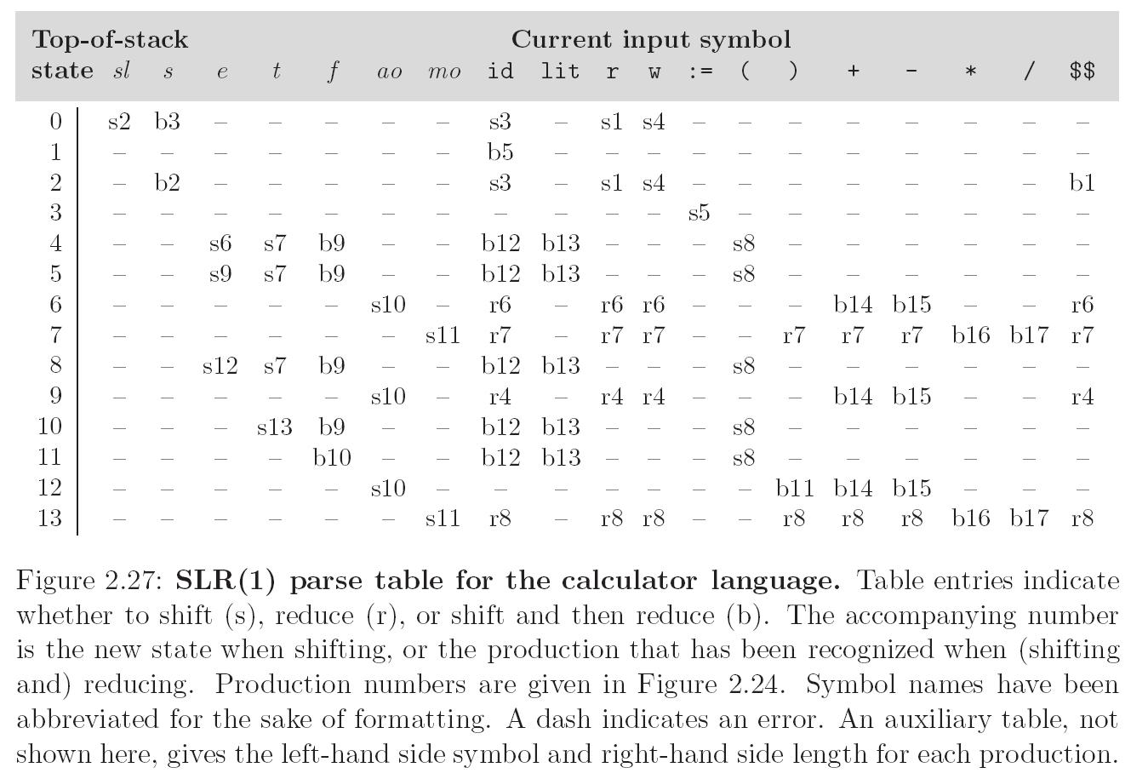

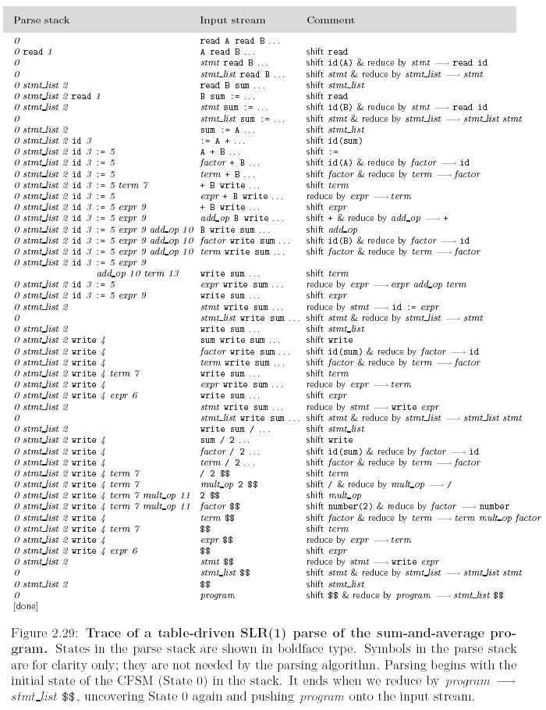

SLR parsing is based on
- Shift
- Reduce
- Shift & Reduce (for optimization)

