Joshua Haupt

jhaupt@siue.edu

CS 434 Project 3

Joshua Haupt, Charles Helf

3.) Tables were created through both the MariaDB console, and through HEIDISQL as demonstrated below.

4.) Data was loaded through both the MariaDB console, and through HEIDISQL as demonstrated in this report. Bot used standard MySQL insert statements. Below are the tables filled with test data.

**All insert queries worked resulting in:**

MariaDB [Project3]> INSERT INTO CrimeReport (ReportNumber, DateFiled, Description) VALUES(109, '2002-10-19', 'Sue Hollenbeck Area Test Desc9');

Query OK, 1 row affected (0.03 sec)

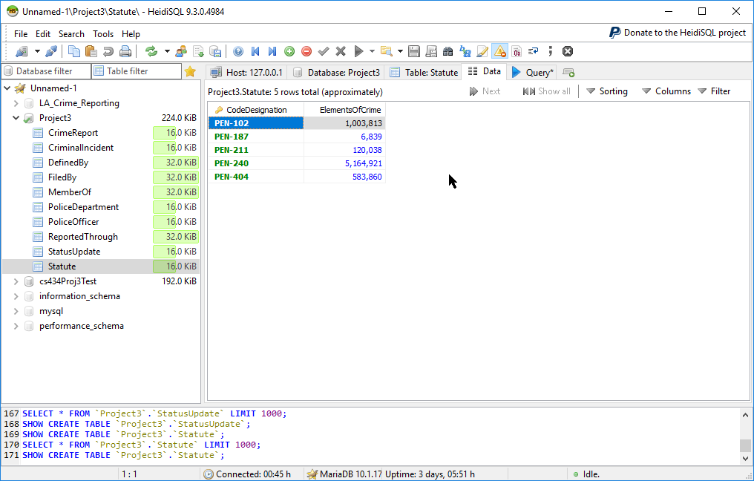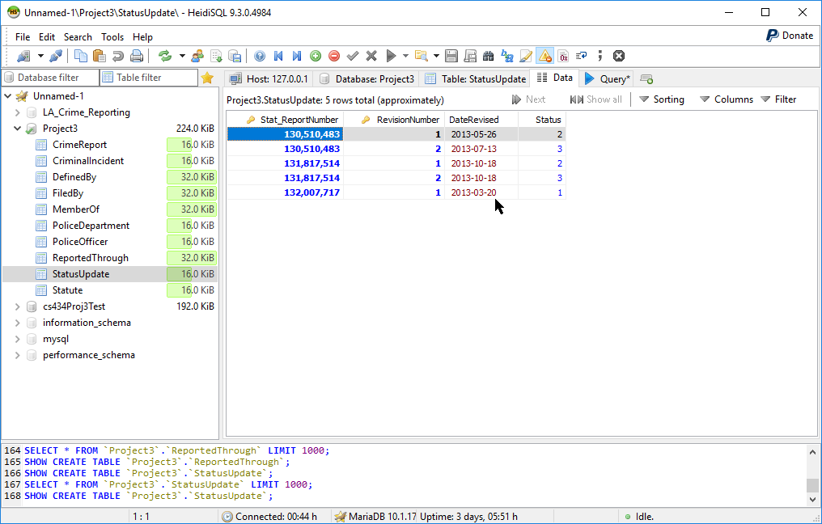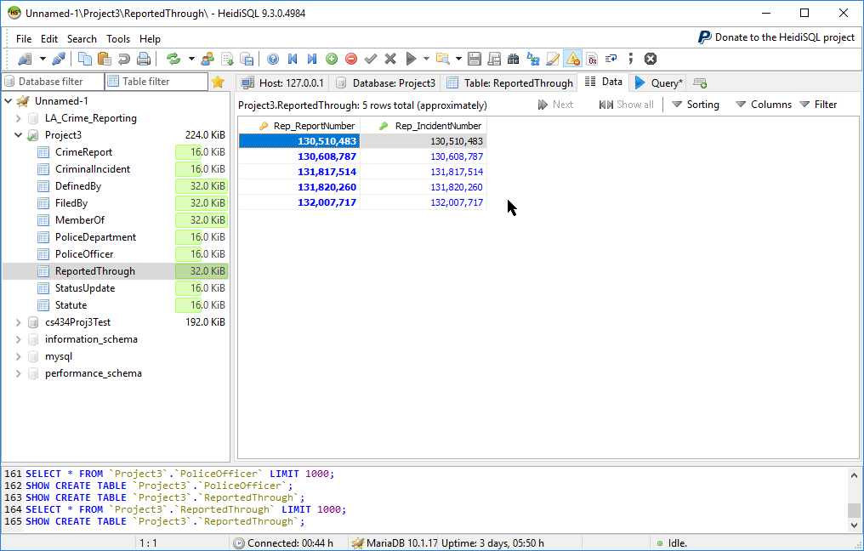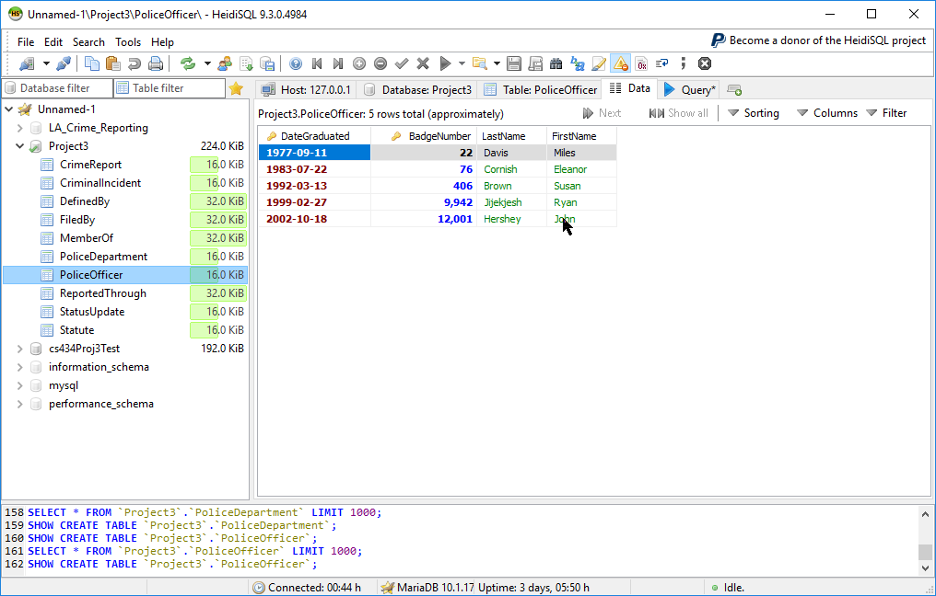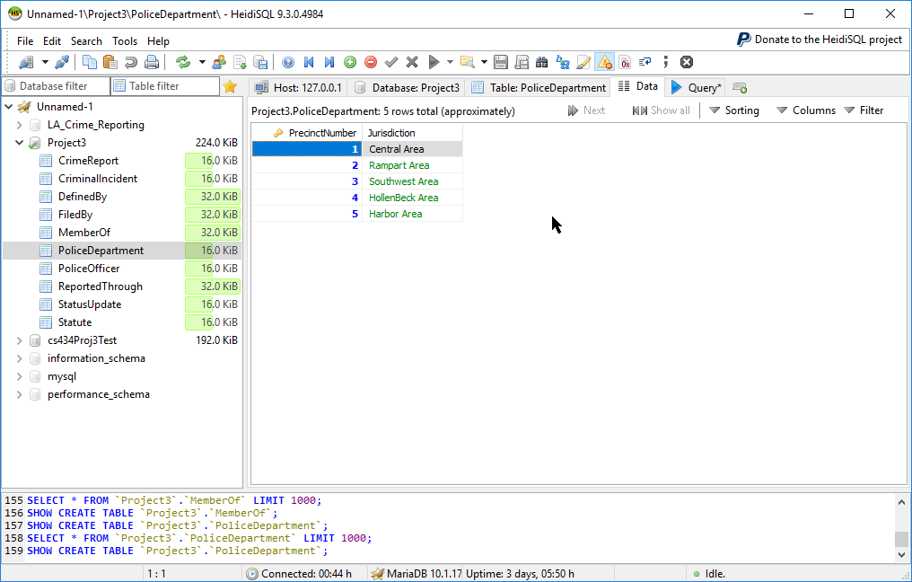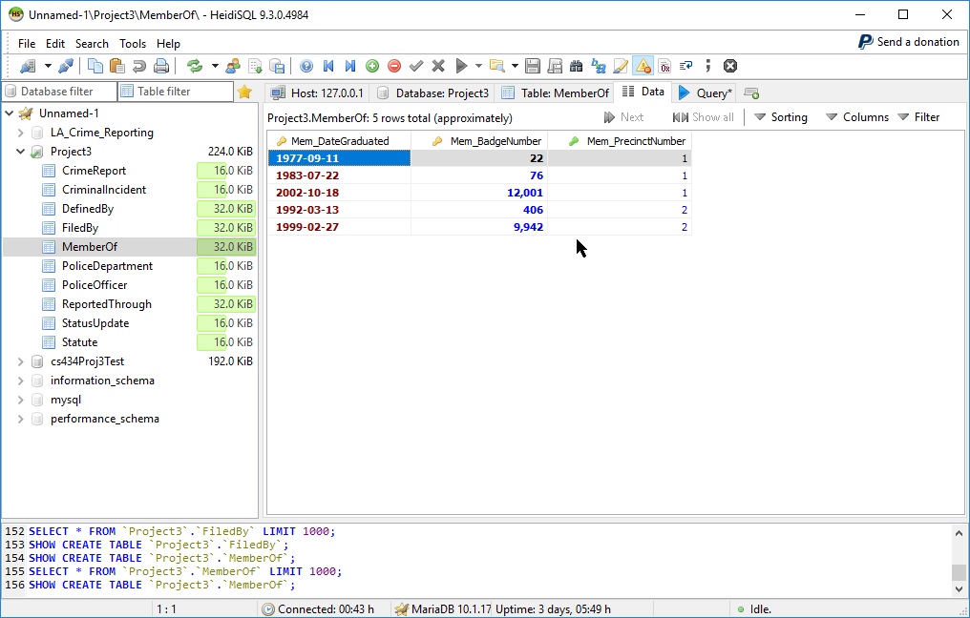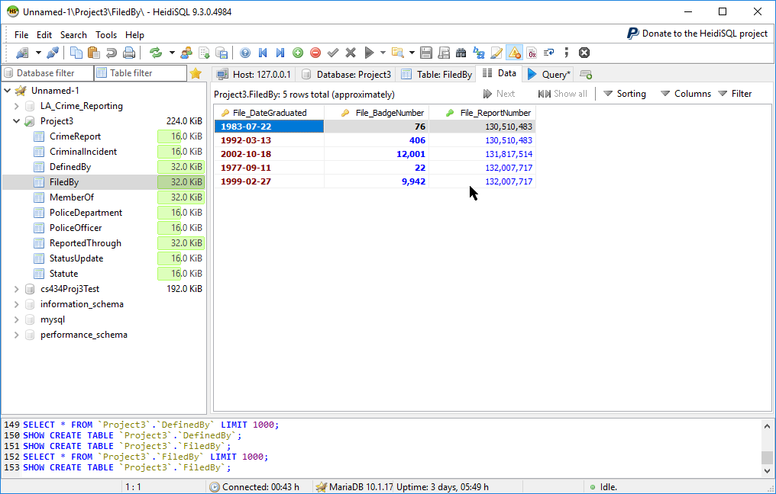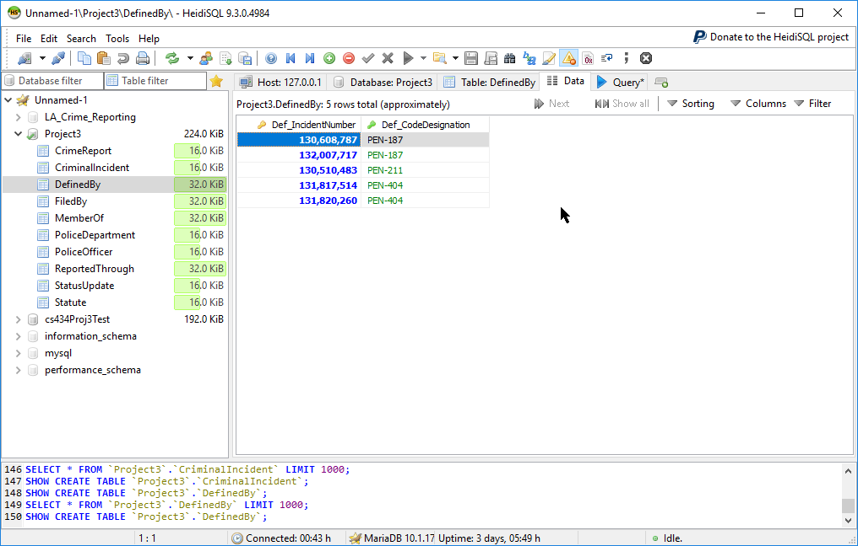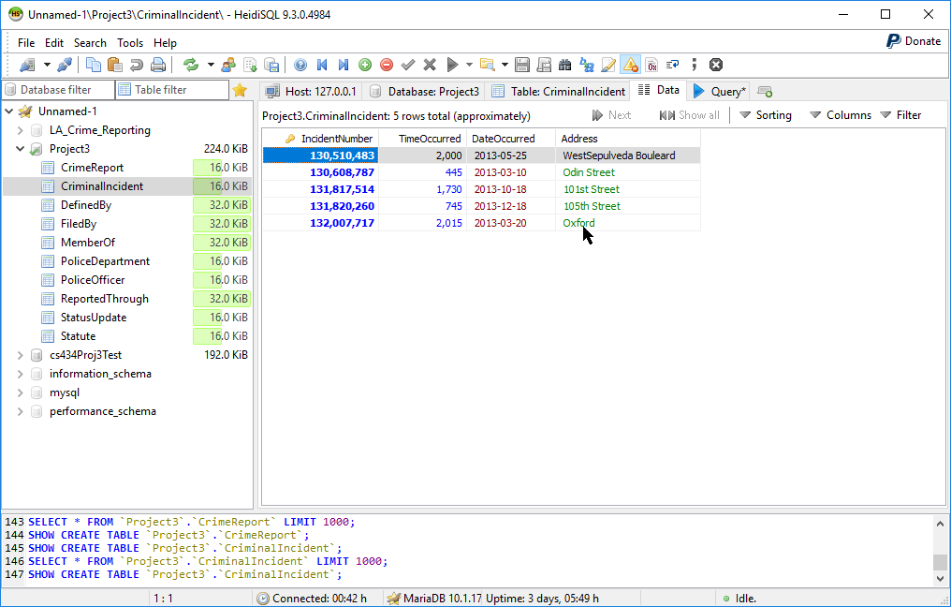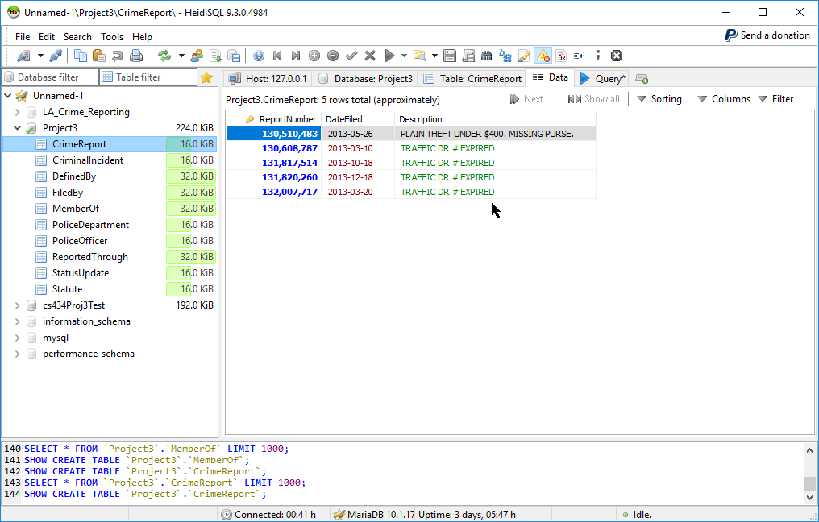

3.) Tables were created through both the MariaDB console, and through HEIDISQL as demonstrated below.

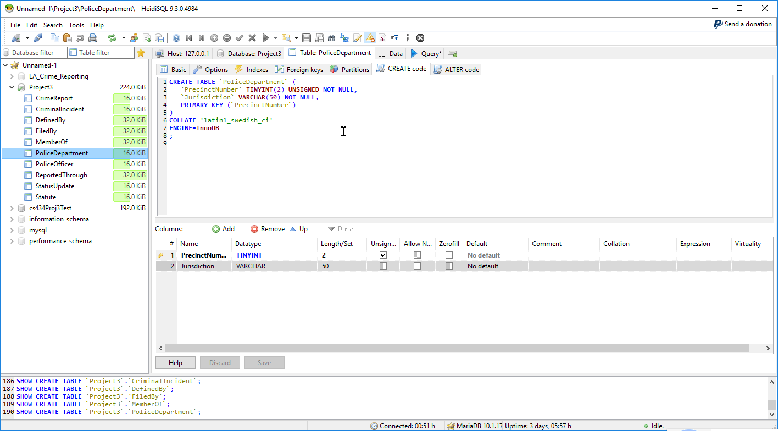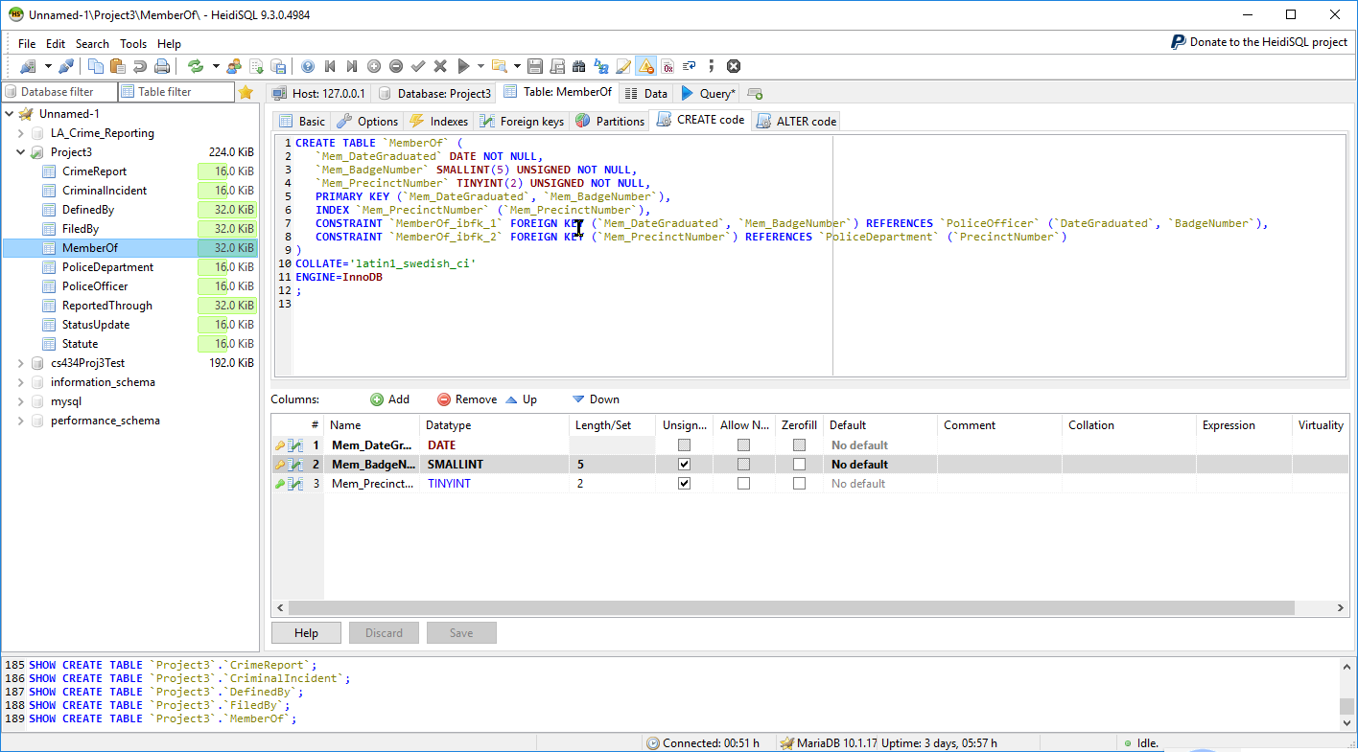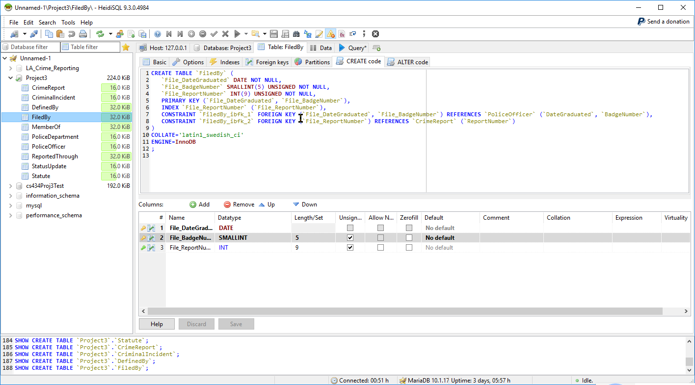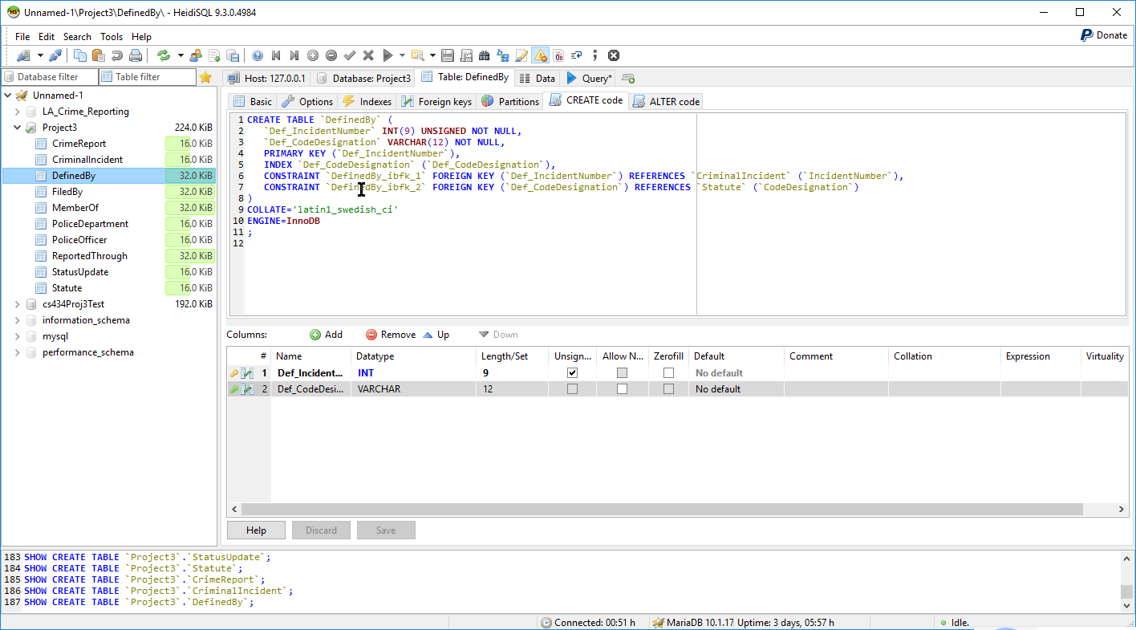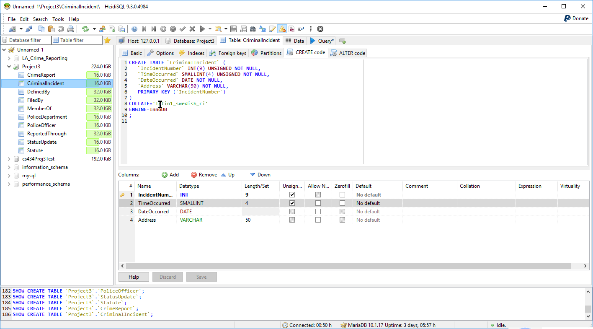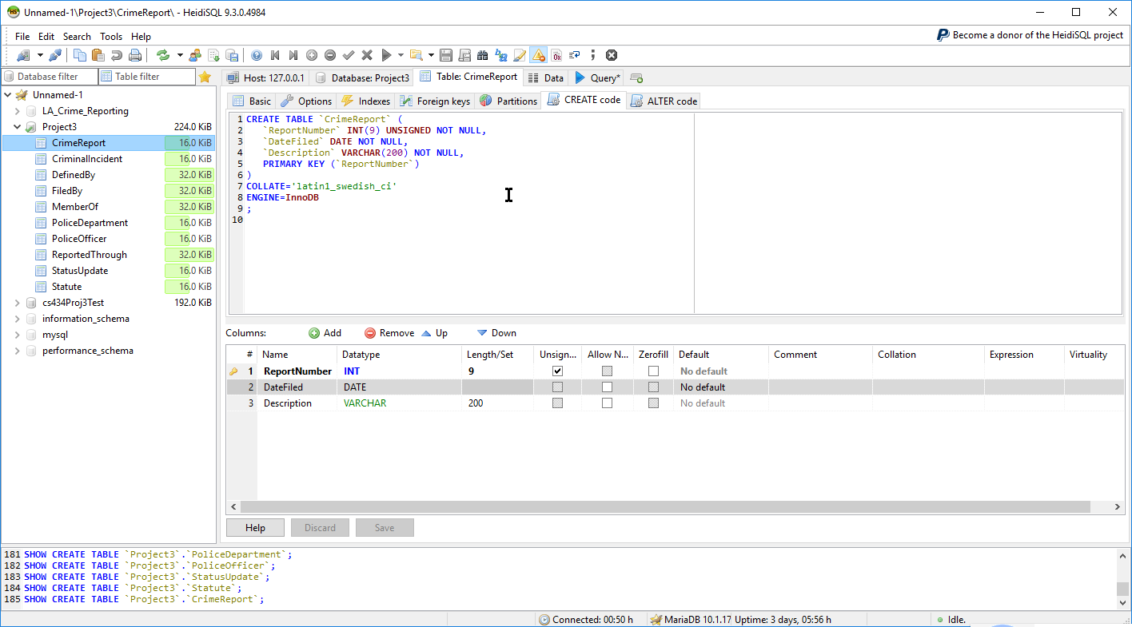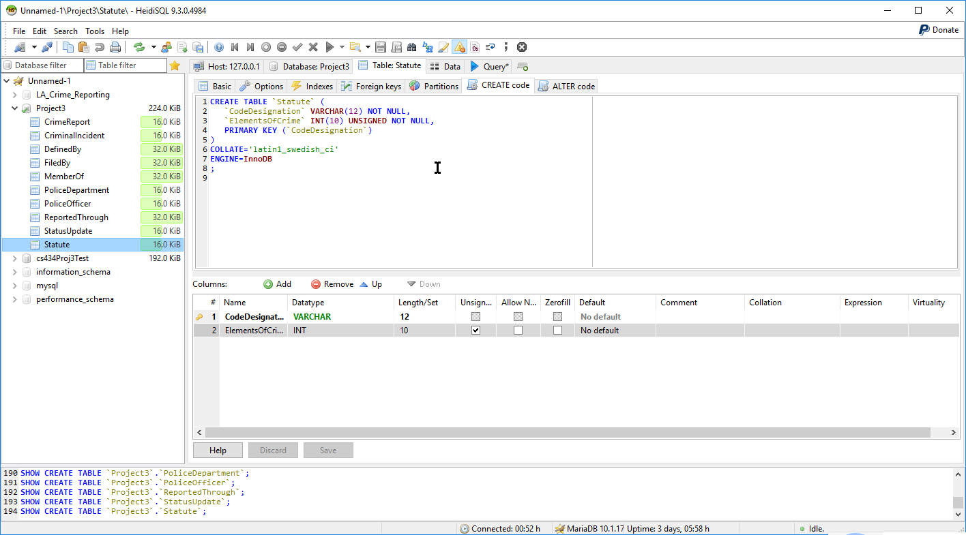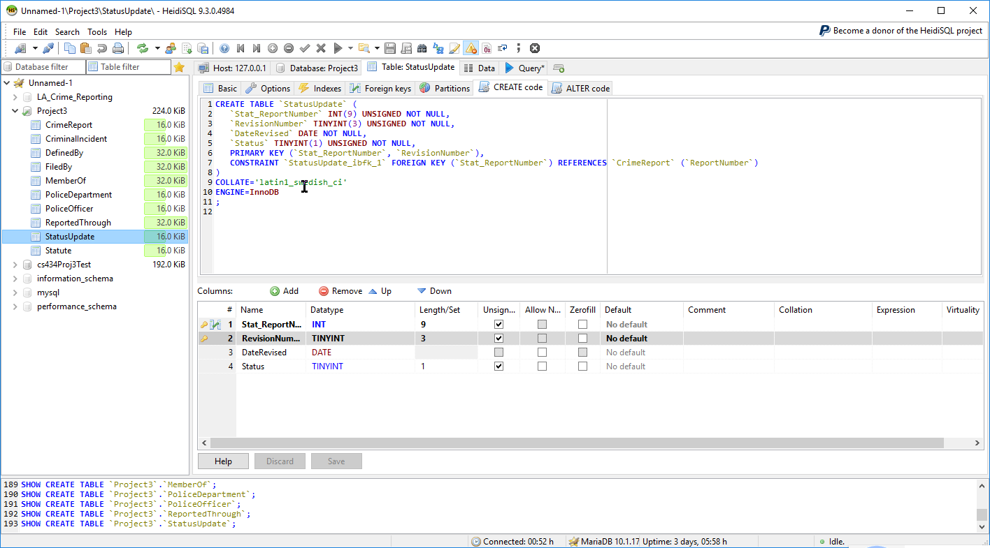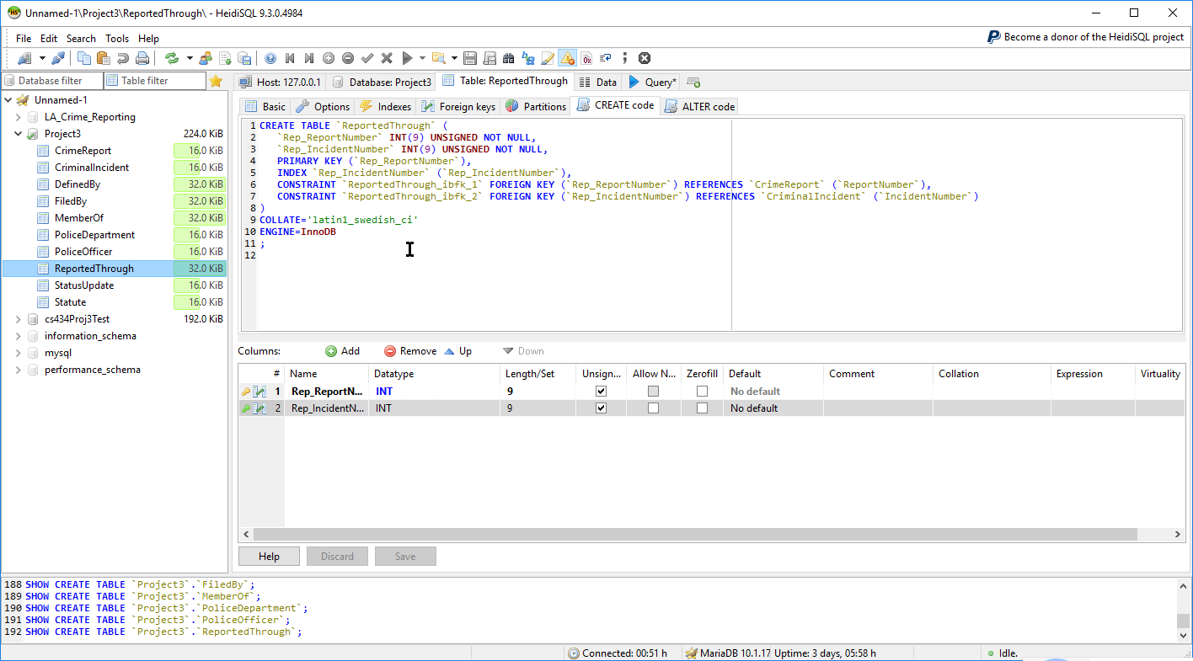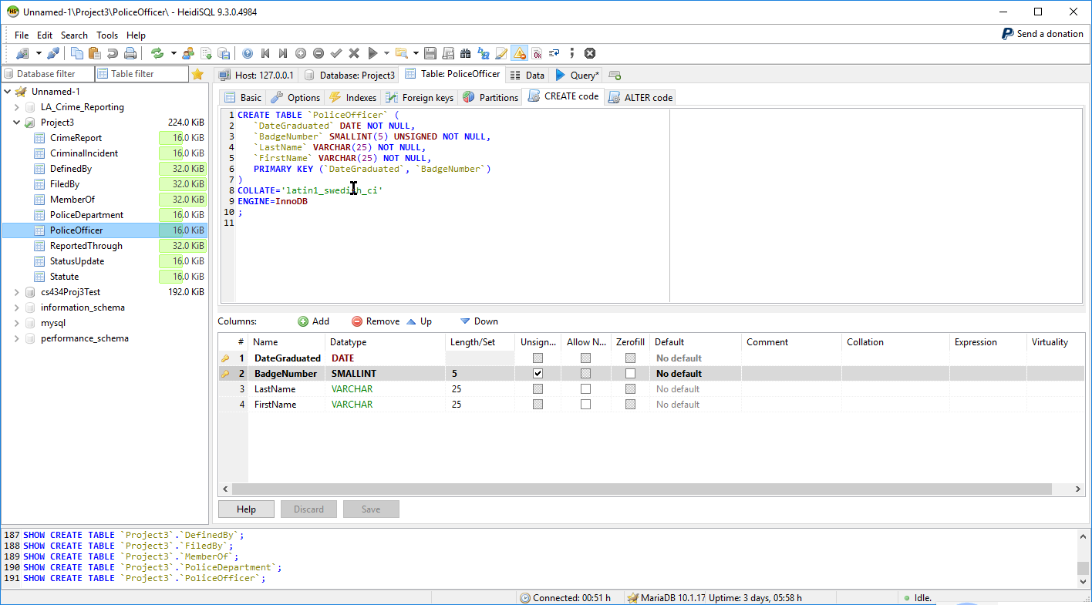

**MySQL Create and Insert Command Statements:**

;

CREATE TABLE IF NOT EXISTS Statute(

CodeDesignation VARCHAR(12) NOT NULL,

ElementsOfCrime INT UNSIGNED NOT NULL,

CONSTRAINT 'pk_code' PRIMARY KEY(CodeDesignation) NOT DEFERRABLE) ENGINE = InnoDB;

CREATE TABLE IF NOT EXISTS Statute( CodeDesignation VARCHAR(12) NOT NULL, ElementsOfCrime INT UNSIGNED NOT NULL, CONSTRAINT 'pk_code' PRIMARY KEY(CodeDesignation) NOT DEFERRABLE) ENGINE = InnoDB;

CREATE TABLE IF NOT EXISTS Statute( CodeDesignation VARCHAR(12) NOT NULL, ElementsOfCrime INT UNSIGNED NOT NULL, CONSTRAINT 'pk_code' PRIMARY KEY(CodeDesignation) NOT DEFERRABLE);

;

CREATE TABLE IF NOT EXISTS Statute(

CodeDesignation VARCHAR(12) NOT NULL,

ElementsOfCrime INT UNSIGNED NOT NULL,

CONSTRAINT pk_code PRIMARY KEY(CodeDesignation) NOT DEFERRABLE INITIALLY IMMEDIATE

) Engine=InnoDB;

CREATE TABLE IF NOT EXISTS Statute( CodeDesignation VARCHAR(12) NOT NULL, ElementsOfCrime INT UNSIGNED NOT NULL, CONSTRAINT pk_code PRIMARY KEY(CodeDesignation) NOT DEFERRABLE INITIALLY IMMEDIATE ) Engine=InnoDB;

CREATE TABLE IF NOT EXISTS Statute( CodeDesignation VARCHAR(12) NOT NULL, ElementsOfCrime INT UNSIGNED NOT NULL, CONSTRAINT pk_code PRIMARY KEY(CodeDesignation) NOT DEFERRABLE INITIALLY IMMEDIATE) Engine=InnoDB;

CREATE TABLE IF NOT EXISTS Statute( CodeDesignation VARCHAR(12) NOT NULL, ElementsOfCrime INT UNSIGNED NOT NULL, CONSTRAINT pk_code PRIMARY KEY CodeDesignation NOT DEFERRABLE INITIALLY IMMEDIATE) Engine=InnoDB;

CREATE TABLE IF NOT EXISTS Statute (Code Designation VARCHAR(12) NOT NULL, ElementsOfCrime INT UNSIGNED NOT NULL, CONSTRAINT pk_code PRIMARY KEY (Code Designation) NOT DEFERRABLE INITIALLY IMMEDIATE) Engine = InnoDB;

CREATE TABLE IF NOT EXISTS Statute (Code Designation VARCHAR(12) NOT NULL, ElementsOfCrime INT UNSIGNED NOT NULL, PRIMARY KEY (CodeDesignation) NOT DEFERRABLE) ENGINE = InnoDB;

CREATE TABLE IF NOT EXISTS Statute (Code Designation VARCHAR(12) NOT NULL, ElementsOfCrime INT UNSIGNED NOT NULL, PRIMARY KEY (CodeDesignation)) ENGINE = InnoDB;

;

CREATE TABLE IF NOT EXISTS Statute (CodeDesignation VARCHAR(12) NOT NULL) ENGINE=InnoDB;

drop table Statute;

CREATE TABLE IF NOT EXISTS Statute (CodeDesignation VARCHAR(12) NOT NULL, ElementsOfCrime INT UNSIGNED NOT NULL, PRIMARY KEY (CodeDesignation)) Engine=InnoDB;

drop Statute;

CREATE TABLE IF NOT EXISTS Statute (CodeDesignation VARCHAR(12) NOT NULL, ElementsOfCrime INT UNSIGNED NOT NULL, PRIMARY KEY (CodeDesignation) NOT DEFERRABLE) Engine=InnoDB;

;

drop Statute;

drop table Statute;

CREATE TABLE IF NOT EXISTS Statute (CodeDeignation VARCHAR(12) NOT NULL, ElementsOfCrime INT UNSIGNED NOT NULL, PRIMARY KEY CodeDesignation NOT DEFERRABLE) ENGINE = InnoDB;

CREATE TABLE IF NOT EXISTS Statute (CodeDeignation VARCHAR(12) NOT NULL, ElementsOfCrime INT UNSIGNED NOT NULL, PRIMARY KEY CodeDesignation NOT DEFERRABLE);

CREATE TABLE IF NOT EXISTS Statute (CodeDeignation VARCHAR(12) NOT NULL, ElementsOfCrime INT UNSIGNED NOT NULL, PRIMARY KEY CodeDesignation DEFERRABLE);

CREATE TABLE Statute (CodeDesignation VARCHAR(12) NOT NULL, ElementsOfCrime INT UNSIGNED NOT NULL, PRIMARY KEY CodeDesignation) ENGINE = InnoDB;

CREATE TABLE Statute (CodeDesignation VARCHAR(12) NOT NULL, ElementsOfCrime INT UNSIGNED NOT NULL, PRIMARY KEY (CodeDesignation)) ENGINE = InnoDB;

CREATE TABLE Statute (CodeDesignation VARCHAR(12) NOT NULL, ElementsOfCrime INT UNSIGNED NOT NULL, PRIMARY KEY (CodeDesignation) NOT DEFERRABLE) ENGINE = InnoDB;

CREATE TABLE Statute (CodeDesignation VARCHAR(12) NOT NULL, ElementsOfCrime INT UNSIGNED NOT NULL, PRIMARY KEY (CodeDesignation) DEFERRABLE) ENGINE = InnoDB;

CREATE TABLE Statute (CodeDesignation VARCHAR(12) NOT NULL, ElementsOfCrime INT UNSIGNED NOT NULL, CONSTRAINT 'pk_codedes' PRIMARY KEY (CodeDesignation) DEFERRABLE) ENGINE = InnoDB;

CREATE TABLE Statute (CodeDesignation VARCHAR(12) NOT NULL, ElementsOfCrime INT UNSIGNED NOT NULL, CONSTRAINT 'pk_codedes' PRIMARY KEY (CodeDesignation)) ENGINE = InnoDB;

CREATE TABLE Statute (CodeDesignation VARCHAR(12) NOT NULL, ElementsOfCrime INT UNSIGNED NOT NULL, PRIMARY KEY (CodeDesignation)) ENGINE = InnoDB;

;

;

;

CREATE TABLE Statute (CodeDesignation VARCHAR(12) NOT NULL, ElementsOfCrime INT UNSIGNED NOT NULL, CONSTRAINT `pk_code` PRIMARY KEY (CodeDesignation) NOT DEFERRABLE) ENGINE = InnoDB;

CREATE TABLE Statute (CodeDesignation VARCHAR(12) NOT NULL, ElementsOfCrime INT UNSIGNED NOT NULL, PRIMARY KEY (CodeDesignation)); ENGINE = InnoDB;

;

drop table Statute;

CREATE TABLE Statute(CodeDesignation VARCHAR(12) NOT NULL, ElementsOfCrime INT UNSIGNED NOT NULL, PRIMARY KEY (CodeDesignation)) ENGINE = InnoDB;

CREATE TABLE CriminalIncident(IncidentNumber INT(9) UNSIGNED NOT NULL, TimeOccurred SMALLINT(4) UNSIGNED NOT NULL, DateOccurred DATE NOT NULL, Address VARCHAR(50) NOT NULL, PRIMARY KEY(IncidentNumber) Engine = InnoDB;

CREATE TABLE CriminalIncident ( IncidentNumber INT(9) UNSIGNED NOT NULL, TimeOccurred SMALLINT(4) UNSIGNED NOT NULL, DateOccurred DATE NOT NULL, Address VARCHAR(50) NOT NULL, PRIMARY KEY(IncidentNumber)) Engine = InnoDB;

CREATE TABLE DefinedBy(Def_IncidentNumber INT(9) UNSIGNED NOT NULL, Def_CodeDesignation VARCHAR(12) NOT NULL, PRIMARY KEY (Def_IncidentNumber), FOREIGN KEY (Def_IncidentNumber) REFERENCES CriminalIncident(IncidentNumber), FOREIGN KEY (Def_CodeDesignation) REFERENCES Statute(CodeDesignation) ENGINE = InnoDB;

CREATE TABLE DefinedBy(Def_IncidentNumber INT(9) UNSIGNED NOT NULL, Def_CodeDesignation VARCHAR(12) NOT NULL, PRIMARY KEY (Def_IncidentNumber), FOREIGN KEY (Def_IncidentNumber) REFERENCES CriminalIncident(IncidentNumber), FOREIGN KEY (Def_CodeDesignation) REFERENCES Statute(CodeDesignation)) ENGINE = InnoDB;

CREATE TABLE CrimeReport( ReportNumber INT(9) UNSIGNED NOT NULL, DateFiled DATE NOT NULL, Description VARCHAR(200) NOT NULL, PRIMARY KEY (ReportNumber)) ENGINE = InnoDB;

CREATE TABLE ReportedThrough( Rep_ReportNumber INT(9) UNSIGNED NOT NULL, Rep_IncidentNumber INT(9) UNSIGNED NOT NULL, PRIMARY KEY (Rep_ReportNumber), FOREIGN KEY (Rep_ReportNumber) REFERENCES CrimeReport(ReportNumber), FOREIGN KEY (Rep_IncidentNumber) REFERENCES CriminalIncident(IncidentNumber)) ENGINE = InnoDB;

CREATE TABLE StatusUpdate( Stat_ReportNumber INT(9) UNSIGNED NOT NULL, RevisionNumber TINYINT UNSIGNED NOT NULL, DateRevised DATE NOT NULL, Status TINYINT(1) UNSIGNED NOT NULL, PRIMARY KEY (Stat_ReportNumber, RevisionNumber), FOREIGN KEY (Stat_ReportNumber) REFERENCES CrimeReport(ReportNumber)) ENGINE = InnoDB;

CREATE TABLE PoliceOfficer (DateGraduated DATE NOT NULL, BadgeNumber SMALLINT(5) UNSIGNED NOT NULL, LastName VARCHAR(25) NOT NULL, FirstName VARCHAR(25) NOT NULL, PRIMARY KEY (DateGraduated, BadgeNumber)) ENGINE = InnoDB;

CREATE TABLE FiledBy (File_DateGraduated DATE NOT NULL, File_BadgeNumber SMALLINT(5) UNSIGNED NOT NULL, File_ReportNumber INT NOT NULL, PRIMARY KEY (File_DateGraduated, File_BadgeNumber), FOREIGN KEY (File_DateGraduated, File_BadgeNumber) REFERENCES PoliceOfficer(DateGraduated, BadgeNumber), FOREIGN KEY (File_ReportNumber) REFERENCES CrimeReport(ReportNumber)) ENGINE = InnoDB;

CREATE TABLE FiledBy (File_DateGraduated DATE NOT NULL, File_BadgeNumber SMALLINT(5) UNSIGNED NOT NULL, File_ReportNumber INT NOT NULL, PRIMARY KEY (File_DateGraduated, File_BadgeNumber), FOREIGN KEY (File_DateGraduated, File_BadgeNumber) REFERENCES PoliceOfficer(DateGraduated, BadgeNumber), FOREIGN KEY (File_ReportNumber) REFERENCES CrimeReport (ReportNumber)) ENGINE = InnoDB;

;

describe FiledBy

;

show create table FiledBy;

show create table DescribedIn;

;

show create table definedby;

show create table DefinedBy;

;

CREATE TABLE FiledBy ( File_DateGraduated DATE NOT NULL, File_BadgeNumber SMALLINT(5) UNSIGNED NOT NULL, File_ReportNumber INT(9) NOT NULL, PRIMARY KEY (File_DateGraduated, File_BadgeNumber), FOREIGN KEY (File_DateGraduated, File_BadgeNumber) REFERENCES PoliceOfficer (DateGraduated, BadgeNumber), FOREIGN KEY (File_ReportNumber) REFERENCES CrimeReport (ReportNumber)) ENGINE = InnoDB;

CREATE TABLE FiledBy ( File_DateGraduated DATE NOT NULL, File_BadgeNumber SMALLINT(5) UNSIGNED NOT NULL, File_ReportNumber INT(9) UNSIGNED NOT NULL, PRIMARY KEY (File_DateGraduated, File_BadgeNumber), FOREIGN KEY (File_DateGraduated, File_BadgeNumber) REFERENCES PoliceOfficer (DateGraduated, BadgeNumber), FOREIGN KEY (File_ReportNumber) REFERENCES CrimeReport (ReportNumber)) ENGINE = InnoDB;

;

CREATE TABLE PoliceDepartment ( PrecinctNumber TINYINT(2) UNSIGNED NOT NULL, Jurisdiction VARCHAR(50) NOT NULL, PRIMARY KEY (PrecinctNumber)) ENGINE = InnoDB;

CREATE TABLE MemberOf ( Mem_DateGraduated DATE NOT NULL, Mem_BadgeNumber SMALLINT(5) UNSIGNED NOT NULL, Mem_PrecinctNumber TINYINT (2) UNSIGNED NOT NULL, PRIMARY KEY (Mem_DateGraduated, Mem_BadgeNumber), FOREIGN KEY (Mem_DateGraduated, Mem_BadgeNumber) REFERENCES PoliceOfficer (DateGraduated, BadgeNumber), FOREIGN KEY (Mem_PrecicntNumber) REFERENCES PoliceDepartment (PrecinctNumber)) ENGINE = InnoDB;

CREATE TABLE MemberOf ( Mem_DateGraduated DATE NOT NULL, Mem_BadgeNumber SMALLINT(5) UNSIGNED NOT NULL, Mem_PrecinctNumber TINYINT (2) UNSIGNED NOT NULL, PRIMARY KEY (Mem_DateGraduated, Mem_BadgeNumber), FOREIGN KEY (Mem_DateGraduated, Mem_BadgeNumber) REFERENCES PoliceOfficer (DateGraduated, BadgeNumber), FOREIGN KEY (Mem_PrecinctNumber) REFERENCES PoliceDepartment (PrecinctNumber)) ENGINE = InnoDB;

;

;

INSERT INTO Statute (CodeDesignation, ElementsOfCrime) VALUES ('PEN-102', 1003813), ('PEN-211', 120038), ('PEN-240', 5164921), ('PEN-187', 6839), ('PEN-404', 583860);

INSERT INTO PoliceOfficer (DateGraduated, BadgeNumber, LastName, FIrstName) VALUES ('2002-10-18', 12001, 'Hershey', 'John'), ('1999-02-27', 9942, 'Jijekjesh', 'Ryan'), ('1983-07-22', 76, 'Cornish', 'Eleanor'), ('1992-03-13', 406, 'Brown', 'Susan'), ('1977-09-11', 22, 'Davis', 'Miles');

INSERT INTO PoliceDepartment (PrecinctNumber, Jurisdiction) VALUES (1, 'Central Area'), (2, 'Rampart Area'), (3, 'Southwest Area'), (4, 'HollenBeck Area'), (5, 'Harbor Area');

INSERT INTO DefinedBy (Def_IncidentNumber, Def_CodeDesignation) VALUES (132007717, 'PEN-187'), (130608787, 'PEN-187'), (131820260, 'PEN-404'), (131817514, 'PEN-404'), (130510483, 'PEN-211');

show table PoliceOfficer;

show PoliceOfficer;

select * from PoliceOfficer;

select * from MemberOf;

select * from PoliceDepartment;

INSERT INTO DefinedBy (Def_IncidentNumber, Def_CodeDesignation) VALUES (132007717, 'PEN-187'), (130608787, 'PEN-187'), (131820260, 'PEN-404'), (131817514, 'PEN-404'), (130510483, 'PEN-211');

select * from DefinedBy;

;

select * from CriminalIncident;

select * from PoliceOfficer;

INSERT INTO CriminalIncident (IncidentNumber, TimeOccurred, DateOccurred, Address) VALUES (132007717, 2015, '2013-03-20', 'Oxford'), (130608787, 445, '2013-03-10', 'Odin Street'), (131820260, 745, '2013-12-18', '105th Street'), (131817514, 1730, '2013-10-18', '101st Street'), (130510483, 2000, '2013-05-25', 'WestSepulveda Bouleard');

INSERT INTO DefinedBy (Def_IncidentNumber, Def_CodeDesignation) VALUES (132007717, 'PEN-187'), (130608787, 'PEN-187'), (131820260, 'PEN-404'), (131817514, 'PEN-404'), (130510483, 'PEN-211');

select * from ReportedThrough;

INSERT INTO ReportedThrough (Rep_ReportNumber, Rep_IncidentNumber) VALUES (132007717, 132007717), (130608787, 130608787), (131820260, 131820260), (131817514, 131817514), (130510483, 130510483);

;

;

INSERT INTO CrimeReport (ReportNumber, DateFiled, Description) VALUES (132007717, '2013-03-20', 'TRAFFIC DR # EXPIRED'), (130608787, '2013-03-10', 'TRAFFIC DR # EXPIRED'), (131820260, '2013-12-18', 'TRAFFIC DR # EXPIRED'), (131817514, '2013-10-18', 'TRAFFIC DR # EXPIRED'), (130510483, '2013-05-26', 'PLAIN THEFT UNDER $400. MISSING PURSE.');

INSERT INTO ReportedThrough (Rep_ReportNumber, Rep_IncidentNumber) VALUES (132007717, 132007717), (130608787, 130608787), (131820260, 131820260), (131817514, 131817514), (130510483, 130510483);

INSERT INTO StatusUpdate (Stat_ReportNumber, RevisionNumber, DateRevised, Status) VALUES (132007717, 1, '2013-03-20', 1), (130510483, 1, '2013-05-26', 2), (130510483, 2, '2013-07-13', 3), (131817514, 1, '2013-10-18', 2), (131817514, '2013-10-18', 3);

INSERT INTO StatusUpdate (Stat_ReportNumber, RevisionNumber, DateRevised, Status) VALUES (132007717, 1, '2013-03-20', 1), (130510483, 1, '2013-05-26', 2), (130510483, 2, '2013-07-13', 3), (131817514, 1, '2013-10-18', 2), (131817514, 2, '2013-10-18', 3);

select * from PoliceOfficer;

INSERT INTO FiledBy (File_DateGraduated, File_BadgeNumber, File_ReportNumber) VALUES ('1977-09-11', 22' 132007717), ('1999-02-27', 9942, 132007717), ('1992-03-13', 406, 130510483), ('1983-07-22', 76, 130510483), ('1977-09-11', 22, 131817514);

;

'

;

INSERT INTO FiledBy (File_DateGraduated, File_BadgeNumber, File_ReportNumber) VALUES ('1977-09-11', 22' 132007717), ('1999-02-27', 9942, 132007717), ('1992-03-13', 406, 130510483), ('1983-07-22', 76, 130510483), ('1977-09-11', 22, 131817514);\012;\012\012';

INSERT INTO FiledBy (File_DateGraduated, File_BadgeNumber, File_ReportNumber) VALUES ('1977-09-11', 22, 132007717), ('1999-02-27', 9942, 132007717), ('1992-03-13', 406, 130510483), ('1983-07-22', 76, 130510483), ('1977-09-11', 22, 131817514);

select * from FiledBy;

INSERT INTO FiledBy (File_DateGraduated, File_BadgeNumber, File_ReportNumber) VALUES ('1977-09-11', 22, 132007717), ('1999-02-27', 9942, 132007717), ('1992-03-13', 406, 130510483), ('1983-07-22', 76, 130510483), ('2002-10-18', 12001, 131817514);

INSERT INTO MemberOf (Mem_DateGraduated, Mem_BadgeNumber, Mem_PrecinctNumber) VALUES ('1977-09-11', 22, 1), ('1999-02-27', 9942, 2), ('2002-10-18', 12001, 1), ('1983-07-22', 76, 1), ('1992-03-13', 406, 2);

**Create Command Statements:**

**CREATE** **TABLE** `CrimeReport` (

`ReportNumber` **INT**(9) **UNSIGNED** **NOT** **NULL**,

`DateFiled` **DATE** **NOT** **NULL**,

`Description` **VARCHAR**(200) **NOT** **NULL**,

**PRIMARY** **KEY** (`ReportNumber`)

)

**COLLATE**='latin1_swedish_ci'

**ENGINE**=**InnoDB**

;

**CREATE** **TABLE** `CriminalIncident` (

`IncidentNumber` **INT**(9) **UNSIGNED** **NOT** **NULL**,

`TimeOccurred` **SMALLINT**(4) **UNSIGNED** **NOT** **NULL**,

`DateOccurred` **DATE** **NOT** **NULL**,

`Address` **VARCHAR**(50) **NOT** **NULL**,

**PRIMARY** **KEY** (`IncidentNumber`)

)

**COLLATE**='latin1_swedish_ci'

**ENGINE**=**InnoDB**

;

**CREATE** **TABLE** `DefinedBy` (

`Def_IncidentNumber` **INT**(9) **UNSIGNED** **NOT** **NULL**,

`Def_CodeDesignation` **VARCHAR**(12) **NOT** **NULL**,

**PRIMARY** **KEY** (`Def_IncidentNumber`),

**INDEX** `Def_CodeDesignation` (`Def_CodeDesignation`),

**CONSTRAINT** `DefinedBy_ibfk_1` **FOREIGN** **KEY** (`Def_IncidentNumber`) **REFERENCES** `CriminalIncident` (`IncidentNumber`),

**CONSTRAINT** `DefinedBy_ibfk_2` **FOREIGN** **KEY** (`Def_CodeDesignation`) **REFERENCES** `Statute` (`CodeDesignation`)

)

**COLLATE**='latin1_swedish_ci'

**ENGINE**=**InnoDB**

;

**CREATE** **TABLE** `FiledBy` (

`File_DateGraduated` **DATE** **NOT** **NULL**,

`File_BadgeNumber` **SMALLINT**(5) **UNSIGNED** **NOT** **NULL**,

`File_ReportNumber` **INT**(9) **UNSIGNED** **NOT** **NULL**,

**PRIMARY** **KEY** (`File_DateGraduated`, `File_BadgeNumber`),

**INDEX** `File_ReportNumber` (`File_ReportNumber`),

**CONSTRAINT** `FiledBy_ibfk_1` **FOREIGN** **KEY** (`File_DateGraduated`, `File_BadgeNumber`) **REFERENCES** `PoliceOfficer` (`DateGraduated`, `BadgeNumber`),

**CONSTRAINT** `FiledBy_ibfk_2` **FOREIGN** **KEY** (`File_ReportNumber`) **REFERENCES** `CrimeReport` (`ReportNumber`)

)

**COLLATE**='latin1_swedish_ci'

**ENGINE**=**InnoDB**

;

**CREATE** **TABLE** `MemberOf` (

`Mem_DateGraduated` **DATE** **NOT** **NULL**,

`Mem_BadgeNumber` **SMALLINT**(5) **UNSIGNED** **NOT** **NULL**,

`Mem_PrecinctNumber` **TINYINT**(2) **UNSIGNED** **NOT** **NULL**,

**PRIMARY** **KEY** (`Mem_DateGraduated`, `Mem_BadgeNumber`),

**INDEX** `Mem_PrecinctNumber` (`Mem_PrecinctNumber`),

**CONSTRAINT** `MemberOf_ibfk_1` **FOREIGN** **KEY** (`Mem_DateGraduated`, `Mem_BadgeNumber`) **REFERENCES** `PoliceOfficer` (`DateGraduated`, `BadgeNumber`),

**CONSTRAINT** `MemberOf_ibfk_2` **FOREIGN** **KEY** (`Mem_PrecinctNumber`) **REFERENCES** `PoliceDepartment` (`PrecinctNumber`)

)

**COLLATE**='latin1_swedish_ci'

**ENGINE**=**InnoDB**

;

**CREATE** **TABLE** `PoliceDepartment` (

`PrecinctNumber` **TINYINT**(2) **UNSIGNED** **NOT** **NULL**,

`Jurisdiction` **VARCHAR**(50) **NOT** **NULL**,

**PRIMARY** **KEY** (`PrecinctNumber`)

)

**COLLATE**='latin1_swedish_ci'

**ENGINE**=**InnoDB**

;

**CREATE** **TABLE** `PoliceOfficer` (

`DateGraduated` **DATE** **NOT** **NULL**,

`BadgeNumber` **SMALLINT**(5) **UNSIGNED** **NOT** **NULL**,

`LastName` **VARCHAR**(25) **NOT** **NULL**,

`FirstName` **VARCHAR**(25) **NOT** **NULL**,

**PRIMARY** **KEY** (`DateGraduated`, `BadgeNumber`)

)

**COLLATE**='latin1_swedish_ci'

**ENGINE**=**InnoDB**

;

**CREATE** **TABLE** `ReportedThrough` (

`Rep_ReportNumber` **INT**(9) **UNSIGNED** **NOT** **NULL**,

`Rep_IncidentNumber` **INT**(9) **UNSIGNED** **NOT** **NULL**,

**PRIMARY** **KEY** (`Rep_ReportNumber`),

**INDEX** `Rep_IncidentNumber` (`Rep_IncidentNumber`),

**CONSTRAINT** `ReportedThrough_ibfk_1` **FOREIGN** **KEY** (`Rep_ReportNumber`) **REFERENCES** `CrimeReport` (`ReportNumber`),

**CONSTRAINT** `ReportedThrough_ibfk_2` **FOREIGN** **KEY** (`Rep_IncidentNumber`) **REFERENCES** `CriminalIncident` (`IncidentNumber`)

)

**COLLATE**='latin1_swedish_ci'

**ENGINE**=**InnoDB**

;

**CREATE** **TABLE** `StatusUpdate` (

`Stat_ReportNumber` **INT**(9) **UNSIGNED** **NOT** **NULL**,

`RevisionNumber` **TINYINT**(3) **UNSIGNED** **NOT** **NULL**,

`DateRevised` **DATE** **NOT** **NULL**,

`Status` **TINYINT**(1) **UNSIGNED** **NOT** **NULL**,

**PRIMARY** **KEY** (`Stat_ReportNumber`, `RevisionNumber`),

**CONSTRAINT** `StatusUpdate_ibfk_1` **FOREIGN** **KEY** (`Stat_ReportNumber`) **REFERENCES** `CrimeReport` (`ReportNumber`)

)

**COLLATE**='latin1_swedish_ci'

**ENGINE**=**InnoDB**

;

**CREATE** **TABLE** `Statute` (

`CodeDesignation` **VARCHAR**(12) **NOT** **NULL**,

`ElementsOfCrime` **INT**(10) **UNSIGNED** **NOT** **NULL**,

**PRIMARY** **KEY** (`CodeDesignation`)

)

**COLLATE**='latin1_swedish_ci'

**ENGINE**=**InnoDB**

;

---Table Creation---

CREATE TABLE IF NOT EXISTS Statute(

CodeDesignation VARCHAR(12) NOT NULL,

ElementsOfCrime INT UNSIGNED NOT NULL,'

PRIMARY KEY (CodeDesignation)

) ENGINE = InnoDB;

CREATE TABLE IF NOT EXISTS CriminalIncident(

IncidentNumber INT(9) UNSIGNED NOT NULL,

TimeOccurred SMALLINT(4) UNSIGNED NOT NULL,

DateOccurred DATE NOT NULL,

Address VARCHAR(50) NOT NULL,

PRIMARY KEY (IncidentNumber)

) ENGINE = InnoDB;

CREATE TABLE IF NOT EXISTS DefinedBy(

Def_IncidentNumber INT(9) UNSIGNED NOT NULL,

Def_CodeDesignation VARCHAR(12) NOT NULL,

PRIMARY KEY (Def_IncidentNumber),

FOREIGN KEY (Def_IncidentNumber) REFERENCES CriminalIncident(IncidentNumber),

FOREIGN KEY (Def_CodeDesignation) REFERENCES Statute(CodeDesignation)

) ENGINE = InnoDB;

CREATE TABLE IF NOT EXISTS CrimeReport(

ReportNumber INT(9) UNSIGNED NOT NULL,

DateFiled DATE NOT NULL,

Description VARCHAR(200) NOT NULL,

PRIMARY KEY (ReportNumber)

) ENGINE = InnoDB;

CREATE TABLE IF NOT EXISTS ReportedThrough(

Rep_ReportNumber INT(9) UNSIGNED NOT NULL,

Rep_IncidentNumber INT(9) UNSIGNED NOT NULL,

PRIMARY KEY (Rep_ReportNumber),

FOREIGN KEY (Rep_ReportNumber) REFERENCES CrimeReport(ReportNumber),

FOREIGN KEY (Rep_IncidentNumber) REFERENCES CriminalIncident(IncidentNumber)

) ENGINE = InnoDB;

CREATE TABLE IF NOT EXISTS StatusUpdate(

Stat_ReportNumber INT(9) UNSIGNED NOT NULL,

RevisionNumber TINYINT UNSIGNED NOT NULL,

DateRevised DATE NOT NULL,

Status TINYINT(1) UNSIGNED NOT NULL,

PRIMARY KEY (Stat_ReportNumber, RevisionNumber),

FOREIGN KEY (Stat_ReportNumber) REFERENCES CrimeReport(ReportNumber)

) ENGINE = InnoDB;

CREATE TABLE IF NOT EXISTS PoliceOfficer(

DateGraduated DATE NOT NULL,

BadgeNumber SMALLINT(5) UNSIGNED NOT NULL,

LastName VARCHAR(25) NOT NULL,

FirstName VARCHAR(25) NOT NULL,

PRIMARY KEY (DateGraduated, BadgeNumber)

) ENGINE = InnoDB;

CREATE TABLE IF NOT EXISTS FiledBy(

File_DateGraduated DATE NOT NULL,

File_BadgeNumber SMALLINT(5) UNSIGNED NOT NULL,

File_ReportNumber INT(9) UNSIGNED NOT NULL,

PRIMARY KEY (File_DateGraduated, File_BadgeNumber),

FOREIGN KEY (File_DateGraduated, File_BadgeNumber) REFERENCES PoliceOfficer(DateGraduated, BadgeNumber),

FOREIGN KEY (File_ReportNumber) REFERENCES CrimeReport(ReportNumber)

) ENGINE = InnoDB;

CREATE TABLE IF NOT EXISTS PoliceDepartment(

PrecinctNumber TINYINT(2) UNSIGNED NOT NULL,

Jurisdiction VARCHAR(50) NOT NULL,

PRIMARY KEY (PrecinctNumber)

) ENGINE = InnoDB;

CREATE TABLE IF NOT EXISTS MemberOf(

Mem_DateGraduated DATE NOT NULL,

Mem_BadgeNumber SMALLINT(5) UNSIGNED NOT NULL,

Mem_PrecinctNumber TINYINT(2) UNSIGNED NOT NULL,

PRIMARY KEY (Mem_DateGraduated, Mem_BadgeNumber),

FOREIGN KEY (Mem_DateGraduated, Mem_BadgeNumber) REFERENCES PoliceOfficer (DateGraduated, BadgeNumber),

FOREIGN KEY (Mem_PrecinctNumber) REFERENCES PoliceDepartment(PrecinctNumber)

) ENGINE = InnoDB;

---SAMPLE TEST Record Insertion---

INSERT INTO Statute (CodeDesignation, ElementsOfCrime) VALUES ('PEN-102', 1003813), ('PEN-211', 120038),

('PEN-240', 5164921), ('PEN-187', 6839), ('PEN-404', 58386001);

INSERT INTO PoliceOfficer (DateGraduated, BadgeNumber, LastName, FirstName) VALUES ('2002-10-18', 12001, 'Hershey', 'John'),

('1999-02-27', 9942, 'Jijekjesh', 'Ryan'), ('1983-07-22', 76, 'Cornish', 'Eleanor'),

('1992-03-13', 406, 'Brown', 'Susan'), ('1977-09-11', 22, 'Davis', 'Miles');

INSERT INTO PoliceDepartment (PrecinctNumber, Jurisdiction) VALUES (1, 'Central Area'), (2, 'Rampart Area'),

(3, 'Southwest Area'), (4, 'Hollenbeck Area'), (5, 'Harbor Area');

INSERT INTO CrimeReport (ReportNumber, DateFiled, Description) VALUES(101, '2002-10-18', 'Sue Hollenbeck Area Test Desc1'), (11111111112, '2002-10-19', 'Bob Hollenbeck Area Test Desc2'), (11111111113, '2002-10-20', 'Bob Hollenbeck Area Test Desc3'), (11111111114, '2002-10-11', 'Bobby Hollenbeck Area Test Desc4'), (11111111115, '2009-10-19', 'Boby Hollenbeck Area Test Desc5')