The Social Psychology of Occupational Status Groups: Relationality in the Structure of Deference

Emily Maloney

December 9, 2019

### Abstract

Affect control theory predictions of average deference toward occupational identities can capture occupational status better than previous operationalizations of prestige (Freeland and Hoey 2018). Combining this new social psychological measurement of occupational status with social network methods, this paper explores the underlying relational patterns hidden within Freeland and Hoey’s (2018) scores of average deference. I construct a complete network of deference relations across 300 occupational identities using Bayesian affect control theory simulations. A blockmodel analysis resulted in four positions within the occupational deference structure:everyday specialists, service-to-society occupations, the inconveniently powerful, and the extremely good and active. These are occupational classes that defer to the same occupational identities, and that receive deference from the same occupations. Exploring the reduced blockmodel provides a more complete depiction of occupational status as measured by affect control theory.

**Keywords:** Affect control theory, occupational status, networks, blockmodeling

### Introduction

Theoretically-driven measurement of occupational class should drive the assessment of stratification questions, but debates on how to do so have little consensus. Freeland and Hoey (2018) advocated using theoretical constructs from sociological social psychology to capture acultural definition of status rather than using measures based on material resources. In that analysis, the authors conceive of prestige as linked to how culturally likely or unlikely occupations were to defer to other occupational identities. They created a ”deference score” based on affect control theory (ACT), which performs better than the General Social Survey (GSS) measure of occupational prestige when predicting workplace outcomes.

However, in Freeland and Hoey (2018) the deference scores were averaged across interactions with all other occupational identities, concealing the variation in how likely or unlikely it was for occupations to defer to other occupations. By foregrounding the relationality within occupational status, this paper advocates for a re-construction of a “big-class” occupational scheme based on this new deference measurement (Goldthorpe and Hope 1962).

Using a blockmodeling technique on a network of deference relations across 300 occupational identities, I find four blocks of occupations, representing different structural positions within the overall occupational structure. I label these blocks as (1) everyday specialists, (2) service-to-society occupations, (3) the inconveniently powerful, and (4) the good actors. Exploration of these blocks and a reduced blockmodel structure reveals the benefit of uniting a social-psychological understanding of the cultural meaning of occupations with network methods that exploit relationality. In conclusion, I compare these classes with previous class schemes, such as Goldthorpe and Hope’s (1962) original big-classes, Featherman, Jones, and Hauser’s (1975) meso-class paradigm, and argue for the benefit of using occupational classes rather than Weeden and Grusky’s (2005) micro-classes.

#### Occupational Prestige

Measuring occupational prestige is a difficult endeavor, as it needs to be able to capture the cultural dimension of social esteem net of material resources and credentials – concepts that are often highly correlated (Freeland and Hoey 2018; Ganzeboom and Treiman 1996). Most recent scholars tend to adhere to Weber’s conception of status honor when considering measurement of status, and thus base their measurements on “cultural beliefs about the relative superiority, equality, and inferiority of members of social groups” (Freeland and Hoey 2018:245). Perhaps the most used measure of occupational status in recent scholarship is the occupational prestige question in the GSS. However, there are concerns about the validity of the GSS measure, as its method of asking respondents to score occupations based on their social standing may fail to accurately measure prestige or status (Freeland and Hoey 2018).

Because sociological social psychology has long been involved in questions of status, it is useful to draw upon when developing operationalizations of cultural understandings of prestige (Ridgeway 2014). Freeland and Hoey (2018) return to the social psychological roots of status beliefs by using a formal model of social interactions, ACT (Heise 1979, 1987; Schröder, Hoey, and Rogers 2016; Robinson and Smith-Lovin 2018). The theory involves measurements of constructs that are approximately analogous to prestige and power, allowing for the explicit inclusion of these dimensions in measurements of occupational status (Rogalin, Soboroff, and Lovaglia 2007).

Using simulations generated from ACT, Freeland and Hoey (2018) constructed a network of deference relations across occupational identities. To create a single deference score for each occupation, they averaged the scores across rows of the full matrix, losing information about which occupations are likely to defer to which others. Because occupational status is such a relational construct, the additional relational data contained in the network is a ripe source for deeper analysis into the classes of occupations that have similar patterns of deference. Since the elements in the occupational deference network are produced through theoretically based ACT simulations, a summary of the theory is presented below. A full description is found in Heise (2007) and Robinson and Smith-Lovin (2018).

#### ACT

ACT is a mathematical model of social interaction that uses measurements of cultural meaning to locate identities and behaviors within a three dimensional affective space (Heise 1979). The three dimensions upon which social concepts are measured are evaluation (good/bad), potency (powerful/weak), and activity (fast/slow) (EPA hereafter). The control aspect of the model indicates that people try to maintaincultural meanings, termed fundamental sentiments.

ACT specifies equations that predict the shift in meaning (called the deflection) that occurs when an Actor does a Behavior to an Object (ABO). The new positions for impressions within affective space after the ABO event are transient impressions. The deflection of cultural meaning created by an interpersonal action (ABO) is the sum of squared differences between the EPA values for the fundamental sentiments and transient impressions of each component of the situation (Robinson and Smith-Lovin 2018). Deflection is an indicator of how culturally (dis)confirming a situation is – a higher deflection score means that an event is more culturally unexpected, because it means that there has been more movement within affective space as a result of the event. Recent scholarship has developed ACT within a Bayesian framework. Rather than point estimates of the position of the identity or behavior along the three axes of cultural meaning, the Bayesian analysis uses a distribution to account for uncertainty in cultural meaning (Schröder et al. 2016).

#### Using ACT to Measure Occupational Status

Freeland and Hoey (2018) used BayesACT’s way of measuring cultural conformity in their operationalization of occupational status. They calculated a mean deflection score for simulations of the event occupation a defers to occupation b across all of their occupational identities. Because deflection is a measure of cultural confirmation, they argued that occupations for which it is more culturally unlikely to defer to other occupations (higher deflection scores) had higher occupational status. They calculated each occupation’s deference score by averaging across all deference events and ranked occupations by these averages, with higher scores (lower deflection from deference by others) indicating greater occupational status. Here, I replicate their analysis but instead of averaging across rows, I examine the entire network of deference relations.

#### Occupational Classes

Creating classes of occupations is not a new development in the field of occupational stratification or social mobility. Positions range from Goldthorpe and Hope’s (1962) big-class scheme of occupations to Weeden and Grusky’s (2005) argumentusing micro-classes is more accurate. Scholars argue about the dimensions of importance when constructing classes, how many parameters to have when defining classes, and the acceptable heterogeneity within classes as well as the purpose of classes.

The Goldthorpe-Hope big-class scale is defined based on the market position (income and chance of mobility) as well as work position (level of authority) of occupations, and consists of seven classes: higher-grade professionals or managers, lower-grade professionals or managers, routine non-manual employees, small proprietors, farmers, lower-grade technicians, skilled manual workers, and non-skilled workers. The arguments against this big-class scheme include the within-class heterogeneity among non-measured dimensions and the theoretical reasoning behind measured dimensions (Goldthorpe 1993; Hertel 2016; Weeden and Grusky 2005).

Meso-classes subdivide the occupations further by reemphasizing hierarchical dimensions of status, culminating in more complex systems that similarly struggle with clear theoretical linkages (Featherman, Lancaster Jones, and Hauser 1975). Finally micro-classes advocate for classes at almost the occupation-level (Weeden and Grusky 2005). In the following, I try to bridge the benefits of having a big-class scheme with respecting the institutional nature of single occupations by using ACT’s clear cultural measurement paradigm to construct the classes based on the individual occupation deference relations.

### Data

The data used to construct the network of occupational deference relations is the sentiment dictionary collected from students at one private and one public university in 2015 (Robinson et al. 2016). ACT dictionaries are constructed by asking participants to rate identities and behaviors on EPA on a scale from -4.3 to 4.3. For BayesACT, the distribution of responses is used as the estimate of the identity or behavior along the three axes (Heise 2010; Schröder et al. 2016). The occupations included in this analysis match those considered in Freeland and Hoey (2018), with the exception of the identity of dishwasher. It appears that respondents envisoned the machine dishwasher rather than the occupation dishwasher when rating the E, P, and A values, so it was not included in this analysis. In total, there are 303 identities total in the data, and a full list is included in an online appendix. Descriptive statistics are displayed in Table 1.

The mean evaluation is 1.21, potency is 1.10, and activity is 0.42, indicating that the majority of occupations are thought of as relatively good, relatively powerful, and somewhat active. An important note is that the behavior to defer to has an EPA rating of -0.15, 0.45, -0.44, indicating a slightly lower then neutral evaluation and activity and a slightly more than neutral potency.

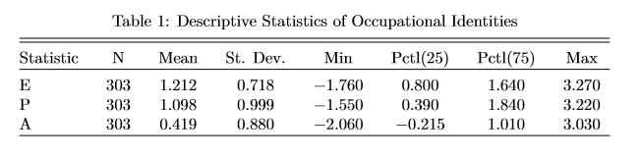

### Method

Replicating an approach developed by Robinson (1996), the network of deference relations was constructed by simulating the event “occupation *i* defers to occupation *j*” across all possible combinations of the 304 occupations, using the BayesACT generalization of the original ACT equations. The deflections produced by these interactions are the tie weights between occupation i and occupation j, making this a valued and directed network (the deflection produced by “occupation i defers to occupation j” is not the same as the reverse) . Deflections range from 2.28 (pawnbroker defers to textile worker) to 13.02 (surgeon defers to surgeon). These deflections cover the range from events that are seen as normal (near zero) to events that seem unusual (over 7.0) (Curdy 2018).

In order to uncover positions within the occupational structure in terms of their deference relations to other occupations, a blockmodel analysis was conducted on the deference network using the sna package in R (McFarland, Messing, Nowak, and Westwood 2010; Butts 2016). Blockmodels group nodes according to their structural equivalence, which is a measure of similarity in relationships to others in the network. Rather than grouping actors who are all connected to each other, as community detection methods do, blockmodeling classifies actors by assessing who has similar relations to the same people (Wasserman and Faust 1994).

The first step in a blockmodel analysis is to get a measure of similarity in relationship patterns for each combination of nodes. To do this, the transpose of the original deference matrix was concatenated onto the initial matrix of deference relations in order to capture both outgoing and ingoing ties in the similarity measure. Next, that 608 by 304 matrix was correlated by column, resulting in a correlation matrix in which the value in cell *i,j* indicated how similar the pattern of deference scores for occupation *i* was to occupation *j*.

However, most algorithms used in blockmodeling methods use indicators of dissimilarity, rather than similarity, when assigning nodes to blocks. As such, all cells in the correlation matrix are subtracted from 1, so larger cell values indicate more dissimilarity, or less structural equivalence. Lastly, the dissimilarity matrix is coerced into a distance measure, changing the meaning of the value from how dissimilar the occupational identities are from each other to how far apart they are, for use by a clustering algorithm. Finally, using Ward’s algorithm, the hierarchical clustering method began with each occupation as its own cluster, and then iteratively joined the occupations into larger and larger clusters until all were in one group. Ward’s algorithm constructs groups with the objective of minimizing the variance within blocks. In practice, this means that at each step of the method, the two clusters that are joined are those that will produce the least amount of within-cluster variance. It does this until all nodes are contained within one overall cluster.

The result of this algorithm is cluster solutions ranging from 1 cluster containing all 303 occupational identities to 303 clusters, each containing a single occupational identity. Choosing the appropriate number of blocks is an issue of both theory and method. Keeping in mind the prior literature on big-class occupational groups, I compared the cluster solutions from 2 to 10 clusters to the initial correlation matrix that resulted from correlating the deference matrix with its concatenated transpose by column. The comparison process involved using the cluster solutions at each step and creating a by-cluster correlation matrix, in which cells indicated either the average within group correlation if both occupation *i* and *j* were in the same block, or between block correlation if occupation *i* and *j* were in different blocks. Finally, the Pearson product-moment correlation between the overall correlation matrix and the by-cluster correlation matrix was computed, measuring the similarity between the baseline measure of structural equivalence and the clustered version, for each solution.

The ideal solution would have a high correlation between the cluster solution matrix and the observed correlation matrix while also penalizing the addition of more clusters (McFarland et al. 2010; Nowak et al. 2012). I chose four blocks, as that is the point before which the increase in correlation decreases below a 45 degree line, as seen in Figure 1.

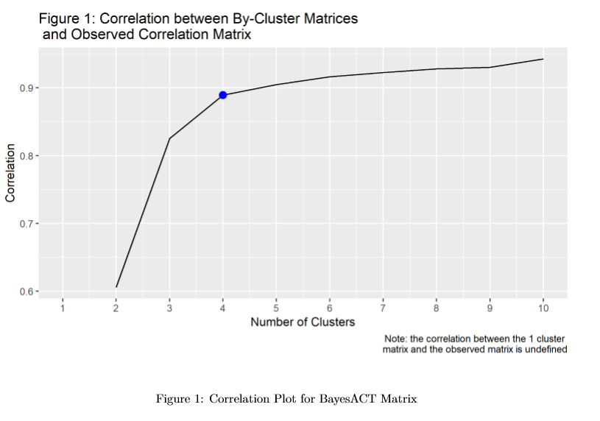

### Results

Figure 2 displays the distribution of Evaluation, Potency, and Activity across the 4 blocks. Evaluation defines each block most conclusively, having the highest peak in every block, which reflects the central place of social esteem in this new measurement of occupational status. Certain blocks are also distinguished by their activity. Blocks 4 and 1 most notably exhibit this feature, with higher and lower average activity distributions, respectively. Typically activity is less explanatory within ACT, but because the action defers to has a low activity score, occupations with high activity ratings are especially unlikely to defer to others. Freeland and Hoey (2018) highlight this impact of activity in their conclusions, because it contributed tothe prestige of service-to-society jobs.

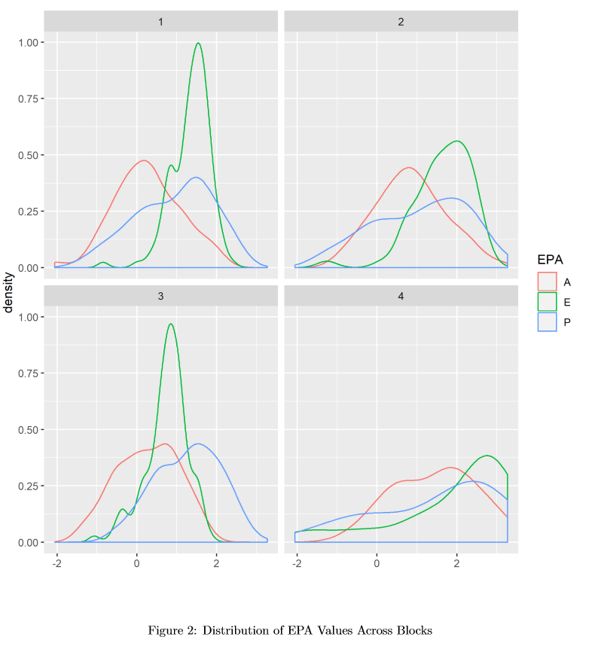

Block Descriptions

|  |  |  |  |  |  |
| --- | --- | --- | --- | --- | --- |
| Block Number | Identity | Mean E | Mean P | Mean A | Count |
| 1 | computer_support_specialist | 1.352114 | 0.9269106 | 0.2664228 | 123 |
| 1 | bricklayer | 1.352114 | 0.9269106 | 0.2664228 | 123 |
| 1 | dental_hygienist | 1.352114 | 0.9269106 | 0.2664228 | 123 |
| 1 | technician | 1.352114 | 0.9269106 | 0.2664228 | 123 |
| 1 | machine_repairer | 1.352114 | 0.9269106 | 0.2664228 | 123 |
| 2 | decorator | 1.645091 | 1.0776364 | 0.8485455 | 55 |
| 2 | travel_agent | 1.645091 | 1.0776364 | 0.8485455 | 55 |
| 2 | environmentalist | 1.645091 | 1.0776364 | 0.8485455 | 55 |
| 2 | musician | 1.645091 | 1.0776364 | 0.8485455 | 55 |
| 2 | hairstylist | 1.645091 | 1.0776364 | 0.8485455 | 55 |
| 3 | foreman | 0.743211 | 1.2692661 | 0.2604587 | 109 |
| 3 | crane_operator | 0.743211 | 1.2692661 | 0.2604587 | 109 |
| 3 | patrolman | 0.743211 | 1.2692661 | 0.2604587 | 109 |
| 3 | bailiff | 0.743211 | 1.2692661 | 0.2604587 | 109 |
| 3 | customs_officer | 0.743211 | 1.2692661 | 0.2604587 | 109 |
| 4 | fundraiser | 1.909231 | 1.4423077 | 1.4384615 | 13 |
| 4 | elementary_school_teacher | 1.909231 | 1.4423077 | 1.4384615 | 13 |
| 4 | nurse | 1.909231 | 1.4423077 | 1.4384615 | 13 |
| 4 | comedian | 1.909231 | 1.4423077 | 1.4384615 | 13 |
| 4 | medic | 1.909231 | 1.4423077 | 1.4384615 | 13 |

The four blocks consist of distinct EPA configurations indicating the type of occupational identity that best fits each position. Table 2 shows the mean EPA values for each block along with the identity that is closest to that mean. Reviewing the occupations within each block, I propose a general label for each set of occupations to summarize the types of jobs in each block. A full list of occupations and their blocks are in the supplemental appendix.

**Block 1 – Everyday Specialists**

Occupational identities in block 1 are characterized by their moderately high evaluation, moderately high potency, and neutral activity. As the largest block, consisting of 120 occupations, these identities range from bricklayer (1.21, 0.69, 0.11), which fits the profile the best, to baker (1.97, 0.70, 0.06).. On the whole, these occupational identities represent a position in the greater occupational structure in which they are respected and have power over their particular range of speciality, but does not extend over the general public. They are respected for their local skills, but not revered more generally.

**Block 2 – Service-to-Society**

The occupational identities in block two are marked by their increase in evaluation and activity over the occupations in block one. The occupations closest to the profile of the block are creative professions, such as decorator (1.70, 0.81, 0.84), musician (1.77, 1.25, 1.47), and storyteller (2.15, 1.62, 0.30). However, this block also contains identities associated with high activity and low power, like hostess (1.94, 0.39, 0.92) and beautician (1.32, 0.05, 1.11), as well as those with high evaluation and high power, such as astronaut (2.33, 2.13, 0.76) and interpreter (2.26, 1.97, 0.80). What unites all 55 of these identities is a position that requires visibility and high cultural esteem. These identities represent a strata of occupations that are well-thought of and do things either directly for us, in the case of teacher or beautician, or for society as a whole, like social worker.

**Block 3 – Inconveniently Powerful**

The most prominent characteristic of block 3 occupational identities are lower evaluation and higher power than blocks 1 and 2. Ultimately, this results in including identities that are punitively powerful, like foreman (0.64, 1.30, 0.34), bailiff (0.72, 1.56, 0.10), and auditor general (0.14, 1.55, 0.10). Additionally, this block consists of occupations which are powerful but perhaps seen as more annoying than simply punitive, like crane operator (0.94, 1.23, 0.29), editor (1.08, 1.70, 0.23), economist (0.87, 0.93, -0.26), and dietician (1.56, 0.90, -0.32).

**Block 4 – Extremes: Heroes and Caretakers**

Finally, block 4 is most marked by their very high average evaluation, potency, and activity. In general, this position represents a good and highly active set of occupations, like nurse (2.84, 1.75, 0.53), firefighter (3.27, 2.85, 2.29), and cheerleader (1.05, 0.24, 2.94). These are esteemed occupational identities, but not necessarily the ones that garner the highest material resources. Looking at both the top 5 closest identities as well as the distribution plot of the EPA values, it seems as though this group is made up of good and active actors who are either also very powerful (the heroes, like firefighter), as well as those who are slightly less powerful, who can be thought of as caretakers. These subgroups would likely split apart with a higher number of blocks, and may have been more apparent if the sample of occupations included a more comprehensive set of occupational identities.

Taking a step back from these individual block discussions, one can see the larger patterns at play in the social-psychological meaning of occupational status groups. The majority of occupations are split along esteem and power lines. In particular, everyday jobs are delineated by the respective esteem they have. High esteem goes to everyday specialists, and low esteem to the inconveniently powerful. We value some trades even while we look askance at some of our powerful but not totally loveable professionals. Occupations with very high cultural esteem are split by how active they are, with moderately active occupations falling into the service-to-society block, and very high active occupations making up the more revered block.

The four blocks discussed here have distinct differences from the major schemes of occupational classes put forward by stratification theorists. Most significantly, potency seems to take a reduced role in these blocks, having less explanatory power over which occupations fall into which blocks than esteem and activity do. In particular, this analysis captures the societal differences in powerful jobs that are more and less socially esteemed, especially in the separation of the everyday specialists from the inconveniently powerful.

#### Reduced Blockmodel

Using the sna package in R, I produced a reduced blockmodel using the mean value in each block (Butts 2016). The reduced blockmodel in Table 3 averages the deflection produced from deference simulations across the occupations within each block-to-block section of the entire deference matrix. The averages have been rounded to the nearest whole number to ease interpretation.

To construct the blockmodel, the original deference matrix is re-ordered by block membership, to group all of the occupational identities in each block together. Then, the deflection scores from all of the simulations falling within each block-to-block subsection (e.g. all deflections produced from simulations of “block 1 occupation defers to block 1 occupation”), are averaged as an indicator of the general unlikeliness of that block-to-block deference relationship from occurring. The benefit of the reduced blockmodel is that it helps to untangle the hierarchical relations between the occupational blocks as it shows general patterns of deference across blocks.

Reduced Blockmodel

|  |  |  |  |  |  |
| --- | --- | --- | --- | --- | --- |
|  | Block 1 | Block 2 | Block 3 | Block 4 | Row Average |
| Block 1 | 6 | 6 | 5 | 7 | 6 |
| Block 2 | 7 | 7 | 6 | 8 | 7 |
| Block 3 | 5 | 6 | 5 | 7 | 5.75 |
| Block 4 | 8 | 9 | 8 | 10 | 8.75 |
| Column Average | 6.5 | 7 | 6 | 8 |  |

When reading the reduced blockmodel, a higher value in cell*i,j* indicates that it is more culturally **unexpected** for occupations from block *i* to defer to occupations from block *j*. When a row has higher values, it indicates that the occupations within that block have higher occupational status and vice versa.

It is most uncommon for block 4 occupations to defer to any of the other occupations, since all of the values contained in the cells within row 4 are higher than the mean value across the entire reduced blockmodel (6.875). Since block 4 consists of esteemed occupations, which are often very active, this pattern of unlikeliness to defer conforms to our cultural expectations. Furthermore, as would be expected given that block 2 consists of occupations that are similar to block 4, just one step down in activity, they have the second highest unlikelihood of deferring to other occupations. Block 1 has a lower average likelihood of deference than blocks 2 or 4, indicating that it is more likely for these identities to defer to others, and especially for them to defer to occupations in block 3. As this represents everyday specialists deferring to the inconveniently powerful, this follows from our expectations of a power hierarchy. For example, a baker deferring to a bailiff results in a deflection of 3.15, which is relatively low.

Lastly, the average for row 3 is the lowest across all of the rows, indicating that it is more culturally expected for occupations from these blocks to defer to others than any of the other rows. This may appear surprising, given the high potency scores of these occupations. Example occupations from this block include defense attorney and senator. But this is actually an illustrative example of what the deference relation reveals that is different than the previous methods of measuring occupational prestige that used either measurements that relied on material resources or the level of education required for entry to the occupation. Because the evaluation for these occupations is fairly low, it is culturally expected for them to defer to others, precisely because people do not think very highly of what these occupations represent. They are not considered socially esteemed in the same way as the other occupations that may have less power but are generally respected to a higher extent, and this lack of cultural esteem lowers these occupations’ relative status regardless of their powerfulness. Further exploration of the reduced blockmodel is in the supplemental online appendix of the paper.

### Discussion

Using ACT’s paradigm to generate a big-class classification of occupational status groups overcomes many of the concerns with the original Goldthorpe-Hope schemes. For one, it is clearly tied to a theoretical paradigm. Second, it limits itself to modeling one type of relation: deference. Deference is definitionally related to prestige without involving complicated decisions about the types of ownership or authority that have plagued earlier conceptions of occupational class. Finally, there is clear evidence for cultural consensus on the EPA dimensions that are being used for classification.

Weeden and Grusky (2005) advocate for using micro-classes because occupations, not larger status groups, represent the institutionalization of work meaning. They say micro-classes perform better when addressing micro-level questions. However, using the cultural definitions of identities to build the classes helps assuage this concern, because the institutionally-defined meanings are explicitly accounted for within the analysis.

Additionally, deflection scores produced from ACT simulations have provided a measurement strategy for concepts of cultural conformity that had previously been difficult to operationalize (Freeland and Hoey 2018; Hunzaker 2016). This paper furthers this theoretical agenda. For one, the method of constructing networks of events across a selection of identities provides a social-psychologically generated meaning network that can be subjected to network techniques. In this case, blockmodeling was used to find status groups of occupations, but other research questions could call for community detection or centrality methods. Further, results from these network methods can be used in standard regression analyses to evaluate their explanatory power.

### Conclusion

Freeland and Hoey (2018) showed how using a measure of occupational status derived from an indicator of cultural conformity in ACT performed better than prior operationalizations of occupational prestige. This analysis used the entire network of deference relations to theorize occupational status groups based on the patterns of deference among 300 occupational identities. The blockmodel analysis resulted in four blocks: everyday specialists, service-to-society occupations, the inconveniently powerful, and the actively revered. These status groups represented varying combinations of evaluation and potency. They reflect Freeland and Hoey’s (2018) argument that to best follow Weber’s definition of status, measurements should include both cultural esteem and material power dimensions. The reduced blockmodel revealed the underlying relationality within the production of deflection as different combinations of occupational identities can produce the same amount of deflection due to different sources of cultural dissonance. On the whole, this analysis showed the benefits of uniting social psychology, networks, and relational sociology.

Works Cited

Butts, Carter T. (2016). sna: Tools for Social Network Analysis. R package version 2.4. <https://CRAN.R-project.org/package=sna>.

Curdy, Brent. 2018. “Explaining Variance in Affect Control Theory: Cultural Consensus, Deflection, and Redefinition.” Duke University, Durham.

Dippong, Joseph and Will Kalkhoff. 2015. “Predicting Performance Expectations from Affective Impressions: Linking Affect Control Theory and Status Characteristics Theory.” *Social Science Research* 50:1–14.

Featherman, David L., F. Lancaster Jones, and Robert M. Hauser. 1975. “Assumptions of Social Mobility Research in the U.S.: The Case of Occupational Status.” *Social Science Research* 4(4):329–60.

Freeland, Robert E. and Jesse Hoey. 2018. “The Structure of Deference: Modeling Occupational Status Using Affect Control Theory.” *American Sociological Review* 83(2):243–77.

Ganzeboom, Harry B. G. and Donald J. Treiman. 1996. “Internationally Comparable Measures of Occupational Status for the 1988 International Standard Classification of Occupations.” *Social Science Research* 25(3):201–39.

Goldthorpe, John H. Erikson Robert; 1993. *The Constant Flux : A Study of Class Mobility in Industrial Societies*. New Ed edition. Oxford: Oxford University Press.

Goldthorpe, John H. and Keith Hope. n.d. “Occupational Grading and Occupational Prestige.” 57.

Heise, David R. 1979. *Understanding Events: Affect and the Construction of Social Action*. Cambridge ; New York: Cambridge University Press.

Heise, David R. 1987. “Affect Control Theory: Concepts and Model.” *The Journal of Mathematical Sociology* 13(1–2):1–33.

Heise, David R. 2007. *Expressive Order: Confirming Sentiments in Social Actions*. Springer US.

Heise, David R. 2010. *Surveying Cultures: Discovering Shared Conceptions and Sentiments*. 1 edition. Hoboken, N.J: Wiley.

Heise, David R. and Neil J. Mackinnon. 1987. “Affective Bases of Likelihood Judgments.” *The Journal of Mathematical Sociology* 13(1–2):133–51.

Heise, David R. and Lynn Smith-Lovin. 1981. “Impressions of Goodness, Powerfulness, and Liveliness from Discerned Social Events.” *Social Psychology Quarterly* 44(2):93–106.

Hertel, Florian R. 2016. *Social Mobility in the 20th Century: Class Mobility and Occupational Change in the United States and Germany*. Springer.

Hout, Michael and Robert M. Hauser. 1992. “Symmetry and Hierarchy in Social Mobility: A Methodological Analysis of the CASMIN Model of Class Mobility.” *European Sociological Review* 8(3):239–66.

Hunzaker, M. B. Fallin. 2016. “Cultural Sentiments and Schema-Consistency Bias in Information Transmission.” *American Sociological Review* 81(6):1223–50.

MacKinnon, Neil Joseph. 1994. *Symbolic Interactionism as Affect Control*. Albany, NY, US: State University of New York Press.

McFarland, Daniel, Solomon Messing, Michael Nowak, and Sean J. Westwood. 2010. "Social Network Analysis Labs in R." Stanford University.

Nowak, Mike, Solomon Messing, Sean J Westwood and Dan McFarland (2012). NetCluster: Clustering for networks. R package version 0.2. https://CRAN.Rproject.org/package=NetCluster.

Ridgeway, Cecilia L. 2014. “Why Status Matters for Inequality.” *American Sociological Review* 79(1):1–16.

Robinson, Dawn T. and Lynn Smith-Lovin. 2018. “Affect Control Theory.” Pp. 137–164 in *Contemporary Social Psychological Theories*, edited by P. J. Burke. Stanford University Press.

Rogalin, Christabel L., Shane D. Soboroff, and Michael J. Lovaglia. 2007. “Power, Status, and Affect Control: Sociological Focus: Vol 40, No 2.” *Sociological Focus* 40(2):202–20.

Schröder, Tobias, Jesse Hoey, and Kimberly B. Rogers. 2016. “Modeling Dynamic Identities and Uncertainty in Social Interactions: Bayesian Affect Control Theory.” *American Sociological Review* 81(4):828–55.

Wasserman, Stanley and Katherine Faust. 1994. *Social Network Analysis: Methods and Applications*. 1 edition. Cambridge ; New York: Cambridge University Press.

Weeden, Kim A. and David B. Grusky. 2005. “The Case for a New Class Map.” *American Journal of Sociology* 111(1):141–212.