Development of a Mission Operation Plan for the CLIMB mission

Master’s Thesis

Submitted by: Fabian Hauser

Matriculation No.: **51841694**

at **Master’s Programme**

**Aerospace Engineering**

Supervisor: **Prof. (FH) Dr. Carsten Scharlemann**

Wiener Neustadt, Date

DECLARATION OF INTEGRITY

I solemnly affirm that this research work was written exclusively by myself and has not been submitted to any other educational institution for the purpose of obtaining an academic degree. In particular, contributions by other persons have been appropriately identified and the data used in this thesis has been correctly obtained and reproduced in accordance with the procedures outlined.

Ich erkläre an Eides statt, dass diese Arbeit ausschließlich von mir selbst verfasst wurde und ich diese Arbeit nicht zuvor an einer anderen Bildungseinrichtung zum Zwecke der Erlangung eines akademischen Grades vorgelegt habe. Insbesondere wurden Beiträge anderer Personen entsprechend kenntlich gemacht sowie die in dieser Arbeit verwendeten Daten entsprechend der dargestellten Verfahren gewonnen und richtig wiedergegeben.

Wiener Neustadt, _______________ ___________________________________

Date Signature

**Abstract in English:**

**Keywords:**

**Table of contents**

List of Abbreviations V

List of figures VI

List of tables VII

No table of figures entries found. VII

1. Introduction 8

2. Background 9

2.1 Overview of CubeSats and Small Satellite Missions 9

2.2 Satellite Mission Operations 9

2.2.1 Mission Operations Phases 12

2.2.2 Mission Operations Functions 13

2.2.3 Mission Operations Plan 16

2.2.4 Mission Planning & Scheduling 18

2.2.5 Monitoring & Command 23

2.2.6 Flight Dynamics 23

2.2.7 Manual vs Automative Operations 25

2.3 Mission Operations of Small Satellites and University CubeSats 26

2.4 CLIMB Mission 26

2.4.1 Mission Objectives 26

2.4.2 Satellite Design 26

2.4.3 Satellite Modes 26

2.4.4 Mission Analysis 26

2.4.5 Ground Station 27

3. Mission Operation Concept of CLIMB 28

3.1 Ground Segment 28

3.2 Mission Operation System Requirements 29

3.3 Mission Operation System Functions 29

3.4 Operations Concept 31

3.5 Mission Planning 33

3.5.1 Mission Analysis 34

3.5.2 Long-Term Planning 35

3.5.3 Short-Term Planning 36

3.5.4 Management of Planning Products 45

3.6 Flight Dynamics & System Simulation 45

3.6.1 Orbit Determination and Propagation 46

3.6.2 Orbit & Attitude Maneuver Design 48

3.6.3 Spacecraft & Environment Simulation and Modelling 49

3.6.4 Collision Risk Assessment & Counter Measures 49

3.7 Monitoring & Command 49

3.7.1 Satellite Monitoring 50

3.7.2 Satellite Commanding 51

3.7.3 Telemetry Processing 51

3.7.4 Management of TM/TC data 51

3.8 Spacecraft Analysis 51

3.8.1 Verification of Subsystem Operations 52

3.8.2 Regular spacecraft system analysis 52

3.8.3 Subsystem Anomaly Analysis 53

3.9 Operations Preparations 53

3.9.1 Command Script Development 53

3.9.2 Testing & Verification of Commands 53

3.10 System Development & Maintenance 54

3.10.1 Development and Acquisition of Software & Hardware 54

3.10.2 Maintenance and Upgrade of Software & Hardware 54

3.10.3 Development & Maintenance of Data Links 54

3.10.4 Development & Maintenance of Databases 54

3.11 Routine Operation Process (Operation Process) 54

3.11.1 Long-Term Operation Cycle 54

3.11.2 Short-Term Operation Cycle 54

4. Conclusion 55

5. References 56

6. Appendix 57

List of Abbreviations

List of figures

**No table of figures entries found.**

List of tables

No table of figures entries found.

# Introduction

# Background

Overview of CubeSats and Small Satellite Missions

Introduction into CubeSats, formfactors, history, university projects, etc.

Satellite Mission Operations

This chapter summarizes and explains the diverse topic of mission operation based on literature. It presents the basics with a focus on general mission operations of unmanned space missions. The most significant and prominent literature includes works [3_6] and [3_8], along with the ECSS (European Cooperation for Space Standardization) standard for ground systems and operations [E1] and the CCSDS (Consultative Committee for Space Data Systems) standards for mission planning [C4] and operations [C1].

A good and illustrative example of what spacecraft (s/c) operations mean is provided by Franck Chatel in [3_1, p.488]:

“*Spacecraft operations can be compared to driving a racing car—that is, engineers design a highly complex product using state of the art technologies to meet the customer requirements. However it is the driver, and the way that they drive the car during the race, that determines the success or otherwise of the endeavour. A final product satisfying all of the requirements, but offering poor ergonomics to the driver, is not likely to win the race! Just as it is common practice in car racing to involve the driver at the design stage, so it is with spacecraft operations.”*

Mission operations encompass all activities that need to be performed during the flight phase of a spacecraft. This includes developing a mission operations concept, policies, data flows, training plans, and cost estimations. A Mission Operation System (MOS) is the integrated system of people, hardware, software, and procedures. The structure of this system varies across organizations with different philosophies and strategies. [3_8].

Mission Operations include the following activities [E1, p.20, 3_4 p.424, C1g]:

* Monitoring and command of the spacecraft
* Spacecraft and mission analysis
* Mission planning and scheduling
* Orbit and attitude determination, prediction and maneuver design
* On‐board software maintenance and management
* Data archiving
* System maintenance
* Operations preparation

Figure 1 shows the phases of a space mission and the location of the operation phase. As seen, the operations phase follows the launch and is conducted during the flight phase. Although the primary focus of mission operations is the spacecraft's flight phase, certain tasks, such as development of procedures and staff training, is carried out prior to launch. The quote above, and many other works [3_8, 3_6, 3_1,3_4], emphasizes the importance of including the operations team as early as possible in the mission to influence the design of the spacecraft and mission from an operational perspective.

Figure 1: Space Mission Phases [3_4, p.426]

A space mission typically consists of two primary components: the space segment and the ground segment. The space segment refers to the spacecraft itself. The ground segment, on the other hand, includes the infrastructure, hardware, software, processes, and teams necessary for operating the space segment [3_6, p. 35]. The ground segment can be further divided into the ground station and the operation system. The ground station ensures communication with the spacecraft and maintains the communication system on the ground. Conversely, the operation system focuses on operating the spacecraft, utilizing the ground station for communication with the space segment.

However, it can be observed that while the ground and space segments are consistently described in most literature, and the ground station is similarly mentioned, the operational part often varies significantly in its nomenclature and distribution across various literature. Sometimes, spacecraft operations and payload operations are distinguished. Payload operation is occasionally referred to as science operations or the science operation center. Often, the entire operations block is called the Mission Control Center. Figures 2 and 3 provide an illustrative overview.

Figure 2: Ground Segment System [E1, p.21]

In figure 2, the mission operations is split into the mission operation system and the payload operation system. Additionally, the ground communication system is mentioned as an own entity. Another example, shown in figure 3 illustrates the operations together as control center. In this example, the ground segment consists of the Mission Control Center (MCC) and three ground stations. The MCC comprises a Flight Data System (FDS), the Ground Data System (GDS) and the Flight Operations System (FOS).

Figure 3: Generic Ground Segment Example [3_6, p.39]

Despite variations in terminology and distribution, the required activities remain the same. These variations arise from individual organization's philosophies and different mission requirements. For example, separate organizations may operate the spacecraft and payload, leading to separate facilities. Sometimes, different operational phases are even divided among different entities. This type of operation is known as distributed operations [C1]. It stands in contrast to centralized operations, where all operations are carried out at a single operation center.

One example of distributed operations is the European Navigation Satellite System Galileo []. For the operation of the GALILEO satellites, the LEOP phase of the satellites is conducted by two LEOP Control Centers (LOCC) located in Darmstadt and Toulouse. For the routine operation, the operation is handed over to the Galileo Control Centre Oberpfaffenhofen (GCC-D), managed by DLR GfR mbH. [3_5] [2_75]. Ground stations, in particular, are often located at different sites or even consist of a network of ground stations distributed globally to achieve more comprehensive coverage for communication.

Figure 3 also illustrates that the spacecraft operator and the manufacturer are typically distinct organizations. The manufacturer supplies the operator with all essential details about the spacecraft, including command loads, operation manuals, and constraints. However, they are not typically involved in operations. In the event of anomalies or other non-standard scenarios, the operator contacts the manufacturer for adversary measures. [Jasmina Interview].

Mission Operations Phases

The ECSS standard for project management [E2] divides a space mission into seven phases, also seen in figure 1. These phases are:

* Phase 0: Mission Analysis/Needs Identification
* Phase A: Feasibility
* Phase B: Preliminary Definition
* Phase C: Detailed Definition
* Phase D: Production/Ground Qualification Testing
* Phase E: Utilization/Operation
* Phase F: Disposal

Phase E is of interest as it is the operational phase. The ECSS standard for space operations [E1] further divides phase E into sub-phases E1 and E2. E1 is the testing and commissioning phase for the space and ground segments, while E2 refers to the routine operation.

However, in general and most literature, the operation phase is divided as follows [jasmina_slides]:

* Operations preparation phase
* Launch and Early Orbit Phase (LEOP)
* Commissioning phase
* Routine phase
* Disposal phase

Operations Preparation Phase

The preparation phase occurs before the spacecraft launch. It involves setting up ground systems and infrastructure, including databases, monitoring displays, software, and simulators. Additionally, this phase includes training the operation team through sessions and rehearsals. Such training is vital for ensuring efficient operations and minimizing incidents. A well-trained team is better equipped to cope with, respond to, and identify irregularities. []

Launch and Early Orbit Phase

Once the satellite is complete and ready for launch, it is turned over to the launch provider. After launch, the satellite is released from its carrier, marking the beginning of the Launch and Early Orbit Phase (LEOP). Depending on the specific satellite and mission, the spacecraft may perform autonomous tasks such as solar array deployment or signal transmission after being deployed. The operator's first task is to track the satellite and establish communication.

The exact trajectory and the state at which the satellite is released is exposed to some error. This uncertainty of the rocket’s final trajectory is referred to as launcher dispersion. As a result, the satellite's orbit and location may not be precisely known. However, most launch providers deliver orbit information shortly after launch, after analyzing the trajectory, which can be used to track the satellite.

This is the most critical phase, as the satellite experiences high mechanical loads during launch in terms of vibration, acceleration, and sound levels. Additionally, after launch, the satellite is exposed to the space environment for the first time. It is essential to establish communication afterward to confirm that the satellite is operational. [3_6]

Commissioning Phase

During the commissioning phase, the satellite and its systems are tested and commissioned. This also involves the payload, which is also referred to as In-Orbit Testing (IOT), and might include tasks such as calibration. Systems are tested using predeveloped procedures. The plan of what to test and in which order can impact the satellite and may pose risks when the satellite enters certain states. Therefore, a well-defined procedure for the commissioning plan is crucial. Typically, this phase requires the presence of experts, either from companies involved with certain systems or experts from the flight operation team. [3_6]

Routine Phase

In the routine phase, the payloads are operated and the mission objectives are fulfilled. Usually, in this phase, the staff can be reduced to a minimum. Nevertheless, the satellite and its systems are monitored daily or weekly depending on the satellite bus and mission. Additionally, weekly or monthly meetings are conducted to discuss the current state, special events, and upcoming actions. Expected events happing during the routine phase are orbit correction maneuvers, updates of flight software, ground station antenna tests or the maintenance of ground systems. Furthermore, trend analyses are crucial within this phase to prevent predictable contingencies or errors during the entire routine phase. These trend analyses are typically performed by subsystem engineers. [3_6]

Disposal Phase

The disposal phase, also called End of Life, is the last operational phase of a space mission. In this phase it is ensured that the spacecraft is removed to make space for other spacecraft and especially to reduce space debris. The removal of spacecraft is handled differently for different orbit types. For earth orbiting satellites there two removal strategies depending on being in a Geostationary Earth Orbit (GEO) or a Low Eart Orbit (LEO).

For an LEO satellites, the satellites altitude is decreased to bring it on a trajectory which enters the earth atmosphere in a controlled manner in which the satellite will be destroyed due to the high thermal energy of the reentry. For GEO, the satellite is brought into a so called graveyard orbit which is a few hundred kilometers above the GEO. [3_6]

It is important to consider the fuel needed for the disposal of the spacecraft. Therefore, the amount of fuel must be calculated and left in the tank after the routine phase. Additionally, there are guidelines for the disposal of the spacecraft that must be followed, depending on national policies. E.g. the ESA Space Debris Mitigation Requirements [3_14] specifies that a LEO satellite must be brought to an orbit with an natural orbit decay duration below five years for orbit disposal.

Mission Operations Functions

As already mentioned at the beginning of the chapter 2.2, mission operations includes the following tasks/activities, depending on the specific mission and requirements support [E1, 3_4, C1g]:

* Monitoring and command
* Spacecraft and mission analysis
* Mission planning and scheduling
* Orbit and attitude determination, prediction and maneuver design
* On‐board software maintenance and management
* Data archiving
* System maintenance
* Operations preparation

These activities are typically referred to as the functions of the mission operation system and represent all activities an operation system must perform to successfully operate the spacecraft [C1g]. The detailed functions and their nomenclature can vary between different missions and organizations. Some missions are more complex and therefore have additional functions than others. For example, a mission to land a rover on the surface of Mars will have different functions compared to an Earth observation satellite.

However, despite different applications, organizations, and missions, the operations team has relatively similar tasks and activities. Reference [3_8] presents a comprehensive set of 13 functions for a common operations concept, shown in table 1. While the functions 1 to 9 consider specific related tasks of the operation, the functions 10 to 13 are referred to as support functions which provide support for the entire mission operations.

Table 1: Functions and Attributes for Space Mission Operations [3_8, p.601]

|  |  |
| --- | --- |
| **Functions** | **Key Responsibilities** |
| 1. Mission Planning | * Coordinate science, trajectory and engineering plans * Allocate and manage mission consumables |
| 2. Activity Planning & Development | * Integrate activity plan requests * Develop time-ordered constraint-checked activities |
| 3. Mission Control | * Monitor in real-time * Command in real-time * Configure and control ground data system |
| 4. Data delivery | see 8 |
| 5. Navigation & Orbit control | * Design trajectories or orbits * Determine position and velocity * Design maneuvers |
| 6. Spacecraft Operations | * Ensure s/c safety and health * Calibrate the s/c and establish engineering performance * Analyse anomalies * Maintain flight software |
| 7. Payload operations | * Ensure payload safety and health Calibrate the payload * Do quick-look payload analysis |
| 8. Data Serv. Includes: (4) Data delivery (8) Data processing (9) Archiving and Maintaining database | * Receive, stage, transport, process data transmit commands * Manage computer, communication and database |
| 10. System engineering | * Manage external interfaces * Manage system performance and internal interfaces * Recover from system failure |
| 11. Computer and Communication Support | * Maintain the hardware * Maintain data links |
| 12. Software Development & Maintenace | * Maintain the system * Upgrade the system * Train and certify operators |
| 13. Management | * Manage the overall mission * Work with sponsors and users |

Defining a set of functions is useful for gathering and organizing requirements. An operation system can be characterized by outlining the interfaces between these functions, specifying data flow, interface format, processes, hardware, and software. While organizations may categorize and name these functions differently, this set includes the most crucial ones. However, when determining the functions of a mission, some may be eliminated or combined to reduce cost and complexity. [3_8]

In smaller missions, a single team may perform all the functions. For other missions, sub-teams are formed, with each team performing a collection of functions [3_8]. A group of functions is also referred to as functional areas. An example is given by the CCSDS standard for mission operation planning [C4], as shown in figure X. The colored blocks represent functional areas belonging to the mission operation system.

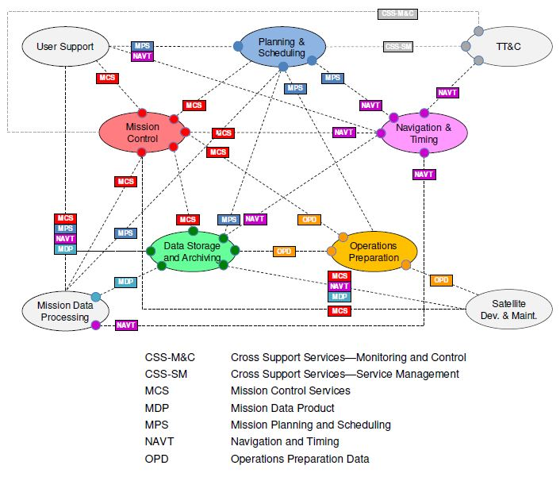

Figure 4: Mission Operations Functional Areas and Their Interactions [C4, p.19]

Figure 4 shows also the interaction of these functional areas. The lines connecting the areas are communication lines indicating the source component by a colored dot. Since this areas are often performed by individual sub-teams of the operation team, this functional areas are also often referred to as sub-teams, e.g. the mission control sub-team. Also mentioned in [C4] is that for every mission and organization this scheme illustrated in figure 4 can be different.

The automation of functions is a crucial part that can lead to a reduction in operational costs and workload [3_8]. For example, the automation of schedule generation, constraint checking, command development, or orbit determination can be traded against ground crew operations, reducing cost and workload. Nowadays, the trend is that functions are increasingly outsourced to the spacecraft due to the increasing power of on-board computers [C1g]. This also decreases the workload of the operation team, however, it increases the complexity of the spacecraft.

The most crucial functional areas common to most space missions include mission planning & scheduling (encompassing function 1 & 2 from table 1), flight dynamics (function 5 from table 1), and monitoring & command (function 3 from table 1). These three areas will be introduced in subchapters 3.5-3.10.

Mission Operations Plan

This chapter introduces the Mission Operations Plan (MOP). Reference [3_8], a well-cited source for space missions and operations, dedicates a chapter to the MOP. It outlines how the ground and space segment operations are conducted, from the perspectives of operators and users. It details the methods for conducting the mission, operating the spacecraft, and utilizing the crew and ground operation teams. The MOP development is an iterative process and can have an significant influence on the mission concept, spacecraft or flight software. In [3_8], the MOP is split into 13 steps as seen in table 2.

Table 2: Developing a Mission Operations Plan [3_8].

|  |  |
| --- | --- |
| Step | Key Items |
| 1. Identify the mission concept, supporting architecture, and performance requirements | * Mission scope, objectives, and payload requirements * Mission philosophies, strategies, and tactics * Characteristics of the end-to-end Information system * Identify performance requirements and constraints |
| 1. Determine scope of functions needed for mission operations | * Identify functions necessary for different mission phase * Functions usually vary for different mission concepts and architectures. Combine or eliminate if possible |
| 1. Identify ways to accomplish functions and whether capability exists or must be developed | * Where functions are accomplished (space or ground) * Space-based crew capabilities * Degree of automation on the ground * Degree of autonomy on spacecraft and for flight crew * Software reuse (space and ground) |
| 1. Do trades for items identified in the previous step. | * Try to define operational scenarios before selecting options. These trades occur within the operations element and include the flight software |
| 1. Develop operational scenarios and flight techniques | * Operations scenarios and flight techniques are step-by-step activity descriptions. Identify key issues and drivers * Develop scenarios and flight techniques for functions from step 2 and options selected in step 4 |
| 1. Develop timelines for each scenario | * Timelines identify events, their frequency, and which organization is responsible. They drive the characteristics for each operations function |
| 1. Determine resources needed for each step of each scenario | * Allocating hardware, software, or people depends on what, how quickly, and how long functions must be done |
| 1. Develop data-flow diagrams | * Data-flow diagrams drive the data systems and the command, control, and communications architecture |
| 1. Characterize responsibilities of each team | * Identify organizations Involved and their structure, responsibility, Interfaces, and size. To be cost-effective, minimize the number of organizations and interfaces * Develop training plan for ground team and flight crew |
| 1. Assess mission utility, complexity, and operations cost driver | * Refine development and operations costs each time you update the Mission Operations Plan |
| 1. Identify derived requirements | * Identify derived requirements and ensure consistency with top-level requirements * Identify cost and complexity drivers * Negotiate changes to mission concept and architecture |
| 1. Generate technology development plan | * If the technology to support mission operations doesn't exist, generate a plan to develop it |
| 1. Iterate and document | * Iteration may occur at each step * Document decisions and their reasons |

Mission Planning

Mission Planning is the task of preparing, organizing and planning of all relevant activities performed by the space and ground segment during the preparation and flight phase of the mission. The output of mission planning is a detailed, constraint checked and time ordered schedule of activities, called a Sequence of Events (SoE) for the ground and space segment [3_6].

The mission planning function deals with planning on various time scales, ranging from years to seconds. This process begins even before the launch of the spacecraft. During the design phase, mission planning should be involved to consult on the ground segment design and to prepare a mission planning system. During operation, mission planning involves scheduling activities down to the sub-second detail level. Figure 5 illustrates mission planning across different time scales. [3_6]

Figure 5: Space Mission depicted in different time scales [3_6, p.191]

Mission Planning Concepts

The mission planning function can be implemented using various concepts and configurations. The CCSDS standard for Mission Planning and Scheduling [C4] provides a comprehensive set of these configurations, summarized below.

**Hierarchical Planning [4]**

To deal with the complexity of mission planning, an approach is to divide the planning process in multiple planning cycles. With every planning cycle, the plans a more refined from lower to higher detail level. This concept is called hierarchical planning. Common planning cycles are the long-term, medium-term and short-term planning cycle and are described below:

* Long-term planning cycle: This planning cycle may focus on achieving mission goals and may include an initial estimation of resources and constraints for planned activities. The duration of this cycle typically ranges from several years to several weeks.
* Medium-term planning cycle: This planning cycle refines the plans from long-term planning and is concerned with a more sophisticated resource allocation and may also include attitude and trajectory planning. The duration of this cycle lies in the range of months to weeks.
* Short-term planning cycle: This cycle focuses on the detailed planning of activities, taking into account resources and constraints at the highest detail level. Typically, this cycle lasts from a weeks to hours.

Planning cycles are defined by the lead-time and the planning horizon. The lead time is the period in which plans are developed before execution. The planning horizon is the duration of the execution of the planned activities. For example, long-term plans may be developed three months in advance for six months of operation. In this case, the lead-time is three months, and the planning horizon six months, leading to a total long-term planning cycle duration of nine months. Depending on the requirements and complexity of the mission, space missions usually utilize less or more of these cycles. An overview of hierarchical planning is depicted in figure 6.

**Distributed vs Centralized Planning [4]**

Mission planning can be performed by a single centralized function. However, other missions use a distributed approach in which mission planning is distributed across several functions. These could be performed by different organizations or even on-board the spacecraft. The output of one function would be the input of the next. The reason for a distributed system may be the use of facilities with special capabilities or experts. With the use of a distributed approach, the standardization of information flow is of great importance to ensure conflict-free data exchange. An example is illustrated in Figure X. Here, the three planning cycles may be distributed over different entities.

Figure 6: Hierarchical and Distributed Mission Planning [C4, p. 23]

**On-Board and Ground Based Planning [4]**

In on-board planning, the mission planning function is performed partially or entirely on the spacecraft. While this approach requires a higher level of automation, it increases the autonomy of the spacecraft and can reduce operational workload. A great example of this are Earth observation satellites. With the equipment on-board, clouds can be detected and imaging activities scheduled automatically, considering cloud coverage. Deep space missions are also drivers for on-board planning, in which communication delays and unpredictable circumstances make real-time planning impossible.

However, the planning process can also be completely performed by the ground segment. This reduces the complexity of the space segment and its development, however, increases the workload of the operation team.

**Iterative planning and replanning [4]**

For certain missions or operations, fixed planning may be used. In this case, the plan is developed prior to execution and remains unchanged afterwards. However, the planning process is typically iterative, allowing for potential replanning. The planning cycles themselves can also be iterative. For instance, in short-term planning, new information about the orbit or satellite health may trigger a replanning process, making the cycle iterative.

Planning & Scheduling

In literature, the terms "planning" and "scheduling" are often used together. However, a specific distinction between the terms that accounts for all literature could not be found. Sometimes these two terms are used synonymously, but sometimes they are defined separately. However, in most cases, "scheduling" describes the task of generating the spacecraft schedule, which contains the spacecraft activities for a certain period of time.

The CCSDS standard for mission planning [C4] also states that within the space operation domain, the distinction between a plan and a schedule is not clear. However, in the domain of artificial intelligence, the difference is stated by [C4] as follows: Planning is the task of selecting activities necessary to achieve a certain goal. Scheduling, on the other hand, is the task of arranging these activities on a timeline, considering predefined constraints.

Within the scope of this thesis, planning encompasses everything from low-detail level activity definitions to high-detail level activity timeline generation for the spacecraft, which is necessary to produce the command sequence. Therefore, scheduling is defined as a subtask of planning and is concerned with the arrangement of activities and provides a schedule that is conflict-free and does not exceed spacecraft limits.

**Planning**

As with most parts of mission operations, the term “planning” varies across different organizations. The work [3_6] thus defines planning as the process of preparing, organizing, and planning activities for the space and ground segment. This includes selecting spacecraft activities, generating a schedule for the spacecraft [C4], as well as coordinating human activities and the use of facilities and equipment [2_16].

The planning period can be different across different organizations and missions. Most mission planning functions cover a one week planning period due to practicality in allocating personnel [2_16]. An example are the GALILEO navigation satellites operated by GSOC. For the routine operations, a short-term plan is issued weekly covering a 10 day period [3_5]. A timeline is provided in figure X. The short term planning process consists of a planning request (PR) approval deadline, a draft issue review, a feedback deadline and the final release of the plan. As seen in Figure X, a one day buffer lies between the final release and the beginning of the plan execution. Furthermore, an overlap is present between the timelines covering three days.

Figure 7:

**Scheduling**

As described at the beginning of this chapter, scheduling is a part of the planning process and is the task of placing spacecraft activities on a timeline, while also taking into account spacecraft resources and constraints. Therefore, it focuses not on the selection of activities, but on their arrangement. The result of this process is a time-ordered series of spacecraft activities, known as the schedule, or often referred to as the Sequence of Events (SoE) [3_6]. The schedule must not violate any constraints and must be executable by the spacecraft without exceeding the capacity of a resource.

When developing the schedule for the spacecraft, it would be desirable to create a detailed schedule for a long period of time. However, due to perturbations influencing the spacecraft's state, the immense effort required to predict the spacecraft's state over a longer period, and the general uncertainty of a mission's future, there is no practical use in performing detailed scheduling for an extended period [2_16]. For example for the earth observation satellite DEIMOS-1 the mission planning team uploads a satellite schedule daily, with a 24/7 rush service if plans need to be updated due to urgent events such as natural disasters [2_17]. An example of spacecraft schedule is provided in figure 7.

Figure 8: Scheduling Timeline Example [2_16, p.8]

In general, the schedule generation underlies the following [3_6]:

* Feasibility and safety: Every subsystem of the spacecraft must be able to execute the timeline without exposing the system to any risk.
* Benefit: The schedule shall be developed to reach as many mission goals as possible.
* Traceability: It must be traceable why the schedule looks like the way it does.
* Performance: The process of schedule generation must be sufficiently fast.
* Flexibility: It should be possible to adapt and modify the schedule for changes.

**Constraints & Resources**

For scheduling spacecraft activities, it is important to consider spacecraft constraints and resources. Resources can be assets which support an activity such as a ground station or a relay spacecraft. However, a resource can also be a consumable such as electric power, memory storage or fuel [2_16]. To schedule activities, the mission planner or the scheduling system must be aware of the availability of such resources. If a data downlink is scheduled, it must be known if the spacecraft has enough power to transmit the data. Simultaneously, a ground station needs to be available to receive the data.

Another factor that needs to be considered is constraints. These can be parametric, where a specific value must be either below or above a certain threshold. However, constraints can also be time-related, defining the relationship between two activities, or capacity-related, where the occurrence of certain activities is limited within a specific time range [2_16]. Examples include maximum thermal limits for the spacecraft or its systems, maximum data memory storage, or the maximum operational duration of a subsystem. The number of constraints identified depends on the mission, satellite architecture and operation concept. For example, for mission planning & scheduling of the TerraSAR-X satellite operated by the DLR, 70 constraints are considered for scheduling, one being that no more than nine telecommands shall be transmitted within one second [2_43].

The goal of the scheduling process is to optimize the use of the spacecraft without violating constraints or depleting resources. For instance, the scheduling for Earth observation satellites aims to capture as many images as possible, within the limits of constraints and resources. The TerraSAR-X satellite, for example, can handle a maximum of 1000 data take requests per day, requiring a highly sophisticated scheduling system [2_43]. Another example is the OE-1 satellite, which initially aimed at capturing 7 scenes per week. Due to significant improvements in the scheduling system, the activities could be increased to 100 scenes per week [2_36].

Models are used to account for constraints and resources. It is important to decide how sophisticated a model should be. For some resources, exact modeling might be necessary, while for others, an approximation might be sufficient. Sometimes a simpler model, which models more conservative, is preferable to a highly sophisticated one, especially when the resource is too complex for exact modeling. Simple models should preferably model on a more conservative side to increase spacecraft safety. [2_16]

Using the TerraSAR-X spacecraft as an example again, the usage of the data memory is modeled exactly, the battery model is a linear approximation, and the thermal model is a simplified heuristic using a time window approximation [3_6]. Another example is the OE-1 satellite, which models the data consumption of the imaging payload by using a function with a base value plus a certain rate times the usage duration of the payload [2_36].

**Scheduling Software**

Software that utilizes scheduling algorithms is usually used for the mission planning of spacecraft. These algorithms solve scheduling problems by establishing a timeline for all activities, taking into account all constraints and resources, and avoiding any conflicts. A scheduling algorithm is discussed in [2_36], with optimization methods outlined in [2_40] and [2_42].

Such software is available commercially developed by companies focusing on software for spacecraft operations. However, agencies or organizations often develop their own scheduling system tailored to their needs. An example of such a software is the PINTA scheduling software [2_79] developed and used by the German Space Operation Center (GSOC). This system has its own modelling language for describing the scheduling problem. An in depth insight in this modelling language is given in the work [3_6].

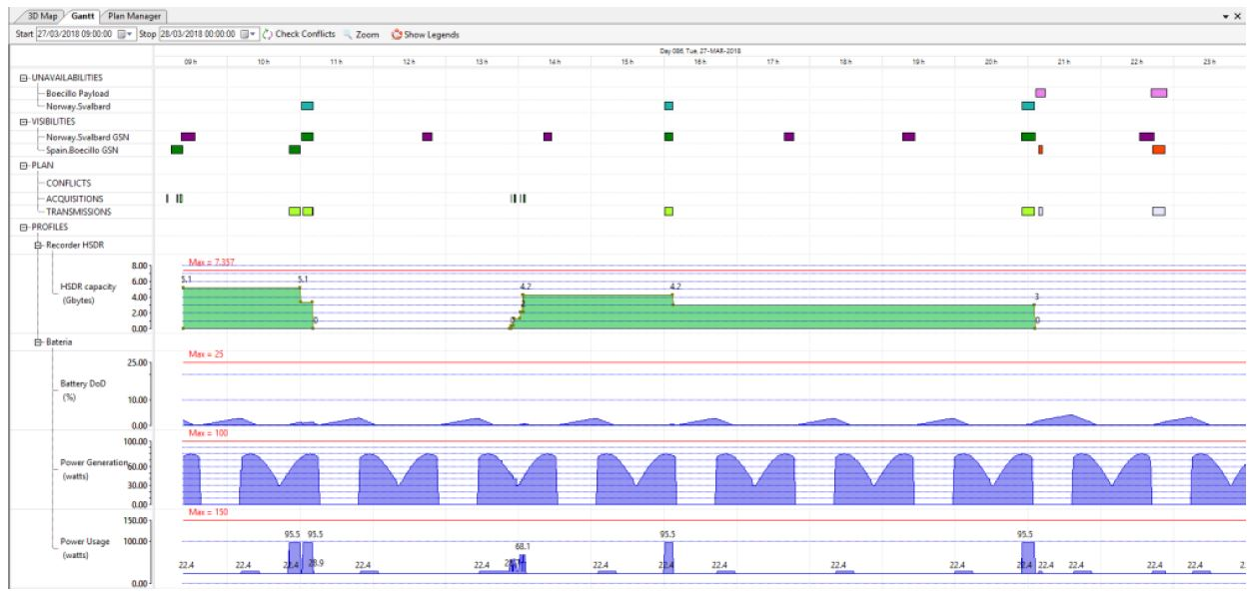

Figure 9: MPsys_Ganttchart_2_17_fig5

Another example is the DEIMOS-1 mission operated by the Spanish company []. The company developed its known mission planning system called PlanOE which was greatly improved over the course of the mission. The tool incorporates a simulation of the behavior of the satellite and orbit. Figure X shows the timeline view of the software. The upper part of the timeline shows the scheduled activities and the lower part the state of the resources showing the data capacity, battery depth of charge (DoD), power generated and the power usage. [2_17]

Figure 10: MPsys_Ganttchart_STKscheduler_sheet

An example of a commercially available scheduling software is the STK scheduler [STKscheduler_sheet]. Figure X shows a Gantt chart view of the software. In the upper part activities are shown for the spacecraft. The lower part shows the resources such as observation and ground station availabilities. The software provides different scheduling algorithms which create a conflict free timeline.

These software are able to not only give a conflict free schedule but also optimizes it by allocating activities in an efficient way. One example being the PINTA modeling language which tries to allocate activities so that as less energy as possible is lost as seen in figure X.

Figure 11:

**Automated vs Manual Scheduling**

Event based Scheduling

Position based scheduling [C4]

Time based scheduling

Monitoring & Command

The Monitoring and Command (M&C) function is responsible for managing, displaying, and monitoring telemetry data received by the ground station. It also controls the spacecraft by sending commands to the ground station, which then uplinks these commands to the spacecraft. This function is often referred to as mission control due to its role in controlling the spacecraft. The monitoring of telemetry data and the also often the commanding of the spacecraft occur in near real-time, meaning that the data monitored is current or nearly current, and commands transmitted are executed almost instantly. [3_8]

The term telemetry (TM) refers to all data transmitted by the spacecraft to the ground. This data is typically split into payload data, generated by the payload, and satellite health data. The satellite health data contains important parameters used to monitor the health of the satellite, such as temperature values, current or voltages, subsystem-specific parameters, etc. This data is often referred to as "housekeeping data" or, in short, "HK data". Telecommand (TC) refers to all data sent from the ground station to the spacecraft and contains spacecraft instructions such as telemetry requests, software updates, or specific activity commands such as attitude changes or propulsive maneuvers. [3_6]

Figure 12: Overview of a typical monitoring and command system [3_6, p.105]

Figure X provides an overview of a typical monitoring and command system. The data received from and sent to the spacecraft is managed via the ground station. This ground station could be located anywhere on Earth and might not be in the same location as the control center. The data is directed from the ground station to the control center, which holds the M&C function. Before the data can be monitored, several steps need to be performed. These include unpacking, calibrating, and processing the telemetry data. However, the necessary steps depend on the system used. After these steps, the data is displayed and monitored. For the commanding process, the telecommands are encoded, packed, and submitted to the ground station via a defined interface. The ground station then transmits the data to the satellite. [3_6]

Spacecraft Monitoring

**Real-Time Monitoring**

As described above real-time monitoring is the task of monitoring current or near current received telemetry data. The telemetry data contains the housekeeping data of all subsystems. However, this doesn’t mean that all this data is downlinked all the time.

What is contained in telemetry (list of some things like temp, voltage etc.)

Displaying alerts (green, yellow, red)

Monitoring Systems (show nice display)

Monitoring is usually conducted by a monitoring software. This software displays data and also categorizing it as nominal, warning or anomaly. Color code etc….

Detect anomalies and isolate probelsm and call in experts of the s/c or ground systems

Often requires shifts

Workload dependents on onboard autonomy.

For LEO missions one of the typical operations tasks during the routine phase is

the “housekeeping” of the spacecraft. Nearly all the telemetry parameters are

monitored. Each SSE monitors his subsystem and reports to the Flight Director in

case any of the parameters do not behave as expected. The [3_6 p68][GRACE mission]

The recorded data of the satellite payload

are dumped over the ground stations and will be distributed to the scientists

afterwards. A dump is the download of a data storage that contains previously

recorded telemetry. All these [3_6]

**Long-Term Monitoring**

The team will not only react

when yellow or red alarm situations are indicated in telemetry, the SSEs will also

perform long-term monitoring where the data will be recorded and plotted over an extended time frame, sometimes even years, and evaluated by the experts to

perform predictions and react in advance to trends and tendencies. [3_6 p68][GRACE mission]

Look at deimos paper [2_17]

Commanding

Look at systems like in slides from jasmina

[3_6]

[3_4]

[2_1] Design_and_Verification_of_CubeSat_Ground_Station_MAIOLINI_CAPEZ

[2_70] CubeSat Control Centre for the management of telemetry, telecommand and operations based on the CCSDS standards

Flight Dynamics

In mission operations, the flight dynamics team serves as the spacecraft navigators, determining and predicting the orbit. They provide crucial data like ground station contact times, launch window possibilities, eclipse times, maneuver designs, etc. In this chapter, the determination and propagation of a satellite is introduced, followed by an introduction into orbit maneuver analysis and the disposal of spacecraft.

For space operators there are many tools addressing these tasks which are used by industry, universities or agencies. The most prominent tools used for flight dynamics operations are System Tool Kit (STK) [], GMV [], Freeflyer [], GMAT [] or also inhouse developed systems.

Orbit Determination and Propagation

The trajectory of a spacecraft is determined by its initial conditions, namely, its position and velocity (also known as state vectors), and the force field acting on it. Integrating the second-order differential equation of motion for a satellite using these conditions, should give the accurate representation of the orbit and position of the spacecraft at any given time. However, it is impossible to know the initial conditions and the force field with absolute precision, leading to an error in the determination and propagation of the satellite state. [2_8]

|  |  |  |
| --- | --- | --- |
|  |  | (1) |

The equation above represents the second-order differential equation of motion for a satellite. Here, is the position vector of the satellite and 'mu' is the gravitational parameter of Earth. represents the sum of all non-central gravitational accelerations, which include gravity effects from other celestial bodies such as the Sun and Moon, solid-Earth tides, general relativity, etc. is the sum of all non-gravitational accelerations such as solar radiation pressure, atmospheric drag, Earth radiation pressure, etc. Due to the impossibility of knowing the exact characteristics of these force fields, models need to be applied. [2_8]

**Orbit Determination**

The determination of the orbit uses algorithms to convert measured satellite state data (also known ephemeris data) to orbital elements and minimizing the error compared to calculated values [3_6]. The acquisition of initial spacecraft state condition forms the basis of the determination and propagation of the orbit. Several methods are available to acquire these data. The most relevant methods are described below:

NORAD TLE:

Two-Line Elements (TLE) are a set of parameters that describe the orbit of a space object. The TLE format was developed during a time when bandwidth and data storage were critical, so it uses the minimum amount of data necessary to propagate an orbit (see figure X). The US Space Surveillance Network (SSN) tracks space objects and uses this data to create TLEs. These TLEs are published by the North American Aerospace Defense Command (NORAD) and are freely available on the internet, for example, on [celestrak] and [[space-track.org](http://space-track.org/)]. The TLE’s are updated approximately once a day, however, this depends on the current NORAD activities [2_26].

Figure 13: Nomenclature of two-line element set in compliance with NORAD [3_4, p.396]

Doppler Ranging:

Another ground based method uses ranging and Doppler shift measurements to get the state vectors. This method involves sending signals from a ground station to the spacecraft, which then returns the signals. The time it takes for the signal to travel to the satellite and back provides the range to the satellite. For the Doppler measurement, a signal with a defined frequency is sent to the satellite. The signal is returned to the ground station with another frequency (to avoid interference with uplink frequency). By measuring the downlink frequency, the Doppler shift can be used to calculate the radial velocity of the satellite, also known as the range-rate. With the range and the range-rate, the orbit can be determined. [3_1]

On-Board GPS:

An onboard method for obtaining the state vectors involves using a GPS system implemented in the spacecraft. The GPS data is stored on the spacecraft and transmitted to a ground station. This information can then be used to determine the orbit [3_6]. This method offers the advantage of acquiring position data more regularly than relying solely on the NOARD TLE publications. It also allows the spacecraft to determine the orbit on-board, enabling more autonomous operations. This can be used for e.g. position based operations in which the satellite can perform activities at a certain position in orbit or over Earth. [see 2_8 p.4]

Reference [2_25] compares the accuracy of orbit determination between TLE data published by NORAD and GPS on-board system data. Reference [2_26] presents a method to convert GPS data into TLE format. Both papers suggest that using GPS data provides more accurate orbit determination than TLE data. However, a substantial amount of GPS data samples are needed to achieve an accurate result.

**Orbit Propagation**

The propagation of the orbit gives not only the current position of the satellite but at any given time based on the initial conditions described above. Choosing the right propagator for the application is important. Equation 1 shows the force fields representing perturbations, depending on the propagator more or less perturbations are accounted for. Also different force models can be used, making some propagators more accurate than others.

Two-Body Propagator:

One of the most simple orbit propagators is the two-body propagator. This is a simple analytic propagator without considering any perturbations. This method is used for fast and rough estimations of the orbit, using very low computational effort.

SGP Propagator:

One of the most notable orbit propagators is the Simplified General Perturbations (SGP) model series, which uses TLE's as input. The most frequently used model from the series is the SGP4 propagator. Developed in 1966 and continually improved since, the SGP4 model is an analytical orbit model for low earth orbiting (LEO) satellites. This method takes into account the J2, J3, and J4 gravity coefficients as well as atmospheric drag effects. [2_26]

The use of this method for orbit propagation is driven by the simple and cost-free acquisition of the TLE data, as well as the speed of propagation. However, this comes at the expense of accuracy and the irregularity of TLE data publication. The irregular release of TLE further decreases accuracy, as propagation often needs to be performed with outdated TLE data to determine the current orbit. The position error of a TLE is around 2 km, but this error can increase to about 100 km over the span of one week [2_25].

High Fidelity Propagators:

High fidelity propagators incorporate more perturbations and use high-precision models for these perturbations. They utilize not only models for Earth's oblateness and atmospheric drag but also take into account factors like solar pressure and gravitational effects from other celestial bodies, such as the Moon and Jupiter. While these propagators yield more accurate results, they are sensitive to initial conditions and require more computational effort than the propagators presented above. The input of such propagators are usually state vectors or orbital elements, however, usually do not support the TLE format.

DEIMOS-1 uses TLE from spacetrack [2_17]

The flight dynamics uses ranging and range-rate measurements to perform orbital determination and propagation. [2_30 INPE]

In general ESA or NASA use their ground stations for tracking using radars, ranging, doppler, etc.

ENVISAT [2_78]: Orbit determination, AOCS telecommand parameter generation, monitoring performance AOCS hard/software, testing and validation of flight dynamics products

ENVISAT [2_78]: routine operations: Orbit determination twice per day, predict orbit for next 8 days, plan maneuvers to keep ground track

Propulsive & Attitude maneuvers

[2_35] Low Thrust sequential orbit rise

[2_47] Direct Optimization of Low-thrust Many-revolution Earth-orbit Transfers

[2_48] Many-Revolution Low-Thrust Orbit Transfer

[3_15]

Spacecraft Disposal

[3_14] ESA Debris Mitigation Guidelines

Flight Dynamics Operation of ESA/NASA

Manual vs Automative Operations

[] Paper Jasmina

[2_9] Operations of Autonomous s/c

[2_21] An Approach for Automation the Satellite of Routine’s Operation and Procedures

Mission Operations of Small Satellites and University CubeSats

EIVE, KOMPSAT(?), MOVE, PEGASUS, INPE, RAX, RADCUBE, CUTE, FLOCK, NPS etc.

Show operation systems from papers, Also INPE MBSE

CLIMB Mission

Introduction to CLIMB mission

CLIMB is the second CubeSat mission of the University of Applied Sciences Wiener Neustadt (FHWN) [2_0_0]. The first satellite developed and launched by FHWN was the PEGASUS satellite [2_0]. This satellite was part of the QB50 program, an international project with the objective of launching 50 CubeSats into the thermosphere with predetermined science instruments onboard [QB50].

The PEGASU Satellite was equipped with UHF communication, an ADCS system and pulsed plasma thruster. Unfortunately due to problems with the sun-sensors the ADCS and therefore also the thruster, could not be operated. However, all other systems remained functional and housekeeping data could be retrieved until deorbit in January 2023.

After the completion of this mission, a new mission, the CLIMB mission, was created. This mission builds upon the lessons learned and heritage from the PEGASUS mission.

(QB50 refer: https://cordis.europa.eu/project/id/284427)

Mission Objectives

Objective Van Allen Belt, rough explanation of phases, etc.

Satellite Design

Introduction of each subsystem

Satellite Modes

Figure 14: Source ?????

Mission Analysis

Orbit -> Mention requirements about orbit and therefore its characteristics -> LEO, Radiation environment, period, inclination with sun-synchronous, sun-sync in general

Perturbation -.> RAAN (explained with sun-sync), Arg. Of Perigee (not always apogee above)

Apogee rise -> how long, refer to other master thesis with graph

Environment ­-> sun 45 min shadow 45 min, or sun 90 min, temperature, power, drag, radiation

Contact windows -> how long, how often, change with apogee rise

Mission Phases

Launch & Early Orbit Phase

Commissioning Phase

Apogee Rise Phase

Science Phase

De-orbit Phase

Trajectory Analysis

As already mention above, the CLIMB satellite has an initial starting orbit with an altitude of about 500 km after launch. Afterwards the orbit apogee is changed with the onboard propulsion system so which increases the apogee of the orbit to 1000 km which is the final orbit. The trajectory details are specified in the mission requirements [CLIMB_Req] and state the following:

* The initial orbit shall be sun-synchronous
* The initial orbit altitude shall be between 400 km and 500 km
* The eccentricity of the initial orbit shall be lower than 0.01
* The final orbit shall have an apogee altitude of 1000 km

What is sun synchronous

The inclination of a sun-synchronous orbit is in relation with the orbit altitude. Following equation X below, one can calculate that the inclination lies between 97.0° and 97.4° using the altitude of the initial orbit specified in the CLIMB requirements listed above.

EQUATION rate of RAAN

For the Rate_RAAN, the value is used which leads to the rotation of the orbit RAAN of 360 degrees per year. Besides the precession of the RAAN, there is also a precession of the argument of perigee, called the apsidal precession. As the initial orbit is almost circular this does not influence the operation. However, in the final orbit it leads to the fact that the apogee and perigee are circling with around 3.2 degrees per day following equation Y. This leads to the fact that around three times a year the apogee passes the ground station of CLIMB.

EQATUION Apsidal Precession

GRAPH APOGEE RISE

Ground Contact Analysis

Show ground track from STK

Space Environment

Ground Station

Capability and structure of Ground Station (SatNOGS)

# Mission Operation Concept of CLIMB

In this chapter, an operation concept for the CLIMB mission is proposed. The concept is based on the chapters presented above, using literature on operation systems (chapter 2.2) the experience from previous small satellite missions (chapter 2.3) and the CLIMB mission concept (chapter 2.4). For the development of the operation concept reference [3_8] was a significant influence. The approach for developing the operation concept is based on table 2 from [3_8], introducing steps for developing a mission operation plan. The main steps used are the following:

* Familiarize with CLIMB mission: This involves requirements, mission goals, satellite capabilities, etc.
* Identifying the functions needed for the CLIMB operation
* Assessing how these functions can be implemented within the context of the FHWN
* Proceeding through a routine operation process

The outcome of the first step in this process is detailed in chapters 2.4 and 3.2. The function identification is outlined in chapter 3.4, followed by an in-depth description of the identified functions in chapters 3.5 - 3.10. Afterwards a process of the operation system is introduced. The results are finally discussed and concluded in chapters 4 and 5.

Maybe to operations Concept:

The CLIMB satellite is fully operated at the FHWN. It uses the local ground station at the FHWn but also utilizes SatNOGS for a greater range to acquire telemetry data.

* See 2_17 **operational concept** p.2

Also say here in concept a rough estimation of effort: X activites per day, however, most are fixed in time and space and attitude are releated to thtat

Ground Segment

As described in chapter 2.2, there are several ways to structure a space mission system using different nomenclature and approaches. The CLIMB mission uses the following concepts (see figure 10): The mission consists of the space segment and the ground segment. The space segment comprises the satellite and its subsystems. The ground segment is further divided in the ground station and the mission operation system (MOS). The ground station is responsible for the communication with the satellite presented in chapter 2.4.5. The mission operation system comprises strategies, hardware, software and processes to conduct the CLIMB operation.

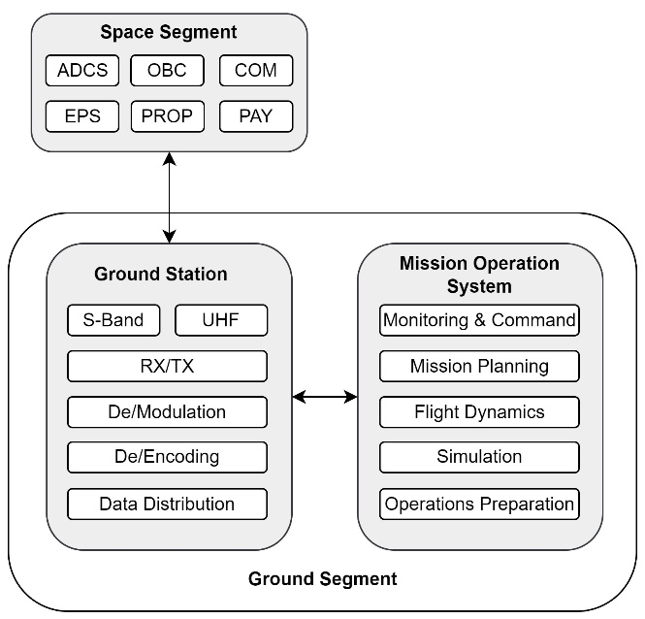

Figure 15: Overview of the CLIMB mission ground segment

The ground segment follows a partially centralized approach by which the ground station and MOS is located at the FHWN, however, with the exception of the use of the SatNOGS system in which ground stations all over the world are used to gather satellite telemetry data. The mission operation system is divided into five functional areas which all together perform the tasks necessary to operate the CLIMB satellite. An overview and interaction of these functional areas of the MOS is shown in figure 11.

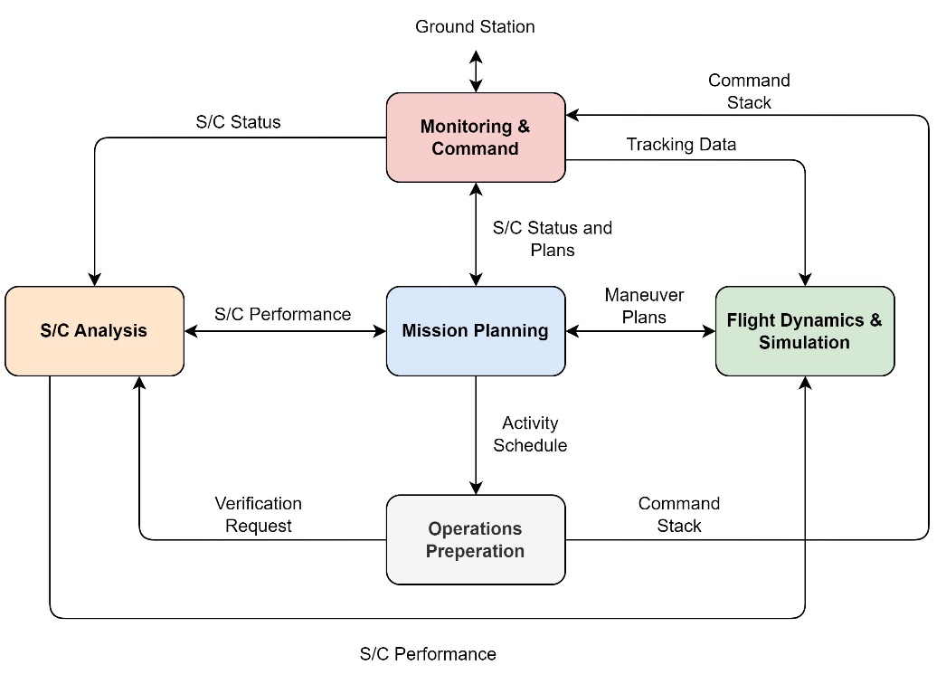

Figure 16: Overview of the Mission Operation System functional areas for CLIMB

Mission Operation System Requirements

Table with most important requirements from CLIMB regarding operations

Table of additional Requirements identified

Mission Operation System Functions

In this chapter, the functions identified for the CLIMB operations are introduced. As described in Chapter 2.2.2, functions are activities necessary for operating the spacecraft. Every mission and organization defines, groups and names these functions differently. According to Table 2, which details the development of an operations plan, identifying these functions is the second step following a mission analysis.

The functions for the CLIMB operations were identified by analyzing and adapting table 1, provided in reference [3_8]. For the CLIMB operations concept, the functions are more detailed compared to those in Table 1. This is due to the functions being selected for a specific mission, whereas the functions in Table 1 are common to all missions. Moreover, this approach brings the activities that need to be conducted to a more application level.

For better organization, these functions are grouped into functional areas. These areas can then be performed by individual subteams within the operations team. Therefore, these functional areas are also referred to as operations subteams.

Table 3: Functions and functional areas of the CLIMB operations system

|  |  |
| --- | --- |
| Functional Areas | Functions |
| Mission Planning | Long-term mission planning |
| Short-term mission planning |
| Regular mission analysis |
| Management of planning products |
| Monitoring & Command | Satellite monitoring |
| Satellite commanding |
| Telemetry processing |
| Management of TM/TC data |
| Operations Preparations | Command sequence development |
| Testing and verification of commands |
| Flight Dynamics & Simulation | Orbit & attitude determination and propagation |
| Orbit & attitude maneuver design |
| Spacecraft & environment simulation |
| Collision risk assessment & counter measures |
| S/C Analysis | Verification of subsystem operations |
| Regular spacecraft system analysis |
| Subsystem anomaly analysis |
| Management of satellite system documents |
| System Development and Maintenance | Development and acquisition of software & hardware |
| Maintenance and upgrade of software & hardware |
| Development and maintenance of data links & databases |

Table 3 lists the identified functions and their corresponding functional areas. These functional areas are closely related and exchange information and data. They might even overlap, depending on the system or software used for certain tasks. Therefore, these functional areas or subteams should not be viewed as independent entities, but rather as areas with specific related tasks. Due to limited staff at the FHWN and the possibility that specific software might combine tasks from different functional areas, it is possible that one subteam or even a single person could be responsible for more than one functional area.

However, the functions listed each require specific background knowledge and have unique characteristics. For instance, scheduling activities and orbit propagation might be executed by a single software, partially automated, allowing one person to perform these tasks. Yet, the task of properly propagating an orbit, for instance, requires different expertise than scheduling spacecraft activities.

Figure 17: Mission Operation System Functional Areas of CLIMB Mission

Figure 12 provides an overview of the functional areas and their interactions, described briefly as follows. The Monitoring & Command functional area communicates with the spacecraft, providing the current satellite status. Mission Planning oversees the overall mission progress and develops plans and activity schedules. The Flight Dynamics & Simulation functional area determine the position of the spacecraft and provide orbit propagations and satellite simulations to mission planning. Operations Preparations converts activity schedules into command sequences and verifies them before sending them to Monitoring & Command for the uplink to the spacecraft.

S/C Analysis evaluates spacecraft performance and supports other functional areas in subsystem specific operations. System Development and Maintenance is responsible for developing, acquiring, and maintaining hardware and software. This functional area contains support functions as introduced in chapter 2.2.2 which concern all other functional areas, therefore illustrated in the background in figure 12. In the following chapters, these functional areas are described in detail and how these functions can be implemented in the FHWN domain.

Operations Concept

Most small satellite missions, especially in the educational context, operate satellites with no propulsion system. The few examples that use propulsion systems, do not use electric propulsion but other kinds of propulsion systems which do not need high frequency thrust operations. The missions that do use electric propulsion, are using it as payload for in-orbit testing missions, thus, also not using it in high frequencies. Therefore, the mission operation of such missions often does not require sophisticated mission planning or an advanced operations concept.

However, for the CLIMB mission, the operation concept is a central part. The propulsion system is used approximately 15 times a day, thereby changing the orbit 15 times a day. The related attitude maneuvers before and after each maneuver result in 45 activities per day, not counting ground communication or science measurement activities. Therefore, an operation concept capable of planning and managing this high activity load is needed.

It would be desirable to plan all activities for operation once for the entire mission or at least for a long timeframe. However, due to the finite time in which spacecraft position predictions are accurate enough for detailed planning and scheduling, and the occurrence of unpredictable events, planning into the future is only feasible for a certain amount of time. Therefore, the task of planning and consequently plan validation and execution needs to be performed regularly to ensure continuous operation of the spacecraft.

To handle the complexity of planning and operation for the CLIMB mission, an approach is introduced that is based on a repetition of so-called operation cycles. An operation cycle consists of activities such as the planning, testing and execution of an operation plan for a certain timeframe. If one cycle is finished, the next cycle starts. Similar as described in chapter 2.2.3, it follows an hierarchical approach in which the operation cycle is split into a long-term and short-term cycle with increased detail level in the short-term cycle. While chapter 2.2.3 only describes mission planning cycles, the operation cycles utilizes not only long-term and short-term planning but also includes other tasks that are repeated with every cycle e.g. a mission analysis or command stack development and validation.

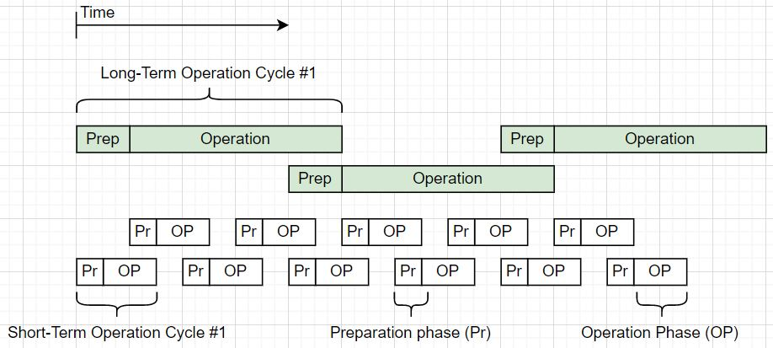

Figure 18: Arrangement of the short-term and long-term operation cycles

The long-term and short-term operation cycles differ in their tasks and covered timeframes. The short-term cycle handles detailed planning and scheduling of activities, development and validation of command stacks, and their execution. The long-term cycle performs activities such as satellite system analysis, mission analysis, and planning of goals and activities that need to be achieved or performed within a timeframe longer than that of the short-term cycle. The long-term cycle provides guidelines for the short-term cycle and ensures that the mission is on track.

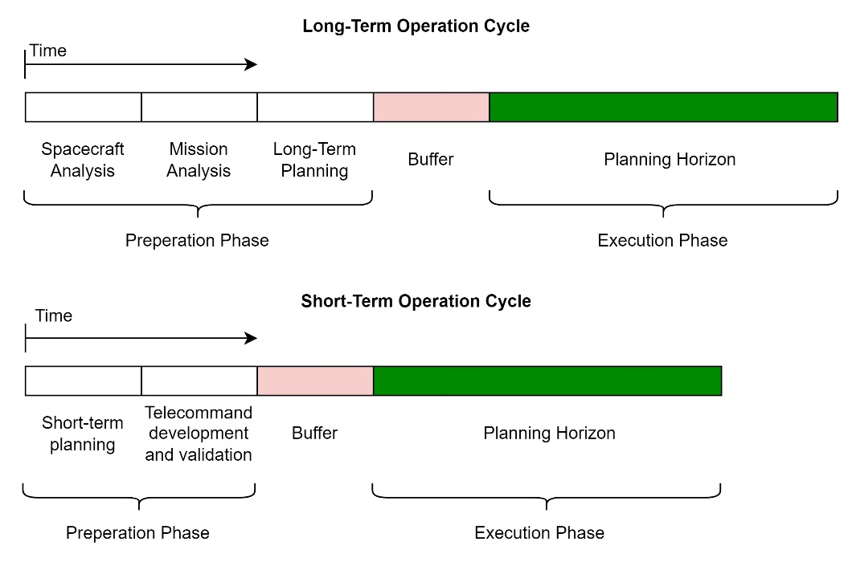

Figure 19: Overview of the short-term and long-term operation cycle

Figure 14 shows the long-term and short-term operation cycle. The short-term operation cycle consists of short-term planning, telecommand development and validation, a buffer time and the plan execution phase (also referred to as the planning horizon). In short-term planning, activities are selected and scheduled for the upcoming operation phase. In the telecommand (TC) development and validation phase the command sequence for the spacecraft is developed, based on the schedule, and tested. A buffer time is introduced to account for delays or disruptions during the preparation phase. Lastly, in the operation phase the plan developed in the preparation phase is executed.

The long-term operation cycle consists of a spacecraft and mission analysis, long-term planning, a buffer time and the execution phase. During the spacecraft analysis, the satellite's status and historical telemetry data are reviewed to assess its overall health and performance progress. In the mission analysis, the overall progress is monitored to determine if the mission goals can be met.

The duration and arrangement of the operation cycles can vary with the mission phase and time in phase. For example, more time for planning is required at the beginning of a phase than later when the operation team is more familiar with the procedures. The exact arrangement of cycles for the different phases will ultimately be determined through experience and is a trade of orbit predication accuracy against operational workload.

Mission Planning

“Since the requirements to a Mission Planning System (MPS) and the tasks that it shall perform vary considerably between different missions, there is not one general planning system that can be used for all different needs. “[3_6, p.168]

For the CLIMB operation, mission planning is a crucial part of the operations system. This function follows a hierarchical approach as described in chapter 2.3.4.1. With this approach, mission planning is distributed over a long-term and short-term planning cycle. The long-term planning cycle focuses on a broader scope of mission planning, ensuring the achievement of the overall mission goals. Short-term planning, on the other hand, concentrates on the detailed planning and scheduling of activities.

Figure 6 introduces also a medium planning cycle. Given that the CLIMB project has a small operations team with limited working hours, this concept introduces only short- and long-term planning, which encompasses all necessary planning.

The hierarchical planning is chosen as this approach allows a structured way to have detailed planning of activities but also the overall mission in scope. As the mission's specialty is that the orbit rise phase takes a long time and needs to yield to a specific target orbit, the global picture of the mission always needs to be considered. Unlike missions described in section 2.3, where routine operations focus on a rather small amount of tasks per day, CLIMB requires frequent thruster operations, changing the orbit around 15 times a day, and associated attitude changes. Therefore, the mission's overall picture requires constant monitoring and planning, leading to the introduction of a long-term planning function.

As described in chapter 2.2.4.1 the planning cycles are defined by the lead time and planning horizon. For the definition of the planning cycle, additionally the lead time is further divided into the planning development time and the buffer time, depicted in figure 15. However, in the context of CLIMB, the planning cycle covers the same timeframe as the operation cycles described above, with the difference that tasks which are not directly planning such as a spacecraft analysis or the telecommand testing are not a part of the planning process itself.

Figure 20: Planning Cycle Definition

During the plan development time, the plans are developed. The buffer time is used as a safety measure if the plan development takes more time than expected. The planning horizon is the time where the plans are in action. The planning horizon is consistent with the operation phase shown in figure 13

The mission planning functional area has the following functions:

* Mission Analysis
* Long-term planning
* Short-term planning
* Management of planning products

Mission Analysis

During operation, it is important to keep track of the mission and its progress. This is essential as this gives information on whether the current mission performance leads to mission success or not. If the goals with the current performance can barely be met, mission planning may take actions to improve. If the current mission state exceeds mission objectives, additional goals could be set, such as increasing scientific activities. For this purpose, a regular mission analysis is utilized in the Climb operation performed by the mission planning function. The mission analysis primarily examines:

* The mission's progress since the last analysis
* The current status of the mission
* The future implications of the mission

Assessing mission success requires a thorough examination of its past progression. Evaluating whether objectives are being met comfortably or only achieved with significant effort and little room for error can inform necessary adaptations in mission operations. Additionally, it is important to verify if the mission's progress aligns with predictions made during the last analysis. Analyzing incidents or unexpected results is equally important in order to learn from them and refine future strategies.

The current status of the mission reveals where the mission stands in the overall project. It gives information on the mission's alignment with the project's timeline and goals. For the apogee rise phase e.g., the status of the achieved apogee altitude is especially of importance. To reach an apogee altitude of 1000 km within a certain time, a specific apogee rise must be achieved weekly or monthly. If a particular progression is not reached, the mission phase must be extended and the impact on the mission investigated.

Furthermore, the analysis gives information on how the current mission status influences the future mission. Especially, the long-term mission impacts in case of deviation or failures is of great importance. If the performance of subsystems changes, e.g. the performance of the battery decreases far more than expected, the long-term impact on the mission needs to be analyzed. A result of such an analysis could be e.g. that the apogee increase of 1000 km cannot be conducted safely. A new mission goal definition would be to only increase to an altitude to 700 km instead of 1000 km.

Conducting regular analysis is crucial to ensure that the mission aligns with the mission goals and is also being executed in a safe and secure manner. Such an analysis can provide valuable insights into the current state of the mission, identify potential issues, and highlight areas that may need immediate attention. The findings of this analysis can lead to changes of the mission goals, requirements, constraints, or operational strategies.

Long-Term Planning

Within long-term planning, activities and strategies are identified which are necessary to meet the overall mission objectives. These plans and strategies are based on the mission and spacecraft analysis (see figure 16) which give the mission and spacecraft status and predicted mission progress. Long-term plans are in the magnitude of weeks to months. This planning cycle considers all influences on the mission from inside and outside the mission operations system. This includes, for example, the planning of holydays where only limited staff is available.

Figure 21: Long-Term Operation Cycle

The long-term planning cycle follows the spacecraft and mission analysis. Figure 16 shows a possible time arrangement of the activities in the long-term operation cycle. Here, long-term planning would be conducted in three to four days with a planning horizon of four weeks. However, as mentioned before, the final time arrangement of the activities in an operation cycle varies with the mission phases and will finally be determined by experience.

In the CLIMB domain long-term planning is recommended to be conducted through a meeting of the operation team with also other relevant CLIMB project team members such as subsystem engineers or consultive individuals. The long-term planning has the following four main tasks:

* Update all relevant CLIMB project participants about the mission status and progress
* Discuss needed activities which also address the mission analysis and the spacecraft analysis (e.g. number and location of science measurements, monitoring of subsystems which show irregularities)
* Discuss special activities (e.g. flight software updates)
* Document and store resulting long-term plan

In this meeting the mission and spacecraft analysis are presented to give everyone in the operations team and other relevant CLIMB project members, an update. Based on that, further steps and activities of the mission are discussed. The s/c system and mission analysis provide predictions for the future which can yield to new requirements, constraints or recommended activities such as minimum apogee rise, new temperature, pointing constraints, or recommended beacon downlinks. For the definition of the long-term plan, actions are identified that need to be performed in the next long-term planning horizon to accommodate these requirements and constraints. All this information needs to be summarized and converted into a plan which is then further refined by short-term planning.

The long-term plan gives a guideline on how to reach the long-term goals. This can be e.g. the rate of apogee rise necessary to reach the final apogee in time. Additionally, specific activities and activity frequencies are defined such as science measurements per week, special activities such as requested in orbit tests of certain systems or specific downlinks or activities necessary due to subsystem anomalies.

Short-Term Planning

Short-term planning performs the detailed definition and scheduling of all activities within the planning horizon of the short-term operation cycle at the highest detail level. It receives the long-term plans and further refines it. The result is an activity schedule for the spacecraft which is also referred to as the Sequence of Events (SoE).

In the context of this thesis, the terms planning and scheduling are differentiated. As described in [C4], planning is concerned with the selection of activities that need to be performed to achieve a certain goal, answering the question of "what" needs to be done. Scheduling, on the other hand, is responsible for the arrangement of the activity on a timeline and deals with the question of "when" it needs to be done by simultaneously considering resources and constraints.

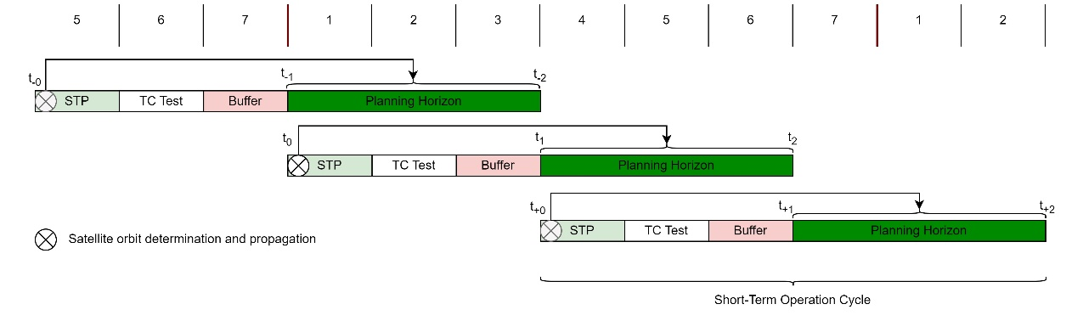

Figure 22: Overview of the short-term planning cycle

Figure 17 shows an arrangement of three short-term operation cycles. In this example the short-term operation cycle consists of a one day short-term plan (STP) development, a one day telecommand (TC) testing and verification phase and a one day buffer, following a three day planning horizon. However, as mentioned before, the days allocated for the different phases within the operation cycle are an example. The difference between the short-term operation cycle and the short-term planning cycle is that in the planning cycle the telecommand testing is not included as this function is not performed by mission planning.

The Scheduling Problem

Short-term planning has the task of planning and scheduling the activities the spacecraft needs to perform. These activities are orbital maneuvers, data down- or uplinks, attitude maneuvers and more. The CLIMB mission utilizes absolute time scheduling. This means that all activities that need to be performed by the spacecraft have absolute start and end times which are defined by mission planning. This is in contrast to event based or position based scheduling in which the spacecraft would perform activities based on certain events or the location of the spacecraft.

The exact dates of certain activities such as orbital maneuvers or contact times with the ground station are dependent on the orbit and position of the spacecraft. Therefore, this information must be known for the planning horizon to determine the dates of certain events, due to the absolute time scheduling approach. As planning and scheduling occur beforehand, the spacecraft state must be predicted for this planning horizon. Figure 17 shows this scenario. In this example we focus on the second operation cycle. The prediction, also referred to as propagation of the orbit, is performed at t0 and propagates the orbit from t0 to t1 and up to t2.

The further a prediction extends into the future, the greater the potential for inaccuracy. Thus, the longer the time interval between t0 and t1, the greater the inaccuracies in the state at t1 and, consequently, t2. Similarly, increasing the time interval between t1 and t2 further increases the inaccuracies at t2. Therefore, it's crucial to identify the optimal time interval between these timestamps.

As seen in figure 17, the state at t0 and t1 is already predicted in the first planning cycle for the planning horizon stretching from t-1 to t-2. However, since this prediction lies a few days ahead at t-0, it is recommended to perform a more current prediction at t0 and compare the results to the prediction of the first planning cycle.

Scheduling

“Since the requirements to a Mission Planning System (MPS) and the tasks that it shall perform vary considerably between different missions, there is not one general planning system that can be used for all different needs. “[3_6, p.168]

Missions such as Terrasar-X have a more challenging scheduling problem since the customers, which are scientific and commercial, both give orders or scheduiling requests. The time and monay and prioritix takss

Scheduling specific for climb mission -> apogee rise perigee passes contact times important

For the CLIMB mission an analysis is perfmomed which shall reveal how the scheduling problem should be approached and how the flight dynamics function interacts with this approach.

Planning Process Analysis

The input of short-term planning are the long-term plans, spacecraft status and performance and the planning horizon timeframe. The output is the sequence of events (SoE), detailing all planned activities such as orbital maneuvers or ground station contact times in a timeline. To generate the SoE, six steps were identified:

1. Activity Definition
2. Orbit Determination and Propagation
3. Activity Scheduling
4. Maneuver Propagation
5. Constraint Analysis
6. Final Definition of SoE

The short-term planning function is closely related to the flight dynamics functional area. As seen from the six steps, there are tasks that need to be performed by the flight dynamics & simulation functional area. The majority of activities for the CLIMB satellite will involve orbital maneuvers and ground communication contacts with associated attitude maneuvers. The dates for these activities depend on the trajectory, which changes with every orbital maneuver, making the scheduling of these activities reliant on flight dynamic related information. All other activities need to be coordinated with these main activities. Therefore, the planning process can be highly iterative, requiring several propagations. As routine mission planning should be as fast as possible to reduce workload and shorten planning preparation time, close cooperation between flight dynamics and mission planning is important.

In this chapter the tasks of the flight dynamics functional area in the process of short-term planning is also described, however, the details on how to perform such tasks are described in chapter 3.6 Flight Dynamics & Simulation.

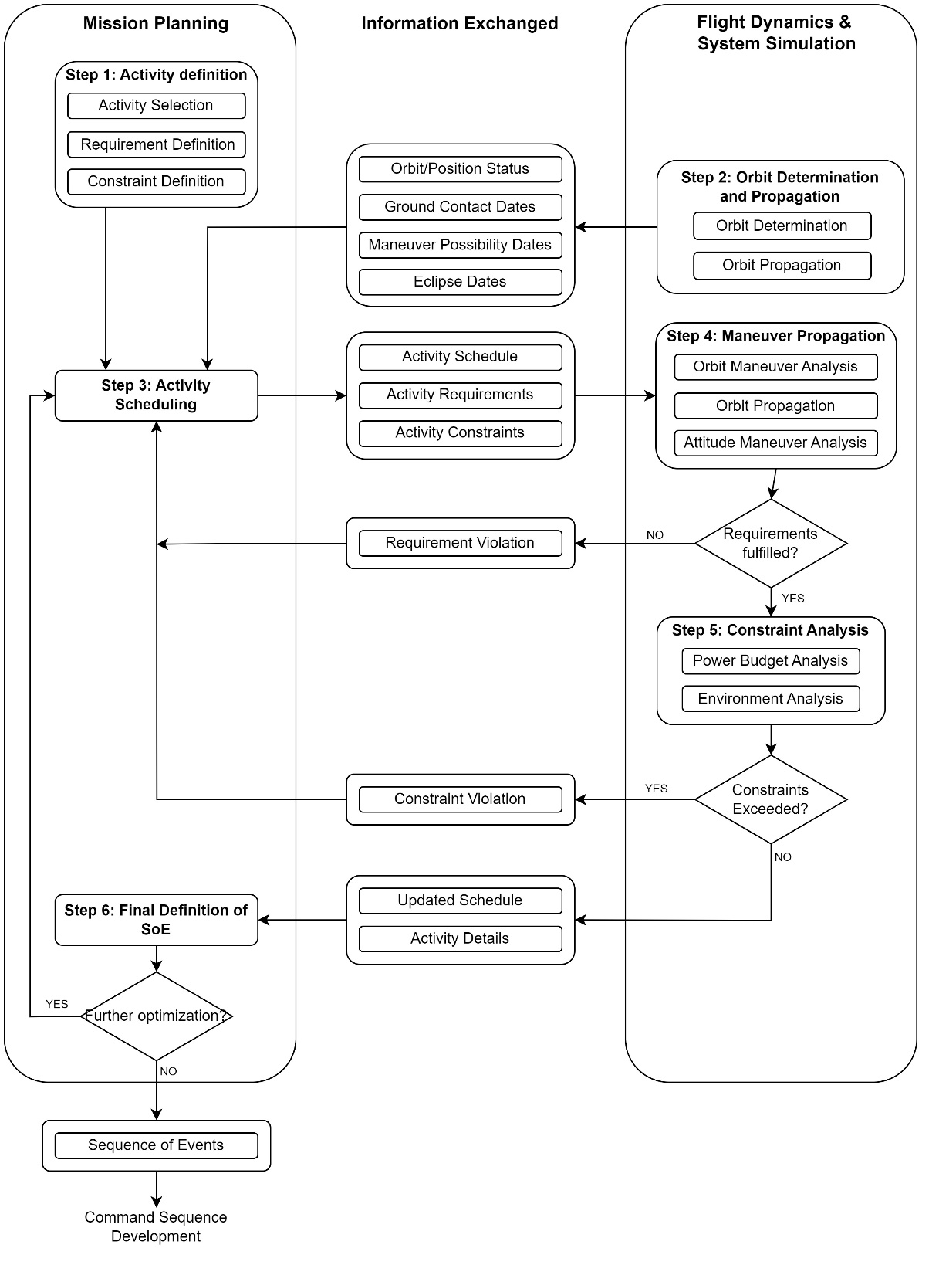

Figure 23: Short-Term Planning Process for the CLIMB satellite

Figure 18 shows the process in a flow diagram and the interaction between the mission planning and the flight dynamics & system simulation functional area. First, the activities that need to be performed are selected and defined (step 1). With the determination of the satellite position and orbit, ground contact dates and orbital maneuver possibilities can be retrieved (step 2) which are used to schedule activities (step 3). With the selected activities such as orbital maneuvers, the new trajectory can be propagated (step 4). Afterwards a constraint check is performed to validate that no system constraints such as power constraints are violated (step 5). If no constraints are violated, the schedule or also called the Sequence of Events (SoE) can be finalized and released (step 6).

**Activity Definition**

Activity Selection:

The first task in the process is to identify and select activities that need to be performed in the upcoming planning horizon. The activity selection depend on the long-term plans but also on the current status of the s/c and requested activities. Due to the s/c system analysis performed during long-term operation cycle, recommendations or required activities for operations are identified. Such recommendations or activities are defined in the long-term plans and e.g. dictate a certain down- or uplink. For example, a specific beacon downlink which contains a parameter to be monitored or a minimum number of science activities are stated in the long-term plans.

The main activities which are performed regularly are:

* Thrust maneuver
* Attitude changes
* Data down- or uplinks
* Science measurements
* ADCS desaturation

However, specific activities can also be submitted via activity requests by all members of the CLIMB project, as well as by entities outside of the project such as other scientific institutions or a supplier of an on-board subsystem. Independent from a long-term plan, a subsystem engineer might be interested in specific downlinks, or the planning team itself is interested in specific data or activities. Such requests need to be implemented in the planning process. Additionally, short-term planning can define activities based on the spacecraft status. If the M&C function receives non-nominal values of certain parameters or anomalies arise, short-term planning can quickly identify actions to address these issues.

Requirement, Resource & Constraint Definition:

The spacecraft system and mission analysis performed in the long-term operation cycle define requirements which are further refined in short-term planning. For example, from long-term planning a certain apogee rise per month is dictated which can be e.g. 80 km/month to reach the overall mission phase goal. Depending on the current progress of the apogee rise, a specific rate of climb per short-term planning horizon is required, leading to a minimum number of orbit maneuver activities that need to be selected. The flight dynamics function needs to address this requirement when designing the apogee rise maneuvers.

However, requirements can change or arise at any time within the mission independent of the long-term planning cycle. The monitoring function might notice a degradation of power generation or faulty sensors. This can lead to new requirements which must be considered for activities that need to be performed in the next planning horizon.

Similar to the definition of requirements, certain constraints must also be complied with for the next planning horizon. These might include specific temperature or power constraints that can vary over time, or even attitude constraints. Addressing these constraints within the planning process is essential to ensure the spacecraft's safety.

**Orbit Determination and Propagation**

Orbit Determination:

The determination of the orbit is performed by the flight dynamics functional area. In this step the orbit and spacecraft position data are acquired and the trajectory determined (see chapter 3.6.1), providing the initial state for satellite propagation.

Orbit Propagation:

In this step the orbit is propagated based on the initial state (see chapter 3.6.2). This provides necessary information for scheduling activities. These information are:

* Contact times and access quality with the ground station
* Perigee pass times which represent apogee rise maneuver possibilities
* Eclipse times

**Activity Scheduling**

In this step the activities that are defined in the activity definition step are distributed in a timely manner, also referred to as scheduling. With the contact times and the orbital maneuver possibilities provided by the flight dynamics & system simulation functional area, a first overview is given. With the additional information on when the spacecraft is in sunlight or eclipse, scheduling can already consider power and temperature to a certain extent. Now, the activities can be distributed in a way that no conflicts with other activities arise.

For example, a science measurement activities can be scheduled at a time that no conflict occurs with a possible thrust maneuver. Critical uplink or downlink activities should be scheduled at ground contacts with high elevation passes. If several ground contacts overlap with thrust maneuver possibilities, maneuvers can be sacrificed to use ground contacts for e.g. housekeeping data acquisition.

However, it is important to note that at this state, the schedule is not final. Every orbital maneuver that is planned, changes the orbit to some extent, causing perigee passes and ground contacts to shift in the timeline. This makes a second orbit propagation necessary which take planned maneuvers into account. More details on this will be provided in the next step.

As described in section 2.2.4.2, the scheduling process can be performed manually or automatically. For the CLIMB project, a manual scheduling approach is favorable. The majority of activities will be ground station contacts, thrust maneuvers and attitude changes. The possibility where these activities can be scheduled are already given by the position of the spacecraft. Spacecraft contacts can only be scheduled where the spacecraft is in line of sight with the ground station. Apogee rise maneuvers will only be performed at perigee passes. Most of the attitude switches are needed before and after a maneuver or an S-band ground contact. The flight dynamics function already provides the dates of the possibility of such activities in the step above, shown in figure 19.

Figure 24:

Figure 19 shows a visualization of the output of the first propagation of the orbit. This already shows a possible activity schedule, for which the desired thrust maneuvers and ground contacts can be selected. Other activities such as scientific measurements, can now be distributed over the schedule manually, in a way that no conflicts occur.

**Maneuver Propagation**

Orbital Maneuver Analysis:

With the activity schedule provided by mission planning the scheduled thrust maneuvers can be analyzed. The orbital maneuvers are characterized by the thrust and Isp of the propulsion system and the duration of the maneuver. The analysis of the maneuver provides the delta-v and apogee gain of every maneuver but also for the entire planning horizon.

With this information and the minimum apogee rise requirement, it can be determined whether the schedule fulfills this requirement or not. If the requirement is not fulfilled, the results of the analysis are provided to mission planning which then has to reschedule the plans. If it is not possible to achieve the requirement, the deficit of the apogee gain needs to be compensated in the next planning horizons. If this is also not possible, the apogee rise phase duration increases.

Orbit Propagation:

Since the orbit is slightly changed at every maneuver, the ground contact and maneuver dates provided by the first trajectory propagation in step 2, are changed. The dates of these activities are therefore shifted back in the timeline. The more thrust maneuvers are performed before an activity, the more this activity will shift back in time. Therefore, a second propagation needs to be performed which takes the desired maneuvers into account.

Since the spacecraft utilizes low thrust maneuvers, the change in time can have an insignificant impact on the schedule. Due to the fact that the orbit determination and propagation is already subject to an error, the order of the error caused by the maneuvers can be insignificant. Nonetheless, this needs to be analyzed to confirm if that is the case. Since the orbit is newly determined at the beginning of every planning horizon, this error only impacts one short-term planning horizon.

Attitude Maneuver Definition:

Besides the thruster maneuvers also the attitude maneuvers need to be taken into account. While no thruster maneuver or other activity is performed, the spacecraft should be in the sun pointing mode. Every time a maneuver or an S-band communication activity is performed, the spacecraft needs to change its attitude.

**Constraint Analysis**

Power Budget Analysis:

The power budget gives information if the activity schedule is possible in terms of power (see chapter 3.6.3). If at some point, more power is drawn then available, the schedule is not durable and needs to be changed. If the power budget analysis indicates that the schedule is not possible, the results are directed to mission planning. Mission planning can then go back in the process to the activity scheduling and change the schedule with the additional information on the power consumption. This is either possible by rearranging or canceling activities.

Environmental constraint checking:

Environmental constraints mainly refer to the temperature of the spacecraft (see chapter 3.6.3). Specific systems are temperature sensitive such as batteries. It is important to keep the temperature within a specified range. One important case to consider is the operation of the thruster. Since this system generates heat, the operation duration might be limited. This is especially the case if the maneuver takes place while the spacecraft is illuminated by the sun. To ensure no temperature limits are exceeded, it might be necessary to estimate or simulate the temperature profile over the planning horizon.

**Definition of Sequence of Events**

If the constraint analysis shows no violations, the activity schedule can be finalized. This schedule now contains all activities for the spacecraft in a timely manner and is also referred to as the Sequence of Events (SoE). Before releasing the schedule, it is recommended to perform a last constraint check. Since this schedule is used to create the command sequence and also gives the ground station the command uplink times, it is important that this schedule is error and conflict free. Errors in the SoE could jeopardize the safety of the spacecraft.

If there is room and desire for optimization of the final plan, this is the last step in the process where this can be done before the development of the command script. If for example the power budget shows a lot of excess power, additional activities such as orbital maneuvers or science measurements could be scheduled.

It is important to note that since all activities and requirements depend on the success of the previous planning horizon, the planning horizon of the last operation cycle must be monitored continuously. Not only by the M&C functional area which monitors the spacecraft systems but also by the mission planning functional area to check if the planning horizon is successful and on track. If e.g. the apogee rise requirement could not be realized in the last operation cycle, additional thrust maneuvers could be scheduled in the current operation cycle.

It is recommended that the SoE contains all details about the activities that were defined during the development process in the steps above which are needed for defining the spacecraft commands such as thruster or ADCS settings. This allows for the development of commands from the SoE, reducing needed interactions with different entities within the mission operation system.

Mission Planning Tool

Based on the problem definition and process analysis above, a preliminary mission planning tool for short-term routine operations could be developed. This tool is specifically tailored to the CLIMB operations. As mentioned at the start of the previous chapter, the mission planning and flight dynamics functional area should work as closely as possible to enhance efficiency. This was a major driver when developing this tool. It demonstrates the feasibility of merging different tasks into one tool, thus enabling a single person to perform these tasks.

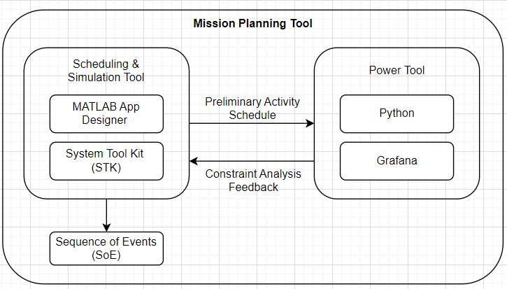

Figure 25: Structure of the Mission Planning Tool

The mission planning tool was developed in cooperation with a student’s project [STP_Report] and follows the steps in figure 18. It consists of the scheduling & simulation tool and a power tool (see figure 20). The scheduling & simulation tool utilizes MATLAB App Designer [] and STK []. MATLAB App Designer provides the front-end GUI, manages the data flow between the user and STK and contains a scheduling function. STK is used as flight dynamics simulation environment for the CLIMB satellite. The power tool is used to perform constraint analyzes and power data visualization, based on the results of the scheduling & simulation tool. It consists of a python script used for power data processing and a Grafana dashboard for visualization of the data.

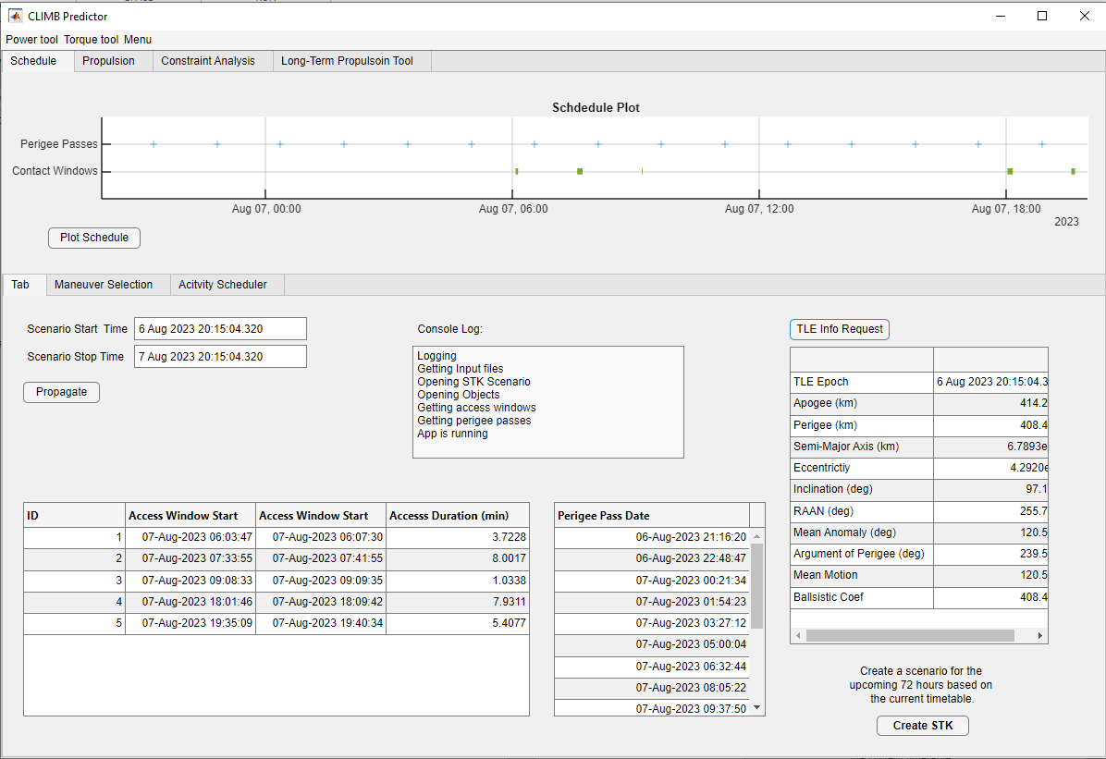

Figure 26:

Figure 21 shows the initial interface when opening the mission planning tool. In this tab, the second step from the short-term planning process is performed, namely the determination and propagation of the orbit. The input for this step is the initial state of the orbit, provided by a NORAD TLE or the on-board GPS system data. With this information the orbit is propagated which gives the ground contact opportunities, the maneuver opportunities, which correspond to the perigee pass dates, and the eclipse times. As seen in the graph in figure 21, this already gives a first overview of a possible activity schedule.

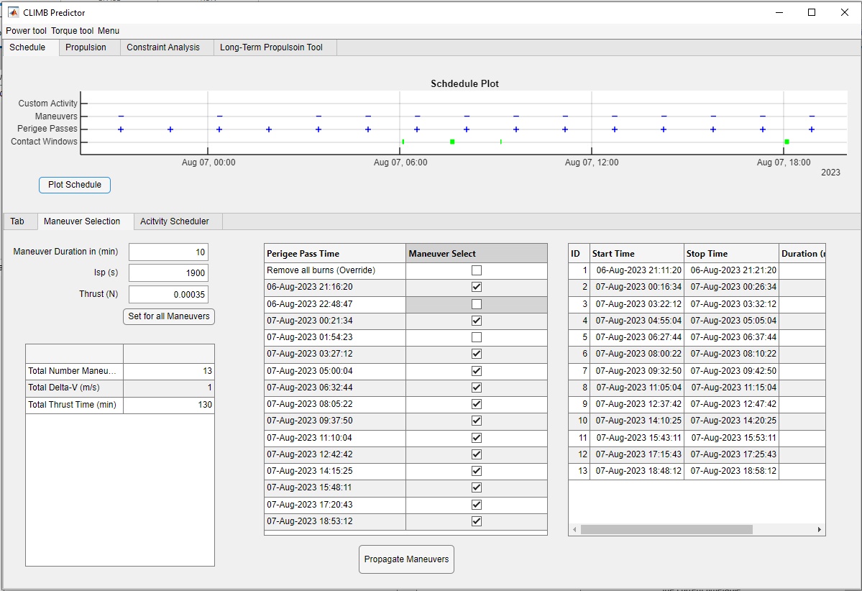

Figure 27:

Figure 22 shows the maneuver selection tab of the mission planning tool. This tab combines steps 3 and 4 of the short-term planning process. It displays all potential orbit rise maneuvers, which can be selected if a maneuver at the corresponding perigee pass is desired (Step 3, activity scheduling). After the selection of the maneuver, the new trajectory can be propagated. The output provides information such as the total generated delta v and the increase in apogee altitude. Due to the possibility of changing maneuver and propulsion system parameters, such as maneuver duration, thrust, and Isp, an analysis of different maneuver designs is possible (Step 4, maneuver analysis).

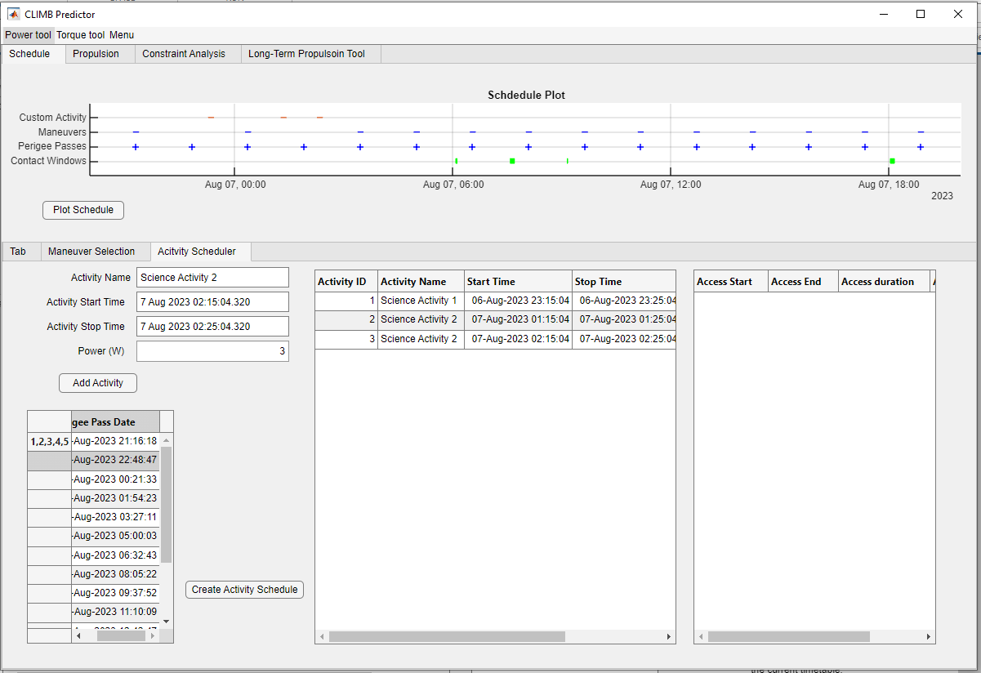

Figure 28:

Figure 23 displays the Activity Scheduling tab where custom activities can be added to the timeline. Each activity is characterized by a name, start time, end time, and a resource such as power consumption or data storage. These activities can be manually arranged to avoid conflicts. If conflicts arise, deselecting a thruster maneuver can create space for a certain activity. Once the timeline is finalized, the "Create Activity Schedule" button can be pressed. This gathers all activities in one table in chronological order based on the activity start date. An algorithm can then check this schedule for any conflicts.

Subsequently, the table is provided to the power tool. This tool collects all power generation and consumption data, using it as an input for the CLIMB battery model. The resulting data is visualized in Grafana to check if any power constraints are exceeded (step 5, power budget analysis). If the constraint check is successful, the previously generated timeline can be officially released as the sequence of events (step 6).

Management of Planning Products

Flight Dynamics & System Simulation

The flight dynamics & system simulation functional area supports operations related to spacecraft and orbit simulations. These simulations offer data on eclipse times, power generation, and attitude changes. Additionally, orbit simulations are conducted to determine and predict the orbit, ground contact times and apogee rise maneuver possibilities. The following functions, which are detailed in the subsequent subchapters, are included in this functional area:

* Orbit & attitude determination and propagation
* Orbit & attitude maneuver design
* Spacecraft & environment simulation
* Collision risk assessment & counter measures

The ANSYS System Tool Kit (STK) will serve as the primary tool to determine, analyze, and propagate the trajectory of the CLIMB satellite. STK is a robust, professional tool that provides a physics-based modeling environment for flight dynamic simulations. However, it not only provides

For CLIMB, the basis of the simulation of the orbit is

Orbit Determination and Propagation

The determination of the orbit provides the current position and trajectory of the spacecraft, while orbit propagation predicts the spacecraft's state at any given time within a specific timeframe. The basis of both is an initial state of the spacecraft, defined by its position and velocity. For the CLIMB operations, the acquisition of the initial state is performed by two methods. The first method is to use the TLE data published by NORAD as the initial state. The second method uses the on-board GPS system to acquire initial state data. The data can be used as input to compatible and available propagators.

The use of Two-Line Element sets (TLEs) and the Simplified General Perturbations model (SGP4) is a popular method for satellite tracking and orbit determination from the ground. The data is freely available online, and there are numerous professional and semi-professional tools to determine and propagate the trajectory using this method. However, one must consider that NORAD releases TLEs approximately once a day with an accuracy of around 1-2 km. Consequently, the current orbit determined is often a prediction based on a TLE that could be hours old, which further reduces the accuracy. Thus, this method may not be suitable for high accuracy applications.

TLEs can be manually acquired by accessing the internet and extracting the current TLE. The data can be copied and saved to a text file, which can be used as input for a propagator. The most prominent sources for obtaining TLE files include:

* CelesTrak []
* Space-track.org []

However, manual acquisition of the TLE might not always be practical. Another method to acquire the TLE is by using a programming language to automatically obtain the current TLE. Space-track.org provides a Python library that can be used to obtain TLE files [].

The second method for determining the initial state uses GPS data from the onboard GPS subsystem. This process involves acquiring GPS data during ground contact and subsequently processing it, depending on the GPS system, to achieve the appropriate format for the propagator input. The conversion to TLE format and an estimation of the accuracy are detailed in paper [2_26]. Initial state data derived from GPS can offer more current, frequent, and precise information than that obtained from NORAD, depending on the GPS system in use.

A recommendation is to use and compare both methods, GPS and TLE’s while operation. Since the determination with the use of NORAD TLE data is rather simple, this can be used for fast and simple monitoring activities while the determination with the GPS system can be used for more advanced purposes. To get the current and predicted orbit and position of the satellite several methods and tools are available. The most relevant tools for the CLIMB operation are presented here:

**Propagator Libraries**

Due to the widespread use of the SGP4 propagator, many libraries for programming languages exist. For Python, the SGP4 library [] or the Ephem library [] can be used to determine and propagate the orbit. However, other libraries are also available using different propagators, such as the Poliastro library []. The input can be in TLE format, state vectors, or orbital elements. These tools also have the capability to predict contact times with the ground station. There is also a library for Arduino [] and ESP32 [] for standalone applications. Together with a script-based TLE acquisition, the CLIMB project team can write custom software for special applications if needed.

**Free available Tools:**

Other freely available tools include Orbitron [] and Gpredict []. These tools automatically import the most recent TLE’s from CelesTrak and predict the orbit and contact times with a specified ground station. They are easy to use and can serve as a satellite monitoring display and ground contact predictor at the CLIMB ground station. They have already been used for the PEGASUS satellite for orbit monitoring and pass prediction. Gpredict has also the capability of controlling ground station antenna rotors. However, it has to be considered that both tools use the SGP4 propagator only.

Figure 29: Orbitron overview example with the CLIMB ground station (FHWN) and the display of COSMOS satellite

**System Tool Kit (STK):**

The ANSYS System Tool Kit (STK) will serve as the primary tool to determine, analyze, and propagate the trajectory of the CLIMB satellite. STK is a robust, professional tool that provides a physics-based modeling environment for flight dynamic simulations. STK includes a variety of propagators, such as the SGP4 propagator that uses TLEs as input, or other more precise propagators using state vectors or orbital elements as input.

The selection of the appropriate propagator is crucial and depends on the application. If high prediction accuracy is needed, a different propagator should be selected than for a quick estimation where accuracy is not as important. For instance, when analyzing a sun-synchronous orbit for CLIMB, a propagator that considers Earth's inhomogeneous gravity field must be used. Table 4 displays a list of the most relevant propagators used for the CLIMB satellite. A more comprehensive list is available at [].

Table 4: Propagators available in STK [website_stk]

|  |  |
| --- | --- |
| **Propagator** | **Description** |
| **Analytic Propagators (Low Fidelity)** | |
| TwoBody | The Two-Body, or Keplerian motion, propagator considers only the force of gravity from the Earth, which is modelled as a point mass. |
| J2 Perturbation | The J2 Perturbation (first-order) propagator accounts for secular variations in the orbit elements due to Earth oblateness. This propagator does not model atmospheric drag or solar or lunar gravitational forces. J2 is a zonal harmonic coefficient in an infinite series representation of the Earth's gravity field. It represents the dominant effects of Earth oblateness. The even zonal harmonic coefficients of the gravity field are the only coefficients that result in secular changes in satellite orbital elements. The J2 propagator includes the first-order secular effects of the J2 coefficient. |
| SGP4 for LEO satellites | The Simplified General Perturbations (SGP4) propagator, a standard AFSPACECOM propagator, is used with two-line mean element (TLE) sets. It considers secular and periodic variations due to Earth oblateness, solar and lunar gravitational effects, gravitational resonance effects and orbital decay using a simple drag model. |
| **Semi-Analytic Propagators (Medium Fidelity)** | |
| LOP | The Long-term orbit predictor (LOP) allows accurate prediction of the motion of a satellite's orbit over many months or years. The LOP propagator uses the same orbital elements as those required by the Two-Body, J2 and J4 propagators. |
| **Numerical Integration Propagators (High Fidelity)** | |
| Astrogator | The Astrogator propagator provides for trajectory and maneuver planning and includes targeting capabilities. |
| HPOP | The high-precision orbit propagator (HPOP) can handle circular, elliptical, parabolic and hyperbolic orbits at distances ranging from the surface of the Earth to the orbit of the Moon and beyond. This propagator uses the same orbital elements to set the state at epoch as those used by the Two-Body, J2 and J4 propagators. |

The SGP4 propagator can be directly used with TLE data. Nevertheless, for more accurate applications like maneuver planning or acquiring contact times and perigee pass times for short-term planning and scheduling, the high-precision orbit propagator (HPOP) is preferred. Since the TLE format is designed for the use of the SGP4 propagator, it cannot be used as input for the HPOP propagator. Given that TLEs will be a primary source of orbit state information for the CLIMB operation, the TLE format must be converted to state vectors or orbital elements. A MATLAB function that converts TLEs into orbital elements is provided in reference [2_37].

The results generated by STK is consists of comprehensive and customizable reports which allows to extract data from the simulation. These data include e.g. orbital elements over time, possible contact windows with the ground station, perigee pass times which give information for possible apogee rise maneuvers, etc.

Orbit & Attitude Maneuver Design

The thrust and Isp of the system can be adjusted depending on the power provided and vice versa. Therefore, the design of the maneuver has different variables which can be optimized to get an optimum apogee rise maneuver depending on the priorities which can be e.g. high climb rates or low power consumption. After some experience, it might be that a specific setting of all these variables is fixed to decrease the workload. Nevertheless, the safety of the spacecraft is always the highest priority.

Astrogator

Long-term orbit maneuver analysis tool

Attitude maneuvers

Spacecraft & Environment Simulation and Modelling

This function provides information of the satellite and environment for operations. The main task is to get the time in sun to get an estimation of the generated power with the solar arrays. Additionally a main task of this function is to operate a model of the CLIMB battery. With the power generated, the power drawn

Time in Sun

Power Generated

Model:

Battery Model

STK, power, temperature, battery state

For using STK partially as modelling tool, in the view of the planner and in the scope of this thesis, these models are a black box.

Figure 30: CLIMB Power Budget Table

Constraints:

Task overlap modelled by

Temperature

Power

ADCS desaturation

ADCS pointing

Collision Risk Assessment & Counter Measures

ESA/NASA Guidelines, Okapi

Monitoring & Command

The monitoring and command (M&C) functional area is responsible for the monitoring of the downlinked satellite data, the commanding of the satellite, processing of telemetry data and the data management. This functional area forms the interface between the ground station and the operation system.

Realt-time

This function is always in action over the entire lifetime of the satellite. In contrast to s/c analysis which is only needed in certain events.

The monitoring & command (M&C) functional area forms the interface between the ground station and the mission operations system. It receives all data from the s/c. It manages this data by categorizing (science, tracking, housekeeping), distributing and storing this data. M&C receives command stacks from the Command Development team and is responsible for storing the commands and transmitting them to the s/c.

Figure 31: M&C functional area overview

Satellite Monitoring

The monitoring of telemetry data is performed by visualizing the data in graphs, diagrams, and metrics. The visual representation of the data allows for quick interpretation and recognition of patterns, enabling the identification of non-standard values or anomalies.. However, before the data can be monitored, it first needs to be acquired.

The CLIMB satellite automatically transmits a beacon every 10 to 60 seconds via the UHF communication system. This beacon contains the most crucial housekeeping data for monitoring. Other beacons containing more specific data can be requested by a command. The exact number and structure of the beacons are not yet defined. However, they will be similar to the PEGASUS satellite. For Pegasus, three beacons were implemented: an EPS, STACIE (communication system), and OBC beacon, each containing specific data of an associated subsystem [1_4]. While the OBC beacon was sent automatically every 30 seconds, the other beacons could be requested by a telecommand. [Beacon stuff]

The telemetry of the CLIMB satellite is acquired from two different sources. The primary source of the telemetry data is the local ground station located at FHWN. The secondary source of the telemetry data is provided by the SatNOGS network. While the local ground station at FHWN can only receive data when the satellite passes over Wiener Neustadt (approximately 5 times a day), the use of SatNOGS enables data acquisition from globally distributed ground stations. This allows for more frequent data reception and therefore the monitoring of more current data, enabling near real-time monitoring. [TM Sources]

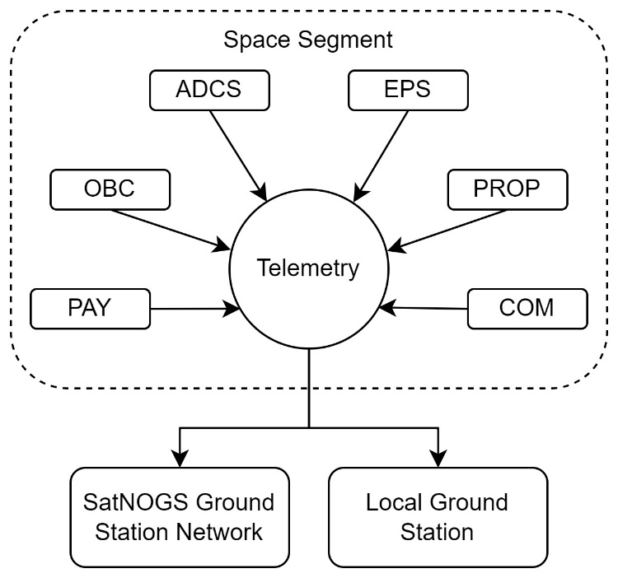

Every subsystem generates housekeeping data, providing insight into the status and health of the satellite. The specific data contained in the CLIMB downlink has not yet been determined. It is crucial to decide which data needs to be downlinked and monitored. The testing phase of the satellite will give a better insight of what needs to be monitored. The satellite's testing phase will provide a clearer understanding of what requires monitoring. With more testing experience, it becomes evident which data is crucial for specific scenarios. For instance, a system might be sensitive to certain situations, and a specific parameter may be identified as important to manage this situation. Knowing such parameters that are important for resolving problems and anomalies is of great importance.

The standard beacon sent by the satellite may only contain current housekeeping data, but no historical data, therefore providing data only at specific points in the orbit. To also obtain data over the entire orbit, a data dump should be requested from time to time, which downlinks all historical housekeeping data for a certain timeframe. The timeframe and how often this should be done depends on the satellite's data storage capability. By using the SatNOGS network, it is also possible to gather data at various points along the orbit. [TM coverage]

<https://libre.space/projects/polaris/>

**Telemetry Downlink Concept**

**Telemetry Source**

SatNOGS

SatNOGS is a cost free open-source ground station network. Users all over the world can build a ground station using off-the-shelf components and connect with the SatNOGS network. SatNOGS provides a software based on a Debian system which demodulates, deframes and decodes the received data, tracks satellites and performs doppler shift corrections []. The SatNOGS system is already implemented in the local ground station at the FHWN and well tested with the PEGASUS and other satellites. Given our experience with the successful implementation at FHWN ground station, integrating SatNOGS as an additional telemetry data source for the CLIMB satellite benefits from our existing expertise.

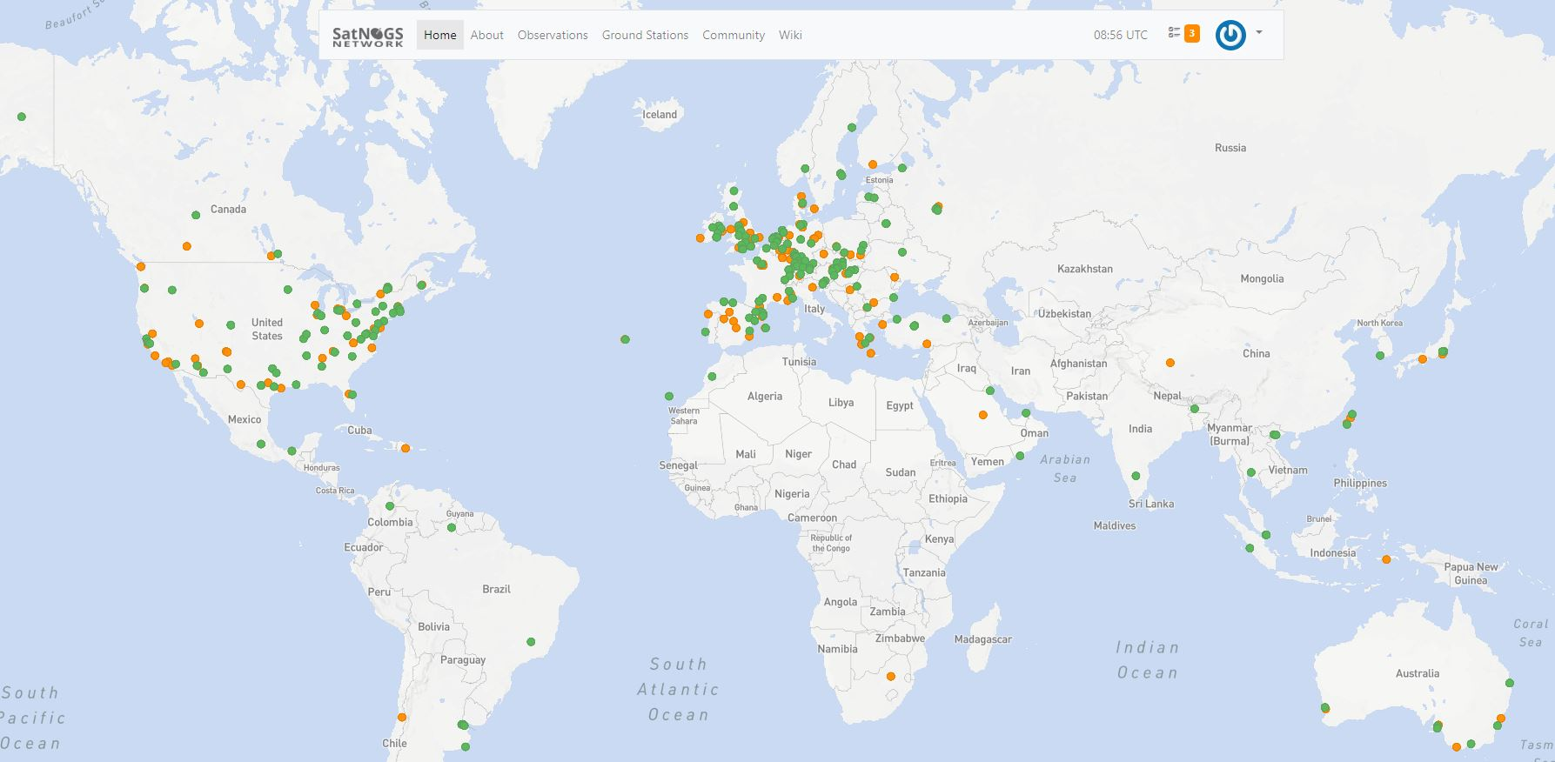

Figure 32:

Depicted in figure X, the ground stations are distributed over the world, operated by private individuals. As seen from figure X, this network provides a broader coverage of possible satellite observation windows. The green dots in figure X show ground stations which are in operation, the orange ones are ground stations in testing mode. As a SatNOGS user, one can simply select a green indicated ground station and schedule a satellite observation. The SatNOGS software will automatically perform the satellite tracking and data reception. After the data is received by the ground station, it is automatically uploaded to the SatNOGS network. However, it's a prerequisite that no one else has scheduled an observation with that ground station during the intended observation timeframe.

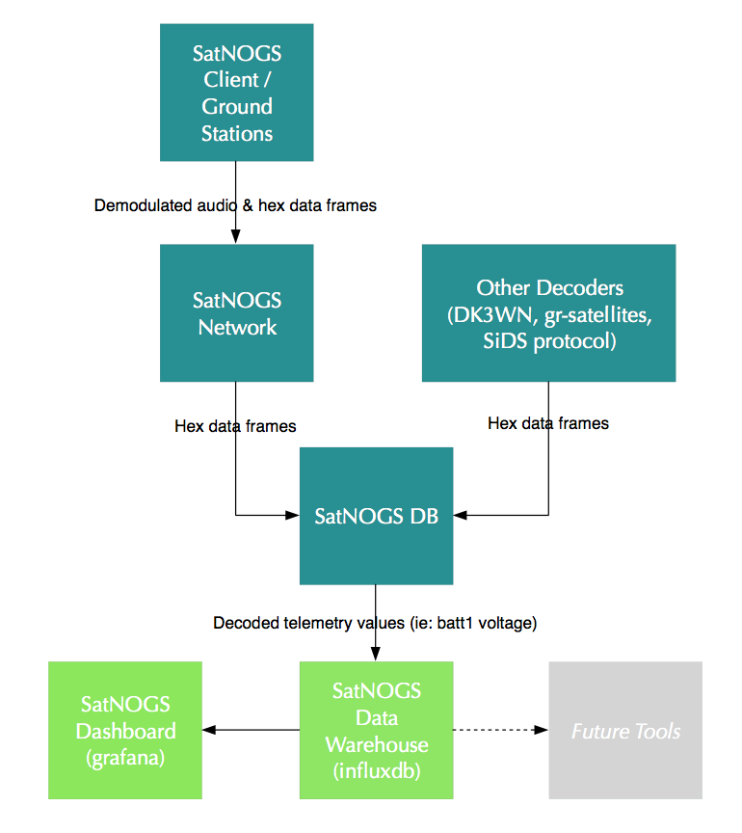

Figure 33: []

Figure X depicts the flow of satellite data between the individual SatNOGS components. The ground station receives the data, which is then forwarded to the SatNOGS network, and subsequently to the SatNOGS database. This data can be decoded and stored in the SatNOGS warehouse, a database built on InfluxDB. Finally, the data can be visualized on the SatNOGS dashboard, which uses crowd-sourced Grafana dashboards to display the collected and decoded data.

Figure 34: Telemetry data visualization of the PEGASUS satellite using SatNOGS dashboard []

Figure X presents the SatNOGS dashboard for the PEGASUS satellite. The data is visualized using Grafana [], an open-source data visualization tool. The dashboard displays decoded telemetry data, including voltages, currents, and temperatures from the latest satellite data reception. It also provides an initial idea and potential structure and design for a monitoring interface for the CLIMB satellite.

As SatNOGS brings many advantages to the monitoring concept of the CLIMB mission, one has to consider the following:

* Observations can only be scheduled if the intended ground station is available at that time
* The ground stations are operated by private individuals who might not be experts, which is why reliability cannot be guaranteed.
* The SatNOGS dashboard is publicly available. However, some telemetry data from CLIMB, produced by subsystems of external companies, are sensitive and not allowed to be public.
* Data reliability (Ask Alex!)

Monitoring System Concept

For monitoring the CLIMB telemetry data, the open-source visualization software Grafana is recommended. This software has already proven suitable for the PEGASUS satellite and is used in various other CubeSat projects, as described in Chapter X. Additionally, a place to store all data in a reliable and structured manner is required, leading to the need for a database. The recommended concept of the telemetry data and visualization system is shown in Figure X.

**System Structure**

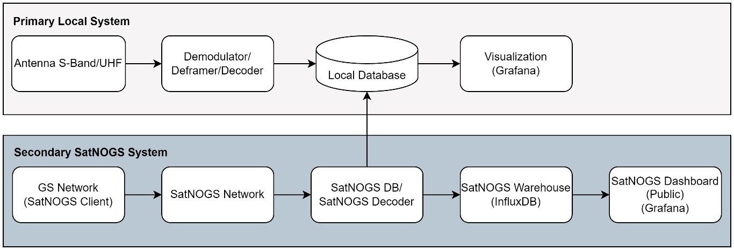

Figure 35:

Figure X illustrates the monitoring concept for the CLIMB monitoring system. The illustration is split into the local and the SatNOGS system, with the local system being the primary one. Starting at the local system, the data is received by the S-band or UHF antenna. This data is then demodulated, deframed, and decoded by the ground station. The data is then stored in a database which runs on a local computer or server. Grafana automatically retrieves the most recent data from the database and visualizes it in a Grafana dashboard developed by the CLIMB team.

In the SatNOGS system, satellite data is received, demodulated, and deframed by the SatNOGS client. This data is then uploaded to the network and stored in the SatNOGS database. From there, the data is pulled by the local system and stored in the local database. This data can then be visualized by a local Grafana dashboard, making it unavailable to the public. Simultaneously, data that is not sensitive for public use can still be loaded onto the SatNOGS dashboard for a secondary and publicly available data visualization. This is considered, firstly, to contribute to the SatNOGS open-source project, but also to enable everyone to easily monitor the data via web access, and to share this exciting CubeSat project with the public.

**Visualization Concept**

Grafana offers a broad range of visualization possibilities such as graphs, metrics, texts etc. To organize the data visualization, from the experience and research of other concepts presented in chapter X, it is recommend to separate associated data visualization. This e.g. can be separation of data of different subsystems. In a Grafana dashboard, data can be separated in pages. For CLIMB, it is recommended to utilize these pages to organize the data visualizations.

It is recommended to have one main page. This page contains the most important data which indicates the overall health and status of the spacecraft. This is e.g. the current satellite mode, main bus voltages and currents, battery temperature and state of charge, etc. Then there would be one page dedicated to each subsystem containing specific data of this system. Finally a page is recommended which shows data over time to see degradation.

Monitoring the current state and most recent recorded parameters by the spacecraft is referred to as real-time or near real-time monitoring. However, with the proposed not only current data but also past data should be monitored together to see how parameters have changed over time. The local database contains all data ever received. Grafana is able to access all data on the database. It is recommended to have a Grafana page which plots parameters of interest over the mission time and adds new received data to this graph. With this approach it is possible to see patterns in the data and detect performance degradation or anomalies. This can be e.g. battery output power, temperatures etc. to see patterns or performance degradation.

Another option to organize the data is using Grafana dashboards instead of pages. Having one single dashboard containing all data can be … Therefore, using Grafana dashboards for each subsystem gives more options for organizing the visualizations using e.g. pages in the a subsystem dashboard. However, the disadvantage is that in this way, not all data can be shown simultaneously since only one dashboard can be opened. The only way is to have several dashboard open in different browser tabs or to have several monitors which have one dashboard open.

For enhancing the visualization it is recommended to implement constraints to indicate spacecraft limits together with color modes as described in section X. These color coded format indicate if values are nominal or if limits are exceeded.

Figure 36: Propulsion system telemetry data visualization using Grafana

A student project [stp] already developed a first Grafana page for the monitoring of the propulsion system. The data important for monitoring were defined in cooperation with the propulsion system manufacturer. This page shows thrust or Isp values of the last received data.

The data is visualized via GRAFANA

Real-time monitoring

Long-term monitoring

Satellite Commanding

The commanding

**Command Script Transmission**

The SoE states at which contact window the command script shall be uploaded. When this time is due, the command script is taken from the database and transmitted to the spacecraft. This process, from the release of the command script to the storage and transmission to the spacecraft can either be done manually or completely automatic.

There are several ways to transmit the command script. It can either be uplinked partially over multiple contact windows or in one contact window. This depends on the size of the command script and the possible data rate of the communication link. However, it is desired to uplink the command script in one contact to reduce the risk of not transmitting the script in time if proper reception by the spacecraft fails. If the command script uplink is not successful, the next contact window needs to be used which mission planning already accounted for.

It might also be that certain commands are uplinked to the spacecraft, which are not in the SoE. This could be, for example, a command for a certain beacon downlink, which is suddenly needed and can be performed at any contact window. However, it is important to check the SoE first to ensure that no conflicts occur with the activities scheduled in the current active command script of the spacecraft.

Additionally, not all activities stated in the SoE may be included in the command script. The SoE can also state that some activities are performed manually. This could be, for example, a calibration or update of a subsystem that should be commanded manually step by step. Similarly, if the timing of an activity is uncertain, it may also be carried out manually. Any manually performed activities should be clearly marked as such in the SoE.

Management of TM/TC data

The management of telecommand and telemetry data is realized by a database. The use of a database

What is a database (advantages…)

Examples of databases

Description of InfluxDB (time-series based database…)

**Telemetry Management**

InfluxDB compatible with Grafana

Database

Everyone/team should have access

Remote access

It is important to separate (or mark every beacon or data, must not necesareliy sperated) between satnogs data and local received data in the local database! Since satnogs data is not as reliable

**Telemetry Processing**

**Command Script Management**

Once the command script is validated and released, it is passed on to the monitoring & command function, which is in charge of managing the telecommand data. This data management needs to be traceable, reliable, and intuitive. When the uplink is due, the command script is pulled from the database, either manually or automatically.

Spacecraft Analysis

This functional area supports the satellite operations in spacecraft system specific tasks. This support includes:

* The verification of operations on subsystem level
* A regular spacecraft systems analysis
* The analysis of system anomalies
* Storing and organizing spacecraft system documents (manuals, reports, analysis, procedures)

The functional area holds specific knowledge of the spacecraft and its subsystems. In commercial or larger space missions, as described in the literature, the spacecraft manufacturer and the operator are often two different organizations. The manufacturer provides detailed information about the spacecraft systems to the operator, enabling them to operate the spacecraft.

In certain situations like subsystem anomalies or special operations, the operator sends telemetry data to the manufacturer for analyzing [Jasmina_interview]. In the CLIMB operations, the spacecraft analysis functional area takes on the role of the manufacturer, holding specific knowledge of the satellite. This function should include subsystem engineers and have the capability to contact relevant individuals who may not be, or may no longer be, at the university, to assist in special situations. This is especially the case for subsystems that are not developed inhouse, such as the ADCS or propulsion system.

https://libre.space/projects/polaris/

Verification of Subsystem Operations

Depending on the depth of the testing phase, most command sequences might be tested thoroughly, or only the most crucial ones. Although, commands are tested before being uplinked to the spacecraft, there might be situations where irregular operations need to be performed. These situations might require more investigation than a routine command sequence test conducted by the operations preparations subteam.

Such cases might include a scenario where a routine test of a command sequence is unsuccessful, leads to a subsystem anomaly, and the cause cannot be identified by the operations preparation subteam. Other cases can involve special operations for which no procedures are pre-developed, thus requiring the development of a command sequence involving specific subsystems. For these situations, resources such as subsystem engineers, manuals, manufacturer customer support, or student reports are necessary. If operations that require deeper investigations are identified, a request is submitted to the S/C analysis subteam.

In the CLIMB project this function can be realized by having a database with all subsystem manuals, reports, thesis and contacts who worked on which system and did what. For external acquired systems, custom service, websites and any other contacts should be documented.

Regular spacecraft system analysis

The regular analysis of the spacecraft systems give the overall status and performance of the spacecraft. While the M&C functional area provides real-time monitoring of the most important s/c parameters during operation, the s/c system analysis takes all archived historical data and performs an analysis of the past long-term operation cycle. It shall also detail all incidents and anomalies along with their resolutions that occurred during the previous operation cycle. Additionally, it provides predictions and impact assessments for the future planning horizon. Such analysis can lead to new requirements and constraints for subsystems and provide operational recommendations. This process aims to enhance spacecraft monitoring, improve damage control, and ensure safer operation.

The evaluation of the spacecraft status gives information about system parameters that might have changed such as average power consumption of specific subsystems or degradation in power generation. Such changes of parameters need to be adapted by short-term planning to provide more accurate predictions for the behavior of the system. For the performance it might not be enough to only take current values provided by M&C but also the historical data which should be taken into account.

The status of the EPS e.g. could be that the operation is nominal, however, a certain parameter has fluctuations, deviates from the expected value or starts to increase or decrease over time. Such small indications can lead to system anomalies and shall be identified within the system analysis. A recommendation on operation for such a case could be e.g. a weekly beacon downlink which contains this one parameter that indicates abnormal behavior. If trends are identified, e.g. the degradation of the solar panel efficiency, predictions can be made on how this will change in the following planning horizon. With this, operation planning can already take such predictions into account and prevent constraint violations.

One of the results of this analysis could be a table of the status of every subsystem, with recommendations on the operation (see table below)

Table 5: Example of a result of the spacecraft system analysis

|  |  |  |  |  |
| --- | --- | --- | --- | --- |
| **Subsystem** | **Status** | **Note** | **Recommendation** | **Beacon** |
| EPS | Nominal | PV-1 Bus voltage lower than expected | Weekly inspection of PV-1 voltage | E |
| TEMP-Sensor X no values |  | E |
| ADCS | Nominal | One sun-sensor indicates high noise levels | Further analysis of sun-sensor by ADCS subsystem engineers | O |
| Thruster | Nominal | Power consumption increased by 1W and predicted to increase further by another 0.5W in next planning horizon | Increase power consumption estimation of thruster by 1.5W | - |

To realize this function in the CLIMB project domain, this function can be assisted by trend analysis tools using MATLAB, Grafana, python, etc.

Subsystem Anomaly Analysis

In the case of anomalies of subsystems, the operation team has to react and resolve the anomaly. Such situations can be challenging and might requires external consultive expertise. Such anomalies can be the loss of a subsystem, a high degradation rate of a system or the production of false data. To tackle such situations, the operation team should work together with subsystem engineers and also reach out to the people who designed or have special expertise with the involved subsystem as mentioned before.

Operations Preparations

Command Script Development

The CLIMB satellite utilizes absolute time commanding in which every activity consists of a command sequence that is assigned to an absolute start time [2_28]. The spacecraft uses an internal clock to execute commands by comparing it to the start times of these commands and executes them when the times align. The activity, start/end time and specific parameters for this command are provided in the SoE. These activities need to be converted into command sequences the spacecraft can understand. The entirety of all command sequences for the activities for the intended planning horizon is referred to as the command script.

All commands that exist for the spacecraft are predeveloped before launch. This is a necessity since no flight software updates are possible while the spacecraft is in space. Therefore, all commands are already implemented in the flight software prior to launch. Since the commands are fixed, only system parameters of the spacecraft can be adjusted but no additional commands can be added after launch.

To decrease the workload while operation templates for most command sequences for activities, such as thrust maneuvers or the switch between pointing modes, should already be predeveloped. With such templates only parameters, such as command sequence start and end time, slew rates, beacon transmission frequencies, etc. within the command sequence need to be adjusted.

Testing & Verification of Commands

Before uploading a command script to the spacecraft, it must be tested and validated. This crucial step prevents the transmission of commands that could potentially exceed the spacecraft's operational limits and enables the detection of any additional errors within the command parameters. For example, the wrong definition of the start and end time could lead to an overlap of activities which could cause errors in the flight software.

The spacecraft's complex subsystems can include hundreds of commands. Due to potential time constraints in the pre-launch testing phase, it may not be feasible to test all these commands prior to launch. However, to avoid the risks of uploading untested commands, command testing is a necessity. For validating commands that could not be tested before launch or to address any uncertainties, the spacecraft analysis functional area can be utilized for validation and constraint checking, as it possesses detailed knowledge about the subsystems.

To test commands several methods are available such as the visual and manual inspection of the command script. However, this method causes high workload and requires detailed knowledge of the spacecraft systems and also cannot emulate the spacecraft behavior. A more reliable method is to test the commands on spacecraft simulators. This can be a model of the spacecraft and its systems but also a flight spare or flatbed by using a copy of the real physical system.

System Development & Maintenance

* Development and Acquisition of Software & Hardware
* Maintenance and Upgrade of Software & Hardware
* Development & Maintenance of Data Links
* Development & Maintenance of Databases

List all databases that are needed

Function interfaces and processes

Bring everything together

Long-Term Operation Cycle

Short-Term Operation Cycle

Plan Development Phase

Command Script Development and Validation Phase

Operation Phase

Automation

# Conclusion

Insert the conclusion here

# References

Section for now only for overview (no proper referencing for now)

[3_1] Spacecraft Systems Engineering (Aerospace Series)

[3_4] Nano-satellites space and ground technologies, operations and economics

[3_6] Thomas Uhlig, Florian Sellmaier, Michael Schmidhuber (eds.) - Spacecraft Operations-Springer-Verlag Wien (2015)

[3_8] Space Mission Analysis and Design-Microcosm-Wiley J. Larson, James R. Wertz (2005)

[3_14] ESA Space Debris Mitigation Requirements

[2_8] Prasad Mission planning challenges for small satellites CubeSat Nanosatellites

[2_16] Planning and Scheduling of Earth Observing Satellites

[2_25] Study of the Two-Line Element Accuracy by 1U CubeSat with a GPS Receiver

[2_26] Estimation of Simplified General Perturbations model 4 orbital elements from global positioning system data by invasive weed optimization algorithm

[2_28] James Webb Space Telescope Ground to Flight Interface Design

[2_37] MATLABSTK TLE Accuracy Assessment Tool

[2_75] Galileo Launch And Early Orbit Phase (LEOP) – A working partnership from two Space Agencies

[Jasmina slides]

[Jasmina interview]

[E1] ECSS-E-ST-70C-Ground Systems and Operation

[E2] ECSS-M-ST-10C Rev.16March2009

[C1] CCSDS MISSION OPERATIONS_520x0g3

[C4] CCSDS MISSION PLANNING_529x0g1

# Appendix