**Topics: Descriptive Statistics and Probability**

1. Look at the data given below. Plot the data, find the outliers and find out $μ, σ, σ^{2}$

|  |  |
| --- | --- |
| **Name of company** | **Measure X** |
| Allied Signal | 24.23% |
| Bankers Trust | 25.53% |
| General Mills | 25.41% |
| ITT Industries | 24.14% |
| J.P.Morgan & Co. | 29.62% |
| Lehman Brothers | 28.25% |
| Marriott | 25.81% |
| MCI | 24.39% |
| Merrill Lynch | 40.26% |
| Microsoft | 32.95% |
| Morgan Stanley | 91.36% |
| Sun Microsystems | 25.99% |
| Travelers | 39.42% |
| US Airways | 26.71% |
| Warner-Lambert | 35.00% |

**Solution:**

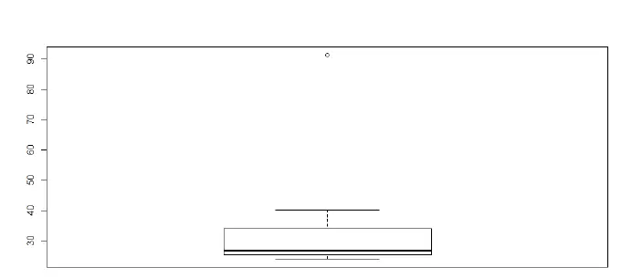

Mean = 33.37

Sd =16.9454

Variance =287.1466

Morgan Stanley = 91.36 is the outlier.



Answer the following three questions based on the box-plot above.

1. What is inter-quartile range of this dataset? (please approximate the numbers) In one line, explain what this value implies.
2. What can we say about the skewness of this dataset?
3. If it was found that the data point with the value 25 is actually 2.5, how would the new box-plot be affected?

**Solution:**

(1). IQR =3 approximately , The Inter Quartile Range Gives us a measurement of how spread out the entirety of our data set.

(2). Right Skewed ,Positive Skewed

(3). The mean Value would change.

3.



Answer the following three questions based on the histogram above.

1. Where would the mode of this dataset lie?
2. Comment on the skewness of the dataset.
3. Suppose that the above histogram and the box-plot in question 2 are plotted for the same dataset. Explain how these graphs complement each other in providing information about any dataset.

**Solution:**

(1). The Mode Lies Between 5-7

(2). Positive Skewed

(3). Skeweness of Both the Plots is same.

4.AT&T was running commercials in 1990 aimed at luring back customers who had switched to one of the other long-distance phone service providers. One such commercial shows a businessman trying to reach Phoenix and mistakenly getting Fiji, where a half-naked native on a beach responds incomprehensibly in Polynesian. When asked about this advertisement, AT&T admitted that the portrayed incident did not actually take place but added that this was an enactment of something that “could happen.” Suppose that one in 200 long-distance telephone calls is misdirected. What is the probability that at least one in five attempted telephone calls reaches the wrong number? (Assume independence of attempts.)

**Given :**one in 200 long-distance telephone calls is misdirected.

**To find :**probability that at least one in five attempted telephone calls reaches the wrong number

**Solution:**

one in 200 long-distance telephone calls is misdirected

=>  probability of call misdirecting  p = 1/200

  Probability of call not Misdirecting = 1 - 1/200 = 199/200

Number of Calls = 5

P(x) = ⁿCₓpˣqⁿ⁻ˣ

n = 5

p = 1/200

q = 199/200

at least one in five attempted telephone calls reaches the wrong number

= 1  -  none of the call reaches the wrong number

= 1  - P(0)

= 1   -  ⁵C₀(1/200)⁰(199/200)⁵⁻⁰

= 1  -  (199/200)⁵

= 0.02475

**probability that at least one in five attempted telephone calls reaches the wrong number = 0.02475**

5.Returns on a certain business venture, to the nearest $1,000, are known to follow the following probability distribution

|  |  |
| --- | --- |
| x | P(x) |
| -2,000 | 0.1 |
| -1,000 | 0.1 |
| 0 | 0.2 |
| 1000 | 0.2 |
| 2000 | 0.3 |
| 3000 | 0.1 |

1. What is the most likely monetary outcome of the business venture?
2. Is the venture likely to be successful? Explain
3. What is the long-term average earning of business ventures of this kind? Explain
4. What is the good measure of the risk involved in a venture of this kind? Compute this measure

**Solution:**

(i) The most likely monetary outcome of the business venture is the **expected value** of the probability distribution. The expected value is calculated by multiplying each value of the random variable by its probability and adding the products. In this case, the expected value is:

-2000 * 0.1 + (-1000 * 0.1) + (0 * 0.2) + (1000 * 0.2) + (2000 * 0.3) + (3000 * 0.1)

= **0.03**

(ii) The venture is not likely to be successful because the probability of getting a negative return is higher than the probability of getting a positive return. The probability of getting a negative return is:

P(-2000) + P(-1000) = 0.1 + 0.1 = **20%**

The probability of getting a positive return is:

P(1000) + P(2000) + P(3000) = 0.2 + 0.3 + 0.1 = **60%**

(iii) The long-term average earning of business ventures of this kind is equal to the expected value which is **800**.

(iv) A good measure of risk involved in a venture of this kind is the **standard deviation** which measures how much variation there is from the expected value. The Good Measure of the risk involved in venture of kind =0.2 , Because the loss of Probability is **0.2.**