- Zapytanie bez CTE:
SELECT TOP 20 COUNT(*) ctn,
p.Name,
pc.Name
FROM Sales.SalesOrderDetail sod
LEFT JOIN Production.Product p
ON sod.ProductID = p.ProductID
LEFT JOIN Production.ProductSubcategory ps ON p.ProductSubcategoryID = ps.ProductSubcategoryID
LEFT JOIN Production.ProductCategory pc ON ps.ProductCategoryID = pc.ProductCategoryID
GROUP BY p.Name, pc.Name
ORDER BY ctn DESC;
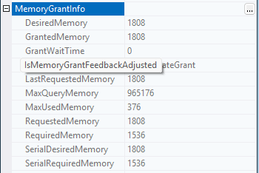
Max memory used: 376 [KB]
- Zadanie z CTE:
WITH topsales AS (SELECT TOP 20 COUNT(*) ctn, ProductID
FROM Sales.SalesOrderDetail sod
GROUP BY sod.ProductID
ORDER BY ctn DESC)
SELECT ts.ctn,
p.Name,
pc.Name
FROM topsales ts
LEFT JOIN Production.Product p
ON ts.ProductID = p.ProductID
LEFT JOIN OLTP.Production.ProductSubcategory ps ON p.ProductSubcategoryID = ps.ProductSubcategoryID
LEFT JOIN Production.ProductCategory pc ON ps.ProductCategoryID = pc.ProductCategoryID;
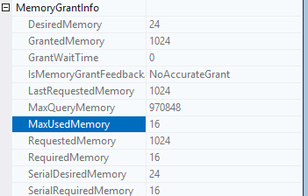
Max memory used: 16 [KB]
Użycie pamięci jest mniejsze w zapytaniu z CTE o 360 [KB] mniejsze niż bez CTE.

