Design and Evaluation Report:

Abstract

This report summarizes research and delves into the evaluation of my three coded design images. These images were created through the coding software ‘Video Studio Code’ while using the downloaded sketch.js, Index and p5.js files from the p5.js website.
Holly (Oz) Havis
Department of Computer Science and Creative Technology
University of the West of England
Coldharbour Lane
Bristol, UK
holly2.havis@live.uwe.ac.uk

Student ID: 21016637
submitted 03/12/2015

Introduction
Throughout the entirety of this report, I aim to explore the research in which I undertook throughout this project and how they were able to inspire and influence my final presented and coded works. Through this breakdown of my project, I hope to include the most important elements of my research process throughout the last few months of completing this project. I will also apply a more critical lens to my work, as this will help to enhance my evaluation section of this report. Delving into my combined strengths and weaknesses found within my three submitted designs, my report should maintain a balanced viewpoint which therefore allows for a fair evaluation.

My Research:
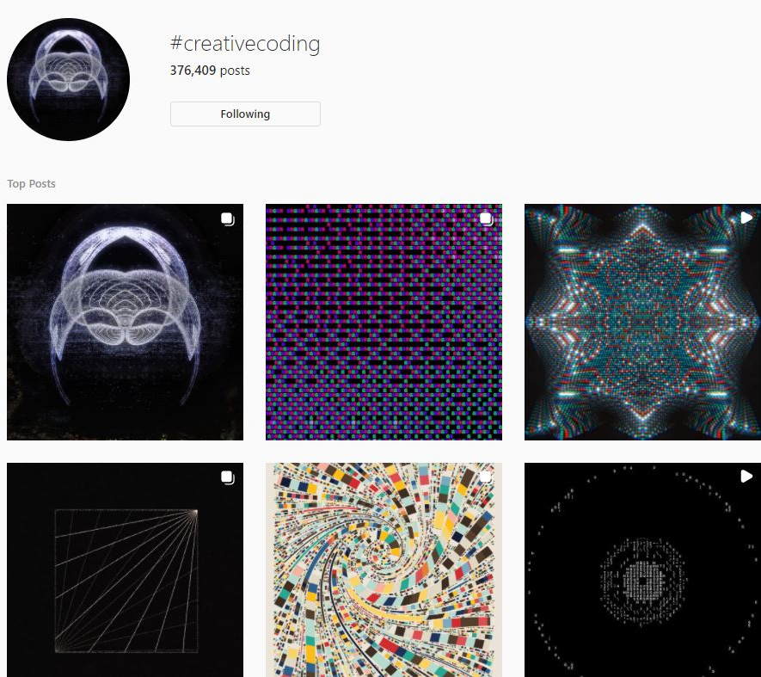
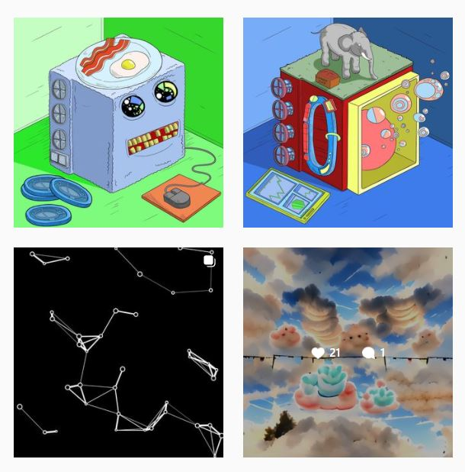
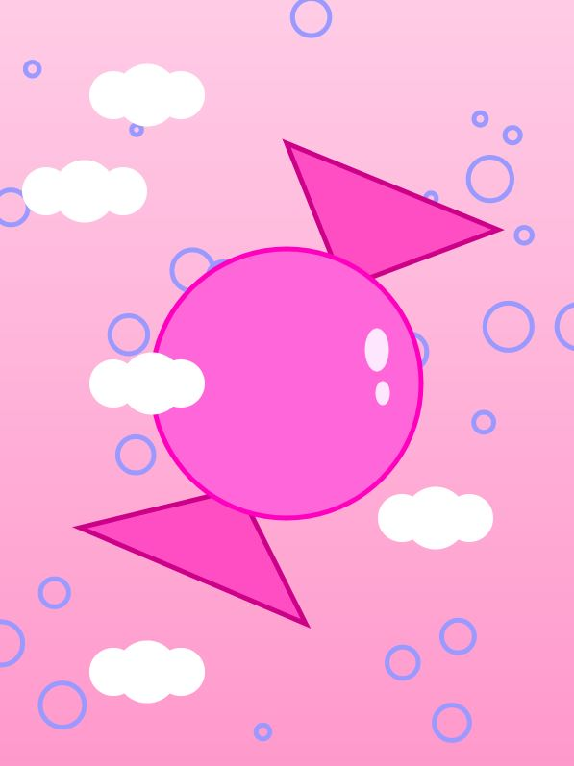
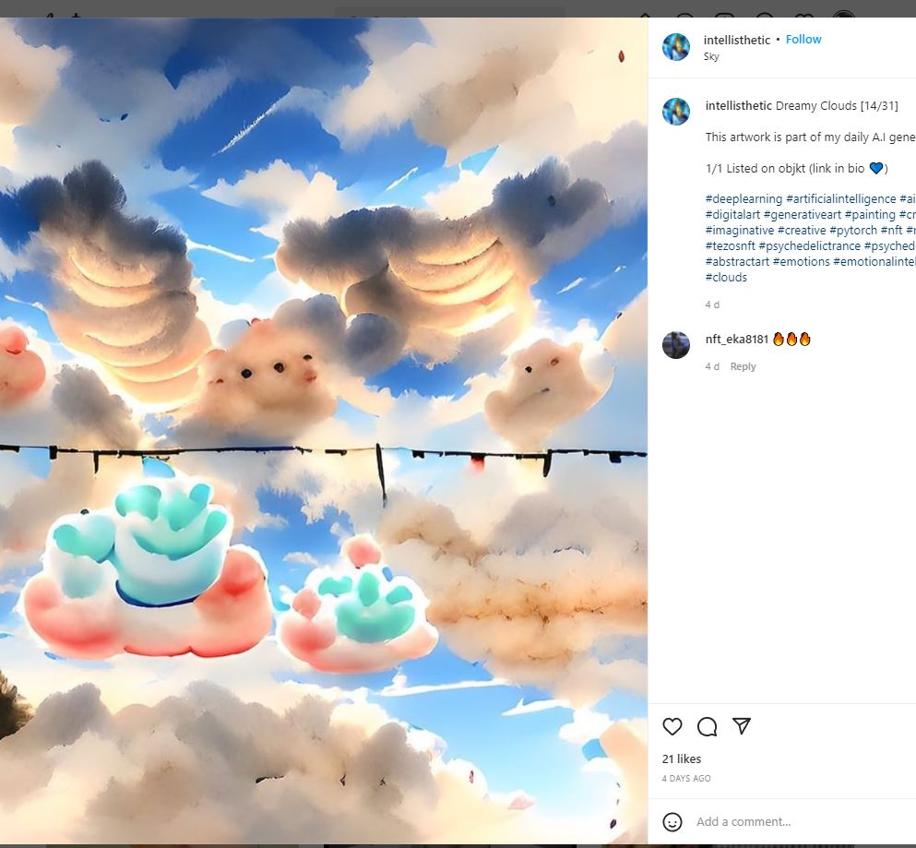
This whole project truly expanded my method of researching, whether it was to gain motivation or to gather help on different coding sequences, I believe that this project has not only opened my eyes to new ways of researching but also to the acknowledgement and appreciation of other coding artists that one can find on the internet (for example, using different social my creative coding journal on blackboard, one can see that most of my inspiration immerged through the exploration of other peoples works through the #creativecoding tag on both Instagram and Twitter. Although a simple sounding method of gathering materials, due to the depth of social media, finding inspiration through these, if self-posted, primary sources I found to be a struggle as there are so many different posts and different styles throughout the hashtag itself. However, the labeling of the source types proves to be more difficult than originally thought, simply since there are so many opinions and even other people reposting other people’s artworks, therefore the term ‘primary source’ should be considered loose in this sense.
Finding my Inspiration and How it was Implemented:
As previously stated, there were many places in which I found inspiration for my designs, the main places being through social media. Within my submitted Journal Entries one can see that I was originally finding it hard to fixate on just one possible theme, as there were many beautiful and frankly unobtainable designs which related to the exploration or the movement of water. I was captivated by these works and optimistic that I would be able to achieve similar designs. However, as I continued with my research, I found that I also found aesthetic pleasure within bright and whimsical designs that were posted. This then evolved into a problem as there were now two themes in which I had to choose between. Ultimately, I resided in the theme in which I utmost best it could. I also found help within an online journal ‘CogDesign.com’, not necessarily for inspiration but instead for motivation, the websites explanations behind the structure and beauty of the code itself was able to power me into wanting to also create someone new and exciting for people to see and for me to be proud that I had made. As well as this, I also used the previously mentioned P5.js Website to not only help me with how to do some of my line of code that I was unsure about but to also open my eyes to further possibilities that I could use throughout my designs, the different techniques that could help my designs to further stand out against others. There were however new difficulties discovered through this method of research simply due to most of the impressive looking codes to learn were for animating your images which I could only do once, here I realized I would have to apply my own knowledge even further and workout how to modify these codes to fit my given brief.

Sweet in the Sky:
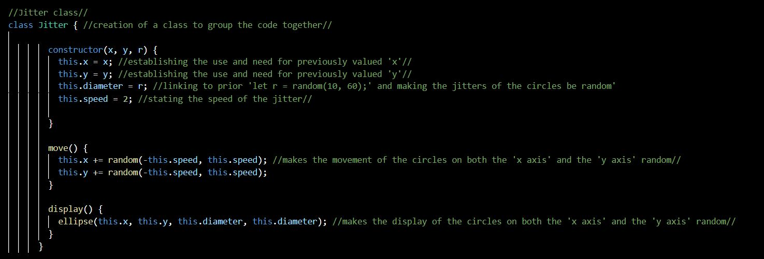
This image was intended to be my ‘simpler’ design idea, originally taking the form of a stereotypical sweet, one that would hopefully remind the viewer of their childhood, which was surrounded by static but fluffy looking clouds. However, when I had created this image how I had drawn it on paper, I felt dissatisfied and instead resulted in making this image the one that was animated, the bubbles that I placed into the background of the design not only adding depth but through the jitter effect I was able to make the image come to life. Through this image, I hope that one can see that my overall theme was taking inspiration from designs such as the ones show on the left of this page. The whimsical colours hopefully conveying childhood joy that one would get from buying sweets. I also drew inspiration from popular children tv shows such as ‘The Amazing World of Gumball’ and ‘Adventure Time’, this such inspiration did not need much research as they were a staple in my childhood.
Figure 1: A screenshot of my code, showing the ‘Jitter Class’.
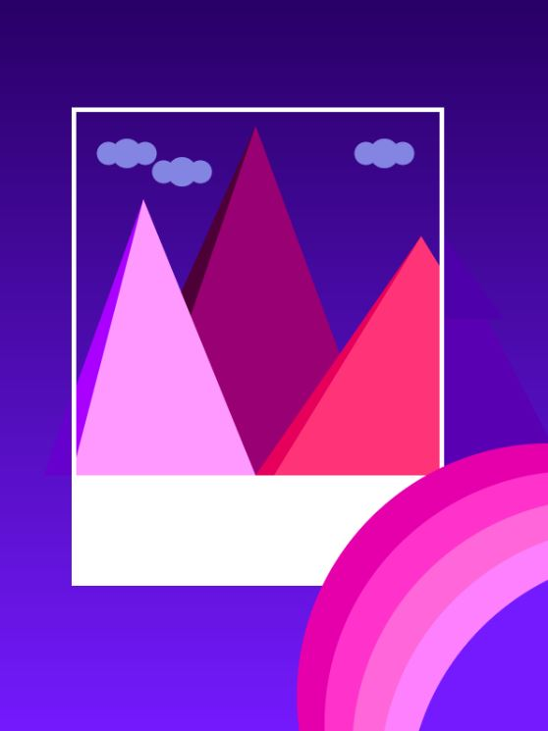

Night Mountains:
This design was the one that ended up being the simplest, the inspiration mostly coming from myself, the use of a polaroid something I hadn’t seen done throughout my research. The use of the mountains, however, were taken from another Instagram post, their mountains however being more dynamic through more ‘jagged’ edging whereas I wanted mine to be more cartoon-like, hence the block colours of pink (colours not seen on mountains in real life) and shadow behind almost as though the clouds are coming out of the polaroid frame. I also wanted to use a gradiented background to help uphold the illusion of a night sky, such a technique I took from one of our classes’ workshops, as I knew we had covered this code before. This design also fits within my ‘candy land’ theme through its colours, the pink stereotypically linking to ‘sweet’ and ‘childish likes’. The use of a pink hue rainbow also furthers this idea as they connote happiness and youth. 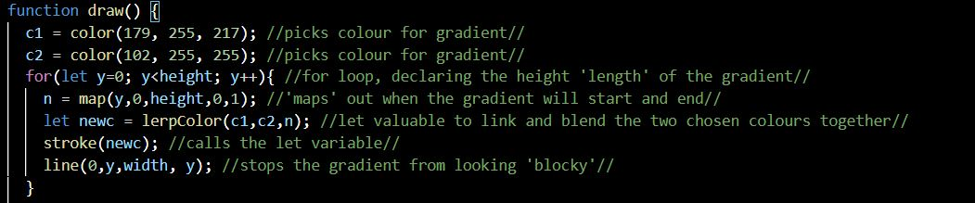
Figure 2: A screenshot of my code from Image2, showing how I achieved my gradient background.

Candy Constellations:
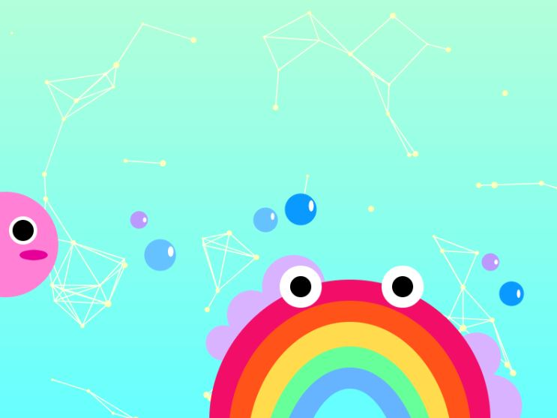
Another one of my designs that are directly corresponding with the research that I undertook throughout the duration of the project is my final image. The background constellations were heavily inspired by another Instagram work called “Geometric Systems’ by @aritst_prototype, the circles in all different sizes throughout the page all connected by different lines, reminding me of constellations which is what gave me the inspiration for this final design. However, I looked to the p5 website as they had an example called ‘Particle Systems’ that created constellation type moving particles. Through examining this code, I was able to write my own similar code that didn’t cause the ‘stars’ to move as I had already done my animated image. The addition of characters within this design takes the theme in the least physical way, the creativity linking to those of child illustrations or TV characters. The block colours once again creating a more cartoon-like style one that would hopefully evoke happiness from the viewer.
Figure 3: A screenshot of my code from Image3, showing the use of an Array to create my particle ‘constellations’.

My Evaluation:

Throughout the entirety of my work, I can say that I am proud of the designs I was able to accomplish; as I was unable to code before joining the course, the complexity of the images I created are not something I believed that I would be able to achieve. However, one cannot just look at my works through the viewpoint of an amateur creative coder but also must also take on the more critical opinion, whether the brief was met or if I could have evidently done any of my images better than I have. Such a lens being quite hard to adopt onto myself simply through the fact that I have been through the whole journey of the project and have experienced all the difficulties faced.
The image that I feel demonstrates my best work is ‘Candy Constellations’ simply because this showcases some of the most complex code that I have used throughout the whole assignment, the use of arrays always confusing me even in the workshop so the fact that I was able edit and alter the code in order to make it fit the image how I had envisioned it shows that I have learnt the different functions of what all those lines of code meant to create those static joined particles. However, you can also look at the image as limiting, this being the only use of complex code does make one wonder whether I could have taken my image further instead of just creating the rest of the image through the position of shapes, despite me being proud of the fact that I was able to showcase my creativity through this design idea.
My second image being the simplest design could be argued that there was much that could have been improved, but I also feel that despite its calmer nature the image itself is still in-keeping with my overall theme through its colours and block-style shapes. However, the simple fact that all the code (disregarding the gradient background) within this image is positioning of different shapes does make one question whether it was the best I could have done. One must also factor in that most of the more complex code found within our past workshop sheets and the p5 website is used to animate images, this did place a motivational and creative block. The overall image does evoke a different emotion compared to the other images, one that is much more peaceful this is something that I like, making my theme appear a little less childish and making it much more dimensional.
The first image I completed being ‘Sweet in the Sky’ does show some flaws simply due to it being the first. The pink colours could possibly be a little too overwhelming to some viewers of the image. On the other hand, the clouds can ‘cut through’ all the candy-like pink theme especially as some are positioned in front of the sweet. As well as this, the bubbles in the background can add a sense of depth to the image that I feel gives the image a more complex appearance. The fact that I was able correctly recall the code that we learnt in a past workshop to make the ‘bubbles’ shake and even add a new sense of interactivity through the ability of adding your own new bubbles through clicking onto the image. A personal disliking, I have regarding this image being the use of stroke around the sweet, even though it is able make the main aspect of the image stand out against the similarly colored background, the use of stroke makes the sweet look much less realistic.

Conclusion:
Throughout the entirety of this project, I was able to face and overcome new difficulties that I had never met before joining this course, as I had never coded before. Despite there being a few improvements that could be made for some of the images, I am overall proud of my project and my designs. The research I did, could have varied a little more but the use of social media was extremely helpful and easy to gain inspiration from all different artists and their different styles.

References:
[1] @artist_prototype, “Geometric Systems”, 15/01/2022, Creative Coding Instagram Artist Post. https://www.instagram.com/p/CYuEwPQl_wf/
[2] @intellisthetic, “Dreamy Clouds”, 16/01/2022, Creative Coding Instagram Artist Post. https://www.instagram.com/p/CYvCjKIolht/
[3] @clias_earlberg, ‘nameless’, 10/12/2021, Creative Coding Instagram Artist Post. https://www.instagram.com/p/CYtjA6fMQxl/
[4] p5.js Website https://p5js.org/
[5] Cog Design Website https://cogdesign.com/journal/generative-art-and-creative-coding/

Bibliography:

[1] YouTube Creator The Coding Train - YouTube
[2] W3 Schools, ‘HTML Color Picker’, https://www.w3schools.com/colors/colors_picker.asp

