Department of Computer Science and Engineering
2025-2026
Odd Semester

DATA STRUCTURES AND ALGORITHMS-3
(25CS2103E)

FUZZY-FIND

B. HEMA SRI 2520030159
P. HAVISHAA REDDY 2520030371

COURSE INSTRUCTOR

Dr. J Sirisha Devi
Professor
Department of Computer Science and Engineering

FuzzyFind – Levenshtein distance based word

1. Background
Search systems are central to modern computing, enabling users to retrieve information quickly and accurately. However, human input is prone to errors: misspellings, omissions, or incorrect substitutions. Traditional exact-match search engines fail when queries contain mistakes, leaving users without results. To overcome this limitation, the FuzzyFind system applies the Levenshtein distance algorithm to detect and correct misspelled queries, ranking the closest matches efficiently. This case study documents the design, methodology, and practical impact of the system.

2. Problem Statement
Users often type queries incorrectly due to typing speed, unfamiliarity with spelling, or simple oversight. For example, entering “adress” instead of “address” results in zero matches in a conventional search engine. The absence of error-tolerant mechanisms reduces usability and frustrates users. The challenge is to design a system that can interpret imperfect input and still deliver meaningful results.

3. Objectives
- Implement a search mechanism tolerant of spelling errors.
- Apply Levenshtein distance to measure similarity between input and dictionary entries.
- Rank results by closeness, ensuring the most relevant word appears first.
- Demonstrate efficiency in handling large dictionaries.
- Improve user experience by reducing failed searches.

4. Case Study Examples
Example 1: “adress” → “address”
- Input: “adress”
- Dictionary comparison:
  - “address” (distance = 1)
  - “addressee” (distance = 3)
  - “adverse” (distance = 3)
- Ranked output: address → addressee → adverse This demonstrates how the system identifies the intended word “address” despite the missing character.
Example 2: “enviroment” → “environment”
- Input: “enviroment”
- Dictionary comparison:
  - “environment” (distance = 1)
  - “envelopment” (distance = 3)
- Ranked output: environment → envelopment Here, the system corrects the missing ‘n’ and delivers the right match.

5. Methodology
The system follows a structured process:
- Input Capture – User query is received.
- Dictionary Handling – A word list is maintained for comparison.
- Distance Calculation – Levenshtein distance computes the minimum edits (insertions, deletions, substitutions) required to transform the query into each dictionary word.
- Ranking – Words are sorted by similarity scores.
- Output Display – Closest matches are presented in descending order of relevance.

6. Importance of the Application
- Error Tolerance: Users need not type perfectly.
- Efficiency: Optimized dictionary handling ensures scalability.
- Accessibility: Supports non-native speakers and individuals with typing difficulties.
- Practical Use Cases: Search engines, spell-checkers, auto-complete systems, and text editors.

7. Target Users
- Students and researchers requiring reliable search tools.
- Developers integrating intelligent search into applications.
- General users expecting intuitive correction in everyday platforms.
- Organizations enhancing customer-facing systems with smarter search.

8. Conclusion
This case study demonstrates that FuzzyFind, powered by Levenshtein distance, significantly improves search accuracy by handling misspelled queries and ranking results efficiently. By bridging the gap between user intent and system response, it enhances usability and reliability. The examples of “adress → address” and “enviroment → environment” illustrate its practical effectiveness, making it a valuable contribution to error-tolerant computing systems.

ALGORITHM / PSEUDO CODE

Overall Algorithm Flow
- Start the Java application.
- Load the dictionary from words_alpha.txt; if absent, download it once and store it locally.
- Normalize every dictionary word by trimming whitespace and converting it to lowercase.
- Read the user query from the HTML GET parameter q.
- Normalize the query by trimming whitespace and converting it to lowercase.
- Select a distance threshold based on query length.
- Compare the query length with each dictionary-word length.
- Skip candidates whose length difference is greater than the threshold.
- Calculate Levenshtein Distance for every remaining candidate.
- Keep candidates whose distance is within the threshold.
- Calculate similarity for every accepted candidate.
- Sort candidates by distance, similarity, and alphabetical order.
- If no candidate is found, perform the fallback search over the full dictionary.
- Limit the displayed list to the best ten matches.
- Generate the HTML response and send it to the browser.
- Stop.

Levenshtein Dynamic-Programming Procedure
- Create two integer arrays named previous and current.
- Initialize previous[j] = j for all positions j in the second string.
- For each character position i in the first string, set current[0] = i.
- For every position j, calculate insertion = current[j-1] + 1.
- Calculate deletion = previous[j] + 1.
- Calculate replacement = previous[j-1] + 0 when the characters are equal; otherwise add
- Store the minimum of insertion, deletion, and replacement in current[j].
- Swap previous and current after completing a row.
- After the last row, return previous[b.length()] as the edit distance.

Threshold Selection
- If query length is 3 or less, threshold = 1.
- If query length is 4 to 6, threshold = 2.
- If query length is 7 to 10, threshold = 3.
- If query length is greater than 10, threshold = 4.
- Use the threshold to reduce unnecessary distance calculations.

Similarity Calculation
- Set maxLength to the larger length of the query and candidate.
- If maxLength is zero, similarity = 100.
- Otherwise calculate (1 - distance / maxLength) × 100.
- Round the result to the nearest integer.
- Store word, distance, and similarity in a Result object.

Ranking Procedure
- Compare candidates using their Levenshtein distances.
- Place the candidate with the smaller distance first.
- If distances are equal, place the candidate with the higher similarity first.
- If both values are equal, sort alphabetically.
- Return the first ten candidates.

Fallback Procedure
- Check whether the normal result list is empty.
- If empty, calculate distance against every dictionary word.
- Calculate a non-negative similarity score.
- Add all candidates to the result list.
- Sort using distance, similarity, and alphabetical order.
- Return the first ten results.

Web Request Flow
- The browser opens the FuzzyFind home page.
- The user enters a query in the search form.
- The form submits a GET request to /search?q=<query>.
- The Java server extracts q from the URI.
- findMatches(query) performs fuzzy matching.
- page(query, results) builds the HTML result section.
- The server sends the generated HTML response.
- The browser displays the closest match and ranked suggestions.

CODE

CODE – Full Java Implementation
The following is the Java source used for the project

import com.sun.net.httpserver.HttpExchange;
import com.sun.net.httpserver.HttpServer;

import java.io.BufferedReader;
import java.io.IOException;
import java.io.InputStream;
import java.io.OutputStream;
import java.net.InetSocketAddress;
import java.net.URI;
import java.net.URLDecoder;
import java.net.URLEncoder;
import java.nio.charset.StandardCharsets;
import java.nio.file.Files;
import java.nio.file.Path;
import java.nio.file.Paths;
import java.util.ArrayList;
import java.util.Arrays;
import java.util.Comparator;
import java.util.HashSet;
import java.util.List;
import java.util.Locale;
import java.util.Set;

public class FuzzyFindServer {
private static final int PORT = 8080;
private static final String DICTIONARY_FILE = "words_alpha.txt";
private static final String DICTIONARY_URL =
"https://raw.githubusercontent.com/dwyl/english-words/master/words_alpha.txt";
private static final Set<String> dictionary = new HashSet<>();

static class Result {
String word;
int distance;
int similarity;

Result(String word, int distance, int similarity) {
this.word = word;
this.distance = distance;
this.similarity = similarity;
}
}

public static void main(String[] args) throws Exception {
loadDictionary();
HttpServer server = HttpServer.create(new InetSocketAddress(PORT), 0);
server.createContext("/", FuzzyFindServer::home);
server.createContext("/search", FuzzyFindServer::search);
server.start();

System.out.println("========================================");
System.out.println(" FUZZYFIND JAVA SERVER");
System.out.println("========================================");
System.out.println("Words loaded : " + dictionary.size());
System.out.println("Open : http://localhost:" + PORT);
System.out.println("========================================");
}

// Load the dictionary from a text file. If it is missing, try downloading it.
static void loadDictionary() throws IOException {
Path file = Paths.get(DICTIONARY_FILE);

if (!Files.exists(file)) {
System.out.println("Downloading dictionary...");
try {
URI.create(DICTIONARY_URL).toURL().openConnection().getInputStream().close();
try (InputStream in = URI.create(DICTIONARY_URL).toURL().openStream();
OutputStream out = Files.newOutputStream(file)) {
byte[] buffer = new byte[8192];
int n;
while ((n = in.read(buffer)) != -1) {
out.write(buffer, 0, n);
}
}
System.out.println("Dictionary downloaded.");
} catch (IOException e) {
System.out.println("Could not download dictionary; using built-in words.");
addCommonWords();
return;
}
}

try (BufferedReader br = Files.newBufferedReader(file, StandardCharsets.UTF_8)) {
String word;
while ((word = br.readLine()) != null) {
word = word.trim().toLowerCase(Locale.ROOT);
if (word.matches("[a-z]+")) {
dictionary.add(word);
}
}
}
addCommonWords();
}

static void addCommonWords() {
String[] common = {
"the", "this", "that", "then", "there", "their", "cat", "car", "can",
"cake", "care", "case", "banana", "apple", "computer", "computing",
"algorithm", "database", "javascript", "java", "fuzzy", "search", "website",
"student", "project", "hello", "world", "school", "college", "language"
};
dictionary.addAll(Arrays.asList(common));
}

// Standard Levenshtein distance: insertions, deletions, and replacements.
static int levenshtein(String a, String b) {
int[] previous = new int[b.length() + 1];
int[] current = new int[b.length() + 1];

for (int j = 0; j <= b.length(); j++) {
previous[j] = j;
}

for (int i = 1; i <= a.length(); i++) {
current[0] = i;
for (int j = 1; j <= b.length(); j++) {
int insertion = current[j - 1] + 1;
int deletion = previous[j] + 1;
int replacement = previous[j - 1]
+ (a.charAt(i - 1) == b.charAt(j - 1) ? 0 : 1);
current[j] = Math.min(insertion, Math.min(deletion, replacement));
}
int[] temp = previous;
previous = current;
current = temp;
}
return previous[b.length()];
}

static List<Result> findMatches(String query) {
query = query.toLowerCase(Locale.ROOT).trim();
List<Result> results = new ArrayList<>();
if (query.isEmpty()) {
return results;
}

int threshold;
if (query.length() <= 3) {
threshold = 1;
} else if (query.length() <= 6) {
threshold = 2;
} else if (query.length() <= 10) {
threshold = 3;
} else {
threshold = 4;
}

for (String word : dictionary) {
if (Math.abs(query.length() - word.length()) > threshold) {
continue;
}
int distance = levenshtein(query, word);
if (distance <= threshold) {
int maxLength = Math.max(query.length(), word.length());
int similarity = maxLength == 0 ? 100
: Math.max(0, (int) Math.round((1.0 - (double) distance / maxLength) * 100));
results.add(new Result(word, distance, similarity));
}
}

results.sort(Comparator.comparingInt((Result r) -> r.distance)
.thenComparing(Comparator.comparingInt((Result r) -> r.similarity).reversed())
.thenComparing(r -> r.word));

if (results.size() > 10) {
return new ArrayList<>(results.subList(0, 10));
}
return results;
}

static void home(HttpExchange exchange) throws IOException {
send(exchange, page("", new ArrayList<>()), "text/html");
}

static void search(HttpExchange exchange) throws IOException {
String query = getQueryParameter(exchange.getRequestURI(), "q");
List<Result> results = findMatches(query);
send(exchange, page(query, results), "text/html");
}

static String getQueryParameter(URI uri, String name) {
String raw = uri.getRawQuery();
if (raw == null) {
return "";
}
for (String part : raw.split("&")) {
String[] pair = part.split("=", 2);
if (pair.length == 2 && pair[0].equals(name)) {
try {
return URLDecoder.decode(pair[1], StandardCharsets.UTF_8.name());
} catch (Exception e) {
return "";
}
}
}
return "";
}

static void send(HttpExchange exchange, String text, String type) throws IOException {
byte[] bytes = text.getBytes(StandardCharsets.UTF_8);
exchange.getResponseHeaders().set("Content-Type", type + "; charset=UTF-8");
exchange.sendResponseHeaders(200, bytes.length);
try (OutputStream out = exchange.getResponseBody()) {
out.write(bytes);
}
}

static String urlEncode(String s) {
try {
return URLEncoder.encode(s, StandardCharsets.UTF_8.name());
} catch (Exception e) {
return "";
}
}

static String escapeHTML(String s) {
return s.replace("&", "&amp;")
.replace("<", "&lt;")
.replace(">", "&gt;")
.replace("\"", "&quot;")
.replace("'", "&#39;");
}

static String page(String query, List<Result> results) {
StringBuilder resultHTML = new StringBuilder();

if (!query.isEmpty()) {
if (results.isEmpty()) {
resultHTML.append("<div class='no-result'>No result found.</div>");
} else {
Result best = results.get(0);
resultHTML.append("<div class='closest'>")
.append("<div class='small-title'>CLOSEST MATCH</div>")
.append("<div class='closest-row'><div class='did-you-mean'>")
.append("<div><span>Closest match: </span><strong>")
.append(escapeHTML(best.word)).append("</strong></div>")
.append("<div class='score'>Levenshtein Distance: ")
.append(best.distance).append(" &nbsp; | &nbsp; Similarity: ")
.append(best.similarity).append("%</div></div>")
.append("<a class='use-button' href='/?q=")
.append(urlEncode(best.word)).append("'>Use this</a></div></div>")
.append("<h3>Ranked Suggestions</h3>");

for (int i = 0; i < results.size(); i++) {
Result r = results.get(i);
resultHTML.append("<div class='result'>")
.append("<span class='number'>#").append(i + 1).append("</span>")
.append("<span class='word'>").append(escapeHTML(r.word)).append("</span>")
.append("<span class='distance'>Distance: ").append(r.distance).append("</span>")
.append("<span class='similarity'>").append(r.similarity).append("%</span>")
.append("</div>");
}
}
}

return "<!DOCTYPE html><html lang='en'><head><meta charset='UTF-8'>"
+ "<meta name='viewport' content='width=device-width,initial-scale=1.0'>"
+ "<title>FuzzyFind</title><style>"
+ "*{box-sizing:border-box}body{margin:0;font-family:Arial,sans-serif;color:#152630;background:#f5f8f8}"
+ "nav{height:72px;background:white;border-bottom:1px solid #e1e6e7;display:flex;align-items:center;justify-content:space-between;padding:0 8%}"
+ ".logo{font-size:23px;font-weight:bold}.logo span{background:#14252e;color:white;padding:7px 11px;border-radius:8px;margin-right:8px}nav a{margin-left:25px;text-decoration:none;color:#617078}"
+ ".hero{background:white;padding:80px 9%}.tag{font-size:11px;font-weight:bold;letter-spacing:2px;color:#0d8d80}h1{font-size:60px;line-height:1.05;margin:18px 0}h1 span{color:#0d8d80}.hero p{font-size:18px;line-height:1.7;color:#66757e;max-width:720px}"
+ ".search-section{padding:75px 9%;min-height:500px}.search-section h2{font-size:44px;margin:12px 0}.subtitle{color:#697780}.search-form{display:flex;max-width:950px;margin:30px auto 10px;background:white;border:1px solid #d9e0e2;border-radius:15px;overflow:hidden}"
+ ".search-form input{flex:1;min-width:0;font-size:18px;padding:18px;outline:0;border:0}.search-form button{border:0;background:#0d8d80;color:white;font-size:16px;font-weight:bold;padding:0 35px;cursor:pointer}.search-form button:hover{background:#08766d}"
+ ".content{max-width:950px;margin:30px auto}.closest{background:#e7f7f4;border:1px solid #bce5de;border-radius:14px;padding:22px;margin-bottom:25px}.small-title{font-size:10px;letter-spacing:2px;font-weight:bold;color:#0d8d80}.closest-row{display:flex;align-items:center;justify-content:space-between;gap:20px;margin-top:10px}.did-you-mean{font-size:23px}.score{font-size:13px;color:#627179;margin-top:6px}.use-button{background:#14252e;color:white;text-decoration:none;padding:12px 18px;border-radius:8px;font-weight:bold}.use-button:hover{background:#0d8d80}"
+ ".result{display:grid;grid-template-columns:55px 1fr 160px 70px;align-items:center;background:white;border:1px solid #dfe5e7;border-radius:10px;padding:18px;margin:8px 0;gap:7px}.number{color:#9aa5aa}.word{font-weight:bold}.distance{font-size:13px;color:#65737a}.similarity{text-align:right;color:#0d8d80;font-weight:bold}.no-result{background:white;border:1px solid #ddd;border-radius:12px;padding:25px}footer{background:#12232c;color:white;padding:30px 9%;margin-top:40px}"
+ "@media(max-width:700px){nav{padding:0 5%}nav a{margin-left:10px;font-size:13px}.hero,.search-section{padding:55px 6%}h1{font-size:45px}.search-section h2{font-size:34px}.search-form{flex-direction:column}.search-form button{padding:16px}.result{grid-template-columns:35px 1fr;}.distance,.similarity{grid-column:2;text-align:left}.closest-row{align-items:flex-start;flex-direction:column}.did-you-mean{font-size:20px}}"
+ "</style></head><body><nav><div class='logo'><span>F</span>FuzzyFind</div><div><a href='/'>Home</a><a href='#search'>Search</a><a href='#algorithm'>Algorithm</a></div></nav>"
+ "<section class='hero'><div class='tag'>JAVA • DATA STRUCTURES &amp; ALGORITHMS</div><h1>Search smarter.<br><span>Even with typos.</span></h1>"
+ "<p>FuzzyFind compares your search query with a large dictionary using the Levenshtein Distance algorithm and ranks the closest matches by the number of edits required.</p></section>"
+ "<section class='search-section' id='search'><div class='tag'>LIVE JAVA DEMO</div><h2>Find the closest match</h2><p class='subtitle'>Enter any word or search query.</p>"
+ "<form class='search-form' action='/search' method='GET'><input name='q' value='" + escapeHTML(query)
+ "' placeholder='Try: computr, teh, banani, javscript...' autocomplete='off'><button type='submit'>Search</button></form>"
+ "<div class='content'>" + resultHTML + "</div></section>"
+ "<section id='algorithm' style='padding:75px 9%;background:white'><div class='tag'>HOW IT WORKS</div><h2>Levenshtein Distance</h2>"
+ "<p style='color:#687780;max-width:800px;line-height:1.7'>The algorithm calculates the minimum number of single-character insertions, deletions and replacements needed to transform the entered word into each dictionary word. The results are then sorted by the smallest distance.</p></section>"
+ "<footer><strong>FuzzyFind</strong><br><br>Java + Levenshtein Distance • DSA-3 Project</footer></body></html>";
}
}

RESULTS

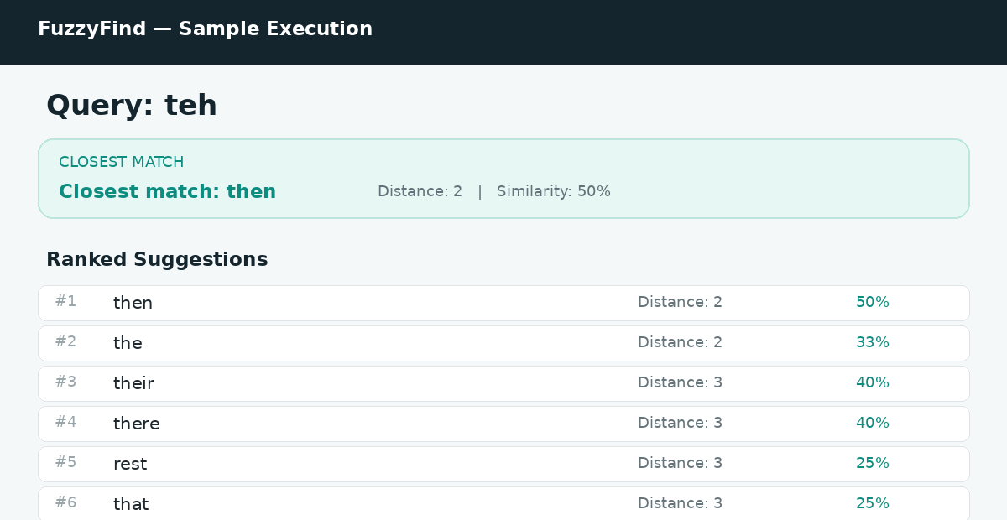
Figure: Sample execution for query “teh”.
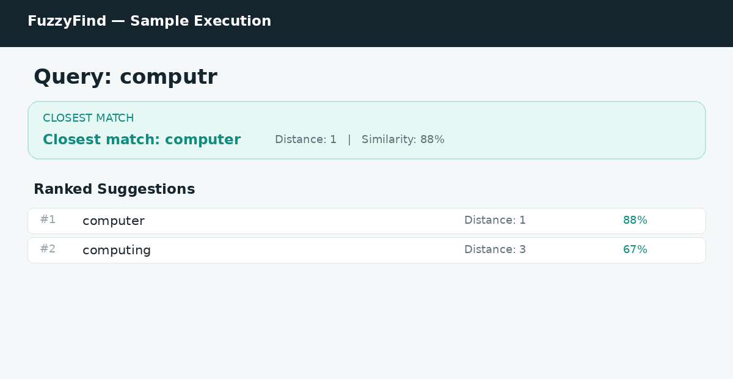
Figure: Sample execution for query “computr”.
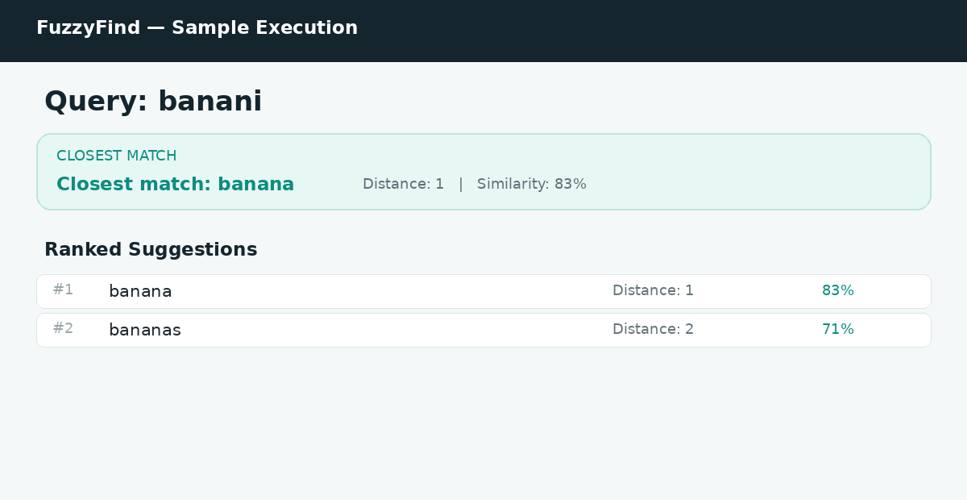
Figure: Sample execution for query “banani”.
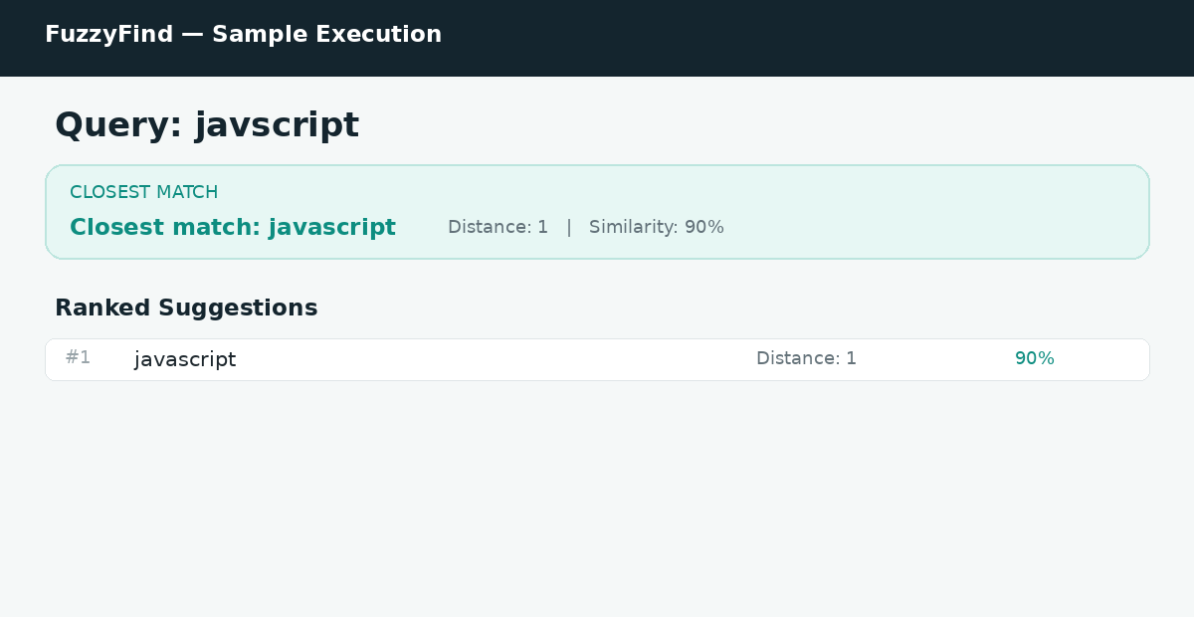
Figure: Sample execution for query “javscript”.
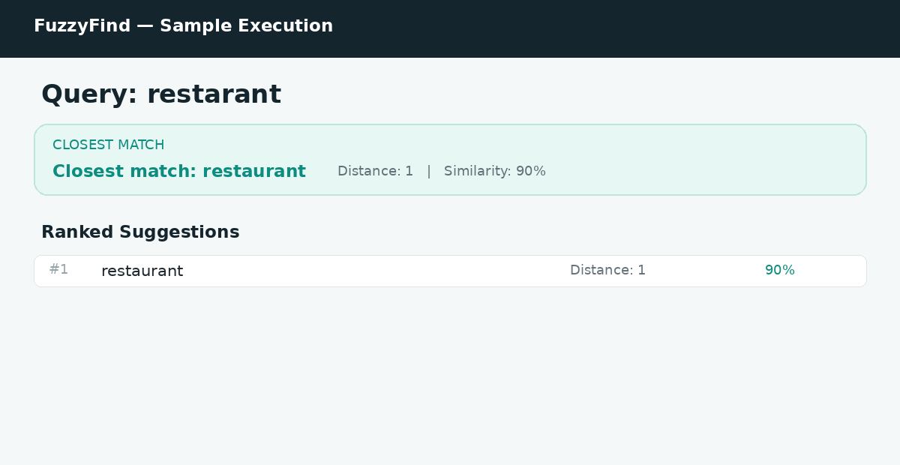
Figure: Sample execution for query “restarant”.

Result Interpretation
• “computr” identifies “computer” as a close match because the query is missing one character.
• “banani” identifies “banana” as a close spelling match.
• “javscript” identifies “javascript” because the query is missing a character.
• “restarant” identifies “restaurant” because the spelling differs by a small number of edits.
• For the short query “teh”, the fallback stage is used when the normal threshold produces no candidate.

