**Made by Serhii Havrylov for portfolio on GitHub**

**Introduction**

This report analyzes the Spotify listening history dataset, focusing on track playback duration, platform usage, and user interaction patterns. It includes visualizations to provide insights into user behavior.

**Libraries used**

Pandas, Matplotlib, Seaborn

**Data Overview**

The dataset consists of 149,860 records with the following key attributes:

* Track information (name, artist, album)
* Playback timestamp
* Platform (web player, mobile, etc.)
* Playback duration
* Shuffle mode and skip status

**Analysis & Insights**

**Top 10 albums**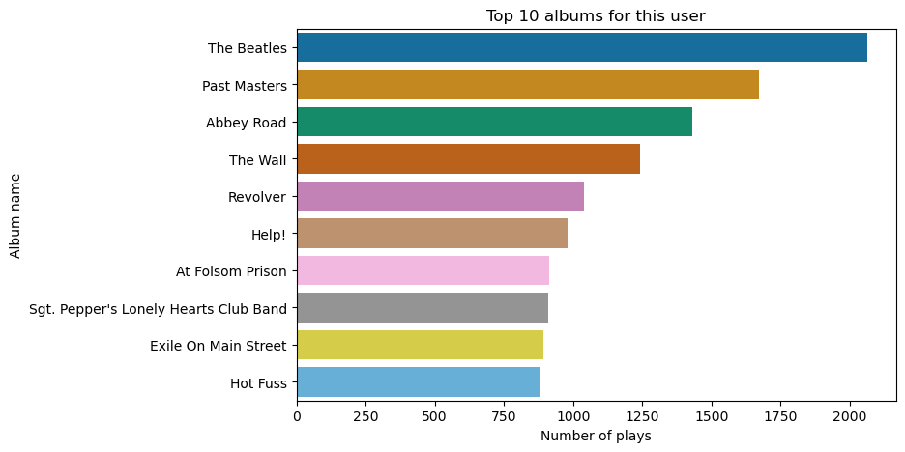

**Top 10 artists**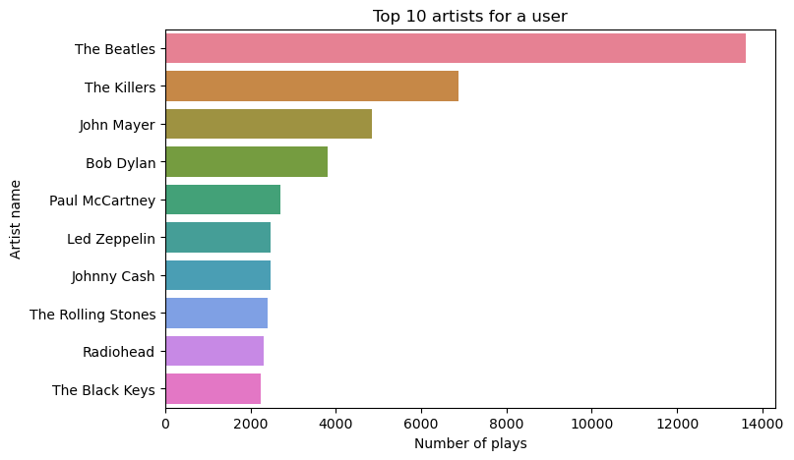

**Top 10 tracks**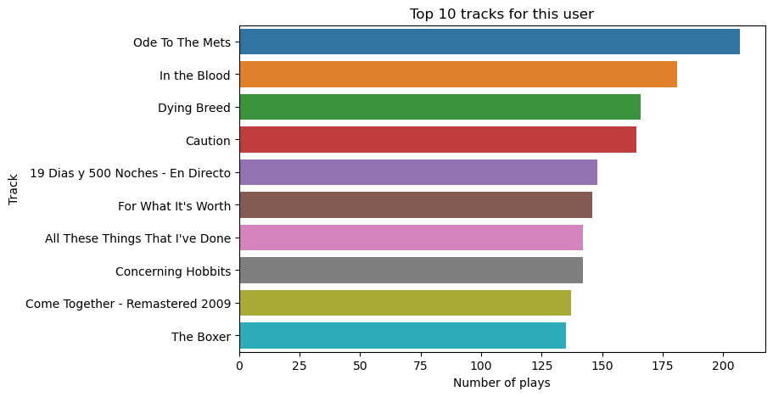

**Week pattern**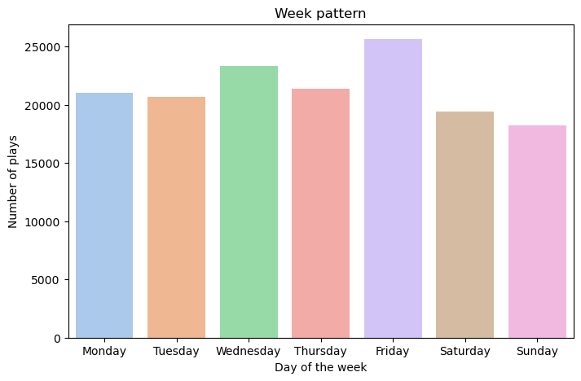

**Hour pattern**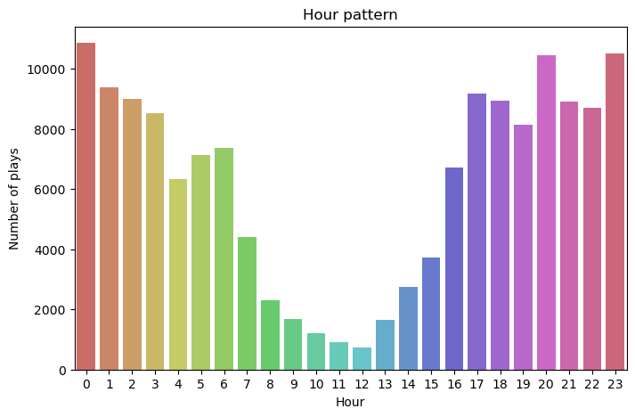

**Platform Usage**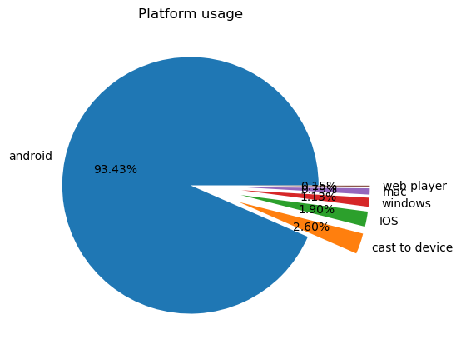

**Starting Reason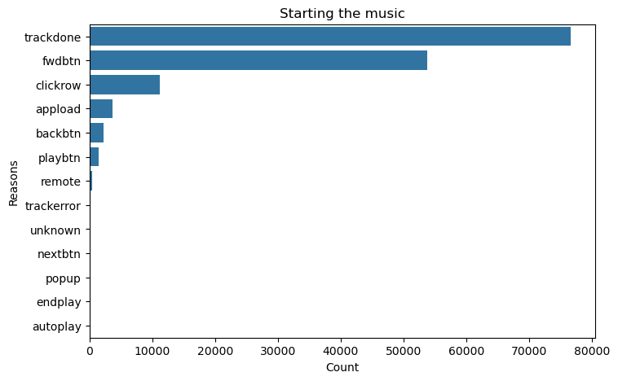Ending reason**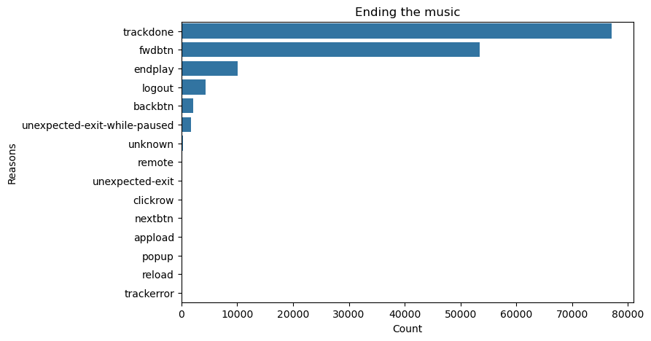

**Skip percentage**

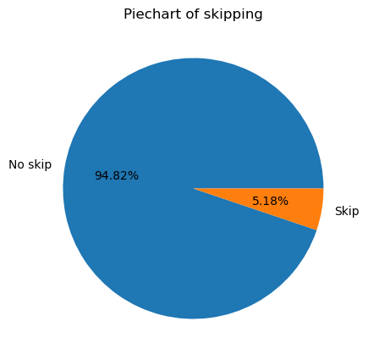

**Shuffle percentage**

