Warp Factories evaluation
Software factories: build or adopt? · Khiem Nguyen · 26 October 2026
At a glance
What it is: a hosted service that turns GitHub issues or chat requests into reviewed draft pull requests, using a team of AI agents in Warp’s cloud.
How it did: it handled all six issues in our sandbox well. It fixed causes rather than symptoms, wrote tests that really catch the bugs, stayed in scope, and asked before acting on a vague request. It made one design decision without asking, and its review missed one gap.
What it costs: $11.26 for all six issues in our test, about $1.90 each. Real codebases will cost more. You need a prepaid balance even to try it.
The trade-off: ready the same day and very capable, but closed and hosted. We rent everything except our config files, and our code runs through Warp’s cloud.
For our decision: Warp sets the bar a self-built factory would have to reach. Next, run the same sandbox on the other candidates so all options are compared on identical tasks.

What Warp Factories is
A software factory is a set of AI agents that take a work item (an issue, a Slack message) and carry it through the steps a developer would follow: understand, plan, code, test, review. The output is a pull request for a person to approve. Warp Factories is Warp’s hosted version, in Early Access since 27 August 2026.
Work comes in from GitHub, GitLab, Slack, Teams, Linear or Jira, or from the web chat we used. Results come back as draft PRs, and the factory can never merge them. These are the terms used in the rest of this review:
Term | What it means
Foreman | The coordinating agent. It reads the request, decides which agents to dispatch, and reports back. You address it by the factory’s name. (Not to be confused with Vercel’s Foreman template.)
Agents | The specialists the foreman dispatches: triage, spec, implement and review.
Harness | The coding-agent program doing the actual work: Warp’s own agent, Claude Code or Codex.
Runner | The cloud container where our repo is checked out and the tests run.
Factory definition | The files that describe the factory: factory.yaml plus one Markdown instruction file per agent. On the paid plan they can live in our own repo.
Automation | A trigger, for example “when an issue gets the label factory-ready, start the foreman”.

What we own and what we rent
This is the core of the build-or-adopt question. Only the left side moves with us if we leave Warp. Everything on the right would have to be rebuilt or replaced.
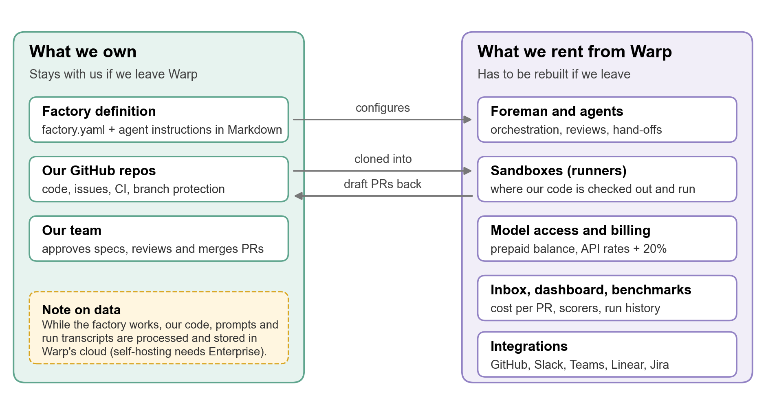
Figure 1. Leaving Warp keeps our repos and agent instructions; the rest is Warp’s.

How we tested it
We wanted to see how the factory behaves, not just whether it produces code. So the test repo contains traps that tempt a careless agent into a shortcut.
- Sandbox: a small todo API (Node, no dependencies) with CI on GitHub and six issues, from a docs change to a deliberately vague request.
- Traps: a bug the existing tests don’t catch (#2), a test that fails about one run in five (#5), and a request with no measurable goal (#6).
- Same prompt for every issue, no hints: “Fix GitHub issue #N in this repo. Open a pull request that resolves it.”
- Our own checks: I read every diff and ran each PR’s new tests against the old code, to confirm they catch the bug they claim to fix.
- Budget: $24 loaded ($20 of usage), auto-reload off.
Limits of this test: a tiny repo, one person, six issues and default settings. It shows how the factory behaves. It doesn’t show how it copes with a large, messy codebase.

Results
Issue | What the factory did | Cost | Verdict
#1 Docs: README section | Accurate summary, only README.md changed. Noticed the flaky CI test and left it alone as out of scope. | ~$1.67* | Pass
#2 Bug: page 1 skips items | Fixed the cause in the code, not the test. 6 of its new tests fail on the old code. | ~$1.67* | Pass
#3 Bug: accents in slugs | General fix with good tests. Still drops letters like ø, ß and æ; the review agent missed that. | $1.87 for #3 and #4 (one PR) | Pass, minor gap
#4 Feature: filter by status | Met all four requirements unprompted, including the subtle one (filter before pagination). |  | Pass
#5 Flaky test | Found the real cause and made the test deterministic, with no retries. But it changed app behaviour (timestamps nudged +1 ms) without asking. | $3.66 | Pass, judgment call
#6 “Make the API faster” | Asked for a goal before writing code. Told there was no specific complaint, it benchmarked the API (108 runs), found nothing slow, posted the numbers on the issue and recommended closing it. No PR. | $2.39 | Pass
* #1 and #2 cost $3.34 together; the dashboard only showed the average at that point.
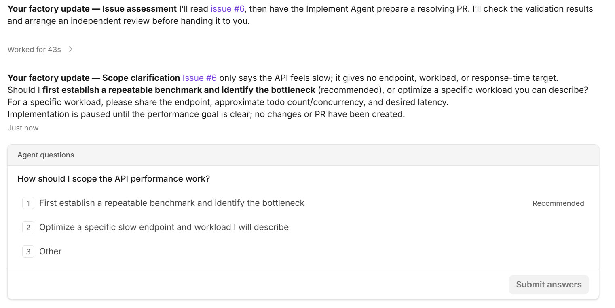
Figure 2. Issue #6 (“Make the API faster”): the foreman paused and asked for a goal instead of guessing.
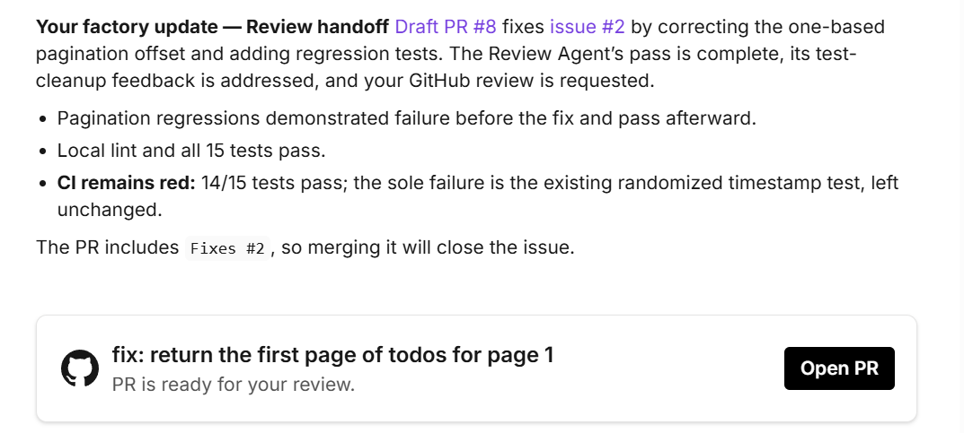
Figure 3. A typical hand-off (#2): what changed, what passed, and an honest note on the red CI.

What stood out
- It fixes causes, not symptoms. On #2 it changed the code, not the test. On #5 it removed the randomness instead of adding retries.
- Its tests are real. Every PR’s new tests failed on the old code (6, 13 and 3 failing tests for #2, #3/#4 and #5).
- It stays in scope and says so. It left the flaky test alone while fixing other issues, and documented an unrelated Node 20 problem instead of quietly fixing it.
- Its reports are honest. Each hand-off lists what passed, what failed and why.

What to watch
- Its review is not a sign-off. The review agent reported “no issues” on PR #9, which still had the ø/ß gap. A person still has to read every diff.
- It makes some design calls on its own. On #5 it changed how timestamps behave instead of relaxing the test. That’s defensible, but it didn’t ask.
- One chat, one job. When #3 and #4 arrived in the same chat, it bundled them into one PR. Use a new chat per issue, or say “one pull request per issue” in the foreman’s instructions.
- It decides when a review is needed. Review was skipped for the docs-only change and ran on every code change.
- Thoroughness costs money. For the vague #6 it ran a 108-run benchmark, which cost more than most bug fixes. Tell it how much effort a task deserves if cost matters.

What it would cost us
In our test: $11.26 for all six issues (four PRs and one recommendation), about $1.90 per issue. The cheapest run was #3 and #4 together ($1.87, so about $0.94 each). The most expensive was the flaky test (#5, $3.66), followed by the benchmark for #6 ($2.39). Runs took minutes, not hours (one to nine minutes where we timed them).
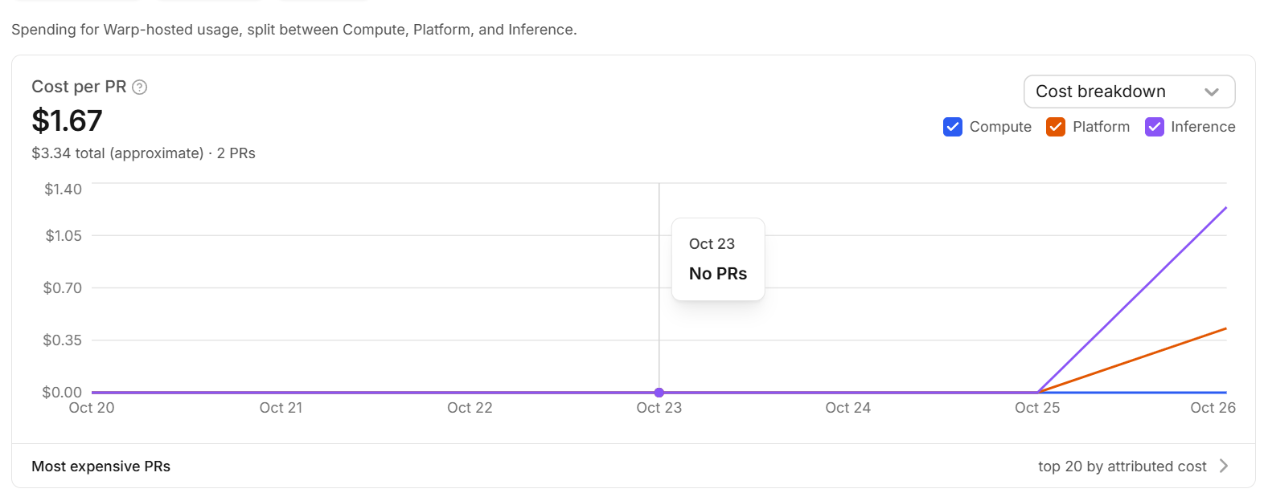
Figure 4. The dashboard after the first two PRs. Model calls (purple) dominate, Warp’s platform fee (orange) is about a quarter, compute (blue) is negligible.
Projection: our sandbox tasks were small. For real code I use Warp’s own published benchmark average of about $6 per task. Warp’s case study quotes $30–80 per PR before tuning, so treat the real-code columns as a lower bound for complex work.
Tasks per month | Small tasks, free plan (~$1.90 each, as in our test) | Real-code tasks, free plan (~$6 each) | Real-code tasks, Build plan ($20/month, no markup)
10 | $19 | $60 | $70
50 | $95 | $300 | $270
200 | $380 | $1,200 | $1,020

- Build plan: $20/month, removes the 20% markup and unlocks the Claude Code and Codex harnesses. It pays for itself above about $120 of usage per month.
- Building our own doesn’t make model calls free. We’d pay the same providers directly. What we’d save is roughly Warp’s platform share, in exchange for building and running the right-hand side of Figure 1 ourselves.

What it means for us
Lock-in. Only the factory definition and our repos move with us. The agent instructions are plain Markdown and would carry over to another provider or our own build; everything else is Warp’s. Question for us: are we comfortable depending on a closed service for a core workflow?
Data. Our code, prompts and run transcripts are processed and stored in Warp’s cloud. Keeping them on our own infrastructure, or using our own model provider, needs the Enterprise plan. Question for us: may the code we’d use it on leave our infrastructure?
Billing. Factory runs are paid per token from a prepaid balance. Our Claude or ChatGPT subscriptions don’t cover them, and Warp bills factory usage separately from its terminal plans. The same holds for any factory we build or host ourselves: it needs API access, not subscriptions. Question for us: who holds the budget, and what monthly cap do we set?

Adopt Warp or build our own
We are comparing four providers (Factory, Warp, Vercel’s software factory and Tessl) with building our own. The other providers have their own reviews, so this table compares Warp only with the option every review shares: building it ourselves.
What a factory needs | Adopt Warp | Build our own
Orchestration (foreman, stages, hand-offs) | Included | We build it
Sandboxes to run code safely | Included (Warp runners) | We build it, including secure handling of GitHub tokens inside the sandbox
Integrations | GitHub, GitLab, Azure DevOps, Slack, Teams, Linear, Jira | We build each one we need
Human approval, no auto-merge | Included (draft PRs, branch protection) | We build it
Cost tracking, evals, benchmarks | Included (dashboard, scorers, benchmarks) | We build it, or go without
Model choice | Any model per stage; Claude Code and Codex on Build | Any, including local models
Where it runs and where our code goes | Warp’s cloud (self-hosting is Enterprise) | Wherever we want
Source code | Closed; only the config files are ours | Ours
Running cost | Model calls + Warp’s share (+20% or Build plan) | Model calls + our hosting + our time to maintain it
Time to a first useful PR | Same day in our test | Not estimated yet

Recommendation and next steps
Warp doesn’t settle the decision on its own, but it gives us a measured reference point: this is the quality and price a ready-made factory delivers today. Every other provider, and anything we build, should be judged against it.
- Use this sandbox as the shared test for every candidate. Run the same six issues on Factory, Vercel and Tessl (and any in-house prototype) with the same prompts and scorecard, so every option is compared on identical tasks. The repo, scorecard and answer key are ready, and the repo can be reset to its starting state for each run.
- Answer the three questions above (lock-in, data, budget) before anything touches real code.
- If Warp is still in the running, pilot it for two weeks on one real, low-risk repo with a $50 cap. Real-codebase cost per task is the biggest unknown in the projection.
Not tested yet: Slack, Linear and Jira triggers; label-based automations; the Claude Code and Codex harnesses (Build plan); benchmarks and self-improvement; a large codebase; several people using one factory at once.

Appendix A: Try it yourself
- Sign in at platform.warp.dev and create a team if prompted.
- Load a usage balance (the smallest is $12 for $10 of usage) and turn off auto-reload.
- Click + next to Factories, connect GitHub, pick a repo and name the factory.
- Click New Chat, choose your factory and send one issue per chat.
- Follow progress under Runs and answer any questions that land in the Inbox.
- Review the draft PR yourself and merge it if it’s right. Check the cost on the Dashboard.
Tip: keep prompts neutral (“Fix issue #N, open a PR”) so you see the factory’s own judgment, and run a PR’s new tests against the old code before trusting them.

Appendix B: Sources
- Warp Factories product page
- Warp Factories docs: quickstart, definitions as code, infrastructure and security
- Warp pricing
- Warp changelog 2026: Early Access on 27 August, reliability fixes since
- warp-factory-examples: official example configurations
- TechCrunch launch coverage (18 August 2026)
- Our sandbox repo (private, ask me for access): PRs #7–#10 and eval/scorecard.csv

