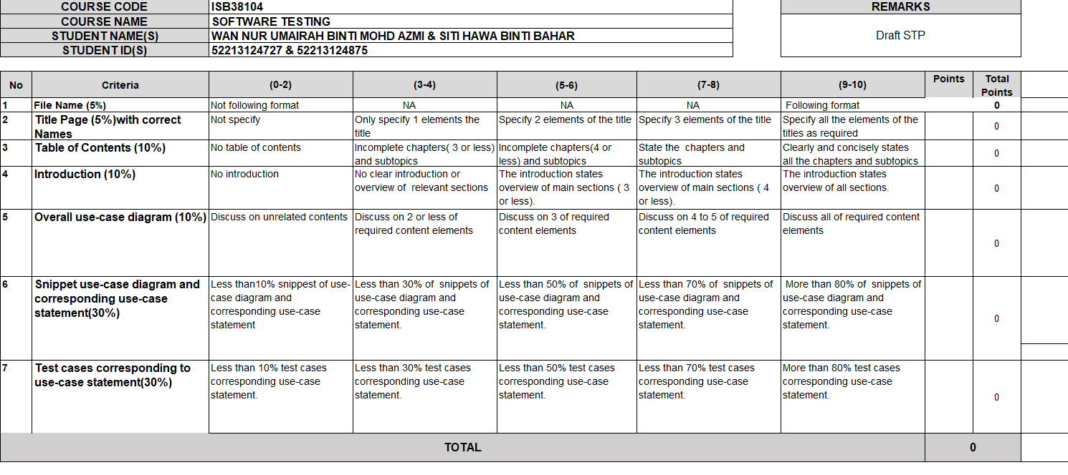

Software
Test Plan
Document

SYSTEM NAME: NYAM – NYAM !: CAMPUS BASED FOOD DIRECTORY SYSTEM WITH MOBILE AND WEB APPLICATION

Name : SITI HAWA BINTI BAHAR
Student ID : 52213124875
Class : L01 B06

Name : WAN NUR UMAIRAH BINTI MOHD AZMI
Student ID : 52213124727
Class : L01 B06

Table of Contents
1. TEST POLICY 5
1.1 Software Testing Term Definition 5
1.2 Advantages of Testing 6
1.3. Testing Principles 7
1.4 Test Missions & Objectives 8
1.5 Communication Among Stakeholders 9
1.6 SDLC Identification 9
2.0 INTRODUCTION TO TEST PLAN 12
2.1. System Description 12
2.2. Assumptions 15
2.3. References 16
2.4. Document Overview 17
3.0 OVERALL USE CASE DIAGRAM 19
4.0 USE CASE SNIPPETS AND USE CASE STATEMENTS 20
4.1 Use Case: User Register 20
4.2 Use Case: Stall Owner Register 21
4.3 Use Case: User Login 22
4.4 Use case: Login 23
4.5 Use case: Update Profile 24
4.6 Use case: Browse Stalls 26
4.7 Use case: Filter Stall by Category 27
4.8 Use case: View Stall Details 27
4.9 Use case: View Nagivation via Google Maps 28
4.10 Use case: Submit Review & Rating 29
4.11 Use case: Manage Favourite Stalls 30
4.12 Use case: User-Stall Owner Messaging 31
4.13 Use case: Submit Report Message 32
4.14 Use case: Manage support Messages 33
4.15 Use case: Manage Stall Profile & Menu 34
4.16 Use case: Reply to reviewers 35
4.17 Use case: Manage User & Stall Accounts 36
4.18 Use case: Monitor Reviews 37
5.0 TEST CASE 39
TC01 - Register New Account (User) 39
TC02 – Register New Stall Owner Account 40
TC03 – User Login (Mobile App) 41
TC04 – Stall Owner / Admin Login (Web Portal) 42
TC05 – Update User Profile (User) 43
TC06 – Browse Stalls (User) 44
TC07 – Filter Stall by Category (User) 45
TC08 – View Stall Details (User) 46
TC09 – View Navigation via Google Maps (User) 47
TC10 – Submit Review & Rating (User) 48
TC11 – Manage Favourite Stall (User) 49
TC12 – User–Stall Owner Messaging (User/Stall Owner) 50
TC13 – Submit Support Message (User) 51
TC14 – Manage Support Messages (Admin) 52
TC15 – Manage Stall Profile & Menu (Stall owner) 53
TC16 – Reply to Reviewers (Stall Owner) 54
TC17 – Manage User & Stall Accounts (Admin) 55
TC18– Monitor Reviews (Admin) 56
6.0 CONCLUSION 57

1. TEST POLICY
This section explains major philosophy of the organization of Vitamin Lab (dummy organization) regarding testing and its terms, meaning and practices. However, most of these policy aspects are widely applied in any other organization even UniKL MIIT may have this in their test policy since this is based on ISTQB (worldwide standard).

1.1 Software Testing Term Definition
Testing is a development activity that is all about process of finding and identifying defects by performing test and checking the actual result match the expected results or not. It also known as process of verification and validation which is based on ISO-9000 standard as shown below:
- Validation - Confirmation by examination and through the provision of objective evidence that specified requirements have been fulfilled. To summarize ISO statement, validation confirms that product build with correct requirement that satisfy the customer requirement.

- Verification - Confirmation by examination and through provision of objective evidence that the requirements for a specific intended use or application have been fulfilled. To summarize the ISO statement, verification confirms that software has been created and fulfilled.

Testing also defines what will happen once defect occur (failure). Testing is performed by testing team which then the report/result will be forwarded to developer team so that they can start debugging.

1.2 Advantages of Testing
There are several significant advantages of testing that can produce magnificent software application with supreme quality. These are numerous advantage that can be extract from testing:

- Testing increases quality in terms of the software attribute indirectly in which defect can be detected and corrected earlier prior to delivery. In addition to that, testing did increase process quality as well since defects are documented which means it can be analyzed, processed and solution to that error can be reused again to prevent same error again.

- Testing boosts confidence of all stakeholders which affects perception of team management regarding the software quality as well its robustness due to very few or no failure are found.

- Testing is like liability insurance where it costs big money, but it ensures all the stakeholders to be at ease as it cover and mitigate all the possible risks.

- Testing that is successfully conducted leads to major reductions in cost as defects can cause huge costs.

1.3. Testing Principles
There are seven testing principles that this organization applies which are based on ISTQB standard.
Principle 1: Testing shows presence of defects.
Testing can determine and reveal defects are present but unable to verify and identify that there are no defects at all are presents. According to Edger W. Dijkstra, 1970 “Program testing can be used to show presence of bugs, but never to show their absence!”

Principle 2: Exhaustive testing is impossible.
Full complete/exhaustive testing is truly not feasible except for trivial situations. Risk-based testing will be used to produce risk analysis to determine priorities of features module that need to be carried out.

Principle 3: Early testing
Testing is not a phase that happens at the end of software development, it should start as early as possible. Early testing (like static testing; review) takes place parallel to development activities, defects are detected earlier thus cost less to fix.

Principle 4: Defect clustering
Testing effort shall be focused proportionally to the expected and observed defect density of modules. A small number of modules often contain most of the defects discovered during pre-release testing/or responsible for most of operational failures.

Principle 5: Repetitions have no effects – Pesticide Paradox Repeating test brings no new insight thus test cases need to be regularly reviewed, revised, and modified. So that we won’t execute the same test and test cases repeatedly, there is a need for changes.

Principle 6: Testing is context dependent.
Testing depends on the context usage of that software. For example, safety-critical software systems are TESTED DIFFERENTLY (more intensive in technique) from commercial applications.

Principle 7: Absence of errors fallacy
System without failures does not imply system will meet user expectations. Sometimes there are no errors and failures, but the functionalities given are not what the user wants and expected.

1.4 Test Missions & Objectives
The mission of the testing process is to deliver Nyam-Nyam! at its highest quality where functional and quality attributes are satisfactory and defects are minimized. Testing activities are conducted in a systematic manner to ensure reliability and usability.

1.5 Communication Among Stakeholders
Communication among all stakeholders is essential during the testing process. All stakeholders must participate, give feedback, and share insights regarding the software. Professional, analytical and straightforward communication is important to ensure smooth testing activities and accurate issue resolution.

1.6 SDLC Identification
The Rapid Application Development (RAD) model is adopted as the Systems Development Life Cycle methodology for developing Nyam-Nyam!: A Campus Based Food Directory Mobile Application.
RAD is selected due to the nature of Nyam-Nyam!, which emphasizes user interaction and requires frequent refinement of system features. The system consists of several interactive modules such as the Food Browsing Module, Stall Details Module, Review Module, Promotion Module and Stall Owner Management Dashboard. These modules benefit from rapid development, early user involvement and continuous feedback throughout the development process.
The RAD approach focuses on quick development cycles through prototyping and iterative enhancement. In the early stages, functional prototypes of key features such as food directory browsing, stall information display and menu management are developed. These prototypes allow students, stall owners and administrators to interact with the system early and provide feedback before the system is fully completed.
RAD also integrates development and testing activities from the beginning of the project. Functional testing and user acceptance testing are conducted continuously as each prototype is built and improved. This helps identify usability issues, functional gaps and defects early, allowing immediate improvements to be made. As a result, risks are reduced and system quality is enhanced progressively.
Through RAD, features such as the Review System, Food Filtering Function, Promotion Display and Stall Owner Dashboard can be prototyped, tested and refined multiple times. This ensures that the final system closely matches user expectations and operational requirements. Changes in requirements can be accommodated easily without disrupting the overall development process.
Overall, the RAD methodology is well suited for Nyam-Nyam! because it supports high user involvement, flexibility in handling changes and rapid delivery of system components. This approach helps ensure that the final system is user friendly, efficient and aligned with the needs of the campus community.

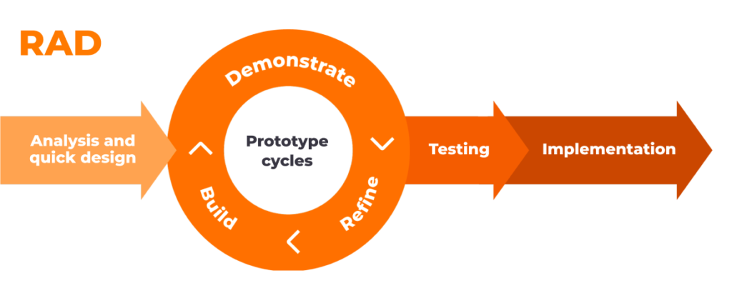
Figure 1 Rapid Application Development Model Diagram
Phases | Description
Requirements Planning | This phase focuses on identifying the high-level requirements of Nyam-Nyam!. Research is conducted to understand the needs of students, stall owners and administrators. Core features are identified such as food browsing, stall listing, menu display, reviews, promotions and stall owner management. In addition, a high-level test plan is prepared to define the testing scope and strategy to ensure that all functional requirements will be validated throughout development.
User Design | In this phase, system prototypes are developed to allow users to interact with early versions of Nyam-Nyam!. Prototypes include interfaces such as the food directory screen, stall detail page, review submission flow and stall owner dashboard. User feedback is actively collected through testing sessions to evaluate usability, navigation and functionality. Based on the feedback, the prototypes are refined to better match user expectations and improve system design.
Construction | During the construction phase, the refined prototypes are transformed into a fully functional system. All system modules such as food browsing, review management, promotion display and stall owner management are coded and integrated. Functional testing is conducted continuously to detect defects and ensure each feature operates according to the Software Requirements Specification. Integration testing is also performed to confirm that all modules work smoothly together.
Cutover | The final phase involves deploying Nyam-Nyam! for actual use. Students access the mobile application while stall owners and administrators use the web based dashboard. Final testing may be conducted in the live environment to ensure system stability and performance. After deployment, maintenance activities are carried out to support users, resolve issues and gather feedback for future enhancements.
Table 1 : Iterative Methodology Description

2.0 INTRODUCTION TO TEST PLAN
The document outlines an Acceptance Test Plan (ATP) for testing the developed Nyam-Nyam !: Campus-Based Food Directory System with Mobile and Web Application. The ATP is used by the acceptance test team to plan, conduct, and document acceptance testing activities.At the acceptance testing level, black-box testing is applied. This testing approach is specification-based, where functional test cases are derived from the Software Requirements Specification (SRS). The test cases are developed using use case testing, based on the use case specifications defined in the SRS.During the testing period, several reference documents are used, as listed in the References section.

2.1. System Description
Nyam-Nyam ! is a campus-based food directory system developed to support UniKL students and staff, as well as stall owners and administrators, in discovering and managing food options available near the campus. The system integrates a mobile application for users and a web portal for stall owners and administrators, providing a structured and user-friendly platform for all actors. It facilitates the process of browsing food stalls, accessing menu information, and enabling direct communication between users and stall owners. Through organised stall listings, stall management functionalities, and integrated communication features, the system ensures effective interaction and efficient information flow. Overall, Nyam-Nyam aims to enhance the campus dining experience by offering a reliable and convenient platform, while supporting efficient operational management for stall owners and administrators.
Modules list for user (UniKL students&Staff):
- User Register
This module allows users to create an account by providing required information such as first name, last name, display name, UniKL email address, password, profile photo, and mobile phone number.
- Login / Logout
Users can securely log in to the mobile application to access system features and log out when their session is complete.
- Update Profile
Users are able to update personal information including display name, profile photo, password, and mobile phone number.
- Browse Stalls
This module enables users to browse food stalls located near the campus through an organised listing that displays stall name, average rating, and food category.
- Search and Filter Stalls
Users can search for stalls and apply filters such as food category and rating.
- View Stall Details
Users can view detailed information about a selected stall, including menu items, ratings, reviews and stall location.
- View Navigation via Google Maps
This feature allows users to view stall locations and obtain navigation directions through Google Maps.
- User-Stall Owner Messaging
Users can communicate directly with stall owners via an in-app chat feature to ask information about their stall and menu.
- Submit Reviews and Ratings
Users can submit reviews and ratings for stalls and view feedback from other users.
- Submit Support Message
Users can contact administrators to report issues or submit complaints.

Modules lists for stall owner:
- Login / Logout
Stall owners can access the system through the web portal using registered credentials.
- Manage Stall Profile and Menu
This module allows stall owners to manage stall information and menu items after receiving approval from administrators.
- Reply to Reviews
Stall owners can respond to reviews submitted by users to address feedback or concerns.
- User-Stall Owner Messaging
Stall owners can communicate with users through the chat feature.
- Submit Support Message
Stall owners can submit support or report messages to administrators when assistance is required.
Modules lists for admin:
- Login / Logout
Administrators access the system through the web portal using pre-configured accounts.
- Manage User and Stall Accounts
Administrators can activate, suspend, or deactivate user and stall owner accounts to control system access.
- Manage Support Messages
Administrators can view, respond to, and resolve support messages submitted by users and stall owners.
- Monitor Reviews
Administrators can monitor reported reviews and take appropriate moderation actions, such as deleting or resolving inappropriate content.

2.2. Assumptions
To conduct and execute the test, it assumed that:

Ref | Assumption
1. | Functional requirements have been reviewed and acknowledged.
2. | There is a Software Requirements Specification (SRS) as reference where it contains all the functional requirements.
3. | Static test has been conducted via observation, reading and review of tested document (SRS)
4. | The test resources and test environment described in section 6 is available
5. | System, database, and server able to run at smooth performance
6. | Identified defects and bugs are expected to be fixed/resolved before the testing
7. | All changes to requirements will be notified and communicated to test team
Table 2 Assumption

2.3. References

SRS  (Software Requirements  Specification) | There is a Software Requirements Specification (SRS) to be referenced where it contains all the functional requirements.
IEEE Standard 829-1983 | IEEE Standard for Software Test Plan.
Nyam-Nyam Project Proposal | A proposal that defines Nyam-Nyam overall during early planning.
ISTQB Slides | Numerous slides from chapter 1 until 7 are used as references. Obtained from Software Testing class.
ISO/IEC 25010:2011 | Reference to define quality requirements and quality attributes.
Table 3 References

2.4. Document Overview

The STP document consists of six sections as brief below:

- Section 1 contains Test Policy components which explain the major philosophy of the development organization regarding their testing and its terms, testing SOP (Standard of Procedure), meaning and practices.

- Section 2 explains Introduction to Test Plan which gives an overview about the current acceptance test plan purpose, system description, references, and document structure overview.

- Section 3 contains Test Strategy which describes the testing approach, test objective, test scope, test process, test level, risk and contingency, entry and exit criteria, item pass/fail criteria, suspension criteria and resumption requirements.

- Section 4 contains Test Case Specification which describes the current test cases in development along with Use Case Diagram.

- Section 5 contains Test Environment which describes all the required facilities, hardware, software, and other necessary requirements for test to be executed smoothly.
- Section 6 contains Test Schedule, which discusses an overall schedule plan including testing activities.
3.0 OVERALL USE CASE DIAGRAM
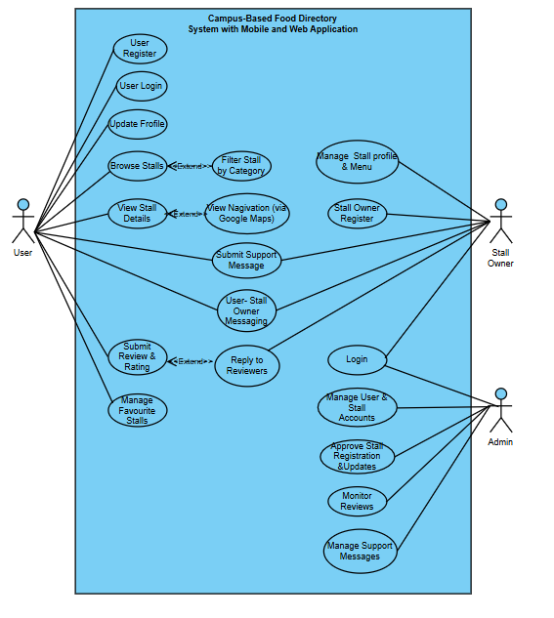
Figure 1 nyam-nyam use case diagram

4.0 USE CASE SNIPPETS AND USE CASE STATEMENTS

4.1 Use Case: User Register
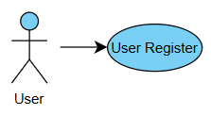
Figure 2 user register snippet
Use case Id:  UC001 | User Register
Primary Actors: | User (UniKL Student / Staff).
Platform: | Mobile Application.
Preconditions: User has not registered.
Trigger: User select “Register” .
Main Flow:
- System displays user registration form.
- User enters required details.
- User submits the form.
- System validates the input.
- System creates user account.
Alternative Flows:
- Invalid input format → System prompts the user to correct the input.
- Password and confirm password do not match → System displays an error message.
- Required fields are empty → System displays an error message.
- Duplicate email → System displays an error message indicating that the email already exists.

Post-conditions: User account is successfully created.

4.2 Use Case: Stall Owner Register

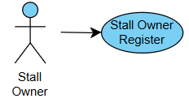
Figure 3 stall owner register snippet
Use case Id:  UC002 | Stall Owner Register
Primary Actors: | Stall owner.
Platform: | Web Portal.
Preconditions: Stall owner has not registered.
Trigger: Stall owner select “Register”.
Main Flow:
- System displays stall owner registration form.
- Stall owner enters personal and stall details.
- Stall owner submits the form.
- System validates the input.
- System saves registration with pending approval status.
- System notifies admin.
Alternative Flows:
- Invalid input format → System prompts correction.
- Password and confirm password do not match → system displays error message.
- Duplicate email → System displays an error message indicating the email already exists.
- Required fields empty → system display erorr message.

Post-conditions: Stall owner account is created with pending approval.

4.3 Use Case: User Login
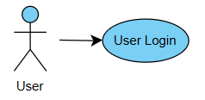
Figure 4 User login snippet
Use case Id:  UC003 | User Login
Primary Actors: | User (UniKL Student / Staff).
Platform: | Mobile Application.
Preconditions: user has a registered account.
Trigger: user enters email and password.
Main Flow:
- System displays login page.
- User enters valid credentials.
- User clicks“Login”.
- System authenticates credentials.
- System redirects user to homepage.
Alternative Flows:
- Invalid input format → System prompts correction.
- Required fields empty → system display erorr message.
- Invalid email or password → System displays an error message.
Post-conditions: User is logged in succesfully

4.4 Use case: Login
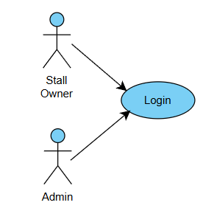
Figure 5 login snippet
Use case Id:  UC004 | Login
Primary Actors: | Stall Owner /Admin.
Platform: | Web Portal.
Preconditions:
- Admin account exist in the system.
- Stall Owner has a registered account.
Trigger: Actor enters email and password
Main Flow:
- System displays the login page.
- Actor enters valid credentials.
- Actor clicks“Login”.
- System authenticates credentials.
- System identifies the actor role.
- System redirects the actor to their dashboard.
Alternative Flows:
- Invalid input format → System prompts correction.
- Required fields empty → system display erorr message.
- Invalid email or password → System displays an error message.
- Stall owner not approved → System displays pending approval message.
Post-conditions: Actor is logged in succesfully
4.5 Use case: Update Profile
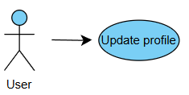
Figure 6 update profile snippet
Use case Id:  UC005 | Update profile
Primary Actors: | User (UniKL Student / Staff).
Platform: | Mobile application.
Preconditions: User is logged in.
Trigger: User selects“Edit profile”.
Main Flow:
- System displays user profile.
- User updates profile details.
- User save changes.
- System updates profile information.
Alternative Flows:
Invalid input → System displays error message.
Post-conditions: user profile is updated

4.6 Use case: Browse Stalls
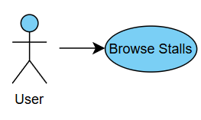
Figure 7 browse stalls snippet
Use case Id:  UC006 | Browse Stalls
Primary Actors: | User (UniKL Student / Staff).
Platform: | Mobile application.
Preconditions: User is logged in.
Trigger: User accesses the home page.
Main Flow:
- System displays list of available stalls.
- User browses the displayed stalls.
- User may search or apply filters to refine the stall list.
Post-conditions: List of stalls matching the search or filter criteria is displayed.

4.7 Use case: Filter Stall by Category
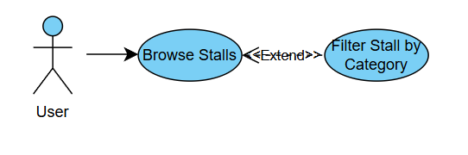
Figure 8 filter stall by category snippet
Use case Id:  UC007 | Filter Stall by Category(Extend UC006)
Primary Actors: | User (UniKL Student / Staff).
Platform: | Mobile application.
Trigger: User selects a category filter.
Main Flow:
- System filters stalls based on the selected category.
- System updates the stall list.
Post-conditions: filtered stall list is displayed.

4.8 Use case: View Stall Details
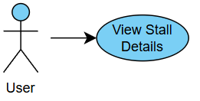
Figure 9 view stall details snippet
Use case Id:  UC008 | View Stall Details
Primary Actors: | User (UniKL Student / Staff).
Platform: | Mobile application.
Preconditions: User is logged in.
Trigger: User selects a stall.
Main Flow:
- System displays stall information (stall name, menu, rating, and location).
- System displays available actions, including viewing navigation and initiating chat.
- User views stall details.
Post-conditions: stall details are shown.

4.9 Use case: View Nagivation via Google Maps
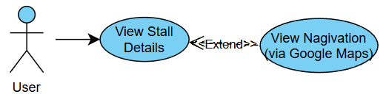
Figure 10 view navigation via google maps snippet
Use case Id:  UC009 | View Nagivation via Google Maps  (Extend UC008)
Primary Actors: | User (UniKL Student / Staff).
Platform: | Mobile application.
Trigger: User selects “ Direction”.
Main Flow:
- System opens Google Maps.
- System displays route to stall.
Post-conditions: Navigation route is shown.

4.10 Use case: Submit Review & Rating
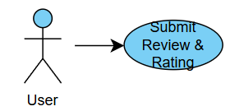
Figure 11 submit review and rating snippet
Use case Id:  UC010 | Submit Review & Rating
Primary Actors: | User (UniKL Student / Staff).
Platform: | Mobile application.
Preconditions: User is logged in.
Trigger: User submit review and rating.
Main Flow:
- User enters review and rating.
- System saves review.
Alternative Flows:
- Missing rating → System displays error message.
Post-conditions: Review is succesfully submitted.

4.11 Use case: Manage Favourite Stalls
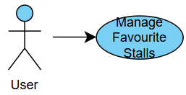
Figure 12 manage favourite stall snippet

Use case Id:  UC011 | Manage Favourite Stall
Primary Actors: | User (UniKL Student / Staff).
Platform: | Mobile application.
Preconditions: User is logged in.
Trigger: User click “ favourite”.
Main Flow:
- User adds or removes a stall from favourites.
- System updates favourite list.
Post-conditions: Favourite stall is updated.

4.12 Use case: User-Stall Owner Messaging
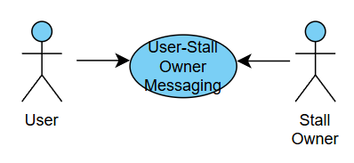
Figure 13 user-stallowner messaging
Use case Id:  UC012 | User-Stall Owner Messaging
Primary Actors: | User (UniKL Student / Staff),Stall Owner.
Platform: | Mobile application.  Web Portal.
Preconditions:
- User is logged in.
- Stall owner is logged in.
- User is viewing stall details.
Trigger: User selects“ Chat” button on the stall details page.
Main Flow:
- System opens the chat interface between the user and the stall owner.
- User enters a message.
- User sends the message.
- System delivers the message to the stall owner.
- Stall owner views and replies to the message.
Alternative Flows:
- Recipient is offline → System stores the message and delivers it when the recipient is online.
Post-conditions: Message is succesfully delivered or stored for later delivery.

4.13 Use case: Submit Report Message
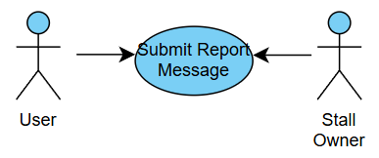
Figure 14 submit report message
Use case Id:  UC013 | Submit Report Message
Primary Actors: | User (UniKL Student / Staff),Stall Owner.
Platform: | - Mobile application.  - Web Portal.
Preconditions:
• User is logged in OR
• Stall owner is logged in.
Trigger: User selects “ admin support”.
Main Flow:
- System displays the support message form.
- Actor enters message details.
- Actor submits the support message.
- System validates the input.
- System sends the message to Admin.
- System confirms submission.

Alternative Flows:
- Required fields empty → System displays error message.
Post-conditions: Support message is submitted and stored in the system.

4.14 Use case: Manage support Messages
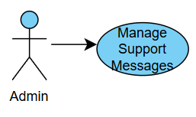
Figure 15 manage support messages
Use case Id:  UC014 | Manage Support Messages
Primary Actors: | Admin.
Platform: | Web Portal.
Preconditions: Admin is logged in.
Trigger: admin selects“ Manage support Messages”.
Main Flow:
- System displays list of support messages.
- Admin views message details.
- Admin responds to or resolves the support message.
- System updates message status.

Alternative Flows:
- Required fields empty → System displays error message.
Post-conditions: Support message is responded to and mark as completed.

4.15 Use case: Manage Stall Profile & Menu
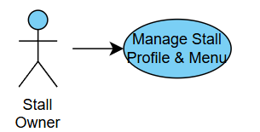
Figure 16 manage stall profile & menu
Use case Id:  UC015 | Manage Stall profile & Menu
Primary Actors: | Stall Owner.
Platform: | Web Portal.
Preconditions
- Stall owner is logged in.
- Stall owner account is approved by Admin.
Trigger: Stall owner selects“manage stall”.
Main Flow:
- System displays stall profile and menu information.
- Stall owner edits stall details (e.g. stall name, description, operating hours).
- Stall owner adds, updates, or removes menu items.
- Stall owner saves the changes.
- System validates and stores the updated information.

Alternative Flows:
- Required fields empty → System displays error message.
- Invalid input format → System displays an error message.
Post-conditions: Stall profile and menu are updated.

4.16 Use case: Reply to reviewers
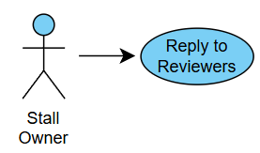
Figure 17 reply to reviewers
Use case Id:  UC016 | Reply to Reviewers
Primary Actors: | Stall Owner.
Platform: | Web Portal.
Preconditions:
- Stall owner is logged in.
- Reviews for the stall exist.
Trigger: Stall owner selects a review to reply to.
Main Flow:
- System displays the list of reviews for the stall.
- Stall owner selects a review.
- System displays the reply input field.
- Stall owner enters a reply.
- Stall owner submits the reply.
- System saves and displays the reply under the review.

Alternative Flows:
- Reply field empty → System displays an error message.
Post-conditions: Reply is successfully posted and visible to users.

4.17 Use case: Manage User & Stall Accounts
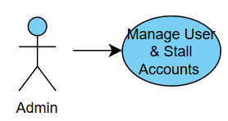
Figure 18 manage user & stall accounts
Use case Id:  UC017 | Manage User & Stall Accounts
Primary Actors: | Admin.
Platform: | Web Portal.
Preconditions:
- Admin is logged in
- User and stall owner accounts exist in the system.
Trigger: Admin selects “ Manage User & Stall Account”.
Main Flow:
- System displays a list of user and stall owner accounts.
- Admin selects an account.
- System displays the account status.
- Admin performs one of the following actions: activate, suspend, or deactivate the account.
- System saves the updated account status.

Alternative Flows:
- Account not found → System displays an error message.
Post-conditions: User or stall owner account is updated successfully.

4.18 Use case: Monitor Reviews
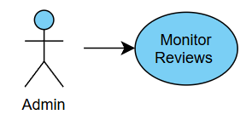
Figure 19 monitor reviews
Use case Id:  UC018 | Monitor Reviews
Primary Actors: | Admin.
Platform: | Web Portal.
Preconditions:
- Admin is logged in
- Reviews for the stall exist.
- Reviews may be reported by users or stall owners for moderation purposes.
Trigger: Stall owner selects“monitor reviews”.
Main Flow:
- System displays a list of reported reviews.
- Admin selects a reported review.
- System displays review details and report reason.
- Admin reviews the reported content.
- Admin deletes or retains the review.
- System updates the review status.

Post-conditions: Reported review is deleted or marked as resolved.

5.0 TEST CASE

TC01 - Register (User)
Test Level: |  | Unit / Functional
Tested By: |  | To be assigned
Test Type |  | Functional
Test Design Technique |  | Equivalence Partitioning
Risk Number |  | R01
Test Case Number |  | TC01
Test Case Name |  | Register with valid details
Requirement Traceability |  | FR1
Test Case Description |  | Verify that a new user can register successfully with all valid details and also university
Item(s) to be tested
1 | First Name, Last Name, Display Name field
2 | Email field
3 | Phone number field
4 | Password field
5 | Confirm password field
Pre-condition: Email used in registration does not already exist in the system.
Specifications
Input |  |  | Expected  Output/Result
 |  |  | System creates new account and shows success notification.
  Valid name, unikl email, phone, strong password
Test Procedure Steps
1 | Open registration page.
2 | Enter valid first name, last name, and display name
3 | Enter valid, unikl email address
4 | Enter valid phone number
5 | Enter valid password and confirm password
6 | Click “Register”
7
Post-condition
New user account is stored and can be used to log in.

TC02 – Register (Stall Owner )
Test Level: |  | Unit / Functional
Tested By: |  | To be assigned
Test Type |  | Functional
Test Design Technique |  | Use-Case Based
Risk Number |  | R02
Test Case Number |  | TC02
Test Case Name |  | Stall Owner Registration with Pending Approval
Requirement Traceability |  | FR2
Test Case Description |  | Verify that a stall owner can successfully register and the account is saved with pending approval status.
Item(s) to be tested
1 | Name field
2 | Email field
3 | Phone number field
4 | Password field
5 | Company name field
6 | Business proof doc (pdf)
7 | Stall name field
8 | Stall location field
9 | Google map link
Pre-condition: Email does not exist in the system.
Specifications
Input |  |  | Expected  Output/Result
Valid personal details, stall info, valid email, matching passwords |  |  | Registration saved with pending approval and admin is notified
Test Procedure Steps
1 | Open stall owner registration page
2 | Enter valid personal and stall details
3 | Enter valid email
4 | Enter matching password and confirm password
5 | Click “Register”
Post-condition
Stall owner account is created with pending approval status.

TC03 – Login (User)

Test Level: |  | Unit / Functional
Tested By: |  | To be assigned
Test Type |  | Functional
Test Design Technique |  | Equivalence Partitioning
Risk Number |  | R03
Test Case Number |  | TC03
Test Case Name |  | User Login with Valid Credentials
Requirement Traceability |  | FR3
Test Case Description |  | Verify that a registered user can log in successfully.
Item(s) to be tested
1 | Email field
2 | Password field
Pre-condition: User account must exist in the system.
Specifications
Input |  |  | Expected  Output/Result
 |  |  | User is redirected to homepage
  Valid email and password
Test Procedure Steps
1 | Open login page
2 | Enter valid email
3 | Enter valid password
4 | Click “Login”
Post-condition
User session is active.

TC04 –Login (Admin/Stall Owner)

Test Level: |  | System / Functional
Tested By: |  | To be assigned
Test Type |  | Functional
Test Design Technique |  | Use-Case Based
Risk Number |  | R04
Test Case Number |  | TC04
Test Case Name |  | Login with role identification
Requirement Traceability |  | FR4
Test Case Description |  | Verify that the system correctly identifies user role and redirects accordingly.
Item(s) to be tested
1 | Email field
2 | Password field
3 | Role detection
Pre-condition: Admin or stall owner account exists.
Specifications
Input |  |  | Expected  Output/Result
Valid credentials |  |  | Redirected to correct dashboard
Test Procedure Steps
1 | Open login page
2 | Enter valid email and password
3 | Click “Login”
Post-condition
Actor logged in successfully.

TC05 – Update Profile (User)

Test Level: |  | System / Functional
Tested By: |  | To be assigned
Test Type |  | Functional
Test Design Technique |  | Use-Case Based
Risk Number |  | R05
Test Case Number |  | TC05
Test Case Name |  | Update profile details
Requirement Traceability |  | FR5
Test Case Description |  | Verify that user can use the search feature to browse for stalls
Item(s) to be tested
1 | Display name field
2 | Phone number field
3 | Password field
4 | Profile picture field
Pre-condition: User is logged in.
Specifications
Input |  |  | Expected  Output/Result
Valid updated profile details |  |  | Profile updated successfully
Test Procedure Steps
1 | Open “Edit Profile” page
2 | Edit profile details ( display name, phone number, password, profile picture)
3 | Click “Save”
Post-condition
User profile information is updated.

TC06 – Browse Stalls (User)

Test Level: |  | System / Functional
Tested By: |  | To be assigned
Test Type |  | Functional
Test Design Technique |  | Scenario-Based
Risk Number |  | R06
Test Case Number |  | TC06
Test Case Name |  | Browse available foods and stalls
Requirement Traceability |  | FR6
Test Case Description |  | Verify that users can view the list of available stalls.
Item(s) to be tested
1 | Stall listing
2 | Search and filter controls
Pre-condition: User is logged in.
Specifications
Input |  |  | Expected  Output/Result
 |  |  | List of foods and stalls displayed
  Access browsing page
Test Procedure Steps
1 | Login to app
2 | Open home page
3 | Click search bar
4 | Browse for foods and stalls
Post-condition
Food and stall list is displayed.

TC07 – Filter Stall by Category (User)

Test Level: |  | System / Functional
Tested By: |  | To be assigned
Test Type |  | Functional
Test Design Technique |  | Equivalence Partitioning
Risk Number |  | R07
Test Case Number |  | TC07
Test Case Name |  | Filter stalls by category
Requirement Traceability |  | FR7
Test Case Description |  | Verify that stalls are filtered based on selected category.
Item(s) to be tested
1 | Category
2 | Access control for notes
Pre-conditionUser is browsing stalls.
Specifications
Input |  |  | Expected  Output/Result
 |  |  | Filtered stall list displayed
  Select valid category
Test Procedure Steps
1 | Browsing page
2 | Select category filter
Post-condition
Filtered stalls are shown.

TC08 – View Stall Details (User)

Test Level: |  | Unit / Functional
Tested By: |  | To be assigned
Test Type |  | Functional
Test Design Technique |  | Use-Case Based
Risk Number |  | R08
Test Case Number |  | TC078
Test Case Name |  | View stall details
Requirement Traceability |  | FR8
Test Case Description |  | Verify that user can view detailed stall information.
Item(s) to be tested
1 | Stall name
2 | Menu
3 | Rating
4 | Location
Pre-condition: User is logged in.
Specifications
Input |  |  | Expected  Output/Result
 |  |  | Stall details displayed
  Select a stall
Test Procedure Steps
1 | Browse stalls
2 | Select a stall
Post-condition
Stall details are visible.

TC09 – View Navigation via Google Maps (User)

Test Level: |  | Integration
Tested By: |  | To be assigned
Test Type |  | Functional
Test Design Technique |  | Use-Case Based
Risk Number |  | R09
Test Case Number |  | TC09
Test Case Name |  | View navigation route
Requirement Traceability |  | FR9
Test Case Description |  | Verify that Google Maps opens with correct route.
Item(s) to be tested
1 | Direction button
2 | Google Maps integration
Pre-condition: User is logged in; stall exists in system.
Specifications
Input |  |  | Expected  Output/Result
Click “Direction” |  |  | Google Maps shows route
Test Procedure Steps
1 | Open stall details
2 | Click “Direction”
Post-condition
Navigation route is displayed.

TC10 – Submit Review & Rating (User)

Test Level: |  | Functional
Tested By: |  | To be assigned
Test Type |  | Functional
Test Design Technique |  | Boundary Value Analysis
Risk Number |  | R10
Test Case Number |  | TC10
Test Case Name |  | Submit valid review and rating
Requirement Traceability |  | FR10
Test Case Description |  | Verify that a user can submit a review with rating.
Item(s) to be tested
1 | Review text
2 | Rating input
3 | Image field
Pre-condition: User is logged in and is submitting review.
Specifications
Input |  |  | Expected  Output/Result
Valid review and rating |  |  | Review saved successfully
Test Procedure Steps
1 | Open stall page
2 | Enter review
3 | Select rating
4 | Submit review
5 | Open stall page
Post-condition
Review is stored.

TC11 – Manage Favourite Stalls (User)

Test Level: |  | Functional
Tested By: |  | To be assigned
Test Type |  | Functional
Test Design Technique |  | Use-Case Based
Risk Number |  | R11
Test Case Number |  | TC11
Test Case Name |  | Add or remove favourite stall
Requirement Traceability |  | FR11
Test Case Description |  | Verify that a user can manage favourite stalls.
Item(s) to be tested
1 | Favourite button
Pre-condition: User is logged in and stall exists in the system.
Specifications
Input |  |  | Expected  Output/Result
Click favourite icon |  |  | Favourite list updated
Test Procedure Steps
1 | Click open stall details
2 | Click heart shape icon
Post-condition
Favourite stall list updated.

TC12 – User–Stall Owner Messaging (User/Stall Owner)

Test Level: |  | Integration
Tested By: |  | To be assigned
Test Type |  | Functional
Test Design Technique |  | Use-Case Based
Risk Number |  | R12
Test Case Number |  | TC12
Test Case Name |  | Send and receive messages
Requirement Traceability |  | FR12
Test Case Description |  | Verify messaging between user and stall owner.
Item(s) to be tested
1 | Chat interface
2 | Message delivery
Pre-condition: Both actors are logged in.
Specifications
Input |  |  | Expected  Output/Result
Send message |  |  | Message delivered or stored
Test Procedure Steps
1 | Open chat
2 | Enter message
3 | Send message
4 | Receive message reply
Post-condition
Message delivered or queued.

TC13 – Submit Support Message (User)

Test Level: |  | Functional
Tested By: |  | To be assigned
Test Type |  | Functional
Test Design Technique |  | Equivalence Partitioning
Risk Number |  | R13
Test Case Number |  | TC13
Test Case Name |  | Submit support message
Requirement Traceability |  | FR13
Test Case Description |  | Verify that users or stall owners can submit support messages.
Item(s) to be tested
1 | Message field
Pre-condition: Actor is logged in.
Specifications
Input |  |  | Expected  Output/Result
 |  |  | Message sent to admin
  Valid message
Test Procedure Steps
1 | Open admin support
2 | Enter message
3 | Submit
Support message is submitted and stored in the system.

TC14 – Manage Support Messages (Admin)

Test Level: |  | System
Tested By: |  | To be assigned
Test Type |  | Functional
Test Design Technique |  | Use-Case Based
Risk Number |  | R14
Test Case Number |  | TC14
Test Case Name |  | Respond to support messages
Requirement Traceability |  | FR14
Test Case Description |  | Verify admin can manage support messages.
Item(s) to be tested
1 | Message list
2 | Response action
Pre-condition: Admin is logged in.
Specifications
Input |  |  | Expected  Output/Result
 |  |  | Message marked completed
  Respond to message
Test Procedure Steps
1 | Open support messages
2 | Select messages
3 | Respond
Support message is responded to and mark as completed.

TC15 – Manage Stall Profile & Menu (Stall owner)

Test Level: |  | Functional
Tested By: |  | To be assigned
Test Type |  | Functional
Test Design Technique |  | Use-Case Based
Risk Number |  | R15
Test Case Number |  | TC15
Test Case Name |  | Update stall profile and menu
Requirement Traceability |  | FR15
Test Case Description |  | Verify stall owner can update stall profile and menu.
Item(s) to be tested
1 | Stall details
2 | Menu items
Pre-condition: Stall owner account approved.
Specifications
Input |  |  | Expected  Output/Result
 |  |  | Stall profile updated
  Valid updates
Test Procedure Steps
1 | Open manage stall
2 | Edit details
3 | Save changes
4 | Wait for admin approval
Stall information updated.

TC16 – Reply to Reviewers (Stall Owner)

Test Level: |  | Functional
Tested By: |  | To be assigned
Test Type |  | Functional
Test Design Technique |  | Use-Case Based
Risk Number |  | R16
Test Case Number |  | TC16
Test Case Name |  | Reply to user reviews
Requirement Traceability |  | FR16
Test Case Description |  | Verify stall owner can reply to reviews
Item(s) to be tested
1 | Review reply field
Pre-condition: Review exist.
Specifications
Input |  |  | Expected  Output/Result
 |  |  | Reply displayed under review
  Valid reply
Test Procedure Steps
1 | Select review
2 | Enter reply
3 | Submit reply
Reply is successfully posted and visible to users.

TC17 – Manage User & Stall Accounts (Admin)

Test Level: |  | System
Tested By: |  | To be assigned
Test Type |  | Functional
Test Design Technique |  | Use-Case Based
Risk Number |  | R17
Test Case Number |  | TC17
Test Case Name |  | Update account status
Requirement Traceability |  | FR17
Test Case Description |  | Verify admin can activate, suspend or deactivate accounts.
Item(s) to be tested
1 | Account status control
Pre-condition: Admin is logged in.
Specifications
Input |  |  | Expected  Output/Result
 |  |  | User or stall owner account status is updated successfully
  Update account status (activate / suspend / deactivate)
Test Procedure Steps
1 | Open manage account
2 | Select account
3 | Update account status
User or stall owner account is updated successfully.

TC18– Monitor Reviews (Admin)

Test Level: |  | System
Tested By: |  | To be assigned
Test Type |  | Functional
Test Design Technique |  | Use-Case Based
Risk Number |  | R18
Test Case Number |  | TC18
Test Case Name |  | Review moderation
Requirement Traceability |  | FR18
Test Case Description |  | Verify admin can monitor and moderate reviews.
Item(s) to be tested
1 | Reported review list
2 | Delete/retain actions
Pre-condition: Reported reviews exist.
Specifications
Input |  |  | Expected  Output/Result
 |  |  | Review status updated
  Delete or retain review
Test Procedure Steps
1 | Open monitor reviews
2 | Select reported review
3 | Action taken
Reported review is deleted or marked as resolved.

CONCLUSION

The Software Testing Plan (STP) for Nyam-Nyam! : A Food Discovery Mobile Application for the UniKL MIIT Community outlines a structured testing approach to ensure that all system functionalities, across both the mobile application and web-based platform, operate accurately and as intended. This STP incorporates the system’s use case diagram, detailed use case statements, and corresponding test cases to comprehensively verify each module, including user and stall owner registration, authentication, stall browsing and filtering, navigation, reviews and ratings, messaging, support management, and administrative controls. Through the application of systematic testing techniques such as functional, unit, and use case testing, the document provides clear guidance for test personnel on execution and validation processes. The standardized test procedures and result formats support consistent defect identification, verification of fixes, and confirmation of system readiness prior to deployment, ensuring the reliability and effectiveness of the Nyam-Nyam! system for the UniKL MIIT community.

