zaki@Daemon

Table of Contents
1. Algorithm/Code
1.1. Whoel Porgram decompsiostion
1.2. Bit Parsing/Data Strucutre [BIT]
1.2.1. inode
1.2.2. datablock
1.2.3. bitmap of indoe/datablock
1.2.4. Sector/Root Inode
1.3. File System [FS]
1.4. File Access [FILE]
1.5. Directory [DIR]
1.6. Disk [DISK]

Algorithm/Code

Whoel Porgram decompsiostion
This is an outline/code of how the whole program will be.

Bit Parsing/Data Strucutre [BIT]
- As we are writing bits, we have to format the disk to be able to read and write bits.
- SUPERBLOCK | indoebitmap | datablock bitmap | sequence of indoes | sequence of datablcoks = 1000
- the sequence of indoes will ahve 3 sectors, due to each indoe being able to represtn 35 inodes.
- The rest of the space, 994 sectors, are for teh databock block.

inode
writeBitStream()
Write teh type, size and allociation, by reversing the blwo opeariton
readBitStream()
read the type, size and allcioation by folowing the following processess
(no term)
There are 4 indoes within a inode sector. The makeup totals to 114 bits.
1 bit
for which type of inode this is.
13 bits
(or 1.625 bytes) for representing the size of datablocks
100 bits
10 seqeunces of 10 bits for reprsenting the location. note that all 1s mean that this is not allociated
(no term)
This results of 106 of useless data, and 3990 of useful data. Since there are 35 inodes in a sector, we split it up into an array, with each piece being a substr of 114 bits.
(no term)
The function below is a method ofreading it. Note it doesn’t return anything. Maybe i’ll try to do that thing where i have an inlnie function and do it there.
(no term)
Anotehr note: there’ll be 35 inodes withn a sector, so the spliting of that by 114 is left to futrue zak.
(no term)
Writing it to bitstream is simple. if need be write a funciton for it.

datablock
- Datablocks are disgshiustehd by two types: file and directory
- the type of the datablock is denoted by teh inode, not the directory.
- For directory, tehre is a 20 bytes/160 bits, which are
16 bytes/128 bits
file name. 15 characters PLUS 1 for end of string, so it’s mroe of 15 characters
4 byte/32 bits
inode that shows which file/driectory this is.
- This means that dictionaries cna have 25 files in a a sector, but 250 files/directories overall.
- This doesn’t have the case, of half a directoriy’s infroamtion being in one datablcok, and the other half being in another datablock. THat isn’t consdiered.
Listing 1.2.1:
using namespace std;
void readDir(string TestString){
bitset<4> inode(TestString.substr(0,4));
cout << inode.to_ulong() << endl;
char temp[10];
for(int i=0; i<16; i++){
bitset<8> temp(TestString.substr(4+i*8,8));
cout << (char)temp.to_ulong() << endl;

}

}

int main(){
/*
string temp1="iiii11111111111111112222222222222222333333333333333344444444444444445555555555555555666666666666666677777777777777778888888888888888";
for(int i=0; i<8; i++){
cout << temp1.substr(4+i*16,16) << endl;
}
*/
/*readDir("111110000000000000001000000000000000100000000000000010000000000000001000000000000000100000000000000010000000000000001000000000000000");*/
readDir("111101000001010000100100001101000100010001010100011001000111010010000100000101000010010000110100010001000101010001100100011101001000");
/*
111101000001010000100100001101000100010001010100011001000111010010000100000101000010010000110100010001000101010001100100011101001000*/
}

bitmap of indoe/datablock
- this is just a bitmap, used to keep trakc of which indoes are allociated and which datablocks are allociated.

Sector/Root Inode
- A sector is a collection of a superblock, bitmaps for in use indoes and datablocks, a sqeunce of indoes, and a sequence of datablocks. However, this information HAS TO BE CONVERETD to that. Otehrwise, a sector is just an array of bitsets of 4096 bits.
- However, the sector converts it’s concats to usuable datasturcutres. After each file/directory operation, it saves the stuff to workign directory. Than, working directory saves it stuff to external disk when FSSYNC() is made.
- The disks are just a bitset array of 4096 bits, with 1000 elements in each.
- The root inode is the indoe that represtns nothing. This is a special variable, as to not have to find out what it is on disk tediously.
std::bitset<4096> ExtDisk[1000];
std::bitset<4096> WorkDisk[1000];

File System [FS]
FSBOOT()
Called when booting filesystem/after a FSRESET()
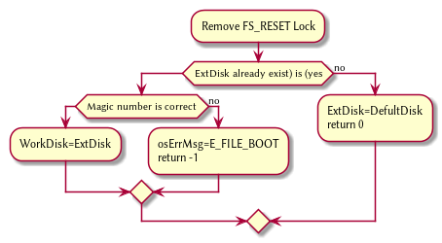 ]
FSSync
Copys the working disk to external disk
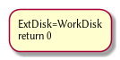
FSRESET()
Stops the filesystem from ebing access, by placing a lock on it.
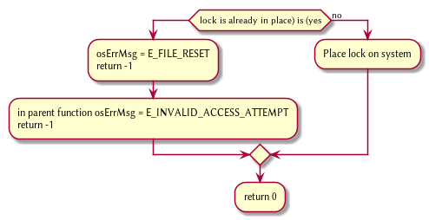

File Access [FILE]
int getInode(string path)
Helper function, used to get the inode given a path.
Ouptut
inode number of where it is, or -1 if it’s not found.
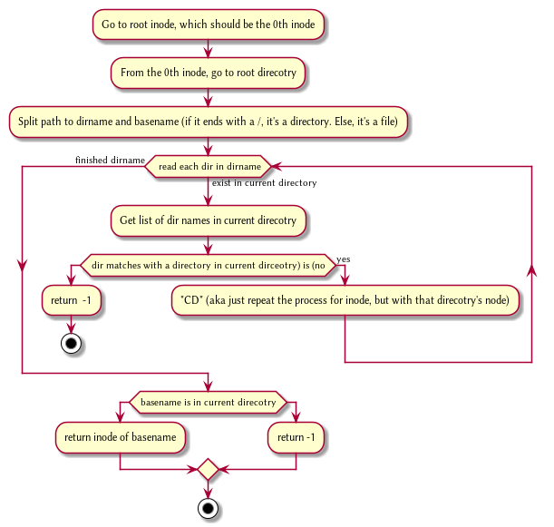
int getInode(string path)
Helper function, used to get the file given a path.
Ouptut
inode number of where it is, or -1 if it’s not found.
FileCreate(string path)
Create a new file at path. There is a check to see if that file already exist, and if there’s a free datablock for it.
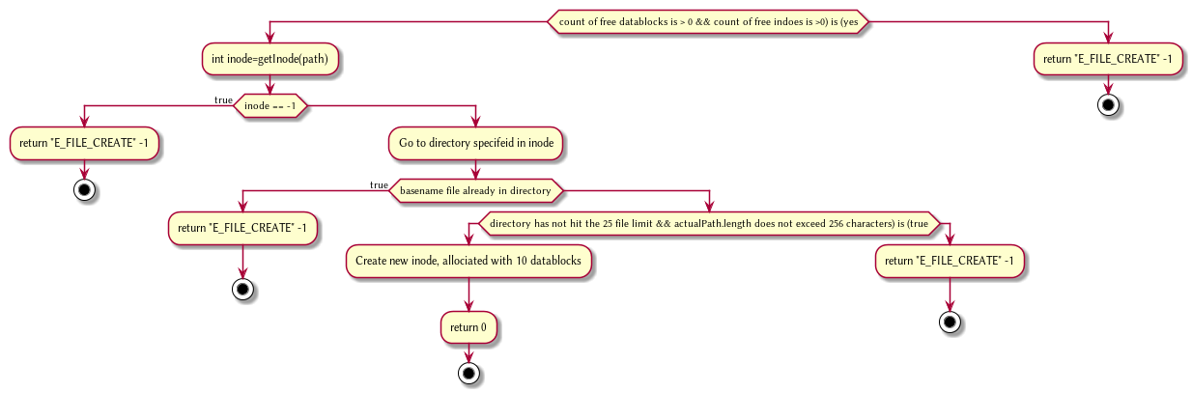
FileOpen(string path)
returns the file descriptor of the file, which can be used to read and write to it.
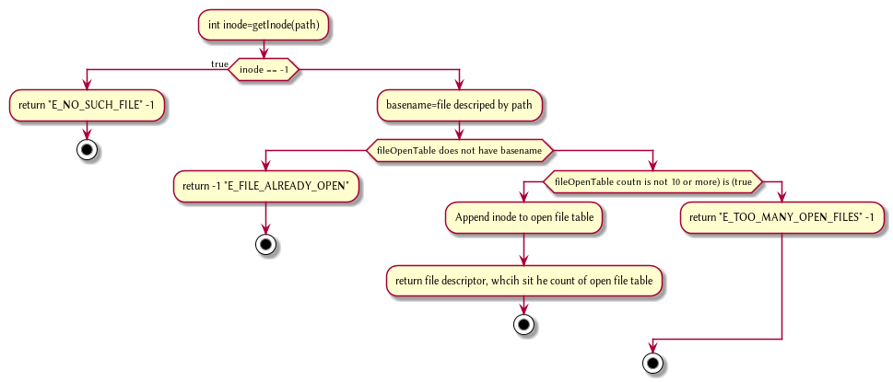
FileRead(int fd, string buffer, int size IN BYTES)
Buffer reads size from the file in fd. Note the file in open file table shuold move by size
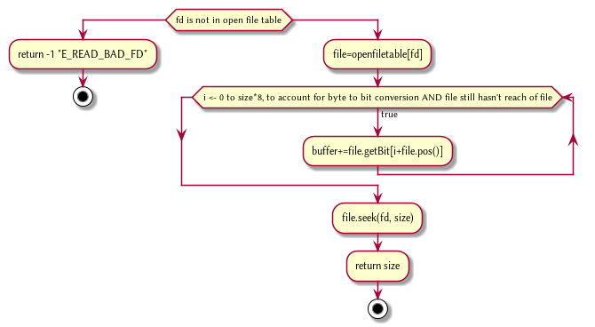
FileWrite(int fd, string buffer, int size IN BYTES)
Write from buffer to the file. NOTE SIZE HAS TO BE CONSISNET. If it’s not, stop the program
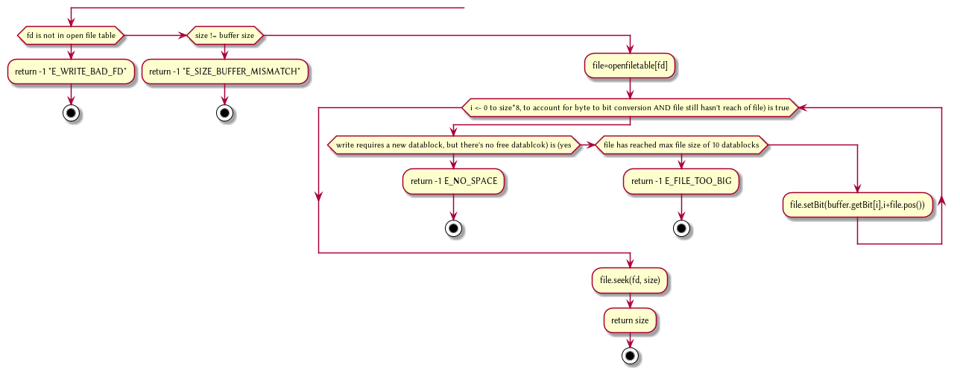
FileSeek(int fd, int offset)
move the file forward by offset.
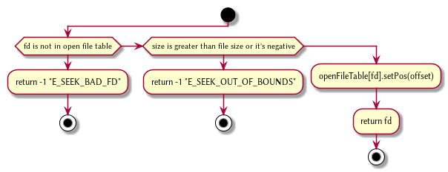
@startuml
FileClose(int fd)
Remove file from table
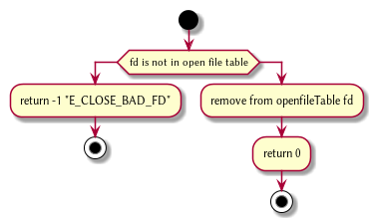
FileUnLink(string path)
Delete file from the filesystem.
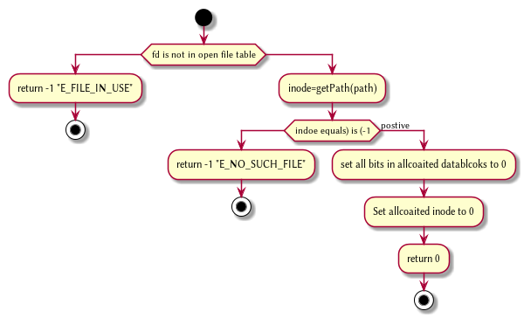

Directory [DIR]
DirCreate(string path)
Create directory at path
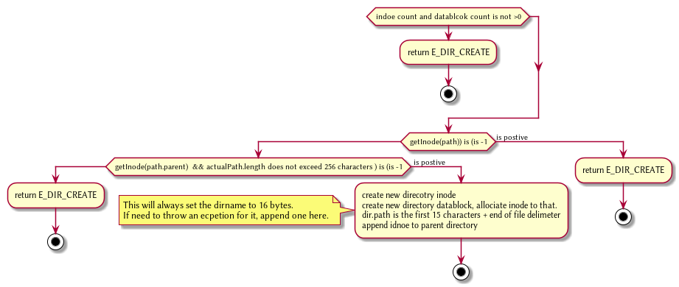
@startuml
DirRead(string path, string buffer, itn size)
Read the contents of a directory.
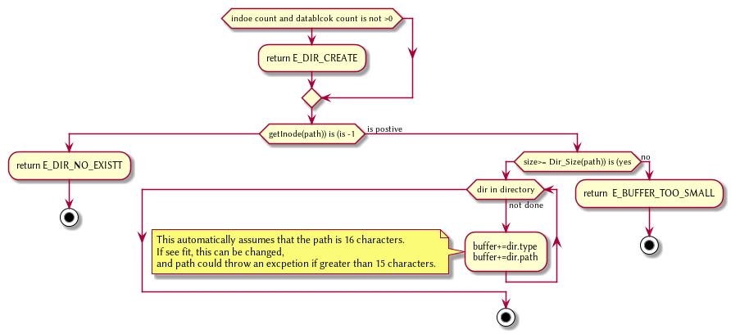
DirUnlink(string path)
Remove file from drive
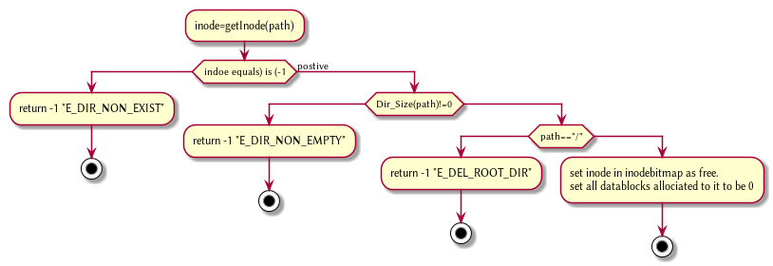

Disk [DISK]
DISKINIT()
Set all the data in the disk to be 0
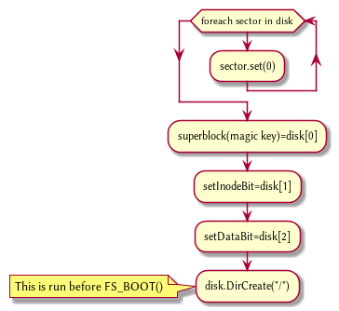
DISKLOAD()
Save external disk to workign disk. Done when booting.
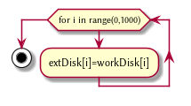
DISKSAVE()
Save working disk to loading. Called by FSSYNC()
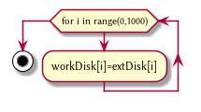
DISKWRITE(int sector, string buffer)
Write from buffer to disk.
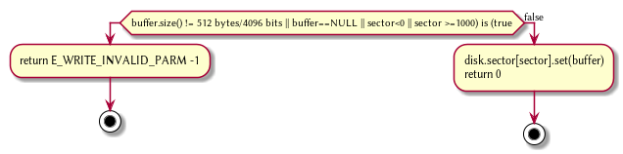
DISKRead(int sector, string buffer)
read from sector to buffer
