Name: | Hawaiza Siddiqui
UID No. | 2022701010
Batch: | D4 CSE DS
Subject: | DAA
Experiment No. | 1
Aim: | To implement the various functions e.g. linear, non-linear, quadratic, exponential etc.
Objectives: | 1) To understand time Complexity Notations.  2) How to represent time Complexity using Functions.

Theory: | - Time complexity: Time complexity is the measure of the amount of time an algorithm takes to run as a function of the size of its input. It's used to analyze the efficiency of algorithms and compare different algorithms for the same problem.  - Different notations in time complexities:  - Big O Notation: It provides an upper bound on the time required for an algorithm to run. It represents the maximum time an algorithm would take for the worst-case scenario.  - Big Omega Notation: It provides a lower bound on the time required for an algorithm to run. It represents the minimum time an algorithm would take for the best-case scenario.  - Big Theta Notation: It provides both upper and lower bounds on the time required for an algorithm to run. It represents the average time an algorithm would take for all cases.  - Little o Notation: It represents a tight upper bound on the time required for an algorithm to run.  - Little omega Notation: It represents a tight lower bound on the time required for an algorithm to run.  - Common Time Complexities :-  - O(1) - Constant time complexity.  - O(log n) - Logarithmic time complexity.  - O(n) - Linear time complexity.  - O(n log n) - Log-linear time complexity.  - O(n^2) - Quadratic time complexity.  - O(n^3) - Cubic time complexity.  - O(2^n) - Exponential time complexity.  - O(n!) - Factorial time complexity.  - O(n^k) - Polynomial time complexity, where k is a constant greater than 1  - O(k^n) - Exponential time complexity, where k is a constant greater than
Program: | #include<stdio.h>  #include<math.h>  int func1(int n){  return n;  }  double func2(int n){  return pow(2,n);  }  double func3(double n){  return log2(n);  }  double func4(double n){  return n*log2(n);  }  double func5(double n){  double a = log2(n);  return sqrt(a);  }  double func6(int n){  return round(pow((3.0/2.0),n));  }  int func7(int n){  return pow(n,3);  }  double func8(double n) {  return round(pow(2, log2(n)));  }  double func9(int n){  return n*(pow(2,n));  }  double func10(int n){  return log2(log2(n));  }  long long factorial(int n) {  if (n == 0) {  return 1;  }  return n * factorial(n-1);  }  int main(){  printf("\n\nFor function n: \n\n");  for(int n=0; n <= 100; n++){  printf("%d \t", n,func1(n));  }  printf("\n\nFor function 2^n: \n\n");  for(int n=0; n <= 100; n++){  printf("2^%d = %.2f \t\t", n,func2(n));  }  printf("\n\nFor function log2(n): \n\n");  for(int n=0; n <= 100; n++){  printf("log2(%d) = %.2f \t", n,func3(n));  }  printf("\n\nFor function n*log2(n): \n\n");  for(int n=0; n<=100; n++){  printf("%d.log2(%d) = %.1f \t\t\t\t", n,n,func4(n));  }  printf("\n\nFor function log2(n)^2: \n\n");  for(int n=0; n<=100; n++){  printf("log2(%d)^2 = %.2f \t\t\t\t", n,func5(n));  }  printf("\n\nFor function (3/2)^n: \n\n");  for(int n=0; n <= 100; n++){  printf("(3/2)^%d = %.2f \t\t", n,func6(n));  }  printf("\n\nFor function n^3: \n\n");  for(int n=0; n <= 100; n++){  printf("%d^3 = %d \t\t", n,func7(n));  }  printf("\n\nFor function 2^log2(n): \n\n");  for(int n=0; n <= 100; n++){  printf("2^log2(%d) = %.2f \t", n,func8(n));  }  printf("\n\nFor function n.2^n: \n\n");  for(int n=0; n<=100; n++){  printf("%d.2^%d = %.1f \t\t\t\t", n,n,func9(n));  }  printf("\n\nFor function log2(log2(n)): \n\n");  for(int n=0; n<=100; n++){  printf("log2(log2(%d)) = %.2f \t\t\t\t", n,func10(n));  }  printf("\n\nFor n!: \n\n");  for(int n = 0; n<=20; n++){  printf("%d! = %d \t", n,factorial(n));  }  }
Output: | Function n: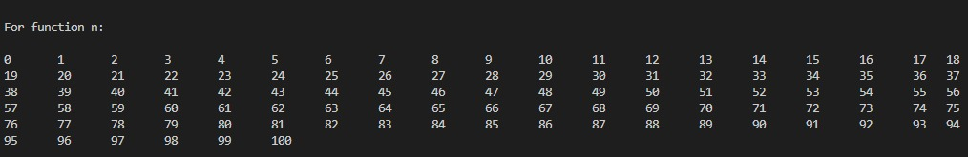  For function 2^n:  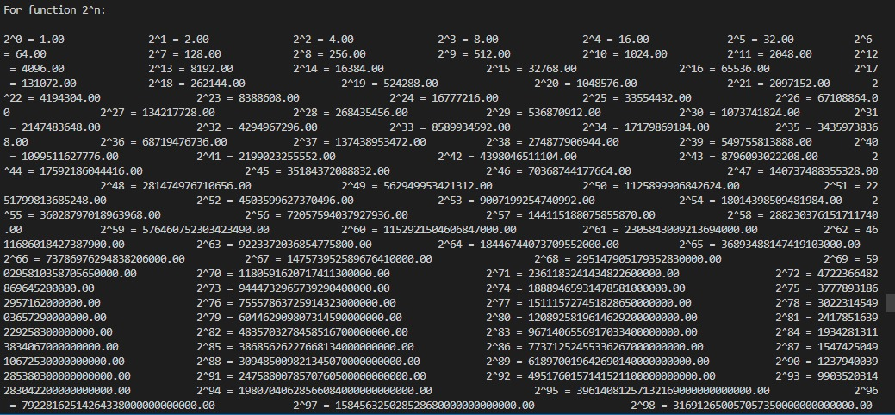  For function log2(n):  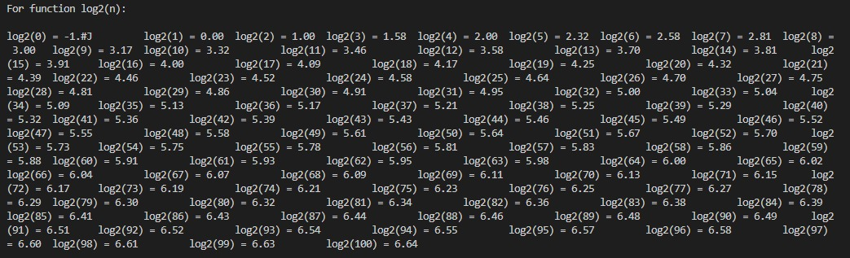  For function n*log2(n):  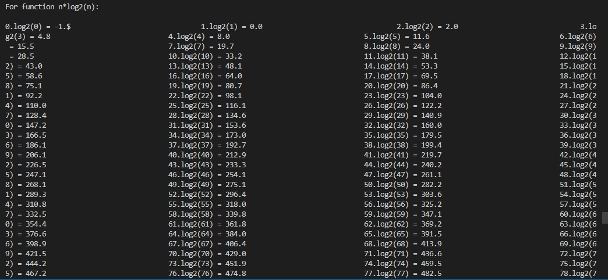  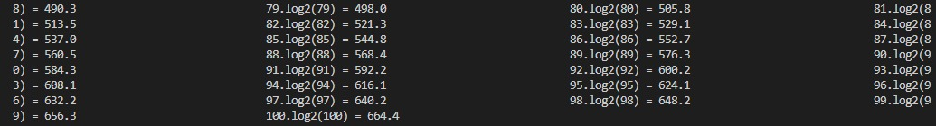  For function log2(n)^2:  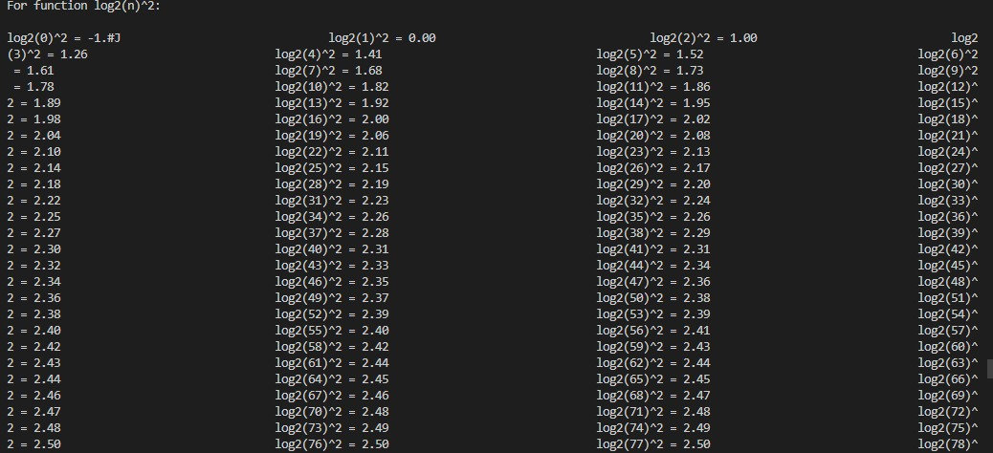  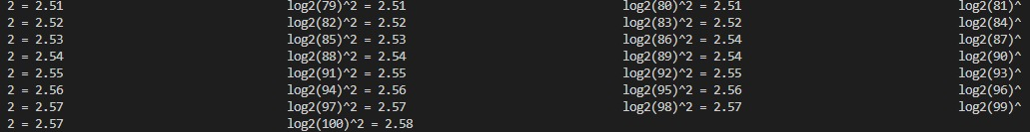  For function (3/2)^n:  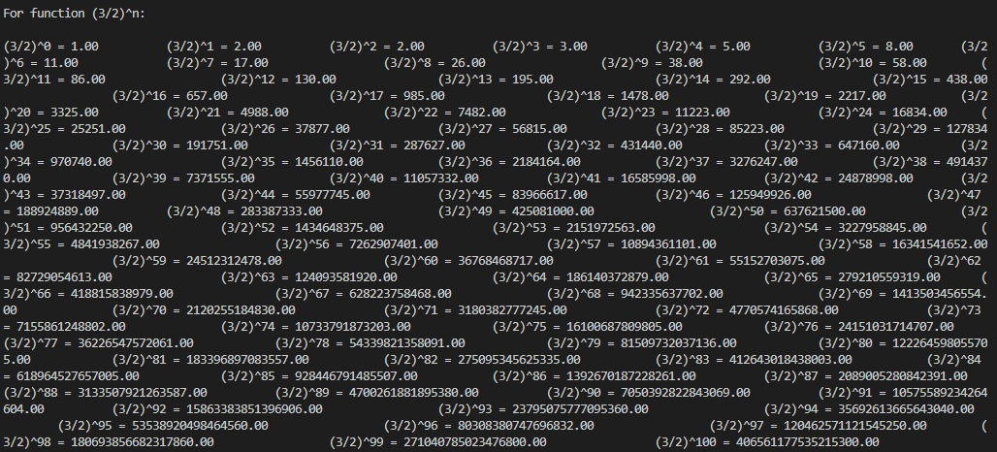  For function n^3:  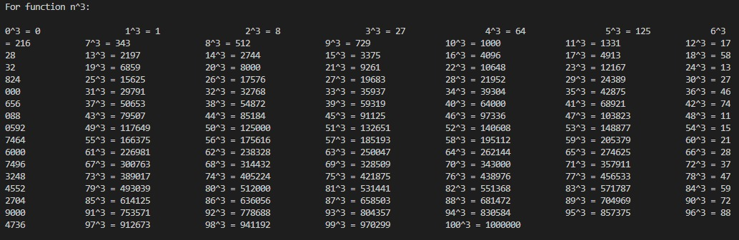  For function 2^log2(n):  For function n.2^n:  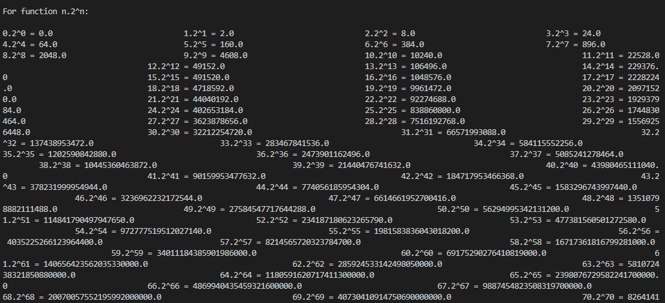  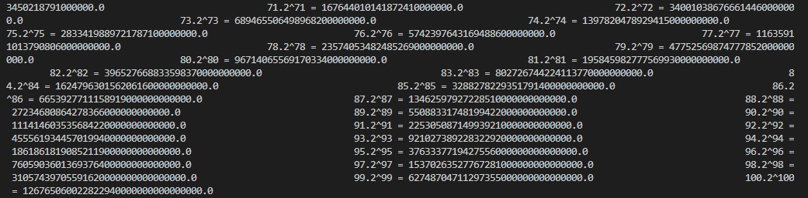  For function log2(log2(n)):  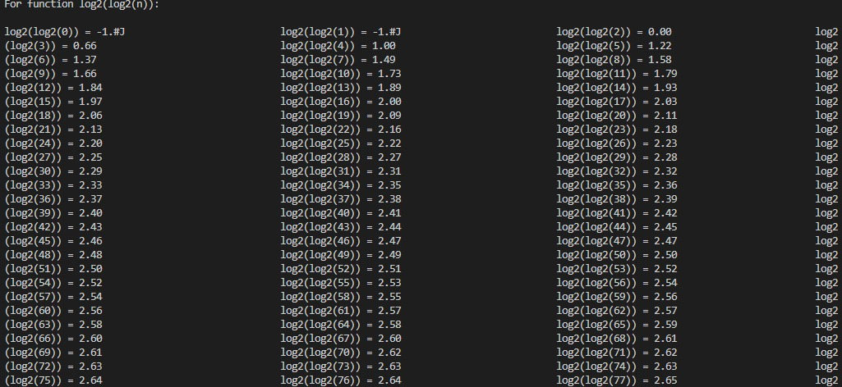  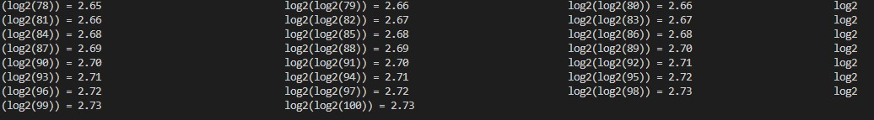  For function n!:
Excel Data: | 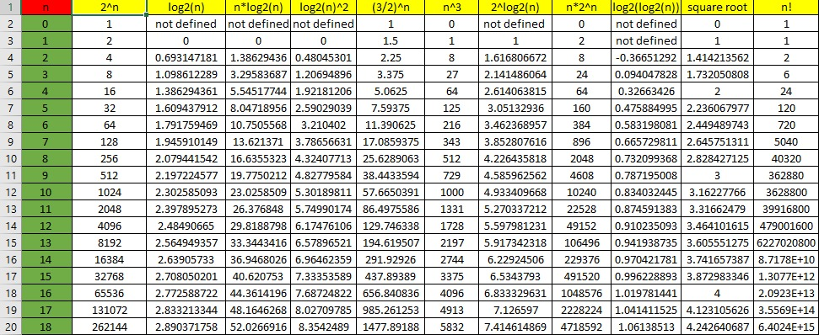  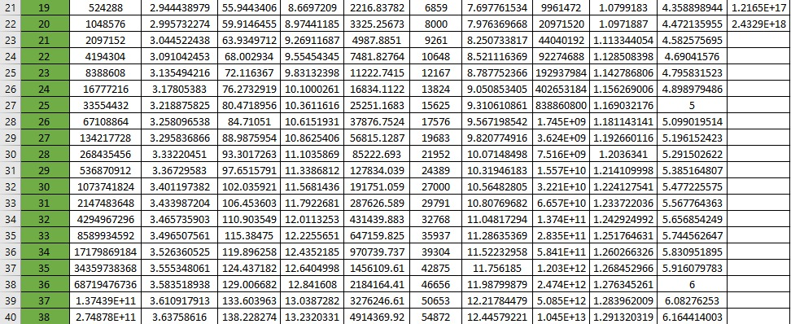  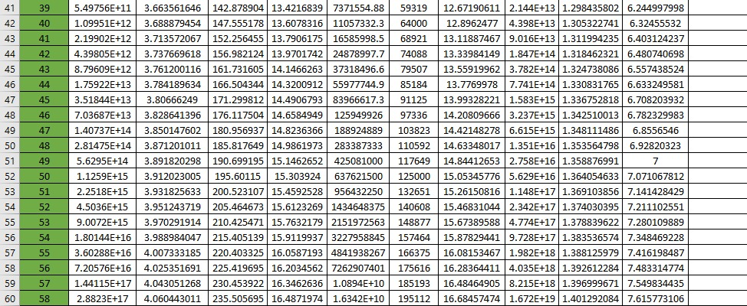  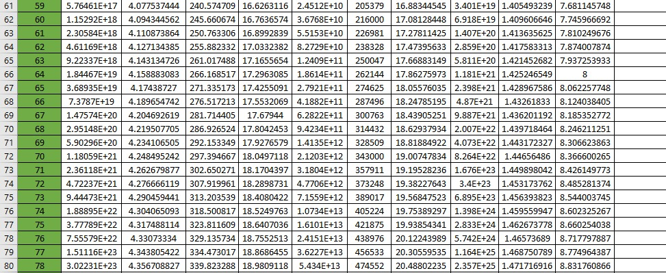  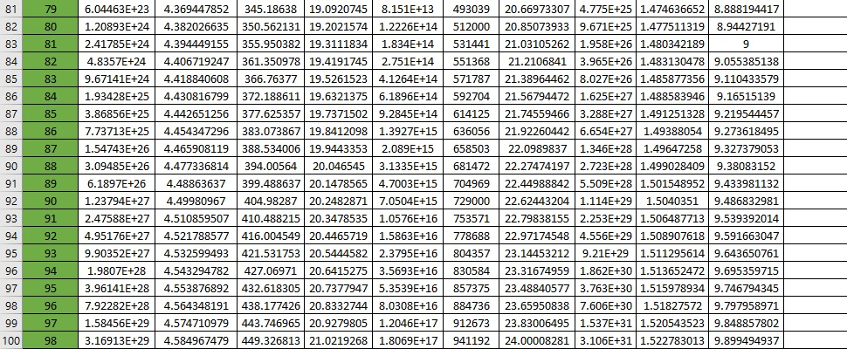
Graphs:  1. Function 2^n | 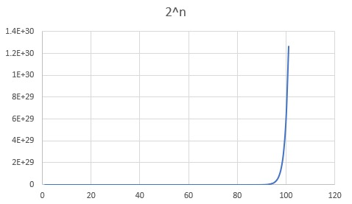
2. Function log2(n) | 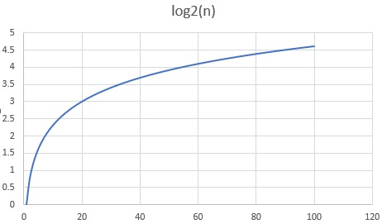
3. Function n*log2(n) | 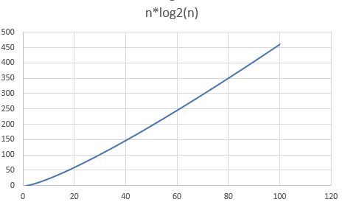
4. Function log2(n)^2 | 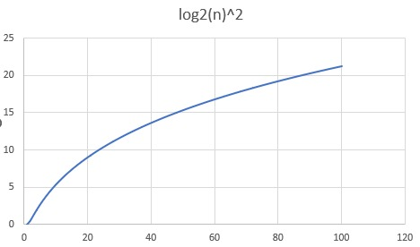
5. Function (3/2)^n | 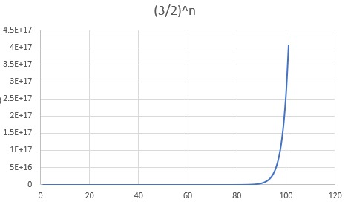
6. Function n^3 | 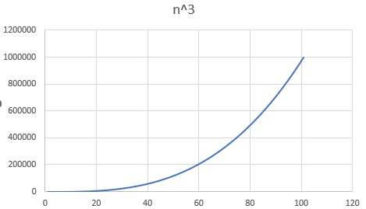
7. Function 2^log2(n)
8. Function n*2^n | 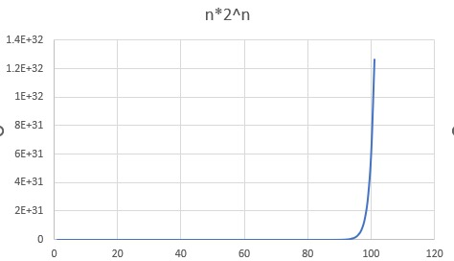
9. Function log2(log2(n))
10. Square Root
11. n! | 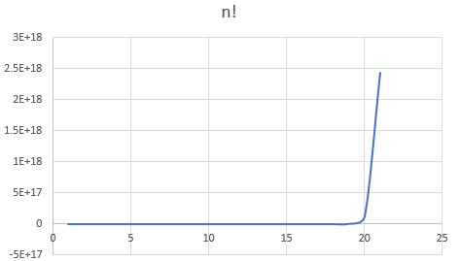
For all functions: | 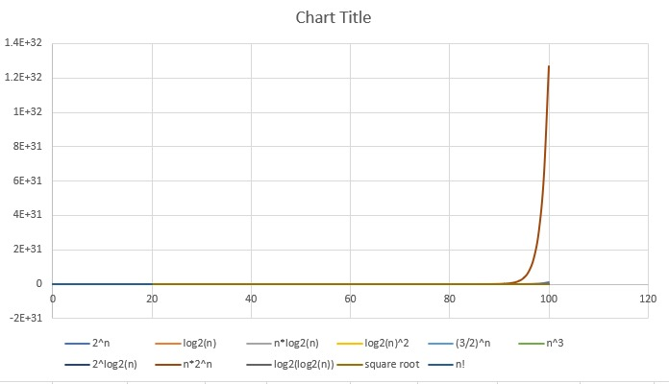
Conclusion: | I learnt about the representation of time complexities using functions and how the the output  values vary when we change one by one the input values

