

**Faculty of engineering - Shoubra**

**Benha University**

**Research Article / Research Project / Literature Review**

in fulfillment of the requirements of

|  |  |
| --- | --- |
| **Department** | **Engineering Mathematics and Physics** |
| **Division** | **-----------------** |
| **Academic Year** | **2019-2020 Preparatory** |
| **Course name** | **Computer** |
| **Course code** | **ECE006** |

**Title: -**

**Report of website on Artificial Intelligence**

By:

|  |  |  |  |
| --- | --- | --- | --- |
|  | Name | Edu mail | B.N |
| 1 | محمود محمد احمد محمد حواره | mahmoud195960@feng.bu.edu.eg | 1184 |

**Approved by:**

|  |  |
| --- | --- |
| Examiners committee | Signature |
| Dr.Ahmed Bayoumi |  |
| Dr.Shady Elmashad |  |
| Dr. Abdelhamid Attaby |  |

**Table of contents**

|  |  |
| --- | --- |
| **Subject / section** | **Page** |
| List of Figures | 2 |
| Application brief | 3-4 |
| Screen shoots | 5-10 |

**List of Figures**

|  |  |  |
| --- | --- | --- |
| **Figure I.D** | **Description** | **Page** |
| Fig.1 | Web page 1 | 5 |
| Fig.2 | Source code of web page 1 | 5 |
| Fig.3 | Web page 2 | 6 |
| Fig.4 | Source code of web page 2 | 6 |
| Fig.5 | Web page 3 | 7 |
| Fig.6 | Source code of web page 3 | 7 |
| Fig.7 | Web page 4 | 8 |
| Fig.8 | Source code of web page 4 | 8 |
| Fig.9 | Web page 5 | 9 |
| Fig.10 | Source code of web page 5 | 10 |

**Application brief**

Artificial intelligence is one of Computer Science’s fascinating and universal fields which will have a great future reach. AI is going to allow a computer to act as a human being.

Artificial Intelligence consists of two terms Artificial and Intelligence, in which Artificial defines "man-made" and Intelligence defines "thinking power," While AI implies "man-made thought power."

Thus, we may describe AI as:

Artificial intelligence occurs when a computer may acquire human skills such as understanding, reasoning , and problem solving You don't need to pre-program a computer with Artificial Intelligence to do any research, given the fact that you can build a computer with programmed algorithms that can research with your own intelligence, and that's the awesomeness of AI.

It is believed that AI is not a new technology, and some people says that as per Greek myth, there were Mechanical men in early days which can work and behave like humans.

Artificial intelligence has many goals like:

* Build Expert Systems .
* Applying human intelligence in machines.

Now, Artificial intelligence is used in many applications such as:

* Natural Language Processing.
* Expert Systems.
* Vision Systems.
* Speech Recognition .
* Handwriting Recognition
* Intelligent Robots.
* Gaming.

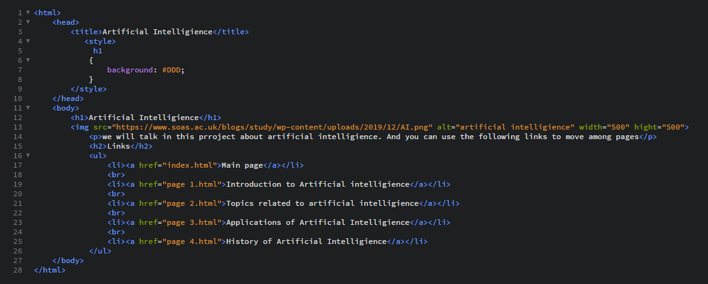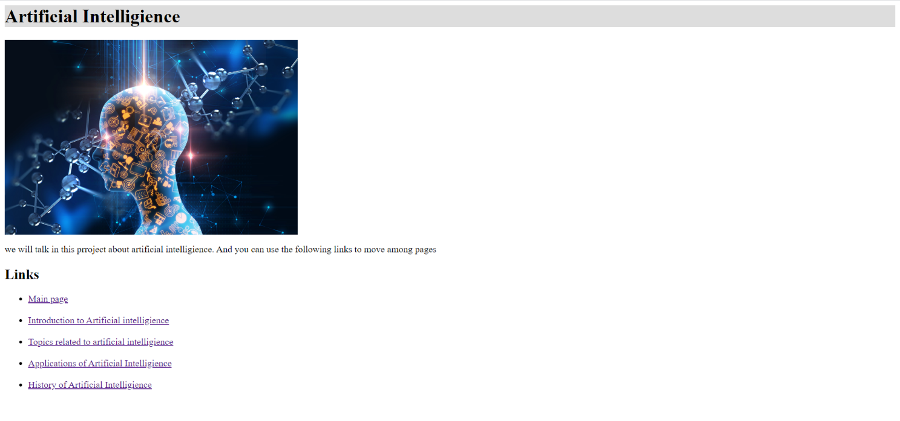Screen shoots

**Fig.2**

**rt**

**Fig.1**

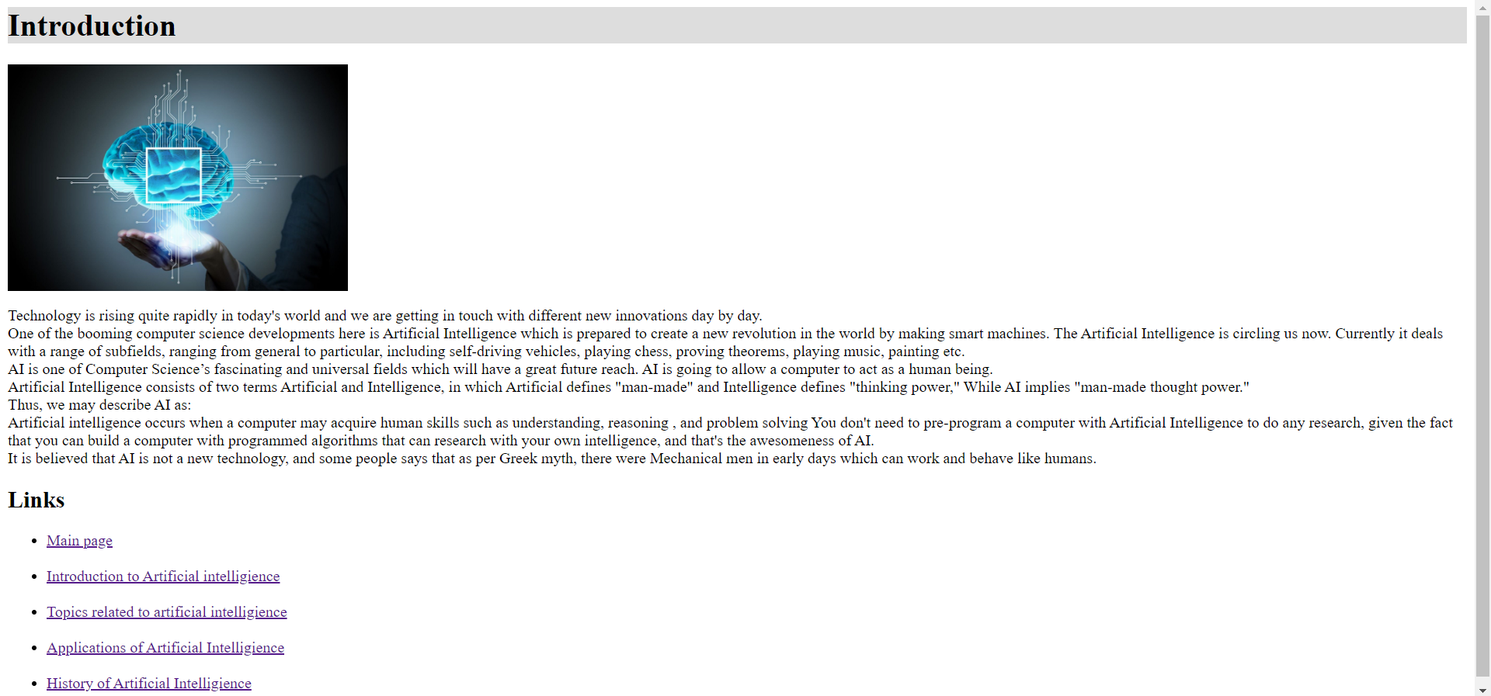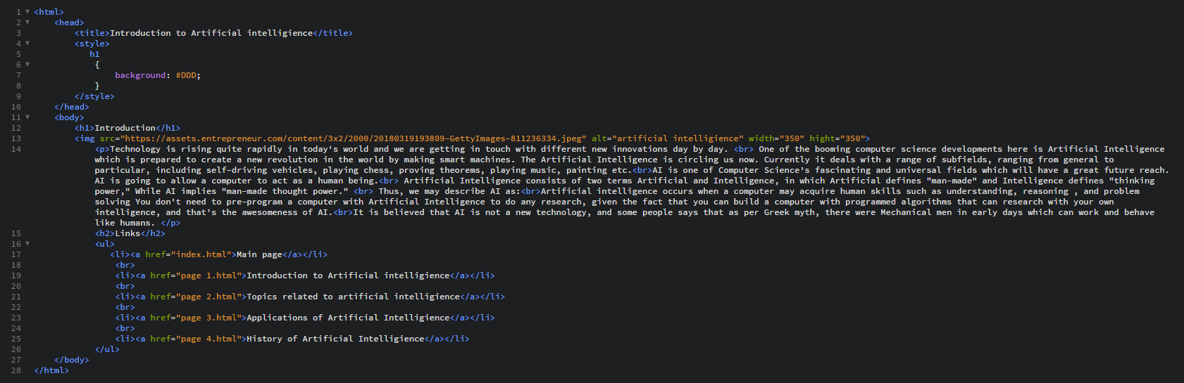

**Fig.3**

**Fig.4**

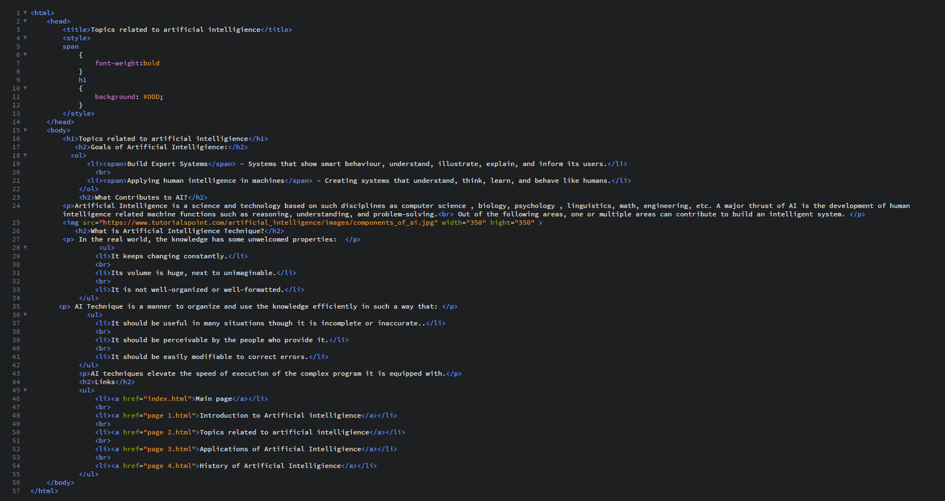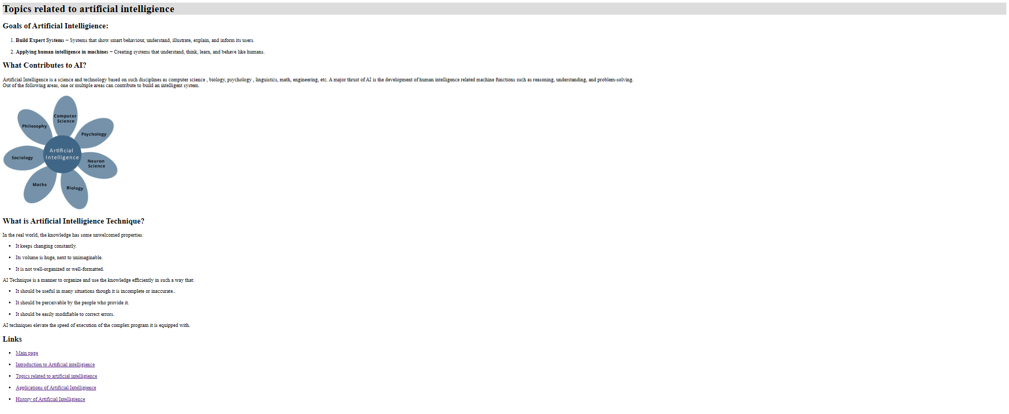

**Fig.6**

**Fig.5**

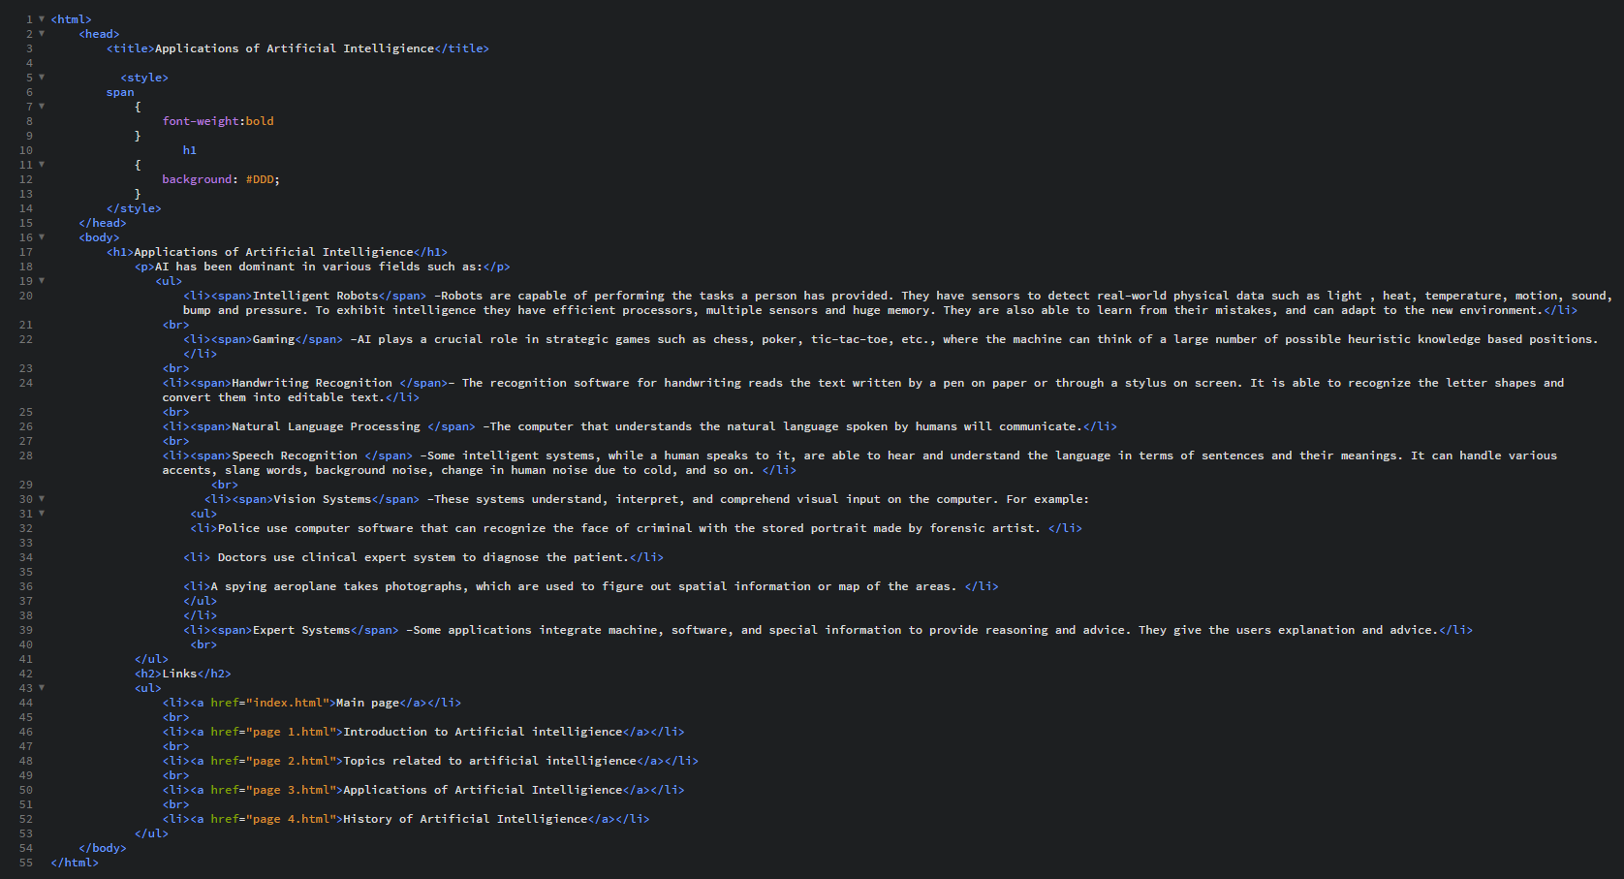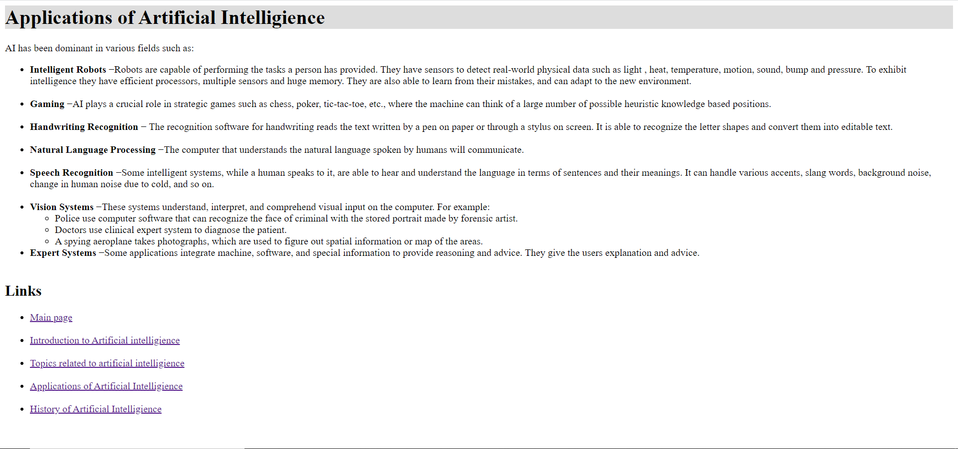

**Fig.8**

**Fig.7**

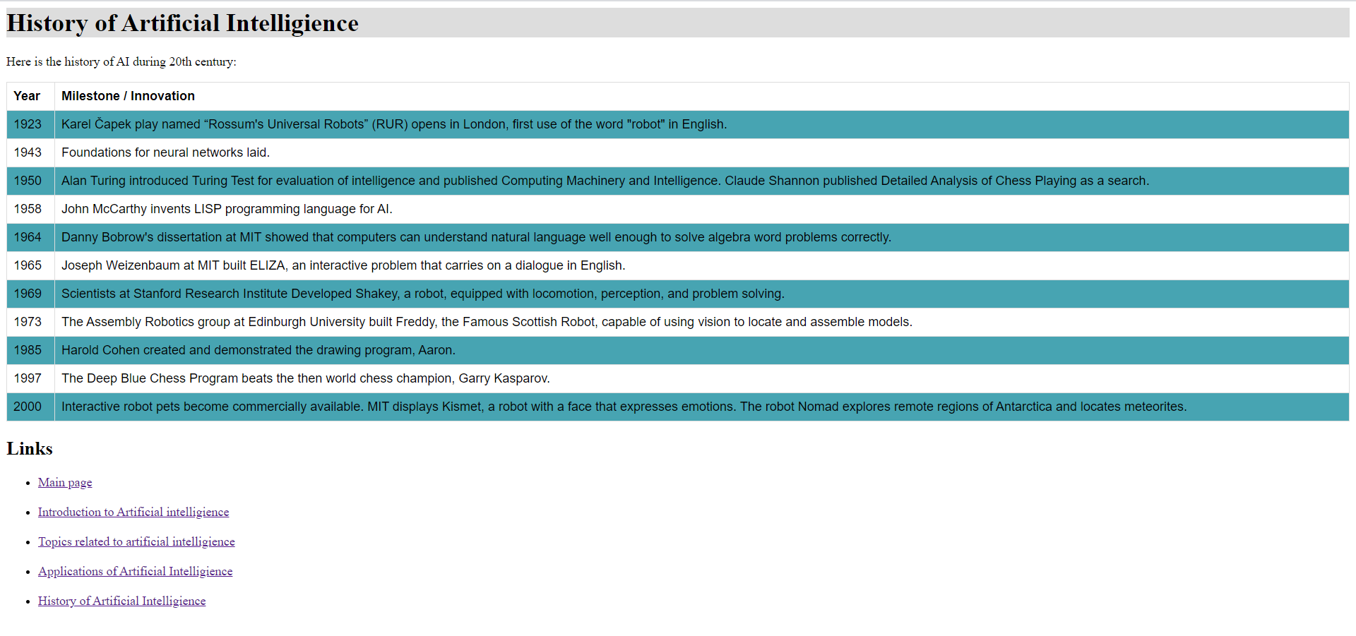

**Fig.9**

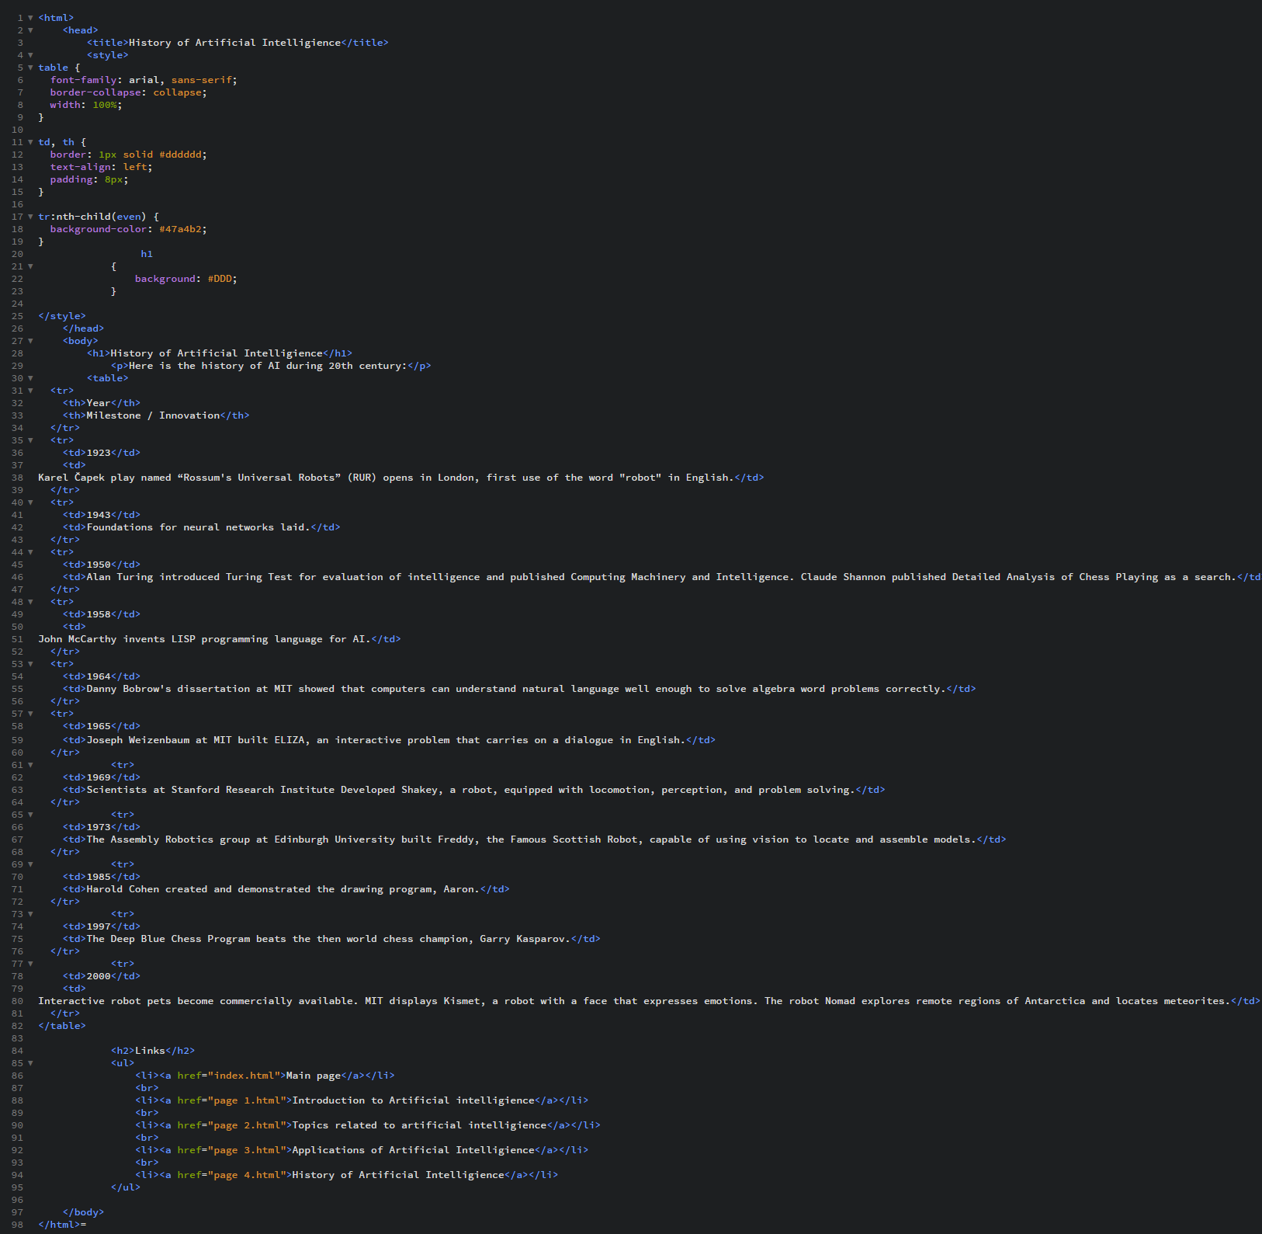

**Fig.10**