ST2195 Programming for Data Science
Coursework 2 - Part 2
US Flight Data Analysis (2004-2008)

Data Source: Harvard Dataverse (DOI: 10.7910/DVN/HG7NV7)
Tools: Python (Jupyter Notebook) and R (RMarkdown)
Jaimurugaesan Ramesh Babu
240635200

Table of Contents
1. Introduction 3
2. Question A: Best Times to Minimize Flight Delays 4
2.1 Methodology 4
2.2 Results 4
2.3 Key Findings 4
3. Question B: Aircraft Age and Flight Delays 5
3.1 Methodology 5
3.2 Results 5
3.3 Key Findings 5
4. Question C: Predicting Flight Diversions 6
4.1 Problem Statement 6
4.2 Methodology 6
4.3 Results 6
4.4 Implementation Differences: R vs Python 7
4.5 Model Performance and Limitations 8
6. References 9

1. Introduction

US domestic flight data from 2004 to 2008, sourced from the ASA Data Expo, forms the basis of this report. The dataset contains millions of records covering delays, diversions, aircraft characteristics, and carrier operations. Three questions guide the analysis: which times and days minimize arrival delays; whether older aircraft experience more delays; and whether flight diversions can be predicted before departure. All processing and statistical analysis were performed in both R and Python to cross-check results.
Supplementary files include annual flight records (2004.csv–2008.csv), aircraft manufacturing data (plane-data.csv), carrier details (carriers.csv), and airport coordinates (airports.csv). Cancelled flights were excluded from delay calculations, and missing manufacturing years were imputed using the dataset median.

2. Question A: Best Times to Minimize Flight Delays

2.1 Methodology
Arrival delays were analyzed across all combinations of day-of-week and departure hour, with cancelled flights excluded. The departure hour came from scheduled departure time, grouped into 24 hourly slots (00:00–23:00). Average arrival delay was calculated for each day-hour combination, year by year. Processing each year separately shows whether delay patterns held across time or shifted.

2.2 Results
Figure 1 shows heatmaps of average arrival delay by day of week and departure hour for each year (green = low delay, red = high delay). The star marks the single lowest-delay slot per year.
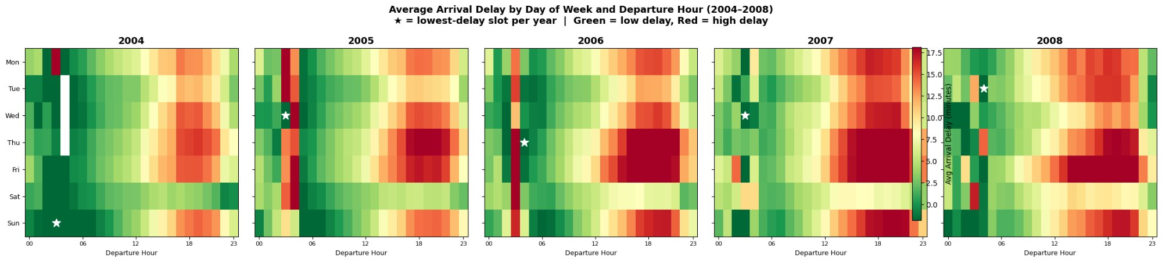
Figure 1. Average arrival delay by day of week and departure hour (2004–2008). Star = lowest-delay slot per year.
Early morning departures on Tuesdays and Wednesdays consistently show the lowest delays—sometimes arriving ahead of schedule. Thursday and Friday evenings between 18:00 and 21:00 are the worst: delays stack from the day's earlier disruptions and peak demand.

2.3 Key Findings
Flying around 06:00 on a Tuesday or Wednesday gives the best shot at an on-time arrival. The system is uncongested early in the day, and disruptions haven't had time to propagate through the network. Evenings on Thursday and Friday are the opposite—the worst windows across all five years. This pattern is stable enough that it likely reflects how the network is structured, not any particular year's conditions.

3. Question B: Aircraft Age and Flight Delays

3.1 Methodology
Aircraft age was calculated as flight year minus manufacturing year from the plane registry, clipped to 0–80 years. Flights with missing tail numbers were assigned the dataset's median manufacturing year. Flights were grouped into six age brackets (0–5, 5–10, 10–15, 15–20, 20–25, 25+ years) and average delay was computed per group per year. Pearson correlation between exact plane age and arrival delay was also calculated using a random 100,000-flight sample per year to keep computation manageable.

3.2 Results
Correlations between plane age and arrival delay sit between 0.01 and 0.02 across all years. Plane age explains less than 0.04% of delay variation. Technically the relationship is positive—older planes average slightly higher delays—but the effect is too small to matter in practice. Delay differences between the youngest and oldest aircraft are small compared to year-on-year shifts in overall delay levels.
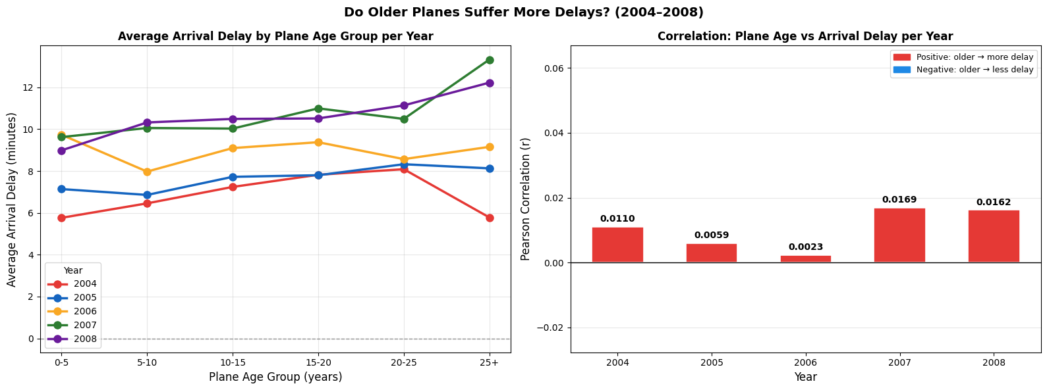
Figure 2: Combined Panel - Delay by Age Group (left) and Correlation Values (right).

3.3 Key Findings
Aircraft age barely affects delays. A correlation of 0.01–0.02 means knowing a plane's age tells you almost nothing about whether your flight will be late. Carrier identity and route characteristics are far stronger drivers. A well-run airline on a short route will typically outperform a poorly managed carrier on a busy hub regardless of how old the aircraft is.

4. Question C: Predicting Flight Diversions

4.1 Problem Statement
Diversions—when an aircraft lands somewhere other than its planned destination—are rare but operationally disruptive. The goal is to predict them using only pre-departure information. Two problems make this hard. First, diversions account for under 0.3% of all flights, so a model that simply predicts "no diversion" every time is technically accurate but useless. Second, variables like weather delays and actual arrival times aren't known until a flight has landed, so they can't be used at prediction time.

4.2 Methodology
A logistic regression model was trained on roughly 4 million flights from 2004–2007 (1 million per year) and evaluated on held-out 2008 data. All diverted flights were retained; non-diverted flights were randomly downsampled. Balanced class weights were applied to stop the majority class from dominating training.
Fourteen features were used: eleven numeric (ArrHour, DayofMonth, DayOfWeek, DepHour, Dest_Lat, Dest_Lon, Distance, Month, Origin_Lat, Origin_Lon, PlaneAge) and three categorical (Dest_State, Origin_State, UniqueCarrier). Numeric features were standardized; categoricals were one-hot encoded. Ridge regularization was applied, and separate models were fitted for each year to track how feature importance shifted over time. All post-flight variables were excluded.

4.3 Results
Figure 3 shows the ROC curve for the model's performance on the 2008 test set. The curve plots true positive rate against false positive rate across all decision thresholds.
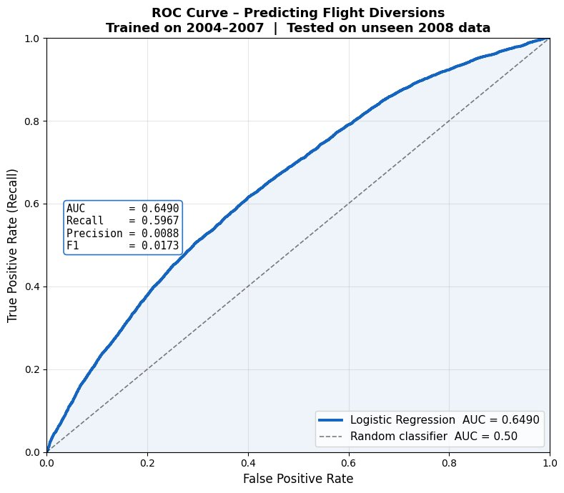

Figure 3. ROC curve for the logistic regression model predicting flight diversions. Trained on 2004–2007; tested on unseen 2008 data. AUC = 0.649.
An AUC of 0.649 is about 30% above random guessing (AUC = 0.50). That sounds modest, but is reasonable: the model has no access to weather data, which is the primary driver of most diversions. Precision (0.0088) and F1 (0.0173) are low by design—when the positive class is 0.3% of all flights, even a well-calibrated model produces more false alarms than true positives at most thresholds. AUC is the right metric here because it measures ranking ability across all thresholds rather than fixing a single cutoff.
Figure 4 shows the logistic regression carrier coefficients from 2004 to 2008. Carriers are sorted by mean diversion tendency (highest to lowest). Red cells indicate higher diversion probability; blue cells indicate lower probability.
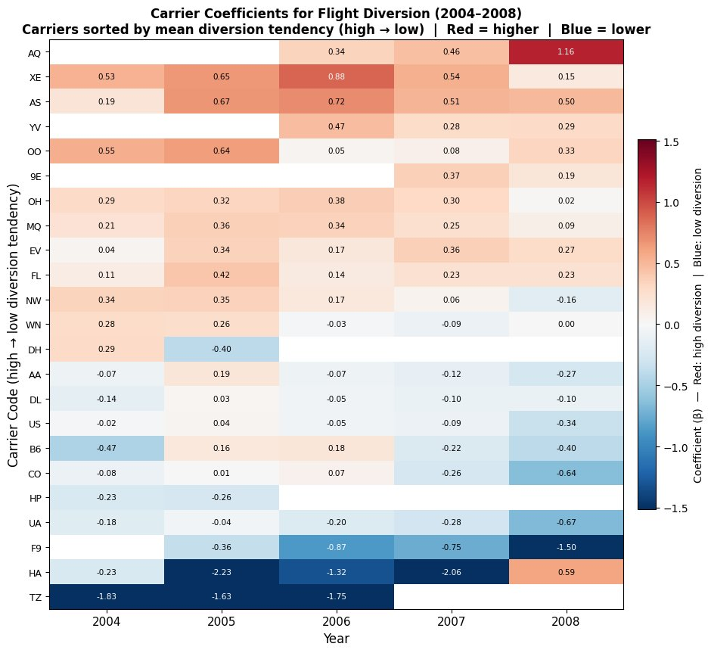

Figure 4. Carrier coefficients for flight diversion prediction (2004–2008). Sorted by mean diversion tendency, high to low. Red = higher diversion tendency; blue = lower.
Distance is the strongest and most consistent numeric predictor across all five years. Longer flights traverse more airspace and face a wider range of weather systems. PlaneAge coefficients are near zero every year, consistent with the findings in Question B. Among carriers, AQ, XE, and AS show persistently high diversion coefficients, while TZ, HA, and F9 are consistently negative.

4.4 Implementation Differences: R vs Python
R uses glmnet with ridge regression; Python uses scikit-learn's LogisticRegression with a different solver. The two methods use different optimization algorithms and see slightly different random samples, so coefficient values differ by small amounts. Both produce the same story: Distance is the main predictor, PlaneAge is irrelevant, and AUC lands around 0.65. Questions A and B give identical results in both languages because averages and correlations are deterministic.
Testing 5 million vs 1 million training samples per year made no meaningful difference. Diversions are rare enough that once the model has seen sufficient examples, adding more non-diverted flights changes little.

4.5 Model Performance and Limitations
The model correctly identifies Distance as the dominant predictor and beats random guessing. The ceiling is real, though. Weather visibility, wind, precipitation, thunderstorms drives most diversions, and none of that is in the model. With weather data, AUC could plausibly reach 0.80 or higher. Low precision and F1 are expected consequences of the class imbalance, not signs the model is broken.
Feature importance also shifts year to year as airlines change routes, merge, or adjust operations. A production deployment would need periodic retraining to stay current.

5. Conclusion

Three findings stand out. First, when you fly matters. Early Tuesday or Wednesday mornings are consistently the lowest-delay windows across all five years; Thursday and Friday evenings are consistently the worst. The pattern is stable enough to reflect the underlying structure of the US aviation network.
Second, aircraft age is essentially irrelevant. The correlation between age and arrival delay is 0.01–0.02—too weak to be practically useful. Carrier identity and route characteristics explain far more of the variation in delays and diversions than airframe age does.
Third, flight distance is the strongest pre-departure predictor of diversion risk. The logistic regression model achieved an AUC of approximately 0.65 on unseen 2008 data, showing genuine predictive ability despite the absence of weather information. Integrating real-time forecasts would likely push that substantially higher.
R and Python produced the same conclusions despite slightly different coefficient values, confirming that both languages are suitable for this type of large-scale flight data analysis.

6. References

ASA Data Expo. (2009). Airline on-time performance. American Statistical Association. http://stat-computing.org/dataexpo/2009/
Friedman, J., Hastie, T., & Tibshirani, R. (2010). Regularization paths for generalized linear models via coordinate descent. Journal of Statistical Software, 33(1), 1–22.
Kuhn, M., & Johnson, K. (2013). Applied predictive modeling. Springer.
Pedregosa, F., et al. (2011). Scikit-learn: Machine learning in Python. Journal of Machine Learning Research, 12, 2825–2830.
R Core Team. (2024). R: A language and environment for statistical computing. R Foundation for Statistical Computing.
Robin, X., et al. (2011). pROC: An open-source package for R and S+ to analyze and compare ROC curves. BMC Bioinformatics, 12(1), 77.
Wickham, H. (2016). ggplot2: Elegant graphics for data analysis (2nd ed.). Springer.

