Grazioso Salvare Animal Shelter Dashboard

An interactive full-stack web application designed for Grazioso Salvare, an international rescue animal training company. This project provides a streamlined interface to identify and categorize shelter dogs suitable for search-and-rescue training (Water Rescue, Mountain/Wilderness Rescue, and Disaster Tracking) using data from the Austin Animal Center.

Project Functionality
The application allows users to filter through a vast database of animal records to find specific candidates for training programs based on breed, age, and sex.

Core Features:
- Interactive Filtering: Custom dropdown options to filter dogs based on specific rescue profiles (Water, Mountain, and Disaster tracking).
- Dynamic Data Table: A responsive table that updates in real-time based on filters, featuring pagination and sorting.
- Geolocation Mapping: A Leaflet-based map that displays the specific location of a selected animal from the data table.
- Data Visualization: A pie chart that dynamically visualizes the distribution of breeds within the current filtered view.

Dashboard States
- Default/Reset State:
The starting view showing the Grazioso Salvare logo, the full unfiltered dataset, and initialized charts.
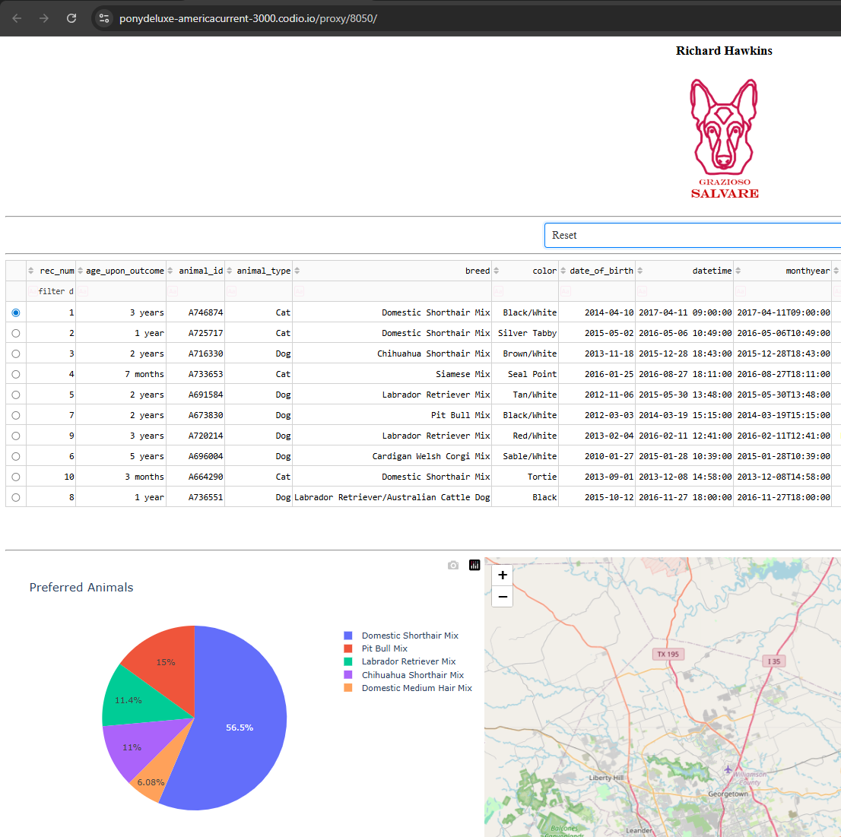

- Water Rescue Filter:
Shows candidates such as Labrador Retrievers, Chesapeake Bay Retrievers, and Newfoundlands.
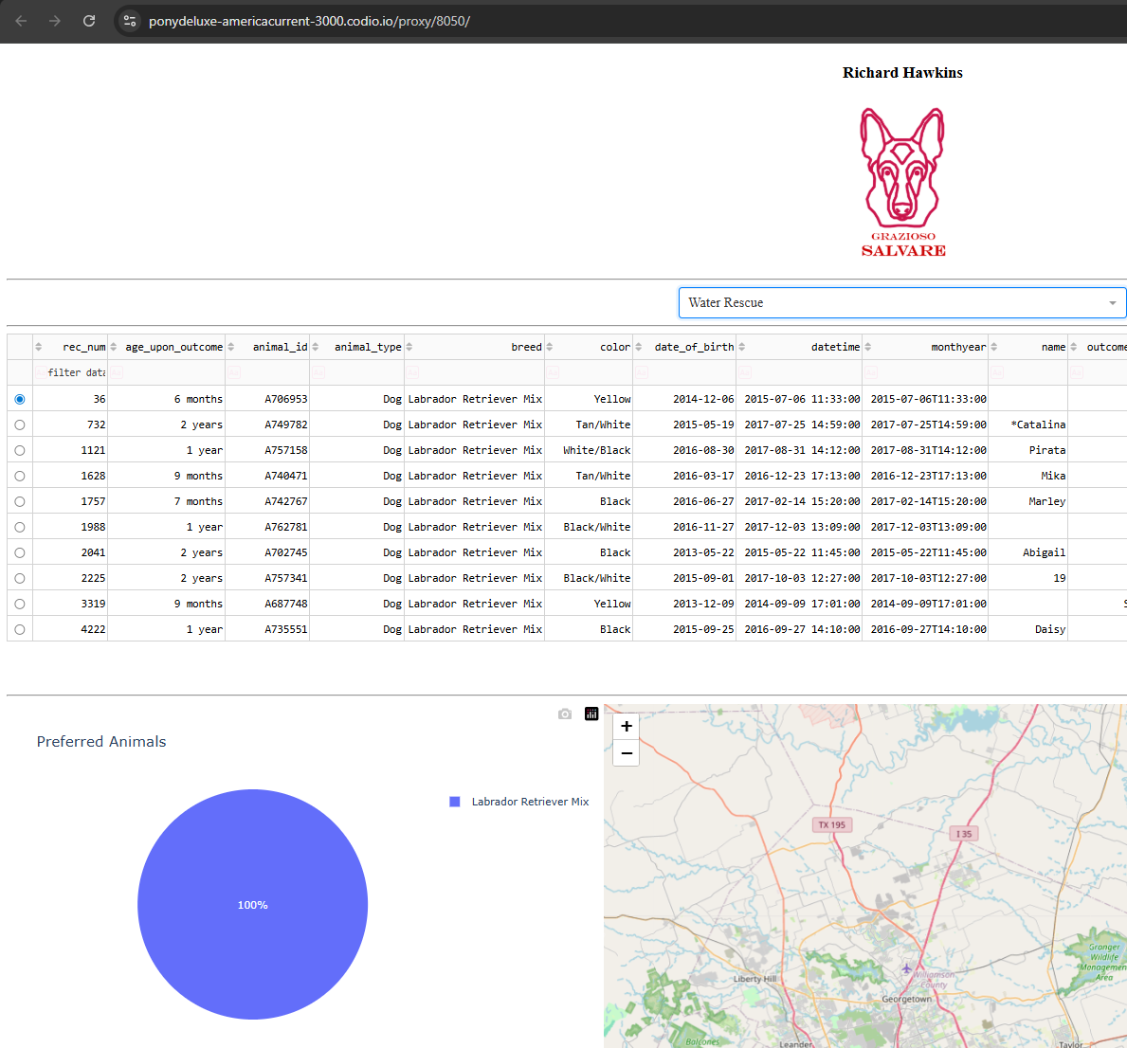

- Mountain or Wilderness Rescue Filter:
Filters for breeds like German Shepherds, Alaskan Malamutes, and Siberian Huskies.
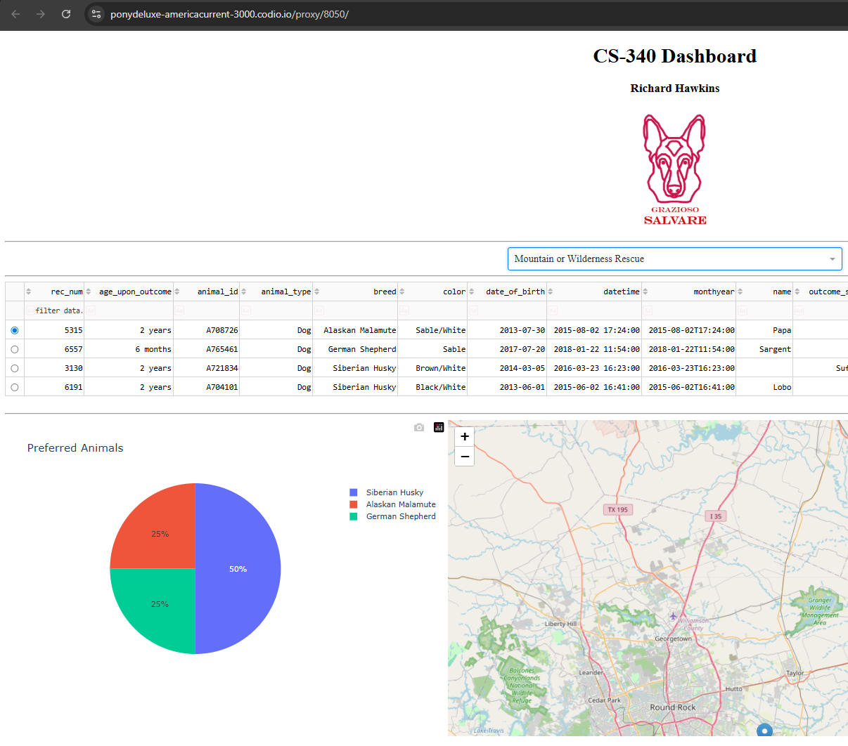

- Disaster or Individual Tracking Filter:
Displays candidates such as Doberman Pinschers, Rottweilers, and Bloodhounds.
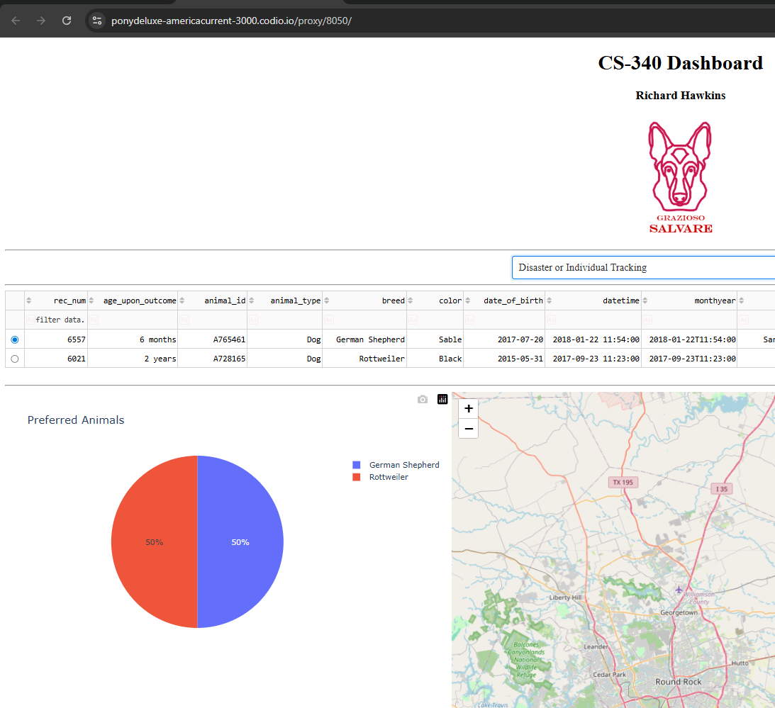

Tools and Rationale
Model: MongoDB/PyMongo
MongoDB was selected as the database for this project due to its document-oriented structure.
- Schema Flexibility: Animal records often contain varying attributes; MongoDB’s BSON format allows for semi-structured data without rigid schema constraints.
- Python Integration: The pymongo library provides a robust, native interface for Python, making CRUD (Create, Read, Update, Delete) operations seamless and efficient.

View & Controller: Dash
Dash was utilized to build the web interface and handle the application logic.
- Python-Centric: Dash allows for the creation of web applications entirely in Python, removing the need for separate JavaScript or HTML/CSS management.
- Reactive Framework: The callback system in Dash provides a way to link UI components (Controller) to the data (Model) and visuals (View), fulfilling the MVC design pattern.

Libraries Used:
- Pandas: For data manipulation and converting MongoDB cursors into dataframes.
- Dash Leaflet: For interactive geolocation mapping.
- Plotly Express: For generating responsive charts and graphs.

Getting Started
Prerequisites
- Python 3.11+
- MongoDB 7.0+
- Dependencies: run the command: “pip install pymongo pandas dash jupyter-dash dash-leaflet plotly” to download and install all python package dependencies.

Database Setup
- Import Data: Import the Austin Animal Center CSV data into your local MongoDB instance by running: “mongoimport --db aac --collection animals --type csv --headerline --file aac_shelter_outcomes.csv”
- Create User: In the MongoDB shell, create the application user by running:
use admin
db.createUser({
user: "aacuser",
pwd: "aacUserPassword",
roles: [{ role: "readWrite", db: "aac" }]
})

Running the Application
- Ensure CRUD_Python_Module.py is in the same directory as the dashboard.
- Open ProjectTwoDashboard.ipynb and run all cells.
- Access the dashboard via the local URL provided by the Dash server output.

Development Process and Challenges
Steps Taken:
- CRUD Module Development: Created a standalone Python class (AnimalShelter) to encapsulate MongoDB logic, ensuring the database could be easily swapped or updated without affecting the UI.
- UI Design: Implemented a clean, user-friendly layout featuring the Grazioso Salvare branding.
- Integration: Linked the Dash callbacks to the CRUD module, translating UI selections into specific MongoDB queries.

Challenges & Solutions:
- Data Type Compatibility: MongoDB’s _id field (“ObjectID”) is not natively JSON-serializable by Dash.
  - Solution: Implemented a dataframe drop (“df.drop(columns=['_id'])”) within the read method to ensure compatibility with the DataTable component.
- Map Responsiveness: Initial maps did not center correctly on new selections.
  - Solution: Integrated “derived_virtual_selected_rows” to track user interaction accurately and update the Leaflet map center dynamically.

