Default and Risk Analysis of an Auto Loan Portfolio
Adrian
Professional Data Analytics Portfolio
Business Intelligence Project
September 20, 2026

Abstract
This project examines 233,154 auto loans to identify portfolio segments that require closer monitoring from a loan servicing and collections perspective. The analysis focuses on five operational variables: disbursed amount, loan-to-value ratio, credit score, recent delinquency, and geographic location. The portfolio recorded an overall default rate of 21.7%. Loans with an LTV between 80% and 90% reached 25.9%, while customers with a delinquent account during the previous six months reached 27.1%. The 301-600 credit-score group also recorded 27.1%. These results support simple monitoring rules before predictive modeling is considered. The scope is descriptive because the dataset does not contain monthly payment history, days past due, promises to pay, cure rate, roll rate, recoveries, charge-off events, or total-loss events.
Keywords: auto loans, default, loan servicing, collections, business intelligence

Default and Risk Analysis of an Auto Loan Portfolio
The purpose of this project was to turn an auto loan dataset into information that a servicing or collections team could interpret. I did not attempt to build a complex prediction model. The project demonstrates a reproducible business intelligence process: clean the data, define understandable segments, calculate portfolio metrics, test differences, and translate the results into operational recommendations.
The main question was which borrower and loan characteristics separate accounts with an above-average default rate. The analysis therefore considered loan-to-value ratio (LTV), credit score, recent delinquency, employment type, and geographic distribution.

Method

Data Source
The analysis uses the Vehicle Loan Default Prediction dataset published on Kaggle (Paul, n.d.). The training file contains 233,154 records and 41 fields. Each record represents one loan, and LOAN_DEFAULT indicates whether the account ended in default. The repository does not redistribute the original file. It provides manual download instructions and retains only aggregated outputs created by the analysis.

Data Preparation and Analysis
Column names were standardized, while LTV and credit score were grouped into ranges that a business reader could interpret. Recent delinquency was converted into a binary indicator based on whether the customer had a delinquent account during the previous six months. Loan volume, disbursed amount, average LTV, and default rate were calculated for each segment. Python produced the analysis and dashboard, and SQL queries replicated the principal portfolio metrics.

Results

Portfolio Overview
The portfolio contains 233,154 loans and 12.67 billion in total disbursed amount, measured in the dataset's unspecified currency. Average LTV is 74.7%, and the overall default rate is 21.7%. This rate serves as the baseline for every segment comparison.
Table 1
Summary of the Main Portfolio Segments
Segment | Loans | Default | Difference
Full portfolio | 233,154 | 21.7% | Baseline
80%-90% LTV | 81,005 | 25.9% | +4.2 pp
Recent delinquency | 18,195 | 27.1% | +5.4 pp
301-600 credit score | 18,716 | 27.1% | +5.4 pp
751-900 credit score | 25,682 | 14.7% | -7.0 pp
State 13 | 17,884 | 30.7% | +9.0 pp

Loan to Value Ratio
Default increased from 13.9% among loans at or below 60% LTV to 25.9% in the 80%-90% band. The segment above 90% recorded 20.6%, but it contains only 883 loans. I therefore did not treat the relationship as perfectly linear. The operationally useful finding is that the 80%-90% band combines an elevated default rate with 81,005 accounts, creating greater exposure than the much smaller group above 90%.

Credit Score
Customers scoring 301-600 recorded the highest default rate at 27.1%. The 1-300 group reached 25.2%, and borrowers without a score reached 23.1%. Customers scoring 751-900 had the lowest rate at 14.7%. The no-score group should not be treated only as missing data because it contains 116,950 loans and performs worse than the portfolio baseline.

Recent Delinquency
Customers with at least one delinquent account during the previous six months recorded a 27.1% default rate. Customers without recent delinquency recorded 21.3%. The 5.8 percentage-point difference supports the use of recent delinquency as a straightforward early-monitoring criterion.

Geographic Distribution
Among states with at least 1,000 loans, State 13 had the highest default rate at 30.7% across 17,884 accounts. This result does not show that location causes default. It identifies a region that combines meaningful volume with above-average risk and therefore deserves further review before collections capacity is allocated.

Figure 1
Auto Loan Portfolio Default and Risk Overview
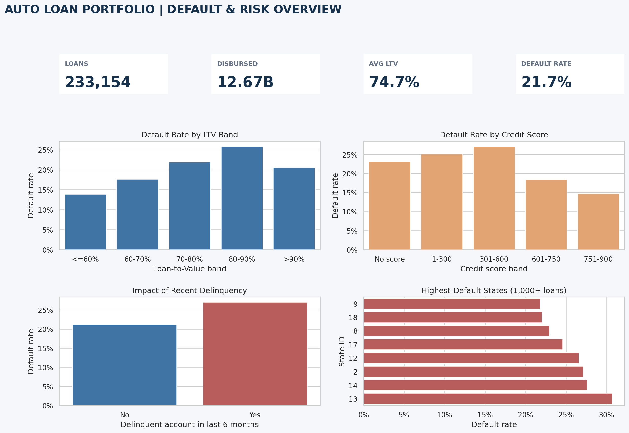
Note. Created from the Vehicle Loan Default Prediction dataset.

Discussion
The findings support an understandable monitoring rule without presenting the project as an automated decision system. An early-review queue could prioritize accounts that combine 80%-90% LTV, recent delinquency, and low or mid-range credit scores. State 13 also merits review because of its volume and default rate. These conditions can organize analysis, but they are not sufficient grounds for an adverse action against a customer.
A production collections analysis would add monthly payment and contact history. Those fields would make it possible to calculate roll rates, cure rate, promise-to-pay results, contact rate, recoveries, and movement toward charge-off. They would also help separate an origination problem from a servicing or collections strategy problem.

Limitations
The dataset provides a binary default outcome but does not show the sequence that led to it. It does not contain days past due, partial payments, customer contacts, repossession, total loss, recovered balances, or charge-off dates. It also does not identify the currency or provide state names. The findings should therefore be interpreted as associations within this portfolio, not causal relationships or complete collections performance measures.

Conclusion
The analysis identified three practical monitoring signals: 80%-90% LTV, recent delinquency, and a 301-600 credit score. Each group performs worse than the portfolio baseline and can support initial account prioritization. The results also show why volume matters. A small segment with a high rate does not necessarily represent the largest exposure for the collections team.
The final repository matches the intended scope of an intermediate business intelligence project. It documents the data source, preparation steps, SQL queries, aggregated tables, dashboard, findings, and limitations. The project can be explained in an interview without relying on a model that is difficult to defend.

References
Paul, A. (n.d.). Vehicle loan default prediction [Data set]. Kaggle. https://www.kaggle.com/datasets/avikpaul4u/vehicle-loan-default-prediction

