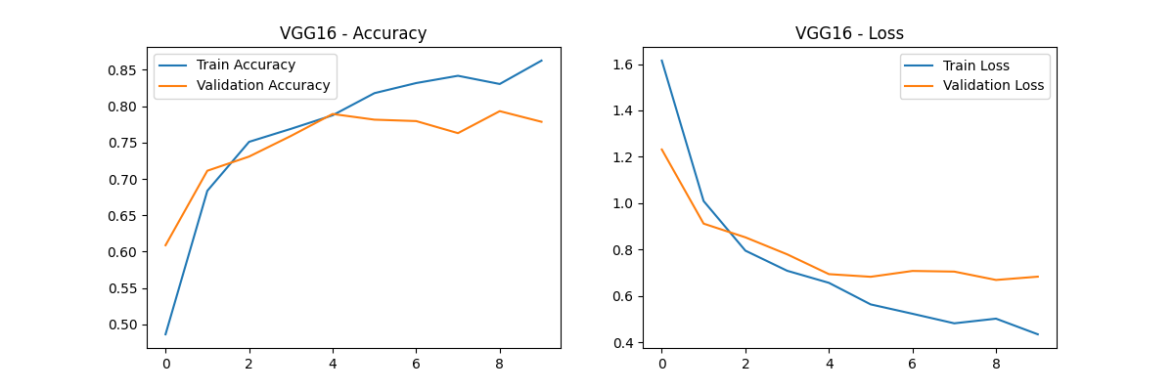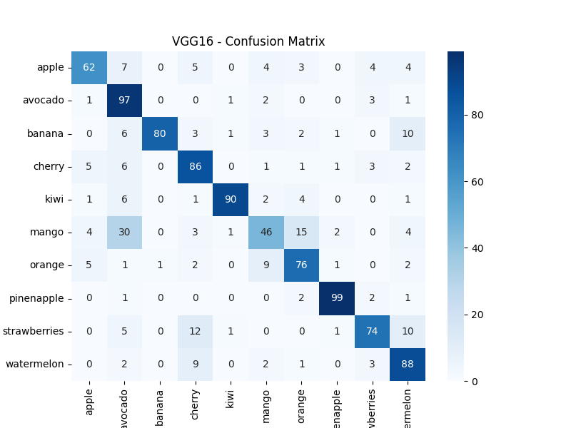

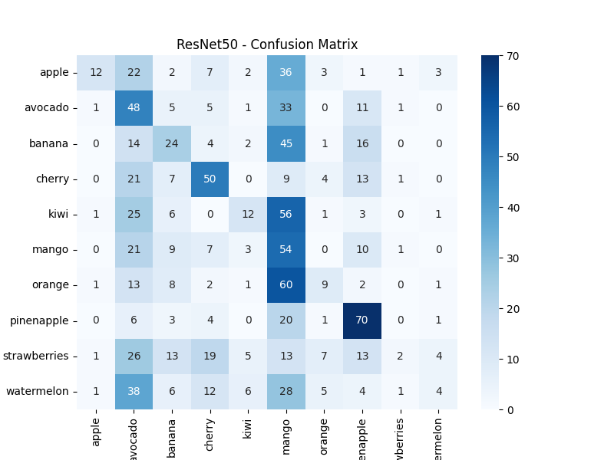

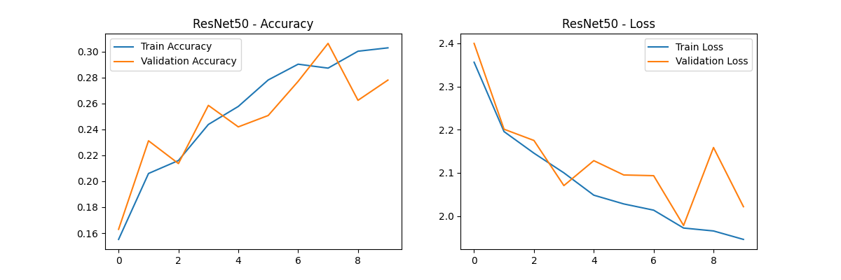

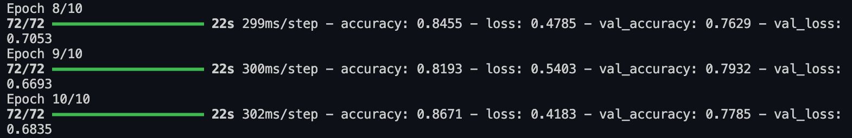

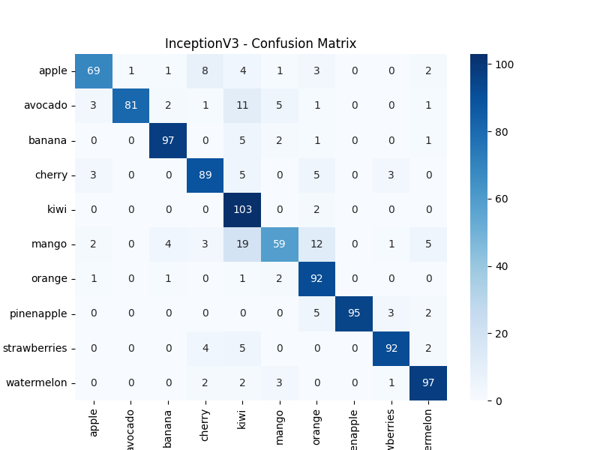

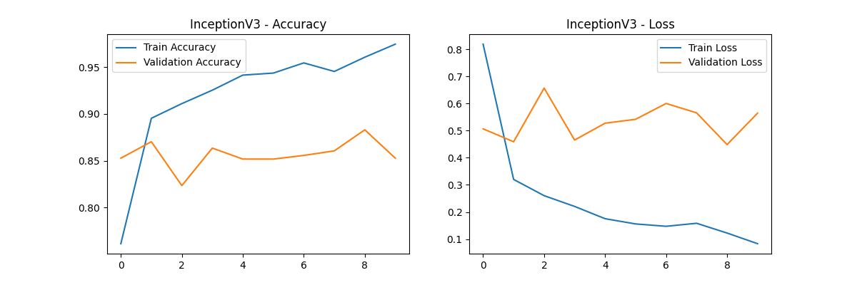

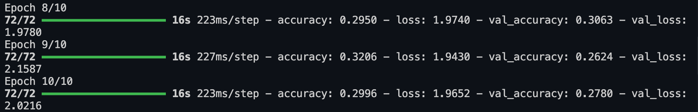

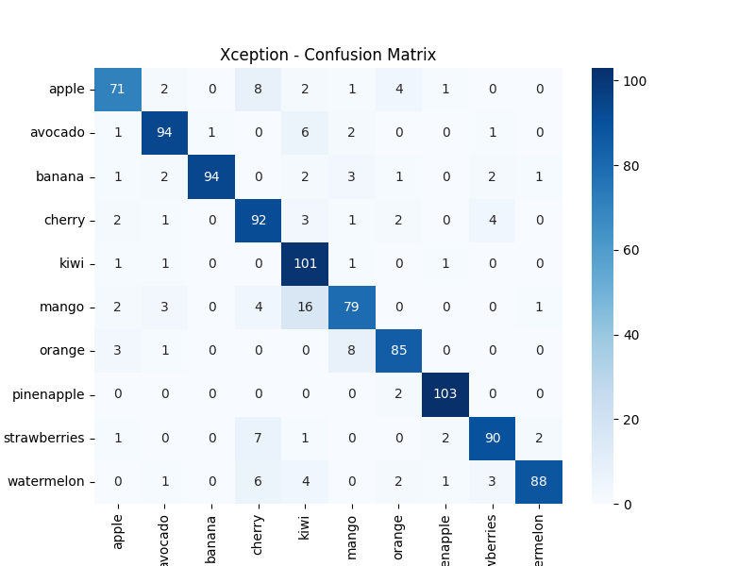

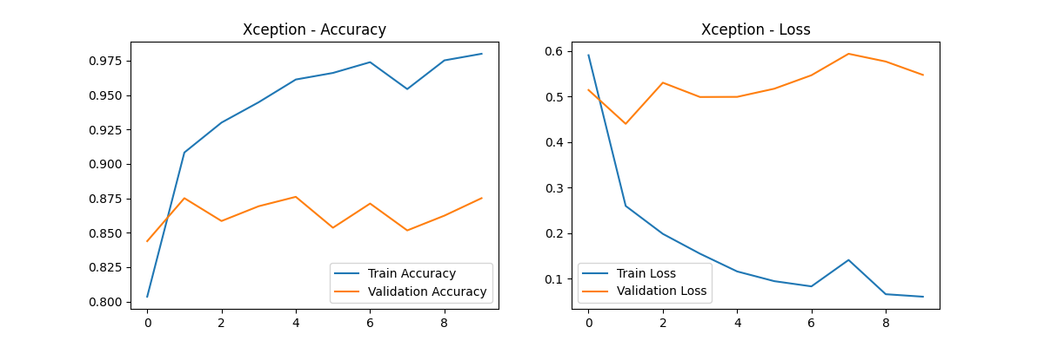

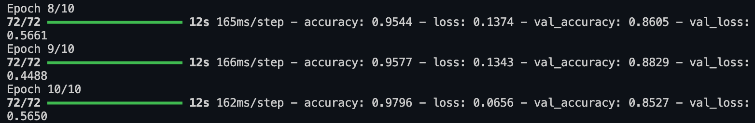

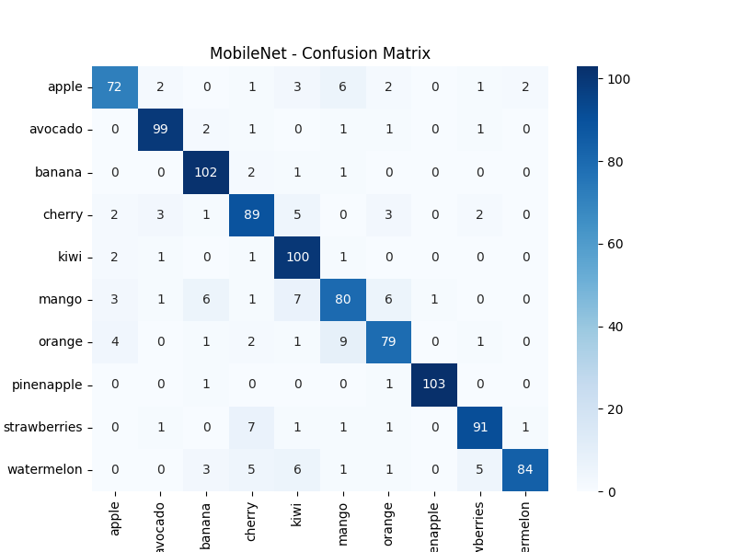

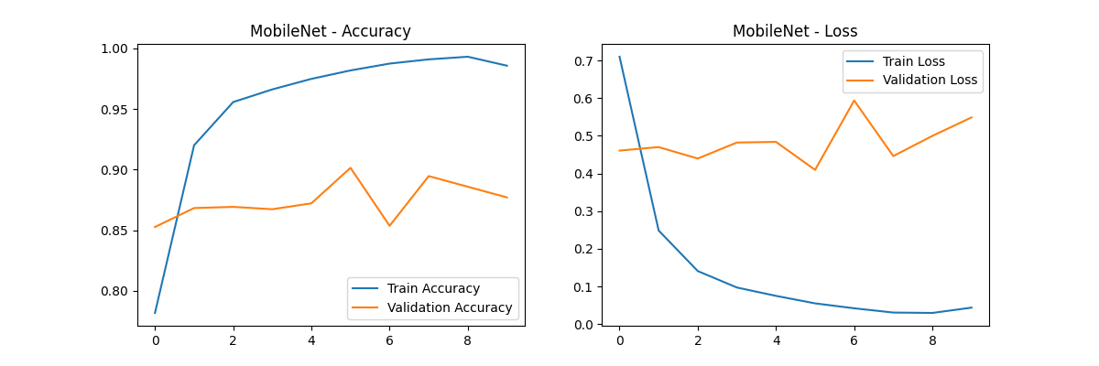

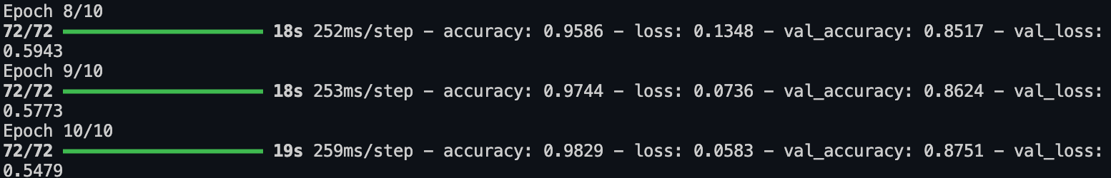

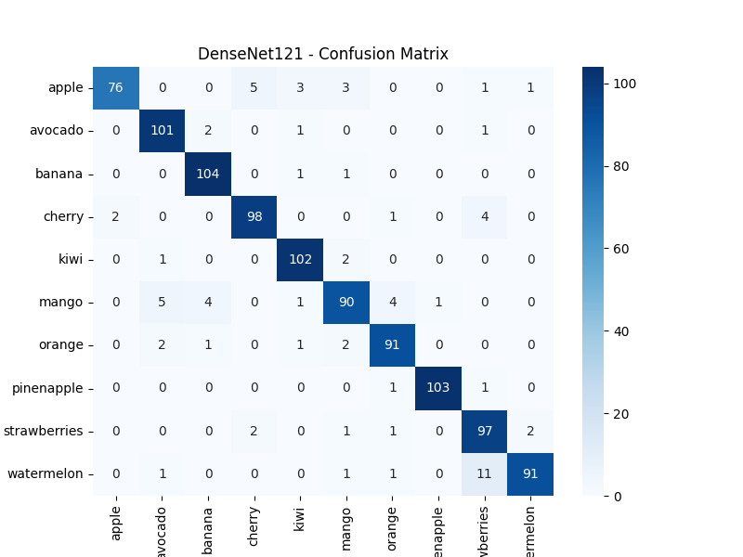

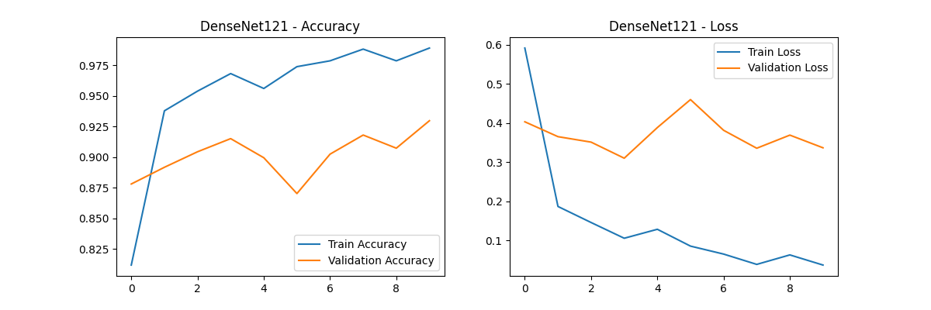

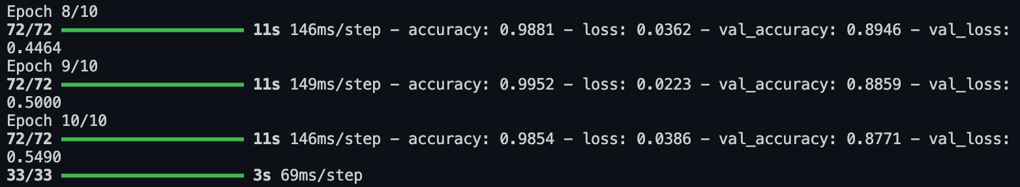

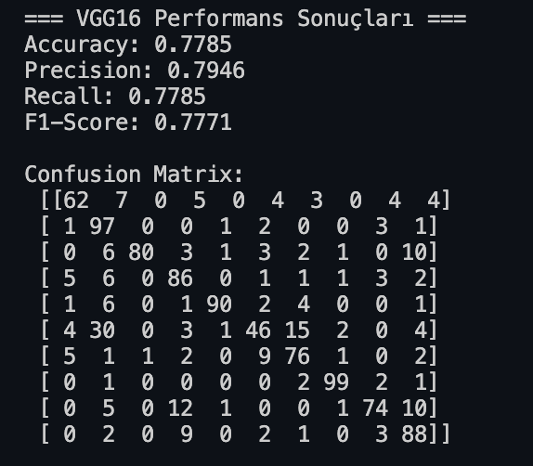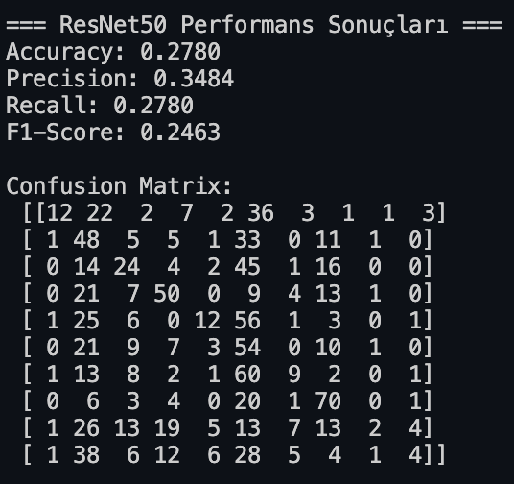

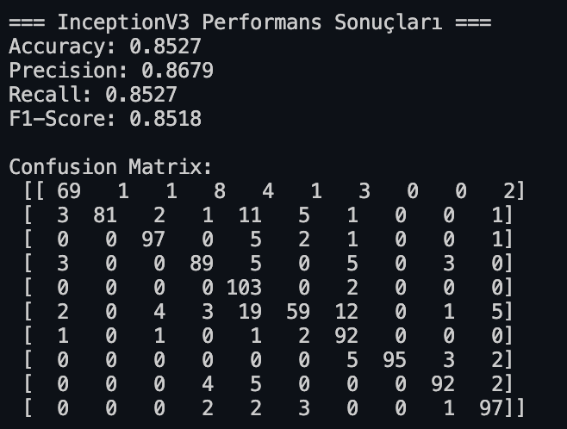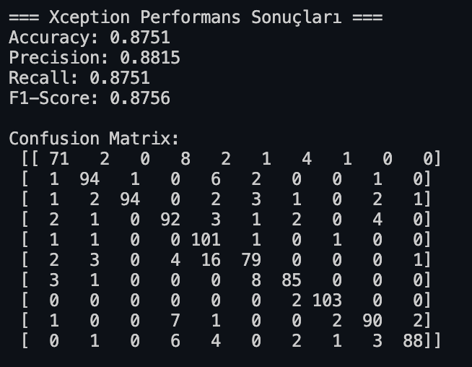

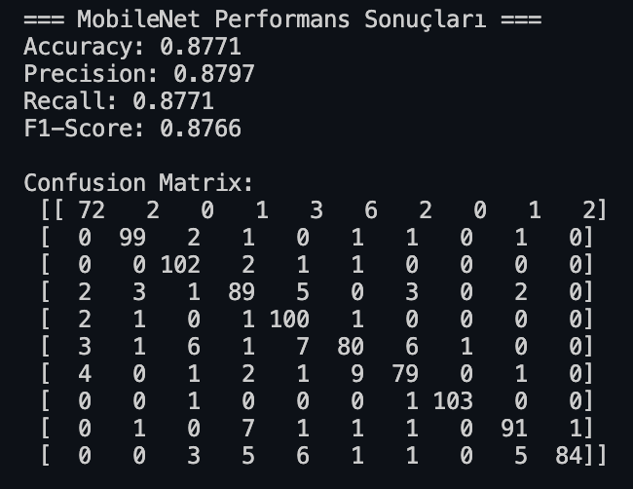

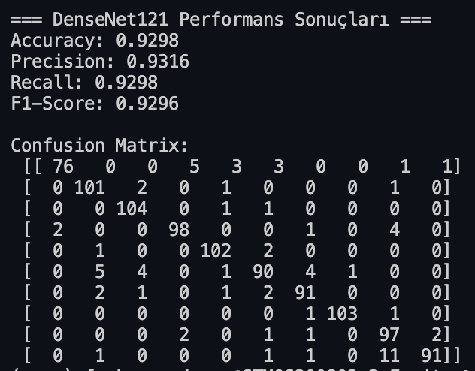

import os

import cv2

import numpy as np

import matplotlib.pyplot as plt

import seaborn as sns

from tensorflow.keras.models import Sequential, Model, load_model

from tensorflow.keras.layers import Conv2D, MaxPooling2D, Flatten, Dense, Dropout, GlobalAveragePooling2D, BatchNormalization

from tensorflow.keras.preprocessing.image import ImageDataGenerator

from sklearn.metrics import confusion_matrix, precision_score, recall_score, f1_score, accuracy_score

from tensorflow.keras.applications import EfficientNetB0

from tensorflow.keras.callbacks import EarlyStopping, ReduceLROnPlateau, ModelCheckpoint

from tensorflow.keras.optimizers import Adam

# Görüntü boyutu artırıldı

IMG_SIZE = 224 # EfficientNet için optimize edilmiş boyut

NUM_CLASSES = 10

# Geliştirilmiş veri artırma işlemleri

datagen = ImageDataGenerator(

rescale=1./255,

rotation_range=30, # Artırıldı

width_shift_range=0.2,

height_shift_range=0.2,

horizontal_flip=True,

vertical_flip=True, # Eklendi

zoom_range=0.2, # Artırıldı

shear_range=0.15, # Eklendi

fill_mode='nearest',

brightness_range=[0.8, 1.2] # Eklendi

)

train_generator = datagen.flow_from_directory(

train_dir,

target_size=(IMG_SIZE, IMG_SIZE),

batch_size=16, # Batch size küçültüldü

class_mode='categorical'

)

test_datagen = ImageDataGenerator(rescale=1./255)

test_generator = test_datagen.flow_from_directory(

test_dir,

target_size=(IMG_SIZE, IMG_SIZE),

batch_size=16,

class_mode='categorical',

shuffle=False

)

# EfficientNetB0 kullanımı (ResNet50 yerine)

base_model = EfficientNetB0(weights='imagenet', include_top=False, input_shape=(IMG_SIZE, IMG_SIZE, 3))

# İlk 100 katmanı dondur, son katmanları eğitilebilir bırak

for layer in base_model.layers[:-30]:

layer.trainable = False

model = Sequential([

base_model,

GlobalAveragePooling2D(),

BatchNormalization(),

Dense(1024, activation='relu'),

BatchNormalization(),

Dropout(0.5),

Dense(512, activation='relu'), # Ek katman

BatchNormalization(),

Dropout(0.3),

Dense(NUM_CLASSES, activation='softmax')

])

# Learning rate ayarlanabilir optimizer

optimizer = Adam(learning_rate=0.001)

# Model derleme

model.compile(

optimizer=optimizer,

loss='categorical_crossentropy',

metrics=['accuracy']

)

# Callbacks eklendi

callbacks = [

EarlyStopping(

monitor='val_loss',

patience=5,

restore_best_weights=True

),

ReduceLROnPlateau(

monitor='val_loss',

factor=0.2,

patience=3,

min_lr=1e-6

),

ModelCheckpoint(

'best_model.h5',

monitor='val_accuracy',

save_best_only=True

)

]

# Model eğitimi

history = model.fit(

train_generator,

epochs=50, # Epoch sayısı artırıldı

validation_data=test_generator,

callbacks=callbacks

)

# Modeli .h5 formatında kaydetme

model.save("model_fruit_classifier_resnet.h5")

# Eğitim ve doğrulama kayıp ve doğruluk grafikleri

plt.plot(history.history['accuracy'], label='Eğitim Doğruluğu')

plt.plot(history.history['val_accuracy'], label='Doğrulama Doğruluğu')

plt.xlabel('Epoch')

plt.ylabel('Doğruluk')

plt.legend(loc='lower right')

plt.title('Model Doğruluğu')

plt.show()

plt.plot(history.history['loss'], label='Eğitim Kaybı')

plt.plot(history.history['val_loss'], label='Doğrulama Kaybı')

plt.xlabel('Epoch')

plt.ylabel('Kayıp')

plt.legend(loc='upper right')

plt.title('Model Kaybı')

plt.show()

# Test verileri üzerinden tahminlerin yapılması

y_pred = model.predict(test_generator)

y_pred_classes = np.argmax(y_pred, axis=1)

y_true = test_generator.classes

# Özellik çıkarımı (Feature Extraction)

feature_extractor = Model(inputs=model.input, outputs=model.get_layer("dense").output)

features = feature_extractor.predict(test_generator)

# Confusion matrix

conf_matrix = confusion_matrix(y_true, y_pred_classes)

plt.figure(figsize=(10, 7))

sns.heatmap(conf_matrix, annot=True, fmt='d', cmap='Blues', cbar=False)

plt.title('Confusion Matrix')

plt.xlabel('Tahmin Edilen Etiket')

plt.ylabel('Gerçek Etiket')

plt.show()

# Metriklerin hesaplanması

precision = precision_score(y_true, y_pred_classes, average='macro')

recall = recall_score(y_true, y_pred_classes, average='macro')

f1 = f1_score(y_true, y_pred_classes, average='macro')

accuracy = accuracy_score(y_true, y_pred_classes)

# Specificity hesaplama

TN = conf_matrix.sum() - (conf_matrix.sum(axis=1) + conf_matrix.sum(axis=0) - np.diag(conf_matrix))

FP = conf_matrix.sum(axis=0) - np.diag(conf_matrix)

specificity = np.mean(TN / (TN + FP))

# Metriklerin yazdırılması

print(f'Accuracy: {accuracy:.4f}')

print(f'Precision: {precision:.4f}')

print(f'Recall: {recall:.4f}')

print(f'F1-Score: {f1:.4f}')

print(f'Specificity: {specificity:.4f}')