Chessir Site Plan

Nickolas Hawley

WDD 130

Overview

Purpose
To make a website to teach chess and simple gambits to help make people ragebait their friends.

Audience
Pretty much anyone who is interested in chess and all those who just want to prank their friends.

Branding

Website Logo
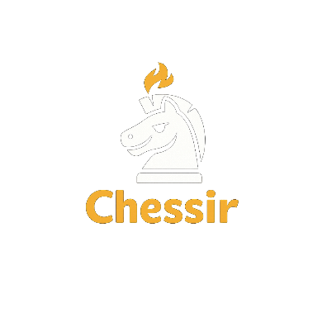

Style Guide

Color Palette
Primary | Secondary | Accent 1 | Accent 2
#f4c542 | #1c1c1c | #ff6b2d | #f9f9f9

Typography

Heading Font: Bebas Neue

Paragraph Font: Inter

Navigation
Home Page2 Page3

Content
https://www.thechesswebsite.com/top-6-chess-traps/

[put all content for the pages here, including written text and images]
Rage bait page
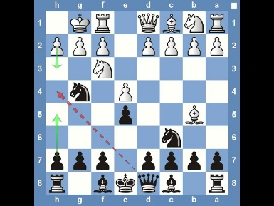fishing pole trap
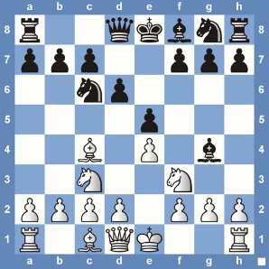Legal Trap
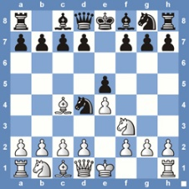blackburn shilling trap
Teaching page
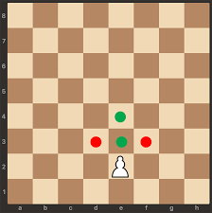How a pawn moves: Green is a legal move, and red is its attack.
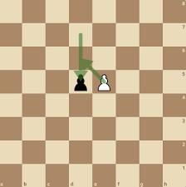En pasant: attack behind a pawn that has moved two spaces.
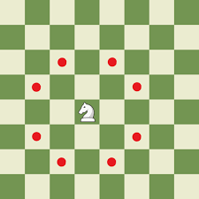How a Knight moves and attacks.
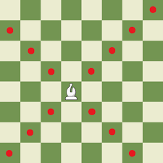How a bishop moves and attacks.
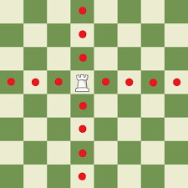How a rook moves and attacks.
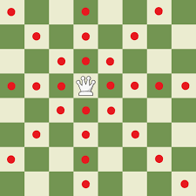How a queen moves and Attacks.
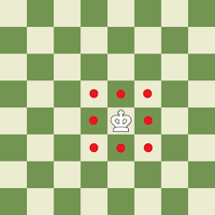How a king moves and attacks.
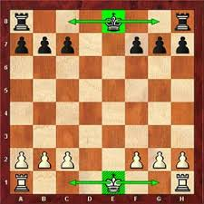Castle is when the king moves two squares towards a rook and the rook moves to the other side of the king. The king can’t castle through a check or while in check.
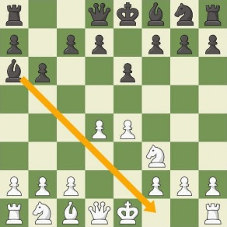For example: the King can not castle in this position.
Home page
background image
Footer


Wireframes

Home
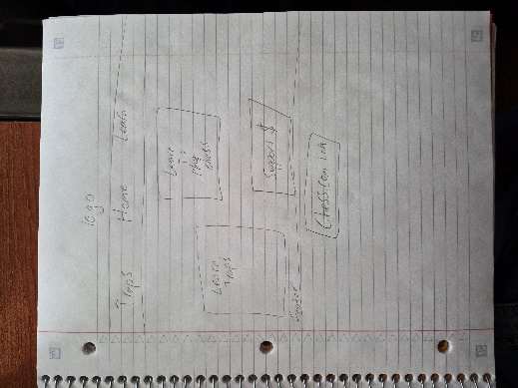
Learn
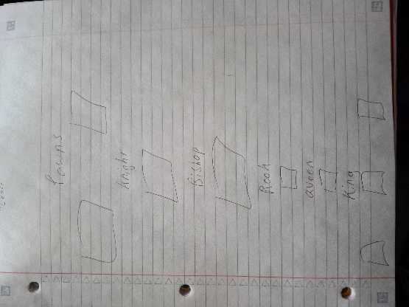
Traps
