Phase 3 Deliverable

CIS4301

Group #15

Christine King

Michael Bentz

Issa Malke

Joshua Trinkler

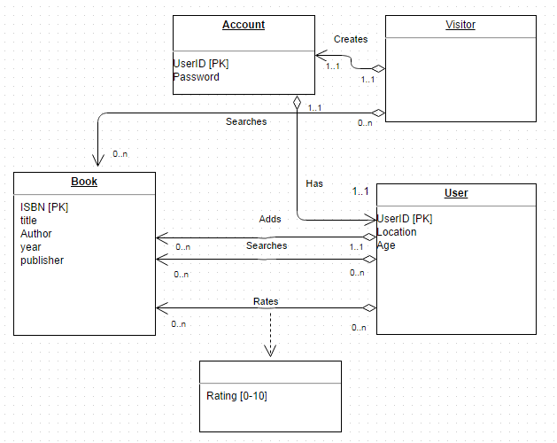

We overlooked that Account and User have the same primary key. Therefore we are updating the primary key of account to (UserID, Password). which will also serve as a foreign key for User.

Database Schema:

Book (ISBN, Title, Author, Year, Publisher)

Primary Key ( ISBN )

User (UserID, Location, Age, Password, ISBN )

Primary Key ( UserID )

Foreign Key ( password ) references Account ( password )

Foreign Key ( ISBN ) reference Book ( ISBN )

Account ( UserID, Password )

Primary key ( UserID, Password )

Visitor ()

Foreign Key ( ISBN ) reference Book ( ISBN )

Foreign Key ( UserID, Password ) reference Account ( UserID, Password)