PC PART RETAIL
AND CONFIGURATION
STORE

Dependecies:

Back end: Java 25
Front end: JavaFX
Database: PostgreSQL
Connectivity: Neon

Behaviour:

This is a combination of a PC builder app and E-commerce platform where users can either shop for individual PC parts, build and order a custom PC, or both. This app is aimed at more intermediate to advanced PC builders. It checks for build errors, but will let you proceed further despite that with the intention that the user knows what they are doing.
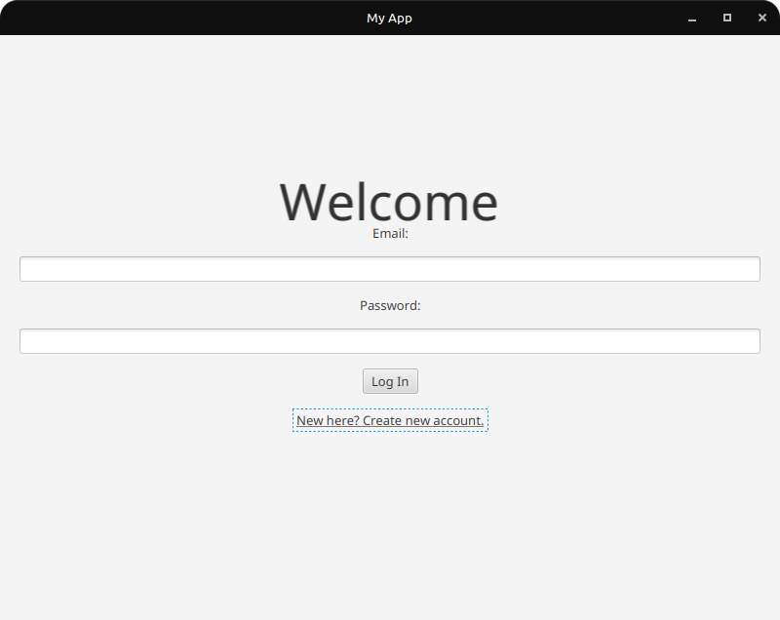
To get started, the user is asked to log in with a preexisting email and password. If not, the user can register by inputting a username, email, address and password.

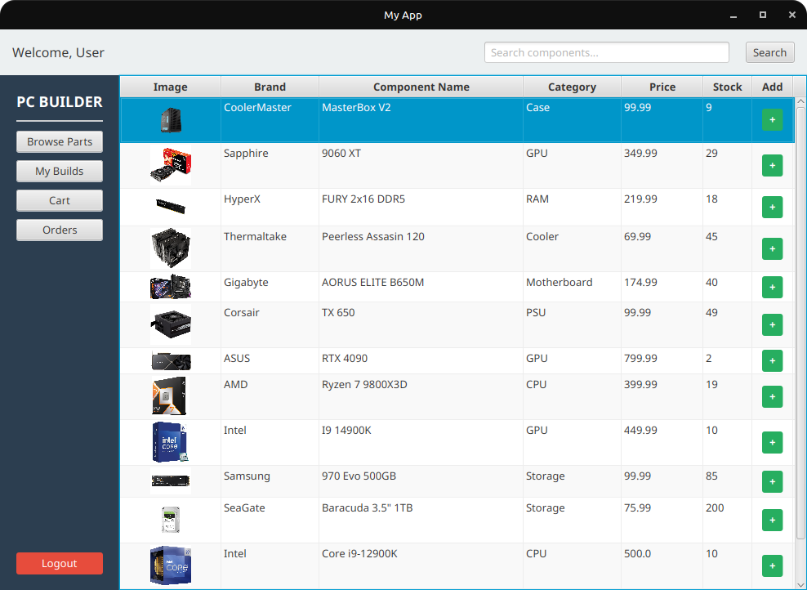
After the user is logged in, they are greeted to a dashboard consisting of various pc parts

