Stockit. Site Plan

Joshua Catala

WDD 130

Overview

Purpose
Provide tailored inventory solutions to help optimize businesses inventory and asset management. Instead of a one-fits-all type of solution we seek to provide a specific solution to your issues.

Audience
Business owners that rely heavily on their inventory (construction, restaurants, etc.)

Branding

Website Logo
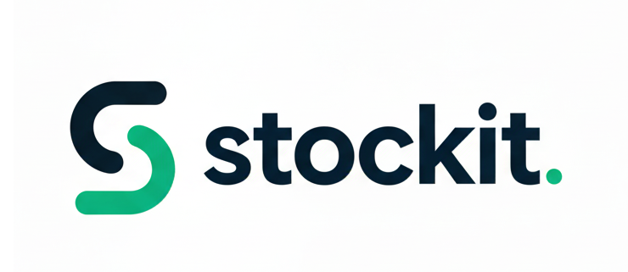

Style Guide

Color Palette
Primary | Secondary | Accent 1 | Accent 2
#000000 | #4CB944 | #47C065 | #9DF5DF

Typography

Heading Font: Rubik

Paragraph Font: Poppins

Navigation
Home About Contact Us

Content

Home Page

Company’s slogan: Your Inventory, Custom-Engineered.

Company’s mission: To deliver precision-engineered inventory solutions that address the unique, direct challenges of every distinct business model, ensuring optimal efficiency and maximizing profitability.

Company’s mission and values: Stockit delivers custom-engineered inventory solutions designed to fit your unique business model. We provide unwavering accuracy and actionable efficiency to directly solve your specific stock issues. Our goal is simple: eliminate guesswork and boost your profits. Partner with us for precision inventory control.

Our Advantages Section:

Sub-header: Precision, Partnership, Profit.

Benefit 1: Tailored System Architecture | Description: We custom engineer your solution to fit your unique business model, not the other way around.

Benefit 2: Uncompromising Data Precision | Description: Eliminate costly errors with unwavering, real-time accuracy and reliable inventory data.

Benefit 3: Direct Profit Optimization | Description: We turn operational efficiency into measurable profit growth by preventing waste and optimizing purchases.

How we work section:

Sub-header: Our 4 Steps to Your Custom Solution

Step 1: Discovery & Needs Mapping | Description: We deeply analyze your business model to pinpoint the exact inventory challenges requiring a custom solution.

Step 2: Solution Design | Description: We custom-engineer the Stockit system and features to directly address your unique operational needs and logic.

Step 3: Integration & Launch | Description: We implement the solution, integrate with existing systems, and provide training for immediate operational improvement.

Step 4: Support & Optimization | Description: Our partnership provides ongoing support to proactively refine the system as your business continues to evolve.

Images:

Logo:
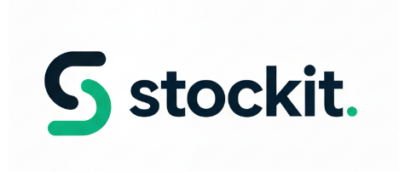
Home Page:


Icons:



About Us

Content:

Title: Inventory Solutions Built Uniquely for You

Header: "Stockit was founded on a single principle: Generic software creates generic problems. We reject the 'one-size-fits-all' model to deliver precision inventory solutions custom-engineered to solve the direct, unique challenges of every business model we serve."

What sets us apart section:

Text: "Stockit delivers custom-engineered inventory solutions designed to fit your unique business model. We provide unwavering accuracy and actionable efficiency to directly solve your specific stock issues. Our goal is simple: eliminate guesswork and boost your profits. Partner with us for precision inventory control."
Our Focus Section:

Focus 1: Tailored System Architecture | Description: Stop forcing your business into rigid software. We start by deeply understanding your specific industry, workflow, and business model (e.g., e-commerce, wholesale, manufacturing). Stockit then delivers a system architecture and feature set custom-engineered to solve your unique, direct inventory challenges.

Focus 2: Uncompromising Data Precision | Description: Eliminate the cost and risk of inaccurate counts, phantom stock, and unexpected write-offs. Our foundation is unwavering accuracy and real-time synchronization, ensuring you always know exactly what you have, where it is, and when you need to reorder—leading to better cash flow management.

Focus 3: Direct Profit Optimization | Description: Inventory management should not just be a cost center; it should drive revenue. By eliminating operational waste, preventing stockouts, and optimizing your purchasing based on precise forecasts, Stockit translates efficiency directly into measurable profit growth for your business.

Images:



Contact Us

Content:

Title: Let's Build Your Custom Solution

Header: "The fastest way to start optimizing your inventory is by scheduling a free, personalized consultation. Let's discuss your unique business model and how Stockit can custom-engineer your solution."

Form:

Full Name

Industry

Email Address

Subject of Inquiry

Message

Wireframes

Home

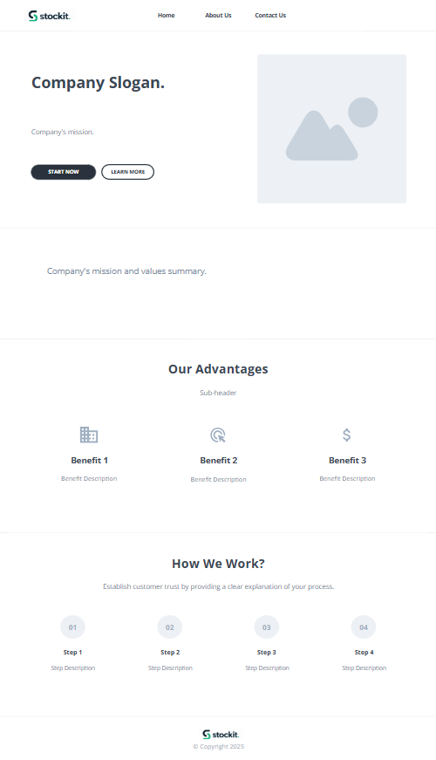

About Us
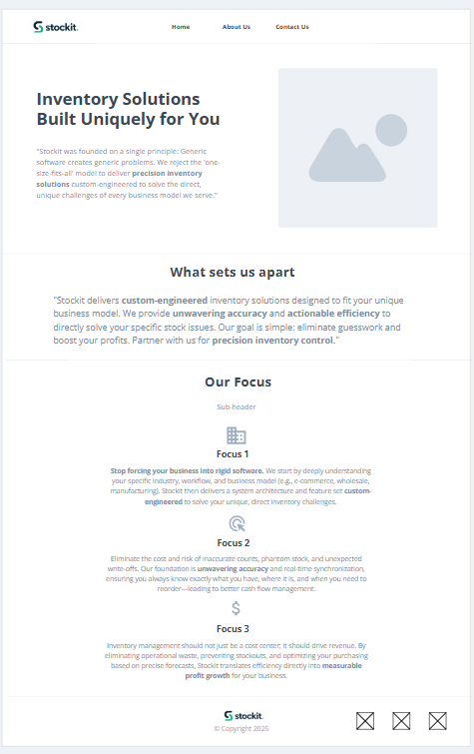

Contact Us
