June 3, 2024

Hawwa Raufath Nizar

SUPERVISORS: DR. REBECCA CAMP (UQ), DR. KATE HODGES (DES) AND DR. JONATHON MARSHALL (DES) S4755382

ANALYSING THE EFFECT OF ENVIRONMENTAL AND HYDROLOGICAL VARIABILITY ON FISH GROWTH RATES IN QUEENSLAND'S DRYLAND RIVERS

.

# Abstract

To add after draft is finalised.

# Introduction

The complex interplay between spatial and temporal variability in physicochemical properties of the environment, and their influence on growth of various marine species has been the subject of extensive research (Jobling 2002; Canosa and Bertucci 2023). Concurrently, the growing evidence of shifting thermal and precipitation regimes, along with the intensification of extreme climate and weather events, (Saintilan et al. 2013; Westra et al. 2014; Vousdoukas et al. 2018; Zhou et al. 2019; IPCC 2022), suggests increased potential for disruptions in ecosystem functions that are strongly linked to growth, such as spawning (Steel et al. 2019), nutrient cycling (D’Odorico et al. 2003) and overall ecosystem productivity (Woodward et al. 2016; Gampe et al. 2021). In lotic habitats such as dryland river systems, these influences are compounded by inherent environmental variability in key abiotic parameters such as turbidity, substrate composition, temperature and most notably, hydrology (Maestre et al. 2012; Lapointe et al. 2014). The distinctive hydrological characteristics of dryland rivers create cyclic conditions of “booms” in productivity due, in part, to episodic floods, followed by “bust” periods after the waters recede, leaving behind perennial and semi-perennial waterholes. During drought periods, these waterholes serve as refuges for many aquatic species (Sheldon et al. 2010; Arthington and Balcombe 2011). Most of these dryland riverine ecosystems experience long periods of low to no-flow (Douglas et al. 2005; Kennard et al. 2010; Morón and Amos 2018), and remain as disconnected refuges for most of the year, with some persisting over several years with no surface flow (Bunn et al. 2006a, 2006b). Though the term ‘refuge’ here is used to denote “places (or times) where the negative effects of disturbance are lower than in the surrounding area (or time)” (Lancaster and Belyea 1997; Sheldon et al. 2010), the isolated, relatively small and densely populated nature of such refuges can introduce novel stressors and intensify existing ones. For instance, research conducted on similar remote habitats suggest that food web interactions, including predator prey interactions are heightened during such cases (Jackson et al. 2001; Magoulick and Kobza 2003; Gido et al. 2015), particularly where species are present in high densities. These impacts have also been documented across a host of other biotic processes and interactions, such as exposure to disease and parasites, competition, and migration (Magoulick and Kobza 2003; Arthington and Balcombe 2011). Sudden and often severe changes in these processes have been associated with fish mortality in such dryland refuges (Wager and Unmack 2000; Magoulick and Kobza 2003; Balcombe et al. 2005; Turschwell et al. 2019). Furthermore, the size and nature of such water bodies can also play a critical role in exacerbating abiotic stressors; the biogeographically insular nature of the refuges themselves can alter much of the physicochemical and biological properties of the habitat (Magoulick and Kobza 2003). For example, not only are smaller water bodies known exhibit a higher degree of temporal variation in oxygen and temperature (Jackson et al. 2001), the increased evaporation and low-flow associated with such water bodies can cause increased sedimentation, salinity and turbidity (Wager and Unmack 2000; Pettit et al. 2012), all of which can potentially contribute to low growth and survival.

Despite their highly variable hydrology and the consequential, often harsh, conditions, these are critically important and highly biodiverse ecosystems that have shaped (Macklin and Lewin 2015; Moggridge and Thompson 2021) and continue to shape not just land-use, sustenance, and livelihoods, but also the cultural values and heritage of the surrounding communities (Anderson et al. 2019). Furthermore, the ecosystem processes of these habitats are greatly influenced by this variability; from dispersal regimes (Petty and Grossman 2004), to spawning (Franssen et al. 2007), to primary production (Balcombe et al. 2015). Hence, investigating the survival, growth, and reproductive success of different species within these habitats is paramount to understanding their response to the frequency and intensity of such disturbance events.

The widespread occurrence of these habitats also underscores the need to focus research efforts on them. Approximate 83% of all 3.5 million kilometres of Australian low land rivers (when mapped at a scale of 1:250,000) have been classified as dryland rivers; that is to say, they are primarily found in arid to semi-arid regions (Thoms and Sheldon 2000; Sheldon et al. 2010). The Murray-Darling Basin alone, where this research project is centred, supports agricultural production valued at AUD 30 billion per year (Murray–Darling Basin Authority 2023). Given the high economic and ecological significance of these habitats, research on non-perennial and semi-perennial rivers in Australia has spanned a vast array of topics, demonstrating clear trends in evolving research focus over the past several decades (Shanafield et al. 2024). Much of the work focusses on the role of waterholes as refuges, and how various aspects of fluvial geomorphology contribute to their suitability as such. This includes research into factors that contribute to their persistence, such as groundwater discharge (Davis et al. 2021; Bourke et al. 2023), bank return flow (Rhodes et al. 2017; Zhou and Cartwright 2021) and drainage and evaporation rates (Hamilton et al. 2005; Brunner et al. 2009). Many papers also report on the response of various species to the hydrological and environmental variability, including the effect of these extreme conditions on various biological processes, such as migration (Marshall et al. 2016), dispersal regimes (Faulks et al. 2010; Chester et al. 2015; Razeng et al. 2017), reproduction and fecundity (Mooij et al. 2002). Works focussing on factors affecting growth of species in dryland river systems includes research on the interactions between growth and extreme high temperatures (Wallace et al. 2015), as well as comparative inter-species and inter-site analyses (Mallen‐Cooper and Stuart 2003; Koehn 2004). Reviews focussed on the Murray-Darling Basin note that much of the data requires updating and highlight the need for further research into factors that affect fish growth (Koehn et al. 2019, 2020). Amid this broad spectrum of research, this project aims to add to the current repository of knowledge by deepening our understanding of the impact of various environmental and hydrological factors on, growth rate of three species across 11 sites in rivers in the Northern Murray-Darling Basin; Golden perch (*Macquaria ambigua*), Bony bream (*Nematalosa erebi*) and Common carp (*Cyprinus carpio*). This research not only models the impact of multiple environmental predictor variables on the growth rates of fish species, but also includes both native and non-native species, thus offering a robust dataset for comparative analysis, providing valuable insights into how different species respond to similar environmental pressures in dryland river systems.

Given the complex nature of interactions between environmental factors and species growth that are expected, reliable and quantifiable methods of measuring growth is required. Especially since monitoring growth and movement in fish populations can be particularly challenging when the species in question exhibit migratory behaviour. Sclerochronological studies, which analyse incremental marks on calcified structures, are one method utilised to address this issue. In particular, otolith (ear bone) growth rings are widely researched and recognised as effective proxies for tracking fish growth, as well as the impact of pertinent environmental parameters such as temperature (Gillanders et al. 2012; Martino et al. 2019; Morrongiello et al. 2019; Dunlop et al. 2023). As such, otolith biochronology is used in this project as a proxy measure for examining the impact of various hydrological and environmental factors and their spatiotemporal variability, on incremental growth rates in the aforementioned three species. Specifically, incremental growth rings on otoliths were visualised and measured using high-precision tools, and the results were then converted into annual growth rates, to be used in the modelling process as the response variable.

# Methods and Approach

## 2.1 Study Area and Data Sources

This analysis encompassed data from a total of 11 sites (see Table 1, Figure 1), all of which were located across south and west Queensland, except for one site in New South Wales (Site ID: 5). Each site features specific hydrological control structures, which are critical in managing water flow and sediment transportation and can thus potentially affecting habitat conditions and fish growth rates. Although this report does not look at the effect of different modes of control on discharge volumes and patterns, there is a notable variety in controls across the sites, from crump weirs, which are a more specialized and precise means of control designed to manage flow rates accurately (Caroline and R Afshar 2014; Bachir and Lyes 2022), to more general and traditional controls such as sand, timber and mud.

The range of ecological and environmental datasets utilized for this project was derived from three main sources:

### 2.1.1 Microsoft Power BI Solution Developed by La Trobe University

All of data on the response variable, otolith-derived annual growth rates from age 1 to age 2 for the three fish species, was accessed and extracted via a cloud-based data dashboard developed using Microsoft Power BI. This dashboard was developed by La Trobe University, with input from the Department of Environment and Science (DES), Queensland. The otolith data was collected twice across the 11 sites, once in 2020 and once in 2021, following the drought of 2018, which resulted in a significant decrease in rainfall across the region (DAFF 2018). This analysis was performed on a dataset of 117 datapoints, which was the result of filtering a much larger dataset to fit the conditional restrictions of this study, in particular, the age range. Additionally, the dataset also included some of the predictor variables utilised for this analysis, most notably streamflow and stream level data, which was sourced from stream gauges installed within the study area. A total of ten gauges were utilised to extract data on 11 sites (see Figure 1).

|  |  |  |  |  |  |
| --- | --- | --- | --- | --- | --- |
| Site ID | Gauge ID | River | Control | Latitude | Longitude |
| 1 | 422201F | Balonne river at St. George | Crump Weir | -28.0614 | 148.5636 |
| 2 | 423204A | Warrego river at Augathella | Sand | -25.7928 | 146.5857 |
| 3 | 422205A | Balonne-minor river at Hastings | Sheet Piling Weir | -28.4312 | 148.2742 |
| 4 | 422206A | Narran river at Dirranbandi-Hebel Road | Mud | -28.8402 | 148.0525 |
| 5 | 422015 | Culgoa river at Brenda | Historic weir (wooden + earthfill) | -29.0296 | 147.3135 |
| 6 | 422207A | Ballandool river at Hebel Bollon Road | Mud | -28.9377 | 147.7524 |
| 7 | 422207A | Ballandool river at Hebel Bollon Road | Mud | -28.9377 | 147.7524 |
| 8 | 422211A | Briarie Creek at Woolerbilla-Hebel Road | Sand And Mud | -28.9081 | 147.6889 |
| 9 | 422209A | Bokhara river at Hebel | Rock and concrete storage Weir | -28.9694 | 147.7973 |
| 10 | 417205A | Moonie river at Flinton | Mud and Timber | -27.8944 | 149.5254 |
| 11 | 422202B | Dogwood Creek at Gilweir | Storage Ogee Weir | -26.7089 | 150.1792 |

Table 1: List of all sites utilised for the study, alongside information on the stream gauges, the locations of the sites, and the form of hydrological control utilised at them

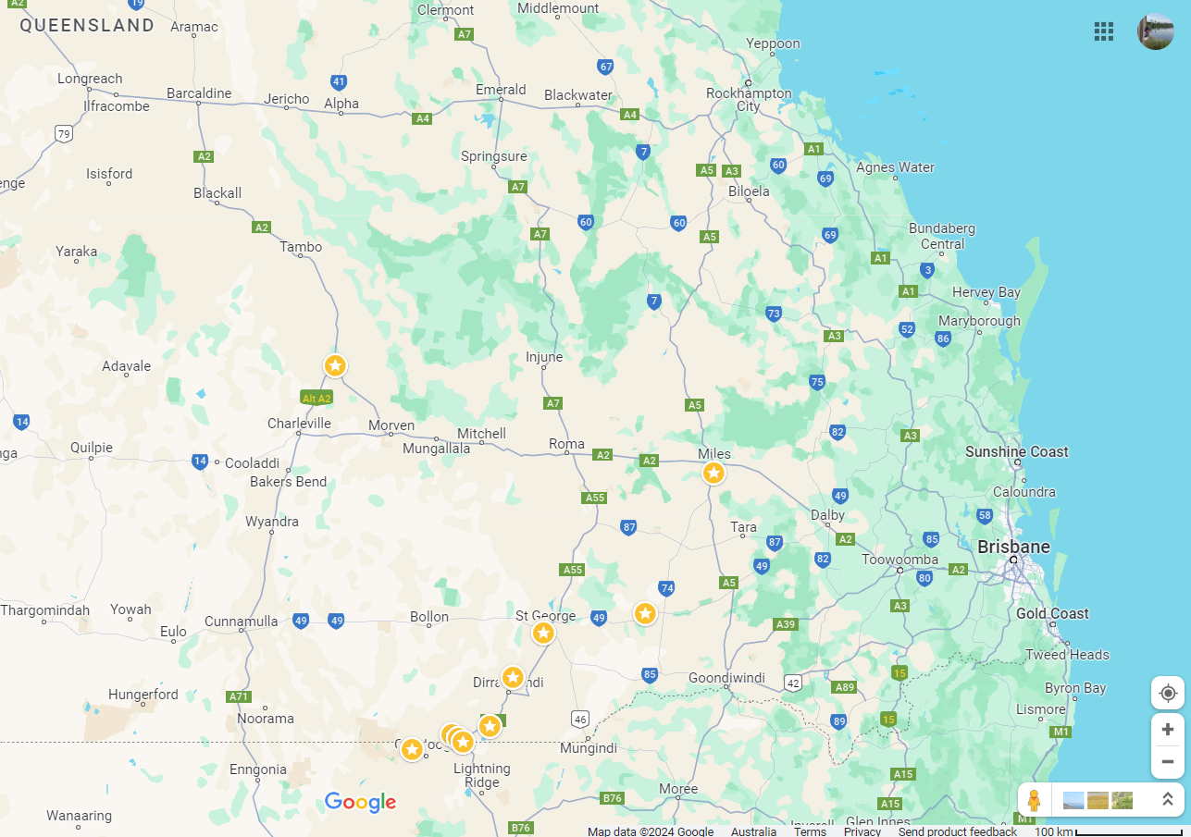

Moonie River, at Flinton

Culgoa River, at Brenda

Balonne River, at St. George

Dogwood Creak, at Gilweir

Narran River, at Dirranbandi-Hebel Road

Bokhara River, at Hebel

Ballandool River, at Hebel Bollon Road

Briarie Creek, at Woolerbilla-Hebel Road

Warrego River, at Augathella

Balonne-minor River, at Hastings



Figure 1: Map showing the location of 10 stream gauges, used to extract data for the 11 study sites where otolith data was collected.

### 2.1.2 SILO Database

Data on annual rainfall and evaporation levels was extracted from the SILO database, which is maintained by the Queensland Government and carries information on a host of environmental variables for the region, from 1889 to present day (Queensland Government 2024a). As this analysis specifically examines the annual growth rate from year 1 to 2, data was downloaded for the years 2020 and 2021.

### 2.1.3 Water Monitoring Information Platform (WMIP)

The WMIP platform, which is also maintained by the Queensland Government and integrates data from various gauges across Queensland (Queensland Government 2024b), was mainly used to access minimum, maximum, and mean water levels across the study sites, for both the duration of the study and the years immediately preceding it. This data was then analysed to identify temporal patterns and trends in water levels, and to calculate the number of zero-flow days and the longest no-flow spells each year for the period 2019-2021.

## 2.2 Data Preparation and Basic Exploratory Data Analysis

Prior to analysis, the data from all three sources was cleaned, prepared and consolidated. For cases with multiple sets of similarly formatted repetitive data, such as the SILO and WMIP gauge datasets, the data was read-in using specifically constructed loops, with the intention of reusing the code snippet for similar projects, given the format of raw data files remains consistent. As discussed above, some data sets such as the daily stream level data and the cease-to-flow level data was used to construct new predictor variables such as number of no-flow days per year and longest no flow periods per year.

After completing basic data cleaning and structuring tasks, only 117 data points were retained distributed by species as seen in Figure 2. Following this, I visualised the data using scatterplots, to examine the spread of data, and identify and visually obvious relationships or patterns. The level of visual information available was limited due to the sparseness of data. While there are no strong positive visible trends, the scatterplot does indicate a slight positive relationship between mean stream level and annual growth rate. While the temperature variables did not show strong correlation with annual growth (see Figure 3a), the clusters evident in the plots could indicate that specific temperature ranges might influence growth rates more significantly. Some outliers were also noted, particularly in the streamflow variables (see Figure 3b). It was assumed that the lack of immediately discernible patterns may also be due to the presence of non-linear relationships.

Figure 2: Count of three fish species in study sample: Bony Bream (45), Common Carp (39), and Golden Perch (33).

(a)

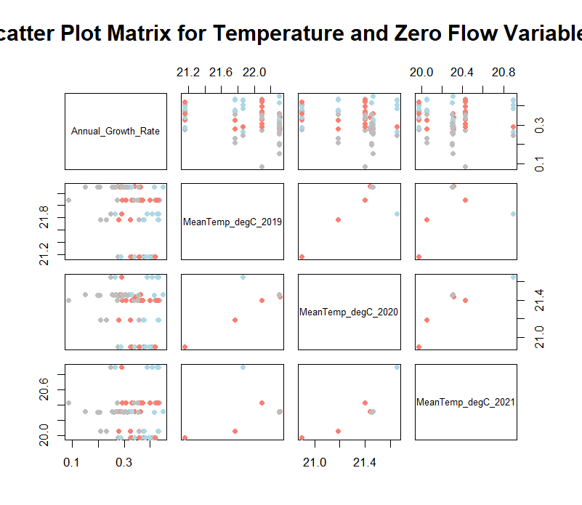

Annual Growth Rate

Mean Temp 2019 (°C)

Mean Temp 2020 (°C)

Mean Temp 2021 (°C)

(b)

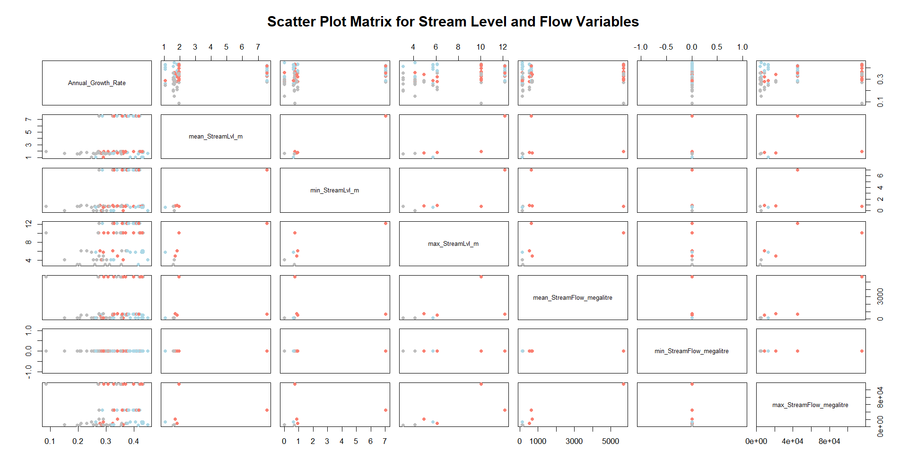

Annual Growth Rate

Mean Stream Level (m)

Min. Stream Level (m)

Max. Stream Level (m)

Mean Stream- flow (Ml)

Min. Stream- flow (Ml)

Max. Stream- flow (Ml)

Figure 3: Sections of the scatterplot matrix depicting (a) relationships between annual growth rate and mean temperature from 2019-2021 and (b) relationships between annual growth rate and various streamflow variables, including mean, minimum, and maximum stream levels (measured in meters) and streamflow (measured in megalitres)

I generated a correlation matrix for the data to determine which variables had high levels of correlation. The exercise revealed a high degree of correlation amongst the predictor variables Figure 4. Thus, several strategies were employed to address the risk of multicollinearity and improve the integrity and robustness of the models. Aside from the Principal Component Analysis (PCA) which was used to reduce dimensionality and address multicollinearity, highly correlated predictor variables were also eliminated or used alternatingly in other iterations of the models, based on model performance and the correlation matrix below.

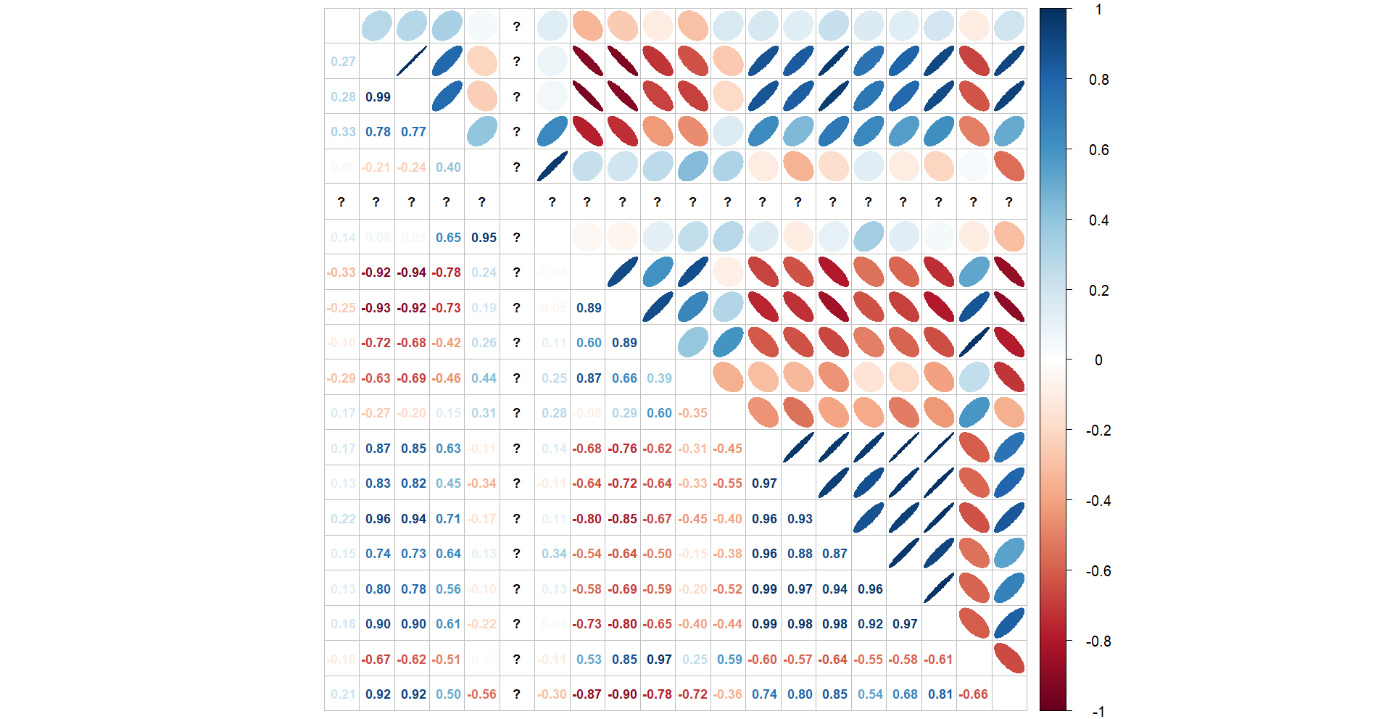

**Growth Rate**

**Mean Stream Level**

**Min Stream Level**

**Max Stream Level**

**Mean Streamflow**

**Min Streamflow**

**Max Streamflow**

**Mean Temp 2019**

**Mean Temp 2020**

**Mean Temp 2021**

**Catchment Area**

**Station to Mouth Distance**

**Longest Zero Flow 2019**

**Longest Zero Flow 2020**

**Longest Zero Flow 2021**

**Zero Flow-days 2019**

**Zero Flow-days 2020**

**Zero Flow-days 2021**

**Evaporation**

**Daily Rain**

Figure 4: Correlation matrix displaying pairwise correlation coefficients between the full set of response and predictor variables. Blue areas represent high positive correlation, while red indicates high negative correlation. The coefficients for Minimum Streamflow level were incalculable, as indicated by the question marks, due to the high degree of zero inflation.

## 2.3 Modeling

The modeling process, as discussed above, was iterative, starting with simple, untransformed variables and linear models, and gradually progressing to more complex model structures, such as Generalized Linear Models (GLMs), and Bayesian GLMs that tested transformed variables, non-linear relationships, predictor variables derived from Principal Component Analysis (PCA), and interaction terms. The aim of this process was not only to progressively determine the effect of various hydrological and environmental factors on annual growth rate, in the three species of interest, but also to gradually improve model fit and develop a model that explains the maximum possible variability in the response variable. The full suite of models fitted are listed in addendum 1 of this report.

While the majority of the analysis was conducted on the 117 datapoints retained after filtering for fish that were aged 2 years old in 2021 (to assess individuals that were progressing from age 1-2 during the study period), a test version of the first basic linear model was also tested on the full set of unfiltered data that included fish aged from 1-20 years. The initial model included selected predictor variables representing stream flow, stream level, atmospheric temperature, longest period of zero flow, and species. While the t-values obtained indicated significant relationships for most of the predictor variables, the DHARMA residual diagnostics revealed significant quantile deviations and the presence of outlier data points. The R-squared value for this model was 0.0274.

Conversely, the version of the model that focused on fish aged 1-2 yielded a slightly better fit and had a higher adjusted R-squared value of 0.290, indicating that more of the variability was being explained by the model. The diagnostic tests for this model revealed no significant outliers, suggesting comparatively more homogeneity in the filtered set of data. While none of the environmental parameters tested in this instance appeared to have a significant relationship with annual growth rate, species-specific effects remained significant, highlighting the interspecific differences in growth responses under similar environmental conditions. It was theorized at this point that it was possible that the differences in model viability and explanatory power are lowered in the full data model due to the complex and varied growth dynamics inherent across different ages and environmental conditions. Especially given that the base formula for both models remained the same:

*Annual_Growth_Rate = α + β1(mean_StreamLvl_m) + β2(mean_StreamFlow_megalitre) + β3(Catchment_area_sq_kms) + β4(Stream_Distance_from_station_to_mouth_km) + β5(MeanTemp_degC_2021) + β6(LongestZeroFlow_2021) + β7(SpeciesCC) + β8(SpeciesGP) + ϵ*

As the improvements in the filtered dataset model suggested that controlling for age and focusing on a specific growth period may provide better understanding of the relationships between the predictor and response variables, all ensuing models utilized only the filtered version of the dataset which only included fish aged 2 years old in 2021.

The selected predictor variables were then tested for skewness using the *e1071* package, and log-transformations were applied to relevant variables using the *log1p()* function. Models were also fitted using interaction terms, paying particular attention to the potential differences in how each of the species react to changes in temperature and flow regimes. However, as linear models consistently produced no further improvements in model fit, the modeling method was progressed to GLMs.

GLMs were fitted on the data with the same select set of variables and standard identity links. Alternative versions of the models were also fitted using the first 3 principal components derived via PCA on the full set of predictor variables except for ‘Species’. Simplified versions of the GLMs were also fitted using only species and a few select variables such as atmospheric temperature and longest period of zero flow, for individual years between 2019-2021. This was to check whether the specific flow status or temperature during spawning (2019), the early growth phase (2020) or collection year (2021) had any impacts on the annual growth rate in 2021. Having noted not significant impact of any of the environmental variables in these models, a GLM was also fitted with only species as the predictor variable, which yielded a slightly better fit. All GLMs were tested for homoscedasticity, and the Pregibon link test was used to test for misspecification. Finally, a Bayesian GLM was fitted using the *brms* package. This approach allowed for the integration of prior knowledge and provided a robust framework for parameter estimation. The Bayesian model also facilitated better handling of uncertainty and was expected to provide richer insights through posterior distributions.

### 2.3.1 Model Validation

Model validation and comparison was only performed on the three best models, as per model diagnostics; namely, the GLM with only species, the GLM based on PCA and the Bayesian GLM. Given the limited number of data points available for model validation (117), instead of the traditional method of data splitting, the entire dataset was used for both model fitting and validation, in order to maintain model integrity. Specifically, 10-fold cross-validation was employed, which involved partitioning the data into ten subsets, and iteratively using nine subsets for training and one for testing. This approach maximized the use of available data while providing a reliable estimate of model performance. While both Root Mean Squared Error (RMSE) and Mean Absolute Error (MAE) were used to provide a more comprehensive evaluation of model performance, it is important to note that RMSE is more sensitive to larger errors, making it useful for highlighting significant discrepancies, whereas MAE provides a more balanced view of average error magnitude (Hodson 2022).

# 3.0 Results

As indicated in Section 2, 3 models were selected from comprehensive suite of models tested, representing the best fits among the various types evaluated.

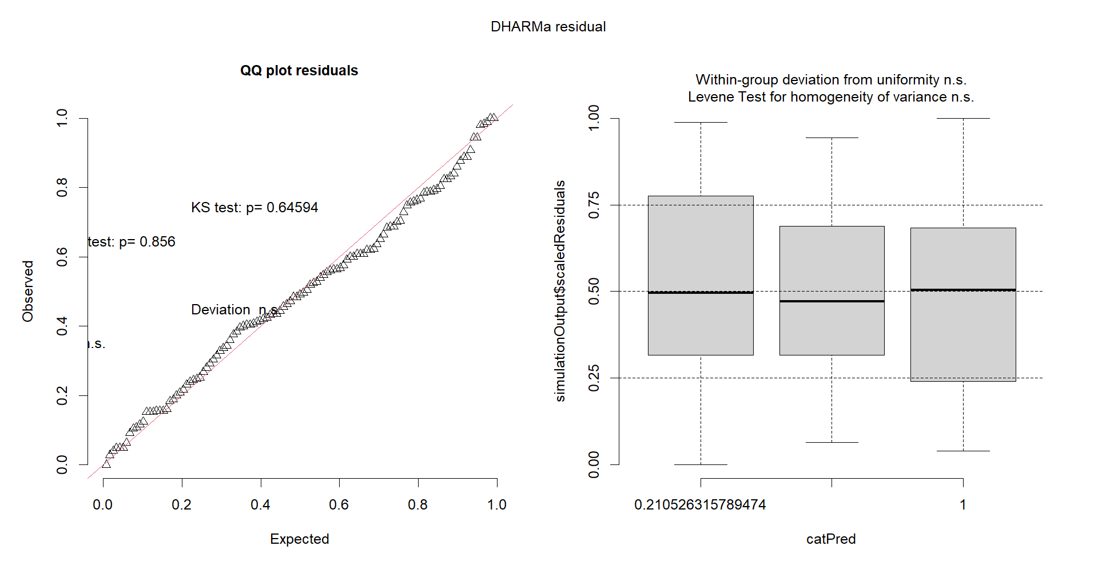

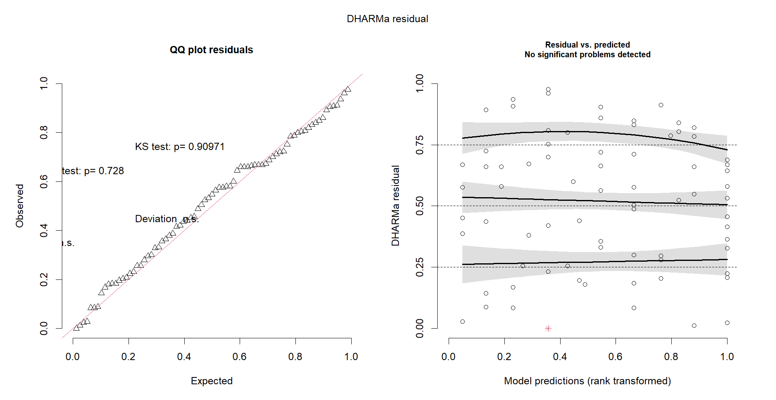

# 4.0 Discussion

# 5.0 Conclusion

# References

Anderson, E. P., S. Jackson, R. E. Tharme, M. Douglas, J. E. Flotemersch, M. Zwarteveen, C. Lokgariwar, M. Montoya, A. Wali, G. T. Tipa, T. D. Jardine, J. D. Olden, L. Cheng, J. Conallin, B. Cosens, C. Dickens, D. Garrick, D. Groenfeldt, J. Kabogo, D. J. Roux, A. Ruhi, and A. H. Arthington. 2019. Understanding rivers and their social relations: A critical step to advance environmental water management. WIREs Water 6(6).

Arthington, A. H., and S. R. Balcombe. 2011. Extreme flow variability and the ‘boom and bust’ ecology of fish in arid‐zone floodplain rivers: a case history with implications for environmental flows, conservation and management. Ecohydrology 4(5):708–720.

Bachir, A., and A. Lyes. 2022. Accurate Discharge Coefficient Relationship For The Crump Weir. LARHYSS Journal 52(2022):93–115.

Balcombe, S. R., S. E. Bunn, F. J. McKenzie‐Smith, and P. M. Davies. 2005. Variability of fish diets between dry and flood periods in an arid zone floodplain river. Journal of Fish Biology 67(6):1552–1567.

Balcombe, S. R., M. P. Turschwell, A. H. Arthington, and C. S. Fellows. 2015. Is fish biomass in dryland river waterholes fuelled by benthic primary production after major overland flooding? Journal of Arid Environments 116:71–76.

Bourke, S. A., M. Shanafield, P. Hedley, S. Chapman, and S. Dogramaci. 2023. A hydrological framework for persistent pools along non-perennial rivers. Hydrology and Earth System Sciences 27(3):809–836.

Brunner, P., P. G. Cook, and C. T. Simmons. 2009. Hydrogeologic controls on disconnection between surface water and groundwater. Water Resources Research 45(1).

Bunn, S. E., S. Balcombe, P. Davies, C. Fellows, and F. McKenzie-Smith. 2006a. Aquatic productivity and food webs of desert river ecosystems. Pages 76–99 *in* R. T. Kingsford, editor. Ecology of Desert Rivers. Cambridge University Press, Cambridge.

Bunn, S. E., M. C. Thoms, S. K. Hamilton, and S. J. Capon. 2006b. Flow variability in dryland rivers: boom, bust and the bits in between. River Research and Applications 22(2):179–186.

Canosa, L. F., and J. I. Bertucci. 2023. The effect of environmental stressors on growth in fish and its endocrine control. Frontiers in Endocrinology 14.

Caroline, L. L., and N. R Afshar. 2014. Effect of Types of Weir on Discharge. Journal of Civil Engineering, Science and Technology 5(2):35–40.

Chester, E. T., A. D. Miller, I. Valenzuela, S. J. Wickson, and B. J. Robson. 2015. Drought survival strategies, dispersal potential and persistence of invertebrate species in an intermittent stream landscape. Freshwater Biology 60(10):2066–2083.

D’Odorico, P., F. Laio, A. Porporato, and I. Rodriguez-Iturbe. 2003. Hydrologic controls on soil carbon and nitrogen cycles. II. A case study. Advances in Water Resources 26(1):59–70.

DAFF. 2018. Analysis of 2018 Drought. https://www.agriculture.gov.au/abares/products/insights/2018-drought-analysis.

Davis, J., N. Munksgaard, J. Hodgetts, and D. Lambrinidis. 2021. Identifying groundwater‐fed climate refugia in remote arid regions with citizen science and isotope hydrology. Freshwater Biology 66(1):35–43.

Douglas, M. M., S. E. Bunn, and P. M. Davies. 2005. River and wetland food webs in Australia’s wet - dry tropics: general principles and implications for management. Marine and Freshwater Research 56(3):329.

Dunlop, E. S., I. Hébert, and C. Taylor. 2023. Validation of the Use of Otoliths to Estimate Age and Growth of Larval Lake Whitefish, Coregonus clupeaformis. Journal of Applied Ichthyology 2023:1–16.

Faulks, L. K., D. M. Gilligan, and L. B. Beheregaray. 2010. Islands of water in a sea of dry land: hydrological regime predicts genetic diversity and dispersal in a widespread fish from Australia’s arid zone, the golden perch ( Macquaria ambigua ). Molecular Ecology 19(21):4723–4737.

Franssen, N. R., K. B. Gido, and D. L. Propst. 2007. Flow regime affects availability of native and nonnative prey of an endangered predator. Biological Conservation 138(3–4):330–340.

Gampe, D., J. Zscheischler, M. Reichstein, M. O’Sullivan, W. K. Smith, S. Sitch, and W. Buermann. 2021. Increasing impact of warm droughts on northern ecosystem productivity over recent decades. Nature Climate Change 2021 11:9 11(9):772–779. Nature Publishing Group.

Gido, K. B., J. E. Whitney, J. S. Perkin, and T. F. Turner. 2015. Fragmentation, connectivity and fish species persistence in freshwater ecosystems. Pages 292–323 Conservation of Freshwater Fishes. Cambridge University Press.

Gillanders, B. M., B. A. Black, M. G. Meekan, and M. A. Morrison. 2012. Climatic effects on the growth of a temperate reef fish from the Southern Hemisphere: a biochronological approach. Marine Biology 159(6):1327–1333.

Hamilton, S. K., S. E. Bunn, M. C. Thoms, and J. C. Marshall. 2005. Persistence of aquatic refugia between flow pulses in a dryland river system(Cooper Creek, Australia). Limnology and Oceanography 50(3):743–754.

Hodson, T. O. 2022. Root-mean-square error (RMSE) or mean absolute error (MAE): when to use them or not. Geoscientific Model Development 15(14):5481–5487.

IPCC. 2022. Climate Change 2022 – Impacts, Adaptation and Vulnerability. Contribution of Working Group II to the Sixth Assessment Report of the Intergovernmental Panel on Climate Change. Cambridge University Press.

Jackson, D. A., P. R. Peres-Neto, and J. D. Olden. 2001. What controls who is where in freshwater fish communities- the roles of biotic, abiotic, and spatial factors. Canadian Journal of Fisheries and Aquatic Sciences 58(1):157–170.

Jobling, M. 2002. Environmental Factors and Rates of Development and Growth. Pages 97–122 *in* P. J. B. Hart and J. D. Reynolds, editors. Handbook of Fish Biology and Fisheries, Volume 1. Blackwell Publishing Ltd, Oxford, UK.

Kennard, M. J., B. J. Pusey, J. D. Olden, S. J. Mackay, J. L. Stein, and N. Marsh. 2010. Classification of natural flow regimes in Australia to support environmental flow management. Freshwater Biology 55(1):171–193.

Koehn, J. D. 2004. Carp ( Cyprinus carpio ) as a powerful invader in Australian waterways. Freshwater Biology 49(7):882–894.

Koehn, J. D., S. R. Balcombe, and B. P. Zampatti. 2019. Fish and flow management in the Murray–Darling Basin: Directions for research. Ecological Management & Restoration 20(2):142–150.

Koehn, J. D., S. M. Raymond, I. Stuart, C. R. Todd, S. R. Balcombe, B. P. Zampatti, H. Bamford, B. A. Ingram, C. M. Bice, K. Burndred, G. Butler, L. Baumgartner, P. Clunie, I. Ellis, J. P. Forbes, M. Hutchison, W. M. Koster, M. Lintermans, J. P. Lyon, M. Mallen-Cooper, M. McLellan, L. Pearce, J. Ryall, C. Sharpe, D. J. Stoessel, J. D. Thiem, Z. Tonkin, A. Townsend, and Q. Ye. 2020. A compendium of ecological knowledge for restoration of freshwater fishes in Australia. Marine and Freshwater Research 71(11):1391.

Lancaster, J., and L. R. Belyea. 1997. Nested Hierarchies and Scale-Dependence of Mechanisms of Flow Refugium Use. Journal of the North American Benthological Society 16(1):221–238.

Lapointe, N. W. R., S. J. Cooke, J. G. Imhof, D. Boisclair, J. M. Casselman, R. A. Curry, O. E. Langer, R. L. McLaughlin, C. K. Minns, J. R. Post, M. Power, J. B. Rasmussen, J. D. Reynolds, J. S. Richardson, and W. M. Tonn. 2014. Principles for ensuring healthy and productive freshwater ecosystems that support sustainable fisheries. Environmental Reviews 22(2):110–134.

Macklin, M. G., and J. Lewin. 2015. The rivers of civilization. Quaternary Science Reviews 114:228–244.

Maestre, F. T., R. Salguero-Gómez, and J. L. Quero. 2012. It is getting hotter in here: determining and projecting the impacts of global environmental change on drylands. Philosophical Transactions of the Royal Society B: Biological Sciences 367(1606):3062–3075.

Magoulick, D. D., and R. M. Kobza. 2003. The role of refugia for fishes during drought: a review and synthesis. Freshwater Biology 48(7):1186–1198.

Mallen‐Cooper, M., and I. G. Stuart. 2003. Age, growth and non‐flood recruitment of two potamodromous fishes in a large semi‐arid/temperate river system. River Research and Applications 19(7):697–719.

Marshall, J. C., N. Menke, D. A. Crook, J. S. Lobegeiger, S. R. Balcombe, J. A. Huey, J. H. Fawcett, N. R. Bond, A. H. Starkey, D. Sternberg, S. Linke, and A. H. Arthington. 2016. Go with the flow: the movement behaviour of fish from isolated waterhole refugia during connecting flow events in an intermittent dryland river. Freshwater Biology 61(8):1242–1258. John Wiley & Sons, Ltd.

Martino, J. C., A. J. Fowler, Z. A. Doubleday, G. L. Grammer, and B. M. Gillanders. 2019. Using otolith chronologies to understand long‐term trends and extrinsic drivers of growth in fisheries. Ecosphere 10(1).

Moggridge, B. J., and R. M. Thompson. 2021. Cultural value of water and western water management: an Australian Indigenous perspective. Australasian Journal of Water Resources 25(1):4–14.

Mooij, W. M., R. E. Bennetts, W. M. Kitchens, and D. L. DeAngelis. 2002. Exploring the effect of drought extent and interval on the Florida snail kite: interplay between spatial and temporal scales. Ecological Modelling 149(1–2):25–39.

Morón, S., and K. J. Amos. 2018. Downstream grain‐size changes associated with a transition from single channel to anabranching. Sedimentology 65(5):1590–1610.

Morrongiello, J. R., P. C. Sweetman, and R. E. Thresher. 2019. Fishing constrains phenotypic responses of marine fish to climate variability. Journal of Animal Ecology 88(11):1645–1656.

Murray–Darling Basin Authority. 2023. Our reliance on the Basin for water. https://www.mdba.gov.au/basin/why-murray-darling-basin-matters/our-reliance-basin-water.

Pettit, N. E., T. D. Jardine, S. K. Hamilton, V. Sinnamon, D. Valdez, P. M. Davies, M. M. Douglas, and S. E. Bunn. 2012. Seasonal changes in water quality and macrophytes and the impact of cattle on tropical floodplain waterholes. Marine and Freshwater Research 63(9):788.

Petty, J. T., and G. D. Grossman. 2004. Restricted movement by mottled sculpin (pisces: cottidae) in a southern Appalachian stream. Freshwater Biology 49(5):631–645.

Queensland Government. 2024a. SILO - Australian Climate Data from 1889 to Yesterday. https://www.longpaddock.qld.gov.au/silo/gridded-data/.

Queensland Government. 2024b. Water Monitoring Information Portal (WMIP). https://water-monitoring.information.qld.gov.au/.

Razeng, E., A. E. Smith, K. A. Harrisson, A. Pavlova, T. Nguyen, A. Pinder, P. Suter, J. Webb, M. G. Gardner, J. Brim Box, R. Thompson, J. Davis, and P. Sunnucks. 2017. Evolutionary divergence in freshwater insects with contrasting dispersal capacity across a sea of desert. Freshwater Biology 62(8):1443–1459.

Rhodes, K. A., T. Proffitt, T. Rowley, P. S. K. Knappett, D. Montiel, N. Dimova, D. Tebo, and G. R. Miller. 2017. The Importance of Bank Storage in Supplying Baseflow to Rivers Flowing Through Compartmentalized, Alluvial Aquifers. Water Resources Research 53(12):10539–10557.

Saintilan, N., K. Rogers, and T. J. Ralph. 2013. Matching research and policy tools to scales of climate-change adaptation in the Murray-Darling, a large Australian river basin: a review. Hydrobiologia 708(1):97–109.

Shanafield, M., M. Blanchette, E. Daly, N. Wells, R. M. Burrows, K. Korbel, G. C. Rau, S. Bourke, G. Wakelin-King, A. Holland, T. Ralph, G. McGrath, B. Robson, K. Fowler, M. S. Andersen, S. Yu, C. S. Jones, N. Waltham, E. W. Banks, A. Flatley, C. Leigh, S. Maxwell, A. Siebers, N. Bond, L. Beesley, G. Hose, J. Iles, I. Cartwright, M. Reid, T. de Castro Tayer, and C. Duvert. 2024. Australian non-perennial rivers: Global lessons and research opportunities. Journal of Hydrology 634:130939.

Sheldon, F., S. E. Bunn, J. M. Hughes, A. H. Arthington, S. R. Balcombe, and C. S. Fellows. 2010. Ecological roles and threats to aquatic refugia in arid landscapes: dryland river waterholes. Marine and Freshwater Research 61(8):885.

Steel, E. A., A. Marsha, A. H. Fullerton, J. D. Olden, N. K. Larkin, S.-Y. Lee, and A. Ferguson. 2019. Thermal landscapes in a changing climate: biological implications of water temperature patterns in an extreme year. Canadian Journal of Fisheries and Aquatic Sciences 76(10):1740–1756.

Thoms, M. C., and F. Sheldon. 2000. Lowland rivers: An Australian introduction. River Research and Applications 16(5):375–383. John Wiley and Sons Ltd.

Turschwell, M. P., B. Stewart‐Koster, A. J. King, B. Pusey, D. Crook, E. Boone, M. Douglas, Q. Allsop, S. Jackson, and M. J. Kennard. 2019. Flow‐mediated predator–prey dynamics influence fish populations in a tropical river. Freshwater Biology 64(8):1453–1466.

Vousdoukas, M. I., L. Mentaschi, E. Voukouvalas, M. Verlaan, S. Jevrejeva, L. P. Jackson, and L. Feyen. 2018. Global probabilistic projections of extreme sea levels show intensification of coastal flood hazard. Nature Communications 9(1):2360.

Wager, R., and P. J. Unmack. 2000. Fishes of the Lake Eyre catchment of central Australia. Department of Primary Industries and Queensland Fisheries Service, Brisbane.

Wallace, J., N. Waltham, D. Burrows, and D. McJannet. 2015. The temperature regimes of dry-season waterholes in tropical northern Australia: potential effects on fish refugia. Freshwater Science 34(2):663–678.

Westra, S., H. J. Fowler, J. P. Evans, L. V. Alexander, P. Berg, F. Johnson, E. J. Kendon, G. Lenderink, and N. M. Roberts. 2014. Future changes to the intensity and frequency of short-duration extreme rainfall. Reviews of Geophysics 52(3):522–555.

Woodward, G., N. Bonada, L. E. Brown, R. G. Death, I. Durance, C. Gray, S. Hladyz, M. E. Ledger, A. M. Milner, S. J. Ormerod, R. M. Thompson, and S. Pawar. 2016. The effects of climatic fluctuations and extreme events on running water ecosystems. Philosophical Transactions of the Royal Society B: Biological Sciences 371(1694):20150274.

Zhou, S., Y. Zhang, A. P. Williams, and P. Gentine. 2019. Projected increases in intensity, frequency, and terrestrial carbon costs of compound drought and aridity events. Science Advances 5(1).

Zhou, Z., and I. Cartwright. 2021. Using geochemistry to identify and quantify the sources, distribution, and fluxes of baseflow to an intermittent river impacted by climate change: The upper Wimmera River, southeast Australia. Science of The Total Environment 801:149725.