CSE535 Mobile Computing (Fall 2017)
Assignment 1, Due on Thursday, Sept 7th, 2017 by 11:59 pm

Submission method
- Please upload the zipped all source code folder from your android studio workspace.
- Before submission, please do double-check whether “app-debug.apk” file in apk in output in build in app folder is existing or not. If not, please build your project at least one time. After build your project, you can see the apk file. Also, please do not touch the file.
- No allow the late submission.

Task - Health Monitoring UI
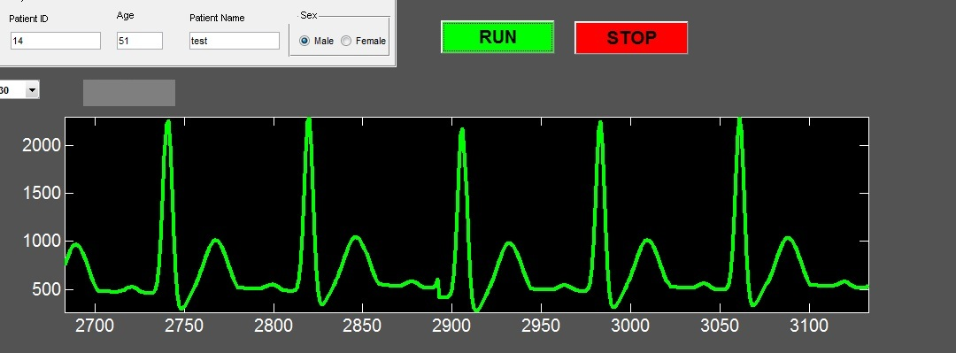

Develop an UI similar to the Matlab UI shown in the above Figure for android phones. Use the emulator to display the UI. For graphing use the graphView class provided in the course webpage. If you want to use the other third-part library instead of the graphView (we provide), it is no problem. First, you generate a sample array of floats using the random library. Whenever the “Run button” is hit, the array is plotted in the canvass. On clicking the “Stop button”, drawing graph should be stopped and the view should be cleared. And, if you click the “Run button” again after clicking the “Stop button”, drawing the graph should be restarted continuously (without clearing the previous graph). Also, the graph should be drawn and moved continuously before “Stop button” was clicked such as real heartbeat signal until clicking the “Stop button”.

Deliverables:
- The source code of your app (acknowledge reused code – mark what is your own code).
- The comments on your source code are required.

Grading Rubric

Testing Environment for Grading
If possible, please follow the below environment setting to avoid you receive the wrong grade. Sometimes, your source code does not work correctly since your development environment is different to the below environment. At that time, we could not give the correct grade because it is not easy to find the reason why your application works incorrectly.
- Android Studio 1.5.1
- Nexus 5
- API 22

Achievable full credit - 100
Condition | Grade deductions
- App runs without being unresponsive  - Can fill patient data  - Graph updates continuously after one time clicking Run button  - Graph clears on hitting Stop button | 0
If app is unresponsive at any stage | 50
Graph not showing | 50
Cannot fill patient data | 30
Cannot hit run button multiple times | 30
Cannot hit stop button multiple times | 30
Graph in layout but no data | 40
Graph with data but cannot update | 25
No graph axis labels | 20

