**King Saud University**

**College of Computer & Information Science**

**CSC111 – Lab04**

**IO, Variables, Expressions**

**All Sections**

**-------------------------------------------------------------------**

# Instructions

Web-CAT submission URL:

http://10.131.240.28:8080/Web-CAT/WebObjects/Web-CAT.woa/wa/assignments/eclipse

# Objectives:

1. Student should learn how to program using selection statements with combined conditions.
2. Student should learn how to combine conditions using logical operators (**!**, **&&**, and **||**)
3. Student should learn how to write expressions using the conditional expression

# Lab Exercise 1

The two roots of a quadratic equation ${ax}^{2}+bx+c=0$ can be obtained using the following formula:

$r_{1}=\frac{-b + \sqrt{b^{2}-4ac}}{2a}$ and $r_{2}=\frac{-b - \sqrt{b^{2}-4ac}}{2a}$

$b^{2}-4ac$ is called the discriminant of the quadratic equation. If it is positive, the equation has two real roots. If it is zero, the equation has one root. If it is negative, the equation has no real roots.

Write a program that prompts the user to enter values for *a*, *b*, and *c* and displays the result based on the discriminant. If the discriminant is positive, display two roots. If the discriminant is **0**, display one root. Otherwise, display “**The equation has no real roots**”.

Note that you can use Math.pow(x, 0.5) to compute $\sqrt{x}$.

Here are some sample runs:

Enter a, b, c: 1 3 1 **↵**

The equation has two roots -0.3819660112501051 and -2.618033988749895

# Solution

Enter a, b, c: 1 2 3 **↵**

The equation has no real roots

Enter a, b, c: 1 2 1 **↵**

The equation has one root -1.0

1. Create a new project in eclipse and name it **lab04**
2. Create a new class and name it **QuadEquation**. Make sure you choose the public static void main option.
3. Write the program as following (you can ignore comments):

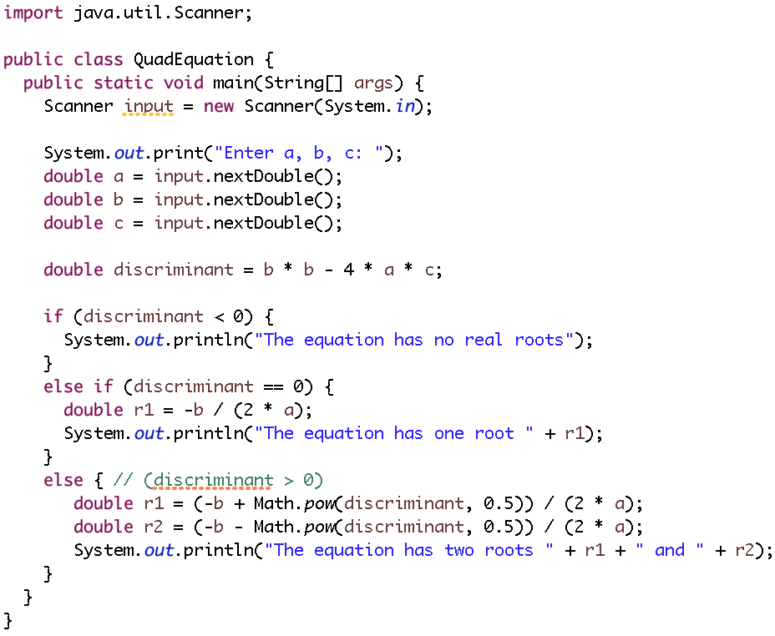

1. When you are done, save your program and run it. Make sure it prints the output as shown above.
2. Submit your program to WebCAT through. Ask your TA for help.

# Lab Exercise 2

# How cold is it outside? Temperature by itself is not enough. In 2001, the National Weather Service (NWS) in United States implemented the new wind-chill temperature to measure the coldness using temperature and wind speed. The formula is

$$t_{wc}=35.74+ 0.6215t_{a}-35.75v^{0.16}+0.4275t_{a}v^{0.16}$$

# where $t_{a}$ is the outside temperature measured in degrees Fahrenheit and $v$ is the speed measured in miles per hour. $t_{wc}$ is the wind-chill temperature. The formula cannot be used for wind speeds below 2 mph or temperatures below oF or above 41oF.

# Write a program that prompts the user to enter a temperature and a wind speed. The program displays the wind-chill temperature if the input is valid; otherwise, it displays a message indicating whether the temperature and/or wind speed is invalid.

Here are sample runs:

Enter the temperature in Fahrenheit: 32 **↵**

Enter the wind speed miles per hour: 30 **↵**

The wind chill index is 17.59665069469402

# Solution

Enter the temperature in Fahrenheit: 20 **↵**

Enter the wind speed miles per hour: 1 **↵**

Speed must be greater than or equal to 2

Enter the temperature in Fahrenheit: 80 **↵**

Temperature must be between -58F and 41F

1. Use the same project **lab04** that you created before
2. Create a new class and name it **WindChill**. Make sure you choose the public static void main option.
3. Write the program as following (you can ignore comments):

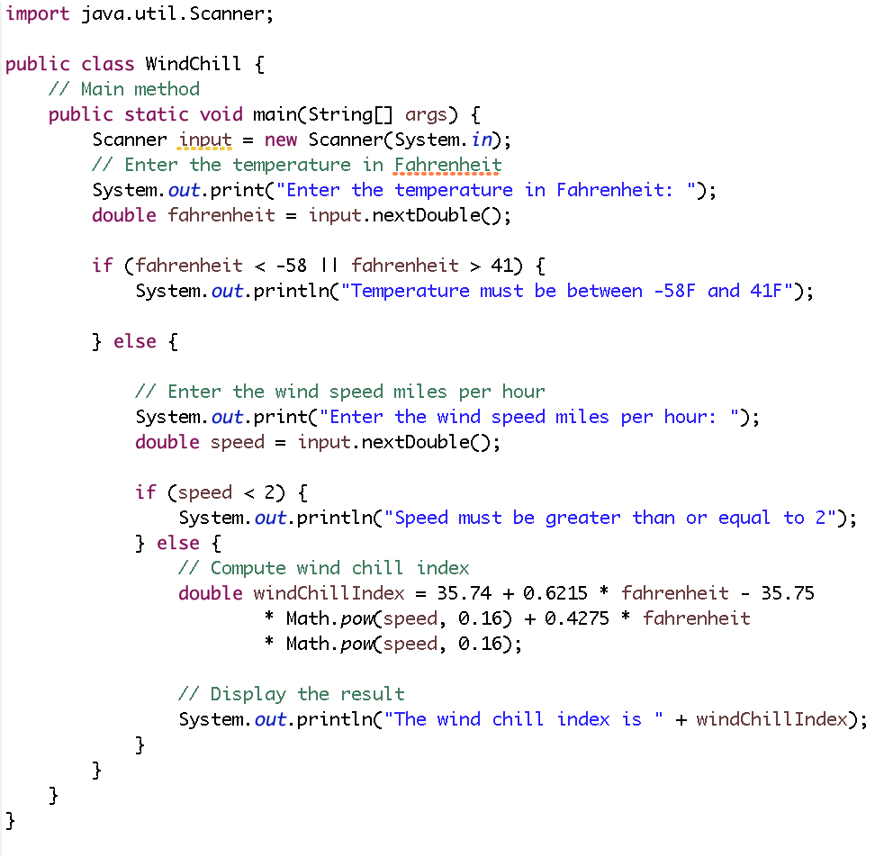

1. When you are done, save your program and run it. Make sure it prints the output as shown above.
2. Submit your program to WebCAT through. Ask your TA for help.

**Done…**