**King Saud University**

**College of Computer & Information Science**

**CSC111 – Lab05**

**Loops**

**All Sections**

**-------------------------------------------------------------------**

# Instructions

Web-CAT submission URL:

http://10.131.240.28:8080/Web-CAT/WebObjects/Web-CAT.woa/wa/assignments/eclipse

# Objectives:

Student should learn how to:

1. Follow the loop design strategy to develop loops.
2. Control a loop with a sentinel value.
3. Write loops using for statements

# Lab Exercise 1

Write a program that reads an unspecified number of integers, determines how many positive and negative values have been read, and computes the total and average of the input values (not counting zeros). Your program ends with the input 0. Display the average as a floating-point number.

Here are some sample runs:

Enter integers ending with 0: 1 2 -1 3 0 **↵**

The number of positives is 3

The number of negatives is 1

The total is 5

The average is 1.25

# Solution

Enter integers ending with 0: 0 **↵**

no numbers are entered except 0

1. Create a new project in eclipse and name it **lab05**
2. Create a new class and name it **CountPosNeg**. Make sure you choose the public static void main option.
3. Write the program as following (you can ignore comments):

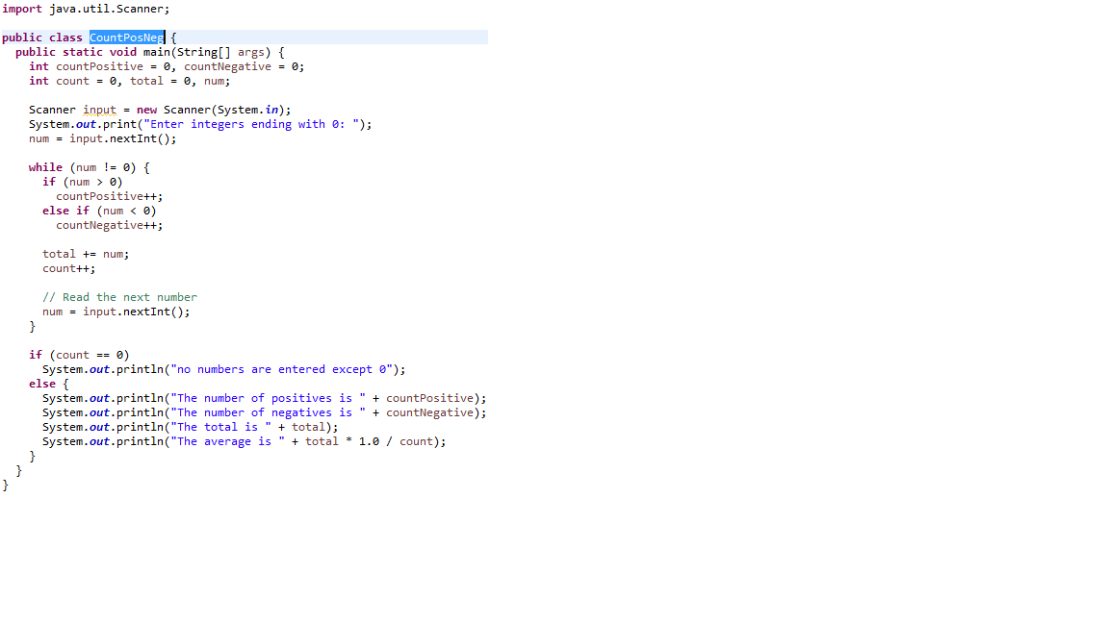

1. When you are done, save your program and run it. Make sure it prints the output as shown above.
2. Submit your program to WebCAT through. Ask your TA for help.

# Lab Exercise 2

Write a program that prompts the user to enter the number of students and each student’s name and score (at least two students), and finally displays the student with the highest score and the student with the second-highest score.

Here is a sample runs:

Enter the number of students: 4 **↵**

Enter a student name: Mohammed **↵**

Enter a student score: 75 **↵**

Enter a student name: Ali **↵**

Enter a student score: 85 **↵**

Enter a student name: Fahad **↵**

Enter a student score: 98 **↵**

Enter a student name: Khalid **↵**

Enter a student score: 65 **↵**

Top two students:

Fahad's score is 98.0

Ali's score is 85.0

# Solution

1. Use the same project **lab05** that you created before
2. Create a new class and name it **HighScore**. Make sure you choose the public static void main option.
3. Write the program as following (you can ignore comments):

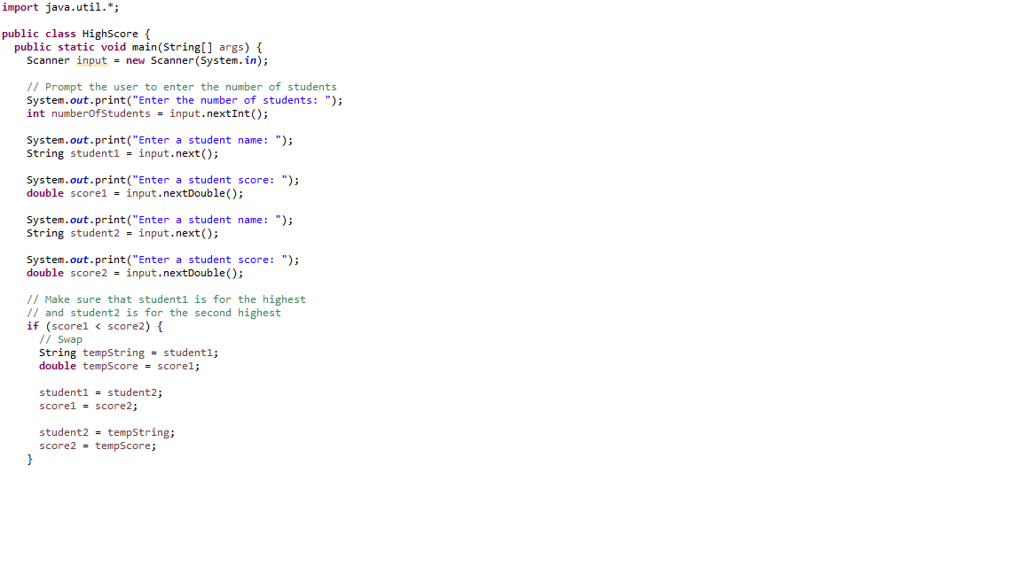

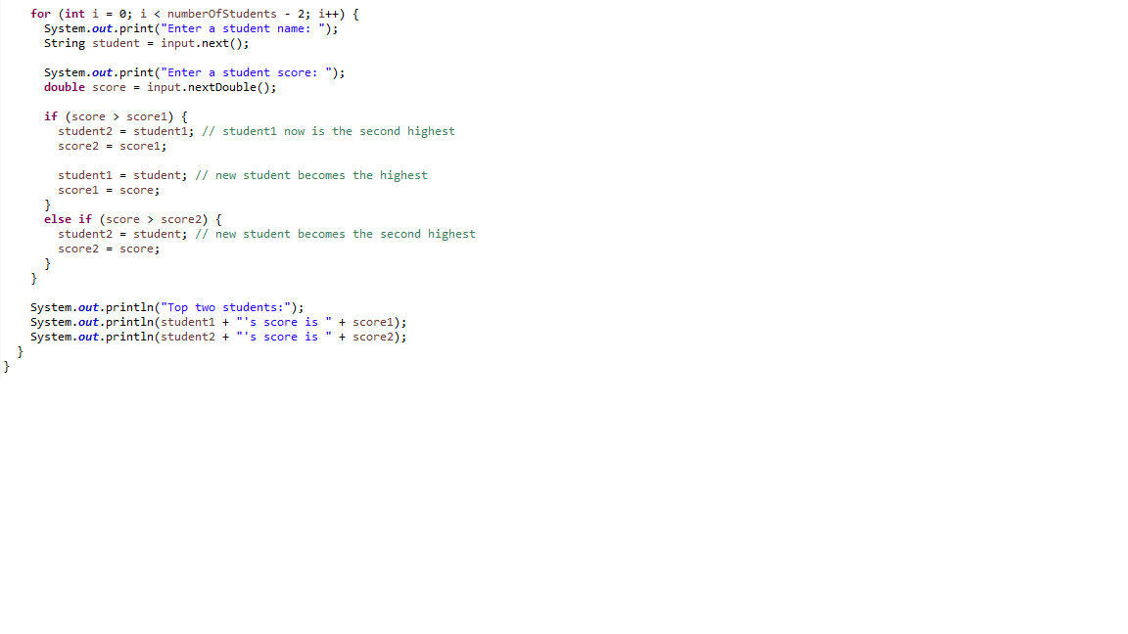

1. When you are done, save your program and run it. Make sure it prints the output as shown above.
2. Submit your program to WebCAT through. Ask your TA for help.

**Done…**