**HOBBY PROJECT REPORT**

**Clone of CY8CPROTO-063-BLE- PSoC_6_BLE_Prototyping_Kit**

**By: Vedant Mundada**

**Roll No: BT2024268**

**OneDrive Link:** [**Vedant_Mundada_KiCAD**](https://iiitbac-my.sharepoint.com/:f:/g/personal/vedant_mundada_iiitb_ac_in/Ejk5QNwR8f1KvMCcpMYX9NEB4_DFn0BmgYCl4tRWE2hesQ?e=zveSCT)

**Schematics: Programming Board-**

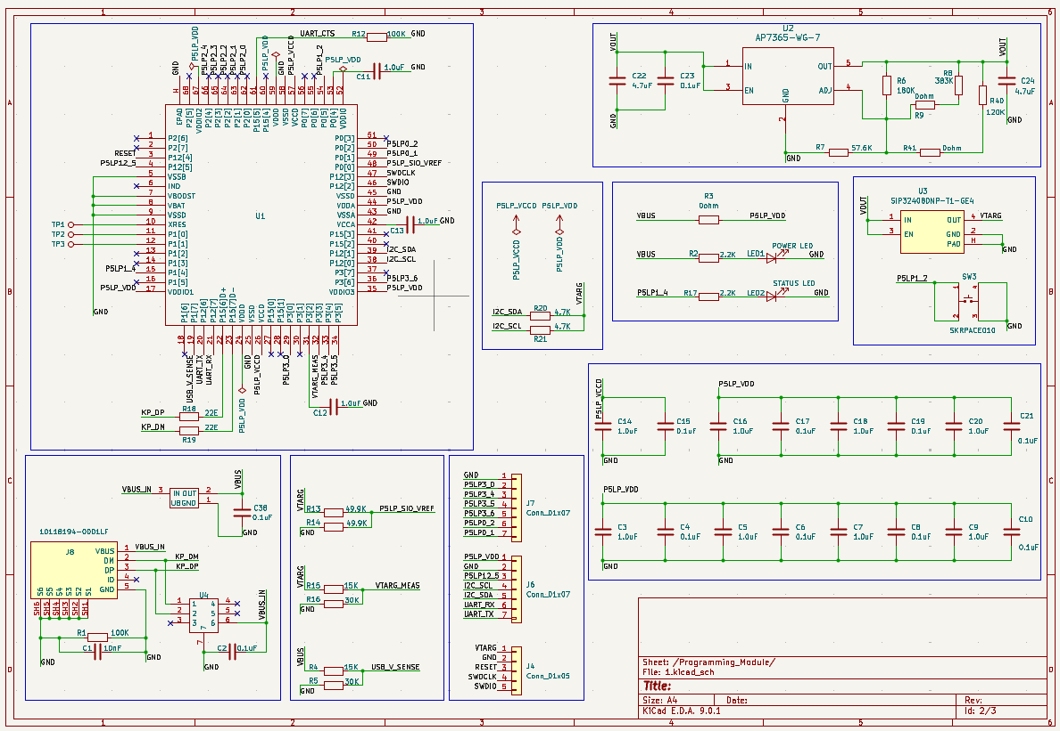

**Schematics: BLE-Module-**

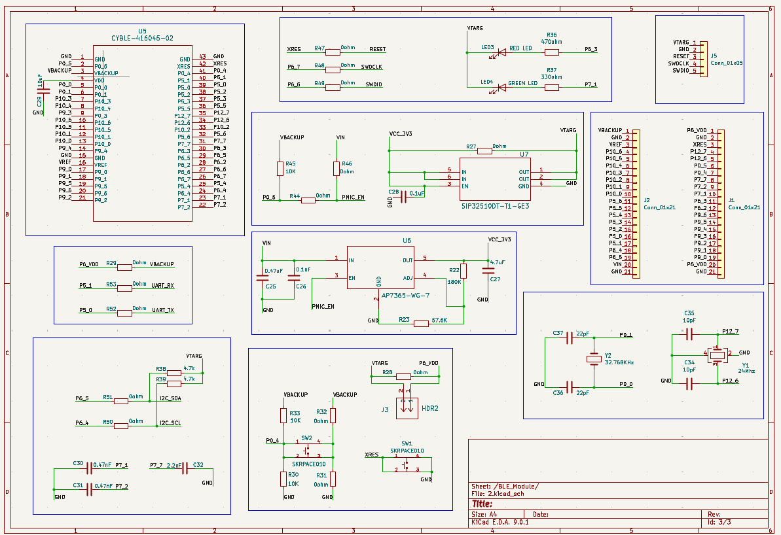

**ERC Results:**

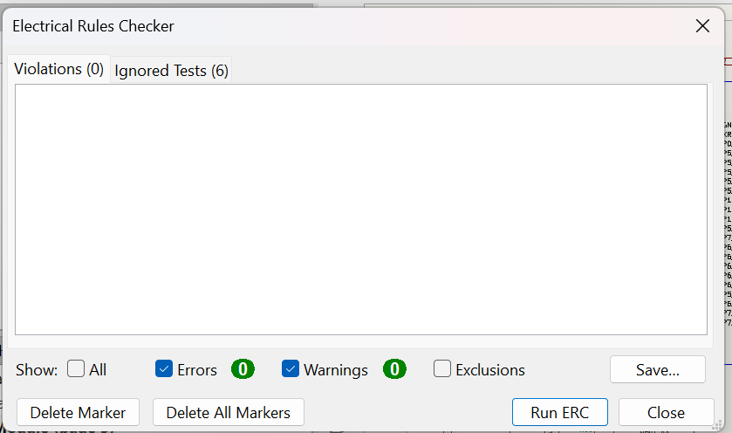

**PCB Design View (All layers) :**

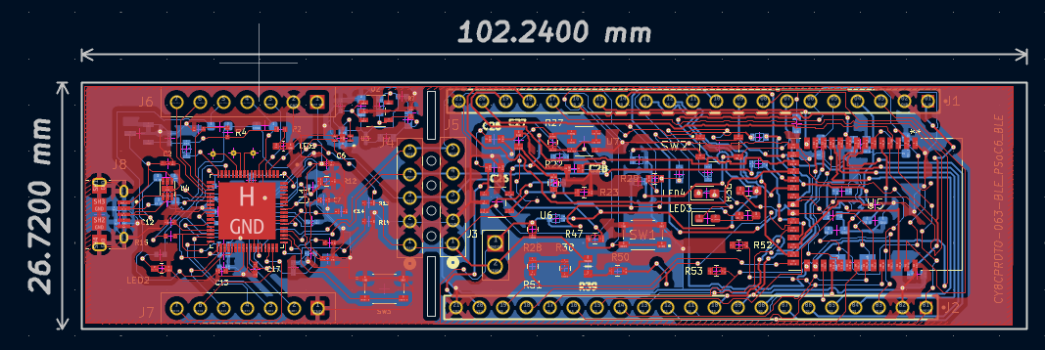

**PCB Design View(Front View) :**

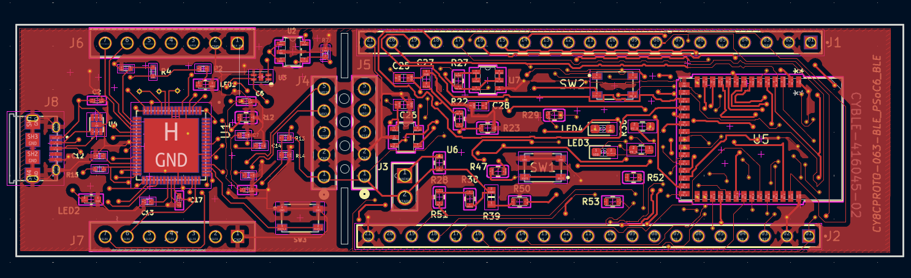

**PCB Design View(Back View)** **:**

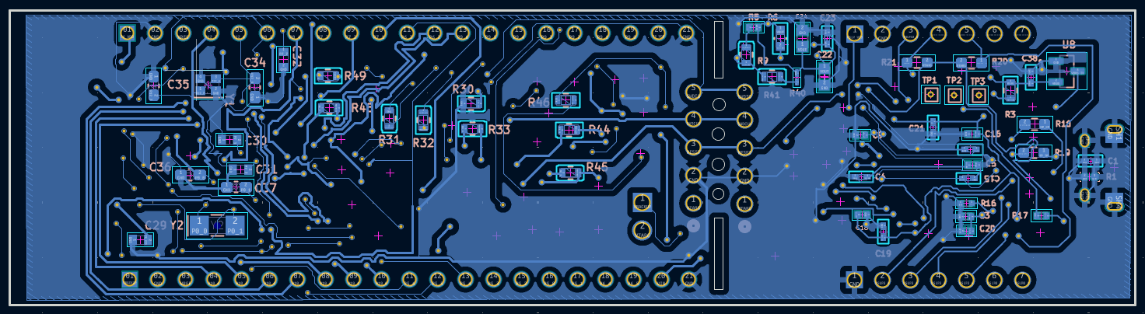

**3D – View:**

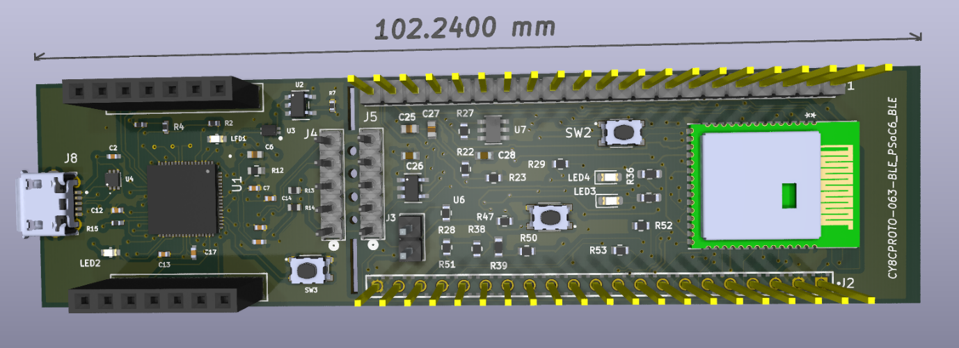

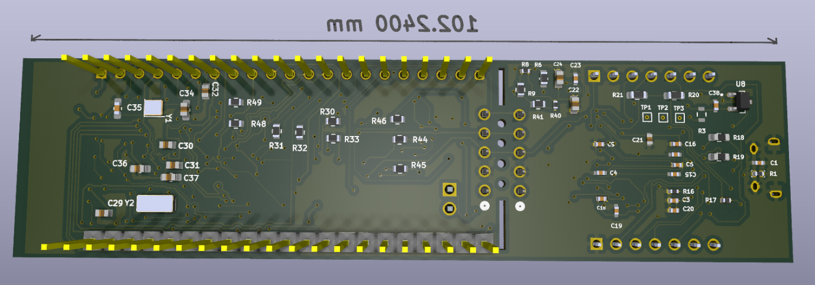**qwqwq**

**DRC Results:**

