***Name: M Hassan***

***Roll no: 20sw012***

***Topic: Power BI***

**TASK 01:**

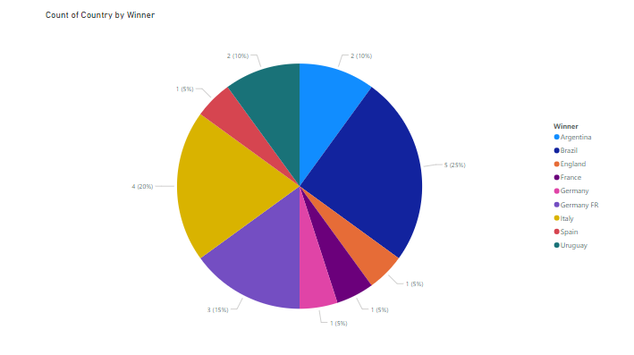

**TASK 02:**

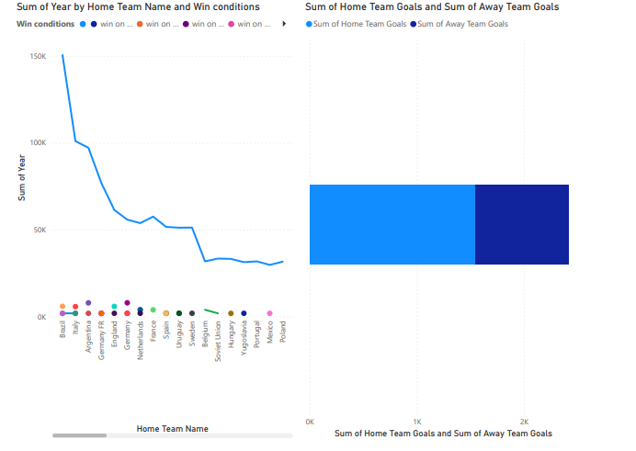

**TASK 03:**

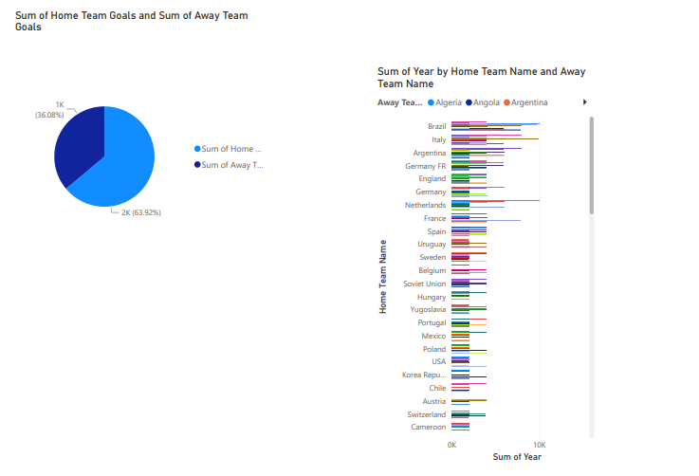

**TASK 04:**

