**Implement the Solution (Word Coding)**

Dispense food =

Roatate servo 90º clockwise

Wait 4 seconds

Rotate servo 90º anticlockwise

Send alert =

Alarm ON

Is time 8am/6pm

If yes, then

Weigh bowl

If weight = 0 then

Dispense food

Weight food

If weight = 0 then

Send alert

Else

Send alert

Wait 10 minutes

Weight bowl

If weight = >0 then

Send alert

Else finish

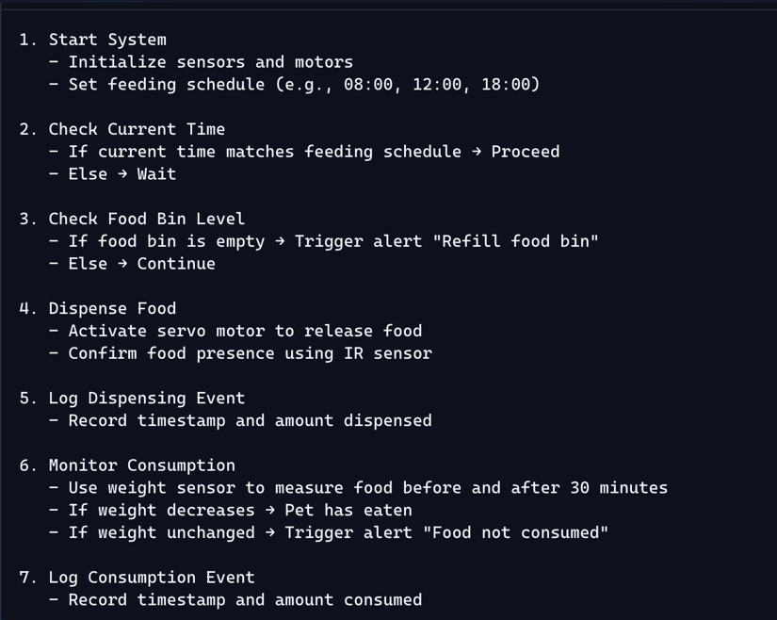I asked copilot how I could improve this, and this is what it gave me.

