Smith_J Mid Term Socket Connect Port Scan

Student: Jesse Smith
School of Cyber Security: National University
Course: CYB333 Security Automation
Instructor: Erika Voss
Assignment: Mid Term
Date: September 26th, 2026

Smith_J Mid Term Socket Connect Port Scan
I started this project by thinking about the way the team at ITPro TV kept their script from creating an endless loop. My first instinct was to add socket timeouts to both the client and the server, since a socket call without a timeout can hang indefinitely if the other side never responds. I set a 200-second timeout on both scripts so that a stalled connection would eventually fail rather than loop the terminal with no explanation. That decision ended up shaping the rest of the build, because once I had timeouts in place, I could actually see and screenshot error conditions on demand instead of hoping they'd show up.
By running the client before starting the server, it hit a ConnectionRefusedError with a clean message telling me the server wasn't running or reachable. That same screenshot also shows me working through the client code with GitHub Copilot Chat inside VS Code, reviewing the connection logic and asking for suggestions on timeouts and general improvements before I added anything to the actual file.
Figure 1
Screenshot of the server script at the beginning in an unreachable status:
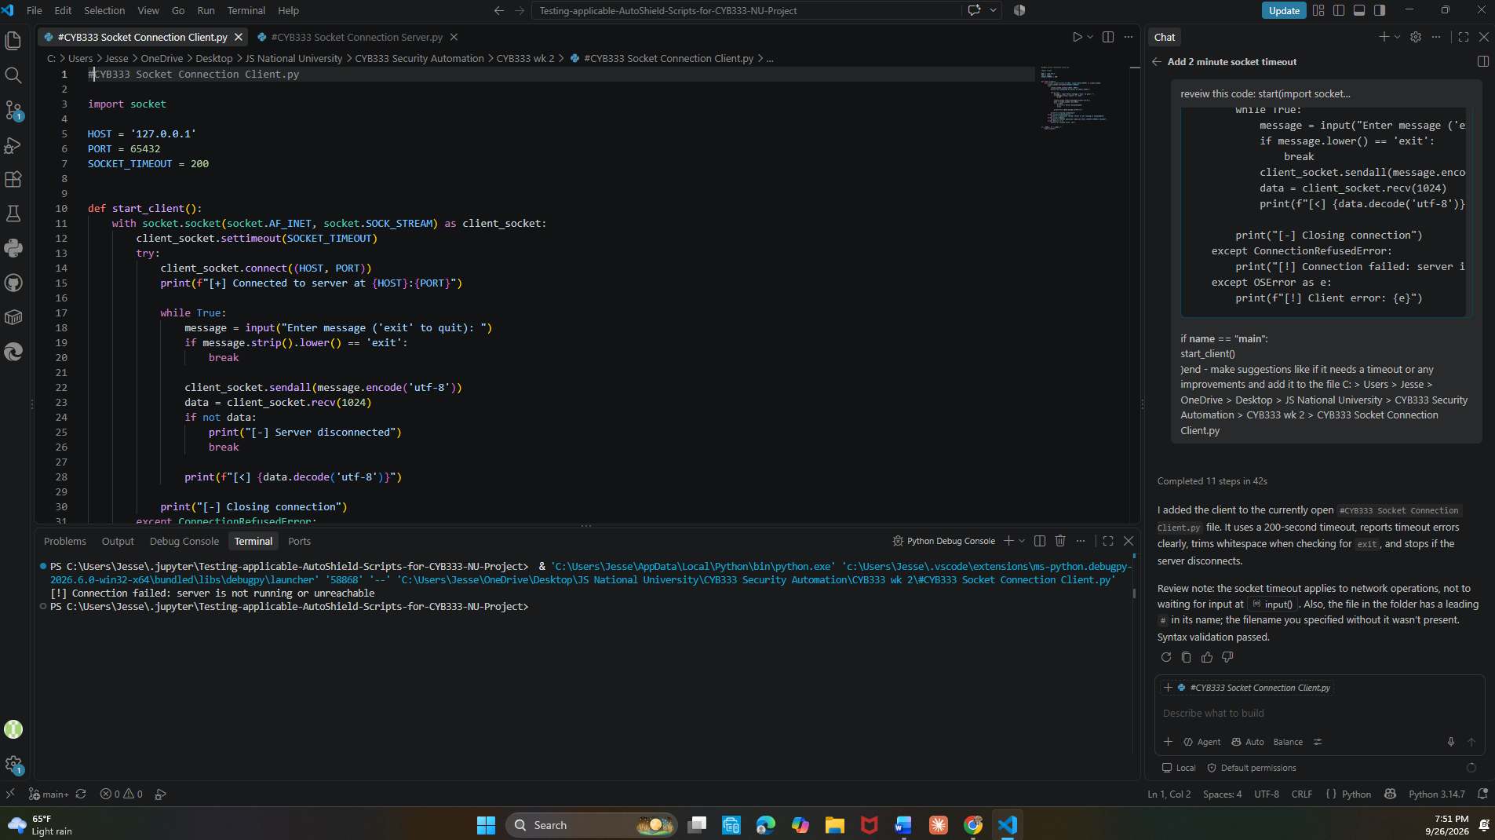
Note. Screenshot taken by the author showing the server script is not reachable before connecting through the terminal in Visual Studio (Visual Studio, 2026).

Once the client and server were solid on their own, I set up two terminals side by side, one running the server script and one running the client, so I could watch both sides of the conversation at the same time instead of switching windows. My second screenshot captures this effective layout of Terminal A, which shows the server listening on 127.0.0.1:65432, and Terminal B showing the client connecting successfully. I typed the message "Working on Python Socket Connection" from the client, and the same screenshot shows the server receiving it, printing it, then sending its response back, which the client displays. After that exchange, I let the connection sit idle long enough to trigger the 200-second timeout on the server side, which closed as expected with a timed-out error, while the client exited cleanly when I typed "exit," closing the connection without any errors.
Figure 2
Screenshot of the side-by-side Terminal communication from Terminal A to B showing client listening, connecting, sending and receiving a message, clean session time out as well as clean closing of the connection when exiting:
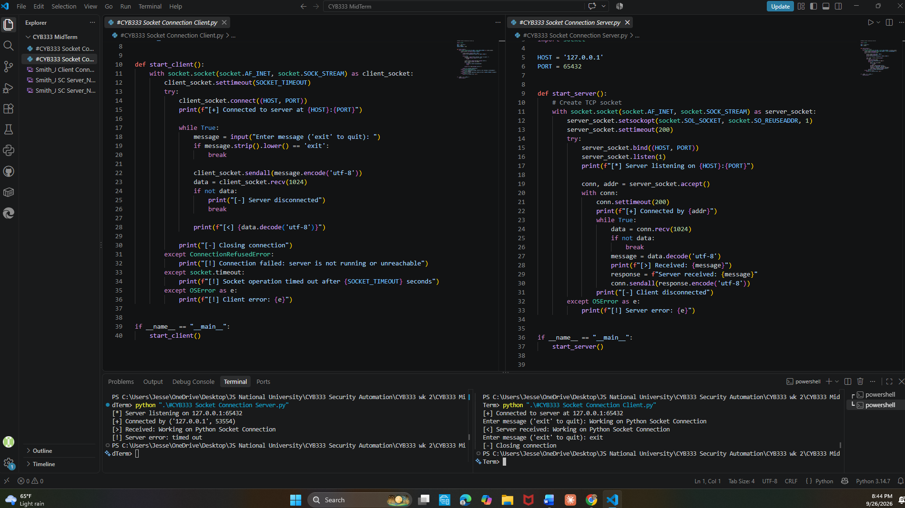
Note. Screenshot taken by the author showing the server and client script as well as terminals in Visual Studio (Visual Studio, 2026).

From there, I moved to the port scanner, which I originally adapted from a version Claude built for me. The first draft worked but wasn't handling input the way I actually wanted for testing, so I went back in and adjusted it to accept either a single port range (like 1-1000) or a comma-separated list of specific ports (like 20,21,22,80,443), and added input validation so bad ports or blank input would fail with a clear message instead of a crash. My third and final screenshot shows the full set of port scanner test cases in one place. A full 1-1000 scan on localhost that I cancelled partway through once I'd confirmed it was working (it was going to take a while at one port per fraction of a second), a common-ports scan (20, 21, 22, 80, 443) against localhost showing no open ports, a scan of ports 20-25 against scanme.nmap.org that correctly found port 22 open, an invalid port number (99999) caught by my validation, and an unreachable/invalid hostname caught by the gaierror handler.
Figure 3
Screenshot of the port scanner running, showing range, list, scanme.nmap.org, invalid port, and invalid hostname:
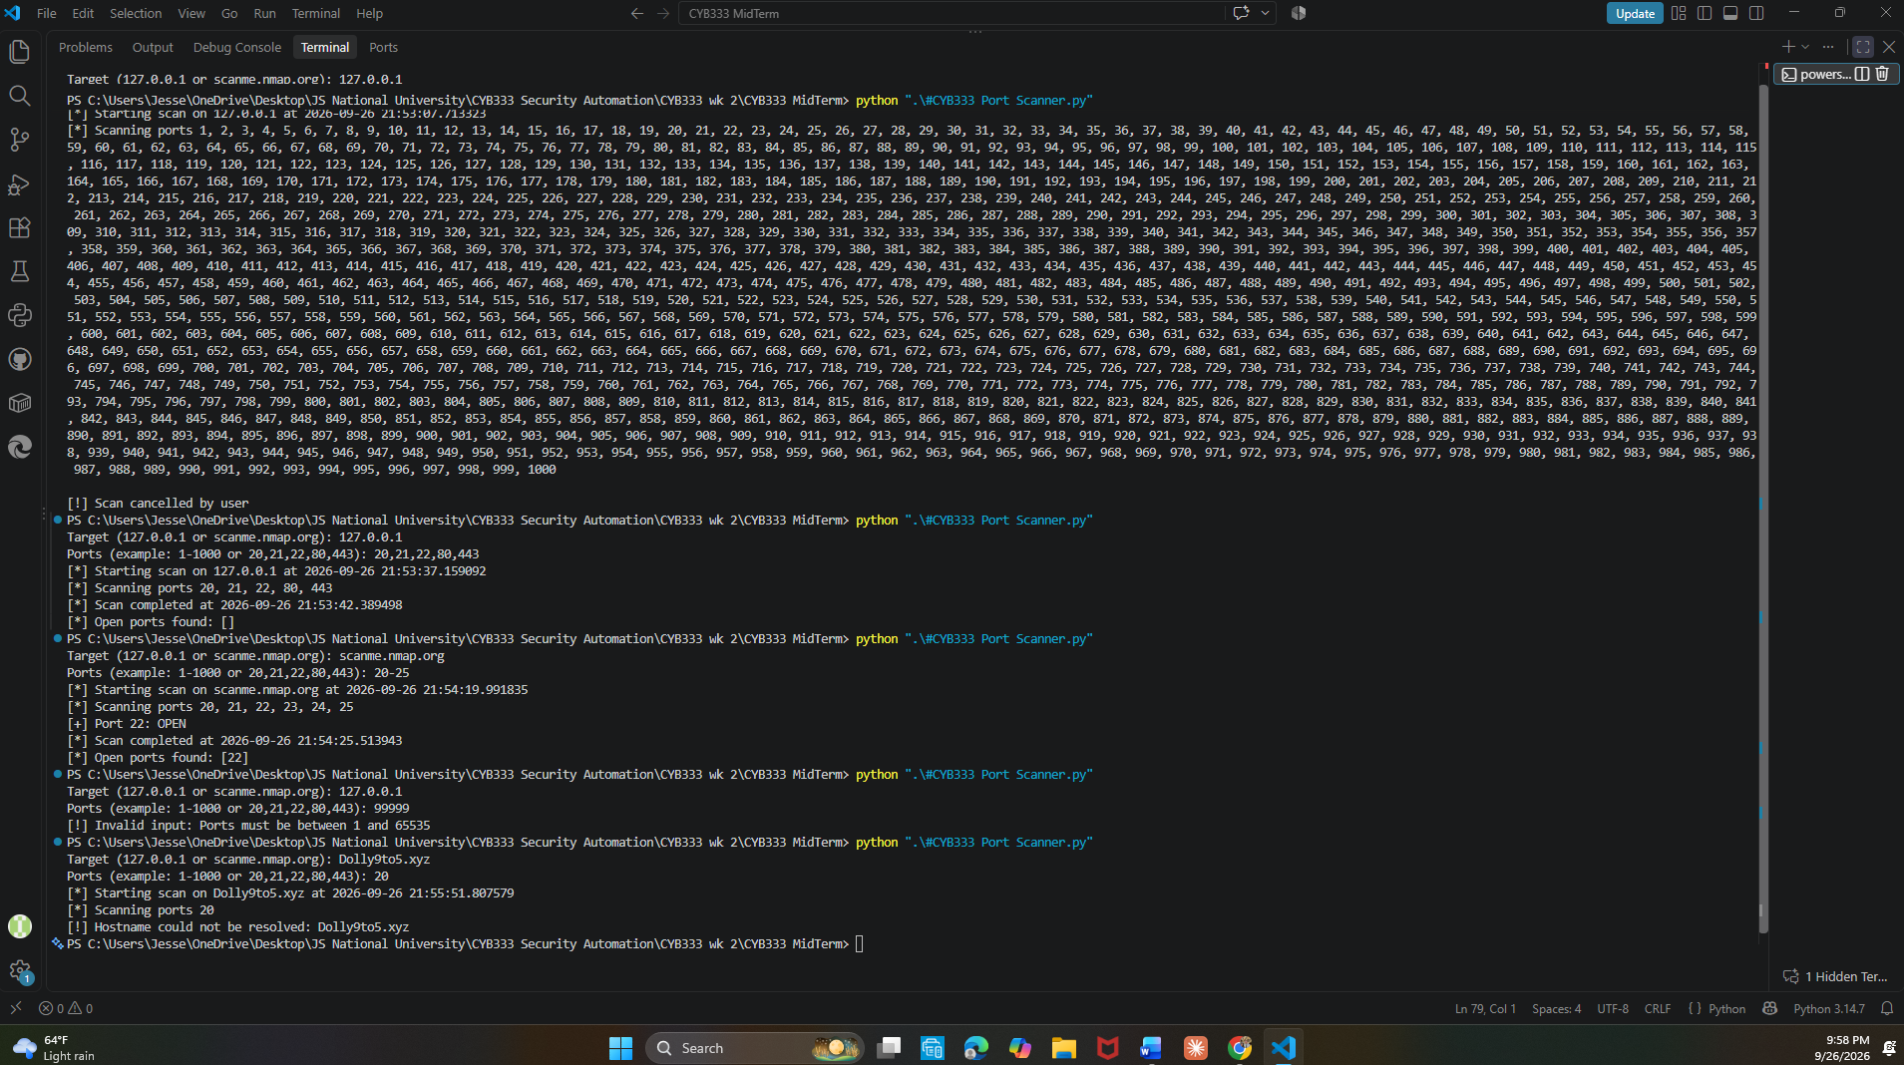
Note. Screenshot showing port scanner script running in terminal (Visual Studio, 2026).
I used GitHub Copilot Chat in VS Code throughout this project, and I want to be specific about how I did so. For the socket connection client, I pasted my in-progress code and asked Copilot to review the current code and make suggestions. Specifically, add a timeout and any other improvements or suggestions that AI can suggest to help the file run more efficiently. Copilot's response added a 200-second timeout, made the timeout error message more descriptive, trimmed whitespace when checking for the "exit" command, and added a check to ensure the client would exit cleanly if the server disconnected first. It also gave me a useful correction I hadn't considered: the timeout applies to network operations, not to the input() call itself, which shaped how I explained the timeout behavior.
GitHub Repository Link HayJJSmith (Jesse Smith): https://github.com/HayJJSmith/CYB333-Socket_Connection_Port_Scan.git

References:
Anthropic. (2026). Claude [Large language model]. https://claude.ai
GitHub. (2026). GitHub Copilot [Large language model]. https://.com/features/copilot
ITProTV. (n.d.). Python for Security [Series]. ITPro TV. https://app.acilearning.com/course/pythonsecurity/overview-python-security

